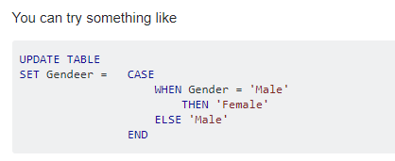

<https://www.java67.com/2013/04/10-frequently-asked-sql-query-interview-questions-answers-database.html>