University of Allahabad
Centre of Vocational studies and skill development


ANDROID & JAVA LAB PRACTICAL FILE
Session: - 2025-26

Submitted By:
Name: Khushi Kumari
Semester: 6th
Enrolment No.: U2364008

Submitted To: Deepak Kumar Singh
Assistant Professor

Familiarization with Android Development Platform
For familiarization with android development, you need to download Android Panda 1 (Android Studio)
Step: 1

Open Android Studio
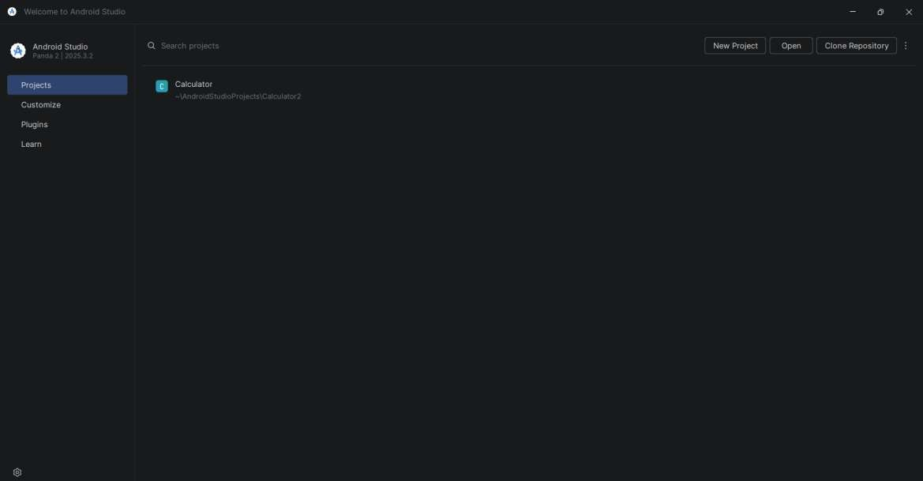
Step: 2

Clicked on New Project
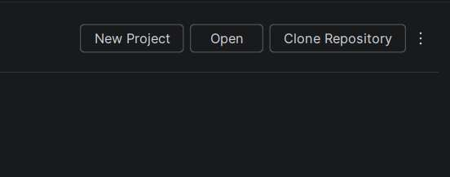

Step: 3

Selected Empty Activity or Basic view Activity
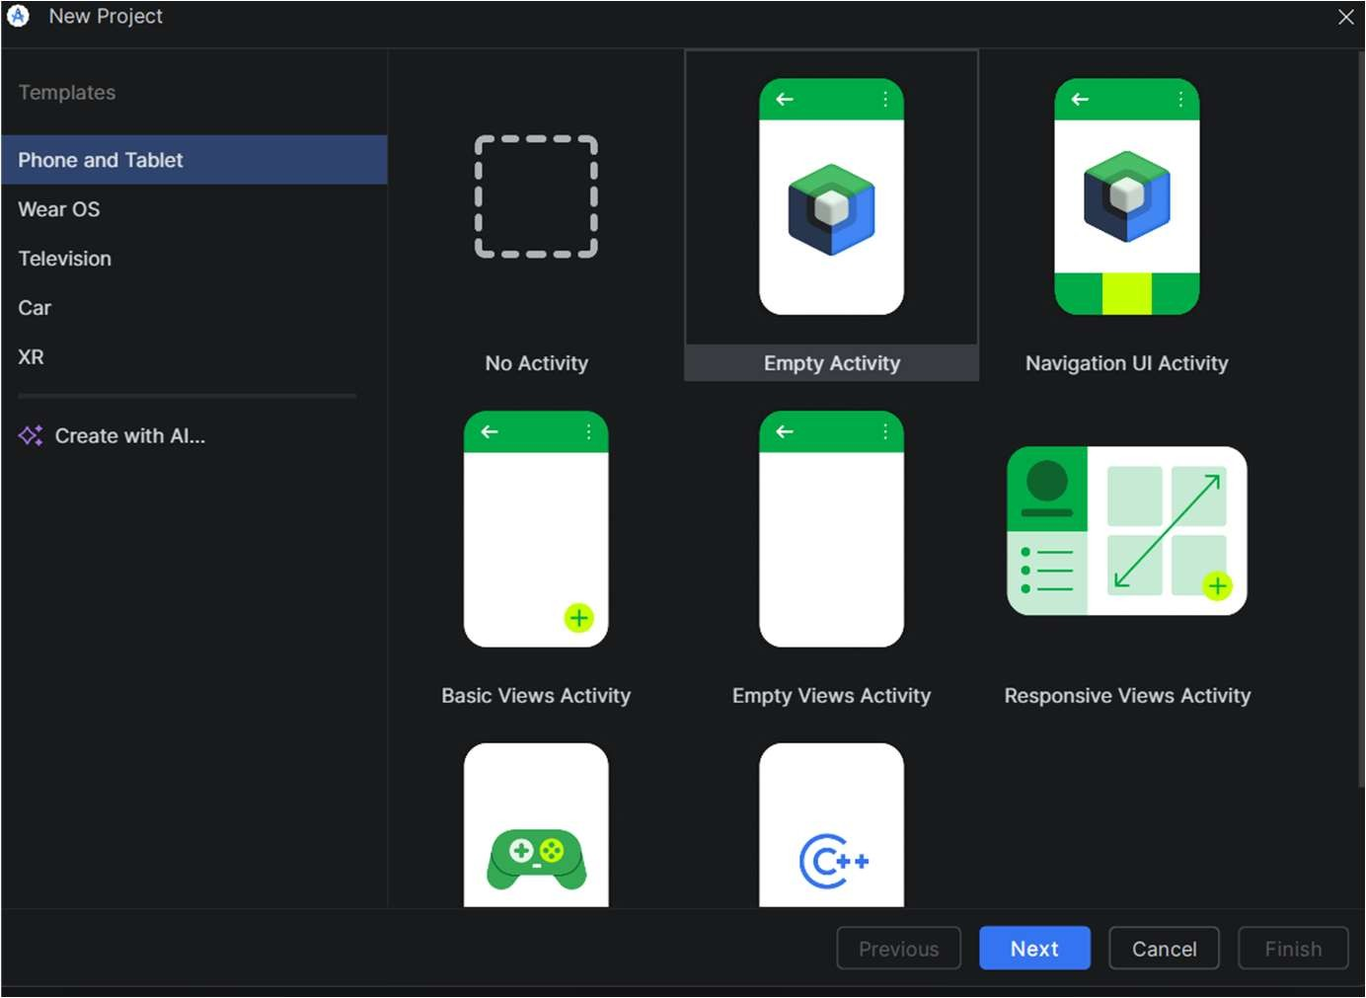
Step: 4

Entered project details and created project
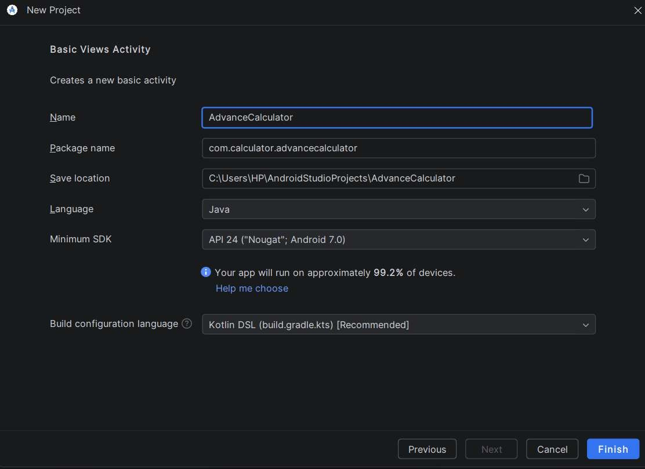

Step: 5
After clicking Finish Observed Android Studio interface.
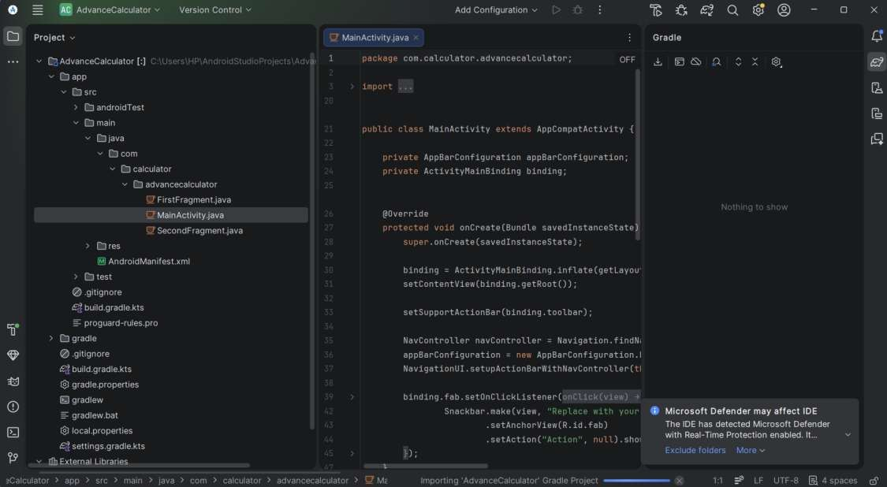
Step: 6
On the Right you can see the project structure
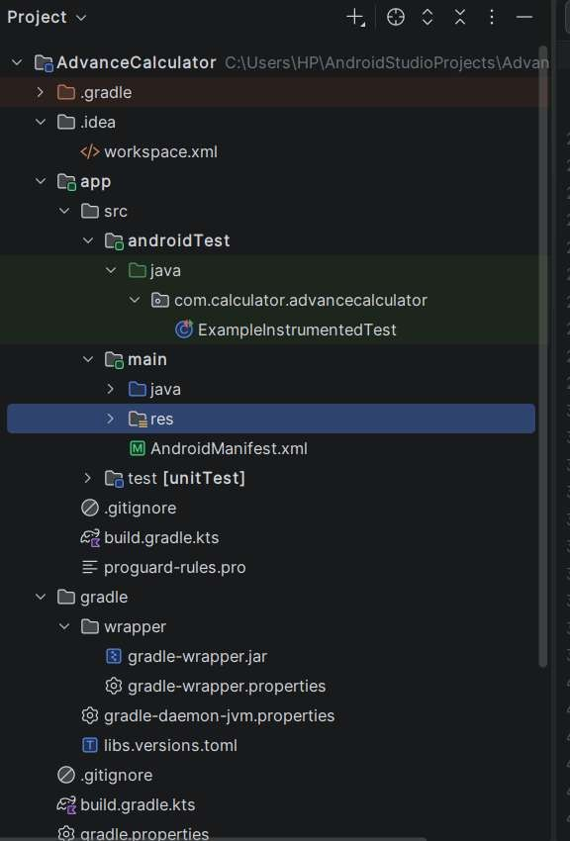
The project contains different folders such as:
- java/ for source code files
- res/ for resources like layouts, strings, and images
- layout/ for XML design files

2.Configure Android Development Environment

Step: 1 Opened Android Studio
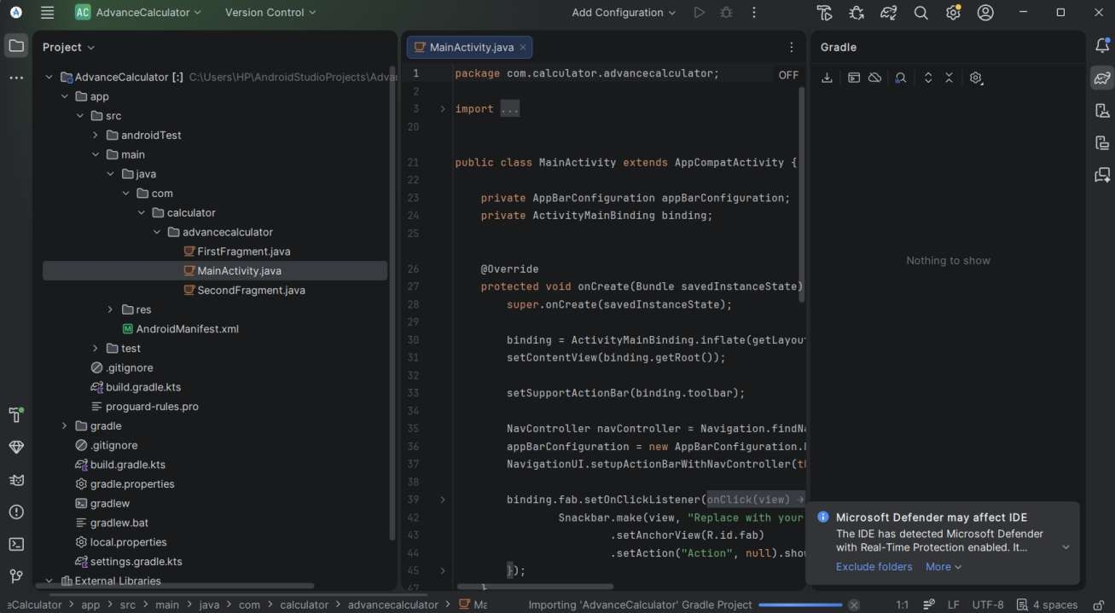
Step: 2
Click on the Tools
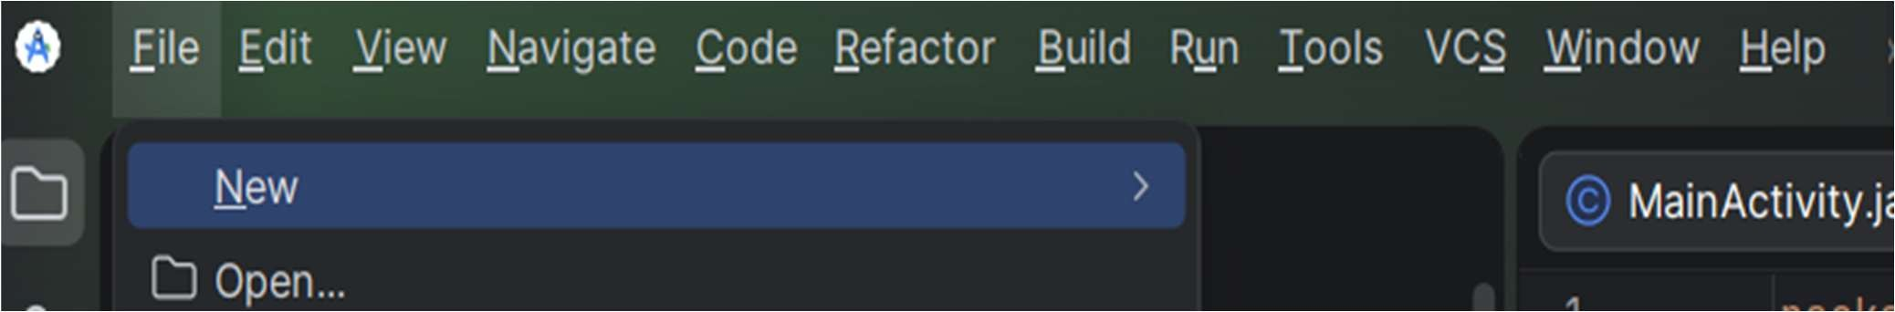
Step: 3
Then click on Device manager
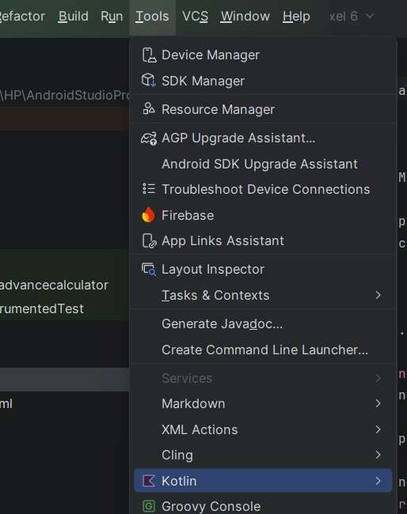
Step: 4
After that a Device manger Screen appear on Right side of Screen
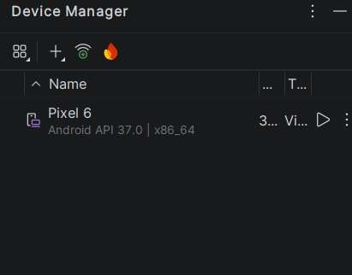
Step: 5
Click on the Add new device(the plus icon ) choose the option Create Virtual Device
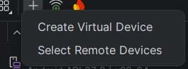

Step: 6 Choose any device you want click on next and download the Emulator
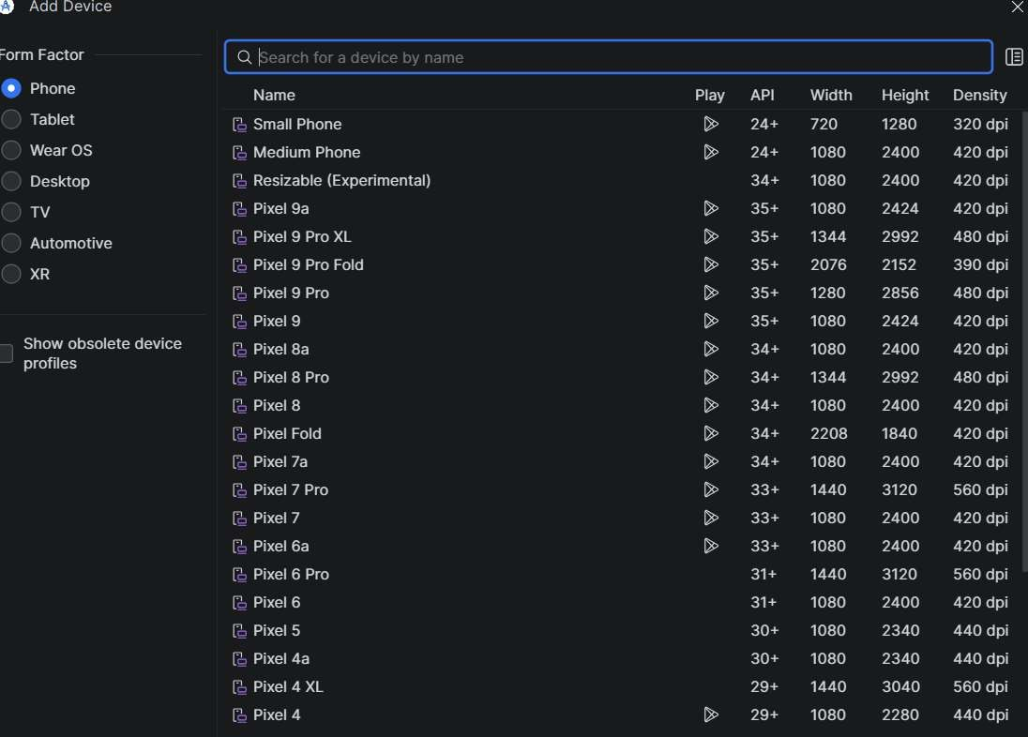

Output:

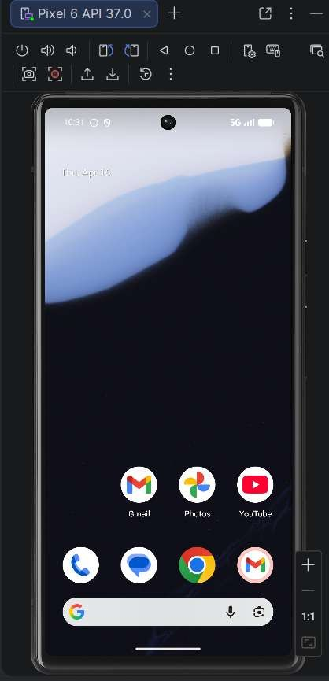
3Connect to an Android device and run the program on the device.

Writing Android Programs

Step: 1
Opened Android Studio.

Step: 2
Created a new project using Empty Views Activity

Step: 3
Entered project details and clicked Finish

Step: 4
Waited for Gradle build to complete successfully

Step: 5
Launch any Emulator such as pixel 6 ,pixel6 pro etc. like this

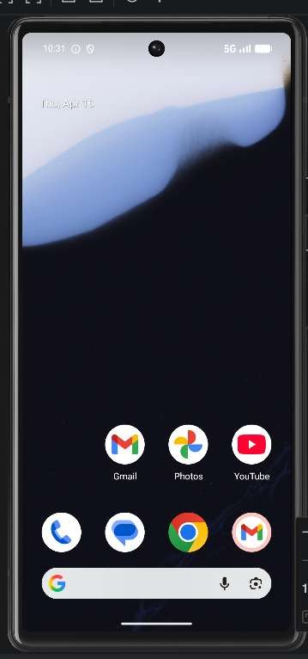

Step: 6 Clicked on the Run (▶) button Observed the output on the emulator screen displaying Hello World

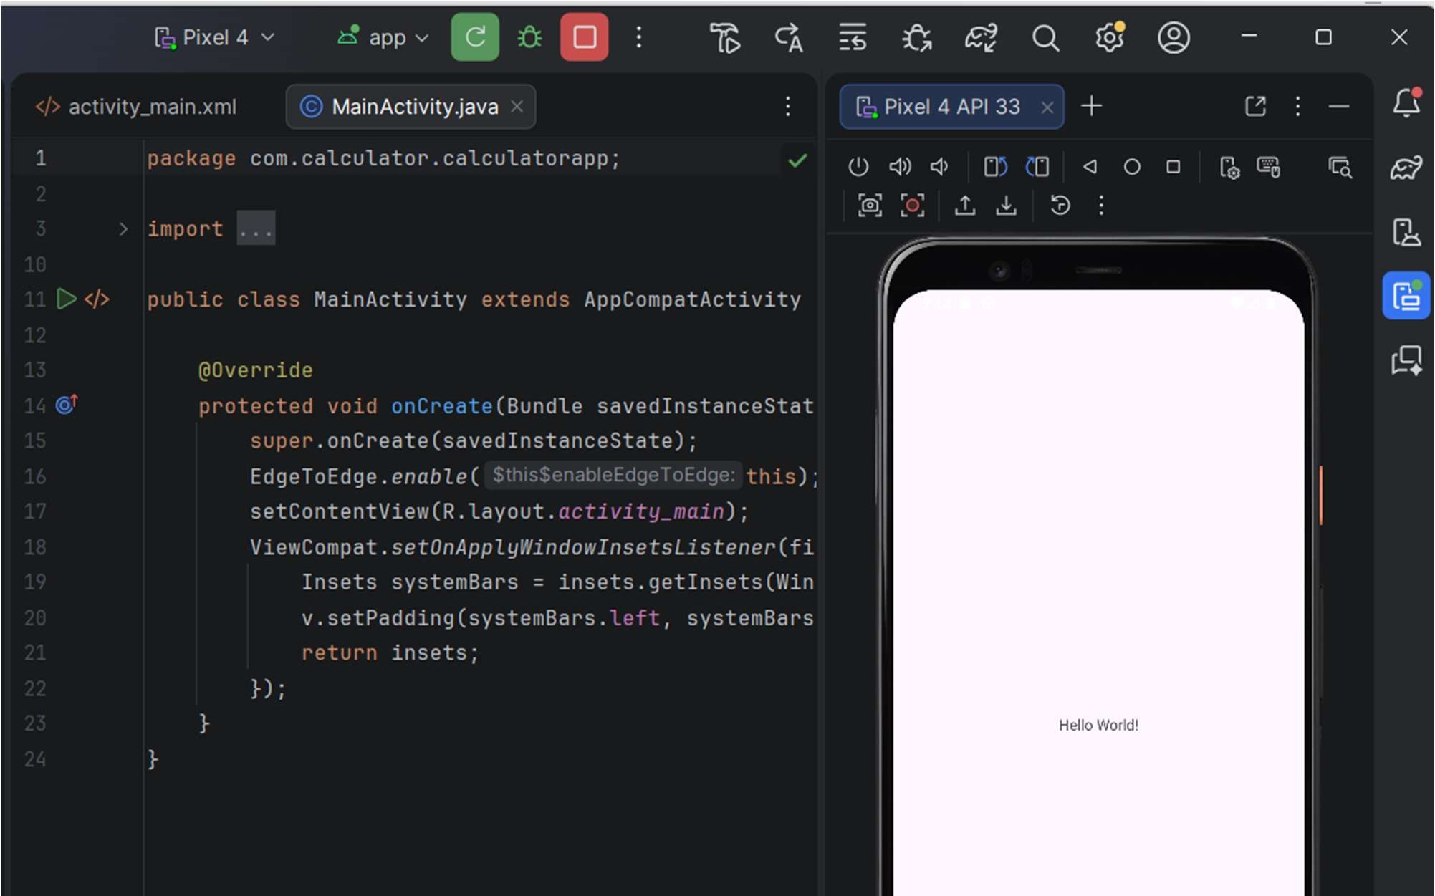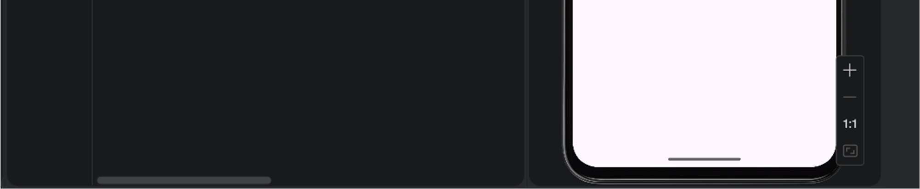

4.Use the IDE to create an app project that has buttons, string resources, View and View Group objects

Step: 1
Create a new Project using Empty Views Activity

Step : 2

Open activity_main.xml remove the Pre written code

Path File:

app → res → layout → activity_main.xml

<LinearLayout
xmlns:android="http://schemas.android.com/apk/res/android" android:layout_width="match_parent" android:layout_height="match_parent"
android:gravity="center"
android:orientation="vertical">

<TextView
android:id="@+id/textView" android:text="Hello" android:textSize="24sp"
android:layout_width="wrap_content"
android:layout_height="wrap_content"/>

<Button android:id="@+id/button" android:text="Click Me" android:layout_width="wrap_content"
android:layout_height="wrap_content"/>

</LinearLayout>
Step: 3

Opened MainActivity.java file.

Path

app → java → com.calculator.calculatorapp → MainActivity.java

package com.calculator.calculatorapp;

import android.os.Bundle; import android.widget.Button;
import android.widget.TextView;

import androidx.appcompat.app.AppCompatActivity;

public class MainActivity extends AppCompatActivity {

@Override
protected void onCreate(Bundle savedInstanceState) { super.onCreate(savedInstanceState);
setContentView(R.layout.activity_main);

// 踘踚踛踜踙 YAHI ADD KARNA THA
Button btn = findViewById(R.id.button);
TextView tv = findViewById(R.id.textView);

btn.setOnClickListener(v -> {
tv.setText("Button Clicked!");
});
}
}

Output:

Before click: “Hello”
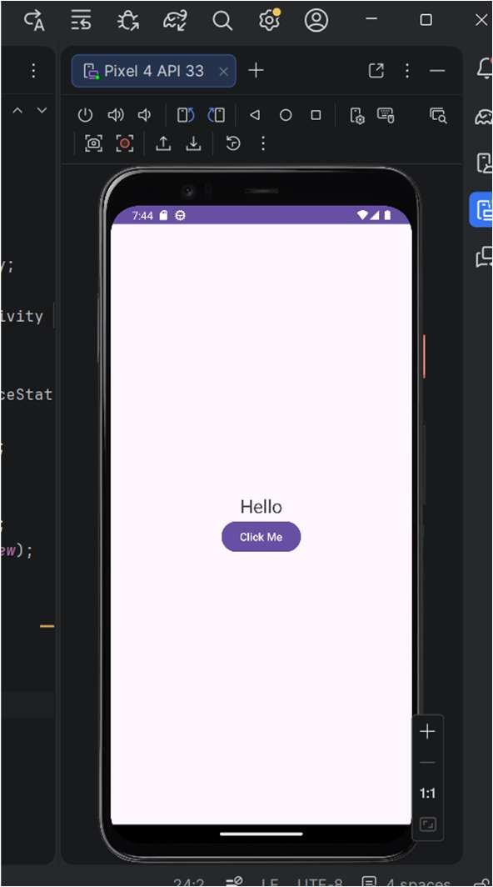

After click: “Button Clicked!”

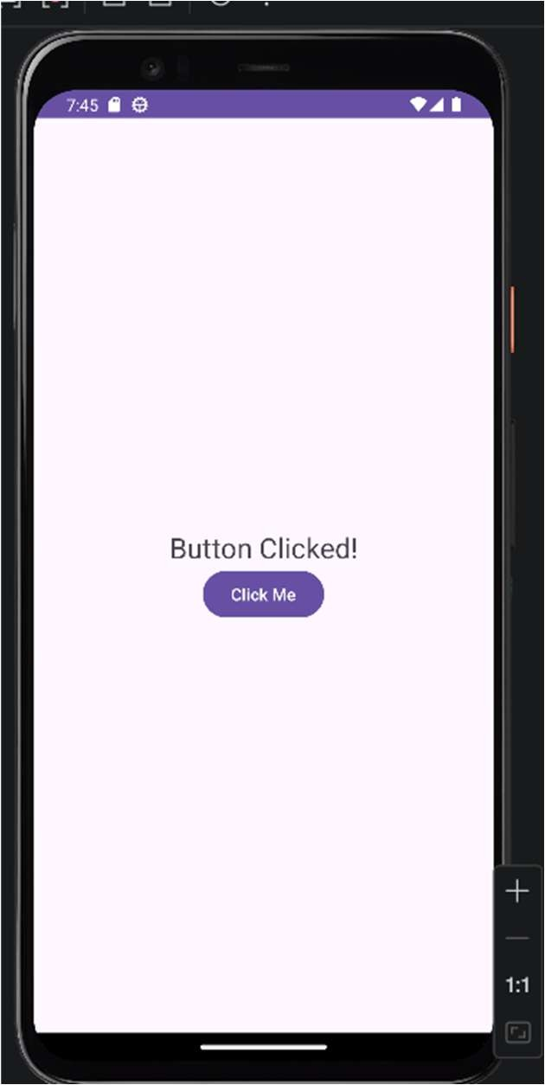

5.Experiment with XML, activities, manifests and intents in this project. Use the emulator to test the application

Step:1
Opened Android Studio and created a new project

Step: 2 Designed the first activity with a button in activity_main.xml
#CODE
<LinearLayout
xmlns:android="http://schemas.android.com/apk/res/android" android:layout_width="match_parent" android:layout_height="match_parent"
android:gravity="center"
android:orientation="vertical">

<Button
android:id="@+id/button" android:text="Go to Next Screen" android:layout_width="wrap_content" android:layout_height="wrap_content"/>

</LinearLayout>

Step:3
Created a second activity using Empty Views Activity.

File → New → Activity → Empty Views Activity
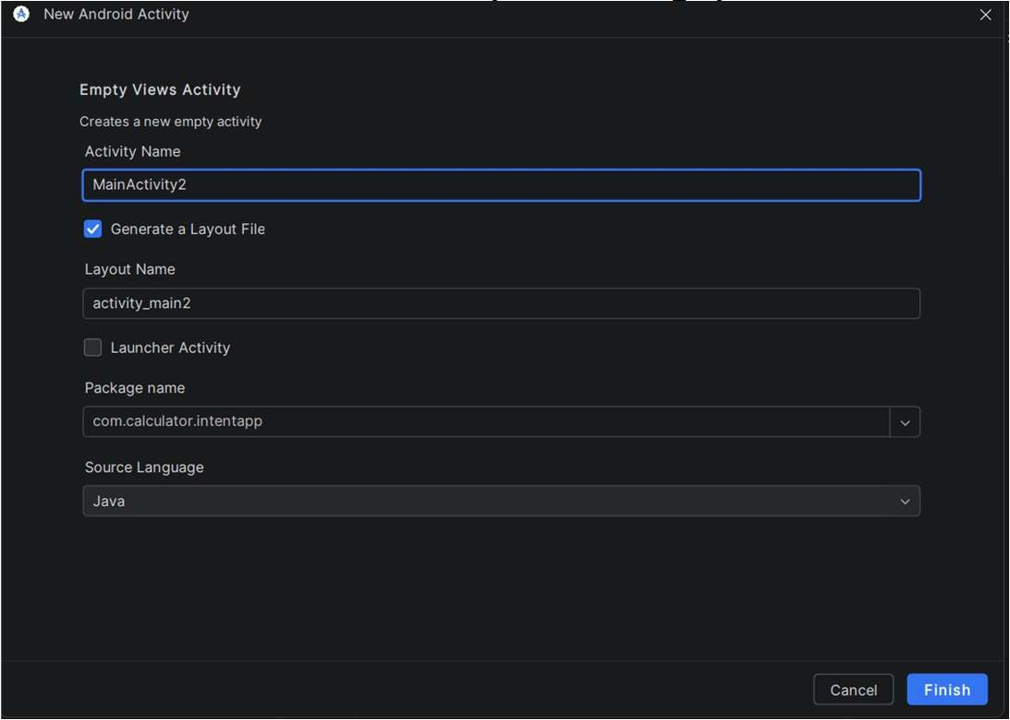
Step: 4

Wrote intent code in MainActivity.java to navigate to second activity

#CODE

package com.calculator.intentapp;

import android.content.Intent; import android.os.Bundle;
import android.widget.Button;

import androidx.appcompat.app.AppCompatActivity;

public class MainActivity extends AppCompatActivity {

@Override
protected void onCreate(Bundle savedInstanceState) { super.onCreate(savedInstanceState);
setContentView(R.layout.activity_main);

Button btn = findViewById(R.id.button);

btn.setOnClickListener(v -> {
Intent i = new Intent (MainActivity.this, SecondActivity.class); startActivity(i);
});
}
}

Step: 5

Ran the application using emulator.

Step: 6

Clicked the button and observed the second activity screen.

Output:

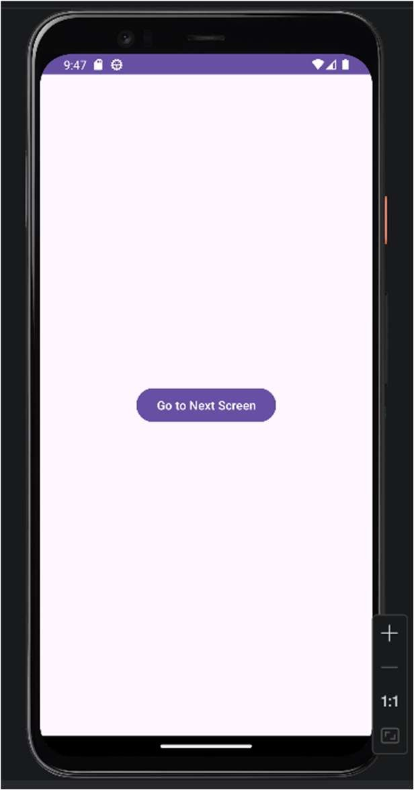

#Second Activity Screen
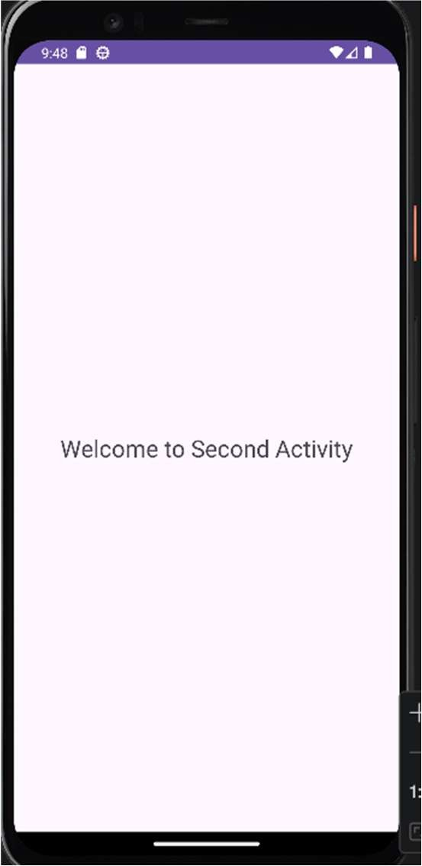
6. Use the IDE to create an app that has an activity lifecycle including some of the following: pause, resume, start, stop, destroy and restore.
Step: 1

Opened Android Studio and created a new project.

Step: 2

Open MainActivity.java and write code of Lifecycle

package com.calculator.lifecycleapp;

import android.os.Bundle;
import android.util.Log;

import androidx.appcompat.app.AppCompatActivity;

public class MainActivity extends AppCompatActivity {

@Override
protected void onCreate(Bundle savedInstanceState) { super.onCreate(savedInstanceState); setContentView(R.layout.activity_main);
Log.d("Lifecycle", "onCreate called");
}

@Override
protected void onStart() {
super.onStart();
Log.d("Lifecycle", "onStart called");
}

@Override
protected void onResume() { super.onResume();
Log.d("Lifecycle", "onResume called");
}

@Override
protected void onPause() {
super.onPause();
Log.d("Lifecycle", "onPause called");
}

@Override
protected void onStop() {
super.onStop();
Log.d("Lifecycle", "onStop called");
}

@Override
protected void onDestroy() {
super.onDestroy();
Log.d("Lifecycle", "onDestroy called");
}
}

Step 3
Open the LogCat to view the result

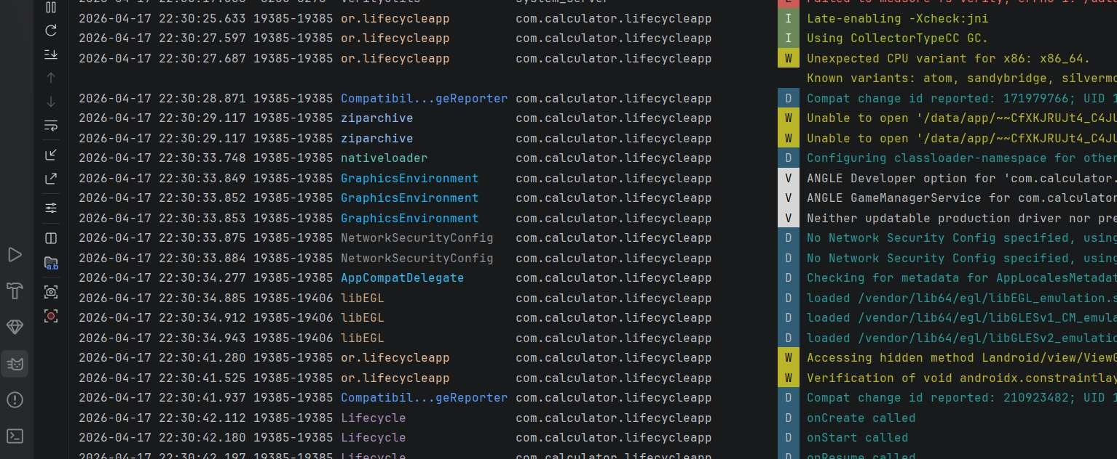

7.Use the emulator to test the application
Step: 1
Opened Android Studio and loaded the project
Step:2
Started the emulator from Device Manager.

Step:3
Run the Application using Run button
Step:4
Application was installed on the emulator Output:
