**UNIVERSITY MANAGEMENT SYSTEM**

**END TERM REPORT**

***By***

SAKSHI PODDAR, AMRITANSHU, SAURABH SINGH

(Section: K19GA)

(Roll Numbers: 25, 26, 27)



Department of Intelligent Systems

School of Computer Science and Engineering

Lovely Professional University, Jalandhar

April-2020

**STUDENT DECLARATION**

This is to declare that this report has been written by us. No part of the report is copied from other sources. All information included from other sources have been duly acknowledged. We aver that if any part of the report is found to be copied, we shall take full responsibility for it.

Sakshi Poddar

25

Amritanshu

26

Saurabh Singh

27

Jalandhar, Punjab

10/04/2020

**TABLE OF CONTENTS**

**Title** **Page no.**

**Background and objectives**…………………………………...…1

**Project description**……………………………………………….3

**Module wise work distribution**………………………………….8

**Implementation**…………………………………………………..9

**Technologies and Framework Used**…………………………....10

**SWOT Analysis**…………………………………………………..11

**BONAFIDE CERTIFICATE**

Certified that this project report “UNIVERSITY MANAGEMENT SYSTEM” is the Bonafede work of “SAKSHI PODDAR, AMRITANSHU, SAURABH SINGH” who carried out the project work under my supervision.

KUNJ MARKEN

UMS Id: 25699

Department of Intelligent System

**BACKGROUND AND OBJECTIVE**

University Management System (UMS) deals with the maintenance of university, college, faculty, student information within the university.

By logging in and visiting the home page the visitor will be able to know all the necessary details starting from registration of a new student in the college, it maintains all the details regarding the attendance and marks of the students. It collects related information from all the departments of an organization and maintains files, which are used to generate reports in various forms to measure individual and overall performance of the students.



Visitors can view all the upcoming events in the events section also the announcements in announcement section. All the contact source will be provided to the visitor which will contain address, email-id, registration number, phone number along with the profile picture of the person.

Development process of the system starts with System analysis. System analysis involves creating a formal model of the problem to be solved by understanding requirements.

The system starts with registration of new staff and students. When the subjects are to be allocated to the faculty, the Head of the Department should enter everything in the Excel sheets.

**DESCRIPTION OF PROJECT**

**UMS** (UNIVERSITY MANAGEMENT SYSTEM) makes management to get the most updated information always by avoiding manual accounting process. This system has the following functional divisions.

* University Administrator
* College Administrator
* User (Students / Faculties)

The main aim of this project is to manage registration of new staffs and students, when the subjects are allocated to the staff the head of the department should enter the detailed information in the excel sheets. The staff enters the attendance of the students of their corresponding subjects and marks of the students. It manages all the details of college, students, classes, faculties, courses, registrations, semester, etc. This project “UNIVERSITY MANAGEMENT SYSTEM” helps us to access to LOVELY PROFESSIONAL UNIVERSITY’S UMS login and home page.

**LOGIN PAGE**: From this page the user can login to their respective accounts as this project is an example where the user can log in to Amritanshu’s account and the user have the access to log in to the home page which is the main web page of this website.

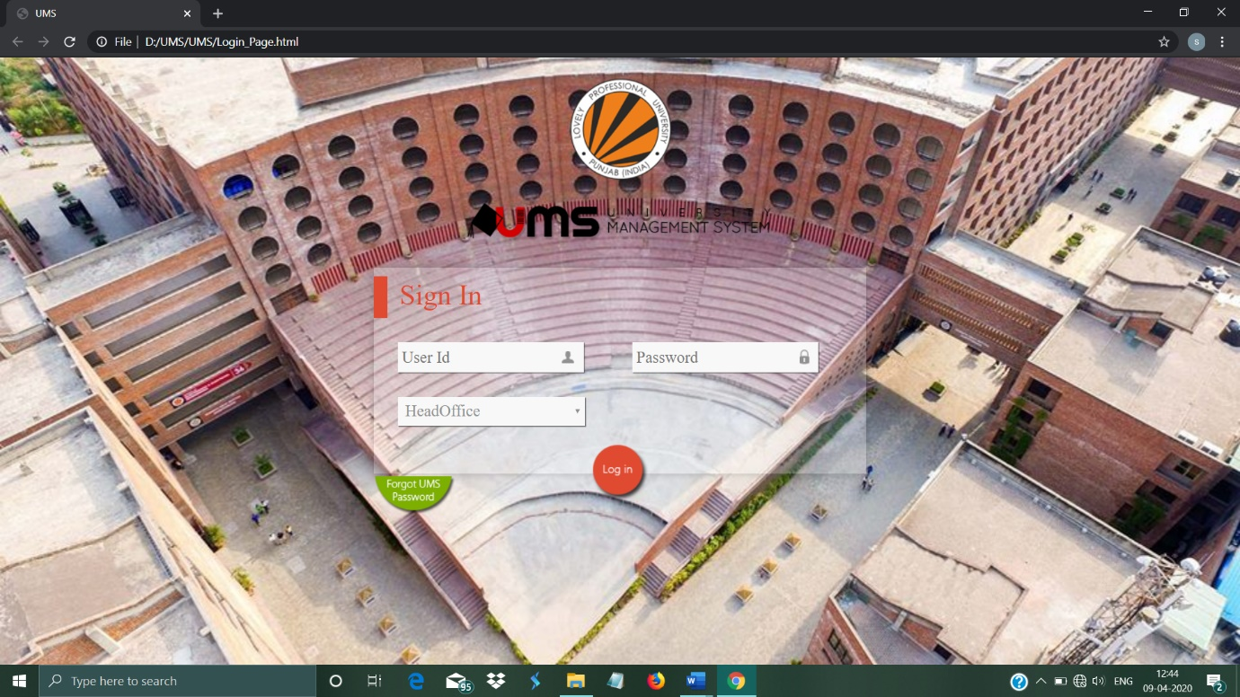

**HOME PAGE**: (Also known as start page) This is the main webpage from where the user can navigate to anywhere. The term can also refer to one or more page always shown in web browser when the application starts up. The homepage of a website serves as landing page for both new and returning visitors. Website homepage is to direct visitor to the area of website that has the answer to the question they need. This creates the first impression and communicate the primary goal of the site to the visitor.

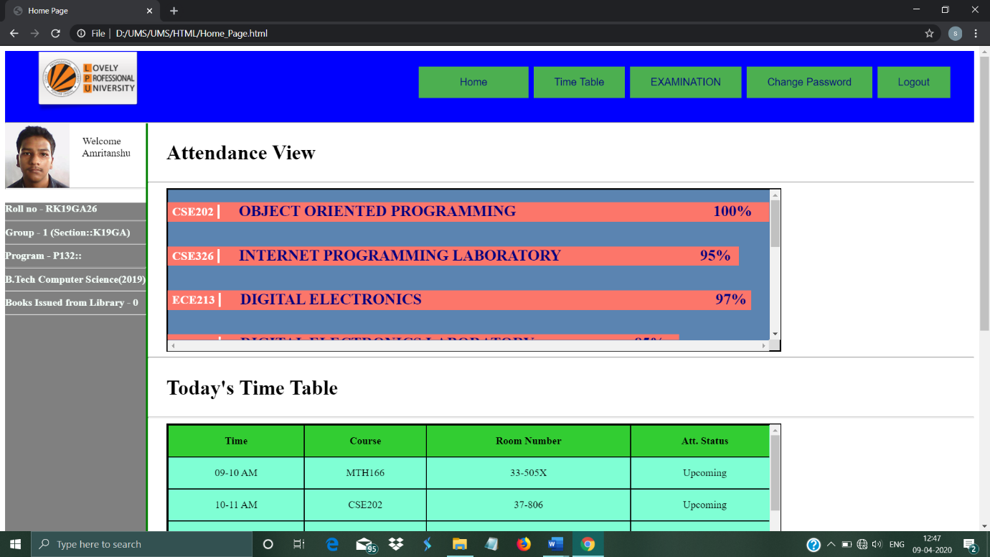

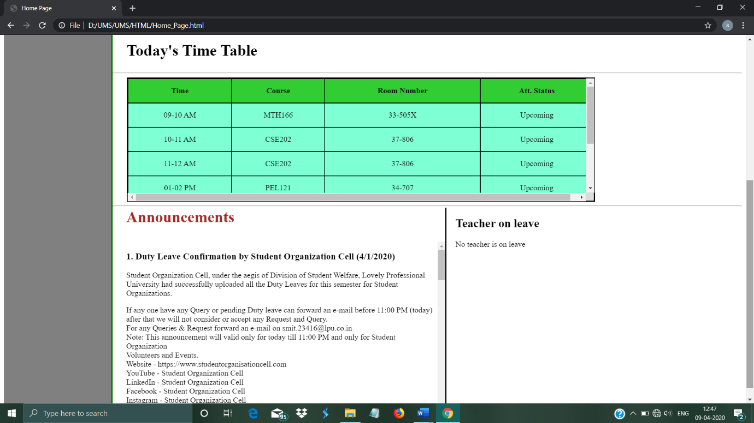

From the Home page the user can navigate to anywhere within the website such as:

**Time table**: This page is meant for the user to check their class timetables.

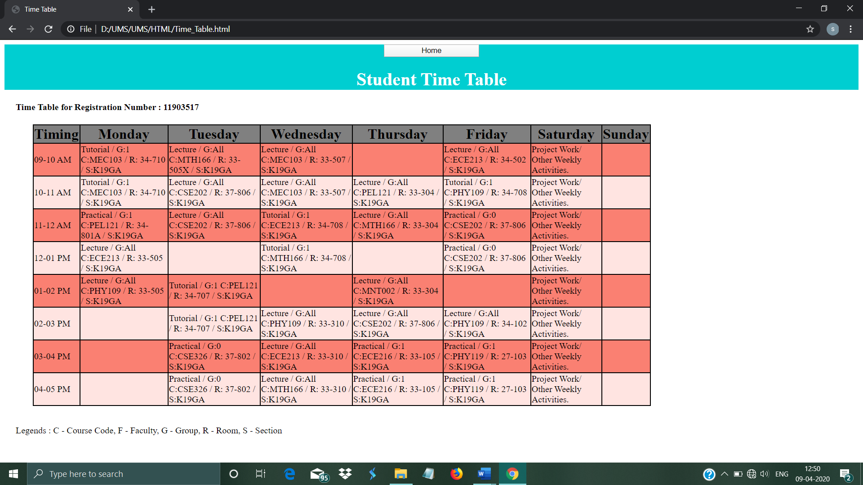

**Examination**: This page is meant so that user can see their exam schedule, their result and seating plans.

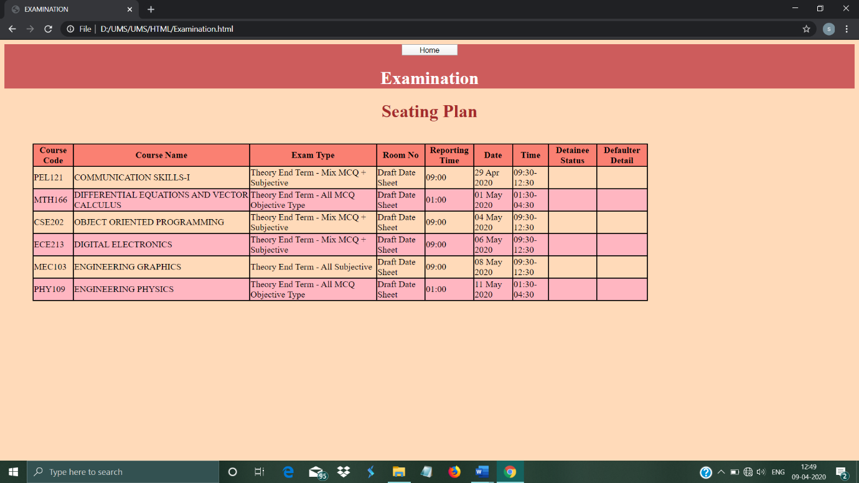

**Announcement and Teacher on leave**:

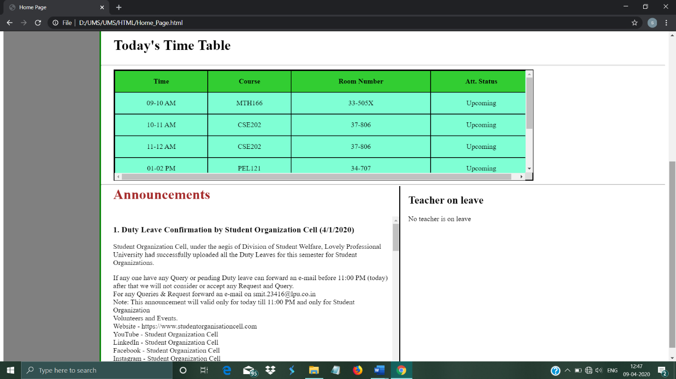

**Attendance:**



**MODULE WISE WORK DISTRIBUTION:**

1. **SAKSHI PODDAR:**

* Login page
* Change password

1. **AMRITANSHU**:

* Home page
* Timetable

1. **SAURABH SINGH**:

* Examination page

**IMPLEMENTATION**

An overview:

* **HTML**provides the basic structure of sites, which is enhanced and modified by other technologies like CSS and JavaScript.
* **CSS** is used to control presentation, formatting, and layout and to make the website look beautiful.
* **JavaScript** is used to control the behaviour of different elements and make the different elements in the website responsive.

With the help of HTML we added different divisions for different purposes. For example, the top most division in the homepage is used make different buttons. So that the user can move to another webpages by clicking the buttons. We also make the division from left side by using <nav> tag to display the profile of the users. Making the lists, forms, text area, tables all this was done by HTML.

With the help of CSS we were able to add color and beautify all the divisions. With CSS we could change scrollbars, customize everything as we wanted. We could also place different divisions on different places on the webpage.

With the help of JavaScript, we made our webpage responsive. All the buttons could work with the help of JavaScript.

In Login page the input wants a correct and valid user id, and correct password to move to Home Page. This was also done using JavaScript.

**TECHNOLOGIES AND FRAMEWORK USED**

In making of this website we have used different front-end technologies used in web development and they are-

Sublime Text-

It is a shareware cross-platform source code editor with a Python application programming interface (API). It natively supports many programming languages and markup languages, and functions can be added by users with plugins, typically community-built and maintained under free-software licenses.

ATOM-

A hackable text editor that is used to search for and install new packages, write code with an autocomplete, split an interface to compare code across files, etc.

NOTEPAD-

Notepad is a simple text editor for Microsoft Windows and a basic text-editing program which enables computer users to create documents.

**FRAMEWORK**

### Project Title: University Management System

**Project Description:** It includes the following modules:

##### Home, timetable, examination, change password, login

##### 

**SWOT ANALYSIS**

S(Strengths):

1. The user can be get the latest news regarding university without going to the university.
2. The student can check their attendance, time table, examination schedule, announcements and much more.

W(Weakness):

1. Only front-end is made and Back-end is not there.

O(Opportunities):

1. To learn HTML, CSS and JAVASCRIPT
2. To gain more knowledge apart from taught in the class.

T(Threats):

1. Completion and proper functionality of the website on different platforms like Mobile, Laptop and Tablet.