Internship Report
STUDY OF THE FRAUSCHER FADC R2 AXLE COUNTING SYSTEM AND DEVELOPMENT OF AN AUTOMATED TENDER DOCUMENT MANAGEMENT SYSTEM FOR RAILWAY STATION DETECTION POINTS
A report submitted
in partial fulfilment of the requirements
for the degree of
Bachelor of Technology (B.Tech)
by
Amrit Bhardwaj
(23EC008)
to the
School of Technology — Electronics and Communication Engineering
GATI SHAKTI VISHWAVIDYALAYA
Central University, Under the Ministry of Railways, Government of India
Vadodara, India – 390004
Date: 10 July 2026

Certificate of Completion
This is to certify that the work contained in the project titled "Study of the Frauscher FAdC R2 Axle Counting System and Development of an Automated Tender Document Management System for Railway Station Detection Points" has been successfully completed by Amrit Bhardwaj (Roll No. 23EC008) under my/our supervision during the Eight-Week Summer Internship (19 May 2026 to 19 July 2026) at Frauscher Sensor Technology (India). During the internship period, the student was found to be hardworking, punctual, and disciplined, and met all the criteria satisfactorily.
Date: 10 July 2026
Place: Vadodara, India
_________________________
[Faculty Guide Name], Faculty Guide, GSV Vadodara
Student Name | Roll Number | Signature
Amrit Bhardwaj | 23EC008
Industry Mentor Details
Name | Signature
Mr. Dinesh Kumhar
Mr. Shiva Kumar
Mr. Amit Raj Gosavi

Acknowledgement
I take this opportunity to express my sincere thanks to my mentors, Mr. Dinesh Kumhar, Mr. Shiva Kumar, Mr. Amit Raj Gosavi, for their guidance and support throughout the internship. I would also like to express my gratitude towards them for showing confidence in me. It was a privilege to have a great experience working under their supervision in a cordial environment.
I am very much thankful to [Faculty Guide Name] and Gati Shakti Vishwavidyalaya, Vadodara, for providing me the opportunity of pursuing my summer internship. I am also thankful to Frauscher Sensor Technology (India) for hosting the internship and providing the resources and infrastructure needed to complete this project.
I am thankful to the office staff and other relevant persons at both the University and the organisation for their continuous support during the internship period.
Amrit Bhardwaj

Abstract
This report presents the work carried out during an eight-week summer internship (19 May 2026 to 19 July 2026) at Frauscher Sensor Technology (India). The internship was structured into two phases. In the first phase, the intern was trained on the Frauscher Advanced Counter (FAdC R2), a SIL-4 certified axle counting system used in railway signalling for train occupancy detection. This phase covered the working principle of the RSR180 wheel sensor, the Axle Evaluation Board (AEB), the Communication Board (COM), the Power Supply with Crowbar Protection (PSC), the Input/Output Extension Board (IO-EXB), and the associated communication interfaces (Serial, CAN, Ethernet, and Hotlink). A comparative study of the FAdC R2 against conventional axle counting architectures, namely the Eldyne EAK/ACE system and the GGTronics High Availability Single Section Digital Axle Counter (HA-SSDAC), was also carried out to understand the evolution of axle counting technology in railway signalling.
In the second phase, the intern was assigned to the project management team and was involved in planning and developing a software system to automate the handling of tender documents across multiple railway station detection points. Tender documents were previously managed manually, which was slow and error-prone. To address this, the intern contributed to the design and development of a four-part automated pipeline: a Windows-based local agent that watches designated folders and performs resumable multipart uploads of tender documents to Amazon S3; an authenticated Node.js/Express and PostgreSQL backend that issues presigned upload URLs and tracks upload sessions; a PDF parsing service that extracts structured data from tender PDFs; and an Excel/dashboard processing pipeline that uses AI-assisted extraction to populate a live spreadsheet for the tender management team.
The internship provided practical exposure to railway signalling hardware, safety-critical system design, and full-stack software development, including cloud storage, authenticated APIs, background services, and AI-assisted document processing.

Contents

(Right-click the table above and select "Update Field" in Microsoft Word to populate page numbers.)

1. Introduction

1.1 Motivation
Railway signalling depends on the accurate and reliable detection of train presence to ensure safe train movement and prevent collisions. Axle counting systems, such as the Frauscher FAdC R2, form a critical part of this safety chain. Understanding the working of such a SIL-4 certified system provides valuable insight into how safety-critical hardware is designed, tested, and deployed in a real-world railway environment.
In parallel, the organisation handles a large volume of tender documents related to multiple railway station detection points. These documents were being managed manually, which was time-consuming, error-prone, and difficult to scale as the number of tenders increased. There was a clear need for an automated system that could receive, validate, upload, parse, and organise these documents with minimal manual effort. This motivated the second phase of the internship, in which the intern contributed to building such a system.

1.2 Objectives

- To understand the working principle of the Frauscher FAdC R2 axle counting system used in railway signalling.
- To study the RSR180 wheel sensor, AEB, COM board, PSC, and IO-EXB, along with their roles in train detection.
- To study the communication interfaces (Serial, CAN, Ethernet, Hotlink) used within the FAdC R2 architecture.
- To compare the FAdC R2 with conventional axle counting systems, namely Eldyne (EAK/ACE) and GGTronics HA-SSDAC.
- To identify the inefficiencies in the manual handling of tender documents for multiple station detection points.
- To design and develop an automated pipeline for tender document upload, validation, parsing, and dashboard generation.
- To gain practical exposure to full-stack development, cloud storage, background services, and AI-assisted data extraction.

1.3 Organization of Report
Chapter 2 describes the methodology followed during both the technical training phase and the project development phase. Chapter 3 presents the technical study of the Frauscher FAdC R2 axle counting system and its comparison with conventional systems. Chapter 4 presents the design, architecture, and implementation of the automated tender document management system developed during the project phase. Chapter 5 discusses the outcomes, implications, and recommendations arising from the internship. The report concludes with references, an appendix containing implementation details, and a week-wise overview of the internship activity.

1.4 Organization Information
Frauscher Sensor Technology (India) is part of the Frauscher Sensor Technology group, an Austrian company specialising in wheel sensors and axle counting systems for railway signalling and traffic management. Frauscher's products, including the RSR180 wheel sensor and the FAdC family of axle counters, are deployed globally for safe and reliable train detection. In India, the organisation supports railway signalling projects, including participation in tenders floated by Indian Railways for the supply and commissioning of axle counting equipment at various station detection points, which necessitated the internal tender-document management system developed during this internship.

2. Methodology
The internship followed a two-phase methodology combining structured technical training with hands-on project development.

2.1 Technical Training Phase
During the first two weeks, the intern studied the Frauscher FAdC R2 system through technical manuals, mentor-led explanations, and hands-on familiarisation with hardware components such as the RSR180 wheel sensor, AEB, COM board, PSC, and IO-EXB. Daily observations and explanations were recorded in a logbook. This was followed by a comparative study of alternative axle counting architectures (Eldyne and GGTronics HA-SSDAC) using reference documentation, to understand how the FAdC R2 architecture improves upon earlier designs.

2.2 Project Development Phase
For the remaining weeks, the intern worked with the project management team using an iterative, version-controlled development approach. Requirements were gathered from the tender management workflow, after which the system was broken down into four independent, loosely coupled components: a local Windows agent, a cloud backend, a PDF parsing service, and an Excel/dashboard processing pipeline. Each component was developed, tested, and integrated incrementally using Git for version control, with the backend and agent connected through an authenticated REST API. Automated tests (Vitest) were written for critical upload and authentication logic, and deployments were verified in a staging environment before integration.

3. Technical Study: Frauscher FAdC R2 Axle Counting System

3.1 Overview and Core Components
The Frauscher Advanced Counter (FAdC R2) is a SIL-4 certified axle counting system used in railway signalling to detect train occupancy. Instead of relying on track circuits, it counts the number of train axles entering and leaving a defined track section (FMA). If the number of axles entering equals the number leaving, the section is declared clear; otherwise, it remains occupied. This method provides reliable train detection even in harsh environmental conditions.

3.1.1 RSR180 Wheel Sensor
The RSR180 wheel sensor is mounted on the rail using the SK140 rail claw and detects every train wheel passing over it, generating signals that are sent to the AEB for processing. It operates on inductive sensing: transmitter and receiver coils inside the sensor housing create an electromagnetic field around the rail, which is disturbed when a steel wheel passes. The sensor contains two independent detection systems (Sensor A and Sensor B) positioned a fixed distance apart, allowing the AEB to determine the direction of train movement from the order in which each system is triggered.
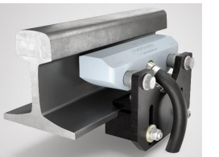
Figure 1: RSR180 wheel sensor mounted on the rail.
The wheel sensor consists of two symmetrical sensor systems (system 1 on the left, system 2 on the right when viewed from the label side), each connected to the evaluation board through one wire of a moulded 4-wire cable (available in 5 m, 10 m, and 15 m lengths); the remaining two wires supply power to the sensor. The cable is protected by a protection tube against physical damage.

3.1.2 SK140 Rail Claw
The SK140 rail claw mounts the RSR180 sensor onto the rail without drilling or welding, enabling fast installation and removal — useful during maintenance, tamping work, or sensor relocation.
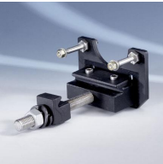
Figure 2: SK140 rail claw used to mount the RSR180 sensor without drilling or welding.

3.1.3 Axle Evaluation Board (AEB)
The AEB supplies and evaluates the RSR180 wheel sensor, outputs digital counting-head information, counts axles, and generates fail-safe clear/occupied indications for up to two track sections (FMA). A single track section can consist of up to 16 counting heads, the hardware limit for one AEB.
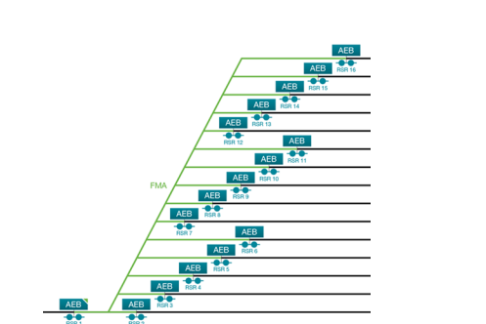
Figure 3: Axle Evaluation Board (AEB) mounted on the backplane.
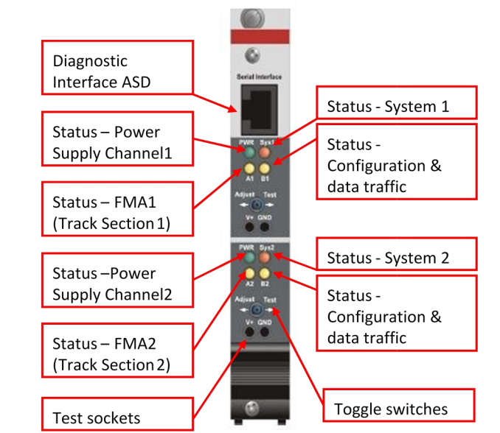
Figure 4: Close-up view of the AEB module and its front-panel connectors.

3.1.4 Power Supply with Crowbar Protection (PSC)
The PSC provides a stable DC power supply (accepting 19 V DC to 72 V DC input) to all system components — the AEB, COM, and IO-EXB boards — inside the axle counter cubicle. Power distribution across backplanes is achieved through the X1 ("PWR IN") and X2 ("PWR OUT/IN") connectors, allowing multiple backplanes to be daisy-chained from a common source.
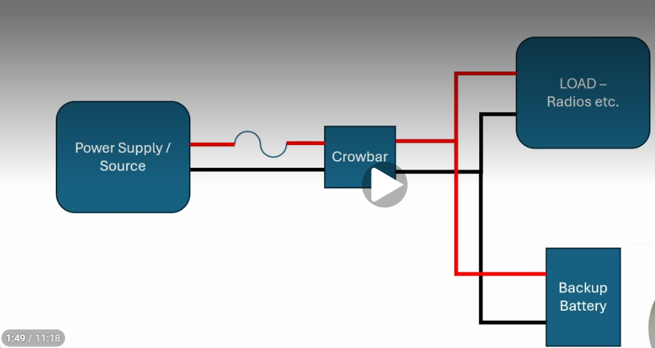
Figure 5: Power Supply with Crowbar Protection (PSC) module and its input/output connectors.

3.1.5 IO-EXB (Input/Output Extension Board)
The IO-EXB extends the input/output capability of an AEB, which can control up to eight IO-EXB boards. It does not require independent configuration and automatically inherits settings from its connected AEB. Depending on configuration, an IO-EXB performs one of three functions: Axle Counting Output (fail-safe clear/occupied relay contacts for up to two FMAs per board), Data Transmission (up to 24 digital input bits per AEB, transmitted over CAN), or Counting Head Output (direction and status information from connected counting heads).
The Clear/Occupied Output uses two relay outputs — Fm (Failsafe Clear) and Occ (Occupied) — wired so that all four Fm relay contacts must operate correctly before a clear indication is sent to the interlocking, preventing false-clear indications on relay or system failure.
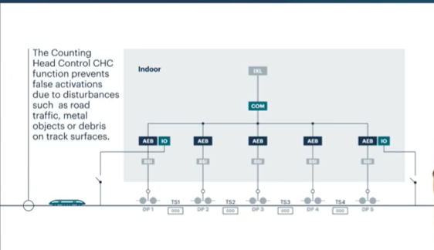
Figure 6: Counting Head Control function of the IO-EXB, showing direction and status output from connected counting heads.
Closely related to Counting Head Control is the Supervisor Control function, which continuously monitors the health of the counting-head connections and flags a fault if a sensor or its wiring becomes unreliable, so that a degraded sensor cannot silently produce an incorrect axle count.
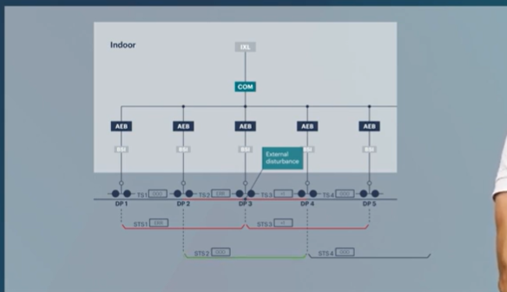
Figure 7: Supervisor Control function and its associated digital-input configuration for data transmission.
For the Data Transmission function, digital input bits collected by the IO-EXB are transmitted to the associated AEB over the internal CAN bus, from where they can be forwarded to the COM board for onward transmission to the interlocking or maintenance system.

3.1.6 COM Board and Backplane BP-PWR
The COM board is the communication module of the FAdC R2, receiving information from the AEB and forwarding track status (Clear/Occupied), diagnostic, and fault information to the interlocking and maintenance systems respectively, over two separate Ethernet ports (Ethernet Port 1 for safety-related data, Ethernet Port 2 for diagnostics).
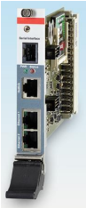
Figure 8: COM board front panel showing Ethernet Port 1 and the associated connectors.
The backplane BP-PWR connects up to eight AEB and/or COM boards to a single PSC. The overall cabling architecture links the PSC, backplane, AEB, IO-EXB, and COM boards into a single cubicle-level assembly, with the COM board's Ethernet ports forming the external boundary of the cubicle.
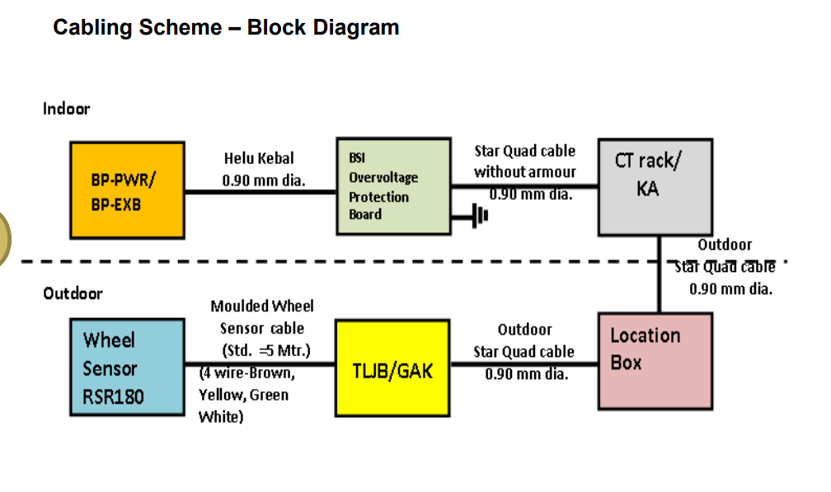
Figure 9: Cabling architecture of the FAdC R2 cubicle, showing PSC, backplane, AEB, IO-EXB, and COM board interconnections.
The PSC additionally incorporates overvoltage protection circuitry to shield the AEB, COM, and IO-EXB boards from transient voltage spikes on the incoming DC supply, which is especially important given the outdoor, trackside power environment in which the cubicle typically operates.
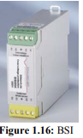
Figure 10: Overvoltage protection (BSI) circuitry within the PSC module.

3.2 Communication Interfaces
The FAdC R2 provides four communication interfaces, each serving a distinct purpose:
- Serial Interface — an RJ45 diagnostic port on the AEB/COM front panel, used with service software (e.g. ASD) for maintenance and fault analysis; not to be confused with Ethernet despite the identical connector.
- CAN Interface — the internal communication backbone linking AEB and COM boards in a linear (non-branching) topology, limited to 20 m per segment, with dual redundant CAN paths for high availability.
- Ethernet Interface — located on the COM board, used for safety-related (track clear/occupied, axle count) and diagnostic communication with external interlocking and maintenance systems, using UDP/IP over 10BASE-T/100BASE-TX.
- Hotlink Interface — a shielded RJ45 link between two redundant COM boards (maximum 2 m crossover cable), enabling instant failover if the active COM board fails.

3.3 Comparative Study: Eldyne and GGTronics Systems

3.3.1 Eldyne System
The Eldyne system consists of outdoor trackside equipment (SK30H rail contacts and the Track-Side Electronic Unit, EAK) and indoor equipment (the Axle Counter Central Evaluator, ACE), connected by a communication link. The SK30H rail contact uses two sensor coils (Sk1, Sk2) to detect wheel passage and direction, and the EAK evaluates this information locally at the trackside before transmitting axle counts to the ACE. The ACE follows a 2-out-of-2 (2oo2) safety architecture with dual CPU cards that must agree before a decision is accepted. A key architectural difference from the FAdC R2 is that Eldyne performs evaluation at the trackside EAK, whereas the FAdC R2 performs evaluation indoors at the AEB, removing the EAK–ACE distance limitation imposed by the ISDN-based communication link.
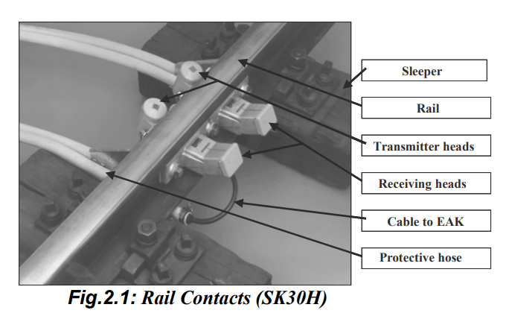
Figure 11: Eldyne ACE (Axle Counter Central Evaluator) with its dual 2-out-of-2 CPU card architecture.
The overall Eldyne architecture — SK30H rail contact, trackside EAK, communication link, and indoor ACE — is summarised below, before turning to the GGTronics HA-SSDAC for comparison.
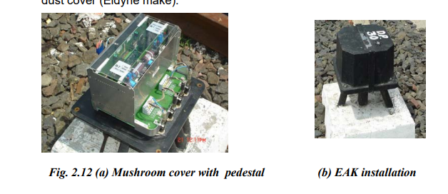
Figure 12: Overall Eldyne system architecture, from trackside SK30H rail contact to the indoor ACE.

3.3.2 GGTronics High Availability Single Section Digital Axle Counter (HA-SSDAC)
The HA-SSDAC, conforming to RDSO Specification RDSO/SPN/177/2013 Ver. 3.0, improves on the conventional Single Section Digital Axle Counter (SSDAC) through dual-system redundancy: two independent SSDAC systems are mounted on different rails, communicating through separate channels, with separate power supplies and parallel vital relays to avoid common-mode failures. It uses a fail-safe 2×(2-out-of-2) microcontroller architecture and Phase Detector (PD) cards that generate carrier frequencies (21 kHz and 25 kHz) for phase-reversal-based axle detection, with dual-frequency validation at the CPU before an axle count is registered.
This comparative study showed that while all three systems (FAdC R2, Eldyne, and GGTronics HA-SSDAC) achieve fail-safe axle counting through redundancy and cross-validation, they differ significantly in where evaluation is performed (indoor AEB vs. trackside EAK), the communication backbone used (CAN/Ethernet vs. ISDN), and the mechanism used for redundancy (COM board hotlink vs. dual SSDAC vs. dual CPU 2oo2).

4. Project Work: High-Level Design of the Automated Tender Document Management System

4.1 Problem Statement
Tender documents for multiple railway station detection points were being received and processed manually — collected on individual laptops, emailed, or copied by hand into spreadsheets — which was slow, inconsistent, and difficult to audit. The project management team required a system that would let a user simply drop a tender document into a folder, and have it validated, uploaded to secure cloud storage, parsed, and reflected in a shared dashboard without further manual effort.

4.2 System Architecture Overview
The system is organised as four independently deployable repositories that together form one integrated pipeline, connected through an authenticated REST API and a shared Amazon S3 bucket. Each repository owns a single responsibility and can be developed, tested, and deployed without redeploying the others:
- Local Agent ("Tender Agent", TypeScript, Windows background service) — watches designated folders on a user's machine and performs resumable multipart uploads of valid tender documents.
- Cloud Backend (Node.js/Express + PostgreSQL, "Tender_automation") — authenticates each agent machine, brokers S3 multipart upload sessions via presigned URLs, and fires a completion webhook.
- PDF Parsing Services (Python) — two services sharing an identical asynchronous submit/poll/result contract: a standalone FastAPI service ("pdfparserautomation", pdftext-based, deployed on Hugging Face Spaces) and an in-repo FastAPI parser (marker + PyMuPDF-based) inside the Excel/Dashboard Processor.
- Excel/Dashboard Processor (Node.js + Python, "excelanddashboardprocessor") — receives the completion webhook, queues background processing, retrieves the file from S3, calls the parser, and uses AI-assisted extraction to populate a shared Google Sheet.
End-to-end data flow: the local agent watches a folder and uploads the file directly to S3 using multipart, presigned URLs authorised by the cloud backend (the backend itself never receives the document bytes) → on successful completion, the backend fires an asynchronous webhook to the Excel/Dashboard Processor's /notify endpoint → that service enqueues a background job on a Redis-backed queue, fetches the object from S3, and calls a PDF parsing service using the shared submit/poll/result contract → the extracted text is passed to Google's Gemini 2.5 Flash Lite model to extract structured tender fields, with a regex-based extractor as an automatic fallback → the resulting fields are appended as a new row to a shared Google Sheet via the Sheets API.

4.3 Part 1 — Local Agent ("Tender Agent", TypeScript, Windows Service)
The agent's entry point (src/agent.ts) loads configuration from config.yaml and .env (validated with Zod), initialises a Winston logger, opens a durable SQLite queue (via better-sqlite3, stored at data/agent.db), and wires a FolderWatcher whose onFileDetected callback inserts a queue row and wakes the upload worker. SIGTERM/SIGINT and uncaughtException handlers ensure a clean shutdown.
watcher.ts uses Chokidar to watch the configured folders and, on each new file, runs a stability check — polling file size and modified time until they are unchanged across several consecutive checks — before treating the file as complete, which guards against partial copies being uploaded. Files that fail extension or size validation are moved to a rejected folder (with automatic de-duplication) and trigger a native Windows notification via PowerShell.
queue.ts implements the SQLite-backed job table (upload_jobs) with states pending, blocked, uploading, completed, and failed, tracking retry_count, upload_session_id, chunk_size, total_parts, and an uploaded_parts JSON array of part number/ETag pairs for multipart resume. It performs idempotent schema migration on startup and, critically, recoverInterruptedJobs() resets any job stuck in the uploading state back to pending after a crash or restart, so no job is silently lost.
uploader.ts (FileUploader) drives the actual upload: it calls the backend's POST /uploads/initiate with an Idempotency-Key, requests a presigned URL per part via POST /uploads/:sessionId/parts/:n, PUTs each byte-range chunk directly to S3, persists each part's ETag to SQLite as it completes (enabling resume), and finally calls POST /uploads/:sessionId/complete. Failures are classified by classifyUploadError() into retryable (e.g. 408/429/5xx) versus blocked (401/403, treated as durable auth/configuration problems), with calculateRetryDelay() applying exponential backoff with jitter. upload-worker.ts is a self-scheduling poll loop that recovers interrupted jobs on start, retries or blocks failed jobs according to this classification, and aborts the S3 multipart upload and marks a job permanently failed once max_attempts is exceeded.
The agent is packaged as a Windows service via WinSW (packaging/TenderAgentService.xml) so that end users only need to drop a file into a desktop folder — no terminal, AWS account, or manual upload step is required. A companion desktop manager app (Electron) was also built for browsing uploads. A design note worth recording here: the project's git history shows a June 2026 README (commit "Readme and Hld updates") that originally planned a five-module architecture — watcher, validator, queue, uploader, orchestrator — as separate files. During implementation this was simplified: validation logic was folded directly into watcher.ts, and orchestration/heartbeat responsibilities ended up split between agent.ts and runtime.ts rather than a dedicated orchestrator.ts. This planned-versus-as-built difference is typical of iterative development and is noted here rather than corrected retroactively, since the simplified structure proved sufficient in practice.

4.4 Part 2 — Cloud Backend ("Tender_automation", Node.js/Express + PostgreSQL)
The backend's entry point (index.js) loads a Zod-validated environment configuration, opens a PostgreSQL connection pool, and runs idempotent CREATE TABLE IF NOT EXISTS statements for two tables: agents (id, agent_id, api_key_hash, name, enabled, created_at, revoked_at) and upload_sessions (id, agent_id, filename, size_bytes, object_key, s3_upload_id, chunk_size, total_parts, status, idempotency_key, created_at, completed_at, last_error), the latter with a unique partial index on (agent_id, idempotency_key) to make retried initiate calls safe.
Routing (src/routes) exposes /health, an agent-management group (create/list/revoke), and an uploads group (/initiate, /:sessionId/parts/:partNumber, /:sessionId/complete, /:sessionId/abort), all protected by bearer-token authentication middleware that hashes the supplied API key with SHA-256 and matches it against agents.api_key_hash — raw keys are never stored. The UploadService (src/services/upload.service.js) sanitises filenames against path traversal, restricts extensions to .pdf/.doc/.docx, builds an S3 object key of the form tenders/{agentId}/{yyyy}/{mm}/{uuid}-{filename}, and uses the AWS SDK v3 to create a multipart upload, issue 15-minute presigned UploadPartCommand URLs per part, and validate the complete, ordered part set before calling CompleteMultipartUploadCommand. On successful completion, it fires a non-blocking webhook (via setImmediate + fetch) to the Excel/Dashboard Processor's /notify endpoint — this is the exact integration seam that connects the upload pipeline (Parts 1–2) to the parsing and dashboard pipeline (Parts 3–4).
Cross-cutting concerns are handled centrally: Zod validators cap file size at 100 MB, a shared error-handling middleware converts validation, application, and body-size errors into consistent JSON responses with URL-redacted logging, and helmet() is applied globally. The service is deployed on Render (render.yaml, Singapore region) with a managed PostgreSQL database and a /health check endpoint.

4.5 Part 3 — PDF Parsing Services (Python, FastAPI)
Two parsing services were built, sharing an identical asynchronous job contract (POST /parse to submit, GET /status/{job_id} to poll, GET /result/{job_id} to retrieve), so that the calling service can treat either implementation interchangeably. The standalone service (pdfparserautomation, deployed as a Hugging Face Space via Docker/uvicorn) uses the pdftext library's plain_text_output() to extract per-page text almost instantly, splitting on form-feed characters; it is stateless, keeping jobs in an in-memory dictionary that is cleared once a result is retrieved, and requires no database. An earlier, OCR/layout-based approach (using the marker library) was evaluated first for higher structural accuracy but was slower; pdftext was ultimately adopted for the standalone service after this comparison because near-instant extraction mattered more than layout fidelity for these documents, while a marker + PyMuPDF-based variant (using ThreadPoolExecutor for concurrency and BeautifulSoup to flatten the resulting layout tree) remains available inside the Excel/Dashboard Processor's own parser/parser.py for documents where layout matters.

4.6 Part 4 — Excel/Dashboard Processor (Node.js + Python)
This service receives the backend's completion webhook at POST /notify (notifyController.js), derives an entityId from the object key, and enqueues a process-file job on a Redis-backed BullMQ queue (services/queueService.js) rather than processing synchronously — decoupling webhook delivery from potentially slow parsing work. The worker (services/workerService.js) fetches the file from S3, calls the chosen PDF parsing service using the shared submit/poll/result contract (polling every 15 seconds for up to 45 minutes), and persists the extracted content to MongoDB (extracted_elements, indexed by objectKey/createdAt and entityId/createdAt).
Field extraction (services/excelService.js) is AI-assisted: extractFieldsLLM() calls Google's Gemini 2.5 Flash Lite model with a prompt engineered specifically for Indian Railway tender documents, requesting a strict JSON object of tenderNo, dueDate, status, valueInCr, nameOfWork, authority, and authorityName. If the Gemini API key is not configured or the call fails, the service automatically falls back to extractFieldsRegex(), a regex-based extractor, so the pipeline degrades gracefully rather than failing outright. The resulting fields are appended as a new row to a shared Google Sheet via the Sheets API v4 (spreadsheets.values.append), authenticated with a Google service account — giving the project management team a continuously up-to-date, centrally accessible dashboard without opening or merging individual tender files. A read-only /extractions API (by entity or by object key) and an /s3/get proxy endpoint were also built for internal inspection of processed records. Excel-append failures are caught as non-fatal so that a temporary Sheets outage does not fail the whole processing job.

4.7 Testing and Verification
Automated unit and integration tests (Vitest) in the cloud backend and local agent repositories cover: valid, invalid, oversized, and still-growing files during folder watching; SQLite schema migration and queue-state transitions; retry scheduling and blocked-job recovery; multipart chunk boundaries and ETag persistence; resume behaviour after an interrupted upload; and backend authentication and upload-service logic. These tests were run before each deployment to the Render staging/production environment.

4.8 Deployment
The cloud backend is deployed on Render with a managed PostgreSQL database provisioned in the same region through an infrastructure blueprint (render.yaml). The standalone PDF parsing service is containerised with Docker and deployed as a Hugging Face Space (uvicorn on port 7860). The Excel/Dashboard Processor runs as a Node.js service with a Redis-backed BullMQ worker and a MongoDB store. The Windows agent is packaged into a self-contained distributable (bundled with its own Node.js runtime and native SQLite bindings) and installed on manager machines as a Windows service (WinSW), with install/uninstall scripts and a production configuration template.

5. Implications and Recommendations

5.1 Outcomes
The internship resulted in a working understanding of a SIL-4 certified railway axle counting system and its safety architecture, as well as a functioning, tested pipeline that automates what was previously a manual, error-prone tender-document workflow across multiple station detection points. The pipeline removes manual data entry for tender records, gives the project management team a continuously up-to-date dashboard, and provides an auditable, resumable upload path for documents from user machines to secure cloud storage.

5.2 Implications
The comparative study of axle counting systems highlights a broader industry shift from trackside evaluation (Eldyne) and pure hardware redundancy (GGTronics HA-SSDAC) towards centralised indoor evaluation with software-configurable redundancy (Frauscher FAdC R2), reducing distance constraints and simplifying field maintenance. On the software side, the tender automation project demonstrates that even a relatively small, four-part system can meaningfully reduce manual effort when the components are kept independent, authenticated, and individually testable.

5.3 Recommendations
- Extend the AI-assisted extraction step with a validation/review step so that a human confirms low-confidence field extractions before they reach the dashboard.
- Add monitoring/alerting on the backend and agent so that blocked or failed uploads are surfaced to the project management team automatically rather than being discovered during manual checks.
- Move the free-tier Render database and web service to a paid plan before storing production tender data, since the free tier has no backups and can sleep after inactivity.
- Document the FAdC R2 vs. Eldyne vs. HA-SSDAC comparison as an internal reference note, since this knowledge is useful beyond the scope of this internship.

References
[1] Frauscher Sensor Technology, "FAdC R2 — Frauscher Advanced Counter, Technical Manual," Frauscher Sensortechnik GmbH.
[2] Frauscher Sensor Technology, "RSR180 Wheel Sensor — Installation and Technical Data Sheet."
[3] Research Designs and Standards Organisation (RDSO), "RDSO/SPN/177/2013 Ver. 3.0 — Specification for High Availability Single Section Digital Axle Counter," Ministry of Railways, Government of India.
[4] Express.js Documentation, https://expressjs.com/.
[5] Amazon Web Services, "Uploading and copying objects using multipart upload," AWS S3 Developer Guide.
[6] Google, "Gemini API Documentation," Google AI for Developers.
[7] Google, "Google Sheets API Reference," Google for Developers.

Appendix A. Repository Layout of the Tender Automation System

A.1 Local Agent (TypeScript)
src/agent.ts — application entry point; src/watcher.ts — folder detection, stability checks, validation; src/queue.ts — durable SQLite queue and multipart state; src/uploader.ts — backend API calls and direct S3 part uploads; src/upload-worker.ts — background processing and retry policy; src/config.ts — YAML/environment validation; manager-app/ — Electron desktop tender download manager.

A.2 Cloud Backend (Node.js / Express / PostgreSQL)
src/app.js — Express application and global middleware; src/config/ — environment and database setup; src/routes/, src/controllers/ — HTTP endpoints; src/services/upload.service.js, src/services/s3.service.js — multipart upload business rules and AWS SDK/presigning logic; src/repositories/ — PostgreSQL queries; src/middleware/, src/validators/ — authentication, validation, and error handling.

A.3 PDF Parsing Service (Python)
app.py — FastAPI/Docker service (uvicorn) that extracts text from tender PDFs using pdftext for near-instant extraction, exposing an async submit/poll/result job contract (/parse, /status/{job_id}, /result/{job_id}); deployed as a containerised Hugging Face Space.

A.4 Excel / Dashboard Processor (Node.js + Python)
app.js, index.js — Express application; controllers/, routes/, services/ — S3 retrieval, parser invocation, and Excel/Google Sheets update logic; parser/parser.py — Python-based field parser invoked from the Node.js service; services/excelService.js — Google Sheets API integration for writing extracted tender rows.

Weekly Overview of Internship Activity
Week | Dates | Activity
1 | 19 – 25 May 2026 | Introduction to the Frauscher FAdC R2 axle counting system: working principle, RSR180 wheel sensor (inductive sensing, direction detection), SK140 rail claw, AEB, PSC, IO-EXB, COM board, and backplane BP-PWR.
2 | 26 May – 1 Jun 2026 | Studied FAdC R2 communication interfaces (Serial, CAN, Ethernet, Hotlink) and power/protection architecture; comparative study of the Eldyne EAK/ACE system and the GGTronics HA-SSDAC against the FAdC R2.
3 | 2 – 8 Jun 2026 | Shifted to the project management team; gathered requirements and planned an automated tender-document workflow for multiple station detection points; scaffolded the Tender Automation backend (Express/PostgreSQL).
4 | 9 – 15 Jun 2026 | Built the local Windows agent: folder watching, file validation and rejection handling, durable SQLite queue, and its automated test suite; added database-backed agent authentication to the backend.
5 | 16 – 22 Jun 2026 | Implemented resumable multipart S3 uploads in the agent and backend (presigned URLs, ETag persistence, retry/backoff), and refined logging, packaging, and the Windows-service setup.
6 | 23 – 29 Jun 2026 | Developed the PDF parsing service (pdftext-based extraction) and the Excel/dashboard processor, including the initial Google Sheets API integration for writing tender rows automatically.
7 | 30 Jun – 6 Jul 2026 | Integrated Gemini 2.5 Flash Lite for AI-assisted extraction of tender fields (authority name, work name, bidding type, status) from parsed PDF text; refined extraction prompts and regex-based field cleanup.
8 | 7 – 13 Jul 2026 | Final integration and testing across all four components; new production database setup; built the Electron-based desktop tender manager app; deployment and verification (ongoing at report submission, internship concludes 19 Jul 2026).
Note: Week boundaries above are inferred from project version-control history and mentor-guided training records, and should be adjusted to match the intern's personal logbook where they differ.

