PL/SQL Exercises

# Exercise 1: Control Structures

## Creating tables:

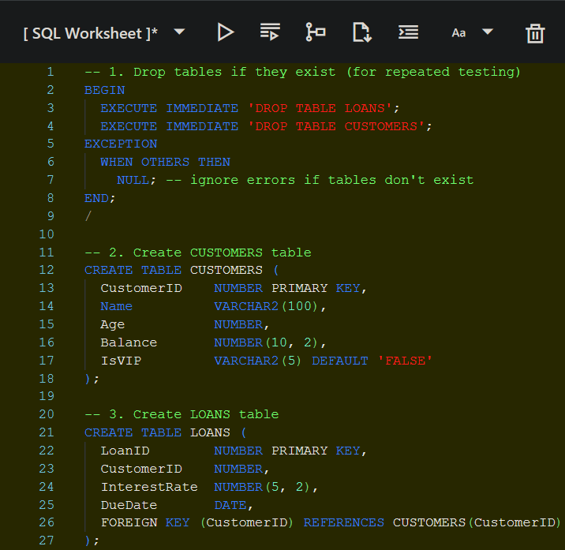

## Scenario 1:

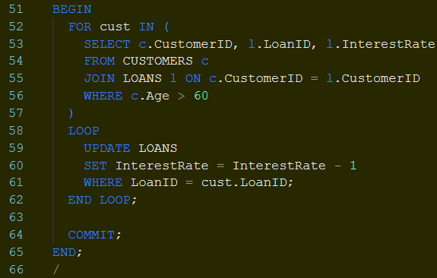

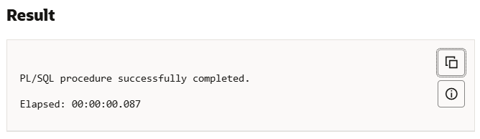

## Scenario 2:

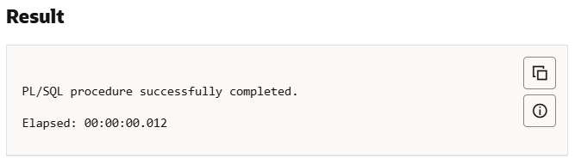

## Scenario 3:

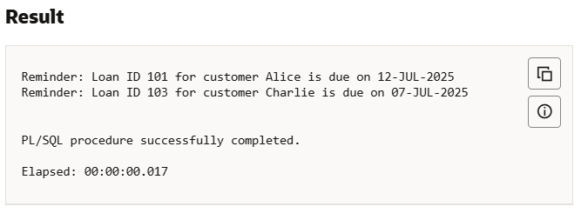

# Exercise 3: Stored Procedures

## Creating tables:

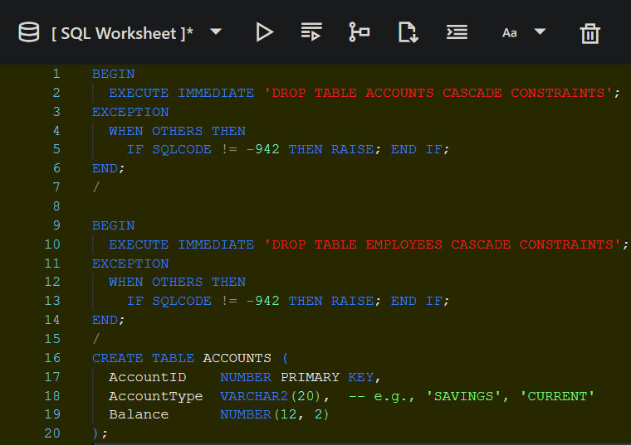

## Scenario 1:

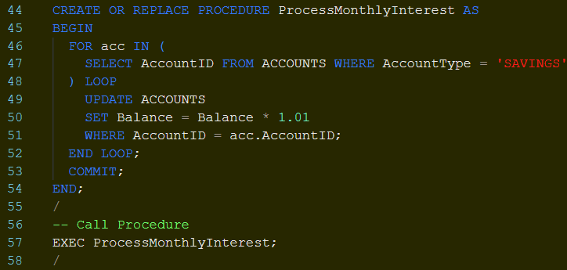

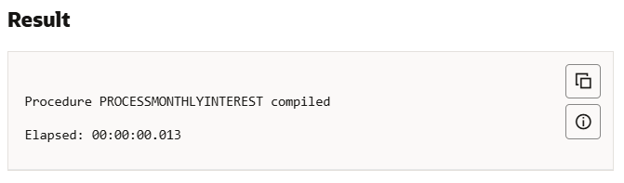

## Scenario 2:

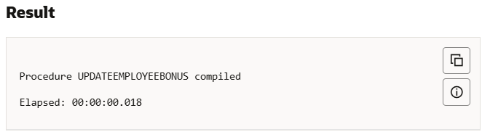

## Scenario 3:

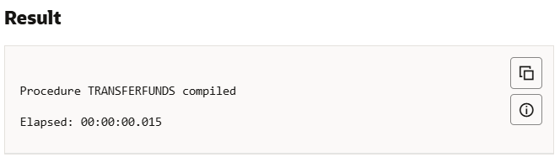

Checking final results:

