Safelense AI
AI Vision Based Worker Safety Monitoring System
Requirements & Technical Documentation
Version 1.0
Last Updated: February 10, 2026
ProDiSyn Innovations

Name | Safelens AI-Overview-Dashboard | Remark
Ver | 1.0 | Draft
Created on | 11-02-2026
Created By | Rajanikant
Reviewed By | Singh
Approved by | Saritha B

1. System Overview

1.1 Introduction
SafelenseAI is a workplace safety monitoring and analytics system designed to detect, track, and visualize safety incidents occurring in industrial environments. The system integrates AI-based detection mechanisms with a structured web dashboard that allows administrators and safety managers to monitor incidents in real time.
The primary goal of the system is to improve workplace safety by providing visibility into:
- Fall detection events
- PPE violations – No-HardHat , No-Vest
- Intrusion incidents
The dashboard provides structured, filterable, and time-based views of incident data, enabling organizations to analyze trends and take corrective action.

1.1 Purpose
This document serves as a complete functional and technical reference for the SafelenseAI Worker Safety Monitoring Dashboard.
It is intended to:
- Describe how the user interface behaves
- Define API endpoints and their usage
- Document database schema and relationships
- Clarify data flow from UI to database
- Provide setup and deployment instructions
- Support future development and maintenance
This document is suitable for:
- Frontend developers
- Backend developers

1.2 Scope of the System
The current implementation focuses specifically on the Overview Dashboard, which provides:
- Incident listing (cards view)
- Date ( Today, Weekly, Monthly, Date Range)-based filtering
- Incident-type filtering
- Time-based analytics
- Donut chart distribution analysis
- Line and bar chart trend visualization
The following are out of scope for this document:
The dashboard is strictly read-only in its current version in English Language only

1.3 Key Functional Capabilities
The system provides the following capabilities:

1. Incident Monitoring
Users can view incidents detected by the system, including:
- Unique event ID
- Timestamp
- Location (camera)
- Incident type
- Image snapshot

2. Filtering Mechanisms
The system supports two independent filtering groups:
Operational Filters (Top Filters)
- Date Range selection
- Incident type selection
These affect incident cards and donut chart.
Analytical Filters (Chart Filters)
- Time range (Today / Week / Month/ Date Range)
- Chart-specific incident type
These affect trend charts only.

3. Time-Based Analytics
The system supports:
- Hourly aggregation (Today)
- Daily aggregation (Week)
- 30-day aggregation (Month)
Missing time intervals are automatically filled with zero values.

4. Pagination
- 6 incidents per page
- Client-side pagination
- No additional API calls for page change

5. Data Visualization
The dashboard includes:
- Line chart (trend over time)
- Donut chart (distribution breakdown)
- Bar chart (comparative count visualization)

1.2 Technology Stack
Component | Technology
Frontend Framework | React 18 with TypeScript
Build Tool | Vite
Backend Framework | Django REST Framework
Database | PostgreSQL
HTTP Client | Axios
Data Visualization | Recharts
Icons | Lucide React

2. System Architecture
SafelenseAI follows a three-tier architecture with clear separation between presentation, application logic, and data layers.
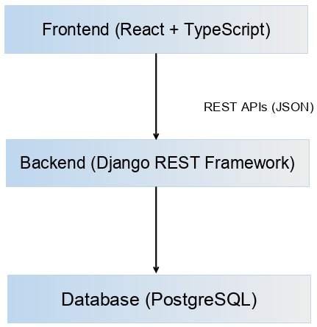

2.1 Architecture Layers

Frontend Layer
- React-based application
- Handles UI rendering and user interactions
- Client-side state management
- Client-side pagination for performance

Backend Layer
- Django REST Framework API server
- Filtering logic
- Business logic and data aggregation
- Query optimization and filtering
- Media URL preparation

Database Layer
- PostgreSQL database
- Stores events, camera metadata, and media references
- Optimized with indexes for time-based queries
- Read-only access for dashboard operations

3. User Interface Design
The SafelenseAI dashboard provides a modern, responsive interface for monitoring workplace safety incidents in real-time.

3.1 Layout Structure

Left Panel — Fixed Sidebar
- Width: 256px
- Always visible
- Contains navigation and user context

Right Panel — Main Content Area
- Flexible width
- Scrollable
- Displays dynamic content
This structure ensures that navigation remains stable while data updates dynamically.

3.3 Responsive Design Behavior
The UI adapts based on screen size.
Device Type | Behavior
Desktop | 3-column incident grid
Tablet | 2-column incident grid
Mobile | 1-column incident grid
Sidebar | May collapse in smaller layouts
Charts and cards automatically adjust spacing and layout to maintain readability.

3.2 Sidebar Components
The sidebar provides persistent navigation and identity context.

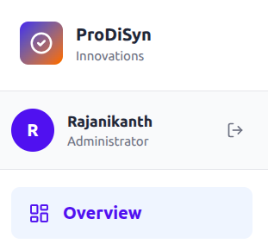

Company Branding
- ProDiSyn logo (gradient style)
- Company name: ProDiSyn Innovations
- Clean, minimal visual styling
Purpose:
- Establish system identity
- Maintain brand consistency




User Profile Section
Displays:
- Circular avatar (initial letter)
- User name
- User role (Administrator)
- Logout icon
Logout Behavior:
- Redirects user to login page
- No API call in current scope

Mention how user / password are managed locally or in central server.

Navigation Menu
Icon | Label | Page ID | Status
📊 | Overview | overview | Active
👥 | User Management | users | Planned
⚙️ | Settings | settings | Planned

3.3 Overview Page Structure
The Overview page is divided into logical blocks:
- Page Title
- Top Filters
- Incident Cards
- Pagination Controls
- Summary Section
- Charts
Each block is visually separated for clarity.

3.4 Page Title
- Text: “Overview”
- Large font size
- Positioned top-left in content area
Purpose:
- Clearly indicate active section

3.5 Filter Control Groups
There are two independent filter groups.

3.5.1 Top Filters (Operational Filters)
Located in the upper-right area of the page header.
Includes:
- Incident Type Dropdown
- Date Picker
These filters affect:
- Incident Cards
- Donut Chart
They do NOT affect time-based charts.

3.5.2 Chart Filters (Analytical Filters)
Located in the Summary section.
Includes:
- Time Range Dropdown
- Chart Incident Type Dropdown
These filters affect:
- Line Chart
- Bar Chart
They do NOT affect incident cards.

3.6 Visual Hierarchy
The dashboard is structured intentionally:
- Incident data first (operational view)
- Summary below (analytical view)
This ensures users:
- First see what happened
- Then analyze trends

3.7 UI State Management
The UI maintains the following state variables:
- selectedDate
- selectedIncidentType
- currentPage
- chartTimeRange
- chartIncidentType
- loading state
State updates trigger re-rendering and API calls where necessary.

4. Overview Dashboard

4.1 Purpose
The Overview Dashboard is the primary operational interface of SafelenseAI. It provides real-time visibility into detected safety incidents and allows users to analyze patterns over time.
This page combines:
- Incident monitoring (cards view)
- Incident distribution (donut chart)
- Trend analysis (line chart)
- Comparative analysis (bar chart)
The design ensures that users can both react to current incidents and analyze long-term trends within a single screen.

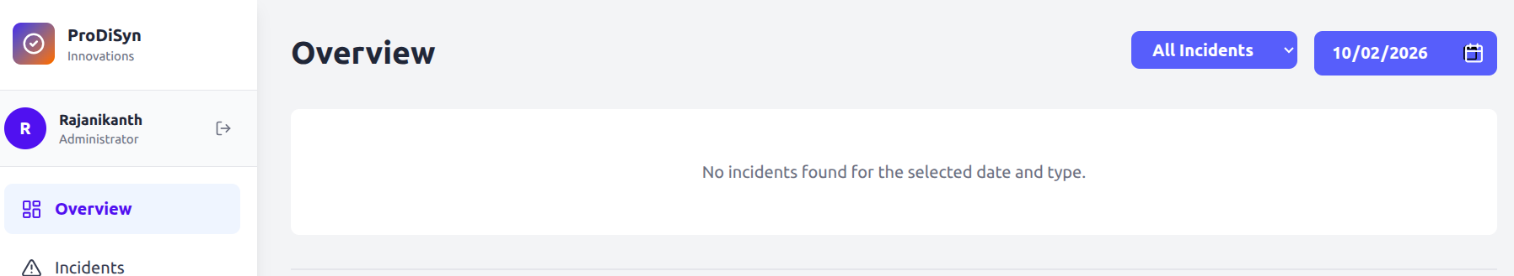

4.2 Page Load Behavior
When a user navigates to /overview, the system initializes default state values:
- selectedDate = today
- selectedIncidentType = all
- chartTimeRange = today
- chartIncidentType = all
- currentPage = 1
Immediately after initialization, three API calls are triggered in parallel:
- Fetch incident events
- Fetch summary data
- Fetch graph data
The UI renders incident cards and charts once responses are received.
This ensures that the dashboard is populated with meaningful data without requiring user interaction.

4.3 Top Filters (Operational Filters)
These filters control the operational view of incidents.

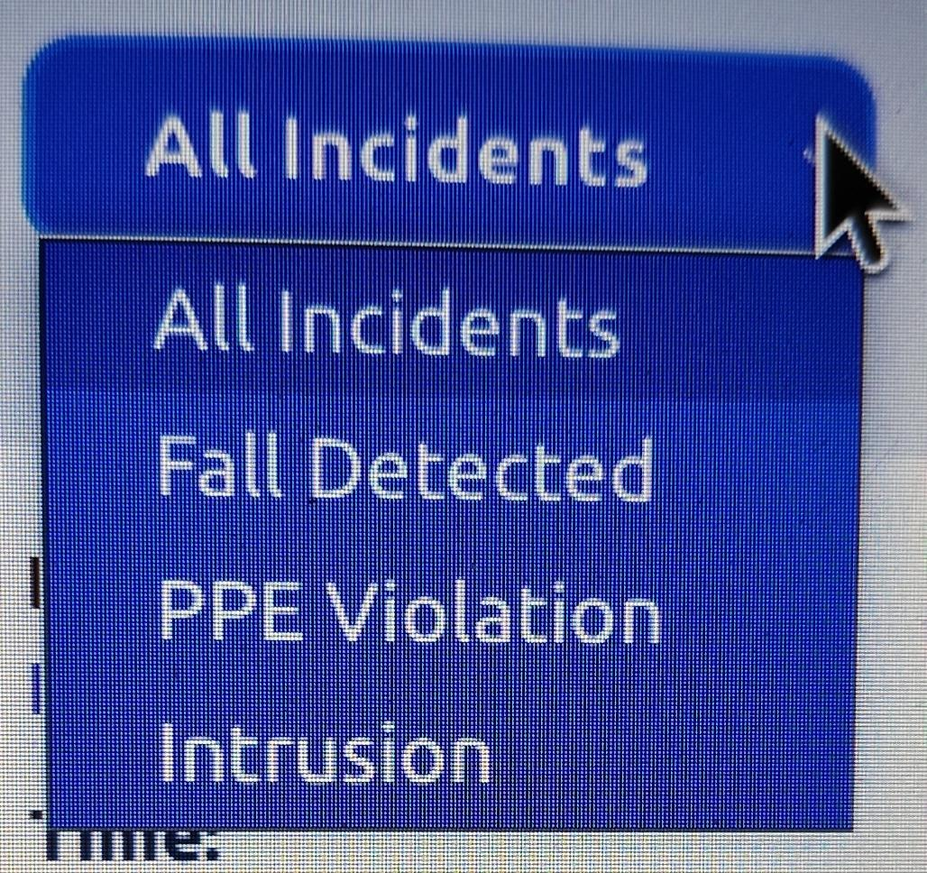
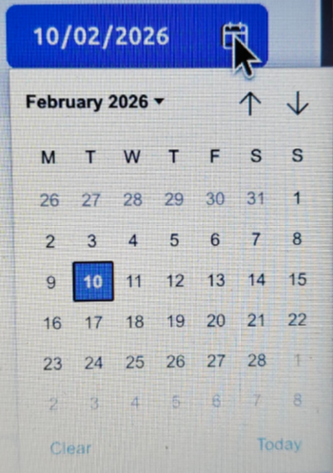

4.3.1 Incident Type Dropdown
Options:
- All Incidents
- Fall Detected
- PPE Violation
- Intrusion
When changed:
- Updates selectedIncidentType
- Resets currentPage to 1
- Calls:
  - GET /api/overview/events/
  - GET /api/overview/summary/
Effects:
- Incident cards refresh
- Donut chart updates
- Trend charts remain unchanged

4.3.2 Date Picker
Default: Current date
Format: DD-MM-YYYY ( will change based on country specific deployment)
When changed:
- Updates selectedDate
- Resets currentPage to 1
- Calls:
  - GET /api/overview/events/
  - GET /api/overview/summary/
Effects:
- Incident cards update to selected date
- Donut chart recalculates distribution
- Charts remain unchanged

4.4 Incident Cards Grid
The incident cards section provides detailed event information.

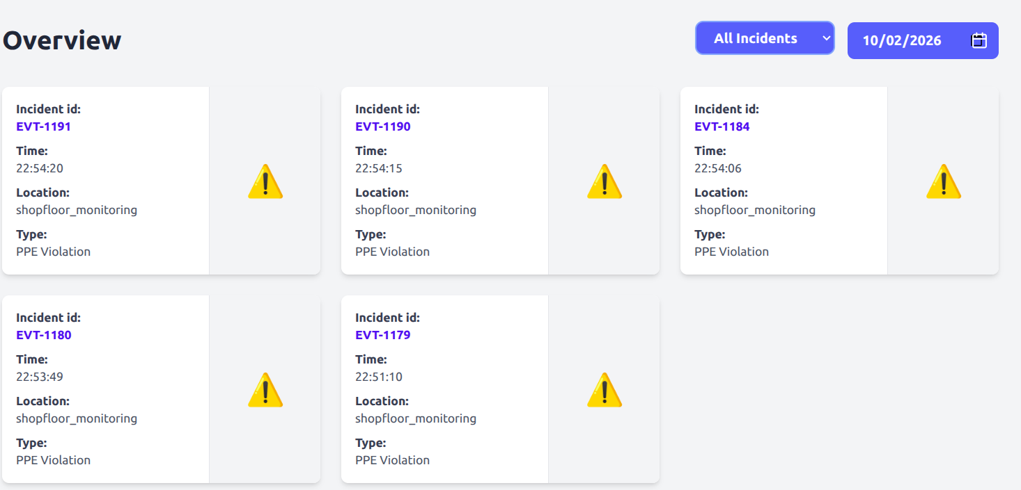

Incident Type: “No-Vest” / “No-HardHat”/ “Entry Violation”

Displayed Information
Each card contains:
- Incident ID (formatted as EVT-{event_id})
- Timestamp (converted to local time)
- Camera ID:(Name)
- Location (camera location)
- Incident type (readable format)
- Detection Type: (Missing items)
- Thumbnail image (if available)

Layout Behavior
- Responsive grid
- 1–3 columns based on screen width
- 6 cards per page
- Client-side pagination

Empty State Handling
If no incidents match selected filters:
Message displayed:
“No incidents found for the selected date and type.”
Pagination controls are disabled.

4.5 Pagination Logic
Pagination is handled entirely on the client side.
Logic:
startIndex = (currentPage - 1) * 6
endIndex = startIndex + 6
displayedIncidents = incidents.slice(startIndex, endIndex)

No additional API call is made when changing pages.
This improves performance and reduces backend load.

4.6 Summary Section
The summary section separates operational data from analytical data.
It contains:
- Chart filters
- Line chart
- Donut chart
- Bar chart
This logical grouping helps users shift from viewing incidents to analyzing trends.

4.7 Chart Filters (Analytical Filters)
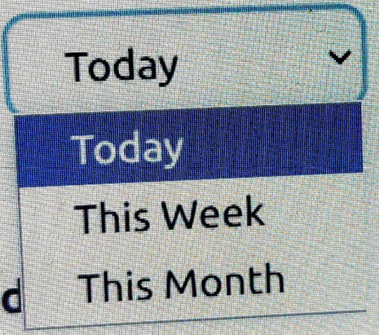

These filters control trend visualization only.

4.7.1 Time Range Dropdown
Options:
- Today (24 hours)
- This Week (7 days)
- This Month (30 days)
When changed:
- Updates chartTimeRange
- Calls:
  - GET /api/overview/graph/?time_range=selectedRange
Effects:
- Line chart updates
- Bar chart updates
- Cards and donut remain unchanged

4.7.2 Chart Incident Type Dropdown
Options:
- All Types
- Fall
- PPE Violation
- Intrusion
When changed:
- Updates chartIncidentType
- Calls:
  - GET /api/overview/graph/?type=selectedType
Effects:
- Line chart updates
- Bar chart updates
- Cards and donut remain unchanged

4.8 Chart Components Behavior
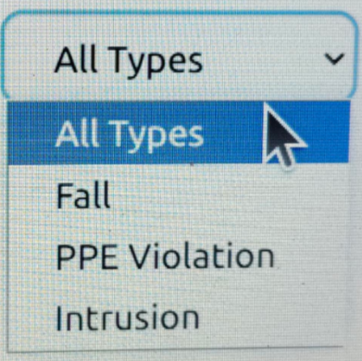

Line Chart — Incidents Trend
- Displays hourly or daily counts
- Uses pre-aggregated backend data
- Shows tooltip on hover
- Fills missing intervals with zero values

Donut Chart — Incident Overview
- Displays percentage breakdown
- Uses summary endpoint
- Updates only when top filters change
- Shows total event count

Bar Chart — Incidents Over Time
- Uses same dataset as line chart
- Displays vertical bars
- Used for comparison rather than trend shape

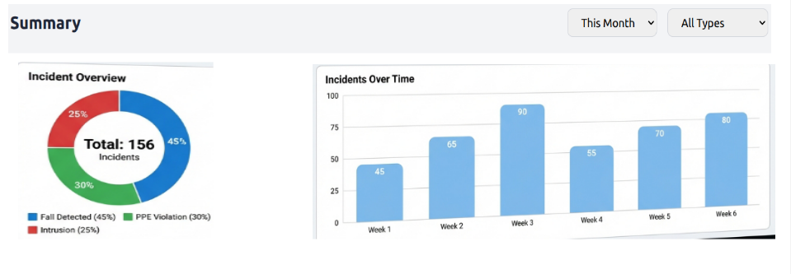

4.9 Data Consistency Rules
The dashboard enforces the following rules:
- Cards and donut depend only on top filters
- Charts depend only on chart filters
- Pagination does not trigger API calls
- All time aggregation is backend-controlled
- UI never modifies raw data
This ensures predictable behavior.

4.10 Performance Considerations in Dashboard
- Parallel API calls on load
- Minimal payload size
- Client-side pagination
- Backend-side aggregation
- Loading indicators during chart updates
The dashboard is optimized for fast response and smooth interaction.

4.11 Functional Strengths
The Overview Dashboard provides:
- Immediate operational visibility
- Flexible filtering
- Reliable time-based analysis
- Minimal user effort for insights
- Clear separation between monitoring and analytics

5. API Documentation
The backend provides RESTful API endpoints for data access, built with Django REST Framework.

5.1 API Design Philosophy
The SafelenseAI backend follows RESTful API principles. The APIs are designed to be:
- Stateless
- Predictable
- Read-only (for the dashboard)
- Query-parameter driven
- Optimized for frontend consumption
All responses are returned in JSON format and structured so the frontend can render data directly without heavy transformation.
The dashboard does not expose any write operations (POST, PUT, DELETE). All endpoints used by the Overview page are GET-only.

5.2 API Configuration
Base URL:
http://localhost:8000/api/

Response Format
- JSON
- UTF-8 encoding
- ISO 8601 timestamp format (e.g., 2026-02-10T14:30:15Z)
Authentication
- Assumed to be handled externally
- Dashboard endpoints are protected at middleware level (if enabled)

5.3 Core Endpoints
Endpoint | Description
GET /api/overview/events/ | List incident events (filtered by date and type)
GET /api/overview/summary/ | Summary statistics (total, type count, percentages)
GET /api/overview/graph/ | Time-based aggregated data for charts
GET /api/events/ | All events (paginated)
GET /api/cameras/ | List all configured cameras
GET /api/decisions/ | List access decisions

6. Database Schema
The PostgreSQL database stores all safety incident data with optimized schema for time-based queries.

6.1 PostgreSQL Configuration
Database Connection Parameters:
Parameter | Value
Database Name | worker_safety_db
User | postgres
Host | localhost
Port | 5432
Version | PostgreSQL 14.20

6.2 Core Tables

events
Stores all detected safety incidents.
- event_id (Primary Key): Unique identifier
- event_type (VARCHAR): FALL_DETECTED, PPE_VIOLATION, INTRUSION, etc.
- timestamp (TIMESTAMP): When the event occurred
- camera_id (Foreign Key): Links to cameras table

cameras
Stores camera metadata.
- camera_id (Primary Key): Unique identifier
- location (VARCHAR): Display name like Warehouse A

event_media_map
Maps events to media files.
- event_id (Foreign Key): Links to events
- media_id (Foreign Key): Links to frames
- media_type (VARCHAR): FRAME or VIDEO

frames
Stores frame image metadata.
- frame_id (Primary Key): Unique identifier
- storage_path (VARCHAR): Path to image file

6.2 Recommended Indexes
For optimal query performance:
- CREATE INDEX idx_events_timestamp ON events(timestamp);
- CREATE INDEX idx_events_type ON events(event_type);
- CREATE INDEX idx_events_date ON events(DATE(timestamp));
- CREATE INDEX idx_emm_event_id ON event_media_map(event_id);
- CREATE INDEX idx_emm_media_type ON event_media_map(media_type);

7. Development Setup
Instructions for setting up the development environment for both frontend and backend.

7.1 Frontend Setup
Prerequisites: Node.js 16+ and npm
- Install dependencies: npm install
- Start development server: npm run dev
- Build for production: npm run build
- Output directory: dist/

7.2 Backend Setup
Prerequisites: Python 3.8+, PostgreSQL
- Activate virtual environment: source ../.venv/bin/activate
- Navigate to API directory: cd worker_safety_api
- Install dependencies: pip install -r requirements.txt
- Start development server: python manage.py runserver 0.0.0.0:8000
- API available at: http://localhost:8000/api/

7.3 Database Configuration
Update settings.py with your database credentials:
- Database Name: worker_safety_db
- Host: localhost
- Port: 5432
- Note: Models are managed=False (read-only access)

8. User Interaction Flows
Detailed explanation of how user actions trigger system responses.

8.1 Initial Page Load
- User navigates to /overview
- UI initializes with default state (date=today, type=all, timeRange=today)
- Three parallel API calls triggered: events, summary, graph data
- Backend processes requests and returns JSON data
- UI renders incident cards and charts

8.2 Date Filter Change
- User selects new date from date picker
- State updates: selectedDate, currentPage resets to 1
- API calls: GET /api/overview/events/?date=YYYY-MM-DD
- API calls: GET /api/overview/summary/?date=YYYY-MM-DD
- Backend filters events by DATE(timestamp)
- UI updates: Incident cards refresh, donut chart recalculates, charts unchanged

8.3 Incident Type Filter Change
- User selects incident type from dropdown
- State updates: selectedIncidentType, currentPage resets to 1
- API calls with type parameter: ?type=FALL_DETECTED
- Backend filters by event_type (case-insensitive)
- UI updates: Cards show filtered incidents, donut chart updates, line/bar charts unchanged

8.4 Time Range Change (Charts)
- User selects time range (Today/Week/Month)
- State updates: chartTimeRange, loading state set
- API call: GET /api/overview/graph/?time_range=week
- Backend aggregates by hour (today) or day (week/month)
- Backend fills missing time intervals with zero
- UI updates: Line and bar charts refresh, cards and donut unchanged

8.5 Pagination
- User clicks page number button
- State updates: currentPage
- No API call made (client-side pagination)
- Data sliced: incidents.slice(startIndex, endIndex)
- UI updates: Incident cards display next 6 items

8.6 Complete API Mapping Table
This table shows EXACTLY which API to call for each UI action.
UI Action | Filter Values | API Call | Updates
Page Load | Date: today, Type: all | GET /api/overview/events/  GET /api/overview/summary/  GET /api/overview/graph/ | Cards, Donut, Bar
Change Date | New date selected | GET /api/overview/events/?date=YYYY-MM-DD  GET /api/overview/summary/?date=YYYY-MM-DD | Cards, Donut only
Change Type | Fall, PPE, or Intrusion | GET /api/overview/events/?type=FALL_DETECTED  GET /api/overview/summary/?type=FALL_DETECTED | Cards, Donut only
Change Time Range | Today, Week, Month | GET /api/overview/graph/?time_range=today | Bar only
Pagination | Click page number | NO API CALL | Cards only (client-side)

8.7 Parsing Examples for Each Endpoint

8.7.1 Initial Page Load Flow
User Action:
User navigates to http://localhost:3000/overview
Step-by-Step Process:
- React Component Initialization
- Component: OverviewDashboard.tsx loads
- Default state initialized:
- selectedDate = today,
- selectedIncidentType = 'all',
- chartTimeRange = 'today'
- Parallel API Calls Triggered (useEffect hook)
Once the component mounts, three API calls are triggered in parallel using Axios.
API Call 1: Fetch Events
  - Request: GET /api/overview/events/?date=2026-02-10&type=all
  - Duration: ~150-300ms
  - Backend Processing: Filters events by DATE(timestamp) and returns with camera location and image URL
API Call 2: Fetch Summary
  - Request: GET /api/overview/summary/?date=2026-02-10&type=all
  - Duration: ~100-200ms
  - Backend Processing: Counts total events, calculates percentages for donut chart
API Call 3: Fetch Graph Data
- Request: GET /api/overview/graph/?time_range=today
- Duration: ~200-400ms
- Backend Processing: Hourly aggregation using DATE_TRUNC, fills missing hours with zero
UI Rendering Flow
After all responses are received:
  - First 6 incident cards are displayed
  - Charts render using aggregated data
  - Pagination controls appear
  - Total page load time: ~500–900ms

Visual Flow Diagram

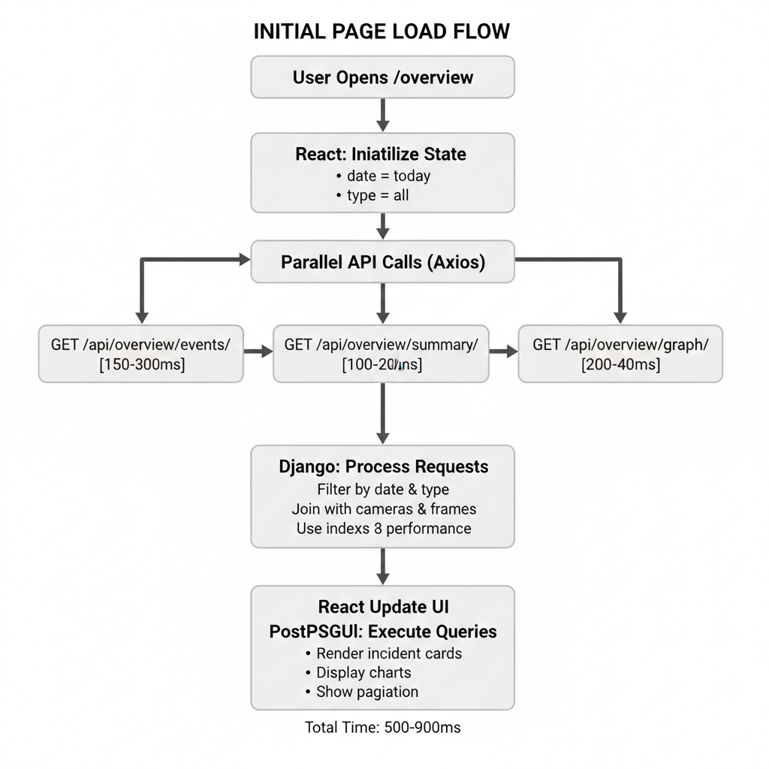

9. User Interface Design & Screenshots
The SafelenseAI user interface provides an intuitive, responsive dashboard for monitoring workplace safety incidents. This section describes the UI layout, components, and interaction patterns with visual references.

9.1 Complete Dashboard View

Main Components
✔ Left Sidebar (256px width)
✔ Branding Section
✔ User Profile (Rajanikanth – Administrator) with logout
✔ Navigation:
- Overview (Active)
- Incidents
- User Management
- Settings
✔ Page Title: Overview
✔ Top Filters:
- Incident Type Dropdown
- Date Picker
✔ Incident Cards (6 per page, responsive grid – 3 columns desktop)
✔ Pagination Controls
✔ Summary Section:
- Time Range Selector
- Chart Type Selector
✔ Charts:
- Line Chart (Incident Trend)
- Donut Chart (Overview)
- Bar Chart (Over Time)

1. Events API Response Parsing
Example response from GET /api/overview/events/?date=2026-02-10
Response:
[
{
"event_id": 250,
"event_type": "FALL_DETECTED",
"timestamp": "2026-02-10T14:30:15Z",
"location": "Warehouse A",
"image_url": "..."
}
]

Parsing Logic
- Convert event_type:
  - "FALL_DETECTED" → "Fall Detected"
  - Use string formatting:
    - Replace _ with space
    - Convert to lowercase
    - Capitalize each word
- Convert timestamp:
new Date(timestamp).toLocaleTimeString()

- Display event ID as:
EVT-{event_id}
Example: EVT-250

If image_url is null:
- Show warning icon or placeholder image

2. Summary API Response Parsing
Example response from GET /api/overview/summary/?date=2026-02-10
Response:
{
"total_events": 150,
"type_count": 45,
"percentage": 30.0
}

Parsing Logic
- total_events → Display in donut chart center
- type_count → Used for selected segment
- Format percentage:
percentage.toFixed(1)

Example:
30.0%

3. Graph API Response Parsing
Example response from GET /api/overview/graph/?time_range=today
[
{ "label": "10:00", "count": 5 },
{ "label": "11:00", "count": 8 }
]

Parsing Logic
- label → X-axis value
- count → Y-axis value
- Same dataset used for:
  - Line chart
  - Bar chart
No additional transformation required if backend formats labels correctly.

10. Performance Optimization
Key strategies implemented to ensure responsive performance.

10.1 Frontend Optimizations
- Client-side pagination: Reduces API calls by handling pagination in browser
- Controlled API calls: Filters trigger only relevant endpoints
- Loading states: Prevent UI jank during data fetching
- Image fallbacks: Graceful handling of missing thumbnails

10.2 Backend Optimizations
- Server-side filtering: All filtering at database level
- Database aggregation: Hour/day grouping in SQL, not application layer
- Indexed queries: Timestamp and event_type columns indexed
- Minimal response payload: Only required fields returned

10.3 Database Optimizations
- B-tree indexes on timestamp and event_type
- Functional index on DATE(timestamp) for date filtering
- LEFT JOINs to prevent data loss
- Read-only models prevent accidental schema changes

11. Future Enhancements
Planned features and improvements for future releases.

11.1 Planned Pages
- Incidents Page: Detailed incident management with advanced filters and search
- User Management Page: Role-based access control and user administration
- Settings Page: System configuration and threshold management

11.2 Feature Enhancements
- Real-time updates: WebSocket integration for live incident feeds
- Multi-date selection: Compare incidents across date ranges
- Export functionality: CSV/PDF export for reports
- Video playback: Stream incident video clips
- Advanced analytics: Heatmaps, trend prediction, risk analysis

11.3 Security Enhancements
- Token-based authentication: JWT implementation
- Role-based access control: Fine-grained permissions
- Audit logging: Track all user actions
- Secure media URLs: Time-limited access tokens

12. Conclusion
SafelenseAI provides a comprehensive, scalable solution for workplace safety monitoring. The system's clean architecture, optimized performance, and intuitive interface make it suitable for enterprise deployment while maintaining flexibility for future enhancements.
Key strengths of the system include:
- Clear separation of concerns between UI, API, and database layers
- Predictable data flow and state management
- Robust error handling and empty states
- Performance optimizations at every layer
- Modern, responsive user interface
This document serves as a complete reference for development, deployment, and maintenance of the SafelenseAI system. For additional support or clarification, please contact the ProDiSyn Innovations development team.

---

