DEVOPS MSE-1

NAME: AMRITESH PANDEY BRANCH / SECTION: CSE-A ROLL NUMBER: 2400290100047

- GitHub repository URL - https://github.com/Amritesh786/github-skills-challenge
- Pull request URL used to validate the workflows -
https://github.com/Amritesh786/github-skills-challenge/pull/1

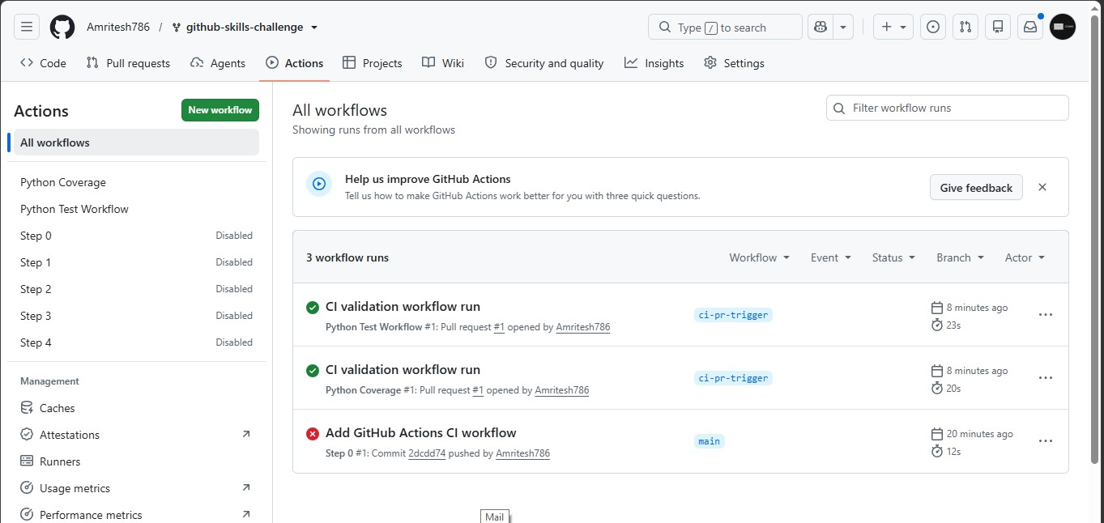
Screenshot showing the GitHub Actions workflows

- Screenshot showing a successful test workflow execution

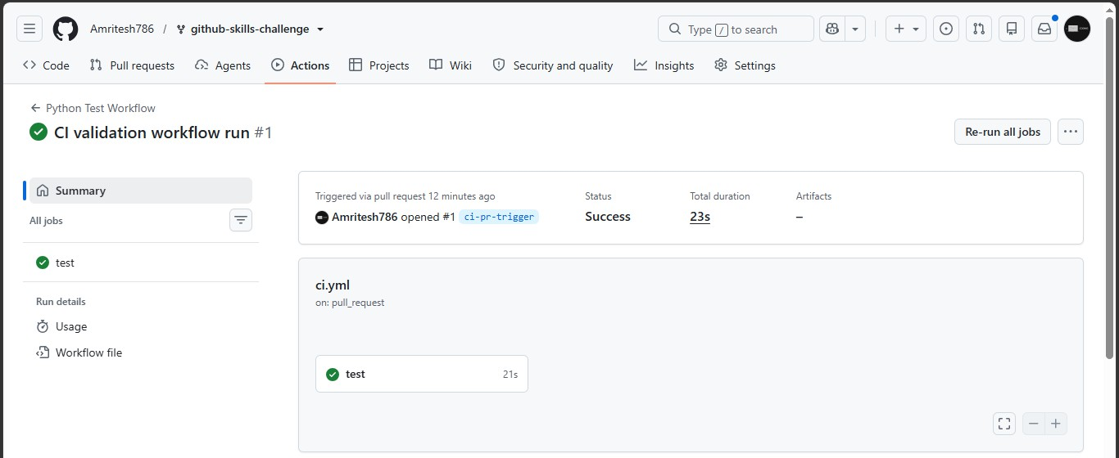

- Screenshot showing the coverage result/comment on the pull request

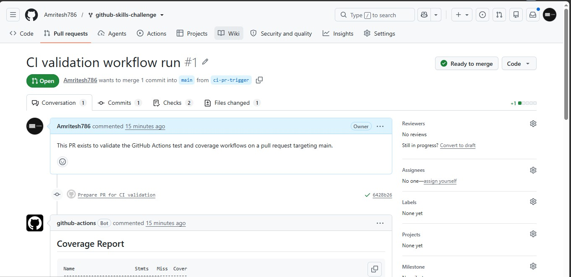
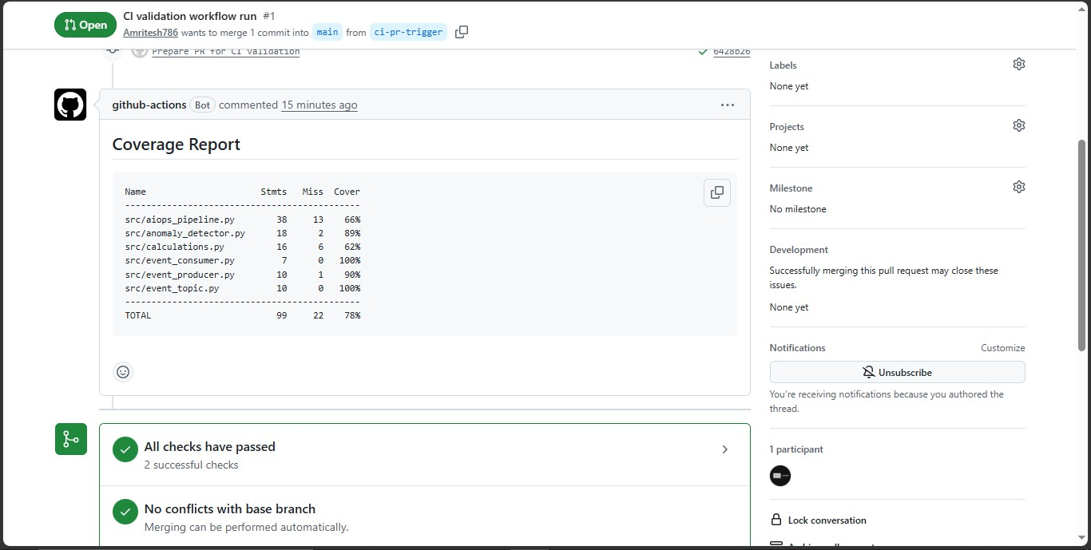

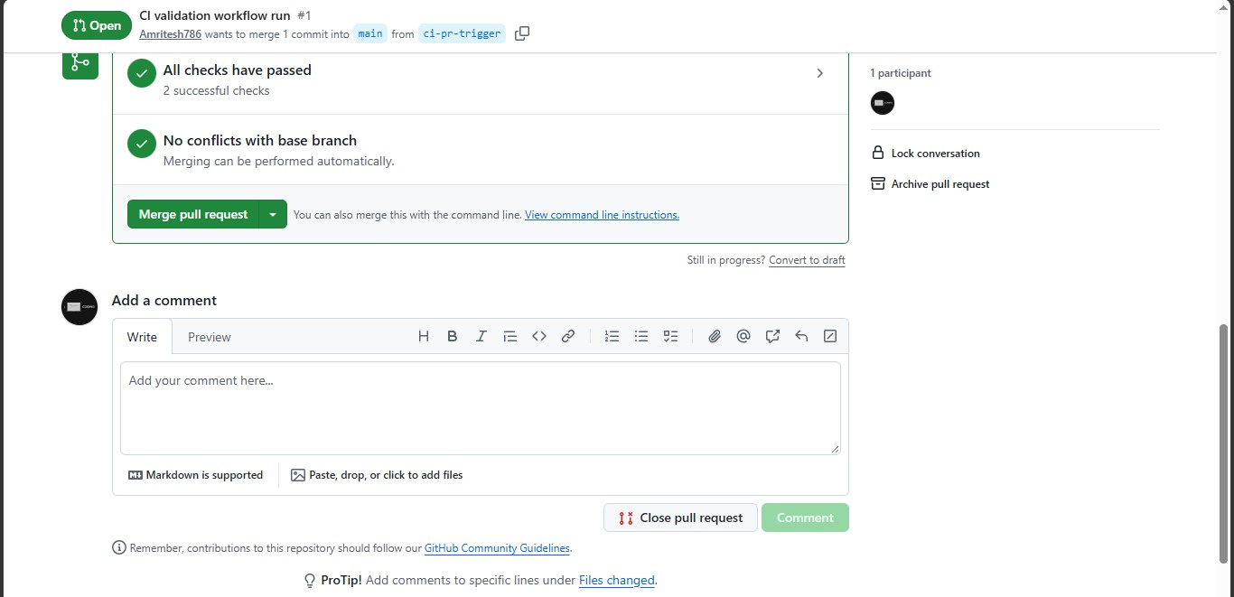

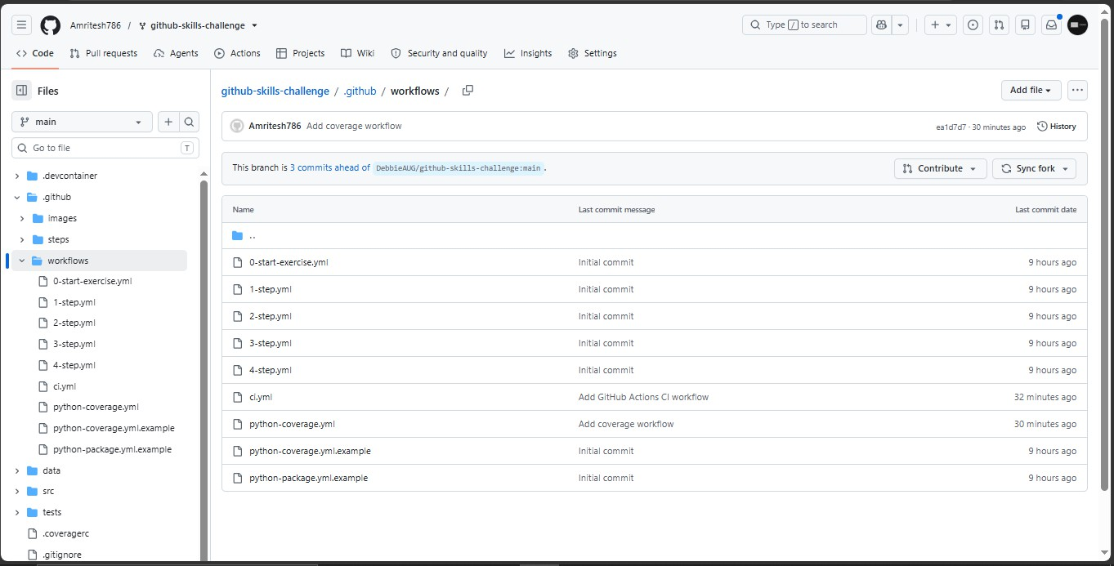
- Screenshot showing the final repository/workflow files

