**Placement Portal**

***Project Submitted in Partial fulfillment of the***

***Requirement for the Award of the Degree of***

Master of Computer Applications

***Semester IV***

## Jan - May, 2022

**Under the guidance of Submitted By**

**Mr. Hitesh Ninama Narendra Kumar**

**(1710134)**



**School of Computer Science & IT**

**Devi Ahilya Vishwavidyalaya, Indore, M.P.**

**2022**

**School of Computer Science & IT**

**Devi Ahilya Vishwavidyalaya, Indore, M.P.**

**DECLARATION**

I hereby declare that the project titled “Placement Portal” submitted by me for the partial fulfillment of the requirement for the award of *Master of Computer Applications* to *School of Computer Science & IT, Devi Ahilya Vishwavidyalaya, Indore,* comprises my own work and due acknowledgement has been made in text to all other material used.

Signature of Student:

Date:

Place:

**School of Computer Science & IT**

**Devi Ahilya Vishwavidyalaya, Indore, M.P.**

**CERTIFICATE FROM GUIDE**

It is to certify that dissertation on “Placement Portal”, submitted by Mr. Narendra Kumar to the *School of Computer Science & IT, DAVV, Indore* has been completed under my supervision and the work is carried out and presented in a manner required for its acceptance in partial fulfillment for the award of the degree of *Master of Computer Applications*.

**Project Guide**

Signature:

**Name:**

**Date:**

**School of Computer Science & IT**

**Devi Ahilya Vishwavidyalaya, Indore, M.P.**

**CERTIFICATE**

It is to certify that we have examined the dissertation on “Placement Portal”, submitted by Mr. Narendra Kumar to the *School of Computer Science & IT, DAVV, Indore* and hereby accord our approval of it as a study carried out and presented in a manner required for its acceptance in partial fulfillment for the award of the degree of *Master of Computer Applications*.

**Internal Examiner External Examiner**

Signature**:** Signature**:**

Name  **:** Name **:**

Date **:** Date **:**

**ACKNOWLEDGEMENT**

I had a great pleasure in acknowledging the help given by various individuals throughout the project work. This project is itself an acknowledgement to the inspiration, drive and technical assistance contributed by many individuals.

I give my sincere thanks to the head of the department **Dr. Sanjay Tanwani** for being an inspiration and a great motivation for all of us.

I express my sincere and heartfelt gratitude to **Mr. Hitesh Ninama** for being helpful and Cooperative during the period of the project and for his valuable guidance, timely suggestions and help in the completion of this main project.

I extend my sincere thanks to all the teaching and non-teaching staff for providing the necessary facilities and help. Without the support of any of them this project would not have been a reality. I am also thankful to all my friends and to my parents for their incredible support given to me in every aspect.

I perceive this big milestone in my career development. I will strive to use gained skills and knowledge in the best possible way and will always do my best for their improvements in order to achieve desired career objectives.

**Sincerely**

Narendra Kumar - 1710134

**ABSTRACT**

The Placement Management System is a web application for the training and placement department of our college. This system can be accessed throughout the organization with proper login credentials. Students will be able to upload their personal and educational information which will be managed efficiently by the system. It intends to provide a fast access to the placement procedures and related activities and ensures to maintain the details of the student secure. The key feature of this project is that it is a onetime registration enabled system. This project will aid colleges to practice full IT deployment.

**TABLE OF CONTENTS**

**Title Page No.**

**ACKNOWLEDGEMENT …………………………………………………….**.. **i ABSTRACT………………………………………………………………………ii**

**TABLE OF CONTENTS……………………………………………………….** **iii**

**LIST OF TABLES……………………………………………………………….vi**

**LIST OF FIGURES…………………………………………….………………**.**.vi**

**ABBREVIATIONS…………………………………………...………………….vi**

**CHAPTER 1. INTRODUCTION………………………………………………………………1-4**

* 1. Introduction……........................................................................................1
  2. Aim ……....................................................................................................2

1.3 Objectives……...........................................................................................2

* 1. Scope of the project……………...………………………....…….…........3

1.5 Existing System……………...…………………………...…………........3

1.6 Proposed System……………...…………………………...….….…........4

**CHAPTER 2.**

**PROJECT ANALYSIS …...................................................................................6-9**

2.1 Feasibility Study………………………………………………………..…6

2.2 Requirement Analysis …………………………………….……………...7

2.3 Hardware Requirements …………………………………………….........8

2.4 Software Requirements …………………………………………........…..9

**CHAPTER 3.**

**PROJECT PLANNING …...................................................................................10**

3.1 Planning…………………………………………………………………..10

3.2 Development Plan…………………………………………………….…..10

**CHAPTER 4.**

**SYSTEM DESIGN...........................................................................................11-19**

4.1 Introduction............................................................................................11

4.2 ER Diagram……………………………………………….….……..…12

4.3 Data Flow Diagram…………………….………………………...........13-15

4.4 UML Diagram…………………………………………………............16

4.5 Activity Diagram……………………………………………………....17.

4.6 Table Design……………………………………………......................19-21

**CHAPTER 5.**

**SOFTWARE DEVELOPMENT METHODOLOGY……….......................22-24**

* 1. Selecting A Methodology …………………………………………….22

5.2 project approach…………………………………………………….…23-24

**CHAPTER 6.**

**IMPLEMENTATION AND MAINTENANCE.............................................25-30**

6.1 Technologies used...................................................................................25

6.2 Hardware Specification ……………………………………….………30

**CHAPTER 7.**

**SYSTEM TESTING..........................................................................................31-33**

7.1 Unit Testing...……………………………………………….………….31

**CHAPTER 8.**

**OUTPUT FORMS AND REPORTS...............................................................33-42**

8.1 User Interface…………………………………………………….…….34

**CHAPTER 9.**

**LIMITATIONS AND FUTURE SCOPE.......................................................43-44**

9.1 Limitations and Future Scope……………………………...…….…….43

**CHAPTER 10.**

**CONCLUSION..........................................................................................45**

10.1 Conclusion……………………………………………………….45

**REFERENCES..........................................................................................46**

References…………………………………………………………….46

**LIST OF TABLES**

**Table 1:** User Table **…………………………………………19**

**Table 2:** Admin Table**……………………………………….20**

**.**

**Table 3:** Drive Post**………………………………………….20**

**Table 4:** Notice Table**……………………………………….21**

**Table 5:** Mailbox**……………………………………………21**

**LIST OF FIGURES**

**Figure 1:** Gantt Chart **…………………..……….….10**

**Figure 2:** ER Diagram of System **……….……….…12**

**Figure 3:** DFD (Level 0) **…………………………...13**

**Figure 4:** DFD (Level 1) **…………………………...14**

**Figure 5:** DFD (Level 2) **…………………………...15**

**Figure 6:** Use Case Diagram **…………..…………...16**

**Figure 7:** Activity diagram – Student……………….**17**

**Figure 8:** Activity diagram – Coordinator…………..**18**

**Figure 9:** Activity diagram – Admin………………..**1**

CHAPTER 1

Introduction

* 1. **Introduction**

A blood donation is a process whereby a person voluntarily has blood drawn to be used

for future transfusions when in need at hospitals for treatment procedures that

require them. Donation may be of whole blood (blood drawn directly from the

body) or of specific components of the blood; such as red blood cells, white blood

cells, plasma, and platelets. Blood banks often participate in the process of

collecting blood and other procedures such as managing stocks, approving blood

requests and updating donation information.

A blood donation is a process whereby a person voluntarily has blood drawn to be used

for future transfusions when in need at hospitals for treatment procedures that

require them. Donation may be of whole blood (blood drawn directly from the

body) or of specific components of the blood; such as red blood cells, white blood

cells, plasma, and platelets. Blood banks often participate in the process of

collecting blood and other procedures such as managing stocks, approving blood

requests and updating donation information.

A blood donation is a process whereby a person voluntarily has blood drawn to be used

for future transfusions when in need at hospitals for treatment procedures that

require them. Donation may be of whole blood (blood drawn directly from the

body) or of specific components of the blood; such as red blood cells, white blood

cells, plasma, and platelets. Blood banks often participate in the process of

collecting blood and other procedures such as managing stocks, approving blood

requests and updating donation information.

A blood donation is a process whereby a person voluntarily has blood drawn to be used

for future transfusions when in need at hospitals for treatment procedures that

require them. Donation may be of whole blood (blood drawn directly from the

body) or of specific components of the blood; such as red blood cells, white blood

cells, plasma, and platelets. Blood banks often participate in the process of

collecting blood and other procedures such as managing stocks, approving blood

requests and updating donation information.

A blood donation is a process whereby a person voluntarily has blood drawn to be used

for future transfusions when in need at hospitals for treatment procedures that

require them. Donation may be of whole blood (blood drawn directly from the

body) or of specific components of the blood; such as red blood cells, white blood

cells, plasma, and platelets. Blood banks often participate in the process of

collecting blood and other procedures such as managing stocks, approving blood

requests and updating donation informatio

In today’s world everyone is travelling for jobs after Completion of their graduation.

It has become need for each and every student, but for that they need to travel worldwide in searching of jobs. For simplicity of this whole hectic procedures, we had proposed Online Placement Management System because of earlier system is totally done manually by maintaining records, time consuming and very difficult to maintain coordination between student and companies. The project is aimed at developing an online web application for the training and placement department of the college. The system is an online web application that can be accessed throughout the Institute with proper login provided.

This system can be used as an application for the TPO of the college to manage

 the student information with regard to placement. This project will aid colleges

to practice full IT deployment. Student logging should be able to upload their

information. Organizations representatives logging in may also access/search an information put up by the students. TPO have to collect the information and manage them manually according to various streams. If any modification is required that is also to be done manually. Overall, it will reduce the paper work and utilize the maximum capability of the setup and organization as well as it will save time and money. The main purpose of this project is to add new features to existing system. The proposed one is an online system which can be accessed throughout the Organization and outside as well with valid login credentials. This system can be used as an application for the Training and Placement Department of the college to manage student’s information regarding Placements. The student’s record includes personal details, educational qualifications, professional skills and academics, etc. This system acts as central repository for student information.

* 1. **Aim**

Our project has a big scope to do. Students can access previous information about placement. We can store information of all students. Various companies can access their information. Notifications are sent to students about the companies.

1. Easy to collect and manage student data.
2. To increase the accuracy and efficiency of placement procedure.
3. Reduce the paper work.
4. Analysis of overall placement activities
   1. **Objectives**

The goal of the project is to develop a web application for blood banks to manage

information about their donors and blood stock. The main objectives of this

website development can be defined as follows:

The goal of the project is to develop a web application for blood banks to manage

information about their donors and blood stock. The main objectives of this

website development can be defined as follows:

The goal of the project is to develop a web application for Placement Procedures to manage information about all the students. The main objectives of this website development can be defined as follows:

1. **To study the existing system:** Upon analysis of the existing system, I found that the current placement drives are being posted on a social media app i.e., WhatsApp, so our first challenge will be to implement a dynamic and interacting web portal for students to view the placement drives and can apply for them.
   1. **Crud:** Our objective is to make a website with all the crud functionality i.e., Create, Read, Update, Delete.
      1. All the **static pages** are needed to be created.
      2. To make them **Dynamic**, Logic is to be written.
      3. **Database creation** and then connecting it to the static sites using the backend language.
2. **Modules:** Static and dynamic pages are as follows:
   1. **Student Panel:** A site to manage all the students, coordinators, and applications for the existing current drives.
   2. **Coordinator Panel:** A site to post the placement drives and also to collect the data of the students applying for the drives
   3. **Admin Panel:** A site to administered the placement drives, student’s applications for current drives and all the coordinators.

1. To develop a system that provides functions to support donors to view and

manage their information conveniently.

2. To maintain records of blood donors, blood donation information and blood

stocks in a centralized database system.

3. To inform donors of their blood result after their donation.

4. To support searching, matching and requesting for blood convenient for

administrators.

5. To provide a function to send an e-mail directly to the donor for their user

account and the hospital, the availability of the blood bag

* 1. **Scope of the Project**

The system functions and features will include the following:

* Registration: Student will be able to register themselves by make the inputs of all necessary information.
* Data is input by the Administrators: The admin will be able to provide access to the students as well as to the coordinators.
* Post Drive: Coordinators would be able to post company drive as well as they can update the drive details.
* Apply drive: Students will have the features to fill their academic details, they can generate resume, as well as check their eligibility and can also apply for the placement drive.
* Resume Generator: Students will be able to create their resume.
* Responsiveness: The project is fully responsive i.e.; it is accessible via smartphone devices and tablets.

**1.5 Existing System:**

* In our college, Training and placement cell used to manage the student’s profile and their information for their placement, manually.
* Placement cell collects the information of various companies who wants to recruit students from the campus and notify the students according to the company requirements by means of a social media group i.e., either on WhatsApp or Telegram, which implies the need for a proper system to manage the student’s placement.
* Also, the data of students is collected via google forms whenever any company arrives for placement, which may sometimes cause errors and mismanagement.
* Placement cell also have to arrange profiles of students according to various company needs which is tedious and time consuming, if done manually or via social media apps, and if any modifications or updates are needed in the profile of any student then it has to be searched and done manually.

**1.6 Proposed System**

The present system can be replaced by an Online Placement Management System, thus eradicating all the tedious and manual work of placement cell by taking the entire process online. The placement management system will store the information of all the students in the database, will also categorize their CV according to the companies’ criteria and notification will be sent to the students about the companies via email so that they directly apply through the portal for the various placement drives. The students would also be informed about upcoming drives, so that they can prepare accordingly. The system has the potential to make the placement process easier.

After implementation of project:

1. Easy to use web-based system.
2. Users can register online.
3. Centralized control by administrator.
4. Managed Information in a secure manner**.**

CHAPTER 2

SYSTEM ANALYSIS

Analysis is the process of breaking a complex topic or substance into smaller parts in order to gain a better understanding of it. The Tool used for Analysis of the system is personal observation. Systems analysis is the study of sets of interacting entities, including computer systems analysis. This field is closely related to operations research. It is also "an explicit formal inquiry carried out to help someone (referred to as the decision maker) identify a better course of action and make a better decision than he might otherwise have made." Analysis is defined as the procedure by which we break down an intellectual or substantial whole into parts so that we can achieve our end goals. The development of a computer-based information system includes a systems analysis phase which produces or enhances the data model which itself is a precursor to creating or enhancing a database. There are a number of different approaches to system analysis. When a computer-based information system is developed, systems analysis would constitute the following steps:

1. The development of a feasibility study, involving determining whether a project is economically, socially, technologically and organizationally feasible.
2. Conducting fact-finding measures, designed to ascertain the requirements of the system's end-users. These typically span interviews, questionnaires, or visual observations of work on the existing system.
3. Gauging how the end-users would operate the system (in terms of general experience in using computer hardware or software), what the system would be used for etc. Another view outlines a phased approach to the process. This approach breaks systems analysis into 5 phases:

* Scope definition
* Problem analysis
* Requirements analysis
* Logical design
* Decision analysis

Use case are a widely-used systems analysis modeling tool for identifying and expressing the functional requirements of a system. Each use case is a business scenario or event for which the system must provide a defined response. Use cases evolved out of object-oriented analysis**:**

**2.1 Feasibility study**

After doing the project Placement Portal, study and analyzing all the existing or required functionalities of the system, the next task is to do the feasibility study.

Feasibility study includes consideration of all the possible ways to provide a solution to the given problem. The proposed solution should satisfy all the user requirements and should be flexible enough so that future changes can be easily done based on the future upcoming requirements.

* **Economic Feasibility:**

It is a very important aspect to be considered while developing a project. We decided the technology based on minimum possible cost factor. It is cost effective in the sense that has eliminated the paper work completely. The result obtained contains minimum errors and are highly accurate as the data is required.

* **Technical Feasibility:**

Technical feasibility is the study that includes function, performance and constraints that may affect the ability to achieve an acceptable system. For this study we studied computer functionality to be provided in the system, as described in the System Requirement Specification (SRS) and checked if everything was possible using different type of frontend and backend platform.

* **Operational feasibility:**

No doubt the proposed system is fully GUI based that is very user friendly and all inputs to be taken all self -explanatory even to layman. Besides a proper training has been conducted to let know the essence of the system to the users so that they feel comfortable with the system.

* 1. **Requirement Analysis**

Information gathering is usually the first phase of the software development project. The purpose of this phase is to identify and document the exact requirements for the system. The user’s request identifies the need for a new information system and on investigation re-defined the new problem to be based on MIS, which supports management. The objective is to determine whether the request is valid and feasible before a recommendation is made to build a new or existing manual system continues. The major steps are –

* Defining the user requirements.
* Studying the present system to verify the problem.
* Defining the performance expected by the candidate to use requirements.

* 1. Hardware and Software requirements
     1. Development End
* MemorY: 1GB ram(Minimum)
* Hard disk space: 2 GB
* Processor: Intel dual core or above
* Operating System: Any commonly used operating system.
* Web browsers: Google chrome, Mozilla Firefox, or Apple Safari
* version control: git/github
* network: Reliable internet connectivity.
* Required tools:
* any ide for writing codes.
* XAMPP APache server for localhost.
* latest version of php installed.
* NPM FOR TAILWIND PACKAGE install.
* COMPOSER INSTALLED FOR PHP dependencies.
* gitbash installed for project repository.
  + 1. Application End
* Web browsers: Google chrome, Mozilla Firefox, or Apple Safari.
* OS: Any commonly used operating system.
* Ram and space: Minimum required to browse a website smoothly.
* Network: Good internet connectivity.

CHAPTER 3

Project Planning

Project planning is part of project management, which relates to the use of schedules such as Gantt charts to plan and subsequently report progress within the project environment.

**3.1 Planning**

Information systems have become increasingly important during the past decade. First, information is now recognized as a vital resource. Second, more and more financial resources are committed to information systems. Third, there is growing need for formal long-range planning with information systems. The most critical phase of managing system projects is planning. It is discipline for stating how to complete a project within a certain timeframe, usually with defined stages, and with designated resources.

* 1. **Development plan**

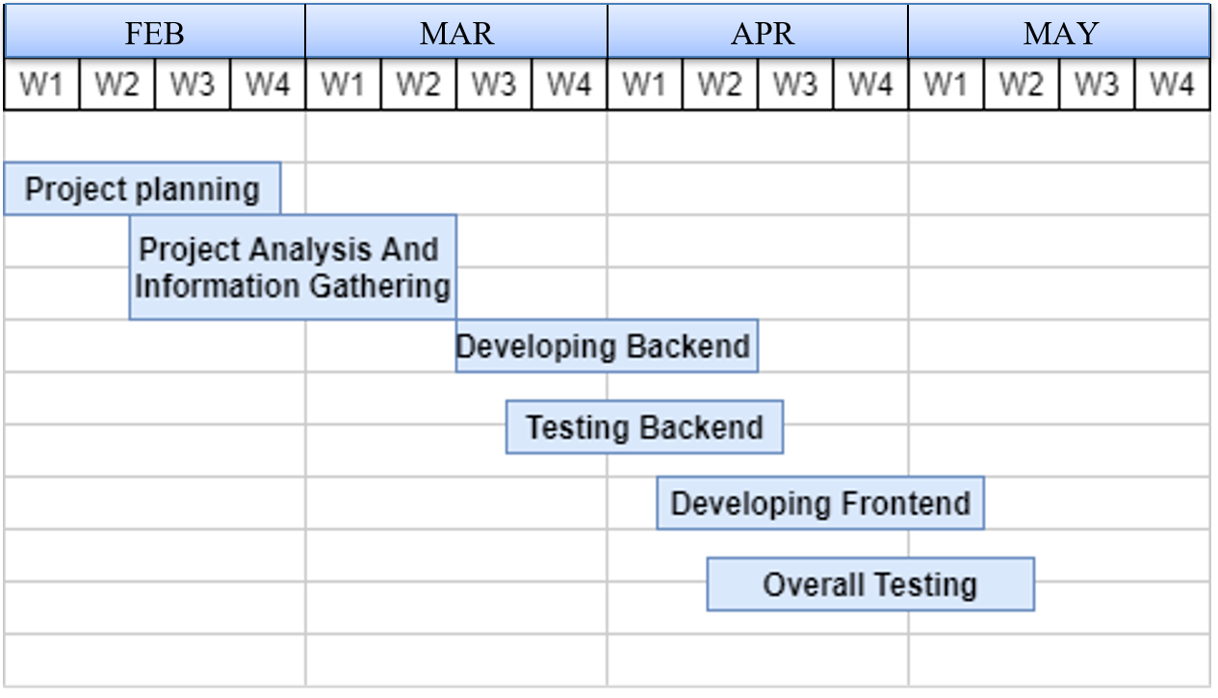

**Figure 1: Gantt Chart**

CHAPTER 4

SYSTEM DESIGN

* 1. Introduction

After the analysis phase we have with us the details of the existing system and the requirements of the user for the new system. This phase diverts focus from the problem domain to the solution domain. It acts as a bridge between the requirement phase and its solution. The design phase focuses on the detailed implementation of the system recommended in the feasibility study. Systems design is the process or art of defining the architecture, components, modules, interfaces, and data for a system to satisfy specified requirements. There is some overlap with the disciplines of systems analysis, systems architecture and systems engineering. Object-oriented analysis and design (ooad) methods are becoming the most widely used methods for computer system design. The uml has become the standard language used in object-oriented analysis and design. It is widely used for modeling software systems and is increasingly used for high designing non-software systems and organizations.

* The external design: External design consists of conceiving, planning out and specifying the externally observable characteristics of the software product. These characteristics include user displays or user interface forms and the report formats, external data sources and the functional characteristics, performance requirements etc. External design begins during the analysis phase and continues into the design phase.
* Logical design: The logical design of a system pertains to an abstract representation of the data flows, inputs and outputs of the system.
  + USE CASE DIAGRAM
  + ER DIAGRAM
* Physical design: The physical design relates to the actual input and output processes of the system. This is laid down in terms of how data is input into a system, how it is verified/authenticated, how it is processed, and how it is displayed as output.

4.2 ER Diagram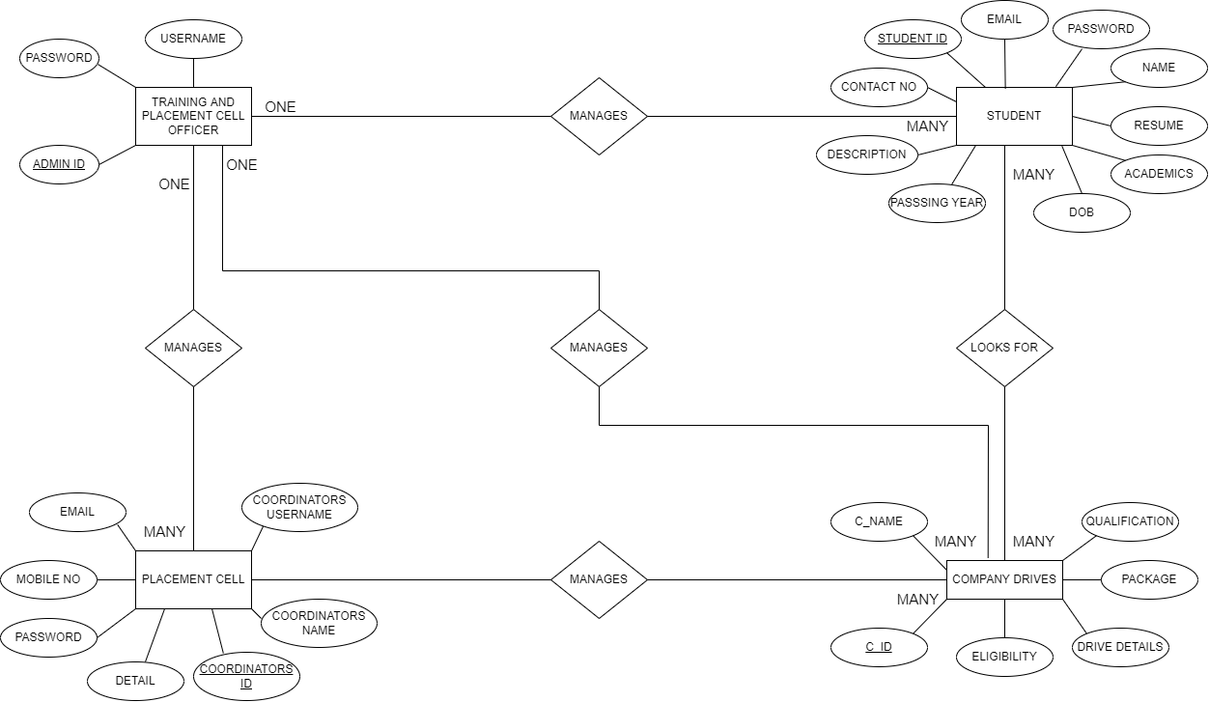

**Figure 2: ER-Diagram**

* 1. DATA FLOW DIAGRAM

Level 0 DFD

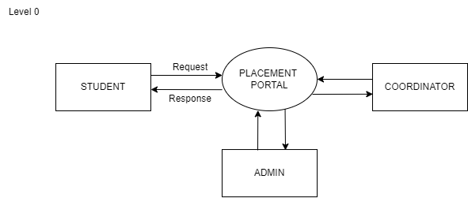

**Figure 3: DFD - Level 0**

Level 1 DFD

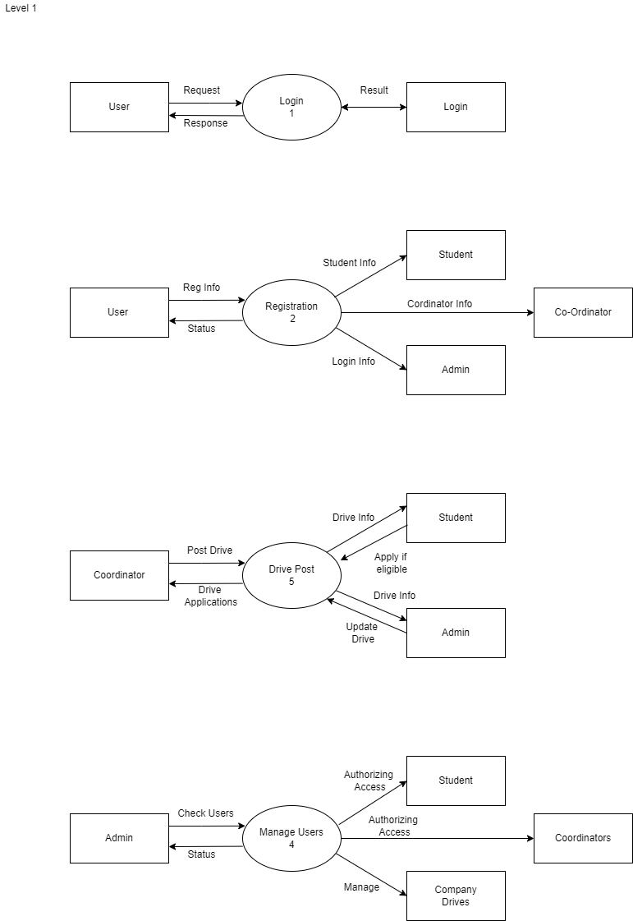

**Figure 4: DFD Level 1**

Level 2 DFD

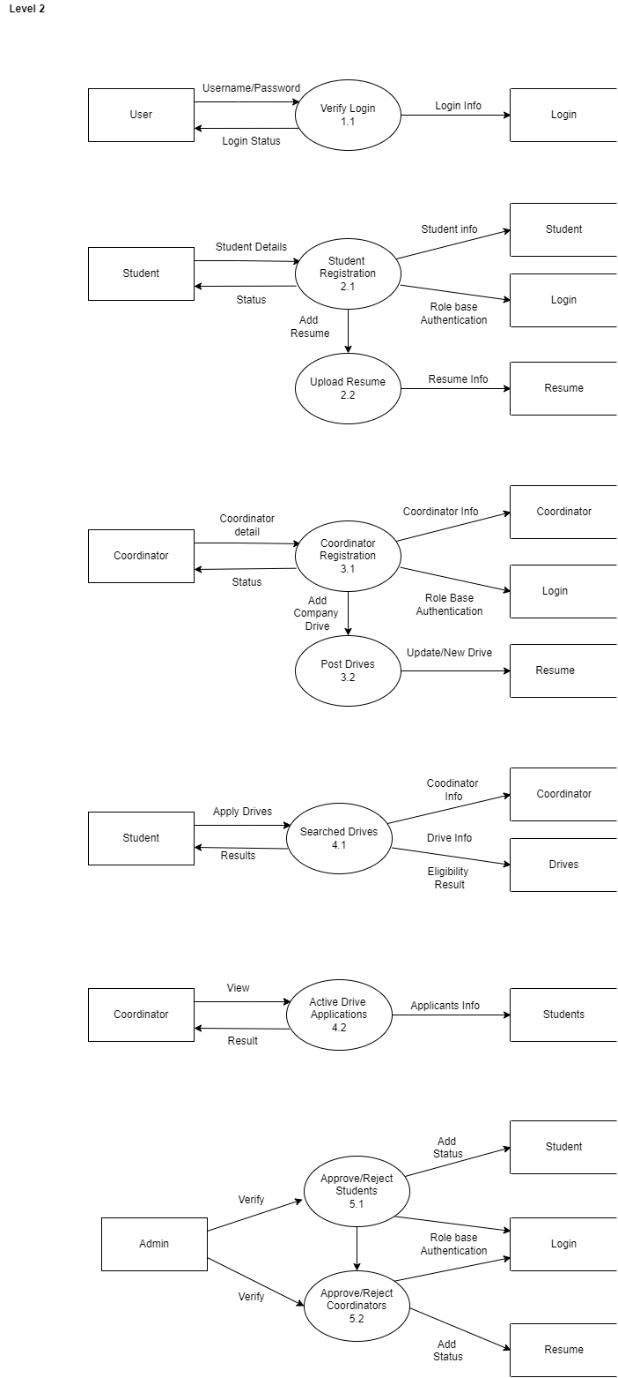

Figure 4: DFD Level 2

4.4 Use CASE DIAGRAM

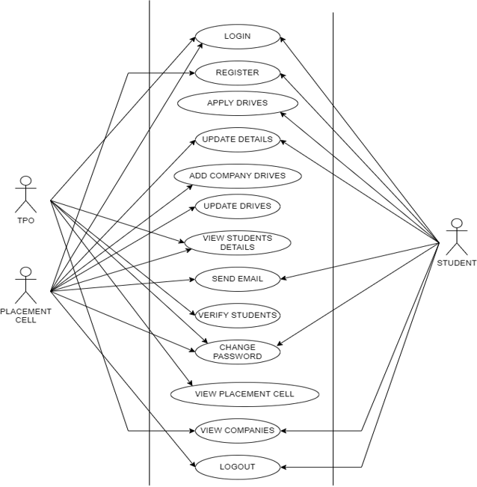 Figure 5: Use CaSE DIAGRAM

4.5 ACTIVITY DIAGRAM

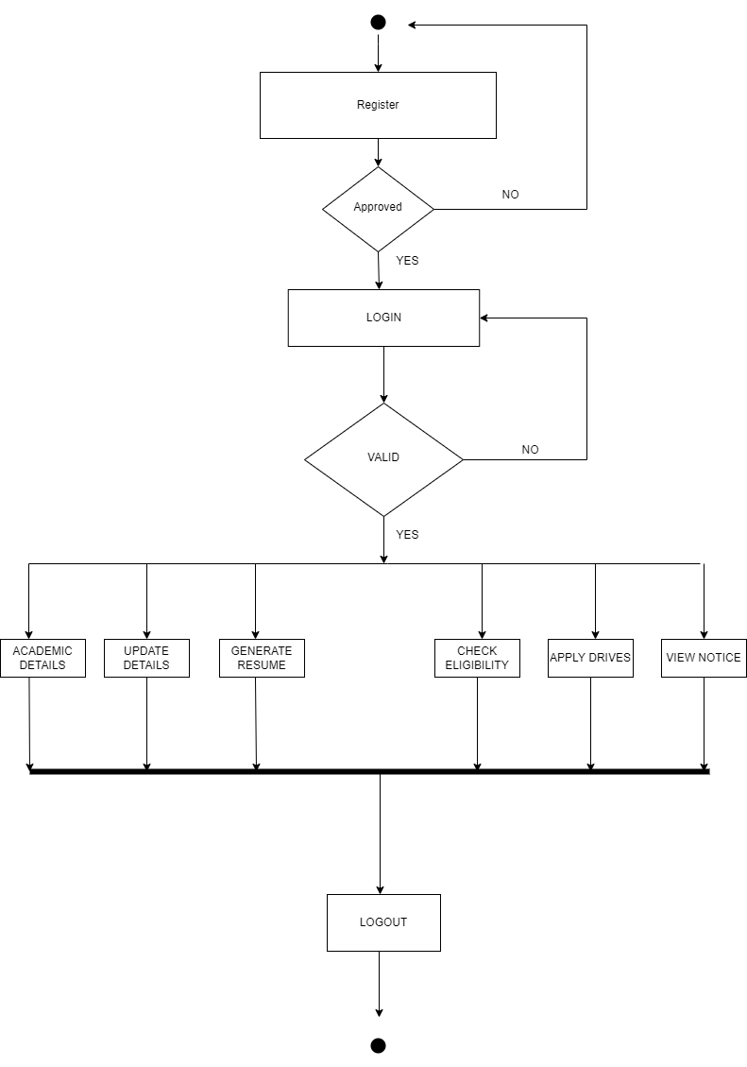

FIGURE 5: ACTIVITY DIAGRAM – sTUDENT

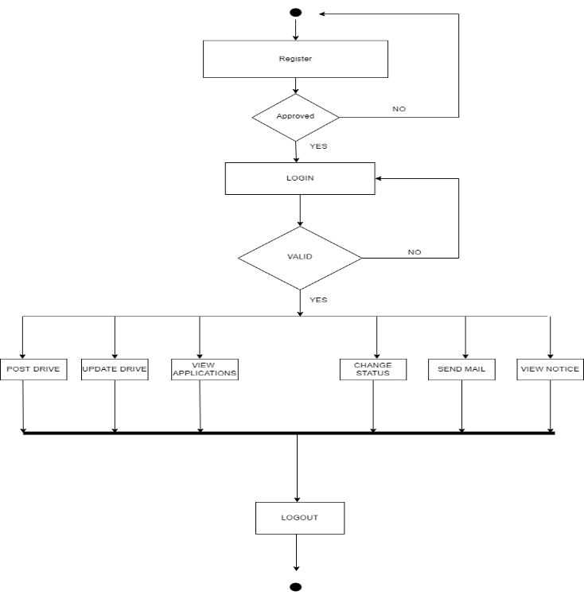

fIGURE 6: aCTIVITY DIAGRAM - COORDINATOR

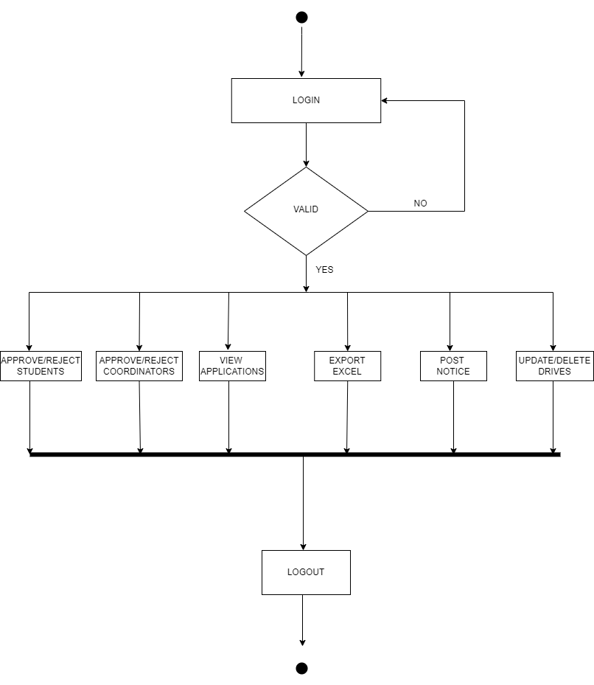

FIGURE 7: ACTIVITY DIAGRAM - ADMIN

* 1. **Table Design**

**Table 1: User Table**

|  |  |  |
| --- | --- | --- |
| **S No.** | **Field Name** | **Data Type** |
| 1 | Id | Number |
| 2 | first name | Varchar |
| 3 | last name | Varchar |
| 4 | Email | Varchar |
| 5 | Password | Date |
| 6 | Address | Varchar |
| 7 | City | Number |
| 8 | State | Number |
| 9 | Contact no | Number |
| 10 | Qualification | Varchar |
| 11 | Stream | Varchar |
| 12 | Passing year | Date |
| 13 | Dob | Date |
| 14 | Age | Number |
| 15 | Designation | Varchar |
| 16 | Resume | Varchar |
| 17 | About me | Varchar |
| 18 | Skills | Varchar |
| 19 | HSC | Number |
| 20 | SSC | Number |
| 21 | UG | Number |
| 22 | PG | Number |

**Table 2: Admin Table**

|  |  |  |
| --- | --- | --- |
| **S No.** | **Field Name** | **Data Type** |
| 1 | Id admin | Number |
| 2 | username | Varchar |
| 3 | password | Varchar |

**Table 3: Drive Post**

|  |  |  |
| --- | --- | --- |
| **S No.** | **Field Name** | **Data Type** |
| 1 | Id drive | Number |
| 2 | Company name | Varchar |
| 3 | Description | Varchar |
| 4 | CTC | Varchar |
| 5 | Percentage Eligibility | Number |
| 6 | Role | Varchar |
| 7 | Qualification | Varchar |
| 8 | Date created | Datetime |

**Table 4: Notice Table**

|  |  |  |
| --- | --- | --- |
| **S No.** | **Field Name** | **Data Type** |
| 1 | id | Number |
| 2 | subject | Varchar |
| 3 | notice | Varchar |
| 4 | Audience | Varchar |
| 5 | date | Datetime |

**Table 5: Mailbox**

|  |  |  |
| --- | --- | --- |
| **S No.** | **Field Name** | **Data Type** |
| 1 | Id mailbox | Number |
| 2 | Id from user | Varchar |
| 3 | From user | Varchar |
| 4 | Id to user | Varchar |
| 5 | subject | Datetime |
| 6 | Message | Varchar |
| 7 | Created at | Datetime |

**CHAPTER 5**

**SOFTWARE DEVELOPMENT**

**METHODOLOGY**

1. **Selecting A Methodology**

The methodology that is used in this project is **Agile Development Methodology**. We are using this methodology because it is an iterative approach to product delivery that builds incrementally from the start of the project, instead of trying to deliver the entire product at once near the end. Other benefits that we discovered by using this methodology for our project are listed below -

##### Increased project control: Team members have control throughout the project with more opportunities to test and adapt.

##### Higher product quality: Because testing is integrated throughout the project development process, the team can perform regular checkups and find areas of improvement.

##### Reduced risk: Agile project management virtually eliminates the chances of absolute project failure. Working in sprints allows teams to develop a working product from the beginning or fail fast and take another approach.

##### Better visibility into project performance: Agile project management lets team members know how the project is progressing. Frequent Scrum meetings and sprint reviews provide increased transparency to everyone on the team.

##### Increased project control: Team members have control throughout the project with more opportunities to test and adapt.

##### Better project predictability: Breaking up the project into shorter sprints allows project managers to predict the exact cost, timeline, and resource allocation necessary for each sprint.

Agile software development refers to a group of software development methodologies based on iterative development, where requirements and solutions evolve through collaboration between self-organizing cross-functional teams. Agile methods or agile processes generally promote a disciplined project management process that encourages frequent inspection and adaptation, a leadership philosophy that encourages teamwork, self-organization and accountability, a set of engineering best practices intended to allow for rapid delivery of high-quality software, and a business approach that aligns development with customer needs and company goals. Agile development refers to any development process that is aligned with the concepts of the Agile Manifesto. Scrum is a subset of Agile. It is a lightweight process framework for agile development, and the most widely-used one.

* A “process framework” is a particular set of practices that must be followed in order for a process to be consistent with the framework. (For example, the Scrum process framework requires the use of development cycles called Sprints, the XP framework requires pair programming, and so forth.)
* “Lightweight” means that the overhead of the process is kept as small as possible, to maximize the amount of productive time available for getting useful work done.

**6.2 project approach**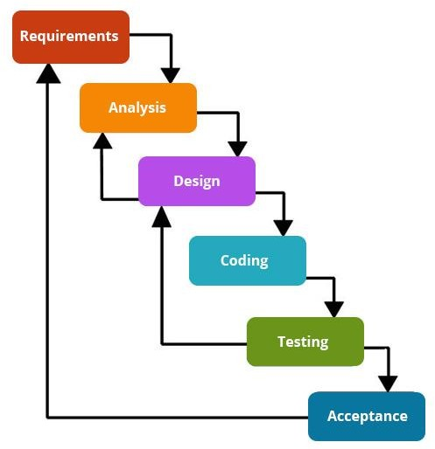

In this project scrum methodology of agile is used, where development phases divided into stages known as sprint.

Scrum is an agile process most commonly used for product development, especially software development. Scrum is a project management framework that is applicable to any project with aggressive deadlines, complex requirements and a degree of uniqueness.

A sprint is a set period of time during which specific work has to be completed and made ready for review.

**CHAPTER 6**

**System Implementation**

System Implementation uses the structure created during architectural design and the results of system analysis to construct system elements that meet the stakeholder requirements and system requirements developed in the early life cycle phases. These system elements are then integrated to form intermediate aggregates and finally the complete system of interest.

* 1. **Technologies Used**

**6.1.1** **HTML (Hypertext Markup Language)**

* HTML is not a programming language; it is a markup language (set of markup tags) which is used to describe the web pages.

|  |
| --- |
| **<html>** // Html tag  **<head>** // head tag for all the header content of site.  **<Meta data of the website>**  **<CSS and other external frameworks CDN links>**  **<title>**Placement Portal**</title>**  **</head>**  **<body>**  All the content of the page.  **</body>**  **</html>** |

* + 1. **CSS**
* CSS stands for Cascading Style Sheets.
* Styles define how to display HTML elements.
* Styles are normally stored in Style Sheets.
* External Style Sheets can save you a lot of work.
* External Style Sheets are stored in CSS files.
* Multiple style definitions will cascade into one.

|  |
| --- |
| #Preloader { //id selector is used to find the attribute to be designed.  **position**: fixed; // Position property of CSS  **z-index**: 9999;  **overflow**: hidden;  **transition**: all 0.6s ease-out;  **width**: 100%;  **height**: 100vh;  } |

CSS provides means to customize inbuilt HTML tags HTML tags were originally designed to define the content of a document. They were supposed to say "This is a header", "This is a paragraph", "This is a table", by using tags like <h1>, <p>, <table>

|  |
| --- |
| and so on. The layout of the document was supposed to be taken care of by the browser, without using any formatting tags. As the two major browsers - Netscape and Internet Explorer - continued to add new HTML tags and attributes (like the tag and the color attribute) to the original HTML specification, it became more and more difficult to create Web sites where the content of HTML documents was clearly separated from the document's presentation layout.  All major browsers support Cascading Style Sheets. |

**CSS** helped in the designing part of the UI.

* + **Bootstrap5** is a CSS framework which was used for buttons display, select options and for various input elements.
  + **Tailwind Utility Framework** is used for the implementations of the navbar, cards, carousel and as well as for footer.
  + **CSS Media Queries** are used for the responsiveness of the website, which makes it easier to access the entire website via a smart phone as well as Tablets and other small screen devices.

**6.1.3 JavaScript**

JavaScript gives HTML designers a programming tool - HTML authors are normally not programmers, but JavaScript is a scripting language with a very simple syntax! Almost anyone can put small "snippets" of code into their HTML pages.

JavaScript can put dynamic text into an HTML page - A JavaScript statement like this: document. Write ("

# " + name + " ") can write a variable text into an HTML page

* JavaScript can react to events - A JavaScript can be set to execute when something happens, like when a page has finished loading or when a user clicks on an HTML element
* Resume Generator is built using JS DOM manipulation.
* Script is used for writing the logic for the sorting technique as well as for the filtering option.
* JS script is also used for creating several effects on the site and also for creating the alert messages.
* Script is used for the site responsive behaviour too.
* JavaScript can read and write HTML elements - A JavaScript can read and
* JavaScript can be used to create cookies - A JavaScript can be used to store and retrieve information on the visitor's computer.
* JavaScript is used to make the site interactive and user friendly.

|  |
| --- |
| <script>function myFunction() {        // Declare variables        var input, filter, table, tr, td, i, txtValue;        input = document.getElementById("myInput");        filter = input.value.toUpperCase();        table = document.getElementById("example2");        tr = table.getElementsByTagName("tr");        // Loop through all table rows, and hide those who don't match the search query        for (i = 0; i < tr.length; i++) {            td = tr[i].getElementsByTagName("td")[0];            if (td) {                txtValue = td.textContent || td.innerText;                if (txtValue.toUpperCase().indexOf(filter) > -1) {                    tr[i].style.display = "";                } else {                    tr[i].style.display = "none";                }            }        }    }</script> |

* + 1. **Core php** and its dependencies are used to write the logic of the website. Xampp mail service as well the PhpSpreadsheets libraries are used.

PHP 5 PHP (recursive acronym for PHP: Hypertext Preprocessor) is a widely-used open-source general-purpose scripting language that is especially suited for web development and can be embedded into HTML.

What distinguishes PHP from something like client-side JavaScript is that the code is executed on the server, generating HTML which is then sent to the client.

The best things in using PHP are that it is extremely simple for a newcomer, but offers many advanced features for a professional programmer. Don't be afraid reading the long list of PHP's features. You can jump in, in a short time, and start writing simple scripts in a few hours.

|  |
| --- |
| <?php // opening php tags  session_start()  // adding database file  require_once(Placement_portal.php);  $sql = "select * from users";  $result = $conn -> query($sql)  if ($result->num_rows>0)  {  while ($result->fetch_assoc()){  echo "echo $row['Name'];  }  }  ?> // closing php tags |

* + 1. **Composer** is used to download the php dependencies.
    2. **Dialog flow** api is used for the implementation of the chatbot answering user/visitors queries on the site.
    3. **Gitbash** is used for committing project changes and pushing the changes to the **GitHub** main site.
    4. The project is published on the **GitHub** main website by creating a repository named **Placement _ portal**
    5. **Xampp/ Apache** cross platform is used for creating a local server.

**MySQL** is used for creating the database named Placement Portal. All the tables related to the project are stored in the same database.

Lists of tables are as following:

* + 1. User table
    2. Admin table
    3. Drive table
    4. Notice table
    5. Mailbox table

6.9 Visual Studio Code being an interactive and user-friendly IDE is used for writing the codes of the website.

* 1. Operating System used is **Windows 11**
  2. Browser for testing: **Google Chrome**

**6.1.2 Hardware Used:**

* Memory: 8 GB
* Hard disk space used: 2 GB
* Processor: AMD-Ryzen

**CHAPTER 7**

**SYSTEM TESTING**

**Unit Testing**- The most ‘micro’ scale of testing; to test particular functions and code modules. Typically done by the programmer and not by the testers, as it requires detailed knowledge of the internal program design and code. Not always easily done unless the application has a well-designed architecture with tight code; may require developing test driver modules or test harnesses.

|  |  |  |  |  |  |  |  |  |  |  |  |  |  |  |  |  |  |  |  |  |  |  |  |  |  |  |  |  |  |  |  |  |  |  |  |  |  |  |  |  |  |  |  |  |  |  |  |  |  |  |  |  |  |  |  |  |  |  |  |  |  |  |  |  |  |  |  |  |  |  |  |  |  |  |  |  |  |  |  |  |  |  |  |  |  |  |  |  |  |  |  |  |  |  |  |  |  |  |  |  |  |  |  |  |  |  |  |  |  |  |  |  |  |  |  |  |  |  |  |  |  |  |  |  |  |  |  |  |  |  |  |  |  |  |  |  |  |  |  |  |  |  |  |  |  |  |  |  |  |  |  |  |  |  |  |  |  |  |  |  |  |  |  |  |  |  |  |  |  |  |  |  |  |  |  |  |  |  |  |  |  |  |  |  |  |  |  |  |  |  |  |  |  |  |  |  |  |  |  |  |  |  |  |  |  |  |  |  |
| --- | --- | --- | --- | --- | --- | --- | --- | --- | --- | --- | --- | --- | --- | --- | --- | --- | --- | --- | --- | --- | --- | --- | --- | --- | --- | --- | --- | --- | --- | --- | --- | --- | --- | --- | --- | --- | --- | --- | --- | --- | --- | --- | --- | --- | --- | --- | --- | --- | --- | --- | --- | --- | --- | --- | --- | --- | --- | --- | --- | --- | --- | --- | --- | --- | --- | --- | --- | --- | --- | --- | --- | --- | --- | --- | --- | --- | --- | --- | --- | --- | --- | --- | --- | --- | --- | --- | --- | --- | --- | --- | --- | --- | --- | --- | --- | --- | --- | --- | --- | --- | --- | --- | --- | --- | --- | --- | --- | --- | --- | --- | --- | --- | --- | --- | --- | --- | --- | --- | --- | --- | --- | --- | --- | --- | --- | --- | --- | --- | --- | --- | --- | --- | --- | --- | --- | --- | --- | --- | --- | --- | --- | --- | --- | --- | --- | --- | --- | --- | --- | --- | --- | --- | --- | --- | --- | --- | --- | --- | --- | --- | --- | --- | --- | --- | --- | --- | --- | --- | --- | --- | --- | --- | --- | --- | --- | --- | --- | --- | --- | --- | --- | --- | --- | --- | --- | --- | --- | --- | --- | --- | --- | --- | --- | --- | --- | --- | --- | --- | --- | --- | --- | --- | --- | --- | --- | --- | --- | --- |
| |  |  |  |  |  |  |  |  | | --- | --- | --- | --- | --- | --- | --- | --- | | Test case id | Test case description | Prerequisites | Steps to execute | Expected results | Actual results | Pass/Fail |  | | T_01 | Login using valid Login ID and password | User must be stored in database with valid credentials | 1) Enter Login ID | Should be Logged in Successfully | Login Successful | Pass |  | |  |  |  | 2) Enter Password |  |  |  |  | |  |  |  | 3) Click on Login |  |  |  |  | |  |  |  |  |  |  |  |  | | T_02 | Login using invalid Login ID and invalid password | User must be stored in database with valid credentials | 1) Enter Login ID | Error message should be displayed "Invalid password or Login ID" | Error message displayed "Invalid password or Login ID" | Pass |  | |  |  |  | 2) Enter Password |  |  |  |  | |  |  |  | 3) Click on Login |  |  |  |  | |  |  |  |  |  |  |  |  | | T_03 | Registration by Coordinator | User must be at registration page | 1) Enter all mandatory fields of form | Message is displayed” To be approved by the admin." | Message is displayed “ to be approved by the admin." | Pass |  | |  |  |  | 2) Click on Submit |  |  |  |  | |  |  |  |  |  |  |  |  | | TA_04 | Send drive post to Student (Valid Drive) | User must be logged into the system | 1) Enter all mandatory fields of form | Drive visible to user. | Drive visible to user. | pass |  | |  |  |  | 2) Click on Post Button |  |  |  |  | |  |  |  |  |  |  |  |  | | TA_05 | Send post to Student (invalid Drive) | User must be logged into the system | 1) Enter all mandatory fields of form | Enter all the required fields. | Enter all the required fields. | pass |  | |  |  |  | 2) Click on Post Button |  |  |  |  | |  |  |  |  |  |  |  |  | | TA_06 | Active Drive Page | User must be logged into the system | 1)click on Upcoming Drive | New pages open and data is displayed | New pages open and data is displayed | pass |  | |  |  |  |  |  |  |  |  | | TA_07 | Active Drive Page | User must be logged into the system | 1)click on Upcoming Drive. | New pages open and Message displayed "No Data Found" | New pages open and Message displayed "No Data Found" | pass |  | |  |  |  |  |  |  |  |  | |  |  |  |  |  |  |  |  | |  |  |  |  |  |  |  |  | | TC_08 | when drive is started- Result Page Designing | User must be logged into the system | 1)click on Post result link | New pages open and data is displayed | New pages open and data is displayed | pass |  | |  |  |  |  |  |  |  |  | |

**CHAPTER 8**

**OUTPUT FORMS AND REPORTS**

**8.1 User Interface**

1. Home Page

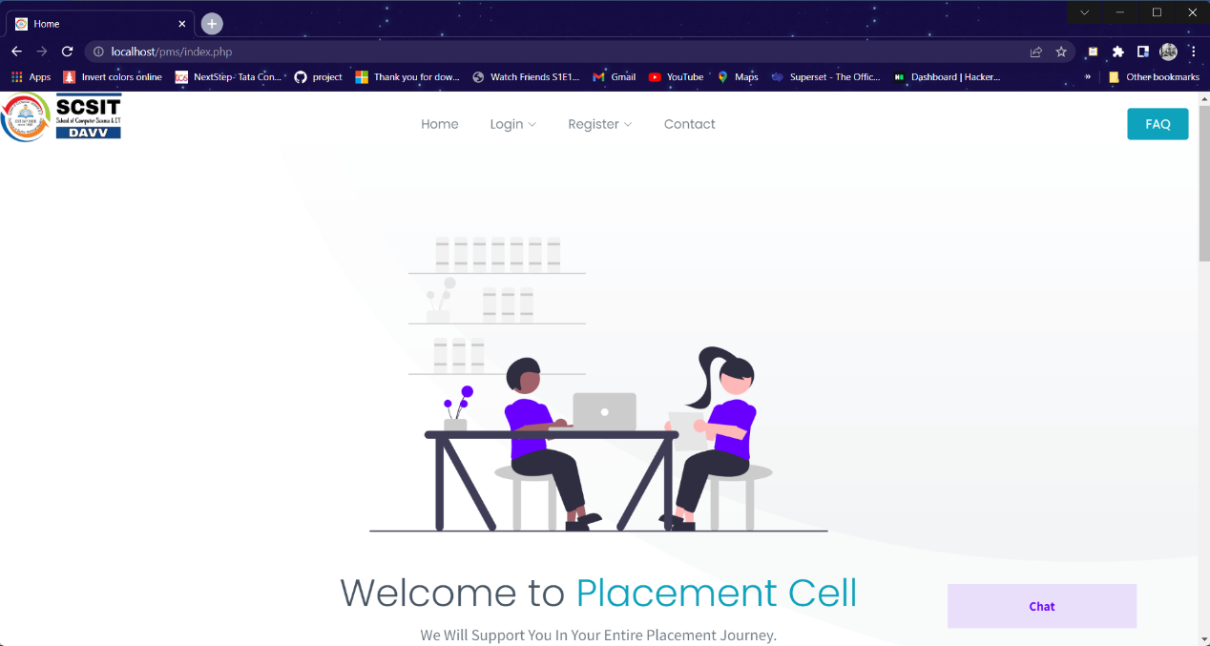

2. Login Page

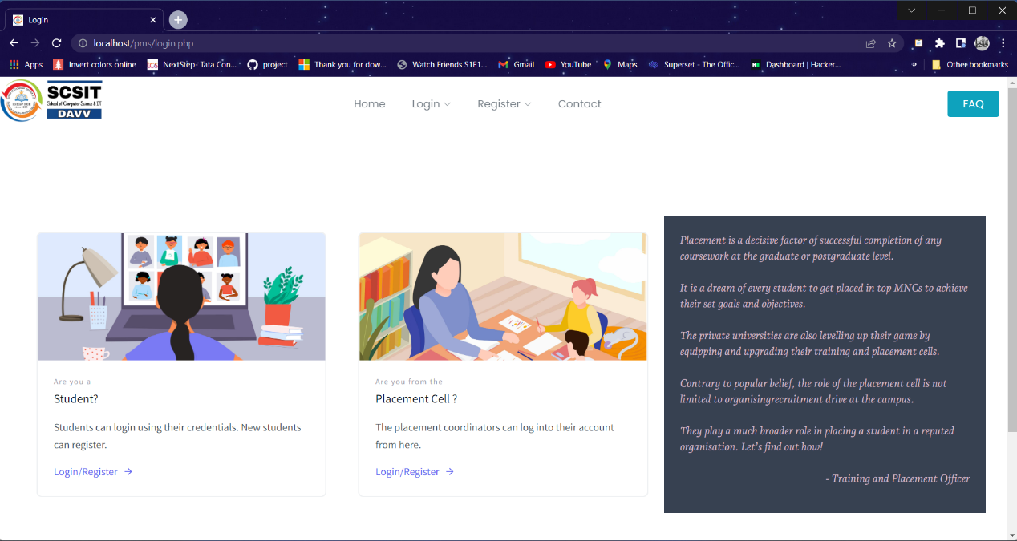

3. Student Login Page

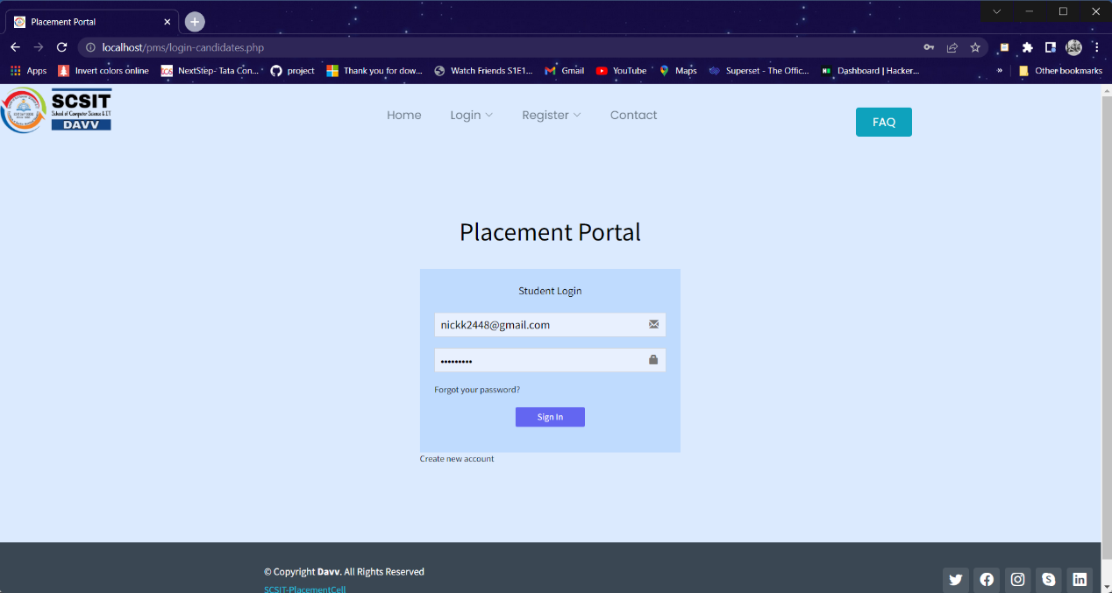

4. Placement Cell Login Page

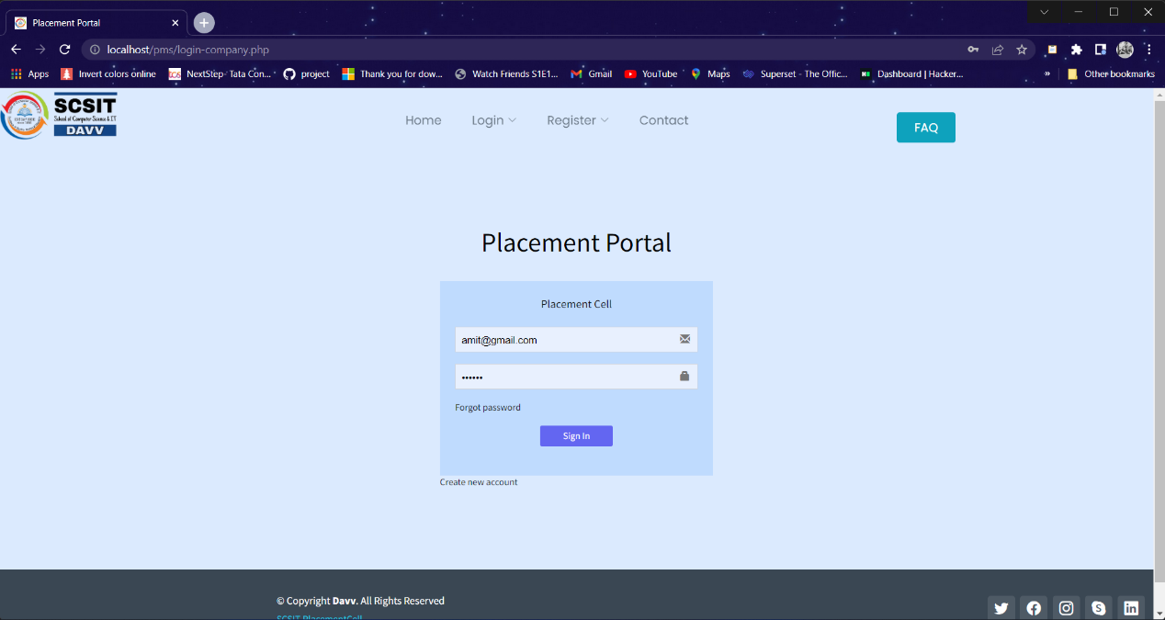

1. Student Register Page

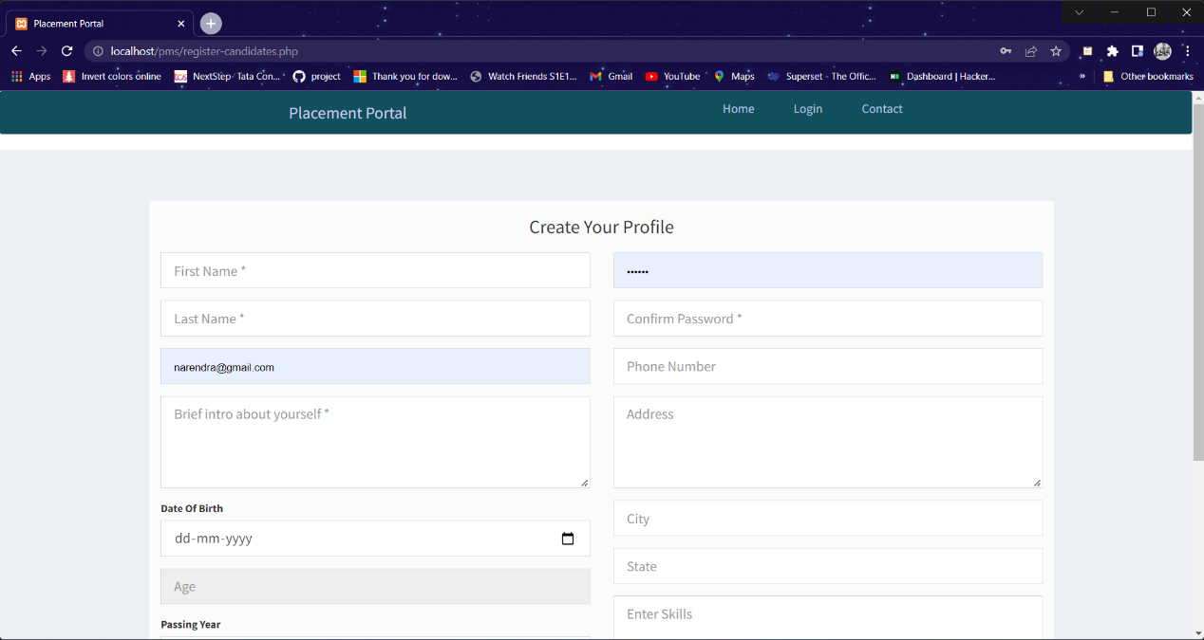

1. Drive Applications

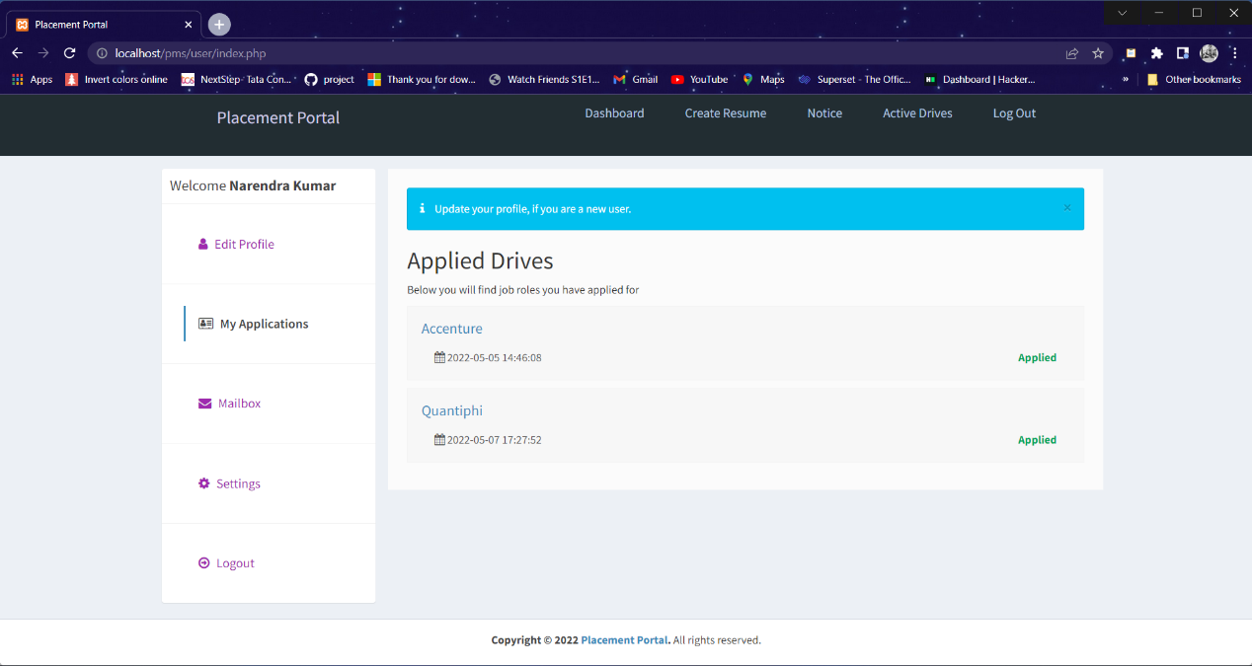

1. Update Profile Page

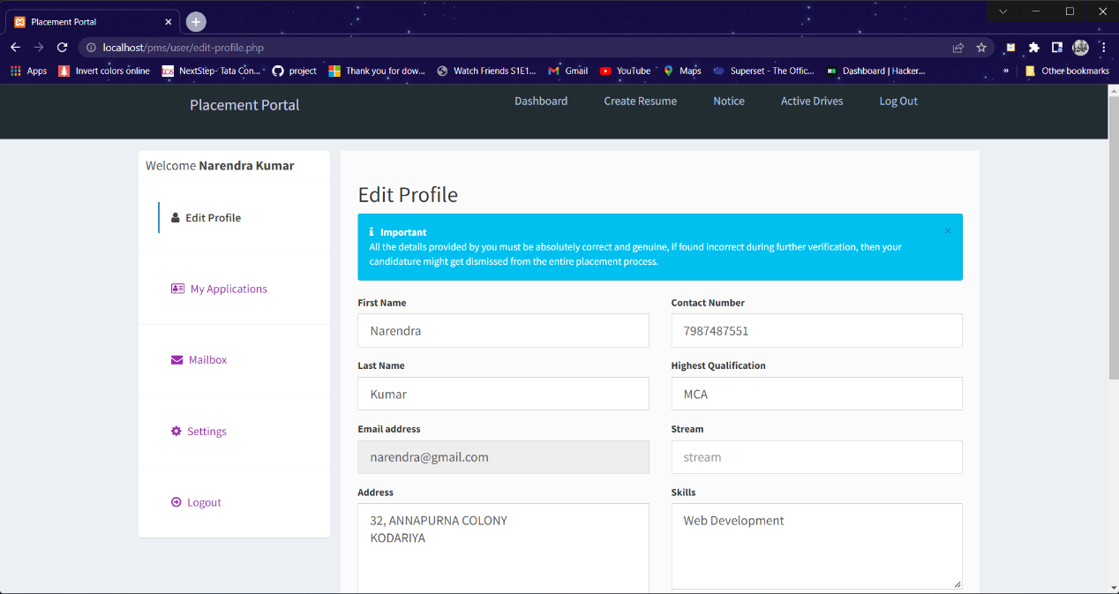

1. Create Resume

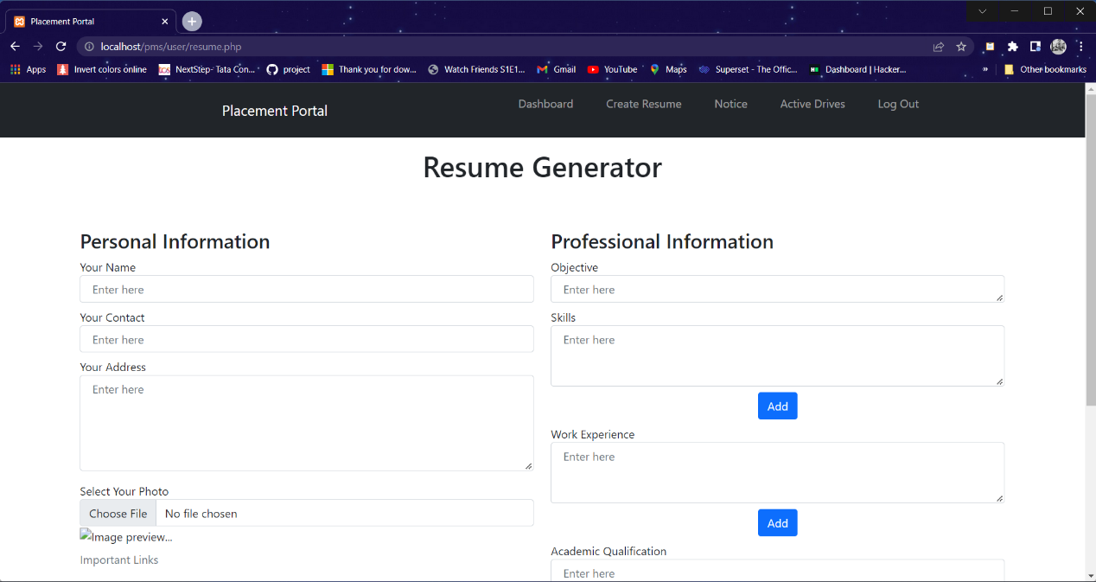

1. Active Drives

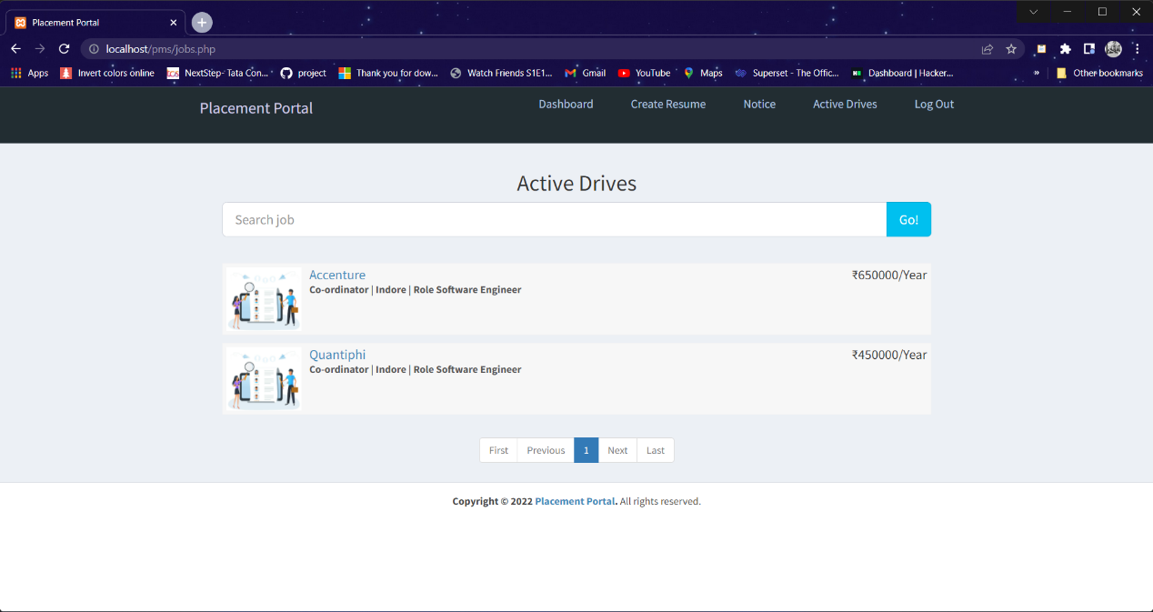

1. Drive Detail

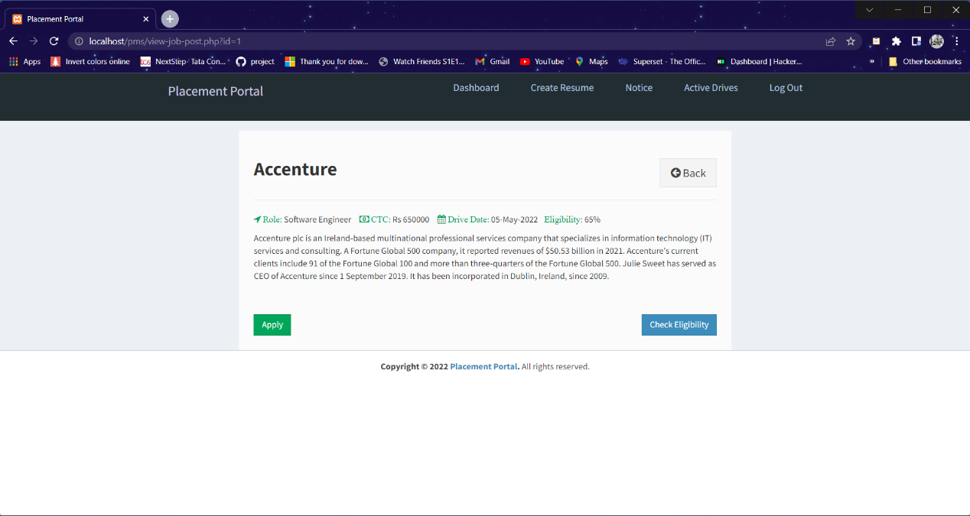

1. Mailbox

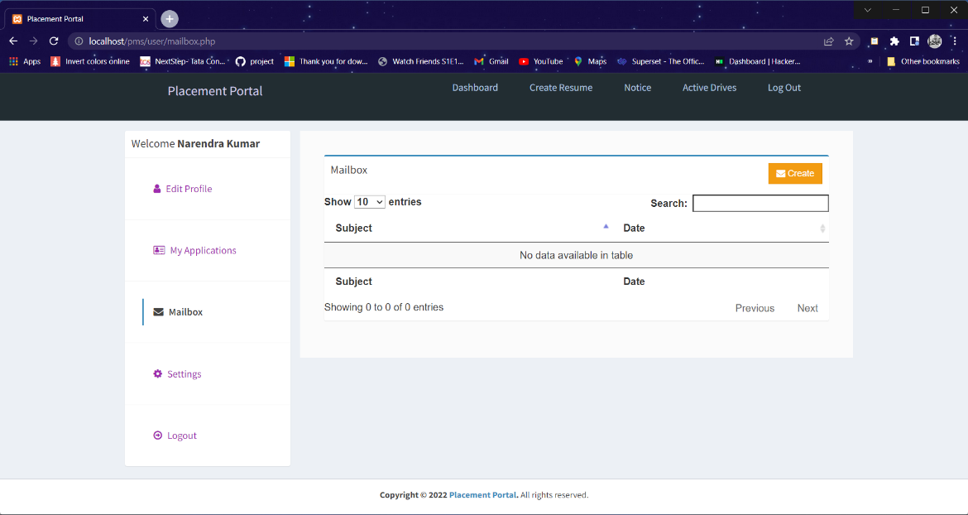

1. Settings Page

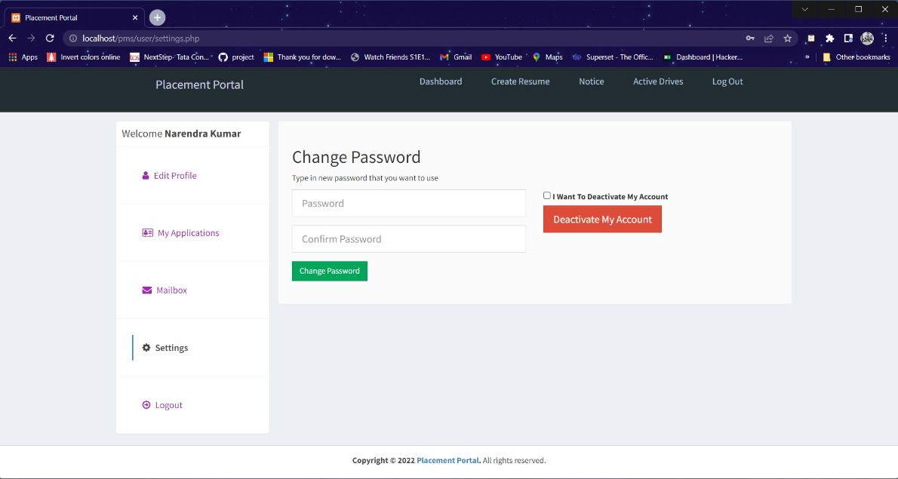

1. Placement - Cell Panel

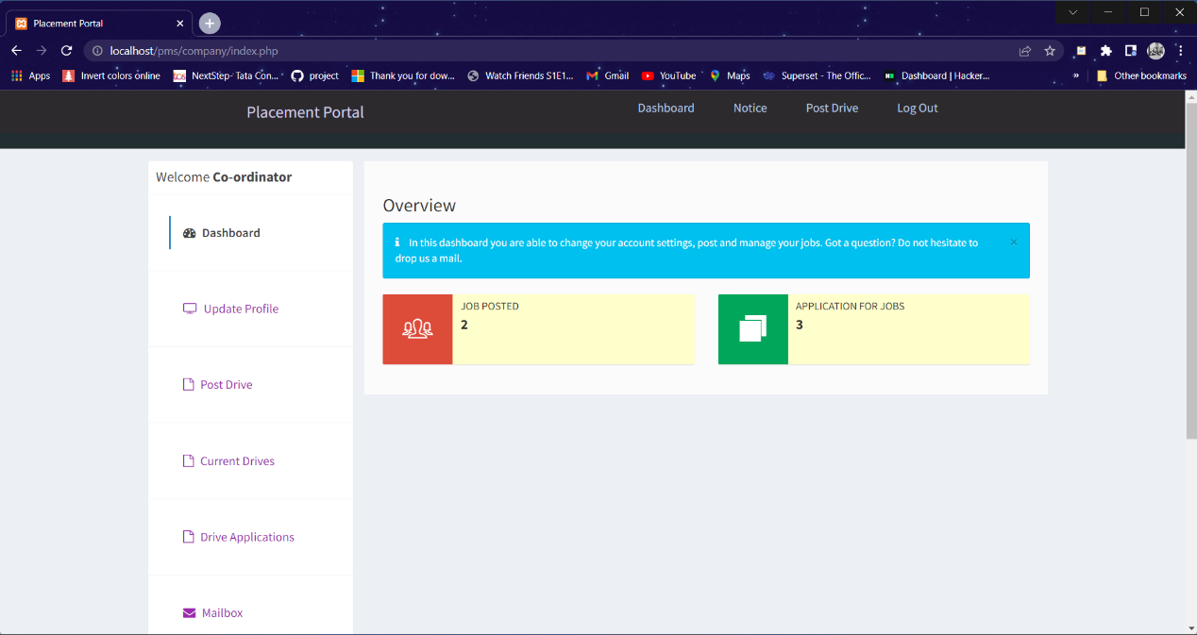

1. Post New Drive

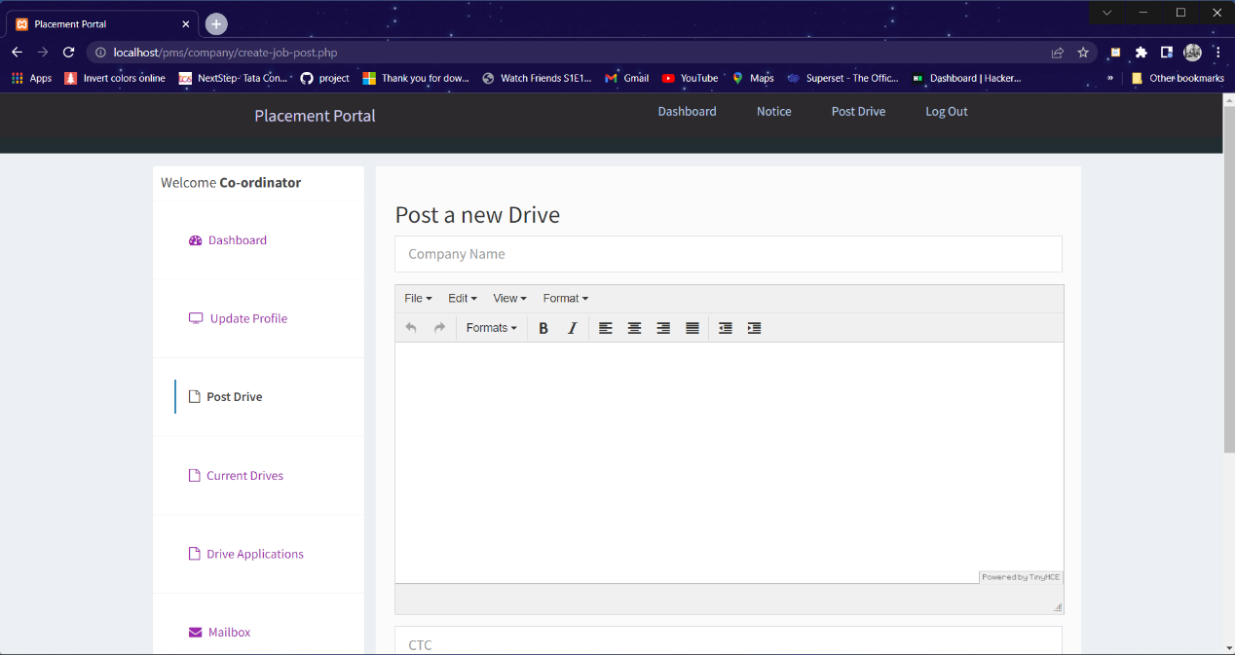

1. Update Drive

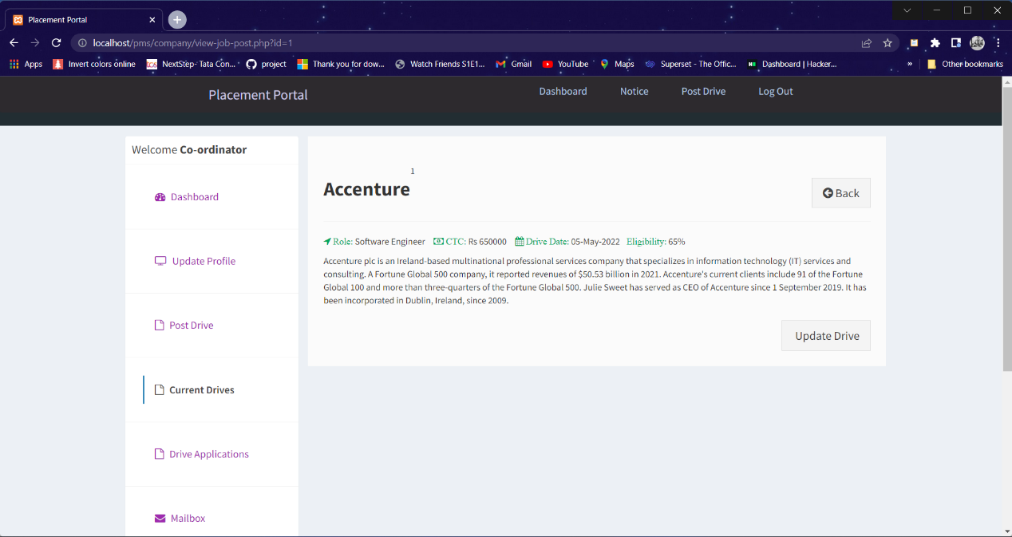

1. Student Application Status

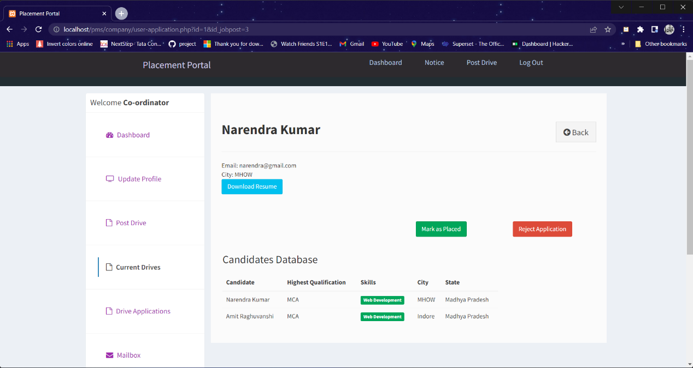

1. Admin Panel

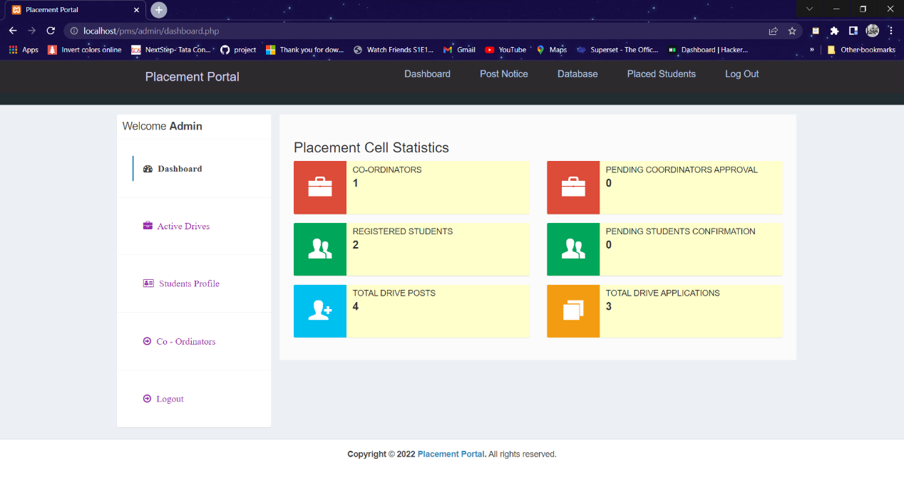

14. Post Notice

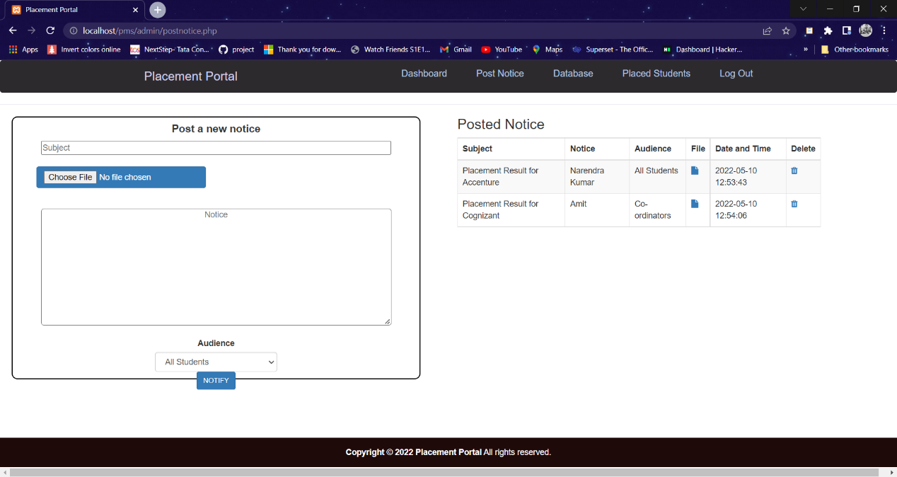

|  |
| --- |
|  |

1. Drive applications

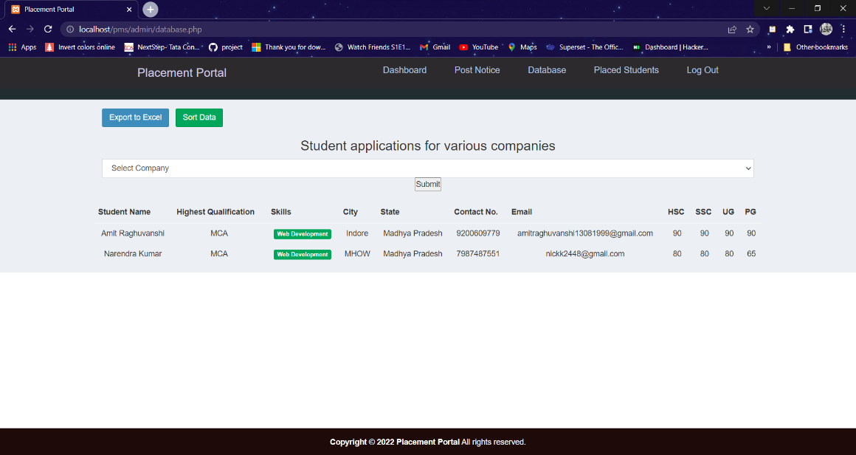

1. Placed Students List

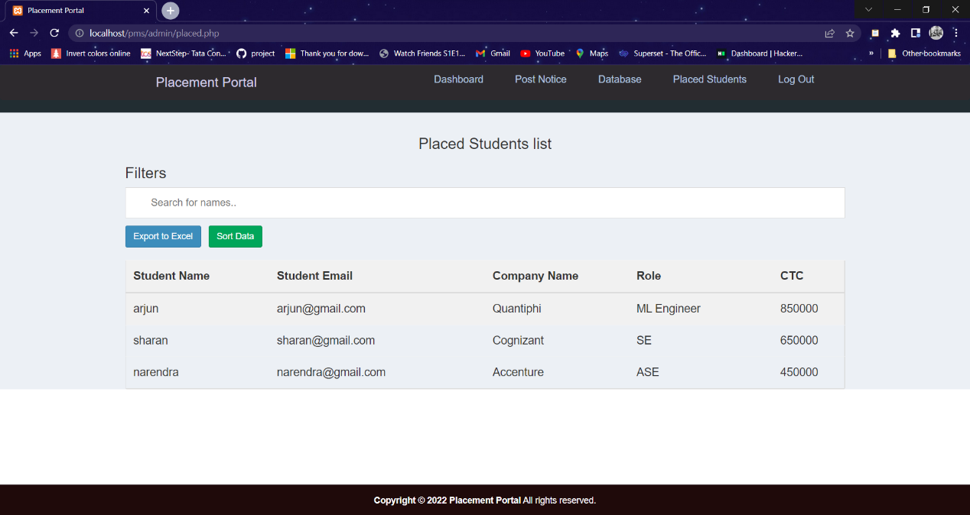

**CHAPTER 9**

LIMITATIONS and future scope

* 1. Limitations
* More Data analysis feature could have been added to the TPO page.
* Sms alert could have been implemented to alert students for the upcoming drive.
* Some pages responsive behaviour is not 100% fluid which is yet to be improved.
  1. Future Scope
* This placement portal can be improved and effectively used at the college main website in the near future as it helps to solve many problems related to placement management in our college.
* This system in future could be joined to sms server so that it can notify the message to students via sms for up-coming company drives.
* The project can be updated in near future as and when the requirement for the same arises, as it is flexible in term of expansion.
* The website responsiveness can further be improved in order to make it more interactive and user friendly for smart users.

**CHAPTER 10**

CONCLUSION

The proposed system is online training and placement management system gives the automation in all the process of campus recruitment, searching student details individually. It intends to provide a fast access to the placement procedures and related activities and ensures to maintain the details of the student secure. It is very helpful, reliable and performs well and is functional to get an alert for the placement drives. All the students as well as the placement cell can carefree rely on this system for the entire placement process.

**REFERENCES**

# 1. Software Engineering: Concepts and Practices: Dr Ugrasen Suman

# Practical Understanding of PHP and MySQL – Udemy

1. https://github.com/
2. [www.stackoverflow.com](http://www.stackoverflow.com)
3. <https://tailwindcss.com/>
4. <https://getbootstrap.com/>
5. <https://www.php.net/>
6. <https://getcomposer.org/doc/00-intro.md>