Title page:

Name: Amrit Gurung

Internship date:

Internship company name:

Company address and contact no.:

Table of content  
1.Introdcution 2.Project Profile 3.1. Organizational profile 3.2.Internship letter 4.Technology learned 4.1. Front end technology 4.2. Back-end technology 5.Your designation 5.1. Duties and responsibilities 5.2 Day to day activities 6.Database design (if any) 7.Sample source code/logs/screen shots (if any) 8.Conclusion

1.Introdcution: -

Placement have become a bridge for people who wish to move into the corporate world after graduation. Through Placement, I was able to see a genuine working atmosphere that was significantly different from what I was studying in class. During my Placement, I had the opportunity to work in the department and learn how a software firm works. I spent the most of my time at RoundSoft learning via assignments. There are several benefits that this job might provide to the learner. Some of them are intellectual in nature, requiring students to apply all of the theories they have learned. Students learn how to deal with genuine challenges in the software development life cycle using these and other communication techniques. My previous job experience enabled me to recognise aspects of the organisation such as grouping work, work atmosphere, and peer support. As a result, the Placement period gave me with the chance to widen my knowledge and recognise my talents and weaknesses, which will be more useful in shaping up my future profession. I wanted to learn more about the software sector and how it operates, as well as what its regulations, responsibilities, and working environment are like. They obviously deal with a wide range of platforms and technologies.

2.Project Profile: -

I was assigned to Round Soft for a twelve-week internship programme as part of the Master of Computer Science degree at University of Wolverhampton. The Placement main goal is to provide participants a complete grasp of the workplace relationship, how to accomplish tasks, and how to engage in the workplace. This report was written only for academic purposes and to meet the requirements for industrial placement. In some ways, it was more about getting a practical application of all of the studies and ideas that I had learned thus far, as well as paving the way for my academic and personal development. I was a member of the Web Application Development team, and I came up with Web application-related concepts. I mostly worked on web apps that were run through a browser.

3.1. Organizational profile: -

Round Corp is the result of Joe Hormenoo's 2012 start-up, Round Software. Round Corp is a software development business based in Telford, United Kingdom. In the commercial and government sectors, they create creative and cost-effective software services. Round Soft has a track record of providing customers in both the commercial and government sectors with the most creative and cost-effective technical services. They combine new applications and concepts for their consumers as a result of the advancement of current technology. They have professionals that are well-trained to design software and match consumer demands. Company can help you figure out where apps or specialised software can help you operate your business more efficiently. Company design Customer/Customer Relationship Management (CRM) systems that provide a safe and effective means of handling various areas of client relationship.

Round Soft has approximately thirteen years of expertise designing and delivering bespoke solutions for businesses in and around Telford, UK, in over 20 industries, in both the public and private sectors, and for start-ups.

Round Corp links, simplifies, and centralises data across a variety of industries, from education to transportation to property management and hospitality, and more. The firm also provides complex yet user-friendly digital presentation and display technologies.

Roundcorp offers a telephone helpdesk, remote access, and site visits, depending on your requirements, and will guarantee that any downtime is kept to a minimal if and when issues arise.

3.2. Internship letter: -

Task/Project Description:

Create PHP application that can read mail from outlook mail where user can download and send attachment.

4.Technology learned: -

PHP, Laravel, Graph API, CSS, Bootstrap, JavaScript and HTML.

4.1. Front end technology:

CSS:

Cascading Style Sheets allow you to create well-defined stylesheets that can subsequently be applied to whole web pages rather than individual parts. Changes to a single sheet may be done instantaneously and scaled up.

HTML:

HTML is a markup language that tells a web browser how to display a page. It's a way for you to talk to your browser. Web development starts with HTML. The World Wide Web was made possible by front end technology.

JavaScript:

With the aid of JavaScript, a front-end language, you may improve your HTML code even more (JS). JS allows you to add complex, interactive, and dynamic elements to your web sites. It provides for improved variable management and the addition of dynamic features to the web page, such as animated pictures.

Bootstrap:

When it comes to CSS frameworks, another of the most popular front-end frameworks is Bootstrap, which is mentioned in practically every conversation. It's one of the most ground-breaking front-end technologies to hit the developer scene. Bootstrap makes it simple to build up projects because to its extensive documentation and active community. Its grid layout makes user interface design much easier than with other front-end development tools.

4.2. Back-end technology:

PHP:

On the internet, you may find a number of free PHP libraries. They may be used by programmers for quick backend development. PHP frameworks allow developers to take use of object-relational mapping (ORM) technologies instead of writing long SQL code.

Laravel:

Back-end framework Laravel is built on PHP. The Laravel framework was created to make authentication, sessions, caching, and routing easier for developers. Laravel's ability to deliver high-class security is one of the most crucial advantages of using it for web app development. Another stronger reason to choose Laravel is its capabilities to provide an excellent performance of the web applications.

and Graph API

5.Your designation:

My role is software developer

5.1. Duties and responsibilities: -

Various platforms and programming languages are learned during the placemen term. The goal was to create a completely functional web-based system utilising various tools and frameworks such as PHP (Laravel). As I got new task after completing last task. As I don’t have full access to my company system so I face different issue during my project design. But most of my issue was authorization.

5.2 Day to day activities: -

RoundSoft is on the lookout for the appropriate people to help them reach their commercial objectives while also creating a welcoming environment. They require a professional setting in which they can operate at their best, and they consider it to be. We are a firm that is driven by its employees and is inventive, free-thinking, diverse, proactive, and hungry for new challenges.

WEEKLY TIMETABLE: -

**Duration/ Weeks: -** 1stweek (16th May 2018 to 14th Nov 2019)

**Work/ Activity: -**

As my 1st project was assigned which is Create a PHP application that reads emails from the Microsoft office 365 API using graph explorer with PhpStorm. Also, I create the homepage or dashpage of my outlook projects. But to fetch outlook mails, I need to log into the outlook mails through my application. So, I need access token to get into my outlook account where I used Azura client ID, Secret ID. And I do the following things:

* Project planning
* Programming
* Preliminary work
* Analysis

Refer Appendix B for a screenshot of a few pages of the final report produced.)

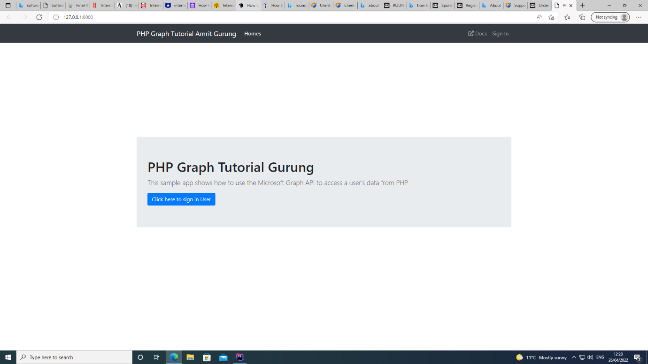

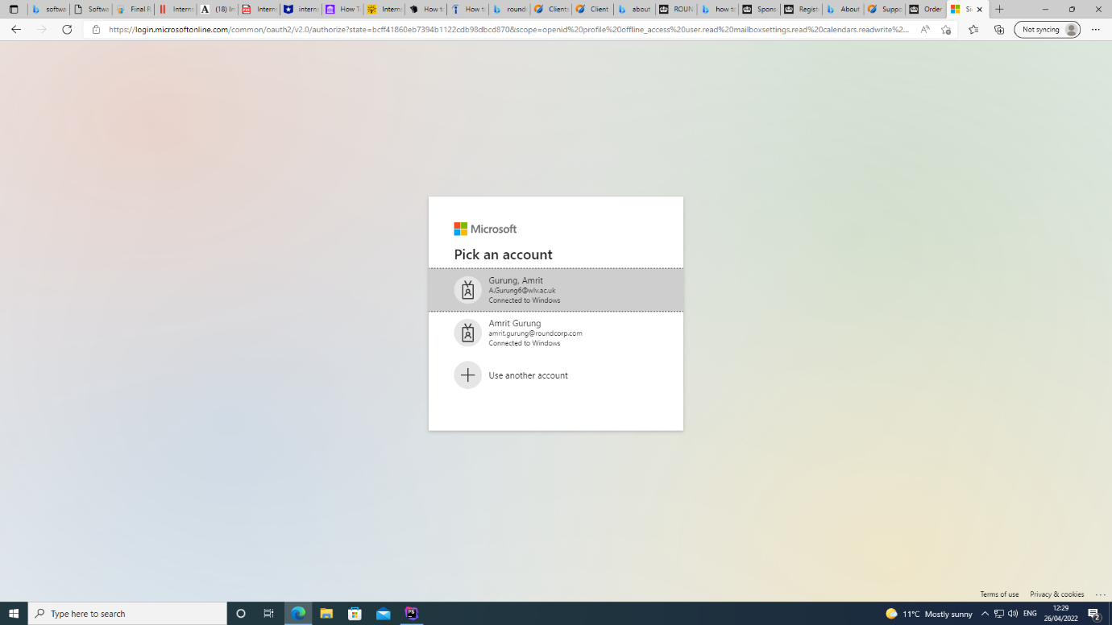

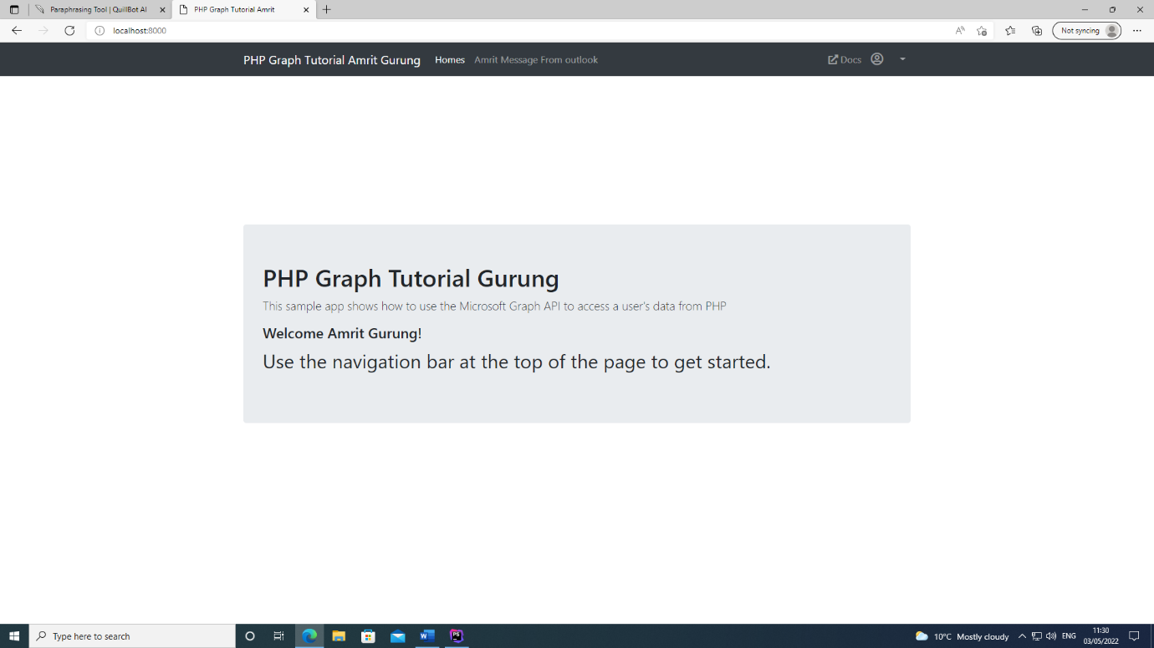

**Duration/ Weeks: -** 2ndweek (16th May 2018 to 14th Nov 2019)

**Work/ Activity: -**

When I click the ‘Amrit Message from outlook’ button. Then all email from outlook is display in single page where my 1st project was completed. And I do the following things:

* Programming
* Coding in PHP (Laravel) API development
* Preliminary work
* Analysis
* supervisor approval

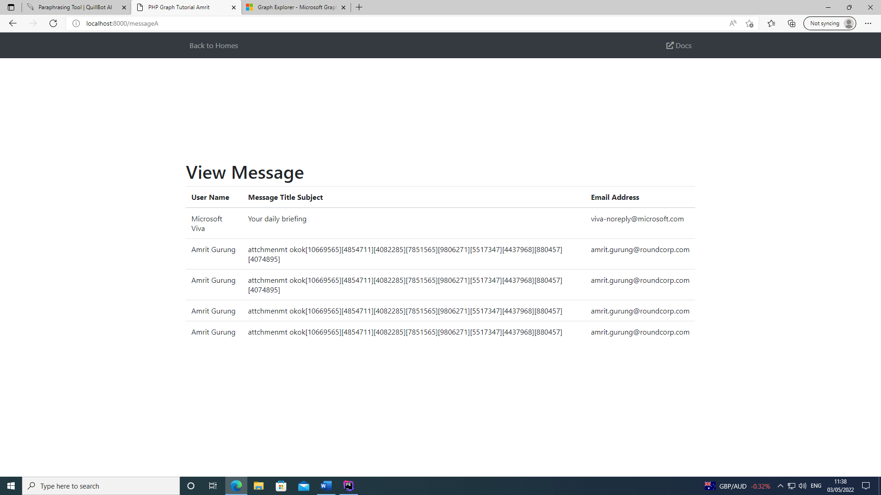

**Duration/ Weeks: -** 3rdweek (16th May 2018 to 14th Nov 2019)

**Work/ Activity: -**

As my 2nd project was assign which is Give outlook email a unique number, include the number in the subject, and respond to the sender. As when I click ‘send’ button then it reply same email with unique number called support ticket number where that support ticket number is assigned to outlook email subject like: - Message Subject: Computer keyboard is not working [5677]. Also, in the outlook email body it said “Message Body: We have received your email. You support ticket number is 5677. We will get in touch with you soon.” I completed this task in same week. And I do the following things:

* Programming
* Analysis
* Examine current internet platforms.

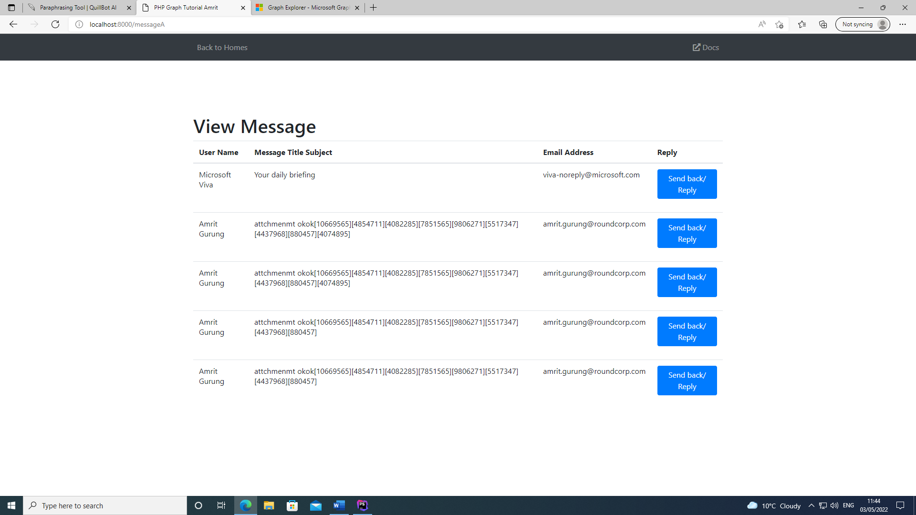

**Duration/ Weeks: -** 4thweek (16th May 2018 to 14th Nov 2019)

**Work/ Activity: -**

As my 3rd project was to fetch outlook individually. Also, each outlook email can be display with Username, email, subject and body by clicking ‘view’ button. Also, I completed the given task in same week. And I do the following things:

* Programming
* Analysis
* Examine current internet platforms.
* Coding in PHP (Laravel) API development

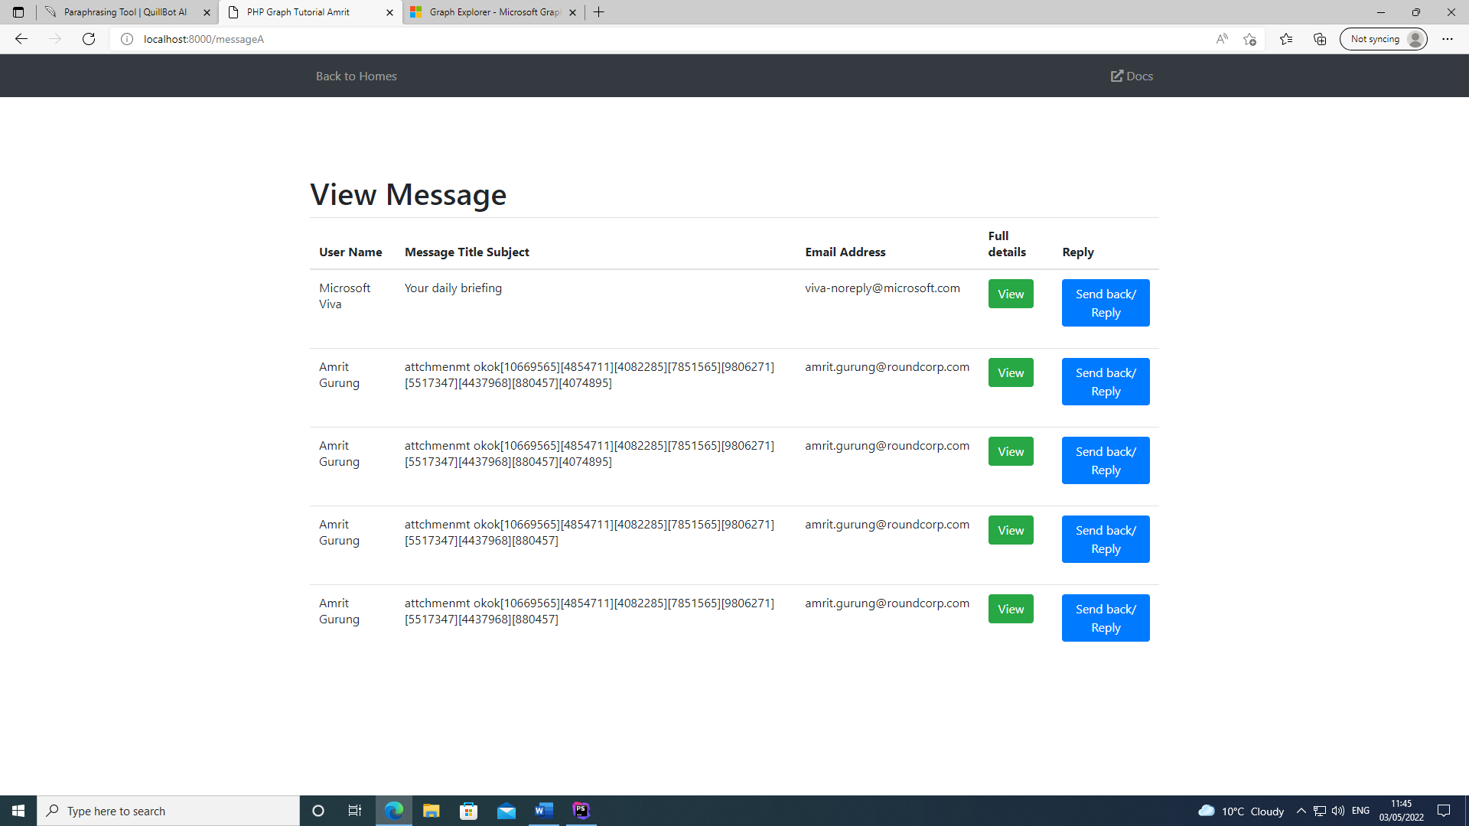

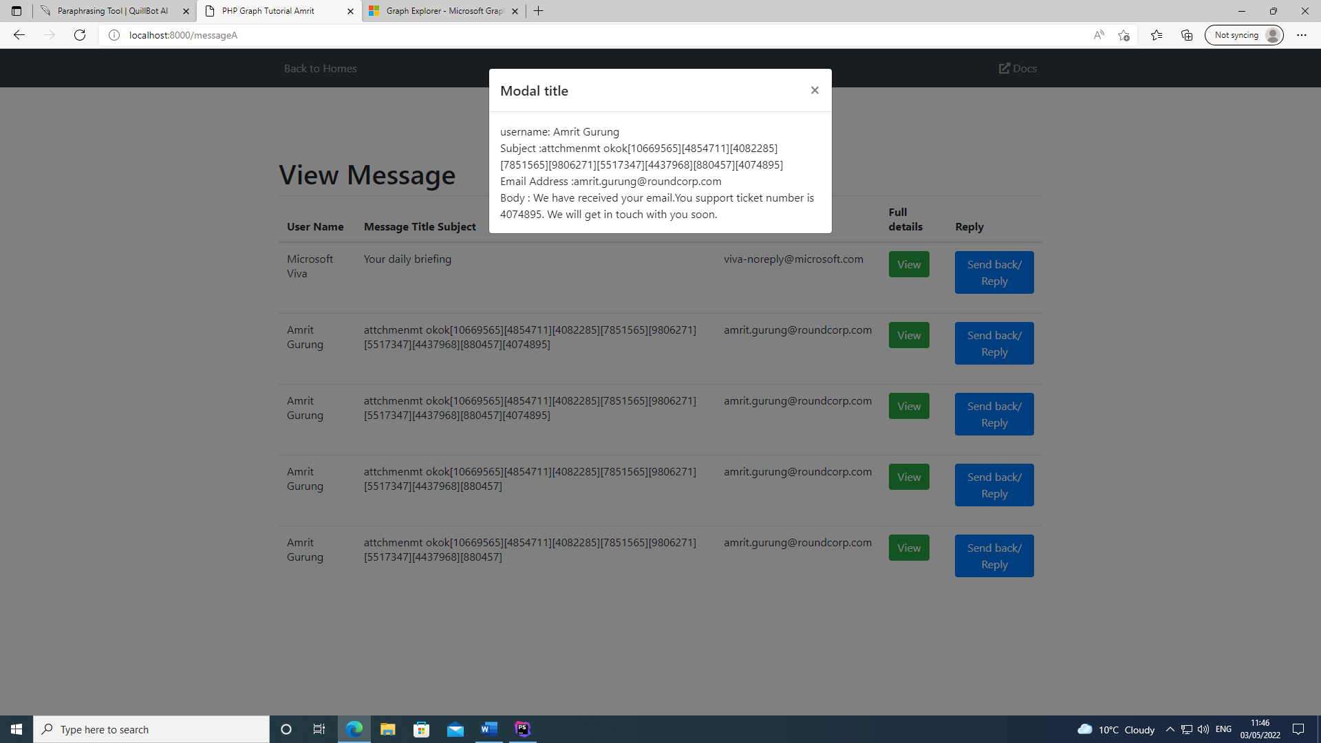

**Duration/ Weeks: -** 5thweek (16th May 2018 to 14th Nov 2019)

**Work/ Activity: -**

As my 4th project was to attach file like image and text to the email and reply back to the sender with attachments assigning unique number to mail. As attachment function is created but cannot send attachment files. And I do the following things:

* Programming
* Analysis
* Examine current internet platforms.
* Coding in PHP (Laravel) API development

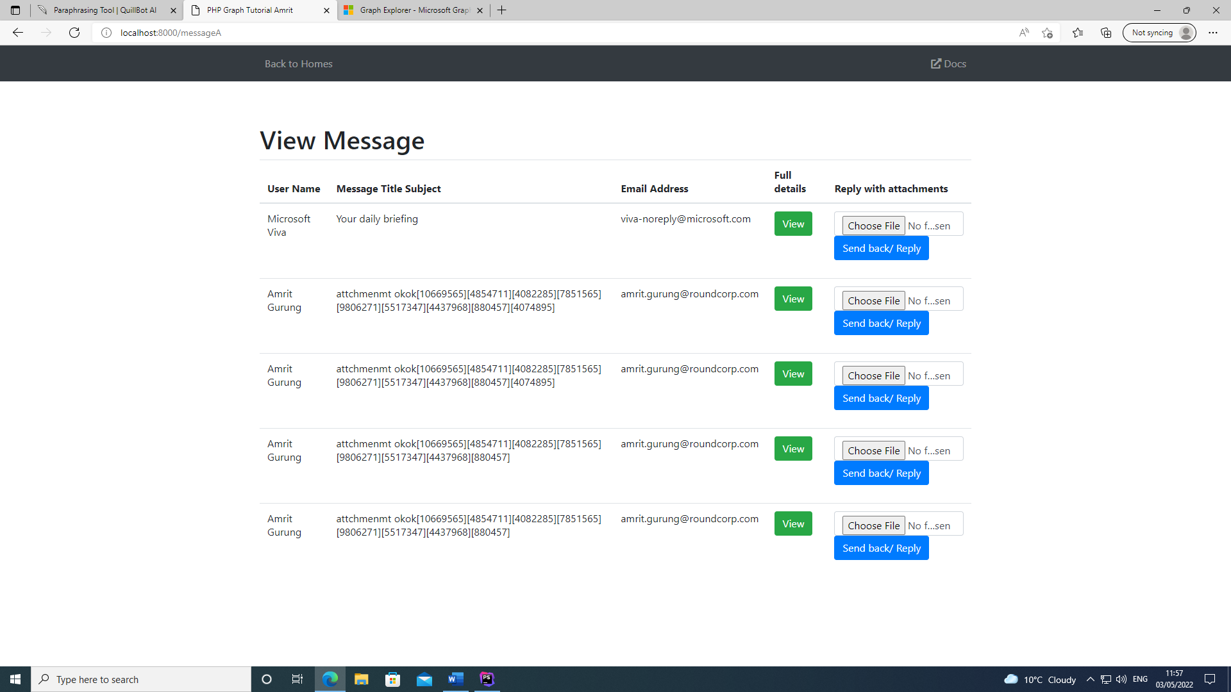

**Duration/ Weeks: -** 6thweek (16th May 2018 to 14th Nov 2019)

**Work/ Activity: -**

As my 4th project was completed. When file is selected after clicking ‘Choose File’ we can send email with attachment file assigning unique number. And I do the following things:

* Programming
* Analysis
* Examine current internet platforms.
* Coding in PHP (Laravel) API development

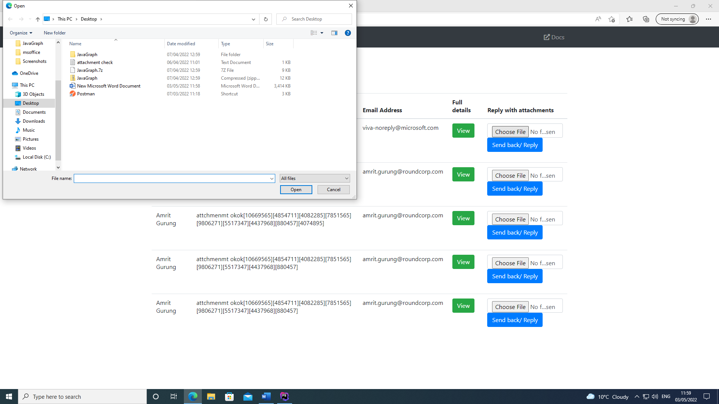

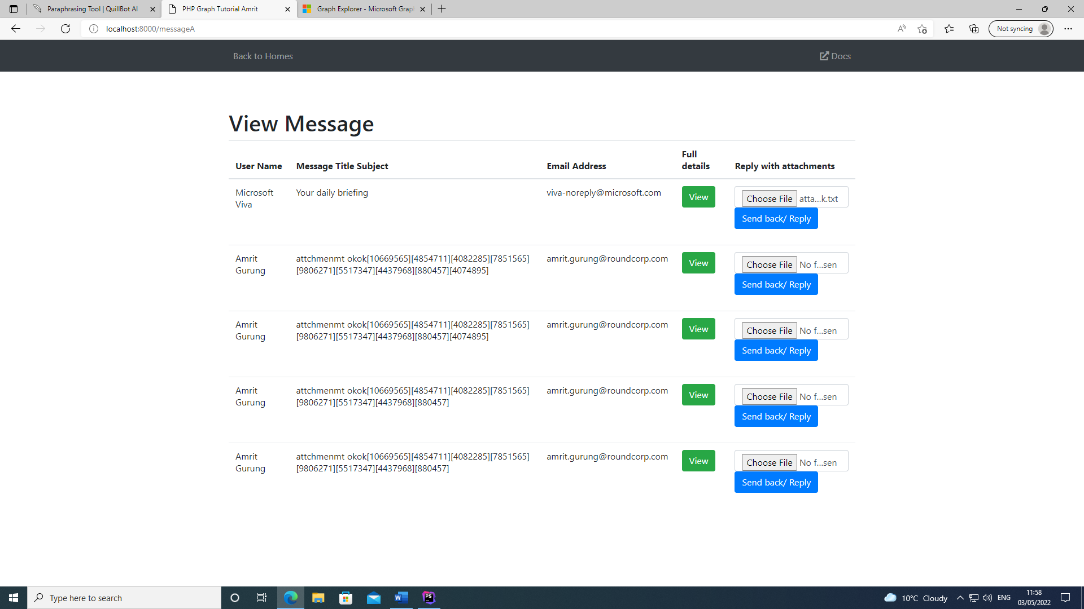

**Duration/ Weeks: -** 7rdweek (16th May 2018 to 14th Nov 2019)

**Work/ Activity: -**

As my 5th project was Create a PHP application that reads calender events from the Microsoft office 365 API using graph explorer with PhpStorm. And I do the following things:

* Programming
* Analysis
* Examine current internet platforms.
* Coding in PHP (Laravel) API development

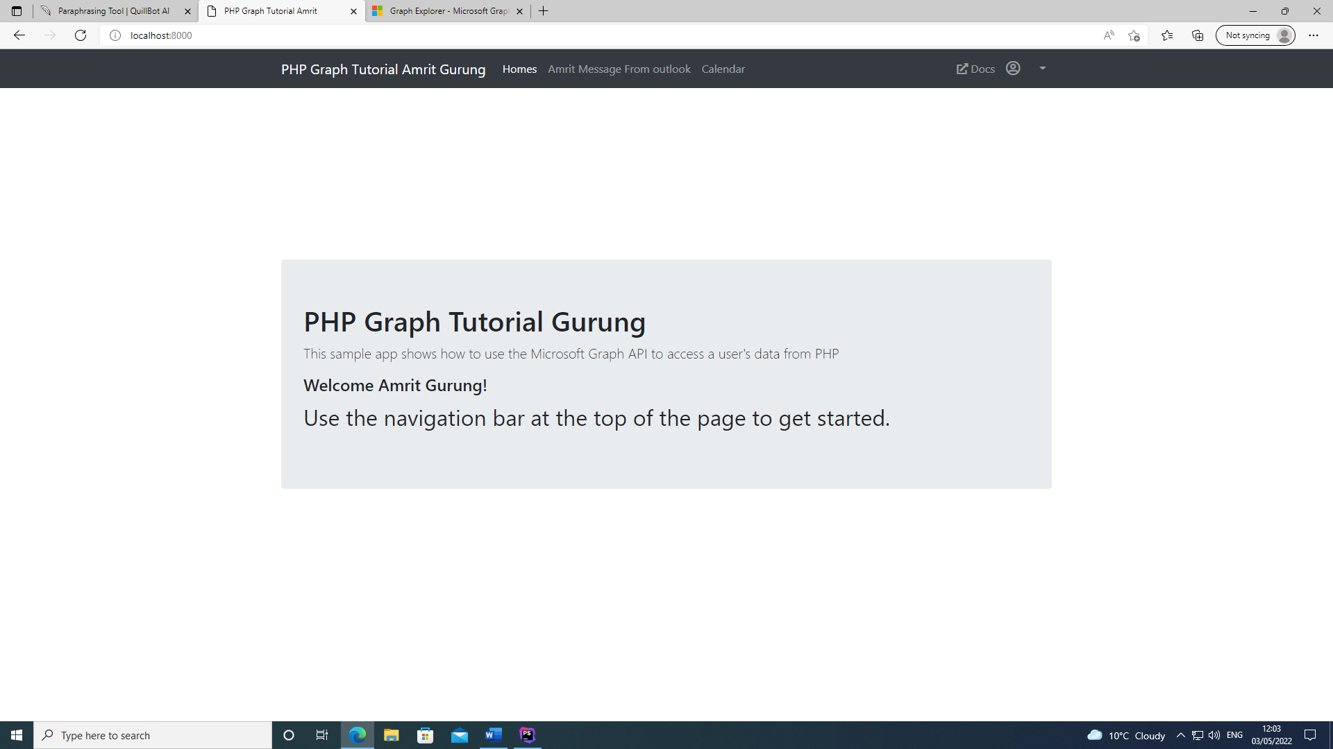

**Duration/ Weeks: -** 8rdweek (16th May 2018 to 14th Nov 2019)

**Work/ Activity: -**

As my 5th project was completed. And I do the following things:

* Programming
* Analysis
* Examine current internet platforms.
* Coding in PHP (Laravel) API development

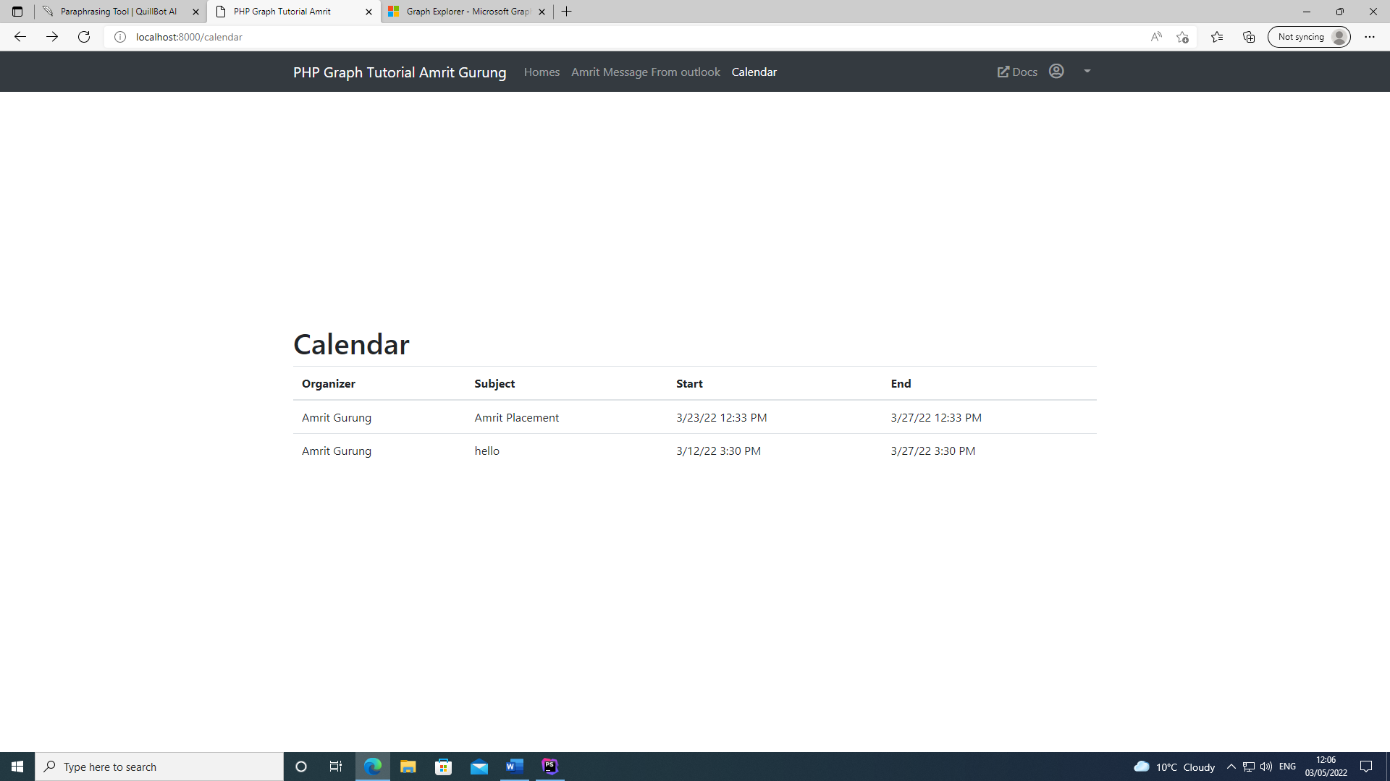

**Duration/ Weeks: -** 9rdweek (16th May 2018 to 14th Nov 2019)

**Work/ Activity: -**

As my 6th project was to display individual calendar event after clicking ‘view’ button. Also, the task was finished on same week. And I do the following things:

* Programming
* Analysis
* Examine current internet platforms.
* Coding in PHP (Laravel) API development

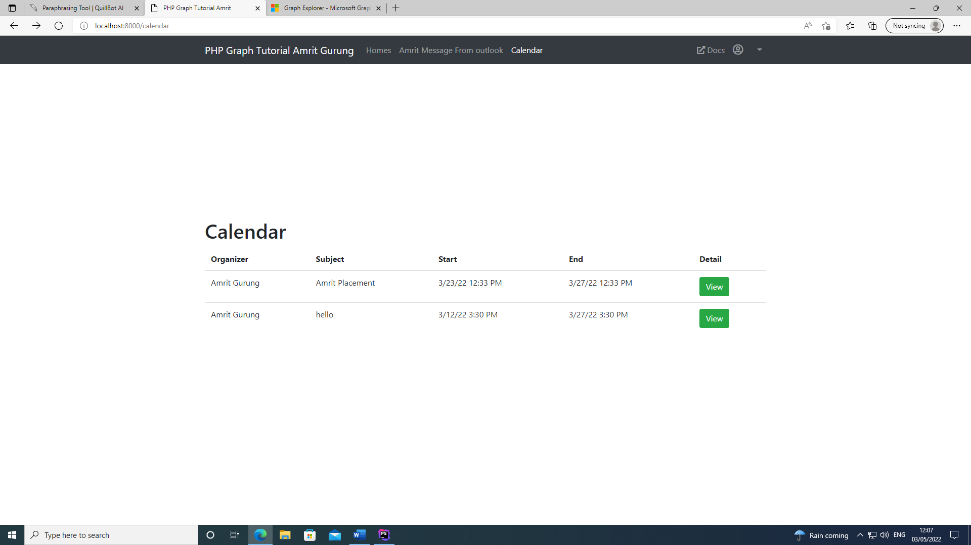

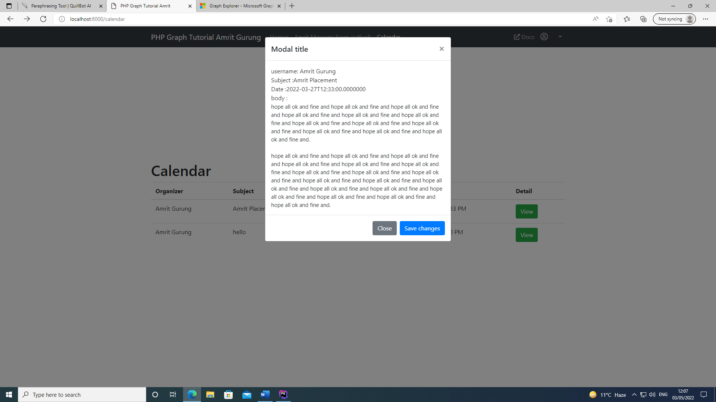

**Duration/ Weeks: -** 10rdweek (16th May 2018 to 14th Nov 2019)

**Work/ Activity: -**

As my 7th project was to create or add calendar event to outlook emails. And I do the following things:

* Programming
* Analysis
* Examine current internet platforms.
* Coding in PHP (Laravel) API development
* Implementation and competition of first phase
* Final report writing

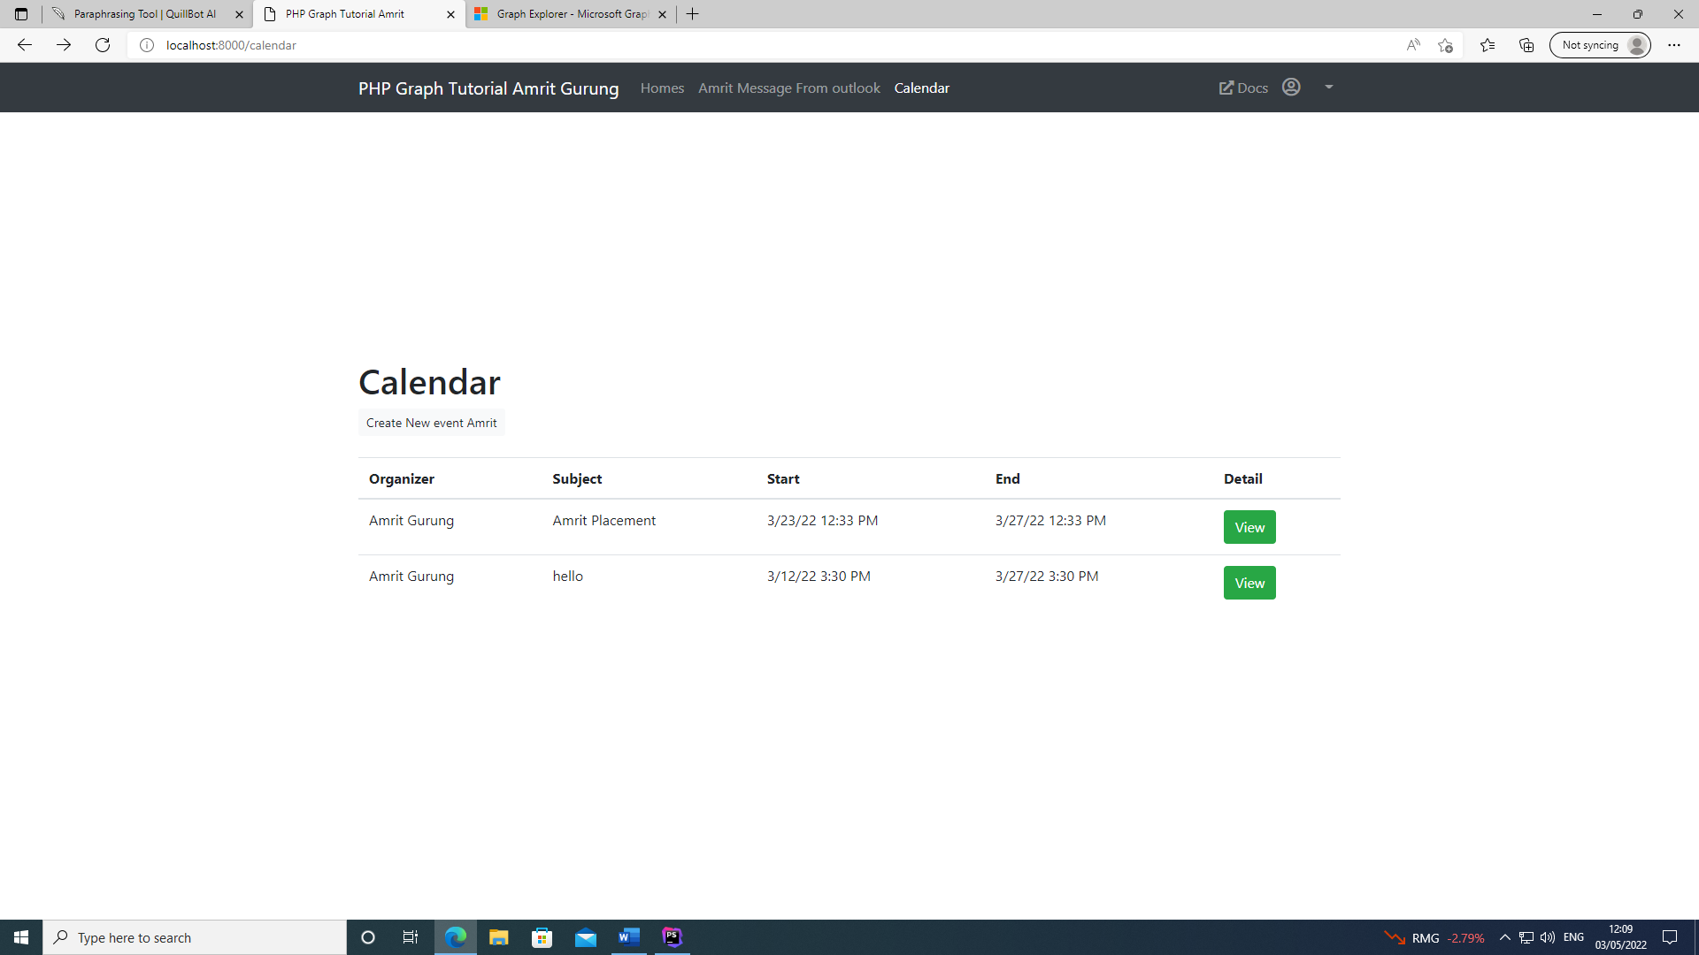

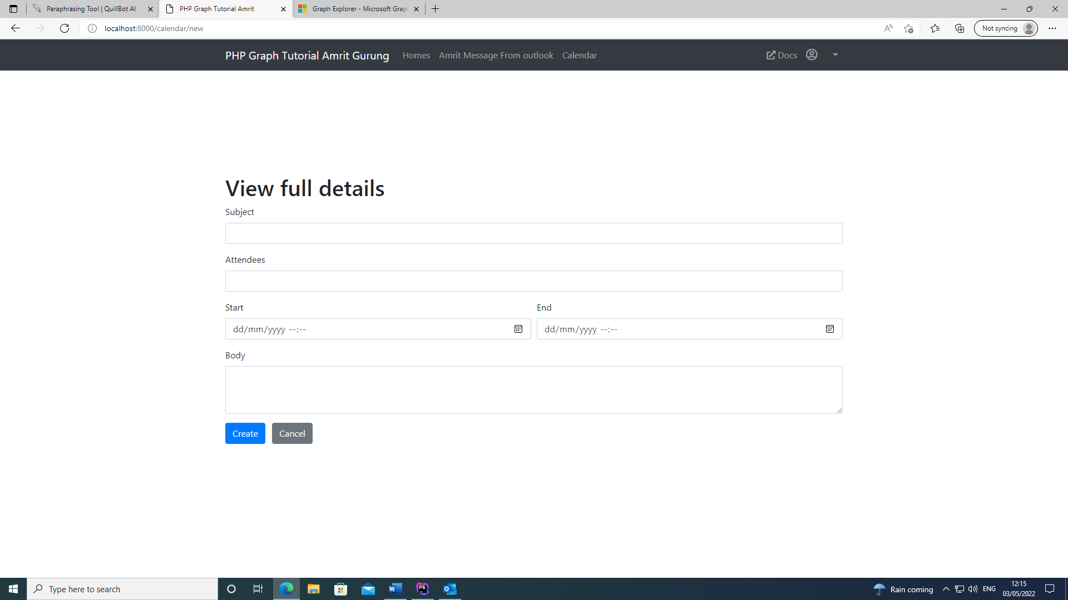

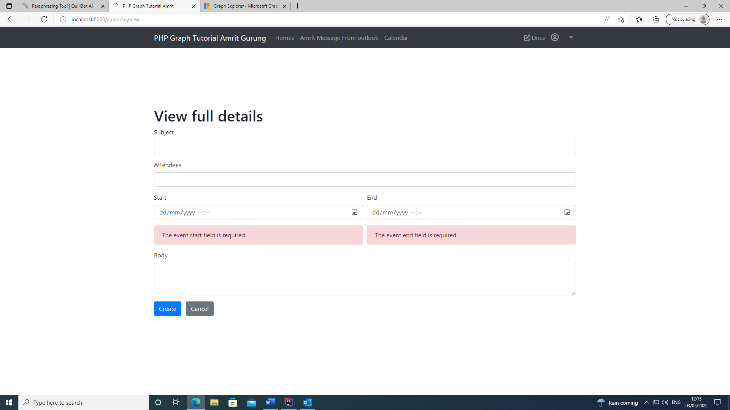

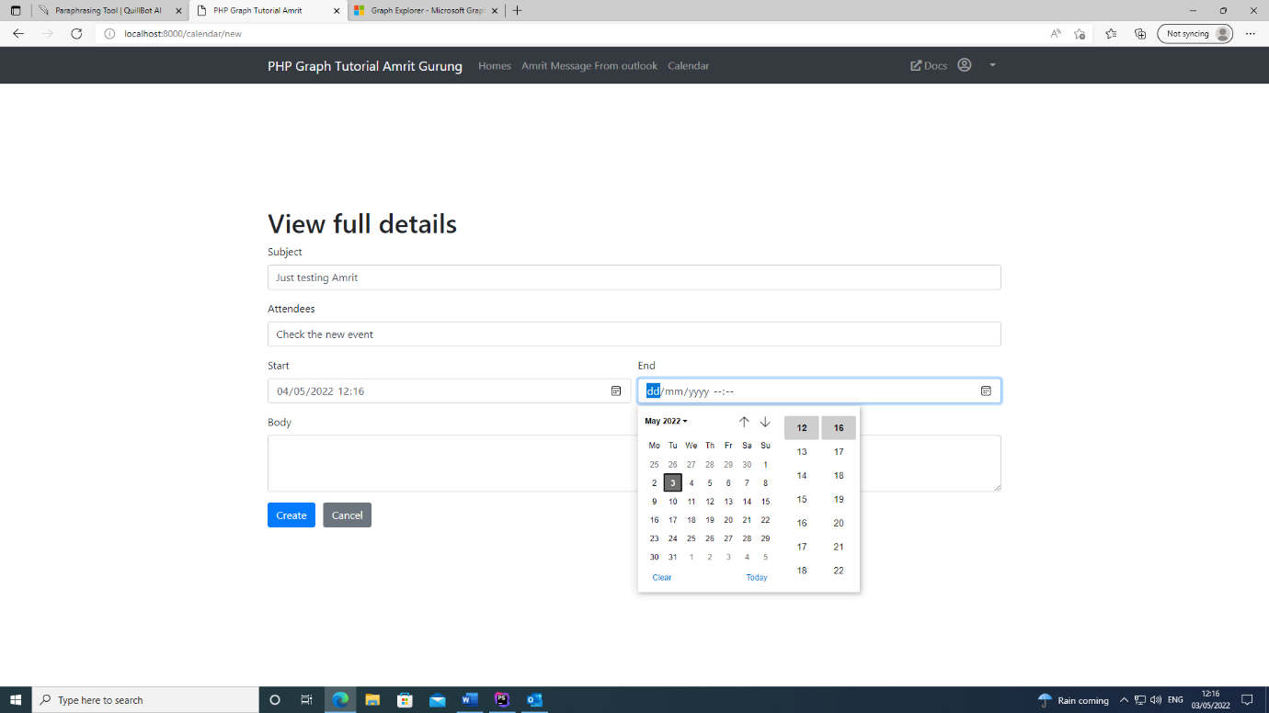

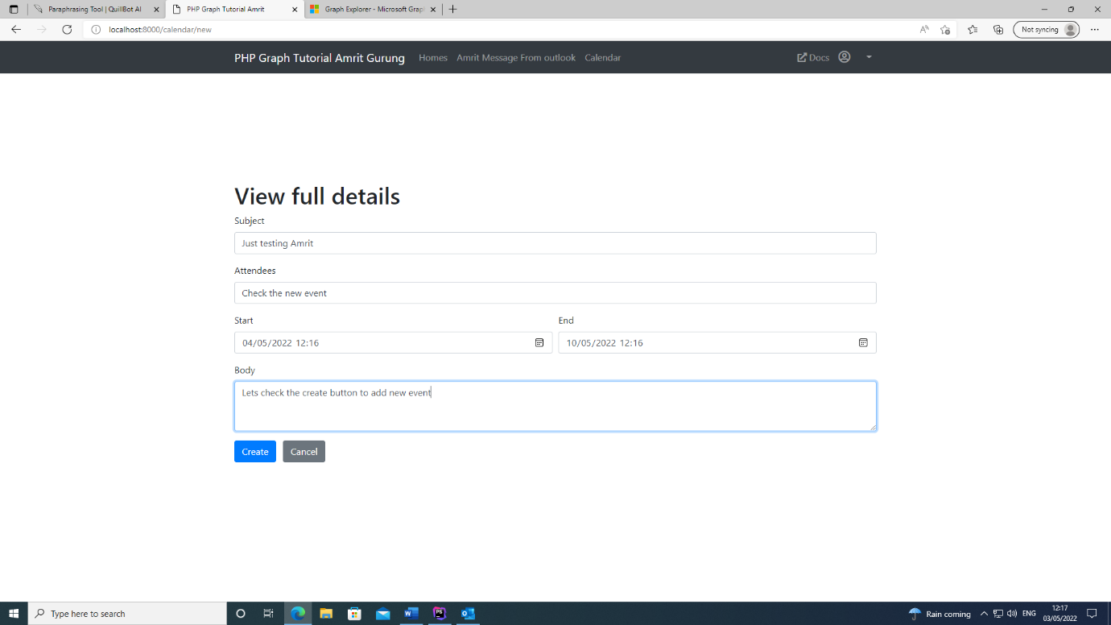

**Duration/ Weeks: -** 11rdweek (16th May 2018 to 14th Nov 2019)

**Work/ Activity: -**

As my 8th project was to download the attach file from outlook mail. And I do the following things:

* Programming
* Analysis
* Examine current internet platforms.
* Coding in PHP (Laravel) API development
* Implementation and competition of first phase
* Final report writing

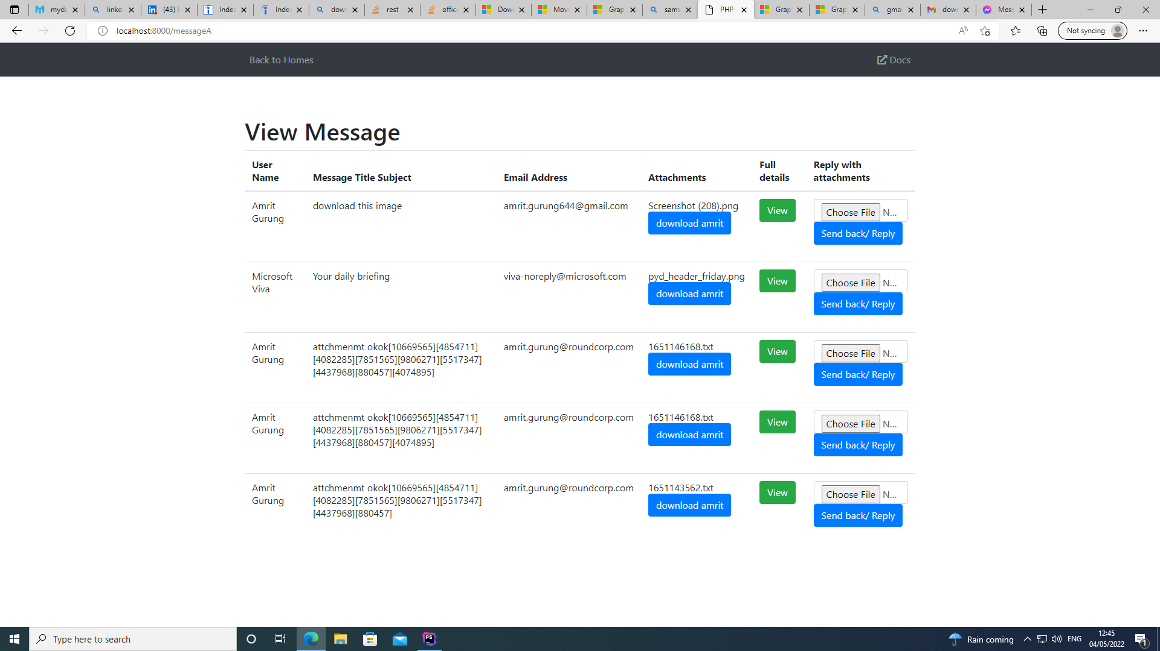

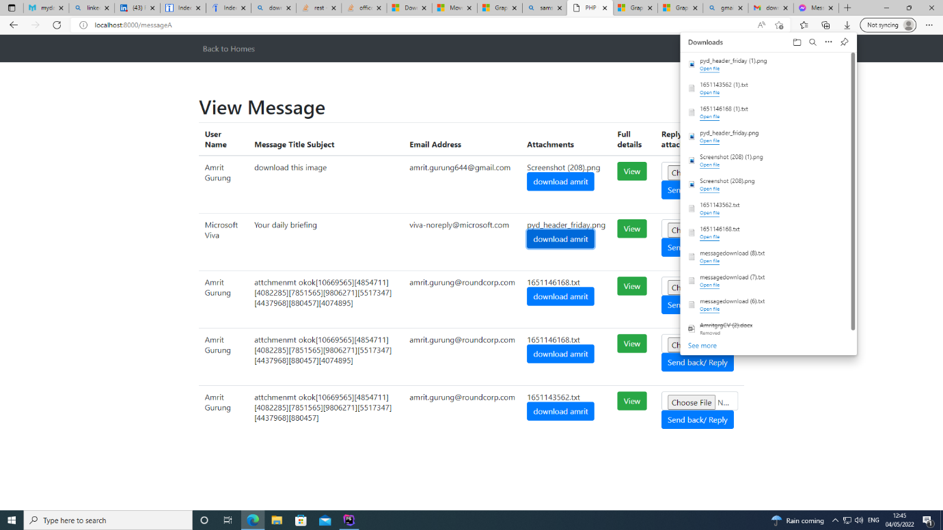

**Duration/ Weeks: -** 12thweek (16th May 2018 to 14th Nov 2019)

**Work/ Activity: -**

As my project was complete and final design of my project snapshot are given below. And I do the following things:

* Analysis
* Implementation and competition of first phase
* Final report writing

7.Sample source code/logs/screen shots (if any): -

Hardware support:

Device name: DESKTOP-334H0KU

Full device name: DESKTOP-334H0KU.rsoftware.local

Processor: Intel(R) Core(TM) i5-8400 CPU @ 2.80GHz 2.81 GHz

Installed RAM: 8.00 GB

Device ID: 988A67FE-DB2E-4DCB-8970-2F3BFB75C3F9

Product ID: 00330-80953-19825-AA919

System type: 64-bit operating system, x64-based processor

Pen and touch: No pen or touch input is available for this display

Software support:

Edition: Windows 10 Pro

Version : 21H1

Installed on: ‎30/‎11/‎2020

OS build: 19043.1645

Experience: Windows Feature Experience Pack 120.2212.4170.0

User Interface Design:

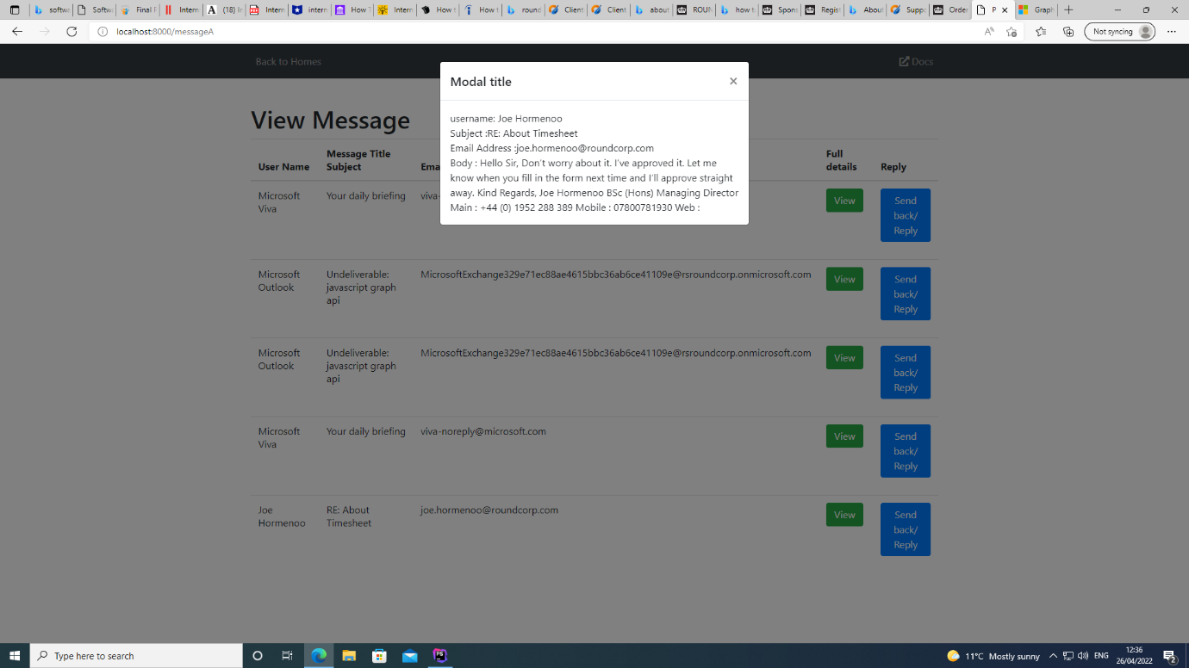

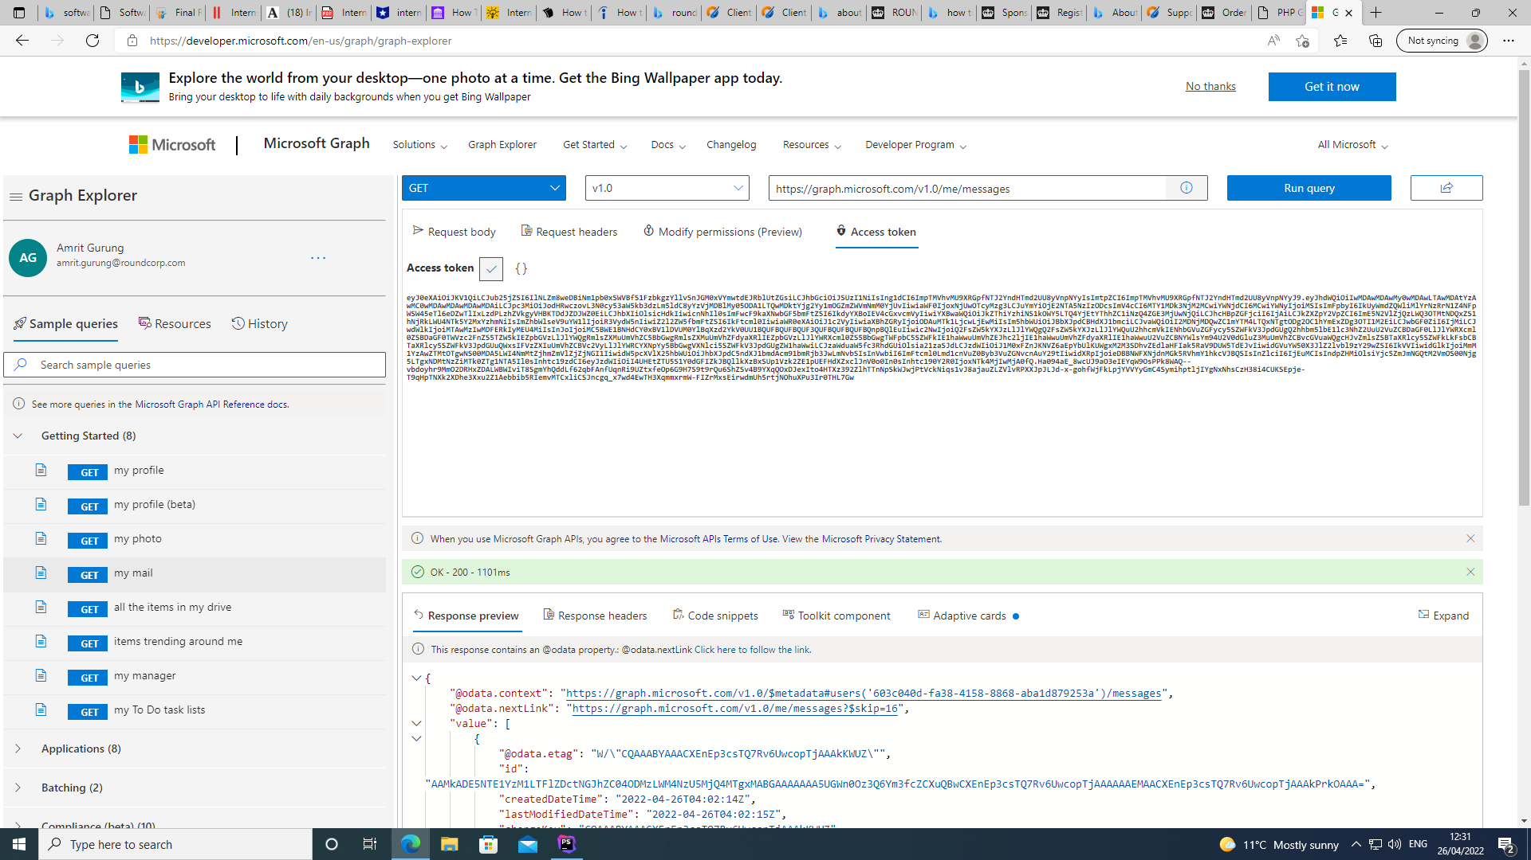

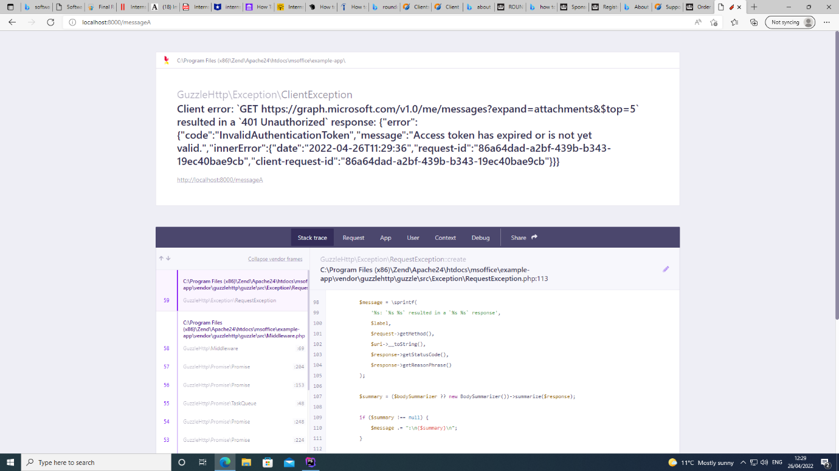

8.Conclusion: -

Working with Round Soft was a great experience for me overall. It will be extremely beneficial to me in the future, because developing high-quality software is nearly impossible without it. Working for an IT firm like Round Corp was one of my aspirations throughout my postgraduate years. I'm ecstatic that I was able to complete my postgraduate career by working for an IT firm. As I took on increasingly challenging responsibilities, I saw that my ability to do tough jobs improved. Every task had a difficulty associated with it that I was able to identify.

Overall, I learnt a lot this week and was able to concentrate on areas in which I had previously lacked confidence and skill. I've had a great time on placement, and I've gained a lot of knowledge. It was tremendously valuable to me, and I will apply the skills and information I obtained in all of my future activities. In compared to my previous placement, I had a lot more work to do during my internship. I was exposed to working in a stressful environment due to the number of assignments I handled throughout this period. Employees' talents and expertise must be committed in such an environment in order for the organization's goals to be realised.