**ImageMap**

The <asp:ImageMap> control is used to create an image that contains clickable hotspot regions. When a user clicks a hot spot, the control can either call a subprogram or link to a specified URL. It works like a combination of <asp:Image> and <asp:ImageButton> controls.

**Creating an Image Map**

An image map can be created from any graphic image by defining rectangular, circular, or polygonal shapes overlying portions of the image. These shapes become the clickable hot spots to issue URL navigations or subprogram calls. The information needed to define these shapes are

• Rectangle - the pixel coordinates of the top-left and bottom-right corners

• Circle - the pixel coordinates of the center and its radius

• Polygon - the pixel coordinates of each corner point

**Property ---- HotSpotMode**

**Navigate , PostBack**

**Demo**

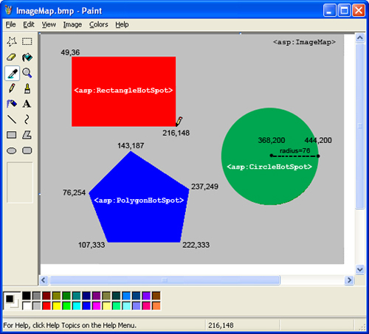

**Example**

* **Navigate Method**

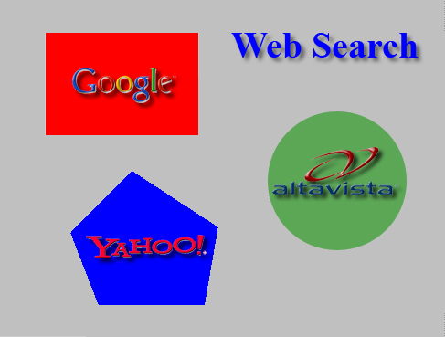

**Coding**

<asp:ImageMap Runat="Server"

ImageUrl=""~/images/ImageMap.jpg"

AlternateText="Web search image map"

**HotSpotMode="Navigate"**>

<asp:RectangleHotSpot

AlternateText="Go to Google"

Left="49"

Top="36"

Right="216"

Bottom="148"

**NavigateUrl="http://www.google.com"**

Target="_blank"/>

<asp:CircleHotSpot

AlternateText="Go to AltaVista"

X="368"

Y="200"

Radius="76"

**NavigateUrl="http://www.altavista.com"**

Target="_blank"/>

<asp:PolygonHotSpot

AlternateText="Go to Yahoo"

Coordinates="143,187, 237,249, 222,333, 107,333, 76,254"

**NavigateUrl="http://www.yahoo.com"**

Target="_blank"/>

</asp:ImageMap>

* PostBack

<asp:ImageMap Runat="Server"

ImageUrl=""~/images/ImageMap.jpg"

AlternateText="Web search image map"

HotSpotMode="PostBack">

<asp:PolygonHotSpot

AlternateText="Go to Yahoo"

Coordinates="143,187, 237,249, 222,333, 107,333, 76,254"

PostBackValue="yahoo"

/>

</asp:ImageMap>

**coding**

protected void ImageMap1_Click(object sender, ImageMapEventArgs e)

{

if (e.PostBackValue == "yahoo")

{

Response.Redirect("CourseDetails.aspx");

}

}