**RAJALAKSHMI ENGINEERING COLLEGE**

**RAJALAKSHMI NAGAR, THANDALAM – 602 105**



|  |
| --- |
| **CS19541**  **COMPUTER NETWORKS LABORATORY** |
| **Laboratory Manual Note Book** |

|  |
| --- |
| **Name : Amritha.A**  **Year/Branch/Section : 3rd year - Computer Science and Design**  **Register No. : 221701007**  **Semester : 5**  **Academic Year : 2024-2025** |

**EXP NO : 10 INTERNETWORK USING WIRELESS ROUTER**

**DATE : 07/10/24**

**AIM:**

To design and configure an internetwork using wireless router in CISCO Packet Tracer.

**SOFTWARE USED:**

CISCO PACKET TRACER

**PROCEDURE:**

Step 1: Configuring Wireless Router1

1. Access the CLI or web interface for Router1.
2. Type enable to enter privileged mode.
3. Type config t to enter global configuration mode.
4. Configure the wireless interface with IP 192.168.10.1 255.255.255.0 and type no shutdown.
5. Configure Ethernet interface with IP 192.168.20.1 255.255.255.0 and type no shutdown.

Step 2: Configuring PCs

1. Assign IP address 192.168.10.2, subnet mask 255.255.255.0, and gateway 192.168.10.1 to PC0.
2. Assign IP address 192.168.20.2, subnet mask 255.255.255.0, and gateway 192.168.20.1 to PC1.

Step 3: Connecting PCs to Wireless Router1

1. Connect PC0 to Router1's wireless network using the SSID and password.
2. Connect PC1 to Router1's wireless network using the SSID and password.

**DESIGNED INTERNETWORK TOPOLOGY:**

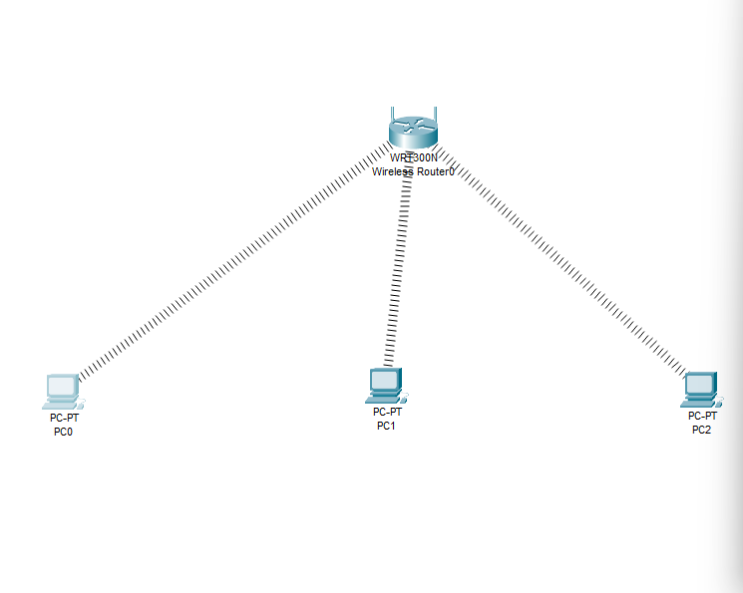

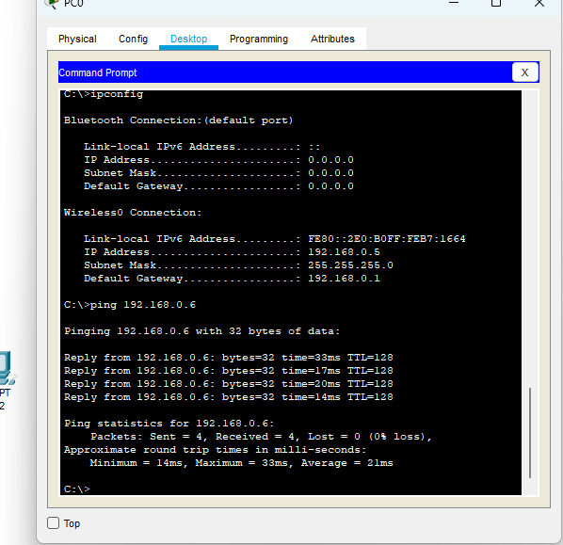

**RESULT:**

Thus, the simple internetwork using wireless routers has been designed and configured in CISCO Packet Tracer successfully.