**RAJALAKSHMI ENGINEERING COLLEGE**

**RAJALAKSHMI NAGAR, THANDALAM – 602 105**



|  |
| --- |
| **CS19541**  **COMPUTER NETWORKS LABORATORY** |
| **Laboratory Manual Note Book** |

|  |
| --- |
| **Name : Amritha.A**  **Year/Branch/Section : 3rd year - Computer Science and Design**  **Register No. : 221701007**  **Semester : 5**  **Academic Year : 2024-2025** |

**EXP NO : 3 WIRESHARK**

**DATE : 05/08/24**

**AIM:**

To capture and analyse packets using Wireshark tool.

**SOFTWARE USED:**

WIRESHARK

**PROCEDURE:**

1. Select Local Area Connection in Wireshark.
2. Go to capture 🡪 option.
3. Select stop capture automatically after 100 packets.
4. Then click Start capture.
5. Save the packets.

**FLOWGRAPH OF ARP:**

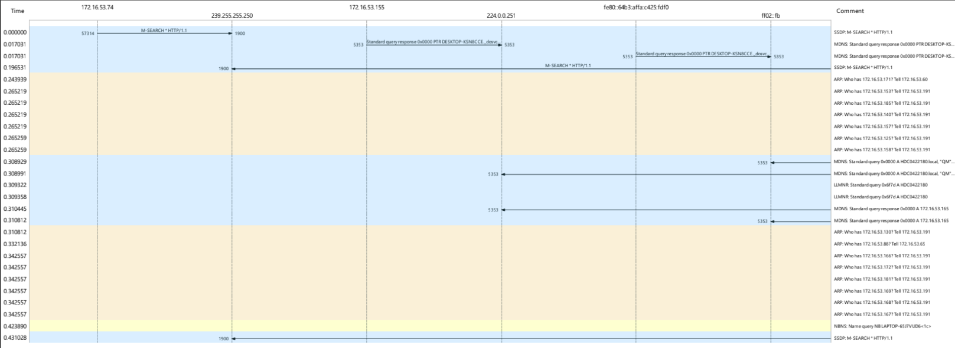

**Packet Details:**

Frame 5: 60 bytes on wire(480 bits), 60 bytes captured (480 bits) on interface \Device\NPF_{2730CCA5-4D6B-44BE-A182-AD11B9F84536}, id 0;

Ethernet II, Src : EliteGroupCo_15:ee:fc(88:ae:dd:15:ee:fc), Dst : Broadcast(ff:ff:ff:ff:ff:ff)

Address Resolution Protocol(request)

**FLOWGRAPH OF TCP:**

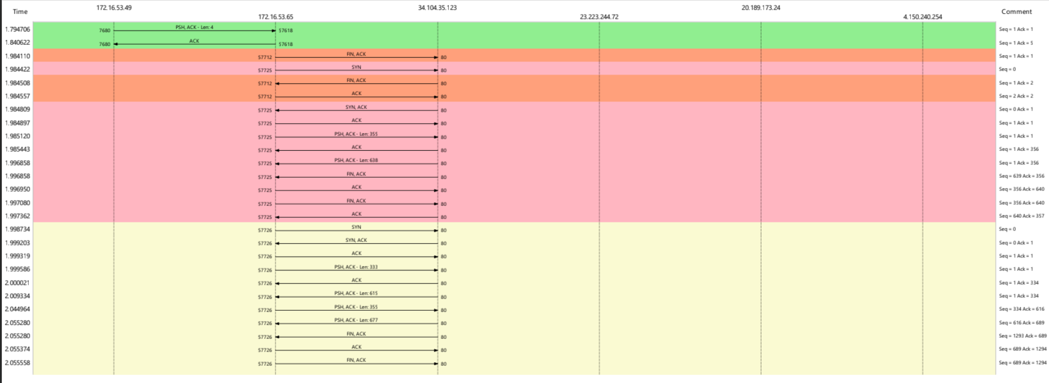

**Packet Details:**

Frame 117: 54 bytes on wire(432 bits), 54 bytes captured (432 bits) on interface \Device\NPF_{2730CCA5-4D6B-44BE-A182-AD11B9F84536}, id 0;

Ethernet II, Src : EliteGroupCo_15:ee:bb(88:ae:dd:15:ee:bb), Dst : Sophos_cf:be:3e(7c:5a:1c:cf:be:3e)

Internet Protocol Version 4, Src : 172.16.53.65, Dst : 34.104.35.128

Transmission Control Protocol, Src Port : 57712, Dst Port : 80, Seq : 1, Ack : 1, Len : 0

**FLOWGRAPH OF UDP:**

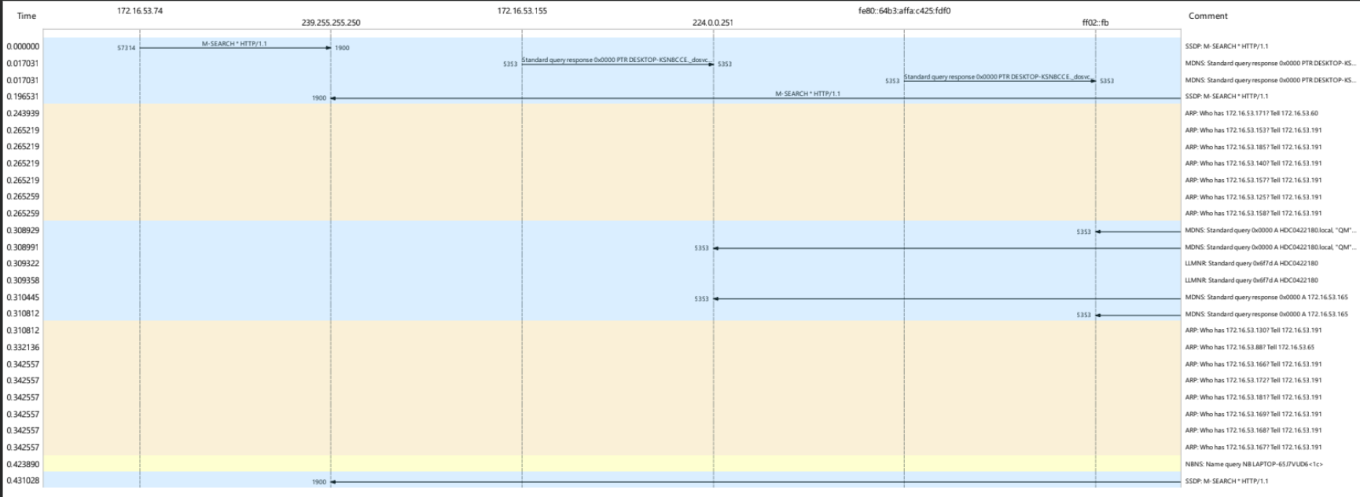

**Packet Details:**

Frame 268: 1292 bytes on wire(10336 bits), 1292 bytes captured (10336 bits) on interface \Device\NPF_{2730CCA5-4D6B-44BE-A182-AD11B9F84536}, id 0;

Ethernet II, Src : EliteGroupCo_15:ee:bb(88:ae:dd:15:ee:bb), Dst : Sophos_cf:be:3e(7c:5a:1c:cf:be:3e)

Internet Protocol Version 4, Src : 172.16.53.65, Dst : 142.250.182.74

User Datagram Protocol, Src Port : 50454, Dst Port : 443

QUIC IETF

**RESULT**:

Thus, the packets has been captured and analysed using Wireshark successfully.