**RAJALAKSHMI ENGINEERING COLLEGE**

**RAJALAKSHMI NAGAR, THANDALAM – 602 105**



|  |
| --- |
| **CS19541**  **COMPUTER NETWORKS LABORATORY** |
| **Laboratory Manual Note Book** |

|  |
| --- |
| **Name : Amritha.A**  **Year/Branch/Section : 3rd year - Computer Science and Design**  **Register No. : 221701007**  **Semester : 5**  **Academic Year : 2024-2025** |

**EXP NO : 6 VIRTUAL LAN**

**DATE : 21/08/24**

**AIM:**

To simulate Virtual LAN configuration using CISCO Packet Tracer Simulation.

**Software Used:**

CISCO PACKET TRACER

**PROCEDURE:**

1. Attach the devices as shown in the topology diagram, and cable as necessary.
2. Click and  drag both switch **S1** and **S2** to the **Rack**.
3. Click and drag both **PC-A** and **PC-B** to the **Table** and use the power

button to turn them  on.

1. Provide network connectivity by connecting **Copper Straight-through** cables, as shown in  the topology.
2. Connect **Console Cable** from device **PC-A** to **S1** and from device **PC-B** to **S2**.
3. Configure basic settings for each switch.
4. Configure PC hosts.
5. Test connectivity.

**Virtual LAN Configuration:**

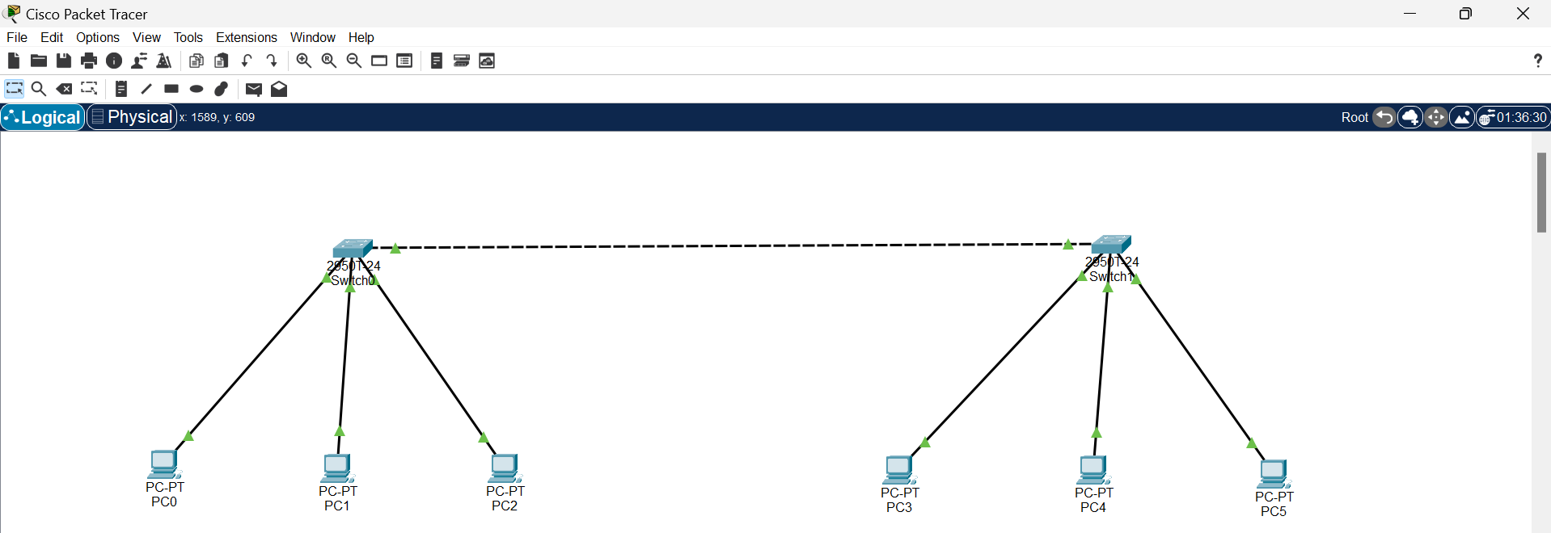

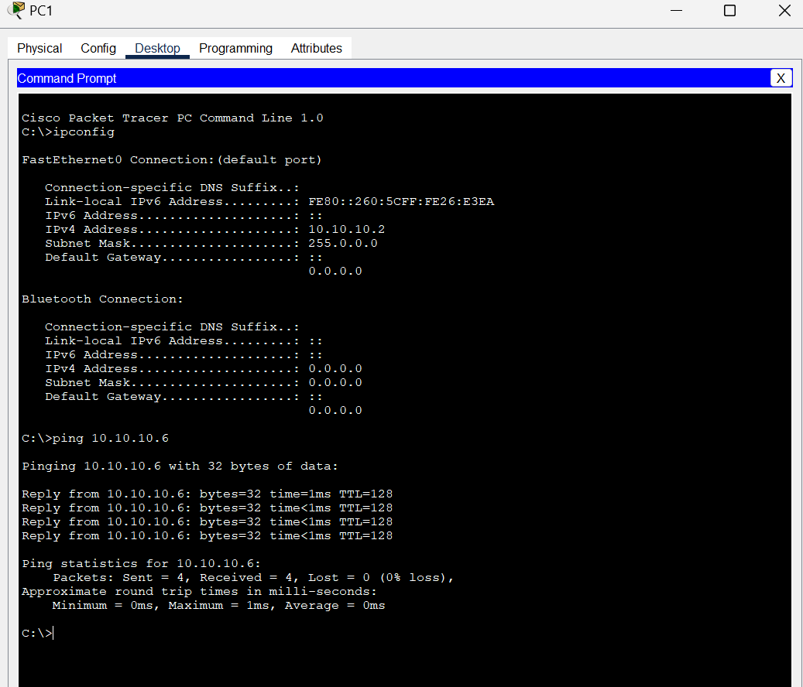

**RESULT:**

Thus, the Virtual LAN configuration using CISCO Packet Tracer has been simulated.