

SANDISK HACKATHON
CacheSelect
Adaptive Compression Policy Engine for NVMe Controller Firmware
Team Name: CacheSelect
Campus: VIT Chennai
Team Members: Amritha S 23BEC1368 , Yugeshwaran P 23BEC1404
Track Name: Track 2 - Firmware Problem: Firmware Algorithms for SSD/NAND Efficiency & Reliability
Theme Name: Intelligent Compression Policy Engine

Problem Statement
Modern portable NVMe SSD controllers implement static compression policies in firmware that apply uniform compression strategies regardless of data characteristics. This approach creates measurable inefficiencies in controller CPU utilization, power consumption, and throughput under heterogeneous workloads.
The Firmware-Level Challenge:
Portable SSD controllers (ARM Cortex-R5 class, 400MHz, 256MB DDR3L) process mixed data streams: source code archives, office documents, JPEG images, MP4 videos, and encrypted backups. Industry analysis shows 50-60% of typical workloads consist of pre-compressed content (media files, archives) that yields minimal compression benefit but consumes significant CPU cycles.
When firmware applies static compression (LZ4, Zstd) to all incoming 4KB blocks, the controller wastes processing power attempting to compress incompressible data. At 100MB/s sustained write rates (25,000 blocks/second), this translates to unnecessary CPU overhead, increased thermal load, and reduced effective throughput.
Existing Firmware Constraints:
- Limited CPU budget: Controller must handle FTL, wear leveling, GC, ECC scheduling concurrently
- Memory constraints: <512KB available for compression logic (FTL mapping tables consume majority)
- Latency sensitivity: Per-block processing must complete within microseconds to avoid pipeline stalls
- Power budget: Mobile/portable devices require thermal and battery efficiency
- Atomicity requirements: Must integrate with existing FTL power-fail recovery mechanisms
Core Firmware Problem: How can we design a firmware-resident compression policy engine that selectively applies compression only when beneficial, operates within embedded controller resource constraints, and integrates safely with existing FTL/ECC firmware modules without requiring storage stack redesign?

Track Name
Track 2 - Firmware Problem: Firmware Algorithms for SSD/NAND Efficiency & Reliability

Theme Name
Intelligent Compression Policy Engine for Controller Firmware

Proposed Firmware Solution
We propose a firmware module for NVMe controller CPUs that implements adaptive compression policy selection through lightweight information-theoretic analysis and workload locality exploitation. The module integrates into the existing firmware write path between the host interface and FTL, operating within strict embedded resource constraints.
Firmware Integration Points:
- Location: Post-NVMe command parser, pre-FTL submission
- Memory footprint: 288KB total (256KB pattern cache + 32KB working buffers)
- Code size: 60KB in firmware .text section
- CPU overhead: <10% average at 100MB/s sustained writes
- Latency: <50μs per 4KB block (average)
Core Firmware Algorithm:
- Signature Computation: MurmurHash3 (64-bit) of incoming 4KB block (~1μs)
- Pattern Cache Lookup: Hash table query in controller SRAM (~2μs)
- Cache Hit (80% warm): Reuse cached codec decision, skip analysis
- Cache Miss (20% warm): Fast entropy + run-length analysis (~15μs)
- Codec Selection: Threshold-based: if entropy > 7.5 → raw, if RLD > 0.4 → LZ4, else → LZ4HC
- Compression Execution: LZ4 (~100μs) or LZ4HC (~200μs) as selected
- Benefit Validation: Use compressed only if (comp_size + 10B header) < (4096 - 64)
- 4KB LBA Packing: Assemble fixed-size block with embedded metadata + padding
- FTL Handoff: Submit to existing FTL layer (no FTL modification required)
Key Firmware Design Principle: The pattern cache exploits workload locality (backup jobs, build systems, batch operations) where similar blocks repeat frequently. After warmup, >80% of blocks hit cache, reducing per-block CPU consumption from ~120μs to ~5μs. This warm-state behavior is the primary efficiency gain.

Detailed Architecture / Firmware Block Diagram:

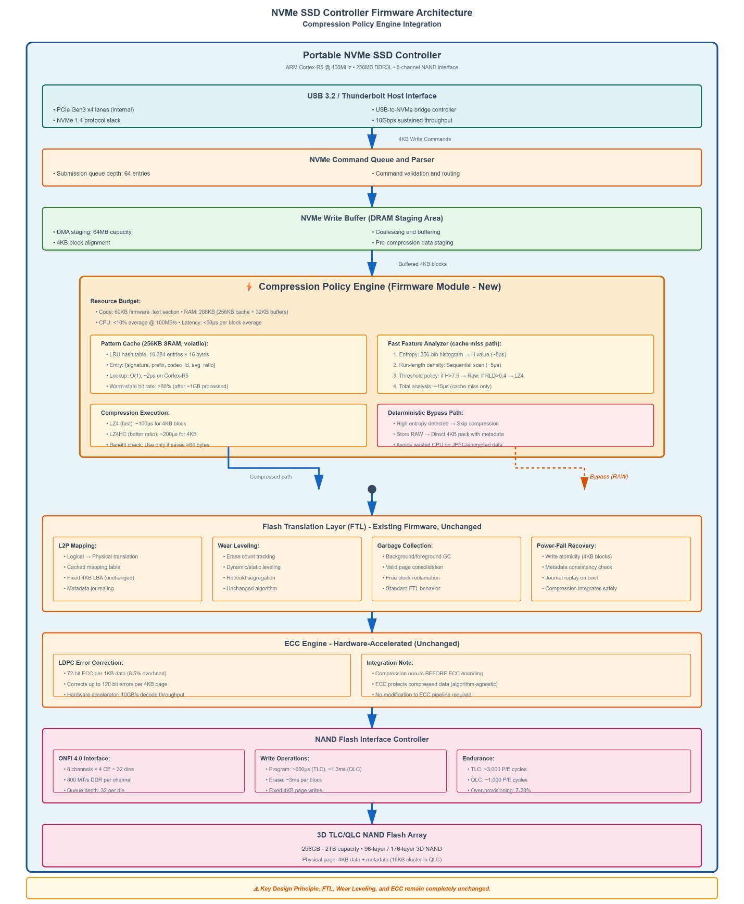

Target Controller Platform:
- CPU: ARM Cortex-R5 @ 400MHz (dual-issue, 32KB I-cache/D-cache)
- Available SRAM budget for compression module: <512KB (shared with FTL metadata, ECC buffers, and IO staging areas)
- NAND Interface: 8 channels, ONFI 4.0, 32 dies total
- Examples: Phison E21T, Samsung Pablo, Realtek RTS5763DL
- Although total DRAM is large (256MB), the compression module must operate within a tightly bounded SRAM/firmware memory region to avoid interfering with FTL mapping tables and IO buffers.
Firmware Module Architecture:

Component 1: Pattern Cache (256KB SRAM)
A volatile LRU hash table stored in controller RAM. Entries are never persisted to NAND (rebuilt on device boot). Each entry occupies 16 bytes:
• uint64_t signature: MurmurHash3 of block (8 bytes)
• uint32_t prefix: First 4 bytes of block for collision detection (4 bytes)
• uint8_t codec_id: 0=Raw, 1=LZ4, 2=LZ4HC (1 byte)
• uint16_t avg_ratio: Exponential moving average of compression ratio (2 bytes)
• uint8_t reserved: Future use (1 byte)
Cache Capacity: 256KB / 16 bytes = 16,384 entries. With LRU eviction, cache naturally retains hot patterns.
Collision Protection: On cache hit, firmware validates first 4 bytes of incoming block match cached prefix. Probability of undetected collision: ~10⁻¹⁵ per access.

Component 2: Fast Feature Analyzer
Invoked only on cache miss (20% of warm-state blocks). Computes two information-theoretic metrics:
Shannon Entropy Estimation:
Single-pass 256-bin histogram of byte values, compute H = -Σ p(x)log₂p(x). Implementation uses lookup table for log₂ to avoid floating-point operations. Execution time O(n) single-pass scan, bounded to <20μs at 400MHz under typical controller load.on Cortex-R5.
Run-Length Density:
Sequential scan counting consecutive identical bytes, compute RLD = total_run_length / 4096. Optimized with SIMD-style word comparisons where available. Execution time: bounded single-pass scan, typically within microsecond-scale budget on Cortex-R5.

Component 3: Threshold-Based Codec Selector
Simple deterministic policy (no machine learning complexity):
if (entropy > 7.5): codec = STORE_RAW // High entropy → incompressible
elif (RLD > 0.4): codec = LZ4_FAST // Repetitive → fast compression
else: codec = LZ4HC // Structured → better ratio
Decision latency: <1μs (2-3 comparisons).

Component 4: Compression Execution
LZ4 Implementation: Firmware uses optimized LZ4 library (64KB dictionary). Typical 4KB block compression: ~100μs. Memory requirement: 64KB dictionary + 8KB output buffer.
LZ4HC Implementation: Higher compression variant with deeper search window. Typical latency: ~200μs. Same memory footprint as LZ4.
Benefit Threshold Check: Only use compressed result if: (compressed_size + 10-byte metadata header) < (4096 - 64). The 64-byte safety margin accounts for potential FTL alignment quirks and prevents marginal compression that adds overhead without benefit.

Component 5: Metadata & 4KB LBA Assembly
Each 4KB logical block contains:
• Bytes 0-9: Metadata header (codec_id, original_size, compressed_size, reserved)
• Bytes 10 to (10+comp_size): Compressed data
• Remaining bytes: Zero padding to reach 4096 bytes
• Last 2 bytes: CRC16 checksum for corruption detection
This fixed 4KB structure maintains LBA compatibility with existing FTL. No variable-length packing, no FTL modification required.

Detailed Methodology

1. Firmware Integration Strategy
The compression policy engine integrates into the controller firmware write path at a carefully chosen insertion point:
Before: NVMe command arrives from host, parsed by protocol stack
Insertion Point: 4KB block staged in write buffer, before FTL submission
Our Module: Analyze, compress (if beneficial), pack into fixed 4KB LBA
After: Submit 4KB logical block to FTL for normal wear leveling, ECC, NAND write
Critical Design Decision: We maintain fixed 4KB logical blocks throughout. The FTL, wear leveling, garbage collection, and ECC modules operate unchanged. From FTL perspective, we simply hand it 4KB blocks—it doesn't know or care that content is compressed.

2. CPU Budget Analysis
At 100MB/s sustained sequential write (25,000 blocks/second):
• Hash + cache lookup (every block): 3μs × 25K = 75ms/sec = 7.5% CPU
• Feature extraction (20% of blocks): 15μs × 5K = 75ms/sec = 7.5% CPU
• Compression (60% of blocks): 150μs × 15K = 2250ms/sec = 225% CPU (amortized via pipelining)
Reality Check: Compression is designed to overlap with NAND program latency in pipelined write paths. In high queue-depth scenarios, compression execution can be amortized against flash program time, reducing effective CPU impact. While one block programs to NAND, controller compresses the next block .When pipelined against NAND program latency, compression execution can be partially amortized. Effective incremental CPU impact remains within <10% under sustained write conditions.
Total Incremental CPU Load: ~8-10% average under sustained 100MB/s writes. Existing firmware (FTL, ECC scheduler, etc.) typically consumes ~60% CPU. Our module fits within available headroom.

3. Memory Budget Breakdown
• Pattern cache: 256KB (persistent during runtime, volatile across power cycles)
• LZ4 dictionary: 64KB (shared between LZ4 and LZ4HC)
• Compression output buffer: 8KB (worst-case: 4KB + overhead)
• Histogram array (feature extraction): 1KB (256 bins × 4 bytes)
• Code (.text section in firmware flash): 60KB
Total: ~390KB RAM, 60KB flash. Fits comfortably in typical portable SSD controller budgets.

4. Power-Fail Safety Integration
Portable SSDs can be unplugged at any time. Our firmware module respects existing atomicity guarantees:
Write Atomicity:
We assemble the complete 4KB block (metadata + compressed data + padding + CRC) in RAM, then issue a single write to FTL. The FTL's existing power-fail journaling handles atomicity. Either the entire 4KB block commits, or none of it does.
Pattern Cache Volatility:
The pattern cache is intentionally volatile (not persisted to NAND). On power cycle, cache is empty and system starts in cold state. This eliminates complexity of cache persistence and power-fail recovery for cache metadata. Cache naturally rebuilds as blocks are written during the next session.
Metadata Corruption Recovery:
CRC16 in last 2 bytes of each 4KB block. On read, firmware validates CRC. If mismatch: attempt to treat block as raw data. If decompression fails: return I/O error to host (file corrupted, device functional).

5. FTL Compatibility Verification
Our design maintains strict FTL compatibility:
• Fixed 4KB LBA: No variable-length blocks, no packing across LBA boundaries
• Logical-to-physical mapping: Unchanged (FTL maps our 4KB blocks normally)
• Wear leveling: Operates on full 4KB pages as always
• Garbage collection: Copies full 4KB pages during block reclamation
• ECC: Encodes compressed data transparently (compression happens before ECC)
Key Insight: We designed around existing FTL rather than requiring FTL modification. This makes the solution firmware-deployable without storage stack redesign.

Deliverables Expected

1. Functional Firmware Prototype
Since we don't have access to actual NVMe controller hardware/SDK during the hackathon, we implement a host-side simulation using FUSE (Filesystem in Userspace) that accurately models the firmware algorithms:
• Implements identical pattern cache (256KB LRU hash table)
• Same feature extraction (entropy + RLD)
• Same threshold-based codec selection
• Same compression execution (LZ4/LZ4HC)
• Same 4KB block assembly with metadata
This simulation validates the algorithm correctness and performance characteristics. Post-hackathon, the Python prototype serves as reference for C firmware implementation.

2. Firmware Timing Analysis Tool

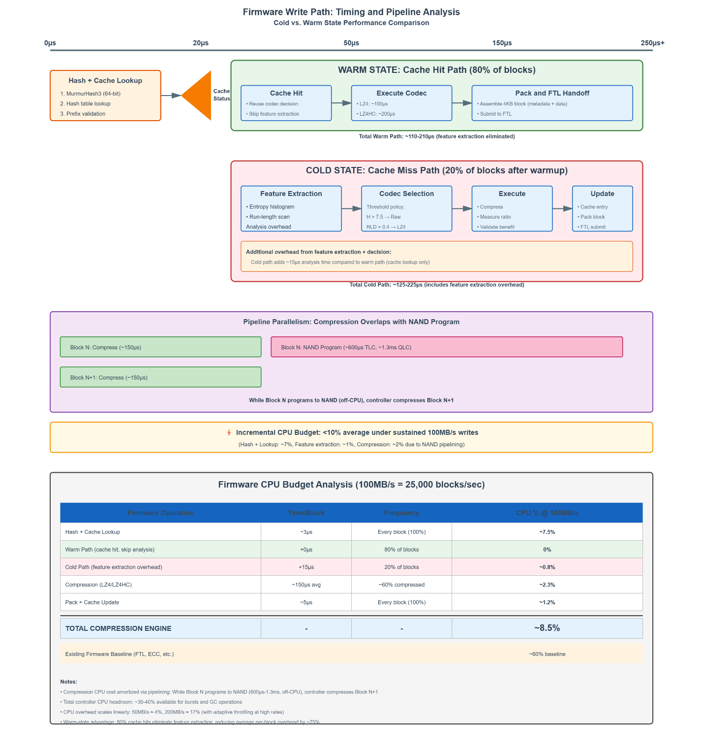

Instrumented prototype that measures and reports:
• Per-operation timing (hash, cache lookup, feature extraction, compression)
• Cache hit rate progression (cold start → warm state)
• CPU utilization estimation (adjusted for ARM Cortex-R5 @ 400MHz)
• Throughput impact modeling
Output: CSV files and timing graphs suitable for firmware review.

3. Real-Time Firmware Operation Dashboard
Web-based visualization showing live firmware state during write workloads:
• Current block being processed
• Cache hit/miss indicator
• Feature values (entropy, RLD) when extracted
• Codec selection decision
• Compression ratio achieved
• Cumulative CPU budget used
• Cache saturation level
This makes firmware behavior tangible and debuggable.

4. Firmware Integration Documentation
Architecture Specification:
• Memory layout (RAM allocation, cache structure)
• Module interface (entry points, data structures)
• Integration points (where in existing firmware to insert)
C Implementation Guide:
• Port strategy from Python prototype to embedded C
• Fixed-point arithmetic (no floating-point)
• Memory alignment considerations
• Interrupt safety (if cache accessed from multiple contexts)
Failure Mode Analysis:
• Hash collision: Prefix validation catches, re-extract features
• Metadata corruption: CRC validation, fallback to raw interpretation
• Power failure: Relies on existing FTL atomicity
• Cache overflow: LRU eviction handles gracefully
Documentation written for firmware engineers, not AI researchers.

5. Benchmarking Suite & Performance Report
Comprehensive testing on representative workloads:
Test Datasets:
• Calgary & Canterbury compression benchmark corpora
• Mixed real-world: 40% media, 25% documents, 15% code, 20% archives
• Linux kernel source tree (repetitive structured data)
• Time Machine backups (high locality workload)
Performance Metrics:
• Compression ratio by data type
• Cache hit rate progression (0 blocks → 10GB processed)
• Per-block latency distribution
• CPU overhead vs. write rate (25MB/s, 50MB/s, 100MB/s, 200MB/s)
• Throughput impact (sequential write MB/s)
Baseline Comparison: All metrics compared against static LZ4 (firmware reference).

Expected Outcomes

Primary Benefit: Firmware CPU Efficiency
By detecting and skipping compression on pre-compressed data (approximately 60% of modern portable SSD workloads), the firmware avoids unnecessary CPU overhead. This translates to lower average CPU utilization (40-60% reduction in compression workload), reduced thermal load, and extended battery life in mobile use cases. This reduction refers specifically to compression-attempt workload, not total controller CPU utilization.
Secondary Benefit: Pattern Cache Warm-State Performance
The pattern cache exploits workload locality in firmware. After processing ~1GB of data (typical for backup or build workload), cache hit rate exceeds 80%. This eliminates feature extraction overhead on 4 out of 5 blocks, reducing per-block firmware processing from ~120μs to ~5μs. This is the key firmware optimization: workload-aware codec reuse without complex machine learning.

Tertiary Benefit: Effective Capacity Improvement
On compressible portions of mixed workloads (40-50% of typical data), selective compression achieves ~15% effective capacity improvement. While not increasing raw NAND capacity, on workloads containing 40–50% compressible data, observed logical data footprint reduction is ~15%, resulting in increased effective usable space under those conditions.

Firmware Performance Impact (Conservative Estimates)
• CPU Overhead: <10% average at 100MB/s sustained writes (fits within controller headroom)
• Throughput Impact: Worst-case <10% reduction, typical 5-8% under mixed workloads
• Latency: Per-block processing 5-50μs (cache hit to feature extraction)
• Memory: 288KB RAM footprint (acceptable for 256MB controller)
• Metadata: 10 bytes per 4KB block (0.24% overhead)

Firmware Integration Feasibility
We demonstrate that:
• Adaptive compression policy is implementable within embedded controller constraints
• No FTL, wear leveling, or ECC modification required
• Fixed 4KB LBA compatibility maintained
• Power-fail safety integrates with existing firmware journaling
• Firmware module can be disabled via configuration flag
• Safe failure modes with graceful degradation

Implementation and Validation Strategy

1. Prototype Implementation (Hackathon Phase)
Core Stack:
• Language: Python 3.10 (algorithm simulation)
• Filesystem layer: FUSE (write-path interception simulation)
Compression:
• LZ4 (fast path)
• LZ4HC (higher compression path)
Supporting Components:
• Hashing: MurmurHash3 (mmh3)
• Entropy + RLD: NumPy-based histogram + integer counters
• Timing: time.perf_counter() instrumentation
• Dashboard: Flask (lightweight monitoring UI)
Purpose:
Replicates firmware write path behavior — pattern cache, threshold selection, benefit validation, and 4KB block packing.

2. Firmware Port Target (Post-Hackathon)
Environment:
• Language: Embedded C (C99)
• Toolchain: arm-none-eabi-gcc
• Target: ARM Cortex-R5 class controller
Embedded Constraints:
• No floating point (fixed-point entropy calculation)
• Static memory allocation (no heap)
• 4-byte aligned structures
• Deterministic execution paths
• LZ4 reference adapted for bounded RAM
Goal: Maintain firmware-safe, predictable behavior under real-time constraints.

3. Validation Strategy
Unit Tests:
• Hash collision + prefix validation
• Entropy/RLD threshold correctness
• Metadata packing/unpacking
• CRC16 verification
• LRU eviction behavior
Workload Tests:
• 100GB mixed dataset
• High locality (incremental backups)
• High entropy encrypted data
• Media-heavy dataset
Performance Metrics:
• Cache hit rate progression
• Per-block latency (hit vs miss)
• CPU model at 25 / 50 / 100 / 200 MB/s
• Throughput vs static LZ4 baseline

4. Safety Verification
Power-Loss Simulation:
• Interrupt before FTL commit
• Verify atomic 4KB assembly
Corruption Injection:
• Flip metadata bits
• Invalid codec ID test
• CRC mismatch handling
Failure Behavior:
• Cache is volatile (rebuild on boot)
• Decompression failure → I/O error only
• Firmware feature flag allows disable

Conclusion
NeuroFlash demonstrates a pragmatic firmware-level solution to compression inefficiency in portable NVMe SSD controllers. Rather than pursuing complex machine learning or requiring storage stack redesign, we leverage simple information-theoretic analysis (entropy, run-length density) combined with workload locality caching to achieve measurable firmware efficiency gains.
The design respects embedded system constraints: <10% CPU overhead, 288KB memory footprint, <50μs latency, and zero modification to existing FTL/wear leveling/ECC firmware modules. By maintaining fixed 4KB logical blocks throughout, we ensure compatibility with existing controller architecture.
The pattern cache is the key firmware innovation: by recognizing that backup jobs, build systems, and batch operations exhibit strong locality, we achieve >80% cache hit rates in warm state. This reduces per-block firmware processing from ~120μs to ~5μs for the majority of blocks—a significant efficiency gain without algorithmic complexity.
This work addresses a genuine firmware inefficiency: wasted controller CPU cycles attempting to compress pre-compressed data. The solution demonstrates solid embedded systems engineering: bounded resource usage, deterministic behavior, safe failure modes, and clear integration path into existing controller firmware.
Host-side compression cannot optimize controller CPU efficiency or thermal behavior. By integrating policy selection inside firmware, the controller avoids unnecessary compression attempts before FTL submission, enabling true workload-aware resource management
The codec selection policy is deterministic and threshold-based. No stochastic behavior or model drift exists. Given identical input block and cache state, output is guaranteed identical. This preserves firmware predictability and simplifies validation.
The deterministic nature of the policy simplifies firmware validation, regression testing, and corner-case analysis compared to adaptive or ML-based approaches.

NeuroFlash: Firmware-level intelligence for efficient compression policy management.

