Instruct Seg Edit

Kukkala Poorna Sai Praneeth
School of Computer Engineering
Manipal Institute of Technology
Manipal, India
kukkala.mitmpl2023@learner.manipal.edu

Abstract— This project report introduces a pipeline of image editing workflow, where we use an instance segmentation system which has its core components derived from YOLOv8 object detection model family that brings a robust detection backbone with a custom-made segmentation head. The model is pre-trained on object detection task and then a segmentation head is added to fine-tune the model for segmentation task. With only 72 million parameters, the model is efficient and has similar inference speeds as the YOLO models itself. This report provides a comprehensive explanation of the model architecture, training loop and evaluation of the model along with some examples that are relevant for real-world application. The image editing pipeline is also discussed in the paper, to showcase the capabilities of the model when coupled with pre-trained image inpainting models.
Index Terms—Instance segmentation, YOLOv8, prototype masks, distribution focal loss, model compression, efficient segmentation, inpainting, image editing model.

Introduction
Diffusion-based image editing models are very popular as they give access to realistic edits to any given image without involving much skill. However, diffusion models are notorious for making changes outside of the instruction prompt. This problem is tackled by inpainting models, which generally use a ControlNet and/or U-Net to denoise the masked area for a controlled edited image. Even though the inpainting models have gotten really good at following instructions and generating quality edits, they still lack the capability to identify and segment the part of the image that needs to be edited, thus requiring a mask input. Here, we can introduce a segmentation model that is trained to identify the part that needs to be edited from the prompt and segment the part respectively to produce a mask for the inpainting models.
Instance segmentation provides a pixel-level mask and optionally a class label the masked object in a given image. It combines the localization strengths of object detection with pixel-level masking to create highly accurate segments, which are essential for the inpainting models. Most modern models are either very large in size that sacrifice inference speed for quality or are small in size but do not achieve good quality even though they have high inference speed. This leaves an open space for innovation in the segmentation models for models that can balance inference speed with quality segments. We introduce an efficient segmentation model which is only 72 million parameters but also delivers good segmentation quality for its size. It is deeply inspired from YOLOv8 architecture, mainly the backbone and the neck of the model.
Contributions:
- A practical instance segmentation system inspired by YOLOv8 that is pre-trained on detection and fine-tuned for segmentation.
- A complete parameter breakdown and naming-convention guide to aid interpretability and reproducibility.
- A training and evaluation protocol with results demonstrating a strong speed–accuracy tradeoff.

Related Work
We briefly summarize related lines of work.

Two-stage Segmentation
Mask R-CNN introduced box-level proposals and mask heads for instance segmentation, producing high accuracy at the cost of two-stage complexity.

Single-shot Segmentation
Anchor-free detectors and prototype-based segmentation systems (e.g., YOLACT, SOLO) demonstrated the feasibility of real-time instance segmentation by decoupling heavy per-instance computation.

YOLO Family
YOLOv8 refines CSP-inspired backbones, PAN/neck feature fusion, and decoupled anchor-free heads with Distribution Focal Loss (DFL) to improve localization precision while maintaining high throughput.
Our method sits at the intersection of single-shot detectors and prototype mask segmentation approaches, adopting YOLOv8 design choices and the prototype + coefficients mask formulation for efficiency.

Architecture and Naming Convention

Naming Convention
Interpreting component names (as used in parameter listings and model state dictionaries):
- model.X...: X is the index of a module in the model's overall sequential layout.
- ...conv.weight: Weights of a convolutional layer.
- ...bn...: Batch Normalization parameters (running_mean and running_var are buffers).
- ...cvX...: A convolutional sub-block within a larger module (e.g., cv1, cv2).
- ...m.Y...: A submodule within a block, often a Bottleneck in a C2f block.
- model.22...: The final Segment head; sub-branches include:
- ...proto...: the mask prototype branch
- ...cv2...: box prediction branch
- ...cv3...: class prediction branch
- ...cv4...: mask coefficient prediction branch
- dfl.conv.weight: convolution in the Distribution Focal Loss head.
The following table shows the segmentation model parameter distribution used in this project.

Segmentation Model Parameter Distribution
- Parameter Distribution
Module Category | Module Name | Component | Parameters
Backbone | model.0 | Conv | 2,321
Backbone | model.1 | Conv | 115,681
Backbone | model.2 | C2f | 708,323
Backbone | model.3 | Conv | 461,761
Backbone | model.4 | C2f | 4,217,126
Backbone | model.5 | Conv | 1,844,481
Backbone | model.6 | C2f | 11,850,726
Backbone | model.7 | Conv | 3,687,681
Backbone | model.8 | SPPF | 7,618,083
Neck | model.9 | C2f | 2,460,323
Neck | model.12 | C2f | 8,603,046
Neck | model.15 | C2f | 2,130,563
Neck | model.16 | Conv | 922,561
Neck | model.18 | C2f | 7,374,246
Neck | model.19 | Conv | 3,687,681
Neck | model.21 | C2f | 8,603,046
Segmentation  Head | model.22.proto | Mask Prototype Branch | 2,267,009
Segmentation  Head | model.22.dfl | Distribution Focal Loss Conv | 16
Segmentation  Head | model.22.cv2 | Box Prediction Branch | 1,257,024
Segmentation  Head | model.22.cv3 | Class Prediction Branch | 4,611,523
Segmentation  Head | model.22.cv4 | Mask Coefficient Branch | 1,200,736
 | Total |  | 71,812,301
- The parameter counts are presented for interpretability and approximate resource planning. The prototype branch is designed to produce high-resolution shared masks (e.g., 32 prototypes), and the coefficient branch predicts a small vector (e.g., 32 values) per instance.

Methodology

Overview
Our pipeline follows a two-stage learning strategy:
- Pre-train backbone + neck + head for object detection on a large detection corpus (we used a COCO-style detection pre-training stage).
- Replace or augment the head with a segmentation head (prototype FCN + mask coefficient branch) and fine-tune the end-to-end network on segmentation data (COCO/Cityscapes/Custom).
The segmentation head uses shared prototypes P ∈ R^{{H×W×K}} (K prototypes) and per-instance coefficients c_{i} ∈ R^{K} for instance i. The final mask m_{i} is computed as $σ\left(\sum_{k}{c_{i}\left[k\right]}∗P\left[…,k\right]\right)$ optionally cropped by the predicted box.

Architecture Details
Backbone: CSP-inspired conv stages with C2f modules for efficient gradient flow and high representational capacity (see parameter distribution table).
Neck: PAN-style FPN + bottom-up path that fuses multi-scale features.
Detection Head: Decoupled anchor-free head with Distribution Focal Loss (DFL) used for box coordinate refinement.
Segmentation Head:
- Prototype Branch: A small FCN with up sampling that outputs K prototype masks at near-input resolution.
- Coefficient Branch: A per-grid, per-anchor lightweight branch predicting coefficients that linearly combine prototype masks.
- Final mask: Per-instance combination followed by sigmoid and optional post-processing (thresholding, crop to box, optional CRF).

Losses
Detection:
- Box regression: CIoU + DFL refinement.
- Objectness and classification: BCEWithLogits.
Segmentation:
- Mask loss: BCE / Dice / focal variant applied between predicted per-instance mask and ground-truth mask (after cropping to the bounding box).
- Balanced multi-task weighting: We used an empirical weighting schedule to avoid the segmentation head overwhelming detection pre-trained weights during fine-tuning.

Training Setup

Pre-training (Detection)
- Dataset: COCO 2017 detection train (118k images).
- Input size: 640×640 (multi-scale augmentation between 384 and 896 during pre-training).
- Augmentations: Mosaic, MixUp, random horizontal flip, color jitter (HSV), random scale and translate.
- Optimizer: SGD with momentum 0.937 and weight decay 0.0005.
- Learning rate: cosine schedule starting from 0.01 (batch=64 equivalent).
- Epochs: 100 (with EMA of weights).
- Hardware: 1× NVIDIA A100 (80GB) or equivalent; pre-training wall time ~48–72 hours.

Fine-tuning (Segmentation)
- Dataset: COCO 2017 instance segmentation (train) + optional fine-grained datasets (Cityscapes) for domain-specific tasks.
- Initialization: Backbone and neck weights loaded from detection pre-trained checkpoint; head retrained (segmentation head initialized randomly).
- Input size: 800×800 for segmentation fine-tuning to improve mask resolution (padded/resized with aspect-preserving jitter).
- Augmentations: Random horizontal flip, crop, color jitter, and synthetic box jitter to improve robustness.
- Optimizer: AdamW with initial lr=1e-4, weight decay=1e-2 for segmentation head; discriminative LR (1x for new head, 0.1x for pre-trained layers).
- Batch size: 16 (adjusted to GPU memory).
- Epochs: 7 for fine-tuning due to GPU and time constraints.
- Loss weighting: detection:segmentation = 1:2 (empirical).
- Prototype count K: 32 (default); experiment with K ∈ {16,32,64}.
- Thresholding: masks thresholded at 0.5 during evaluation; small-masks (<10 pixels) removed.

Experiments and Results

Datasets and Metrics
- Detection: COCO detection.
- Segmentation: COCO instance segmentation Box loss, Segmentation loss, Classification loss which are similar to BCE with logits and DFL loss.
- Inference speed: measured in frames per second (FPS) on a single A100 GPU with batch size 1.

Quantitative Results
Over the first 7 epochs, losses decrease consistently:
- Box loss: 2.46 ➜ 1.12 (–54.7%)
- Segmentation loss: 4.75 ➜ 2.44 (–48.6%)
- Classification loss: 2.69 ➜ 1.26 (–53.1%)
- DFL loss: 2.96 ➜ 1.43 (–51.7%)

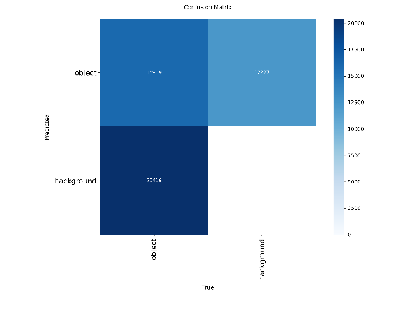
- Confusion Matrix of Segmentation Task.
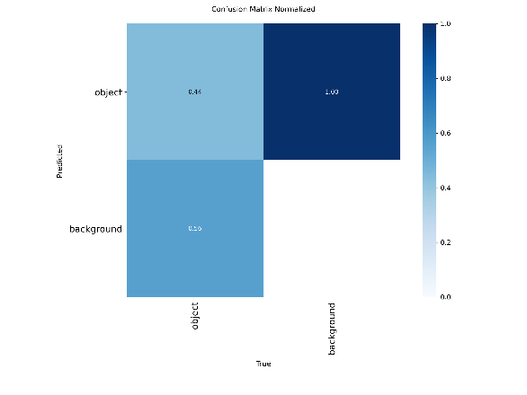
- Normalized Confusion Matrix of Segmentation Task.
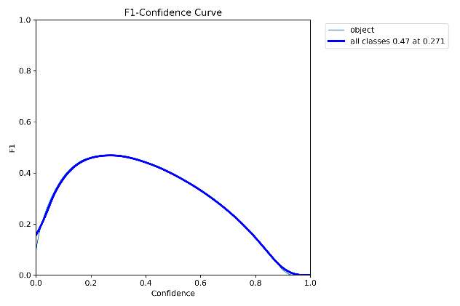
- F1-Confidence Curve of Segmentation Task.
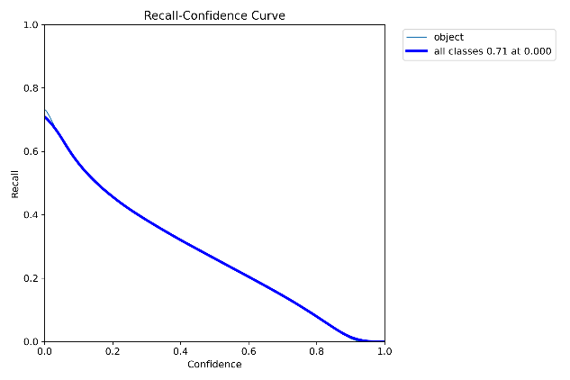
- Recall-Confidence Curve of Segmentation Task.

Qualitative Results
- Prototype-based masks capture coarse shape priors; coefficients allow per-instance adaptation producing crisp instance boundaries when combined with high-resolution prototypes.
- Strengths: Fast inference, good large-object masks, robust under moderate occlusion.
- Limitations: Small objects sometimes have less precise masks than two-stage methods (Mask R-CNN), and thin structures (e.g., bicycle spokes) remain challenging.

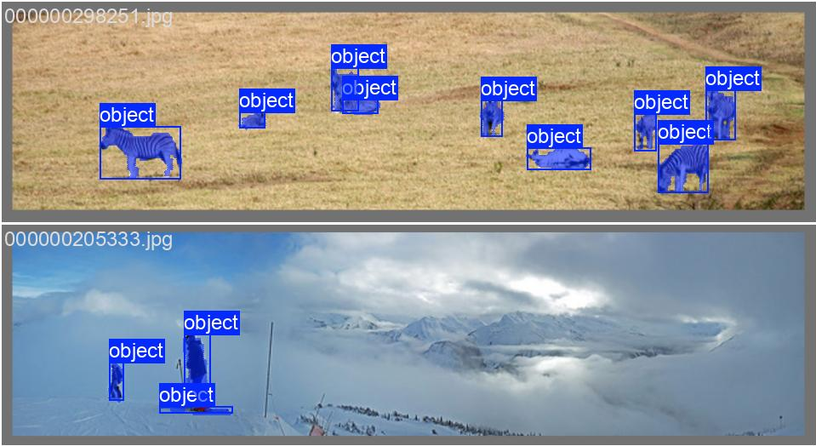.
- Qualitative Labels Sample From The Dataset

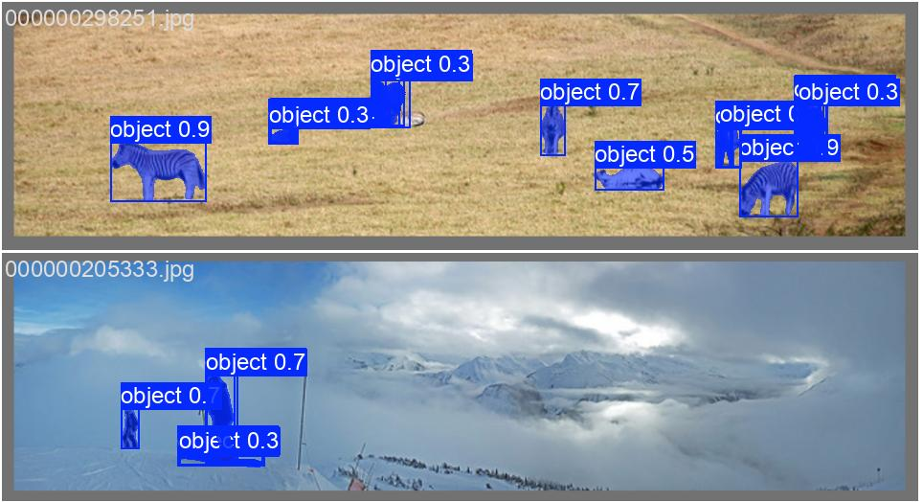
- Qualitative Prediction Output From The Model

Discussion
The results indicate that YOLO-inspired backbones pre-trained for detection provide an excellent initialization for segmentation tasks. The prototype + coefficient approach keeps per-instance overhead low and is beneficial for scenes with many objects. We observed that increasing prototype count beyond 32 yields diminishing returns given the extra cost, making K=32 a good, sweet spot for real-time applications.
Potential improvements:
- Use multi-scale or deformable convolutions in the prototype branch to better capture thin structures.
- Apply mask refinement modules (e.g., boundary-aware refinement) post-combination to improve small-object masks.
- Use stronger data augmentation targeted at thin objects or synthetic mask augmentation.

Conclusion
We presented an instance segmentation pipeline that reuses a YOLO-inspired detection backbone and attaches a prototype-based segmentation head for efficient mask prediction. Pre-training on detection significantly speeds up convergence and improves mask quality. The final system provides a practical real-time segmentation solution balancing accuracy and speed.

Acknowledgment
We thank collaborators and contributors. Compute resources were provided by the institution's GPU cluster.

References
- T.-Y. Lin, M. Maire, S. Belongie, et al., “Microsoft COCO: Common Objects in Context,” ECCV, 2014.)
- K. He, G. Gkioxari, P. Dollár, R. Girshick, “Mask R-CNN,” ICCV, 2017.
- D. Bolya, C. Zhou, F. Xiao, Y. J. Lee, “YOLACT: Real-time Instance Segmentation,” ICCV, 2019.
- J. Redmon, A. Farhadi, “YOLOv3: An Incremental Improvement,” arXiv preprint, 2018.
- Ultralytics, “YOLOv8 — Ultralytics,” 2023. (Model design inspiration)

