# 3. Proposed System Architecture

## 3.1. Flowchart

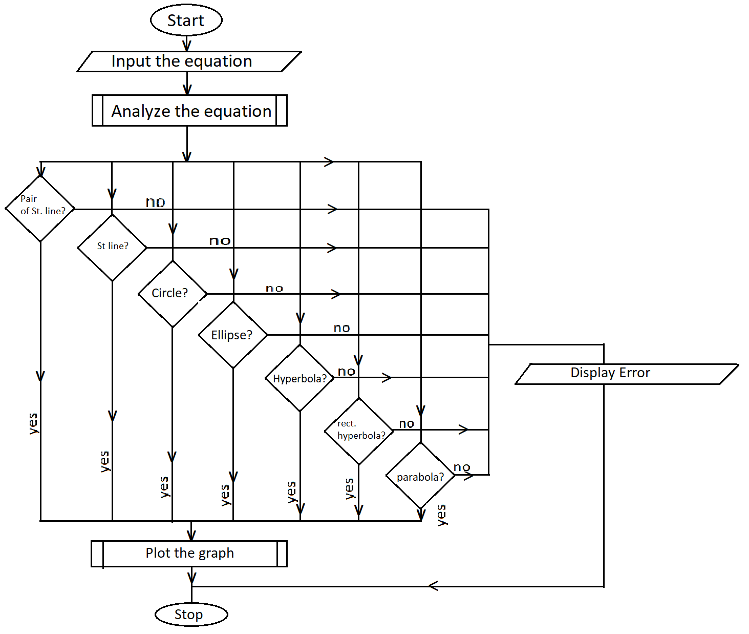

Figure 3.1.1 Flowchart for the program

## 3.2. Tools and Environment

1. Visual Studio Community 2022

2. Code::Blocks

3. Visual Studio Code

# 4. Methodology

## 4.1. Input the equation

The first step for running the program is taking the input of equation from the user. The user will be asked to input the equation through the GUI of the program. The inputs shall be taken either in the form of a complete equation or they may just enter all the coefficients of a second-degree equation. The equation must be in the form of (Ax2 + By2 + Hxy + Gx + Fy + C = 0). If the user is asked to enter the complete equation, just the coefficients of the equation are taken and stored in the respected variables.

The GUI includes a text-box take the input. There may be separate text boxes for different coefficients. The coefficients will be converted as of the standard form. After the coefficients are collected, we can analyze the equation for the further part of the program.

## 4.2. Analyze the equation

After all the coefficients of the standard second-degree equation are obtained, the curve can be analyzed and can be determined what kind of curve does the equation represent. The equation can represent at most seven types of curves (i.e. straight line, pair of straight lines, circle, ellipse, hyperbola, rectangular hyperbola or parabola). We can compare the coefficients for different curves as follow:

### 4.2.1 St line

A straight line is the curve that is represented by the equation y = mx + c. If the If all the coefficients of second-degree x any y are zero then the curve formed is a straight.

For a general second degree equation to be a straight line, following conditions should be matched:  
(ax2 + by2 +2hxy + 2gx + 2fy + c = 0) -> a second degree equation

* a = 0
* b = 0
* h = 0

If the above conditions are matched, the we can confirm that the given equation is of a st. line.

### 4.2.2 Pair of straight lines

For the given equation to be of pair of straight lines, it should meet the following criteria.

(ax2 + by2 +2hxy + 2gx + 2fy + c = 0) -> a second degree equation

Let ∇ = abc + 2fgh – af2 -bg2 -ch2

* a, b must not be 0
* ∇ = 0

### 4.2.3 Circle

For the given equation to be a circle, it should meet the following criteria.

(ax2 + by2 +2hxy + 2gx + 2fy + c = 0) -> a second degree equation

Let ∇ = abc + 2fgh – af2 -bg2 -ch2

* a = b
* h = 0
* ∇ must not be zero

### 4.2.4 Parabola

For the given equation to be a parabola, it should meet the following criteria.

(ax2 + by2 +2hxy + 2gx + 2fy + c = 0) -> a second degree equation

Let ∇ = abc + 2fgh – af2 -bg2 -ch2

* ∇ ≠ 0
* Either a or b should be 0
* h2  - ab = 0

### 4.2.5 Ellipse

For the given equation to be an ellipse, it should meet the following criteria.

(ax2 + by2 +2hxy + 2gx + 2fy + c = 0) -> a second degree equation

Let ∇ = abc + 2fgh – af2 -bg2 -ch2

* ∇ ≠ 0
* a, b ≠ 0
* h2  - ab < 0

### 4.2.6 Hyperbola

For the given equation to be a hyperbola, it should meet the following criteria.

(ax2 + by2 +2hxy + 2gx + 2fy + c = 0) -> a second degree equation

Let ∇ = abc + 2fgh – af2 -bg2 -ch2

* ∇ ≠ 0
* a, b ≠ 0
* h2  - ab > 0

### 4.2.7 Rectangular hyperbola

For the given equation to be a rectangular hyperbola, it should meet the following criteria.

(ax2 + by2 +2hxy + 2gx + 2fy + c = 0) -> a second degree equation

Let ∇ = abc + 2fgh – af2 -bg2 -ch2

* ∇ ≠ 0
* a + b = 0
* h2  - ab >0

## Plot the graph

For this process, we may take the help of different cpp libraries and frameworks like graphics.h, OpenGl, vector, etc. <epsum lorem>