Coronavirus (CoV)

Coronaviruses (CoV) are a large family of viruses that causes illness ranging from the common cold to more severe diseases such as [Middle East Respiratory syndrome (MERS-CoV)](https://www.who.int/emergencies/mers-cov/en/) and [Severe Acute Respiratory syndrome (SARS-CoV).](https://www.who.int/csr/sars/en/) A novel coronavirus (nCoV) is a new strain that has not been previously identified in humans.

Coronaviruses are **zoonotic** (related to zoonosis : An animal disease which can be transmitted to humans) .

Common signs of infection include respiratory symptoms, fever cough, shortness of breath and breathing problems. In severe cases, infection can cause pneumonia (infection in one or both lungs causing inflammation in the alveoli. The alveoli fill with fluid or pus, making it difficult to breath.), severe acute respiratory syndromes, kidney failure and even death.

Standard recommendations to prevent infection spread include regular hand washing, covering mouth and nose when coughing and sneezing, thoroughly cooking meat and eggs. Avoid close contact with anyone showing symptoms of respiratory illness such as coughing and sneezing.

**COVID-19** epidemic

Coronavirus disease 2019.

* A pneumonia of unknown cause was detected in Wuhan, china was first reported to the WHO country office in china on 31 December 2019.
* The outbreak was declared a Public Health Emergency of international concern on 30 January 2020.
* On 11 February 2020, WHO announced a name for the new coronavirus disease: COVID-19.

[Dr. **Tedros Adhanom Ghebreyesus**](https://en.wikipedia.org/wiki/Tedros_Adhanom) is the 8th Director-General of the World Health organization.

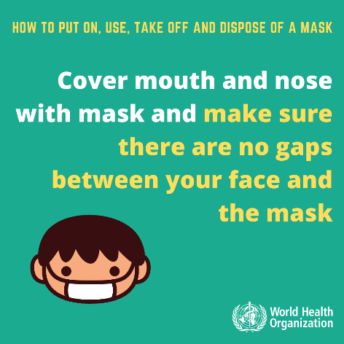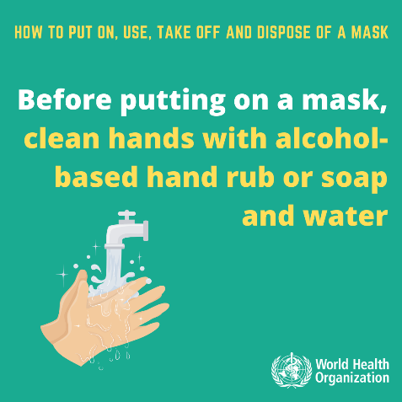**Protect Yourself**

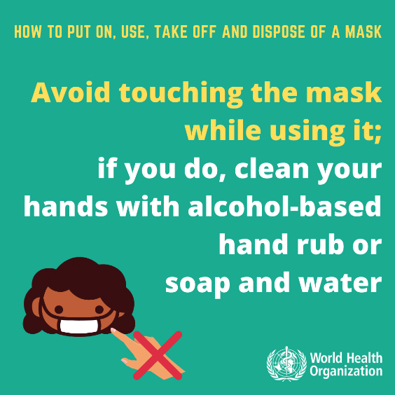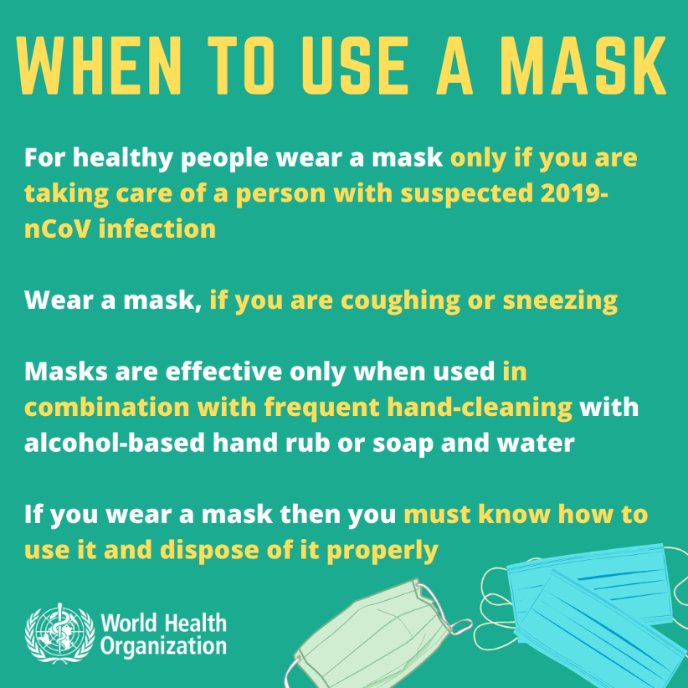

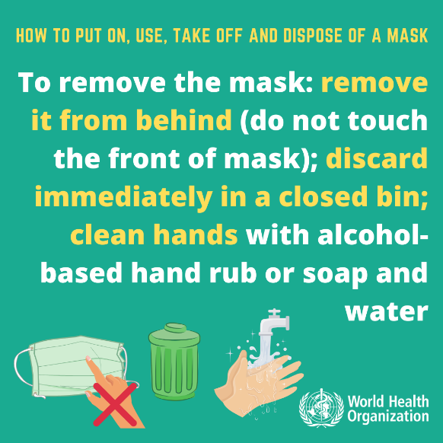

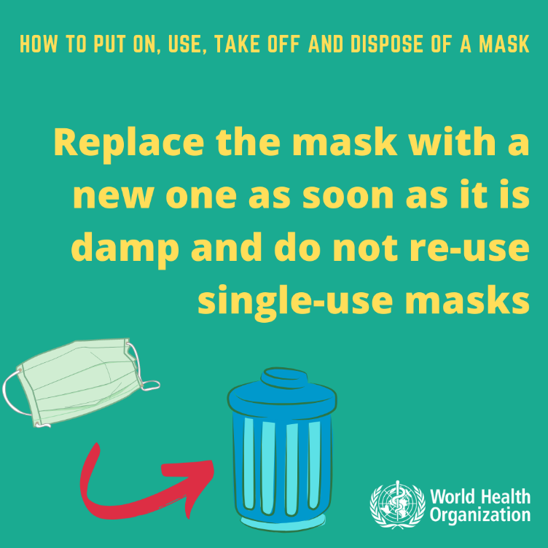

Viruses are named based on their genetic structure to facilitate the development of diagnostic tests, vaccines and medicines. Virologists and the wider scientific community do this work, so viruses are named by the International Committee on Taxonomy of Viruses (ICTV).

Human disease preparedness and response is WHO’s role, so diseases are officially named by WHO in the International Classification of Diseases (ICD).

ICTV announced “severe acute respiratory syndrome coronavirus 2 (SARS-CoV-2)” as the name of the new virus on 11 February 2020. This name was chosen because the virus is genetically related to the coronavirus responsible for the SARS outbreak of 2003. While related, the two viruses are different.

WHO announced “COVID-19” as the name of this new disease on 11 February 2020.

**How does COVID-19 spread?**

People can catch COVID-19 from others who have the virus. The disease can spread from person to person through small droplets from the nose or mouth which are spread when a person with COVID-19 coughs or exhales. These droplets land on objects and surfaces, then touching their eyes, nose, mouth. People can alse catch COVID-19 if they breathe in droplets from a person with COVID-19 who coughs out or exhales droplets. This is why it is important to stay more than 1 meter (3 feet) away from person who is sick.

**Can the virus that causes COVID-19 be transmitted through air?**

Studies till date suggest that the virus that causes COVID-19 is mainly transmitted through contact with respiratory droplets rather than through the air.

**Are antibiotics effective in preventing or treating the COVID-19?**

No, Antibiotics do not work against viruses. They only work on bacterial infections. Since COVID-19 is caused by virus, so antibiotics do not work.

**Is COVID-19 the same as SARS?**

No. The virus that caused COVID-19 and the one that causes Severe acute respiratory syndrome (SARS) are related to each other genetically, but they are different. SARS is more deadly but much less infectious than COVID-19. There have been no outbreaks of SARS anywhere in the world since 2003.