**How to connect two Linux instances**

**Step1:**

* Create two instances Server 1(master) And Server2(client)
* Create the ssh-keygen in the Server1

**Step 2:**

* Open that key cat /root/.ssh/id_rsa.pub
* Copy that key
* Go to server 2and paste it into the Server2 vi /root/.ssh/authorized_keys
* Paste the key at top

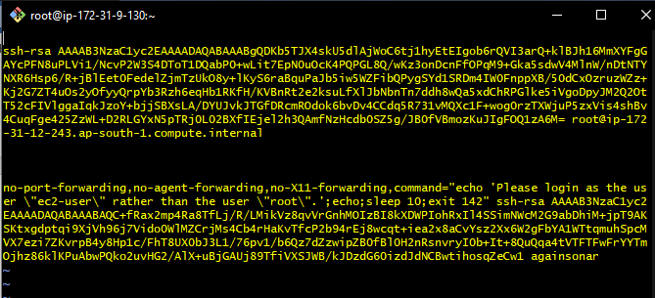

**Step 3:**

* Now change the configuration setting of both Servers vi/etc/ssh/sshd_confg
* Change only the Password authentication to yes
* Then restart the sshd in both Servers after the configuration
* Systemctl restart sshd

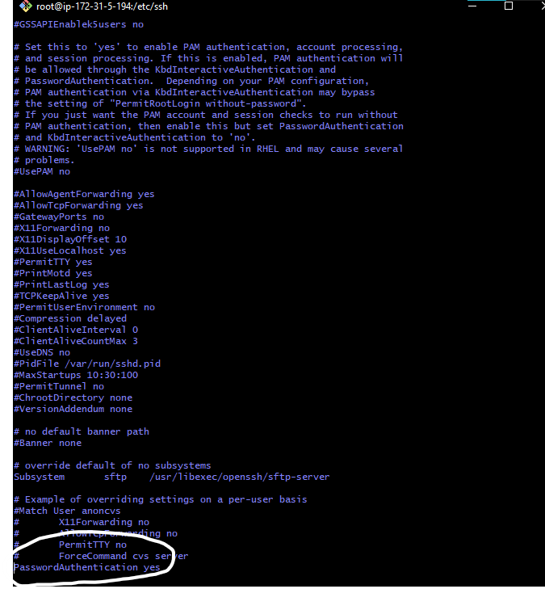

**Step 4:**

* Now write ssh root@public ip of client
* Now you can access the Server 2 From Server 1

**Now we have to do rsync (Sync the content of Server1 into Server2):**

The command for the rsync is

rsync [OPTION] -e ssh [SRC]... [USER@]HOST:DEST

- rsync -av -e ssh /root/amrit/* [root@65.0.7.1:/root/aps/](mailto:root@65.0.7.1:/root/aps/)

The files from the source destination will be copied in the receiver destination

**Rsync Option description**

* -a, --archive (tells sync directories recursively, transfer special and block devices, preserve symbolic links, modification times, groups, ownership, and permissions.
* -z, --compress (used to compress the data if conneaction is slow)
* -P, --partiall progress (tells progress bar during transfer, used when transferring large file over a slow and unstable network.
* -e (to use ssh)
* -v –verbose output (Displays the details of the transfer.

**Automate rsync:**

Now we have the automate the process of rsync so that it can sync automatically without writing commands again and again

**Step 1:**

* Firstly create a script file in which you have to define the rsync command
* First create a directory in Server and and create a script in that directory

vi script

* !/bin/sh
* rsync -azz -e ssh /root/aps1/* [root@65.0.7.1:/root/aps/](mailto:root@65.0.7.1:/root/aps/)

[the rsync takes file from /root/aps1 and sync it into the another(destination) server’s /root/aps/ directory]

* save and exit

* chmod +x script

**Step 2:**

Now create cronjob

* crontab -e
* a vi file will appear
* write a comment #backup everyminute
* * * * * * /root/scripts/script (give the address of your script)cd

MIN HOUR DOM MON DOW CMD

* * * * * Stars mean after every minute it will sync the data

**Field Description Allowed Value**

MIN Minute field 0 to 59

HOUR Hour field 0 to 23

DOM Day of Month 1-31

MON Month field 1-12

DOW Day Of Week 0-6

CMD Command Any command to be executed.