Team:

1-مصطفي احمد مصطفي

احمد خالد محمود -2

**The idea of the project:**

We make a text editor that have alot of features

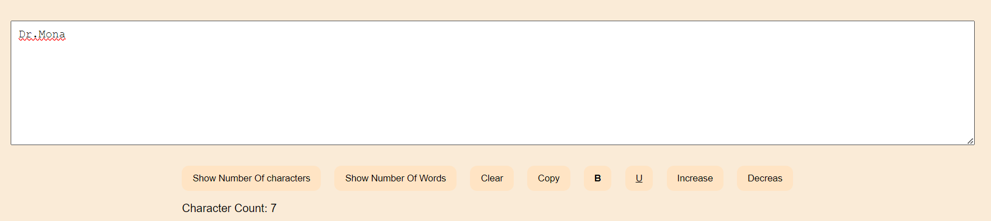

An button to show the count of chars and another one to show how many words on the text area

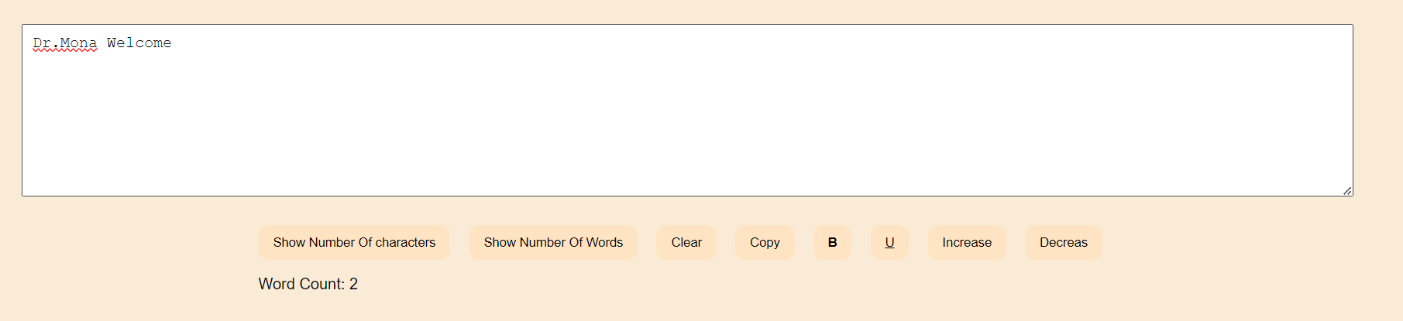

And one for clear , copy , Bold the text , to uncerline the text , and the least two ones to increase and decrease the font size

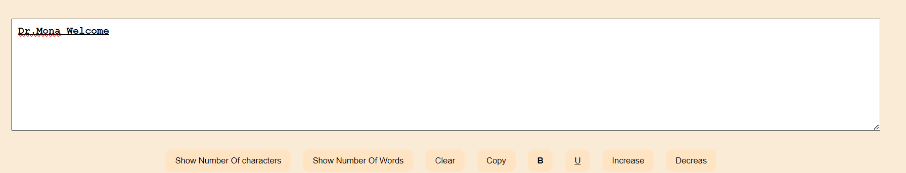

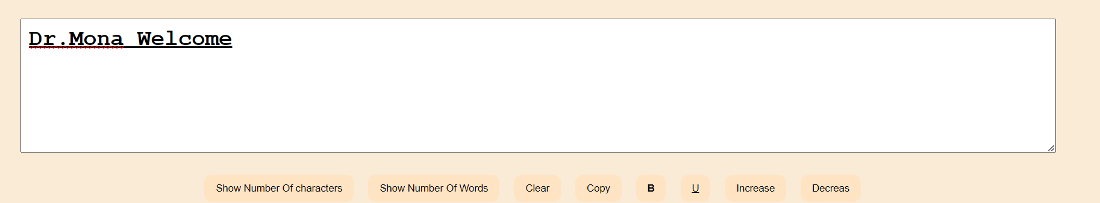

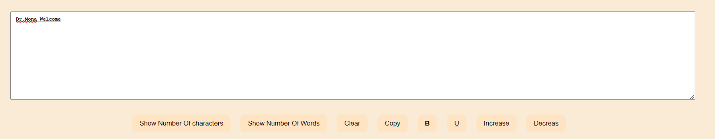

**Code:**

**HTMl File:**

|  |
| --- |
| <!DOCTYPE html>  <html>  <head>      <title>Electron Text Editor</title>      <link rel="stylesheet" type="text/css" href="style.css">  </head>  <body>      <textarea id="Text"></textarea>      <div class="Btns">          <button class="charNms">Show Number Of characters</button>          <button class="wordNums">Show Number Of Words</button>          <button class="clear">Clear</button>          <button class="copy">Copy</button>          <button class="bold" style="font-weight: bolder;">B</button>          <button class="underline">U</button>          <button class="increasesize">Increase</button>          <button class="decreasesize">Decreas</button>          <p class="res"></p>      </div>      <script src="render.js"></script>  </body>  </html> |

**CSS File:**

|  |
| --- |
| body {    font-family: Arial, sans-serif;    display: flex;    justify-content: center;    align-items: center;    flex-direction: column;    height: 100vh;    background-color: antiquewhite;  }  .Bold {    font-weight: bold;  }  .underline {    text-decoration: underline;  }  textarea {    width: 90%;    height: 20%;    font-size: 16px;    padding: 10px;    margin-bottom: 30px;  }  .chars_num {    font-size: 1em;    color: black;  }  button {    padding: 10px 15px;    border: none;    border-radius: 10px;    background-color: bisque;    margin-right: 15px;    transition: 1s;    cursor: pointer;  }  button:hover {    background-color: rgb(222, 192, 146);  } |

**Java Script Files**

1-main.js

|  |
| --- |
| const { app, BrowserWindow } = require('electron');  function createWindow () {    const window = new BrowserWindow({      width: 800,      height: 600,      webPreferences: {        nodeIntegration: true      }    });    window.loadFile('index.html');  }  app.whenReady().then(createWindow);  app.on('window-all-closed', () => {    if (process.platform !== 'darwin') {      app.quit();    }  });  app.on('activate', () => {    if (BrowserWindow.getAllWindows().length === 0) {      createWindow();    }  }); |

Render.js

|  |
| --- |
| const result = document.querySelector(".res");  const Text = document.getElementById("Text");  const charNms = document.querySelector(".charNms");  const wordNums = document.querySelector(".wordNums");  const clear = document.querySelector(".clear");  const copy = document.querySelector(".copy");  const undo = document.querySelector(".undo");  const Bold = document.querySelector(".bold")  const underline = document.querySelector(".underline")  const increasesize = document.querySelector(".increasesize")  const decreasesize = document.querySelector(".decreasesize")  const updatecharactercount = () => {    const text = Text.value;    const characterCount = text.length;    result.textContent = `Character Count: ${characterCount}`;  };  charNms.addEventListener("click", () => {    updatecharactercount();  });  clear.addEventListener("click", () => {    Text.value = "";    updatecharactercount();  });  copy.addEventListener("click", () => {    Text.select();    document.execCommand("copy");  });  wordNums.addEventListener("click", () => {    const text = Text.value.trim(); // Remove leading/trailing whitespace    const wordCount = text === "" ? 0 : text.split(/\s+/).length; // Split text by whitespace to count words    result.textContent = `Word Count: ${wordCount}`;  });  Bold.addEventListener("click", () => {    Text.classList.toggle("Bold")  })  underline.addEventListener("click", () => {    Text.classList.toggle("underline")  })  increasesize.addEventListener("click", () => {      const currSize = ((window.getComputedStyle(Text)).fontSize);    Text.style.fontSize = `${parseFloat(currSize) + 2}px`;  })  decreasesize.addEventListener("click", () => {    const currSize = ((window.getComputedStyle(Text)).fontSize);    Text.style.fontSize = `${parseFloat(currSize) - 2}px`;  }) |