SOFTWARE ARCHITECTURE DOCUMENT
ClearUnit -- Property Management System

Version 1.0 • Phase 1 • May 2, 2026

Team Members
Rafik Ajam | ID: 2309116215
Amro Akel | ID: 2309115620
Hasan Altabbaa | ID: 2309035318

SAD Revision History

Version | Date | Authors | Description
1.0 | May 2, 2026 | Rafik Ajam Amro Akel Hasan Altabbaa | Initial release -- ClearUnit SAD Phase 1

Team Members & Contributions

The following table documents each team member's student ID and their specific contribution to this Software Architecture Document and project implementation, as required by the project guidelines.

Full Name | Student ID | SAD Contribution
Rafik Ajam | 2309116215 | System architecture design, SAD writing (all sections), UML diagrams, Flask backend implementation
Amro Akel | 2309115620 | Use-case analysis, resident-side UI templates, requirements gathering, testing
Hasan Altabbaa | 2309035318 | Database design (Supabase/PostgreSQL), models definition, manager-side features, deployment setup

SAD Revision History 1
Team Members & Contributions 1
1. Introduction 1
1.1 Purpose 1
1.2 Scope 1
1.3 Architectural Style 1
1.4 Architectural Representation 1
1.5 Technical Platform 1
1.6 Quality Goals 1
2. Use-Case View 1
2.1 Actors 1
2.2 Use-Case Diagram 1
2.3 Use-Case Descriptions 1
UC-01: Register / Login 1
UC-02: Add / Edit Building (Manager) 1
UC-03: Add / Assign Unit (Manager) 1
UC-04: Create Dues (Manager) 1
UC-05: Notify Payment (Resident) 1
UC-06: Confirm / Reject Payment (Manager) 1
UC-07: Submit Maintenance Request (Resident) 1
UC-08: Post Announcement (Manager) 1
2.4 Partial UI Code -- Resident Dashboard Template 1
3. Logical View 1
3.1 Overview 1
3.2 UML Class Diagram 1
3.3 Domain Model Description 1
3.4 Architecturally Significant Design Packages 1
Authentication Package (routes/auth.py) 1
Manager Package (routes/manager.py) 1
Resident Package (routes/resident.py) 1
API Package (routes/api/) 1
3.5 Partial Backend Code -- Core Models 1
4. Process View 1
4.1 Sequence Diagram -- Resident Notifies Payment 1
4.2 Request Lifecycle 1
4.3 Session Management 1
4.4 Concurrency 1
4.5 Process Workflow 2 — User Login 1
4.6 Process Workflow 3 — Manager Creates Dues 1
4.7 Related Code -- Payment Notify Route 1
5. Implementation View 1
5.1 Component Interaction Overview 1
5.2 Layer-to-File Mapping 1
6. Deployment View 1
6.1 Deployment Diagram 1
6.2 Request Flow Between Components 1
6.3 Development vs. Production Topology 1
7. References 1

1. Introduction

This document provides a comprehensive architectural overview of ClearUnit, a web-based property management system, as part of Phase 1 of the Software Architecture project. It applies the 4+1 view model to document the system's architecture.

1.1 Purpose
The SAD provides an architectural overview of ClearUnit v1.0. It captures and conveys significant architectural decisions using the "4+1" View Model, allowing all stakeholders to find what they need in the architecture.

1.2 Scope
ClearUnit is a multi-role web-based property management application. It serves two user roles: Managers (who own and manage buildings and units) and Residents (who are assigned to units). Core features include dues management, payment notification and confirmation, maintenance requests, and building announcements. All data is scoped by building_id and stored in a Supabase-hosted PostgreSQL database.

1.3 Architectural Style
ClearUnit follows a layered MVC architecture:
- Model -- SQLAlchemy ORM models (models.py) represent all business entities.
- View -- Jinja2 HTML templates (frontend/templates/) render all user interfaces.
- Controller -- Flask Blueprints (routes/) handle HTTP requests, enforce business rules, and coordinate between models and views.
- REST API -- A parallel set of JSON endpoints (routes/api/) protected by JWT for programmatic access.

1.4 Architectural Representation
The views used to document ClearUnit:

View | Audience | Area | Artifact
Use-Case View | All stakeholders | Central functionality described as use cases | Use-Case Diagram
Logical View | Designers | Object model, class relationships, domain structure | UML Class Diagram
Process View | Integrators | Request lifecycle, concurrency, session management | Sequence Diagram
Implementation View | Programmers | Layers, blueprints, directory structure | Component overview (Phase 2)
Deployment View | Deployment managers | Hardware/software topology, Supabase cloud DB | Deployment Diagram (Phase 2)

1.5 Technical Platform

Component | Technology
Language | Python 3.11
Web Framework | Flask (Werkzeug WSGI)
ORM | SQLAlchemy via Flask-SQLAlchemy
DB Migrations | Flask-Migrate (Alembic)
Authentication | Flask-Login (session) + Flask-JWT-Extended (API)
Password Hashing | Werkzeug Security (PBKDF2-SHA256)
CSRF Protection | Flask-WTF / CSRFProtect
Template Engine | Jinja2
CSS Framework | Tailwind CSS (CDN)
Database | PostgreSQL 15 -- hosted on Supabase (AWS eu-west-1)
DB Connection | Supabase connection pooler -- aws-0-eu-west-1.pooler.supabase.com:5432
Config | Environment variables via .env (SECRET_KEY, DATABASE_URL)

1.6 Quality Goals

Quality Goal | Description | Solution
Authentication | All routes require authenticated sessions via Flask-Login. | Session cookies signed with SECRET_KEY; passwords hashed with PBKDF2-SHA256.
Authorization | Two roles: manager and resident, each with their own blueprint and role-guard decorator. | manager_required / resident_required decorators on every protected route.
CSRF Protection | All HTML form POST requests carry a CSRF token. | Flask-WTF CSRFProtect globally; API blueprints exempt for JWT auth.
Data Isolation | Managers see only their buildings; residents see only their unit. | All ORM queries filtered by manager_id or resident_id at the route level.
Reliability | Consistent state via atomic transactions; validation errors surface without data corruption. | SQLAlchemy session commit/rollback; server-side validation before every db.session.add().
Scalability | Stateless business logic; no shared in-memory state between requests. | Deployable on Gunicorn multi-worker; Supabase handles DB connection pooling.

2. Use-Case View

This section describes the primary use cases that drive the ClearUnit architecture and provides the use-case diagram showing the system's actors and their interactions.

2.1 Actors
- Manager -- registered user (role='manager') who owns and manages one or more buildings.
- Resident -- registered user (role='resident') assigned to one unit in a building.

2.2 Use-Case Diagram
The diagram below shows all system actors and their use cases. Shared use cases (Register/Login) are available to both roles.

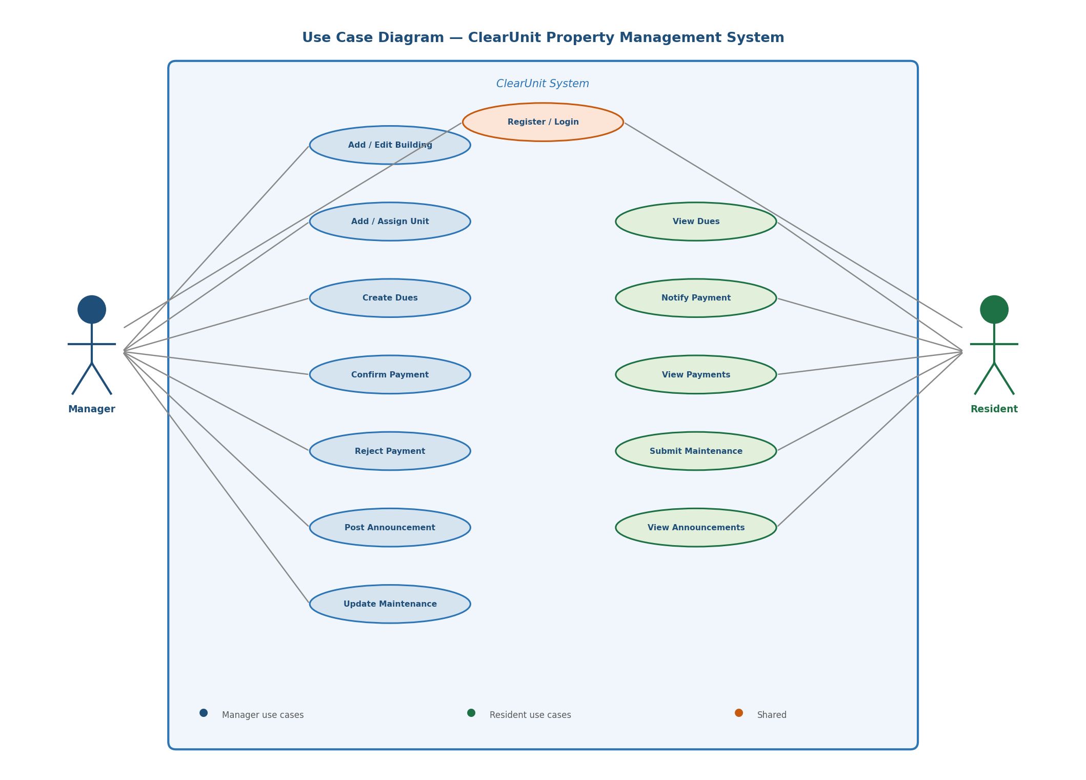
Figure 1 -- ClearUnit Use-Case Diagram

2.3 Use-Case Descriptions

UC-01: Register / Login
Any user registers with full name, email, password, and role. The system validates uniqueness and stores the hashed password. On login, Flask-Login creates a session and redirects to the role dashboard.

UC-02: Add / Edit Building (Manager)
The manager creates a building by providing a name and address. Buildings are owned by the manager (manager_id). The manager can also edit or delete buildings; deletion cascades to all units, dues, and payments.

UC-03: Add / Assign Unit (Manager)
The manager adds a unit (number, floor) to a building and optionally assigns a resident. Residents can be re-assigned or unassigned later.

UC-04: Create Dues (Manager)
The manager selects a building (or all buildings), a monthly amount, and a target month. A Dues record is created for every unit and the amount is added to unit.current_balance.

UC-05: Notify Payment (Resident)
The resident submits a payment notification (amount, month). A Payment record is created with status='pending'. The manager reviews it and confirms or rejects it.

UC-06: Confirm / Reject Payment (Manager)
The manager confirms a pending payment (status → confirmed, balance decremented) or rejects it (status → rejected, balance unchanged). Only pending payments can be acted on.

UC-07: Submit Maintenance Request (Resident)
The resident submits a description of a maintenance issue. The manager advances status: pending → in_progress → resolved (records resolved_at timestamp).

UC-08: Post Announcement (Manager)
The manager posts a titled announcement to one or all buildings. All residents of the targeted building(s) see it in their announcements feed.

2.4 Partial UI Code -- Resident Dashboard Template
The following Jinja2 template snippet shows how the resident dashboard renders unit balance and quick-action links:

<!-- resident/dashboard.html -- extends base.html -->
{% extends 'base.html' %}
{% block content %}
<div class="max-w-4xl mx-auto py-8 px-4">
<h1 class="text-2xl font-bold text-blue-900">
Welcome, {{ current_user.full_name }}
</h1>
{% for unit in units %}
<div class="bg-white shadow rounded-lg p-6 mt-4">
<h2 class="text-lg font-semibold">
Unit {{ unit.unit_number }} -- Floor {{ unit.floor }}
</h2>
<p class="text-red-600 font-bold mt-2">
Outstanding Balance: ${{ '%.2f' | format(unit.current_balance) }}
</p>
<div class="flex gap-4 mt-4">
<a href="{{ url_for('resident.dues', unit_id=unit.id) }}"
class="btn-blue">View Dues</a>
<a href="{{ url_for('resident.notify_payment', unit_id=unit.id) }}"
class="btn-green">Notify Payment</a>
<a href="{{ url_for('resident.maintenance', unit_id=unit.id) }}"
class="btn-gray">Maintenance</a>
</div>
</div>
{% endfor %}
</div>
{% endblock %}
Code Snippet 1 -- frontend/templates/resident/dashboard.html (Jinja2)

3. Logical View

3.1 Overview
ClearUnit follows a strict N-tier layered architecture. Each layer has a single responsibility and communicates only with the layer directly below it. The presentation layer renders data from the controller; the controller delegates to the domain logic and the ORM; the resource layer handles all persistence via Supabase PostgreSQL. This separation ensures maintainability, testability, and a clean upgrade path to a pure REST API in the future.

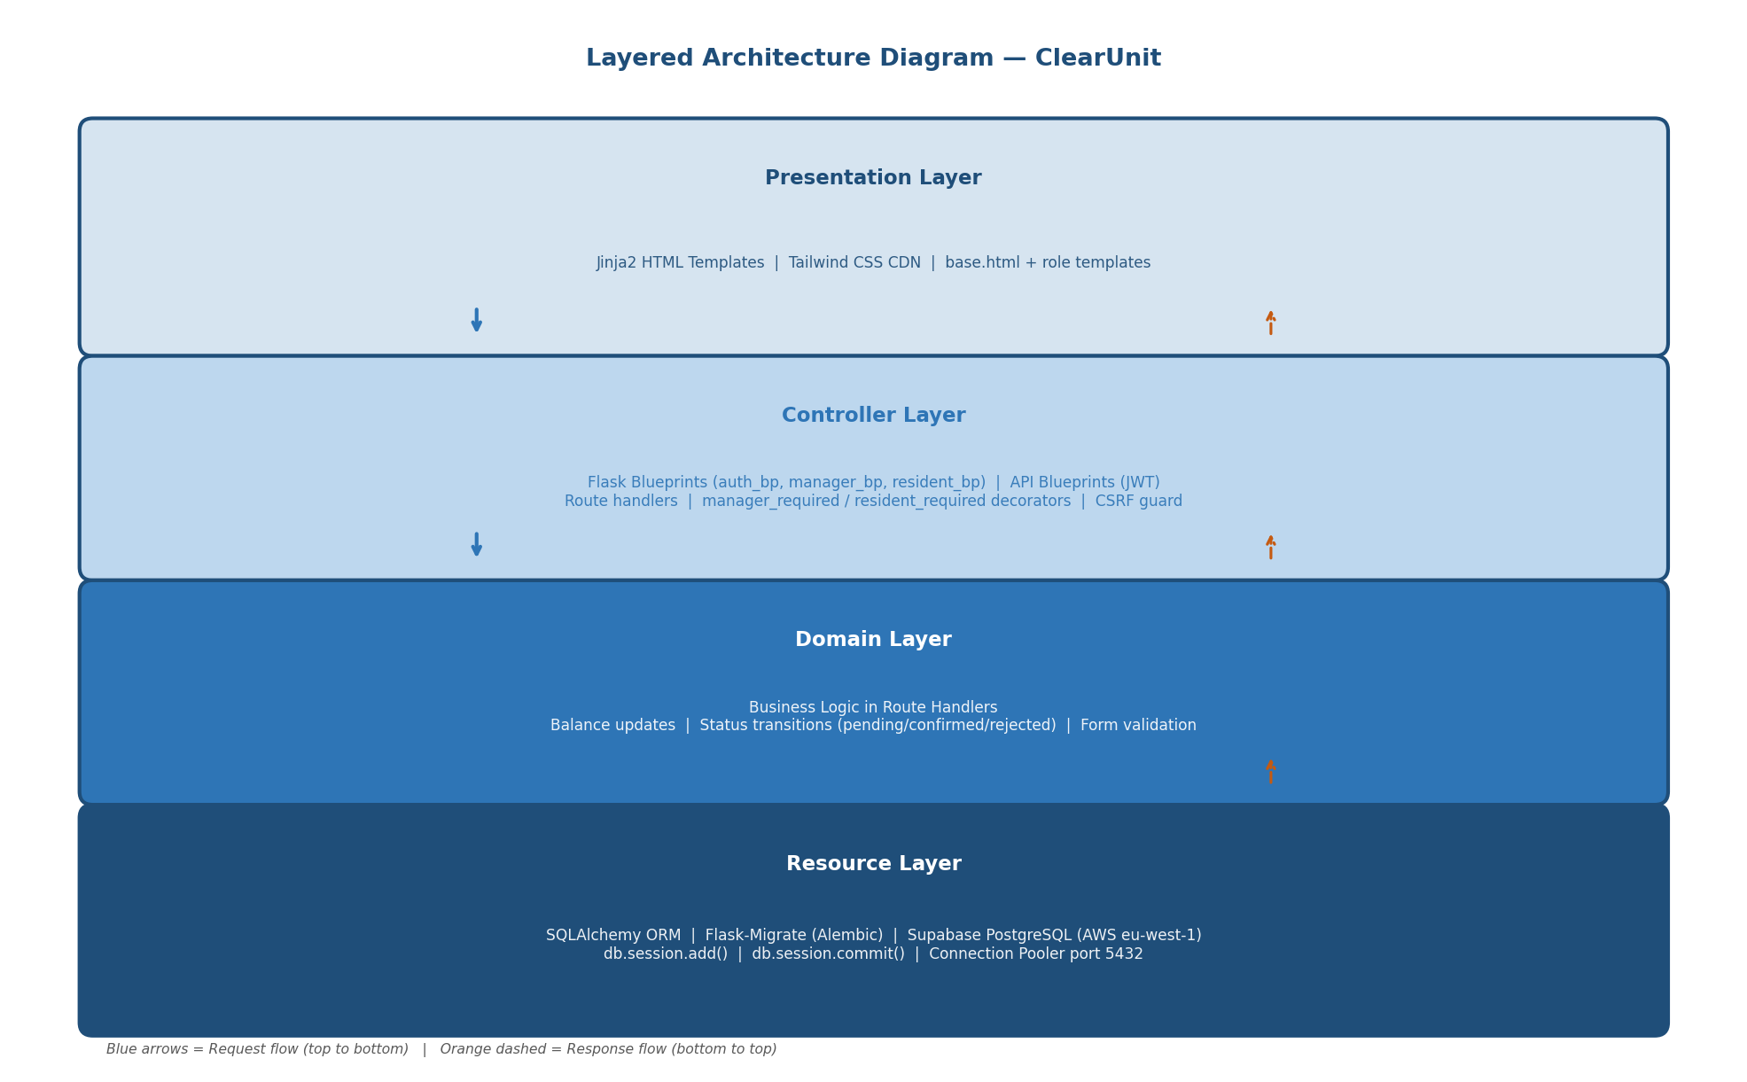
Figure 2 — ClearUnit Layered Architecture Diagram
The Presentation Layer (Jinja2 templates) renders HTML by consuming context data passed from the Controller Layer (Flask Blueprints). The Controller Layer validates input, enforces access control, and calls into the Domain Layer where business rules (balance updates, status transitions) are applied before any persistence call. The Resource Layer (SQLAlchemy + Supabase) is accessed exclusively through the SQLAlchemy session, ensuring a clean separation between business logic and database technology.

3.2 UML Class Diagram

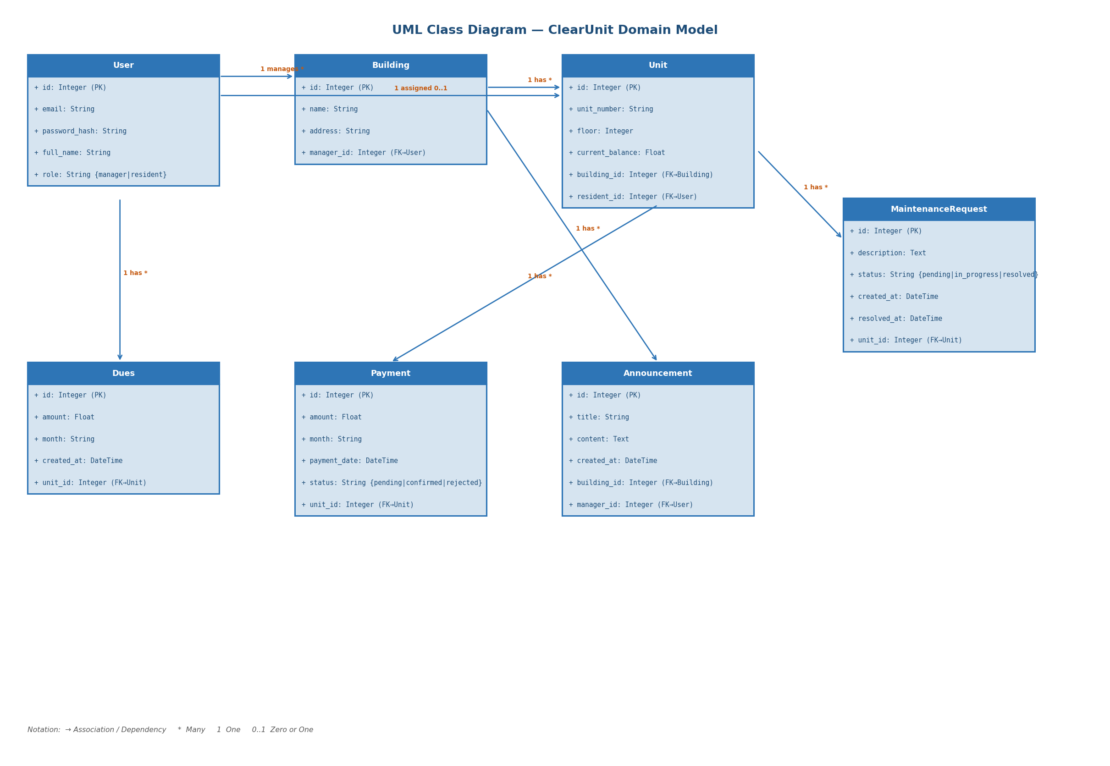
Figure 2 -- ClearUnit UML Class Diagram (Domain Model)

3.3 Domain Model Description

Model | Key Fields | Relationships
User | id, email, password_hash, full_name, role | Manages many Buildings; Assigned to 0..1 Units
Building | id, name, address, manager_id (FK→User) | Belongs to User (manager); Has many Units, Announcements
Unit | id, unit_number, floor, current_balance, building_id, resident_id | Belongs to Building; Belongs to User (resident); Has Dues, Payments, MaintenanceRequests
Dues | id, amount, month, created_at, unit_id (FK→Unit) | Belongs to Unit
Payment | id, amount, month, payment_date, status, unit_id (FK→Unit) | Belongs to Unit; status: pending | confirmed | rejected
Announcement | id, title, content, created_at, building_id, manager_id | Belongs to Building; Belongs to User (manager)
MaintenanceRequest | id, description, status, created_at, resolved_at, unit_id | Belongs to Unit; status: pending | in_progress | resolved

3.4 Architecturally Significant Design Packages

Authentication Package (routes/auth.py)
Handles registration, login, and logout. Uses Flask-Login for sessions. The index route acts as a smart redirect sending authenticated users to their role dashboard.

Manager Package (routes/manager.py)
All manager business logic: building/unit CRUD, dues creation (bulk or per-building), payment confirmation/rejection, announcement publishing, and maintenance status progression. All routes are protected by manager_required.

Resident Package (routes/resident.py)
All resident operations: viewing dues/payments, submitting payment notifications, filing maintenance requests, and reading announcements. All routes are protected by resident_required.

API Package (routes/api/)
Parallel JSON blueprints (api/auth, api/manager, api/resident) expose all functionality as REST endpoints protected by Flask-JWT-Extended. CSRF-exempt for programmatic clients.

3.5 Partial Backend Code -- Core Models
The following snippet shows the key SQLAlchemy models that form the domain layer:

# backend/app/models.py
from flask_login import UserMixin
from werkzeug.security import generate_password_hash, check_password_hash
from app import db

class User(UserMixin, db.Model):
id = db.Column(db.Integer, primary_key=True)
email = db.Column(db.String(120), unique=True, nullable=False)
password_hash = db.Column(db.String(256), nullable=False)
full_name = db.Column(db.String(100), nullable=False)
role = db.Column(db.String(20), nullable=False) # manager | resident
managed_buildings = db.relationship('Building', backref='manager',
foreign_keys='Building.manager_id')
units = db.relationship('Unit', backref='resident',
foreign_keys='Unit.resident_id')

class Unit(db.Model):
id = db.Column(db.Integer, primary_key=True)
unit_number = db.Column(db.String(20), nullable=False)
floor = db.Column(db.Integer, nullable=False)
current_balance = db.Column(db.Float, default=0.0)
building_id = db.Column(db.Integer, db.ForeignKey('building.id'))
resident_id = db.Column(db.Integer, db.ForeignKey('user.id'))
dues = db.relationship('Dues', backref='unit', cascade='all, delete-orphan')
payments = db.relationship('Payment', backref='unit', cascade='all, delete-orphan')
maintenance_requests = db.relationship('MaintenanceRequest', backref='unit',
cascade='all, delete-orphan')

class Payment(db.Model):
id = db.Column(db.Integer, primary_key=True)
amount = db.Column(db.Float, nullable=False)
month = db.Column(db.String(20), nullable=False)
payment_date = db.Column(db.DateTime, default=datetime.utcnow)
status = db.Column(db.String(20), default='pending')
unit_id = db.Column(db.Integer, db.ForeignKey('unit.id'))
Code Snippet 2 -- backend/app/models.py (key models)
4. Process View

ClearUnit follows the synchronous WSGI request-response model. There is a single process; the web server manages concurrency through workers at the deployment level. This section shows system behaviour and workflows using a sequence diagram.

4.1 Sequence Diagram -- Resident Notifies Payment
The sequence diagram below illustrates a complete, representative workflow: a resident submitting a payment notification. It shows all system layers involved -- from the browser through Flask's auth guard, the route handler, SQLAlchemy, and finally Supabase.

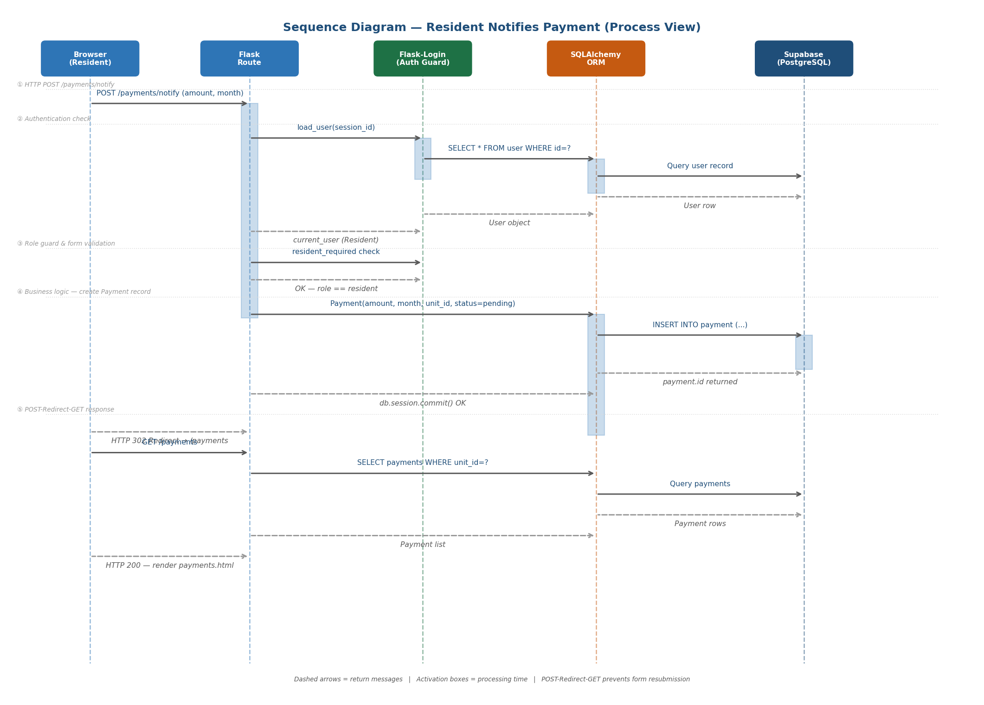
Figure 3 -- Sequence Diagram: Resident Notifies Payment

4.2 Request Lifecycle
- ① Browser sends HTTP POST /payments/notify with form data (amount, month).
- ② Flask-Login reconstructs current_user from the signed session cookie (load_user queries Supabase via SQLAlchemy).
- ③ resident_required decorator verifies role == 'resident'; rejects unauthorized requests with redirect.
- ④ Route handler validates form input, creates a Payment record (status='pending'), and commits to Supabase via db.session.commit().
- ⑤ POST-Redirect-GET: Flask returns HTTP 302 → /payments. Browser follows redirect; route queries and renders the updated payment list.

4.3 Session Management
Flask-Login manages sessions using a signed server-side cookie. The session stores only the user ID; the full User record is fetched from Supabase on every request via the load_user callback. Sessions persist until logout or cookie expiry.

4.4 Concurrency
In development, Flask's built-in server handles requests sequentially. In production (Gunicorn + multiple workers), each worker handles requests independently. All business logic is stateless -- no shared in-memory state -- so horizontal scaling is safe. Supabase's connection pooler manages concurrent database connections across workers.

4.5 Process Workflow 2 — User Login
The login workflow demonstrates how Flask-Login authenticates a user and establishes a session:

# | Step | Detail / System Action
1 | User submits login form | Browser sends HTTP POST /login with email and password fields.
2 | Route handler reads credentials | Flask extracts email (lowercased) and password from request.form.
3 | Database lookup | SQLAlchemy queries: User.query.filter(func.lower(User.email) == email).first()
4 | Password verification | Werkzeug's check_password_hash() compares the submitted password against the stored PBKDF2-SHA256 hash.
5 | Session creation | If credentials match: login_user(user) is called. Flask-Login writes a signed user_id cookie to the browser.
6 | Role-based redirect | System checks user.role: 'manager' → redirect to /dashboard (manager_bp); 'resident' → redirect to /dashboard (resident_bp).
7 | Failed login | If credentials are invalid, flash('Invalid email or password.', 'danger') is called and the login form is re-rendered (no redirect).

4.6 Process Workflow 3 — Manager Creates Dues
The dues creation workflow shows how the manager triggers a bulk write operation across multiple database records:

# | Step | Detail / System Action
1 | Manager opens dues form | Browser sends HTTP GET /dues/create. Flask queries all buildings owned by current_user and renders the form.
2 | Manager submits the form | Browser sends HTTP POST /dues/create with amount, month, and building_id (a specific building ID or 'all').
3 | Input validation | Route handler validates: amount must be a positive float, month must be non-empty, building_id must be valid and owned by the manager.
4 | Resolve target buildings | If building_id == 'all', target_buildings = all manager buildings. Otherwise, the specific building is fetched and ownership is confirmed.
5 | Bulk Dues creation | For each building in target_buildings, for each unit in building.units: a Dues record is created (amount, month, unit_id) and db.session.add() is called.
6 | Balance update | For each affected unit: unit.current_balance += amount. This is applied in-memory before commit.
7 | Atomic commit | db.session.commit() writes all Dues records and balance updates in a single database transaction. If any write fails, all changes are rolled back.
8 | Response | Flash message: 'Dues of $X created for N unit(s) for [month].' Manager is redirected to /dues (POST-Redirect-GET).

4.7 Related Code -- Payment Notify Route
The following snippet shows the exact Flask route handler that corresponds to the sequence diagram above:

# backend/app/routes/resident.py
@resident_bp.route('/payments/notify', methods=['GET', 'POST'])
@login_required
@resident_required
def notify_payment():
units = Unit.query.filter_by(resident_id=current_user.id).all()
unit_id = request.form.get('unit_id', type=int)
unit = _get_unit(units, unit_id)

if request.method == 'POST':
amount_str = request.form.get('amount', '').strip()
month = request.form.get('month', '').strip()

# Validate input
try:
amount = float(amount_str)
if amount <= 0: raise ValueError
except ValueError:
flash('Amount must be a positive number.', 'danger')
return render_template('resident/notify_payment.html',
unit=unit, units=units)

# Create Payment record (status defaults to 'pending')
payment = Payment(amount=amount, month=month,
unit_id=unit.id, payment_date=date.today())
db.session.add(payment)
db.session.commit() # ← atomic write to Supabase

flash('Payment notification sent to your manager.', 'success')
return redirect(url_for('resident.payments', unit_id=unit.id))

return render_template('resident/notify_payment.html',
unit=unit, units=units)
Code Snippet 3 -- backend/app/routes/resident.py (notify_payment route)
7. References

Reference | Details
Flask | Pallets Projects. Flask Web Framework. https://flask.palletsprojects.com
SQLAlchemy | SQLAlchemy ORM. https://www.sqlalchemy.org
Flask-SQLAlchemy | SQLAlchemy extension for Flask. https://flask-sqlalchemy.palletsprojects.com
Flask-Migrate | Alembic-based schema migrations. https://flask-migrate.readthedocs.io
Flask-Login | User session management. https://flask-login.readthedocs.io
Flask-WTF / CSRFProtect | CSRF protection. https://flask-wtf.readthedocs.io
Flask-JWT-Extended | JWT authentication for APIs. https://flask-jwt-extended.readthedocs.io
Werkzeug | WSGI toolkit + password hashing. https://werkzeug.palletsprojects.com
Jinja2 | Template engine for Python. https://jinja.palletsprojects.com
Tailwind CSS | Utility-first CSS framework (CDN). https://tailwindcss.com
PostgreSQL | Open-source relational database. https://www.postgresql.org
Supabase | Managed cloud PostgreSQL with connection pooling. https://supabase.com
4+1 View Model | Kruchten, P. (1995). Architectural Blueprints - The 4+1 View Model. IEEE Software, 12(6), 42-50.
RUP SAD Template | IBM Rational Unified Process -- Software Architecture Document Template

