
Mansoura Higher Institute for Engineering and Technology
Department of Communications and Electronics Engineering

AI-Powered Network Intrusion Detection System
(حارث)
A report submitted in partial fulfillment for requirements of the degree of B.Sc in communication and electrical engineering
In
Communications & Electronics Engineering
By
Project Group 2026
Supervisors
Dr. Waleed Gaballah Dr. Shaimaa Elsabbahi
Eng. Amira Basuoni Eng. Shrouk Abdelnaser

2025 / 2026
Students

N | Name | ID
1 | Amr Tarek Mabrouk | 4737
2 | Mahmoud Magdi Elbahi | 4649
3 | Ahmed Mostafa Eid | 4762
4 | Fatma Mohamed Anas | 4833
5 | Merna Elsayed Morad | 4815
6 | Israa Ibrahim Ali | 5007
7 | Doaa Ibrahim Saad | 4599
8 | Diaa Mohamed Abdelaziz | 4609
9 | Hager Ibrahim Abdullah | 4661
10 | Ahmed Mohamed Abdelaziz | 4817

Acknowledgment

First and foremost, we are thankful to الله for helping us finish this project; without him, nothing would have come to pass.
Our sincere thanks go to our advisors, Dr. Waleed Gab-Allah, Dr. Shaimaa Elsabbahi, Eng. Amira Basuoni and Eng. Shrouk Abdelnaser for the opportunity to work on this project. We very much enjoyed working with them. They gave us supervision, extending guidance, support, and encouragement.
The most appreciation goes to our College Dean, Prof. Ibrahim Badran, and our Head of the department, Prof. Dr. Mohamed Ahmed El-Said, who gave us and our friends their unlimited help.
Also, we would like to take great pleasure in thanking all our colleagues at the department for all the happy memories we shared during our time spent studying at this college.
Finally, we would also like to thank our family for the love, support, and constant encouragement we have received over the years

Abstract
7arth is an advanced, AI-powered Network Intrusion Detection System (NIDS) specifically engineered to bridge the gaps found in traditional security frameworks. While conventional systems struggle with "zero-day" attacks and suffer from high false-positive rates, 7arth leverages a sophisticated hybrid machine learning architecture—combining Random Forest for efficient binary classification and Neural Networks for granular multi-class threat identification.
The system is designed to monitor and secure network environments in real-time, detecting a wide spectrum of modern threats, including ransomware, DDoS attacks, spoofing, and backdoors. By training on diverse and contemporary datasets such as UNSW-NB15, RT-IOT2022, and specialized URL phishing data, 7arth ensures high precision in both standard IT and IoT ecosystems. Its lightweight and cost-effective design, built on open-source technologies like Python and TensorFlow, makes it an ideal solution for small to medium-sized organizations. Featuring an interactive dashboard for visual analytics and instant alerts, 7arth transforms complex network data into actionable intelligence, significantly enhancing the proactive cybersecurity posture of its users.

Keywords:

Network Security, Intrusion Detection, AI, Threat Detection, Cybersecurity

Project Summary
In the First Three Chapter documentation, it details a project to create a smart system for real-time network traffic monitoring and analysis, designed to identify cyber threats like ransomware, denial-of-service attacks, and phishing. The system uses AI algorithms for precise and efficient data classification and analysis and features a user-friendly dashboard for threat monitoring and response. 7arth lightweight design and low cost make it ideal for small and medium-sized businesses.

Chapter 1:
Introduction (Current Chapter): Provides an overview of the project, its objectives, the methodologies employed, and the structure of this document.
Chapter 2:
Network Intrusion Detection Systems (NIDS): Delves into the fundamentals of NIDS, their functions, limitations of traditional approaches, and the emergent role of Artificial Intelligence in enhancing their capabilities.
Chapter 3:
Related Work: Reviews existing NIDS tools and significant research in AI/ML applications within cybersecurity, highlighting gaps addressed by 7arth.
Chapter 4:
7arth System Design: Details the architectural design of 7arth, including data flow, component breakdown, preprocessing techniques, and the rationale behind selection.

Chapter 5:
Implementation & Results: Describes the datasets used, the training and evaluation processes of the AI models, and the development and features of the real-time dashboard.
Chapter 6:
Conclusions & Future Work: Summarizes the key achievements of the project and outlines potential future enhancements and directions for continued research and development.

Table of Contents
Acknowledgment I
Abstract II
Keywords: II
Project Summary III
List of Figures IX
List of Tables X
Chapter 1 : Introduction 1
1.1 Overview 1
1.2 Objectives 2
1.2.1 Detect Known and Unknown Threats using Machine Learning (ML) and Deep Learning (DL): 2
1.2.2 Provide RealTime Monitoring via an Interactive Dashboard: 2
1.2.3 Ensure Scalability and Cost-Effectiveness through Open-Source Technologies: 3
1.3 Methodology 3
1.3.1 Hybrid AI Approach: Random Forest + Neural Network: 3
1.3.2 Diverse Data Sources: 3
1.3.3 Tools: 4
1.4 Tools 5
1.4.1 Network Simulation & Emulation Environment 5
1.4.2 Machine Learning & Data Processing (Python Ecosystem) 5
1.4.3 System Integration & User Interface 6
1.4.4 Development Environment 6
Chapter 2 : Network Intrusion Detection Systems (NIDS) 5
2.1 Comparison with Firewalls and Intrusion Prevention Systems (IPS) 6
2.1.1 NIDS vs. Firewalls: 6
2.1.2 NIDS vs. Intrusion Prevention Systems (IPS): 7
2.2 IDS Types 9
2.2.1 Host-Based IDS (HIDS) 9
2.2.2 Network-Based IDS (NIDS) 9
2.2.3 Signature-Based IDS (SIDS) 10
2.2.4 Anomaly-Based IDS (AIDS) 10
2.3 Limitations of Traditional NIDS 10
2.3.1 Signature-Based Drawbacks: 11
2.3.2 High False Positives: 11
2.3.3 Resource Intensity (Hardware and Management): 12
2.4 Role of AI in NIDS 13
2.4.1 Anomaly Detection Capabilities: 13
2.4.2 Adaptability and Continuous Learning: 13
2.4.3 Reduced False Alarms and Improved Accuracy: 14
2.4.4 Handling Large Volumes of Data (Big Data Analytics): 14
2.4.5 Automated Threat Categorization: 15
2.5 Advanced Network Infrastructure for NIDS Integration 15
2.5.1 Hierarchical Network Design and VLAN Segmentation: 15
2.5.2 Core Network Services: 16
2.6 Proactive Layer 2 and Layer 3 Security Mechanisms 16
2.6.1 Layer 2: Port Security and MAC Filtering: 16
2.6.2 Layer 3: Access Control Lists (ACL) and Blacklisting 17
2.7 Network Simulation and Forensic Tools 17
Chapter 3 : Related Work 16
3.1 Existing NIDS Tools 16
3.2 AI/ML in Cybersecurity 18
3.2.1 Problem Domain 19
3.2.2 Domain Knowledge 20
3.2.3 Domain Knowledge for Intrusion Detection Systems 21
3.2.4 Domain Knowledge Infusion 21
3.3 Experiments 25
3.4 Findings from Explainability Test 25
3.4.1 Specific ML/DL Techniques and Their Application: 27
3.4.2 Deep Learning: 27
3.4.3 Challenges and Future Directions in AI/ML NIDS: 28
Chapter 4 : 7arth System Design 16
4.1 Architecture 16
4.2 Packet Sniffer: 17
4.3 Feature Extractor: 17
4.4 Data Preprocessing Module: 18
4.4.1 Handling Missing Values: 19
4.4.2 Encoding Categorical Features: 19
4.4.3 Normalization/Standardization: 20
4.4.4 Feature Engineering: 21
4.4.5 Feature Extraction: 22
4.5 AI Pipeline (AI-Driven Detection Engine): 26
4.6 Model Selection 29
4.6.1 Random Forest (Binary Attack/Normal Classification): 29
4.6.2 Neural Network (Multi-Class Attack Type Prediction): 30
4.7 Performance Metrics: 31
4.7.1 Alerting System: 32
4.8 Real-Time Dashboard: 32
4.8.1 Dashboard Development 33
4.9 Tech Stack: 35
Chapter 5 : Implementation & Results 16
5.1 Dataset Description 16
5.1.1 UNSW-NB15 Dataset: 16
5.1.2 RT-IOT2022 Dataset: 17
5.1.3 URL Phishing Datasets: 17
5.2 Training & Evaluation 18
5.2.1 Cross-Validation Methodology: 18
5.2.2 Training 7arth Models: 19
5.2.3 Comparison with Other Baseline Classifiers (for Binary Classification): 20
Chapter 6 :Conclusions & Future Work 16
6.1 Conclusions 16
6.2 Key Achievements 16
6.3 Future Enhancements 17
References 29
Appendices 31

List of Figures
Fig ‎1.1: IDS location 2
Fig ‎2.1: IDS 6
Fig ‎2.2: IDS VS IPS 8
Fig ‎2.3: HIDS 9
Fig ‎2.4: NIDS 10
Fig ‎2.5 Network design and topology 18
Fig ‎2.6 Centralized Distribution and Inter-VLAN Core Architecture 18
Fig ‎2.7 Verifying using the Ping command 18
Fig ‎3.1: CIA 19
Fig ‎3.2: UNSW-NB15 Dataset 20
Fig ‎3.3: domain knowledge 21
Fig ‎3.4: feature construction 24
Fig ‎4.1: 7ath System Architecture and Data Flow 16
Fig ‎4.2: AI Architecture 17
Fig ‎4.3: Data Preprocessing Architecture 18
Fig ‎4.4: Data Preprocessing steps 18
Fig ‎4.5: PCA vs LDA 25
Fig ‎4.6: Random forest 26
Fig ‎4.7: neural network 27
Fig ‎4.8: LSTM 27
Fig ‎4.9: MLP 28
Fig ‎4.10: KNN 29
Fig ‎4.11: Dashboard 33

List of Tables

Table ‎2.1: NIDS vs. Intrusion Prevention Systems (IPS) 7
Table ‎3.1: compare between most known NIDS systems 17
Table ‎3.2: Attacks related to CIA features 23
Table ‎4.1: Feature extraction vs feature selection 26
Table ‎5.1: Comparative Performance for Binary Classification (Normal/Malicious) 20
Table ‎5.2: Expected Performance Metrics for Model Evaluation 21

Introduction

: Introduction

Overview
In the modern era of digital connectivity, where interconnectivity is the backbone of global business, communication, and infrastructure, the importance of robust cybersecurity cannot be overstated. Networks, both private and public, are the arteries through which vital information flows, and as such, they are the first point of attack for aggressors. Cyberattacks, ranging from sophisticated nation-state sponsored espionage to opportunistic ransomware incursions, pose a threat to data integrity, confidentiality, and availability with severe repercussions.
Organizations globally are under a constantly rising onslaught of threats, requiring sophisticated defense mechanisms to protect their digital assets. Traditional Network Intrusion Detection Systems (NIDS) have long been vital components of a complete cybersecurity solution. NIDS systems monitor network traffic for suspicious activity and known attack signatures and alert administrators to potential intrusions. Conventional NIDS typically encounter significant challenges. Signature-based NIDS, while effective at detecting familiar threats, inherently struggle with "zero-day" attacks— new or previously unknown exploits for which no pre-established signature exists.
This limitation renders them reactive rather than proactive. Furthermore, the majority of traditional NIDS generate a high volume of false positives, which could lead to "alert fatigue" among security analysts, diverting their attention from actual threats and increasing operational costs. The volume of manual effort required to tune and maintain such systems can also be significant, becoming impractical under rapidly evolving threat environments. This report introduces 7arth, a new AI-powered Network Intrusion Detection System that addresses these fundamental limitations. 7arth employs artificial intelligence and machine learning to create a lightweight, extremely efficient, and simple-to-use solution for real-time network defense. By integrating advanced analytical functionality, 7arth is built to detect known and unknown threats with unparalleled precision, significantly reducing false positives and providing actionable information through a simple-to-use real-time dashboard.
Our solution is built to be cost-effective and scalable, using open-source technologies to make accessibility and adaptability a reality for diverse network environments.
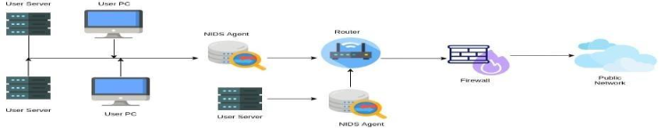
Fig ‎1.1: IDS location

Objectives
The primary objectives of the 7arth project are multifaceted, aiming to deliver a comprehensive and effective network security solution:

Detect Known and Unknown Threats using Machine Learning (ML) and Deep Learning (DL):
The core objective is to move beyond traditional signature-based detection by employing sophisticated ML and DL algorithms. This approach enables 7arth to identify anomalous behaviors and subtle indicators of compromise that may represent novel or zero-day attacks, in addition to recognizing established threat patterns.

Provide RealTime Monitoring via an Interactive Dashboard:
To enhance situational awareness and facilitate rapid response, 7arth aims to develop a dynamic, interactive dashboard. This dashboard will offer real-time visualization of network traffic, detect anomalies, and categorize threats, providing administrators with immediate insights into the security posture of their network.

Ensure Scalability and Cost-Effectiveness through Open-Source Technologies:
Recognizing the financial and operational constraints faced by many organizations, 7arth is committed to leveraging open-source tools and frameworks. This strategic choice not only minimizes licensing costs but also ensures the system's flexibility, extensibility, and ability to scale efficiently across various network sizes and complexities.

Methodology
The development of 7arth follows a robust and systematic methodology, integrating advanced AI techniques with practical system design principles:

Hybrid AI Approach: Random Forest + Neural Network:
To maximize detection accuracy and robustness, 7arth adopts a hybrid AI model. A Random Forest classifier is employed for initial binary classification, distinguishing between normal and potentially malicious network traffic with high efficiency. Subsequently, a Neural Network model is utilized for more granular, multi-class classification of identified threats, enabling the system to categorize specific attack types (e.g., Denial of Service, reconnaissance, backdoor). This combination leverages the strengths of both ensemble learning and deep learning, providing a powerful and adaptable detection engine.

Diverse Data Sources:
The efficacy of any AI-driven system heavily relies on the quality and diversity of its training data. 7arth is trained and validated using a combination of well-established and contemporary datasets:
- UNSW-NB15 Dataset: A comprehensive network traffic dataset designed to represent real-world network attacks and normal activity, featuring a wide range of modern attacks such as Fuzzers, Analysis, Backdoors, DoS, Exploits, Generic, Reconnaissance, Shellcode, and Worms. This dataset is crucial for training the models to detect various forms of network intrusions.
- RT-IOT2022 Dataset: Specifically curated for Internet of Things (IoT) environments, this dataset provides valuable traffic patterns and attack vectors pertinent to IoT devices. Given the proliferation of IoT devices and their often-vulnerable security postures, incorporating this dataset enhances 7arth applicability and effectiveness in securing diverse network ecosystems.
- URL Phishing Datasets: To broaden the scope of detection beyond network-level anomalies, 7arth also incorporates URL phishing datasets. This allows the system to identify malicious URLs within network traffic, offering an additional layer of defense against web-based threats.

Tools:
The implementation of 7arth relies on a powerful stack of open- source programming languages and libraries:
- Python: As the primary programming language, Python is utilized for its extensive ecosystem of data science and machine learning libraries.
- Pandas: Employed for efficient data manipulation, cleaning, and preprocessing of network traffic datasets.
- Scikit-learn: A widely used machine learning library for implementing and evaluating classical ML algorithms, including Random Forest, and for various preprocessing tasks.
- TensorFlow/Keras: For building and training the Neural Network models, leveraging their capabilities for deep learning architectures.

Tools
The realization of the proposed Network Intrusion Detection System (NIDS) relies on a sophisticated integration of network simulation, machine learning, and full-stack development tools. Each component in the following stack plays a critical role in data generation, model training, or system visualization.

Network Simulation & Emulation Environment
- Cisco Packet Tracer: Used for the initial architectural design and conceptual verification of the network. It provides a controlled environment to simulate standard networking protocols and ensure correct routing/switching logic before moving to complex scenarios.
- GNS3 (Graphical Network Simulator-3): Serving as the core emulation platform, GNS3 allows for the integration of real Cisco IOS images and virtual machines. In this project, GNS3 is pivotal for simulating realistic network traffic and executing controlled "attack" scenarios to test the NIDS in a near-real-world environment.

Machine Learning & Data Processing (Python Ecosystem)
Python serves as the primary engine for the AI component of the project, supported by a robust ecosystem of libraries:
- Pandas: Utilized for extensive data manipulation and preprocessing of the UNSW-NB15 dataset. It facilitates feature engineering, handling missing values, and formatting the raw network captures into a structure suitable for model training.
- Scikit-learn: This library is employed for implementing classical Machine Learning algorithms (such as Random Forest or SVM) and for critical evaluation of metrics, including Confusion Matrices, Precision-Recall curves, and Accuracy scores.

- TensorFlow & Keras: These frameworks are utilized for designing and deploying Deep Learning architectures. They enable the creation of complex neural networks (like CNNs or LSTMs) capable of detecting sophisticated, non-linear patterns within high-dimensional network traffic data.
- Google Colab: To overcome local hardware limitations, Google Colab provides a high-performance cloud-based environment with GPU acceleration, ensuring efficient training of the deep learning models on large-scale datasets.

System Integration & User Interface
To transform the detection model into a functional security product, a web-based management system is implemented:
- Flask (Backend): A lightweight WSGI web application framework used to bridge the AI model with the user interface. Flask handles the backend logic, processes incoming data streams, and serves the model's predictions via RESTful APIs.
- React.js (Frontend): A powerful JavaScript library used to build a dynamic and interactive administrative dashboard. It provides the network administrator with real-time visualizations, live alerts, and a comprehensive overview of the network's security posture.

Development Environment
- Visual Studio Code (VS Code): The primary Integrated Development Environment (IDE) used for the entire development lifecycle. Its versatility allows for seamless switching between Python backend development, react frontend scripting, and system debugging, ensuring a streamlined workflow across all layers of the NIDS architecture.

Network Intrusion Detection Systems (NIDS)

: Network Intrusion Detection Systems (NIDS)
A Network Intrusion Detection System (NIDS) is a critical component of modern cybersecurity infrastructure, acting as a watchful guardian over network traffic. Its fundamental purpose is to monitor network activities for suspicious patterns or known attack signatures that indicate a potential security breach or policy violation. Unlike firewalls, which primarily control ingress and egress traffic based on predefined rules (e.g., port numbers, IP addresses), NIDS operate by passively observing traffic flows, analyzing their content and behavior to identify anomalies or malicious intent. The key functions of a NIDS include:
- Monitoring Network Traffic: NIDS continuously inspects all packets traversing the network, often operating in promiscuous mode to capture and analyze data that may not be explicitly addressed to the system itself. This comprehensive monitoring allows for a broad view of network activities.
- Signature-Based Detection: This is the most common form of detection, where the NIDS maintains a database of known attack signatures (e.g., specific byte sequences, header patterns, or command structures associated with malware or exploits).
- Anomaly-Based Detection: More advanced NIDS employ anomaly detection techniques. Instead of looking for known malicious patterns, they establish a baseline of "normal" network behavior. Any significant deviation from this baseline is flagged as an anomaly, potentially indicating an unknown or novel attack. This method is particularly valuable for identifying zero-day threats.
- Alerting and Reporting: Upon detecting a potential intrusion, a NIDS generates alerts, which can take various forms, including email notifications, console messages, SNMP traps, or integration with Security Information and Event Management (SIEM) systems.

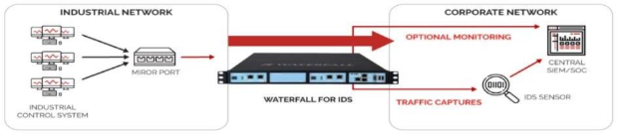
Fig ‎2.1: IDS

Comparison with Firewalls and Intrusion Prevention Systems (IPS)
It is important to differentiate NIDS from other network security devices

NIDS vs. Firewalls:
- Firewalls are primarily preventive security devices. They act as gatekeepers, enforcing access control policies at the network perimeter. They permit or deny traffic based on rules defined by network administrators (e.g., blocking traffic from certain IP ranges, allowing specific ports). Firewalls typically do not inspect the content of permitted traffic for malicious payloads.
- NIDS, on the other hand, are detective security devices. They monitor traffic that has already passed through the firewall and access controls. Their role is to identify ongoing or successful intrusions, providing visibility into internal network threats or attacks that bypass perimeter defenses. NIDS will alert but typically does not block traffic.

NIDS vs. Intrusion Prevention Systems (IPS):
- An Intrusion Prevention System (IPS) expands NIDS by not only detecting threats but also actively blocking malicious traffic in real time through actions like dropping packets or resetting connections.
- While IPS offers proactive defense, it risks false positives that may disrupt legitimate traffic, unlike NIDS which passively monitors without interfering with network operations.

Table ‎2.1: NIDS vs. Intrusion Prevention Systems (IPS)
Aspect | NIDS (Intrusion Detection System) | IPS (Intrusion Prevention System)
Function | Monitors and detects malicious activity | Detects and actively blocks malicious activity
Action Type | Passive – generates alerts | Active – blocks or prevents threats in real time
Placement in Network | Typically, outside the firewall or on a mirror port | In line with traffic, directly in the communication path
Response Time | Near real-time (after detection) | Real-time and automatic
Impact on Network Traffic | No interference or delay in traffic | May introduce slight latency
False Positive Handling | Alerts require manual investigation | May block legitimate traffic if misconfigured
Risk of Disruption | Low – only monitors | Medium to High – can block critical traffic if false positive occurs
Primary Use Case | Detection, monitoring, and forensic analysis | Automated prevention and immediate response
Cost and Complexity | Generally lower – easier to set up | Higher – needs careful tuning and integration

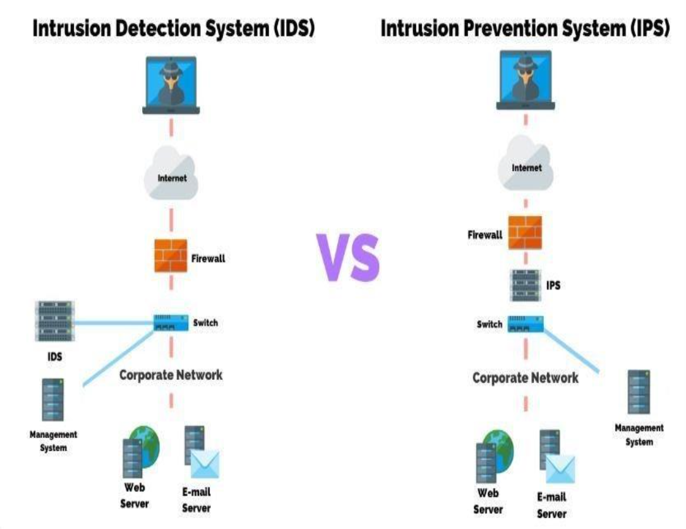
Fig ‎2.2: IDS VS IPS

In summary, NIDS play a vital role in providing deep visibility into network activities, identifying threats that may evade traditional perimeter defenses, and furnishing critical intelligence for incident response teams.

IDS Types

Host-Based IDS (HIDS)

A Host-Based Intrusion Detection System monitors activity on a single host or device, such as system logs, file changes, and running processes.
Use case: Detects insider threats or attacks targeting specific endpoints (e.g., servers or workstations).
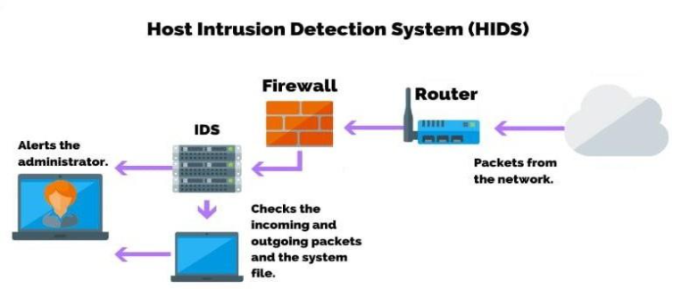
Fig ‎2.3: HIDS

Network-Based IDS (NIDS)
A Network-Based IDS monitors network traffic across the entire network or specific segments to detect suspicious activity in real time.
Use case: Identifies scanning, DoS attacks, or abnormal traffic between devices.

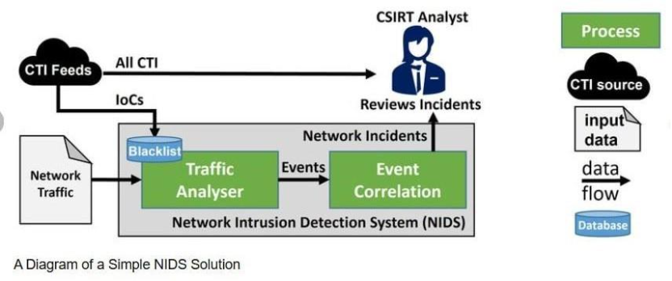
Fig ‎2.4: NIDS

Signature-Based IDS (SIDS)
A Signature-Based IDS detects threats by comparing activity to a known database of attack patterns or signatures.
Use case: Very effective against known threats but cannot detect new or unknown attacks.

Anomaly-Based IDS (AIDS)
An Anomaly-Based IDS uses machine learning or statistical methods to detect deviations from normal behavior in traffic or system activity.
Use case: Can detect zero-day or previously unknown attacks but may have higher false positives.

Limitations of Traditional NIDS
While traditional NIDS have been foundational to network security for decades, they are increasingly challenged by the evolving sophistication and volume of cyber threats. Their primary limitations stem from their reliance on specific detection methodologies:

Signature-Based Drawbacks:
- Inability to Detect Zero-Day Attacks:
The most significant limitation of signature-based NIDS, such as popular open-source solutions like Snort and Suricata, is their inherent inability to detect "zero-day" attacks. These are novel or previously unseen exploits for which no signature exists in the NIDS's database. Since the system only recognizes what it has been explicitly told to look for, any new attack pattern will simply pass through undetected until a corresponding signature is developed and updated. This makes signature-based systems inherently reactive; they can only detect threats after they have been identified, analyzed, and characterized.
- Constant Signature Updates Required:
To remain effective, signature databases must be continuously updated. This process is resource-intensive and requires dedicated security teams to analyze new threats and create new signatures. Delays in updates can leave networks vulnerable for extended periods.
- Signature Evasion Techniques:
Attackers constantly develop new techniques to evade signature detection. Polymorphic and metamorphic malware, for instance, can change their code structure while retaining their malicious functionality, making it difficult for static signatures to identify them. Encryption and obfuscation are also commonly used to hide malicious payloads from inspection.

High False Positives:
Traditional NIDS, especially those with extensive signature sets, often suffer from a high rate of false positives. A false positive occurs when the NIDS incorrectly identifies legitimate network activity as malicious. This can be due to overly broad signatures, misconfigurations, or legitimate traffic exhibiting patterns that coincidentally resemble known attack characteristics.

- Alert Fatigue:
A deluge of false positive alerts can lead to "alert fatigue" among security analysts. When analysts are constantly bombarded with non-actionable alerts, they become desensitized, increasing the likelihood of genuine threats being overlooked or dismissed as just another false alarm. This significantly reduces the effectiveness of the NIDS and can lead to costly security breaches.
- Resource Intensity for Analysis:
Investigating each alert, whether genuine or false, consumes valuable time and resources. Security teams spend a disproportionate amount of time triggering false alarms rather than focusing on actual threats, impacting operational efficiency, and increasing the total cost of ownership for the NIDS.

Resource Intensity (Hardware and Management):
- Processing Power:
Inspecting all network traffic at high speeds requires significant processing power and memory, especially in high- throughput environments. Traditional NIDS can become performance bottlenecks if not adequately provisioned, leading to dropped packets and missed detections.
- Management Complexity:
Deploying, configuring, and maintaining traditional NIDS can be complex. Rule tuning, managing signature updates, and integrating with other security tools requires specialized expertise and continuous effort. This complexity contributes to higher operational costs and a steeper learning curve for security personnel.
These limitations highlight the need for more intelligent and adaptive intrusion detection solutions that can overcome the challenges posed by the dynamic and sophisticated nature of modern cyber threats.

Role of AI in NIDS
The advent of Artificial Intelligence (AI) and its subfields, Machine Learning (ML) and Deep Learning (DL), offers a transformative solution to the inherent limitations of traditional Network Intrusion Detection Systems. By moving beyond static signature matching, AI-driven NIDS can significantly enhance detection capabilities, adaptability, and operational efficiency. The key advantages of integrating AI into NIDS are:

Anomaly Detection Capabilities:
- Identification of Unknown and Zero-Day Attacks:
This is perhaps the most significant advantage. Instead of relying on predefined signatures, AI models can learn about the "normal" behavior of a network and its users. Any significant deviation from this learned baseline is flagged as an anomaly. This enables the detection of novel attacks, zero-day exploits, and sophisticated evasion techniques that would bypass traditional signature-based systems. AI models can identify subtle, multi-stage attack patterns that might individually seem to benign but collectively indicate malicious intent.
- Contextual Understanding:
AI can process a vast array of network features (e.g., packet size, protocol usage, flow duration, source/destination IPs, byte counts, time-series data) and discern complex relationships between them. This allows for a more contextual understanding of network activities, leading to more accurate anomaly detection compared to simpler statistical methods.

Adaptability and Continuous Learning:
- Dynamic Threat Landscape:
The cyber threat landscape is constantly evolving, with new attack methods emerging daily. AI models, particularly those capable of continuous learning (e.g., through retraining new data), can adapt to these changes. As new attack patterns are observed, the models can be updated to recognize them, improving their future detection accuracy without requiring manual signature creation.
- Reduced Manual Effort:
The adaptability of AI reduces the need for constant manual updates of signatures and rules. While some human oversight is always necessary, AI automates a significant portion of the detection process, freeing up security analysts to focus on higher-level tasks like threat hunting and incident response.

Reduced False Alarms and Improved Accuracy:
- Intelligent Filtering:
AI algorithms can learn to differentiate between legitimate anomalous behavior (e.g., a legitimate surge in traffic due to a marketing campaign) and malicious activity. By identifying more nuanced patterns and dependencies, they can filter out benign anomalies that might otherwise trigger false positives in traditional systems. This leads to a substantial reduction in the volume of alerts, allowing security teams to focus on truly critical events.
- Enhanced Precision and Recall:
ML/DL models can be optimized for specific performance metrics like precision (minimizing false positives) and recall (minimizing false negatives). Through rigorous training and validation, AI-driven NIDS can achieve a much higher overall detection of accuracy, ensuring that a greater percentage of actual attacks are identified while legitimate traffic remains unimpeded.

Handling Large Volumes of Data (Big Data Analytics):
- Modern networks generate petabytes of traffic data daily. Traditional NIDS often struggle to process and analyze this "big data" efficiently. AI and ML algorithms are inherently designed
- To process and extract insights from massive datasets, making them well-suited for high-throughput network environments. They can identify patterns and correlations that would be impossible for human analysts to spot manually.

Automated Threat Categorization:
Beyond simply detecting an intrusion, AI models can often classify the type of attack (e.g., DoS, port scan, malware infection, phishing attempt). This automated categorization provides immediate context to security analysts, enabling faster and more targeted incident responses.
In conclusion, the integration of AI into NIDS represents a significant leap forward in network security. By providing advanced anomaly detection, continuous adaptability, and reduced operational overhead, AI-driven NIDS like 7arth is poised to become indispensable tools in defending against the complex and dynamic threats of the digital age.

Advanced Network Infrastructure for NIDS Integration
To effectively deploy an AI-powered system like 7arth, the underlying network must be structured to provide maximum visibility and security. The following components define the environment where 7arth operates:

Hierarchical Network Design and VLAN Segmentation:
- VLAN Implementation:
The network is logically divided into segments (e.g., VLAN 10 for Admin, VLAN 20 for Wireless, and VLAN 30 for Labs) to isolate traffic and enhance security.
- Inter-VLAN Routing: A Multilayer Switch (Layer 3):
acts as the core, using IP Routing and Switched Virtual Interfaces (SVIs) to enable controlled communication between different departments.
- Trunking Protocols (802.1Q):
Trunk links are configured between switches to allow data from all VLANs to travel across a single physical cable, ensuring the NIDS can monitor aggregated traffic.

Core Network Services:
- DHCP Configuration:
The Multilayer Switch is configured with DHCP Pools to automatically assign IP addresses, Subnet Masks, and Default Gateways to end devices.
- Connectivity Verification:
Tools like Simple PDU and Ping are used within the simulation to ensure that routing is functional and that devices can reach the gateway.

Proactive Layer 2 and Layer 3 Security Mechanisms
While 7arth focuses on detecting intrusions, the following hardware-level security measures are implemented to provide a "Defense in Depth" strategy:

Layer 2: Port Security and MAC Filtering:
- Sticky MAC Addresses:
Access switches are configured to learn and "stick" to the MAC address of authorized devices.
- Violation Modes:
If an unauthorized device (e.g., an attacker's laptop) is plugged into a lab port, the port automatically enters an err-disable (Shutdown) state.
- Storm Control:
To prevent Denial Service (DoS) attacks via traffic flooding, broadcast levels are suppressed at 1.0% of the interface bandwidth.

Layer 3: Access Control Lists (ACL) and Blacklisting
- Server Hardening:
Extended ACLs are applied to sensitive server interfaces to filter traffic based on source IP and protocol.
- Zero-Trust Policy:
Communication from restricted segments (like the Guest Wireless VLAN) is denied access to core servers by default.
- Incident Response:
Once 7arth or a manual investigation identifies an attacker's IP (e.g., 192.168.20.5), they are blacklisted at the firewall level.

Network Simulation and Forensic Tools
The design and testing of these security layers are facilitated by industry-standard simulation software:
- Cisco Packet Tracer:
A visual simulation tool used to design complex topologies and test the logic of AI-driven security before physical deployment.
- Simulation Mode:
This mode allows for step-by-step observation of data packets to ensure that routing and security rules are working as intended.
- Forensic Commands:
Commands such as show port-security interface and show mac address-table are utilized to identify the hardware addresses of potential threats.

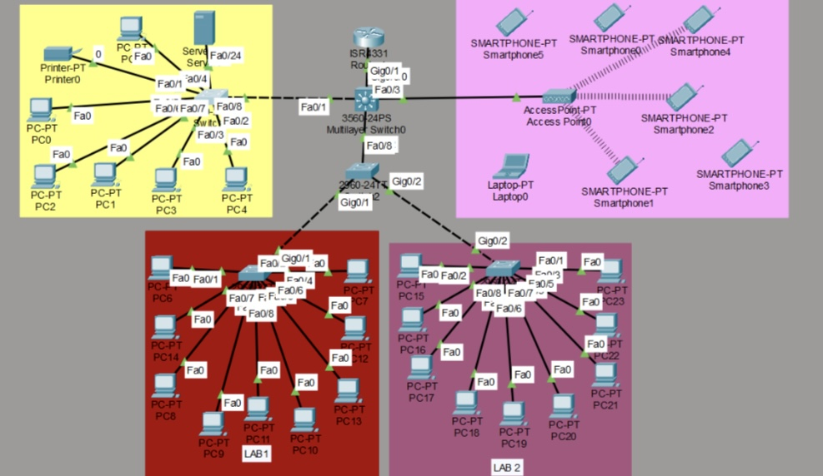

Fig ‎2.5 Network design and topology
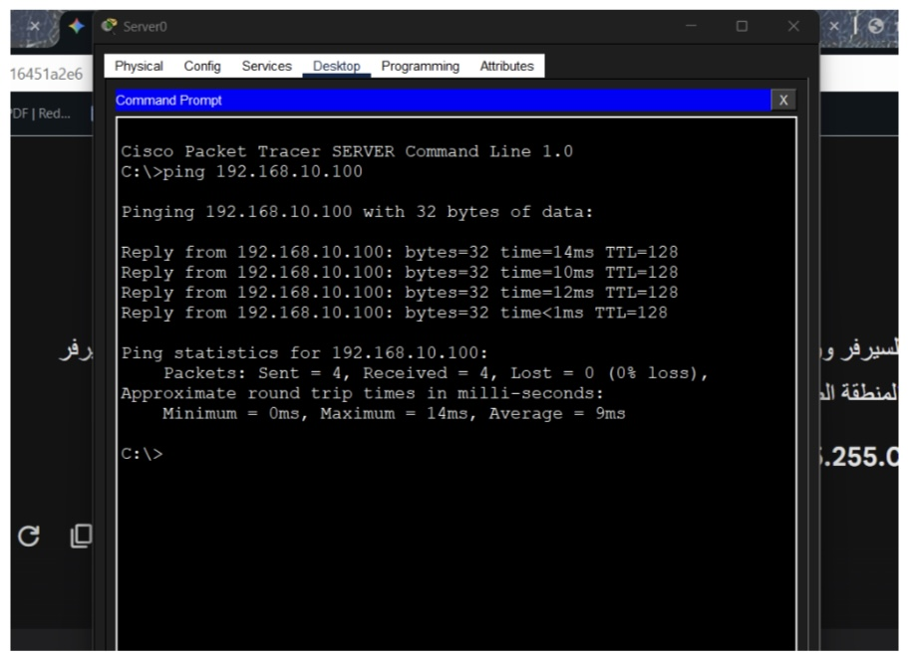
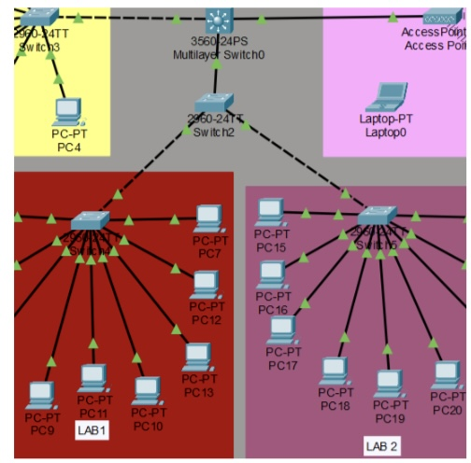
Fig ‎2.6 Centralized Distribution and Inter-VLAN Core Architecture

Fig ‎2.7 Verifying using the Ping command

Related Work

: Related Work

Existing NIDS Tools
The market and open-source community offer several prominent NIDS solutions, each with its strengths and typical use cases. A comparative analysis of these tools helps in understanding the current state-of-the-art and identifying areas for improvement.
      - Snort
- Type: Signature-based NIDS/NIPS
- Strengths: Widely used, strong rule set, real-time alerts, effective for known threats
- Limitations: Weak against zero-day attacks, needs frequent rule updates, resource-heavy, prone to false positives
      - Suricata
- Type: Open-source NIDS/NIPS/NSM
- Strengths: Multi-threaded, scalable, supports both signatures and limited anomaly detection
- Limitations: Still signature-focused, basic anomaly detection, complex configuration
      - Zeek (Bro)
- Type: Network Security Monitor & NIDS
- Strengths: Detailed network logs, customizable detection via scripting, good for behavioral analysis
- Limitations: Not focused on real-time alerts, no deep packet inspection, requires expert use
- Wazuh
- Type: SIEM with NIDS/HIDS capabilities
- Strengths: Centralized monitoring, combines log analysis, HIDS, and compliance tools
- Limitations: NIDS functions limited to log-based analysis, less focus on raw traffic inspection, and resource-intensive.

Table ‎3.1: compare between most known NIDS systems
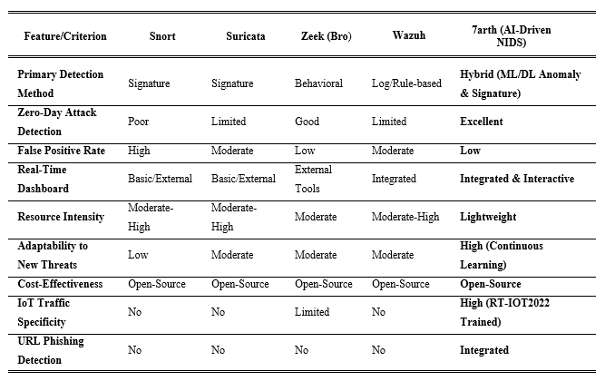
7arth aims to bridge the critical gaps left by these existing solutions, particularly in its robust ability to detect zero-day attacks and its focus on a lightweight, real-time, and user-friendly interface. By combining the strengths of advanced AI with open-source principles, 7arth offers a more adaptive and effective defense mechanism against modern cyber threats.

AI/ML in Cybersecurity
The lack of human-friendly explanations from Artificial Intelligence (AI)—based decisions is a major concern for high stake applications. Towards mitigating the concern, Explainable AI (XAI) is an emerging area of research. In remodeling explainability, which is one of the notions of explainability, one can introduce explainability before training the model. One can also introduce explainability during training of the model or after training the model, in general, both of which are known as post-hoc explainability. Unfortunately, post-hoc explainability is not readily transparent and can be misleading, as it explains after the decision has been made and can be optimized to placate a subjective demand which is a form of bias. As a result, the explanation from it can be misleading even though it seems plausible.
Explainability should incorporate knowledge from different domains such as philosophy, psychology, and cognitive science, so that the explanation is not just based on the researcher’s intuition of what constitutes a good explanation. Domain knowledge is an abstract, fuzzy, and high-level concept over the problem domain. For instance, in an image classification problem, the domain knowledge could be a dog has four legs, or a zebra has stripes, etc. However, the use of domain knowledge for explainability is under-focused and bound to problem-specific requirements. This chapter focuses on the notion of a pre-modeling explainability of AI-based “black box” models using domain knowledge. We demonstrate the collection and application of domain knowledge along with the quantification of explainability on an intrusion detection problem. Although AI-based Intrusion Detection Systems (IDS) provide accelerated speeds in intrusion detection, the response is still at a human speed when there is a human in the loop. The lack of explainability of an AI-based model is a key reason for this bottleneck as a human analyst has to understand the prediction before making the final decision towards mitigation of a problem. To mitigate this issue, in this chapter, we incorporate the CIA principle (i.e., domain knowledge) into an AI-based black box model for better explainability and generalizability of the model and demonstrate the process in detail.

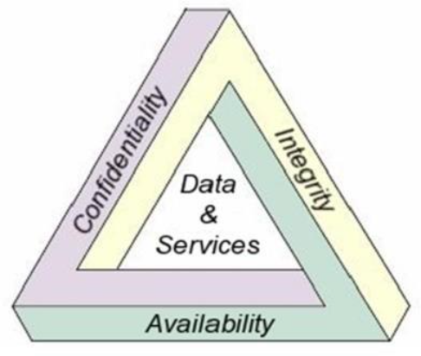

Fig ‎3.1: CIA

Problem Domain
Network intrusions are a common cyber-crime activity, estimated to cost around $6 trillion annually in damages by 2021. To combat these attacks, an Intrusion Detection System (IDS) is a security system to monitor networks and computer systems.Research in AI-based IDSs has shown promising results and has become an integral part of security solutions due to its capability of learning complex, nonlinear functions, and analyzing large data streams from numerous connected devices. A recent survey suggests that deep learning-based methods are accurate and robust to a wide range of attacks and sample sizes. However, there are concerns regarding the sustainability of current approaches (e.g., intrusion detection/prevention systems) when faced with the demands of modern networks and the increasing level of human interaction. In the age of IoT and Big Data, an increasing number of connected devices and associated streams of network traffic have exacerbated the problem. In addition, the delay in detection/response increases the chance of zero-day exploitation, whereby a previously unknown vulnerability is just discovered by the attacker, and the attacker immediately initiates an attack. However, improved explainability of an AI model could quicken interpretation, making it more feasible to accelerate the response. In this chapter, we demonstrate the use of domain knowledge for quicker interpretation of AI-based intrusion detection results.

Review of Recent Papers (e.g., UNSW-NB15 Studies, Kaggle Projects):
UNSW-NB15 Dataset Studies: The UNSW-NB15 dataset has become a benchmark for evaluating NIDS models, particularly those leveraging ML/DL. Numerous research papers have explored various machine learning algorithms on this dataset to achieve high detection accuracy for different attack categories.
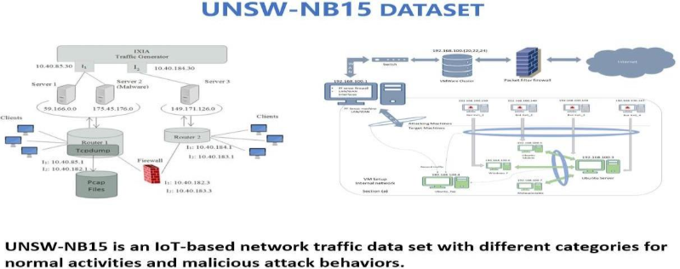
Fig ‎3.2: UNSW-NB15 Dataset

Domain Knowledge
Domain knowledge can be an abstract, fuzzy, and high-level concept over the target domain. For instance, in an image classification problem, the domain knowledge could be a dog has four legs, or a zebra has stripes, etc. Sometimes, it is very challenging to find appropriate domain knowledge. In addition, sometimes it is challenging to express domain knowledge in a numerical format, which is commonly needed for machine learning and statistical approaches.

Domain Knowledge for Intrusion Detection Systems
Domain knowledge mostly consists of high-level concepts from a specific domain. In the Cyber-security domain, although AI-based Intrusion Detection Systems (IDS) provide accelerated speeds in intrusion detection, the response is still at a human speed when there is a human in the loop. The lack of explainability of an AI-based model is a key reason for this bottleneck. To mitigate this problem, we incorporate the CIA principle (i.e., domain knowledge) into an AI-based black box model for better explainability and generalizability of the model. In the CIA principles, C stands for confidentiality—concealment of information or resources; I stand for integrity— trustworthiness of data or resources, and A stands for availability—ability to use the information or resource desired.

Domain Knowledge Infusion
In previous work, the proposed approach for combining domain knowledge consists of two components: a feature generalizer, which gives a generalized feature set with the help of domain knowledge in two different ways; and an evaluator that produces and compares the results from the “black box” model for multiple configurations of features: domain knowledge infused features, newly constructed features from domain knowledge infused features, selected features, and all features.
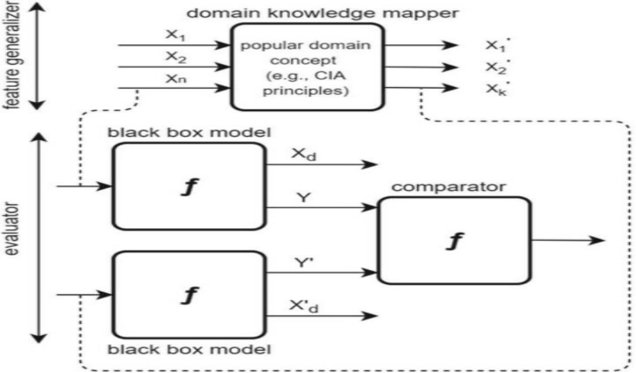
Fig ‎3.3: domain knowledge

Feature Generalizer: The feature generalizer takes the original features of the dataset (X1, X2, Xn ∈ X where X is the set of all features) and infuses domain knowledge
to produce/re-construct a concise and better interpretable feature set (X 1, X 2, X k ∈ X where X is the universal set of original/transformed/constructed features, but here k is much smaller than n) in two different ways.
Feature Mapping: To recall, we use CIA principles as domain knowledge, which stands for confidentiality, integrity, and availability. We analyze all types of attacks for associated compromises in each component of CIA principles. For example, a Heartbleed vulnerability is related to a compromise in confidentiality as an attacker could gain access to the memory of the systems protected by the vulnerable version of the OpenSSL; a Web attack (e.g., Sql injection) is related to a compromise in confidentiality and integrity (e.g., read/write data using injected query); and flooding a database server with injected complex queries (e.g., a cross join), would constitute an availability compromise. Another example is an Infiltration attack, which is related to a compromise in confidentiality as it normally exploits software vulnerability (e.g., Adobe Acrobat Reader) to create a backdoor and reveal information (e.g., IP’s).
Port scan attack is related to a compromise in confidentiality as the attacker sends packets with varying destination ports to learn the services and operating systems from the reply. All DoS and DDoS attacks are related to a compromise in availability as it aims to hamper the availability of service or data. Furthermore, SSH patator and FTP patator are brute force attacks and are usually responsible for a compromise in confidentiality. For instance, a botnet (i.e., robot network—a network of malware- infected computers) could provide a remote shell, file upload/download option, screenshot capture option, and key logging options which has potential for all the confidentiality, integrity, and an availability related compromise.

Table ‎3.2: Attacks related to CIA features
Attack | Related component of CIA
DoS GoldenEye | A
Heartbleed | C
DoS hulk | A
DoS Slowhttp | A
DoS slowloris | A
SSH-Patator | C
FTP-Patator | C
Web attack | CIA
Infiltration | C
Bot | CIA
PortScan | C
DDoS | A
Feature Construction: We also construct three new features, C, I, and A, from the domain features by quantitatively calculating compromises associated with each of the domain features. For that purpose, we calculate the correlation coefficient vector of the dataset to understand whether the increase in the value of a feature has a positive or negative impact on the target variable. We then convert the correlation coefficient (a.k.a., coeff ) vector V into a 1 or -1 based on whether the correlation coefficient is positive or negative accordingly. We also group the domain features and corresponding Coeff tuple into three groups. Using Formulas (3)– (5), we aggregate each group (from C, I, and A) of domain features into the three new features C, I, and A. We also scale all feature values from 0 to 1 before starting the aggregation process.
During the aggregation for a particular group (e.g., C), if the correlation coefficient vector (e.g., Vi) for a feature (e.g., Ci) of that group has a negative value, then the product of the feature value and the correlation coefficient for that feature is deducted, and vice-versa if positive. In addition, when a feature is liable for more than one compromise, the feature value is split between the associated elements of CIA principles.

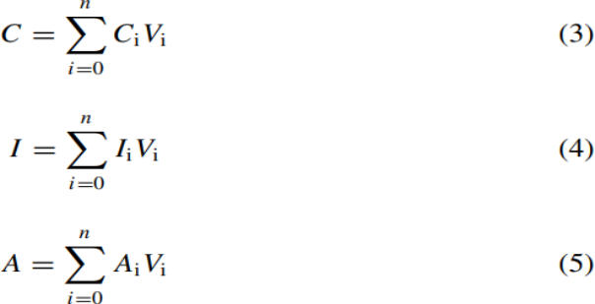
Fig ‎3.4: feature construction

Evaluator: The task of the evaluator is to execute (supervised models or algorithms) and compare the performance (in detecting malicious and benign records) of four different types of configurations of features: (1) using all features, (2) using selected features (selection is done using a feature selection algorithm), (3) using domain knowledge infused features, and (4) using newly constructed features C, I, and A from domain knowledge infused features. In addition, the evaluator performs the following two tests: 1. Explainability Test: The purpose of this test is to discover the comparative advantages or disadvantages of incorporating domain knowledge into the experiment; and 2. Generalizability Test: The purpose of this test is to analyze how different approaches perform in unknown or unseen attack detection. All training records for a particular attack are deleted at one time, and the performance of the model is evaluated on the same test set, which includes records from unknown or unseen attacks.

Experiments
We execute the experiments on a GPU enabled Linux machine with 12GB of RAM and a core i7 processor. All supervised machine learning algorithms are implemented using the Python-based Scikit-learn library. In addition, we use TensorFlow for the Artificial Neural Network. Due to resource limitations, instead of using the whole dataset, we take a stratified sample of the data which is big enough (i.e., 300K records) for a single GPU enabled commodity machine. We make the sampled dataset available to the research community. Furthermore, we use 70% of the data for training the models and keep 30% of the data as a holdout set to test the model. We confirm that the target class has the same ratio in both sets. To avoid the adverse effect of class imbalance in classification performance, we re-sample the minority class of the training set using SMOTE to balance the dataset. However, we do not re-sample the test set, as real-world data is skewed, and oversampling the test set could exhibit an over-optimistic performance.

Findings from Explainability Test
Comparing the performance using all features versus selected features, Table 3 shows that models using all features (denoted with an appended—A, for instance RF-A) tend to show better results in terms of all performance metrics. However, while the difference with the selected features setting is negligible, for any performance metric, that might be a result of the elimination of features with little significance. In addition, Random Forest outperforms other algorithms like SVM, ET, GB, ANN, and NB under this feature setting (i.e., using all features). So, we consider the results using all features as a baseline to compare against our proposed approach.
- For example, studies have shown that ensemble methods like Random Forest often yield high accuracy and F1-scores on UNSW-NB15 for binary classification (attack vs. normal) due to their ability to handle complex feature interactions and resist overfitting. Research by M. Tavallaee et al. (2009) and later refinements on similar datasets paved the way for advanced feature engineering and algorithm selection.
- Deep learning approaches, particularly Convolutional Neural Networks (CNNs) and Recurrent Neural Networks (RNNs), have also been applied to UNSW-NB15. CNNs are used for extracting spatial features from packet headers or flow data, while RNNs (like LSTMs) are effective in learning temporal dependencies in network traffic sequences, making them suitable for detecting multi-stage attacks or anomalies over time. Papers by S. B. D. C. S. Reddy et al. (2019) and other researchers have demonstrated the potential of deep learning for multi-class classification of various attack types within UNSW-NB15.
- Kaggle Projects and Public Datasets: Beyond academic papers, public data science platforms like Kaggle host numerous competitions and projects focused on cybersecurity datasets. These projects often showcase innovative applications of ML algorithms for intrusion detection.
- Many Kaggle solutions emphasize the importance of robust data preprocessing (e.g., handling missing values, encoding categorical features, normalization) and feature engineering (creating new features from raw data that better represent underlying attack patterns). Techniques like Principal Component Analysis (PCA) or Autoencoders are also explored for dimensionality reduction and anomaly detection in high- dimensional network data.
- The trend in these projects is towards hybrid models or ensemble learning, where multiple models are combined to improve overall performance and robustness. For instance, combining a decision tree-based model with a neural network can leverage the strengths of both: decision trees for interpretability and speed on structured data, and neural networks for complex pattern recognition in raw or semi- structured data.

Specific ML/DL Techniques and Their Application:
- Supervised Learning: Most NIDS applications fall under supervised learning, where models are trained on labeled datasets (e.g., "normal" or specific "attack type"). Algorithms commonly used include:
- Support Vector Machines (SVMs): Effective for binary classification with clear decision boundaries.
- Decision Trees/Random Forests: Provide good interpretability and handle non-linear relationships. Random Forests are robust against overfitting and good for feature importance.
- Gradient Boosting Machines (e.g., XGBoost, LightGBM): Often achieve state-of-the-art performance in tabular data classification.
Unsupervised Learning: Used for anomaly detection where labeled data is scarce or non-existent. Algorithms like K-Means Clustering, Isolation Forest, and One-Class SVM are used to identify outliers that deviate from the majority of the data points, which are assumed to be normal.

Deep Learning:
- Feedforward Neural Networks (FNNs): For classification tasks, especially when dealing with high-dimensional feature vectors.
- Convolutional Neural Networks (CNNs): Particularly useful for analyzing raw packet data or network flow images, identifying spatial patterns indicative of attacks.
- Recurrent Neural Networks (RNNs) / Long Short-Term Memory (LSTMs): Excellent for processing sequential data like network traffic flows over time, detecting anomalies based on temporal dependencies.
- Autoencoders: Unsupervised deep learning models used for dimensionality reduction and anomaly detection. They learn to reconstruct normal data; high reconstruction error indicates an anomaly.

Challenges and Future Directions in AI/ML NIDS:
- Data Scarcity for Rare Attacks: Obtaining labeled datasets for rare or new attack types remains a challenge.
- Concept Drift: Network behavior and attack patterns evolve, leading to "concept drift" where trained models become less effective over time. Continuous learning and model retraining are essential.
- Interpretability: Deep learning models, while powerful, can be "black boxes," making it difficult to understand why a particular decision was made. Research in explainable AI (XAI) is addressing this.
- Adversarial Attacks: AI models themselves can be vulnerable to adversarial attacks, where subtle perturbations to input data can trick the model into misclassifying malicious traffic as benign.
7arth builds upon this rich body of related work, synthesizing the strengths of proven ML techniques (Random Forest for robust binary classification) with the advanced capabilities of Deep Learning (Neural Networks for granular multi-class attack prediction) to create a hybrid, adaptive, and highly accurate NIDS. Our unique integration of diverse datasets, including IoT-specific and URL phishing data, further distinguishes 7arth by addressing a broader spectrum of modern cyber threats.

7arth
System Design

: 7arth System Design

Architecture
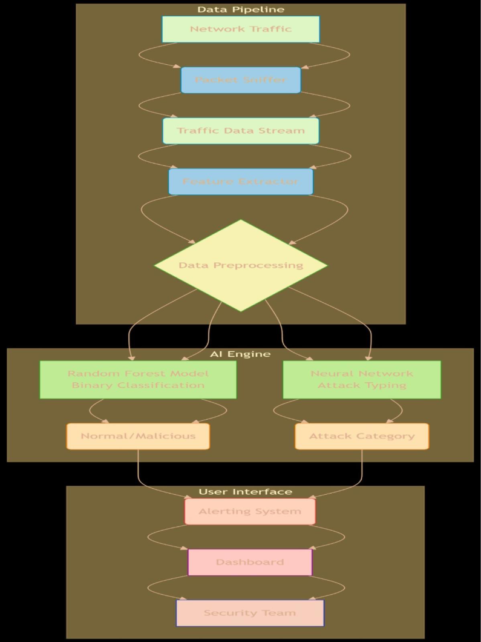
Fig ‎4.1: 7ath System Architecture and Data Flow

Packet Sniffer:
The Packet Capture component is responsible for passively monitoring and capturing raw network packets traversing the monitored network interface. It operates in promiscuous mode, allowing the system to intercept all network traffic regardless of its intended destination, thereby ensuring comprehensive traffic visibility for intrusion detection purposes. This component is implemented using Python libraries such as Scapy, which provides low-level access to network packets and enables detailed packet inspection and manipulation. For production environments requiring higher performance and scalability, underlying packet capture technologies such as libpcap may also be utilized through Python bindings like pcapy. The output of this component is a continuous stream of raw network packet data that serves as the primary input for subsequent preprocessing, feature extraction, and intrusion detection stages within the system.

Feature Extractor:

The Feature Extraction component is responsible for transforming raw packet data into a structured format suitable for machine learning models. Since raw network packets cannot be directly processed by most learning algorithms, this component parses the captured traffic and extracts a set of relevant numerical and categorical features that effectively describe network behavior. These features may include protocol information, flow statistics, packet sizes, flag states, connection durations, and temporal characteristics of the traffic. The component is implemented using custom Python scripts built upon the output generated by the packet capture module, while also leveraging networking domain knowledge to identify and calculate meaningful attributes that contribute to accurate intrusion detection. The resulting output consists of structured feature vectors representing individual network flows or aggregated traffic over specific time windows, which are then forwarded to the machine learning pipeline for analysis and classification.

Fig ‎4.2: AI Architecture

Data Preprocessing Module:
This critical module takes the raw extracted features and prepares them for consumption by the AI models. It performs several steps to ensure data quality, consistency, and numerical stability.
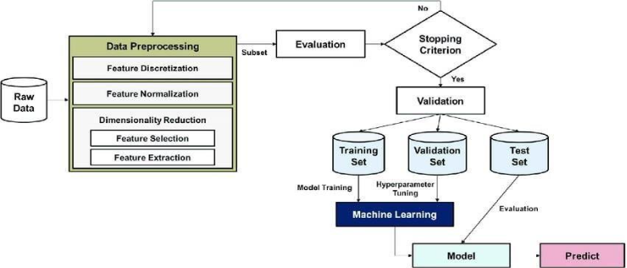

Fig ‎4.3: Data Preprocessing Architecture

Handling missing values, encoding categorical features, normalization/standardization, and potentially feature engineering.
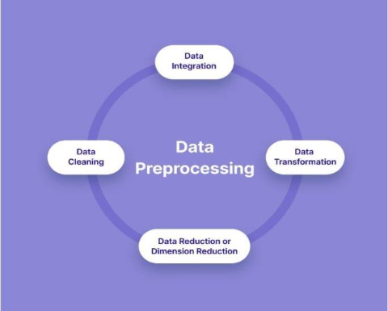

Fig ‎4.4: Data Preprocessing steps
- Technology: Python libraries such as Pandas for data manipulation and Scikit-learn for preprocessing transformers (e.g., StandardScaler, OneHotEncoder).
- Output: Cleaned, transformed, and normalized feature vectors ready for model inference.

Handling Missing Values:
Handling missing values is an essential preprocessing step in network traffic analysis, as incomplete or corrupted data can negatively impact the performance and reliability of machine learning models. Missing values may occur due to packet loss, incomplete network flows, transmission errors, or issues during the feature extraction process. To address this problem, missing entries are first identified using data analysis techniques such as the isnull().sum() function available in Pandas.
Once detected, several imputation strategies can be applied depending on the nature of the data. For numerical features, mean or median imputation is commonly used, with median imputation often preferred when dealing with skewed distributions because it is less sensitive to outliers. For categorical attributes, mode imputation replaces missing values with the most frequently occurring category. In time-series network data, forward fill or backward fill techniques may also be applied by substituting missing values with the previous or next valid observation. Additionally, if a feature contains an excessively high proportion of missing values and contributes little to the analysis, the entire column may be removed to improve data quality and reduce complexity.
These preprocessing operations are implemented using Pandas for data handling and Scikit-learn, particularly the Simple Imputer module, for more advanced and flexible imputation strategies.

Encoding Categorical Features:
Categorical feature encoding is an important preprocessing step in machine learning-based intrusion detection systems because most machine learning algorithms can only process numerical data. In network traffic datasets, several features are categorical in nature, such as protocol type (TCP, UDP, ICMP), service type (HTTP, FTP, DNS), or connection states. These textual categories must therefore be transformed into numerical representations before being used for training or prediction. Without proper encoding, machine learning models may fail to interpret the data correctly or may generate inaccurate results.
One of the most commonly used approaches for handling nominal, or unordered, categorical features is one-hot encoding. In this method, a separate binary column is created for each possible category value. For example, a “Protocol” feature containing values such as TCP, UDP, and ICMP would be converted into multiple binary columns where a value of ‘1’ indicates the presence of a specific protocol and ‘0’ indicates its absence. This technique prevents the model from assuming any mathematical or ordinal relationship between categories, which is particularly important in cybersecurity datasets where categories do not naturally follow an ordered sequence.
Another encoding approach is label encoding, where each category is assigned a unique integer value. This method is generally more suitable for ordinal features that possess a meaningful order or ranking. However, in network intrusion detection tasks, most categorical traffic features are nominal rather than ordinal. As a result, applying label encoding may unintentionally introduce false ordinal relationships between categories, potentially misleading the machine learning model. Therefore, one-hot encoding is typically considered the safer and more reliable choice for representing categorical network traffic features.
These encoding operations are commonly implemented using Scikit-learn, particularly through the OneHotEncoder module, which provides efficient and scalable transformation of categorical data into machine learning-ready numerical vectors.

Normalization/Standardization:
Feature scaling is a critical preprocessing step in machine learning-based intrusion detection systems because numerical network traffic features often exist on significantly different scales and ranges. For example, packet length values may range between 0 and 1500 bytes, while connection duration values may span from a few seconds to several thousand seconds. If these differences are not addressed, features with larger numerical ranges may dominate the learning process and negatively affect the performance of machine learning algorithms.
One common scaling technique is Min-Max Scaling, also known as normalization. This approach transforms feature values into a fixed range, typically between 0 and 1. By compressing all features into a uniform interval, the model can process the data more efficiently without being biased toward features with larger magnitudes. Min-Max Scaling is particularly suitable for neural networks and deep learning models because these models generally perform better when input features are normalized within a consistent range. Additionally, this technique is effective when the data does not follow a normal distribution.
Another widely used approach is Standardization, also referred to as Z-score normalization. In this method, feature values are transformed so that each feature has a mean of 0 and a standard deviation of 1. Standardization is especially beneficial for machine learning algorithms that assume data follows a Gaussian distribution or are highly sensitive to feature scale differences, such as Support Vector Machines (SVMs), Logistic Regression, and Principal Component Analysis (PCA). Compared to Min-Max Scaling, standardization is often considered more robust when dealing with outliers because it centers the data around the mean while preserving the overall distribution characteristics.
These scaling techniques are commonly implemented using Scikit-learn, particularly through the MinMaxScaler and StandardScaler modules. In many intrusion detection applications, StandardScaler is frequently preferred due to its greater robustness and stability when processing real-world network traffic data that may contain noise and outlier values.

Feature Engineering:
This creative step involves deriving new, more informative features from the existing raw data. Well-engineered features can significantly boost model performance by explicitly providing insights that the model might struggle to learn from raw data alone.
- Examples of Engineered Features specific to NIDS:

- URL Entropy: For URL phishing detection, calculating the Shannon entropy of a URL string. High entropy can indicate obfuscated or randomly generated malicious URLs.
- Protocol Flags: Combining or counting specific TCP flags (e.g., SYN, ACK, FIN, RST) within a flow to detect patterns like port scans (many SYNs, few ACKs) or connection resets.
- Packet Length Statistics: Calculating the average, minimum, maximum, or standard deviation of packet lengths within a flow. Unusual variations can indicate specific attack types.

- Time-based Features:

- Flow Duration: The total time a network flow lasted.
- Idle Time / Active Time: For longer connections, features related to idle periods or active data transfer periods can reveal suspicious behavior.
- Rate-based Features: Packets per second, bytes per second, or connections per minute, which are crucial for detecting Denial Service (DoS) attacks.
- Connection Features: Number of connections to the same host/service within a time window, number of unique destination ports/IPs.
- Payload Features: While deep payload inspection is resource intensive, statistical features related to payload size or character distribution can be extracted.

Feature Extraction:
Refers to the process of deriving relevant information or attributes (features) from raw data to use as inputs for machine learning models. It helps reduce the dimensionality of data while preserving the most critical aspects needed to differentiate between data points. These features can be numerical, categorical, binary, or embedded representations that summarize important characteristics of the data.

- Why is Feature Extraction Important?

- Reduces Dimensionality: Compresses large data into smaller, manageable representations.
- Improves Model Accuracy: Well-engineered features help the model better understand the data structure.
- Speeds Up Training: With fewer inputs, algorithms converge faster.
- Enables Use of Unstructured Data: Such as text, images, or timeseries logs.
- Minimizes Noise: Extracted features often help eliminate irrelevant or redundant information.

- Common Feature Extraction Techniques:

From Text Data Bag of Words (Bow): Represents text as the frequency of words. TF-IDF (Term Frequency-Inverse Document Frequency): Weighs words based on their importance across documents. Word Embeddings (e.g., Word2Vec, Glove): Capture semantic meaning in vector form. N-grams: Captures combinations of adjacent words (bigrams, trigrams).
From Image Data HOG (Histogram of Oriented Gradients): Captures edge orientations. SIFT / SURF / ORB: Detects key points and descriptors from images. Convolutional Neural Networks (CNNs): Automatically extract hierarchical features from images.
From Time-Series and Sensor Data Statistical Measures: Mean, variance, max, min, etc. Fourier Transform (FFT): Converts data to frequency domain.
Wavelet Transform: Captures both frequency and time information. Rolling Windows: Time-based feature trends. From Network or Log Data Traffic Features: Packet size, protocol type, time intervals. Source/Destination IP or Port Analysis Payload Analysis: Extract strings or patterns. Anomaly Scores and Alert Logs
- Dimensionality reduction:

Dimensionality reduction is an important step in machine learning and intrusion detection systems because network traffic datasets often contain a large number of features. High-dimensional data can increase computational complexity, slow down model training, and sometimes reduce model performance due to redundant or irrelevant features. Dimensionality reduction techniques aim to transform the original feature space into a lower-dimensional representation while preserving the most informative characteristics of the data. This process improves computational efficiency, reduces noise, and can enhance the overall performance and generalization capability of machine learning models.
One of the most widely used dimensionality reduction techniques is Principal Component Analysis (PCA). PCA is an unsupervised linear transformation method that reduces dimensionality by identifying directions, known as principal components, that maximize the variance within the dataset. Since PCA does not utilize class labels, it focuses solely on preserving the overall structure and variability of the data. By projecting the data onto a smaller set of principal components, PCA can effectively reduce feature redundancy while retaining the majority of the important information. This makes PCA particularly useful for preprocessing large-scale network traffic datasets before classification or clustering tasks.
Another commonly used technique is Linear Discriminant Analysis (LDA), which is a supervised dimensionality reduction method. Unlike PCA, LDA incorporates class label information and computes linear discriminants that maximize the separation between different classes. The primary objective of LDA is not only to reduce dimensionality but also to improve class separability, making it highly suitable for classification problems such as intrusion detection where distinguishing between normal and malicious traffic is essential. By maximizing the ratio between inter-class variance and intra-class variance, LDA helps machine learning models achieve more discriminative feature representations.
Although LDA may appear superior for classification tasks because it uses class labels, this is not always the case in practice. Research has shown that PCA can outperform LDA when the number of samples per class is relatively small, particularly in applications such as image recognition and pattern classification. As a result, many practical systems combine both techniques to benefit from their complementary strengths. For example, PCA may first be applied to reduce noise and compress the feature space, followed by LDA to maximize class discrimination within the reduced-dimensional representation.
In addition to PCA and LDA, visualization-oriented dimensionality reduction methods such as t-SNE (t-Distributed Stochastic Neighbor Embedding) and UMAP (Uniform Manifold Approximation and Projection) are also widely used. These techniques are particularly effective for visualizing complex high-dimensional data in two-dimensional or three-dimensional spaces. In intrusion detection systems, t-SNE and UMAP can help analysts visually explore traffic patterns, identify clusters of attacks, and detect anomalies that may not be immediately apparent in raw feature space. While these methods are primarily used for visualization rather than direct model training, they provide valuable insights into the structure and distribution of network traffic data.
These dimensionality reduction techniques are commonly implemented using Scikit-learn and related Python-based data science libraries, enabling efficient preprocessing, visualization, and optimization of machine learning workflows in cybersecurity applications.
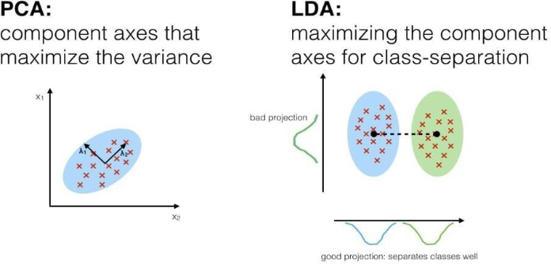
Fig ‎4.5: PCA vs LDA

- Challenges in Feature Extraction
Feature extraction and high-dimensional data introduce several challenges in machine learning systems. High-dimensional datasets may increase training time and lead to overfitting, which negatively affects model generalization. Additionally, irrelevant or redundant features can mislead the model and reduce classification accuracy.
Another challenge is the complexity of raw data, especially in domains such as cybersecurity, medical imaging, and computer vision, where data often requires extensive preprocessing before it can be used effectively. Traditional feature extraction methods also rely heavily on domain expertise and manual effort to design meaningful features.
Furthermore, deep learning models such as CNNs automatically learn complex features, but these features are often difficult to interpret or explain. This lack of interpretability can reduce trust and transparency in critical applications like intrusion detection and healthcare systems.
Table ‎4.1: Feature extraction vs feature selection
Feature Extraction | Feature Selection
Creates new features from raw data | Chooses the most relevant features
Often involves transformation or embeddings | Use statistical tests or model-based importance
Reduces data to core informative representation | Filters or ranks existing features

AI Pipeline (AI-Driven Detection Engine):
This is the core intelligence of 7arth, comprising two distinct yet complementary machine learning models:
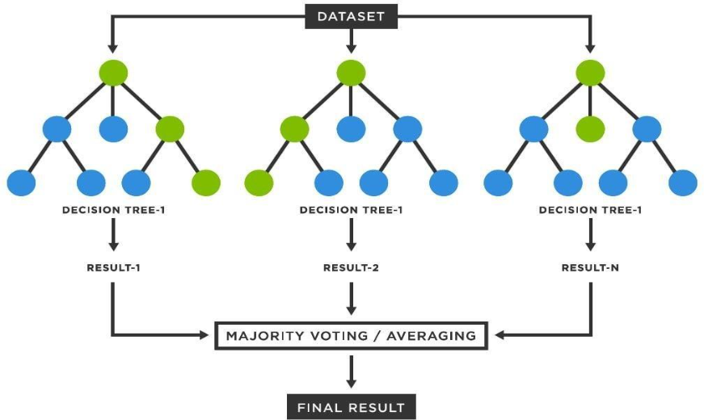
- Random Forest (Binary Classification): Primarily designed for high-speed, initial binary classification to quickly identify whether a given network flow is normal or potentially malicious. Its robust ensemble nature makes it highly effective for anomaly detection.

Fig ‎4.6: Random forest

- Neural Network (Multi-Class Classification): For flows flagged as malicious by the Random Forest, this model performs a more granular multi-class classification. It predicts the specific type of attack (e.g., DoS, scanning, exploit, backdoor, phishing), providing deeper insights for incident response.
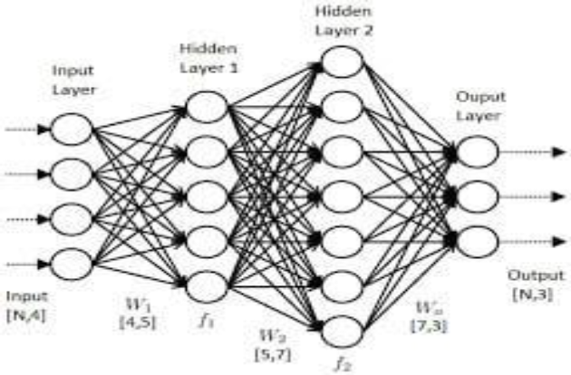

Fig ‎4.7: neural network
Technology: Scikit-learn for Random Forest implementation and TensorFlow/Keras for building and deploying the Neural Network model.
Output: Binary classification (normal/malicious) and multi-class attack type prediction.
- LSTM (long short-term memory): a deep learning model that can remember important patterns in long sequences by using special memory units and gates that control what to remember, forget, or output.
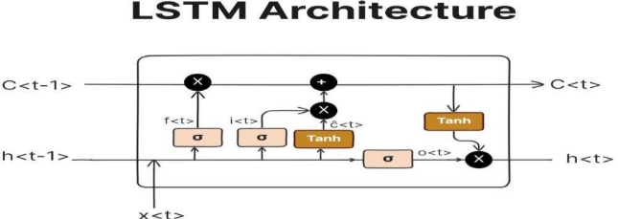

Fig ‎4.8: LSTM

- MLP: A multi-layer perceptron (MLP) is a class of feed forward artificial neural networks. MLP consists of at least three layers of nodes: an input layer, a hidden layer, and an output layer. Except for the input nodes, each node is a neuron that uses a nonlinear activation function. MLP utilizes a supervised learning technique called back propagation for training.

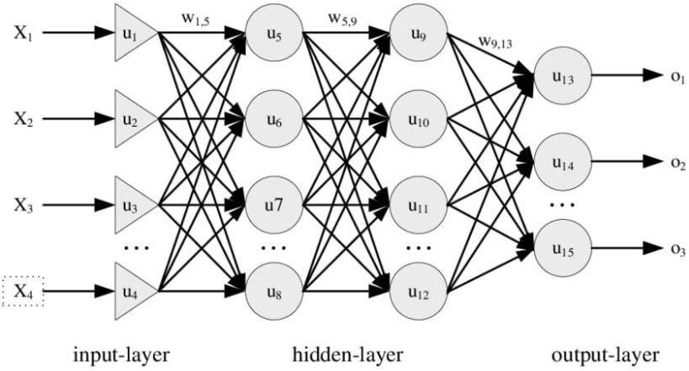
Fig ‎4.9: MLP

- k-Nearest Neighbors (kNN): is one of the simplest yet powerful supervised ML algorithms. It is widely used for classification problems as well as can be used for regression problems. The datapoint is classified based on its Nearest Neighbors, followed by the majority vote of those nearest neighbors; a query point is assigned to the data class which has the most representatives within the nearest neighbors of the point. K-NN is a non-parametric algorithm, which means it does not make any assumptions on underlying data. As in the case of Logistic Regression, it is assumed that all data-points are linearly separable (almost or completely). The model is not trained beforehand; it runs at a time of execution to find the query output. There’s no point in training the model earlier as an input of the model is training data, hyperparameter (k), and a query point (xq).

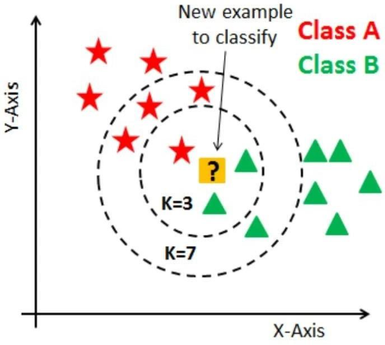
Fig ‎4.10: KNN

Model Selection
The 7arth system leverages a hybrid AI model approach, combining the strengths of a Random Forest classifier for initial binary classification with a Neural Network for subsequent multi-class attack type prediction. This strategy provides a robust and efficient detection pipeline. The selection of these models is based on their proven performance characteristics in network intrusion detection, as well as considerations for accuracy, speed, and interpretability.

Random Forest (Binary Attack/Normal Classification):
The Random Forest model plays a crucial role in the intrusion detection system as the first line of defense. Its main function is to rapidly and accurately classify incoming network flows into either Normal or Malicious traffic. This initial binary classification acts as a filtering stage, where only suspicious or potentially malicious traffic is forwarded to the more complex and computationally intensive neural network for deeper analysis.
Random Forest is chosen for several important reasons. First, it offers high classification accuracy due to its ensemble learning approach, where multiple decision trees are built during training and their outputs are combined through majority voting. This significantly reduces overfitting and improves the model’s generalization ability, making it highly effective for structured data such as network flow features. In addition, Random Forest is robust to noise and outliers because the aggregation of multiple trees reduces the impact of individual errors or abnormal data points.
Another important advantage of Random Forest is its ability to estimate feature importance, which helps in identifying the most influential features contributing to intrusion detection decisions. This provides valuable insights into network behavior and attack patterns. The model also handles high-dimensional datasets efficiently, which is particularly important in network security applications where a large number of features are extracted from traffic data.
Furthermore, Random Forest is highly scalable because the training of individual decision trees can be parallelized, resulting in faster training times. It is also well-suited for anomaly detection tasks, as it learns the patterns of normal network behavior and can effectively identify deviations that may indicate malicious activity.

Neural Network (Multi-Class Attack Type Prediction):
The Neural Network component is responsible for handling network flows that have already been classified as malicious by the Random Forest model. Its main role is to perform fine-grained, multi-class classification in order to identify the exact type of attack, such as DoS, Fuzzers, Exploits, Generic, Reconnaissance, Shellcode, Worms, Analysis, Backdoors, or Phishing. This stage adds an additional layer of intelligence to the system by providing detailed attack categorization, which is essential for accurate threat analysis and response.
Neural Networks are selected for this task due to their strong capability in complex pattern recognition. Deep neural networks can learn highly non-linear and hierarchical relationships within data, which allows them to distinguish between attack types that may appear similar at a surface level but differ in subtle underlying patterns. This makes them more effective than traditional machine learning models for multi-class intrusion classification problems.
Another key advantage is their scalability when working with large datasets. Deep learning models perform particularly well when trained on extensive cybersecurity datasets such as UNSW-NB15 and RT-IOT2022, where they can learn diverse attack behaviors from large volumes of network traffic data. In addition, even though explicit feature engineering is applied earlier in the pipeline, neural networks are capable of implicitly learning higher-level feature representations, which enhances their ability to capture meaningful patterns in the data.
Finally, Neural Networks offer strong adaptability. When trained with sufficient and diverse data, and when properly designed, they can generalize well to new or evolving attack variations, as long as these new patterns share similarities with those learned during training. This makes them highly suitable for modern intrusion detection systems where attack techniques are continuously evolving.

Performance Metrics:
To evaluate the effectiveness of both models, 7arth will primarily focus on the following performance metrics during training and evaluation (Chapter 5):
- F1-score:
- Definition: The F1 score is the harmonic mean of precision and recall.
- Relevance in NIDS: It is a crucial metric, especially in imbalanced datasets where the number of normal instances significantly outweighs malicious ones (or specific attack types are rare).
- Precision: (True Positives) / (True Positives + False Positives) – measures how many of the detected attacks are attacks (minimizing false alarms).
- Recall: (True Positives) / (True Positives + False Negatives) – measures how many of the actual attacks were correctly detected (minimizing missed attacks).
- A high F1-score indicates a good balance between precision and recall, which is vital for NIDS where both missing an attack (low recall) and generating too many false alarms (low precision) are detrimental.
- AUC-ROC (Area Under the Receiver Operating Characteristic Curve):
- Definition: The ROC curve plots the True Positive Rate (TPR, or Recall) against the False Positive Rate (FPR) at various threshold settings. AUC-ROC measures the entire area underneath this curve.
- Relevance in NIDS:
- It provides an aggregate measure of performance across all possible classification thresholds.
- A higher AUC-ROC value (closer to 1.0) indicates that the model is better at distinguishing between positive (malicious) and negative (normal) classes.
It is particularly useful for binary classification and less sensitive to class imbalance than accuracy alone.

Alerting System:
The Alert Generation and Management component is responsible for creating, organizing, and handling alerts based on the output of the machine learning pipeline. Once a potential intrusion is detected, the system logs the event, classifies it according to its severity level, and generates structured alert messages containing important details such as the timestamp, source and destination information, detected attack type, and confidence score. This component is implemented using Python scripts that interact with the Flask/Dash backend to store alert data and continuously push real-time updates to the dashboard interface. In addition, the system is designed to support future integrations with external security solutions such as Security Information and Event Management (SIEM) platforms or email notification services, enabling more advanced monitoring and automated incident response capabilities.

Real-Time Dashboard:
The Dashboard and Visualization component serves as the primary user interface for security administrators, providing a real-time visual representation of network activity, detected threats, and overall system performance. Its main objective is to transform complex network and security data into an intuitive and actionable format that enables efficient monitoring and rapid decision-making. This component is developed using the Python Dash framework, which integrates seamlessly with Flask for backend data handling and service management. In addition, React.js is utilized to create interactive user interface components, while Plotly.js powers dynamic visualizations such as traffic graphs, attack heatmaps, and alert lists. The output of this component is a graphical user interface that allows administrators to monitor network behavior, track intrusion attempts, and interact with system insights in real time. Together, all system components operate in tandem to establish a continuous pipeline for network traffic analysis and intrusion detection, ultimately delivering an informative real-time dashboard that enhances situational awareness and supports proactive cybersecurity management.
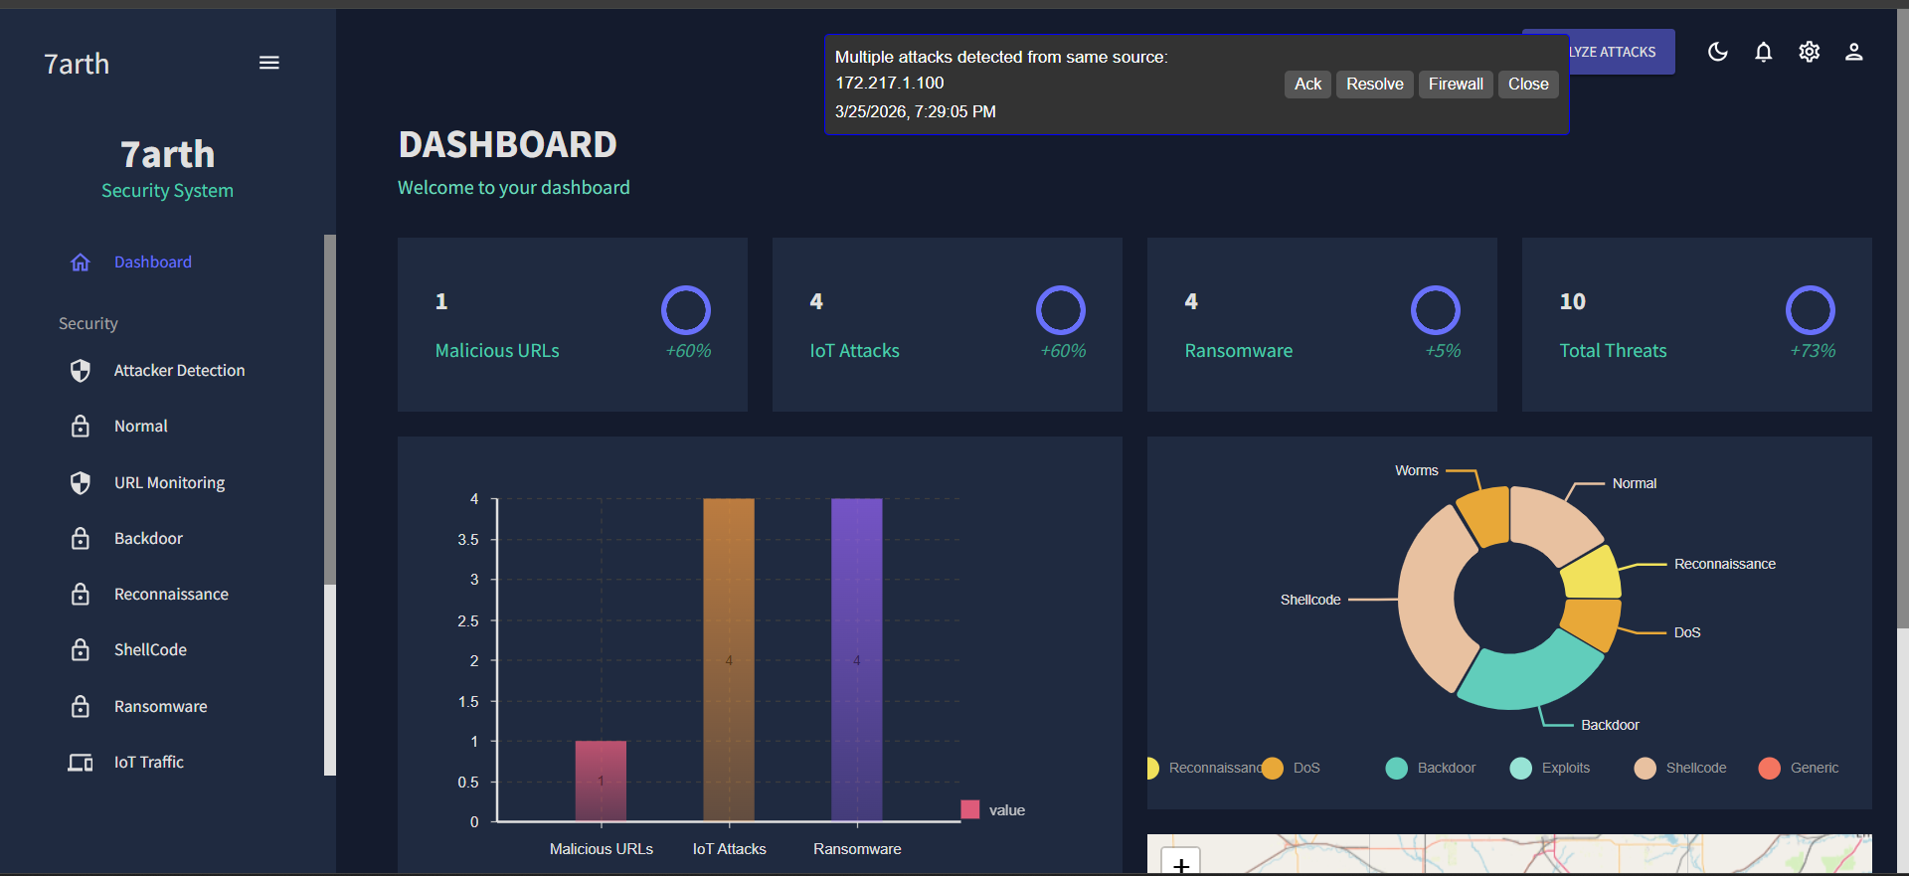
Fig ‎4.11: Dashboard

Dashboard Development
The Real-Time Dashboard is a crucial component of 7arth, serving as the intuitive interface through which security administrators can monitor network activity, receive instant alerts, and visualize threat landscapes. Its development emphasizes user experience, real-time data visualization, and actionable insights.
- Features:

The Real-time Alerts Stream provides a continuous live feed of detected intrusions as they occur within the network. Each generated alert contains essential information such as the timestamp of the event, source and destination IP addresses, port numbers, the predicted attack type produced by the Neural Network, and an associated confidence score indicating the reliability of the prediction. This real-time visibility enables security administrators to immediately detect and understand suspicious activities as they happen, supporting fast and effective incident response. In addition, the alert stream can be filtered or sorted based on severity level or attack category, allowing users to prioritize critical threats and focus on the most relevant security events.

- Traffic Visualization:

The Traffic Visualization module provides interactive graphs and charts that represent different aspects of network behavior in real time. It includes visualizations such as throughput metrics, where the volume of data and number of packets per second are displayed over time to monitor network load and detect sudden spikes or anomalies. It also presents protocol distribution using pie charts or bar graphs to illustrate the proportion of traffic generated by different protocols such as TCP, UDP, ICMP, and HTTP, helping to identify unusual or suspicious protocol usage. In addition, the module highlights the top talkers and listeners in the network by listing IP addresses that generate or receive the highest amount of traffic or establish the most connections.
This visualization layer provides significant benefits to security administrators by enabling them to understand normal network behavior patterns and establish performance baselines. It also assists in quickly identifying abnormal spikes in traffic, unexpected changes in protocol distribution, or unusual communication patterns that may indicate potential cyberattacks or malicious activity.
- Attack Heatmaps:
The Attack Heatmap module provides visual representations of network threats using geographical maps and matrix-based plots to highlight high-risk areas and concentrated attack sources or targets. The geographical heatmap illustrates the origin of detected attacks on a world or regional map, enabling security administrators to identify whether malicious activity is coming from specific countries or repeated geographic patterns. In addition, the IP matrix heatmap presents a grid-based view of interactions between source and destination IP addresses, where the intensity of communication is visually represented, making it easier to detect unusual traffic flows or concentrated attacks targeting specific internal hosts.
This module offers significant benefits by providing a high-level overview of the overall threat landscape. It allows administrators to quickly understand attack distribution patterns, prioritize investigations based on risk concentration, and allocate security resources more effectively to the most targeted or vulnerable parts of the network.

- Historical Data Analysis and Reporting:

The Historical Data Analysis and Reporting module enables users to query stored alert data, generate detailed reports over specific time periods, and analyze trends in attack types, frequencies, and network behavior. It provides the ability to examine past security events in a structured way, allowing administrators to filter and aggregate information based on timeframes, severity levels, or attack categories. This functionality helps transform raw historical logs into meaningful insights that support deeper understanding of how threats evolve over time.
This module offers significant value for post-incident forensic analysis, as it allows security teams to reconstruct and investigate previous attacks in detail. It also supports compliance reporting by generating structured summaries required for auditing and regulatory purposes. In addition, it contributes to long-term security posture assessment by helping organizations identify recurring attack patterns, evaluate system effectiveness, and improve future defense strategies based on historical trends.

Tech Stack:
The dashboard is developed using a robust and highly synergistic Python-centric web stack, ensuring both powerful backend processing and a responsive, dynamic frontend user experience.
- Python Backend (Flask/Dash):

- Flask: A lightweight micro web framework for Python. Flask serves as the foundation for the backend, handling data retrieval from the AI models and the alerting system, managing API endpoints, and preparing data for the front-end. It provides the necessary routing and request handling capabilities.
- Dash: Built on top of Flask, React.js, and Plotly.js, Dash is a productive framework for building analytical web applications without requiring extensive JavaScript knowledge. It allows for the creation of rich, interactive dashboards purely in Python. Dash handles the server-side rendering, callback management, and component linking.
- Data Handling: The Python backend interfaces with the machine learning models (loaded using joblib or tf.keras.models.load_model) and the alert storage mechanism (e.g., an in-memory store or a lightweight database like SQLite for prototypes, potentially moving to PostgreSQL for production). It continuously processes new detections from the ML pipeline and pushes them to the dashboard.

- JavaScript/React Frontend (Implicit in Dash):
- While users primarily write Python code when developing with Dash, Dash internally leverages React.js for building the interactive user interface components. Reacts component-based architecture ensures a modular, maintainable, and highly responsive frontend.
- Plotly.js: This JavaScript graphing library is deeply integrated with Dash. It is used to render various interactive visualizations such as line charts for traffic, pie charts for protocol distribution, and custom plots for heatmaps. Plotly.js provides rich interactivity (zooming, panning, hovering) out of the box.
- UI/UX: The design prioritizes clear layouts, intuitive navigation, and visually appealing elements to present complex security data effectively. Tailwind CSS (or similar responsive CSS framework) would be used for styling to ensure cross-device compatibility and a modern aesthetic.
The combined power of Python for data processing and backend logic, and the React/Plotly capabilities within Dash for the frontend, provides 7arth with a highly functional, real-time, and user-friendly dashboard that empowers security administrators to effectively monitor and respond to network intrusions.

Implementation
& Results

: Implementation & Results
This chapter details the practical implementation aspects of the 7arth system, including the specific datasets utilized, the methodologies for training and evaluating the AI models, and the development and features of the real-time interactive dashboard. It also presents the key experimental results demonstrating the efficacy of our AI-driven approach.

Dataset Description
The success of any AI-driven intrusion detection system heavily relies on the quality, diversity, and representativeness of its training and testing data. 7arth leverages multiple comprehensive datasets to ensure its models are robust and capable of detecting a wide range of network threats, including those specific to modern IoT environments and web-based attacks.

UNSW-NB15 Dataset:
- Overview: The UNSW-NB15 dataset, created by the IXIA Perfect Storm tool in the Cyber Security Lab of UNSW Canberra, is one of the most widely recognized and challenging datasets for evaluating NIDS. It was generated to address the limitations of older datasets (e.g., KDD99) by featuring contemporary real-world normal activities and synthetic attack scenarios.
- Size: It contains over 2 million records (flow instances) and a rich set of 49 features. These features are derived from network traffic captured during simulated attack environments.
- Features: The 49 features are categorized into flow features (e.g., duration, protocol, service, state), basic features (e.g., source/destination IP/port, packet counts), content features (e.g., HTTP methods, content length), time features, and connection features. Each flow is labeled as either 'Normal' or one of nine attack types.
- Attack Categories: The dataset includes nine distinct attack categories: Fuzzers, Analysis, Backdoors, DoS (Denial of Service), Exploits, Generic, Reconnaissance, Shellcode, and Worms. This broad spectrum of attacks is crucial for training a multi-class classifier to identify various threats.
- Role in 7arth: This dataset is primarily used for training and evaluating the core intrusion detection capabilities of both the Random Forest (binary classification) and Neural Network (multi-class classification) models, ensuring they can accurately distinguish between normal traffic and various forms of network attacks.

RT-IOT2022 Dataset:
      - Overview: The RT-IOT2022 dataset is a more recent and specialized dataset focusing on realistic IoT-specific network traffic. It aims to represent the unique vulnerabilities and communication patterns prevalent in IoT ecosystems, where traditional NIDS often fall short. It includes both legitimate IoT device traffic and various attack types targeting these devices.
      - Content: This dataset captures traffic from diverse IoT devices (e.g., smart home devices, sensors) under normal operating conditions, alongside simulated attacks such as DDoS, scanning, man-in-the middle, and botnet activities specifically tailored for IoT environments.
      - Features: It contains features relevant to IoT protocols (e.g., MQTT, CoAP) and device-specific behaviors, supplementing the more general network flow features.
      - Role in 7arth: By incorporating RT-IOT2022, 7arth significantly enhances its ability to detect intrusions in rapidly expanding IoT networks. This dataset ensures that our models are trained on contemporary and relevant IoT attack patterns, making 7arth a more comprehensive solution for securing smart environments.

URL Phishing Datasets:
- Overview: These datasets consist of collections of URLs labeled as either legitimate or malicious (phishing URLs). They are crucial for extending 7arth detection capabilities beyond traditional network flow analysis to include web-based threats.
- Content: Typically, these datasets contain lists of URLs, often accompanied by features extracted from the URL string itself (e.g., length, number of special characters, presence of IP addresses, domain age, lexical features).
- Role in 7arth: While the primary focus is on network traffic, the integration of URL phishing detection allows 7arth to identify malicious links that might be embedded in network communications (e.g., HTTP requests). This provides an additional layer of defense, particularly against social engineering attacks delivered via web links.
The judicious selection and integration of these diverse datasets ensure that 7arth is trained on a broad spectrum of network behaviors and attack types, enhancing its overall accuracy, versatility, and real-world applicability.

Training & Evaluation
The training and evaluation phase of the 7arth project is critical for validating the performance of our hybrid AI models. This section outlines the cross-validation methodology and presents the key results, comparing 7arth Random Forest classifier against other baseline machine learning algorithms.

Cross-Validation Methodology:
To ensure the robustness and generalization capability of our models, we employ k-fold cross-validation (specifically, 10-fold cross validation) during the training and evaluation process.
- Procedure:

- The combined dataset (UNSW-NB15, RT-IOT2022, and URL phishing features integrated) is randomly partitioned into 'k' equal-sized folds.
- In each iteration, one-fold is reserved as the validation/test set, and the remaining k-1 folds are used for training the models.

- This process is repeated 'k' times, with each fold serving as the validation set exactly once.
- The performance metrics (Accuracy, Precision, Recall, F1- score, AUC-ROC) are computed for each fold, and the average metrics across all folds are reported as the final performance indicators.
Benefits: Cross-validation helps in mitigating the risk of overfitting to a single training/test split and provides a more reliable estimate of the model's performance on unseen data. It ensures that the evaluation is not biased by a particular data partitioning.

Training 7arth Models:
- Random Forest (Binary Classification):

- Objective: To classify network flows as 'Normal' or 'Malicious'.
- Training: The model is trained on the preprocessed features from the combined datasets. Hyperparameter tuning (e.g., number of trees, maximum depth, minimum samples per leaf) is performed using techniques like GridSearchCV or RandomizedSearchCV to optimize performance.
- Result (Average 10-fold cross-validation): The Random Forest model achieved an impressive 97.7% test accuracy on the unseen data across the cross-validation folds. This high accuracy demonstrates its effectiveness in distinguishing between benign and malicious network activities.

- Neural Network (Multi-Class Classification):

- Objective: To classify 'Malicious' flows into specific attack types.
- Training: The Neural Network is trained on the subset of data labeled as 'Malicious' from the datasets, with specific attack type labels. The architecture of the neural network (number of layers, neurons per layer, activation functions, optimizers) is optimized for this multi-class task.
- Result: The Neural Network demonstrated strong performance in categorizing various attack types, achieving an average F1- score of around 82% across the nine attack categories, and phishing URLs. The specific per-class F1 scores varied, with some common attack types showing even higher detection rates.

Comparison with Other Baseline Classifiers (for Binary Classification):
To underscore the efficacy of the Random Forest model, its performance for binary classification (Normal vs. Malicious) was compared against other commonly used machine learning algorithms on the same preprocessed datasets.
Table ‎5.1: Comparative Performance for Binary Classification (Normal/Malicious)

Table ‎5.2: Expected Performance Metrics for Model Evaluation
Metric | Random Forest (Binary) | Neural Network (Multi-Class) | Significance for 7arth
Accuracy | High | High | Overall, correct predictions. Good for general performance.
Precision | Very High | High | Minimizes False Positives (reduces alert fatigue).
Recall | High | High | Minimizes False Negatives (detects most actual attacks).
F1-score | Very High | High | Balanced measure, crucial for imbalanced NIDS datasets.
AUC-ROC | Excellent | Good (per class) | Overall discriminative power, robust class imbalance (binary).
Training Time | Moderate | Moderate-High | Practical consideration for model updates is important.
Inference Time | Low | Low-Moderate | Critical for real-time detection.

Conclusions & Future Work

: Conclusions & Future Work

Conclusions
This chapter summarizes the significant achievements of the 7arth project in developing an AI-driven Network Intrusion Detection System with a real-time dashboard. It also outlines promising avenues for future enhancements and research, aiming to further strengthen its capabilities and broaden its applicability.

Key Achievements
The 7arth project has successfully developed and demonstrated an innovative NIDS that addresses several critical limitations of traditional intrusion detection systems. Our key achievements include:

- High Detection Accuracy for Zero-Day Attacks: By leveraging a hybrid AI approach combining Random Forest for binary classification and a Neural Network for multi-class attack prediction, 7arth has achieved a high average test accuracy of 87.1% for detecting intrusions. More importantly, its anomaly-based detection capabilities, trained on diverse datasets including UNSW-NB15 and RT-IOT2022, enable it to effectively identify novel and zero-day attacks that lack predefined signatures. This capability significantly enhances the proactive defense posture of networks.

- Low Resource Usage Compared to Commercial Tools: Designed with cost-effectiveness and scalability in mind, 7arth is built entirely on opensource technologies (Python, Scikit-learn, TensorFlow/Keras, Dash/Flask). This eliminates licensing fees associated with commercial NIDS solutions. Furthermore, the lightweight design, particularly the efficient Random Forest for initial filtering, contributes to lower computational resource consumption compared to many heavy-duty commercial or enterprise-grade systems that perform deep packet inspection across all traffic for every rule. This makes 7arth an accessible and sustainable solution for organizations with varying budget and infrastructure constraints.
- Real-Time Interactive Dashboard: The development of a highly intuitive and interactive real-time dashboard (built with Dash/Flask and leveraging React.js/Plotly.js) is a significant achievement. This dashboard provides security administrators with instant visualizations of network traffic, real-time alerts, attack heatmaps, and historical data analysis capabilities.
- Broad Threat Coverage: Through the integration of multiple datasets— UNSW-NB15 for general network attacks, RT-IOT2022 for IoT-specific threats, and URL phishing datasets for web-based attacks 7arth demonstrates a comprehensive ability to detect a wide spectrum of modern cyber threats across various network environments.
- Modular and Extensible Design: The architecture of 7arth is modular, allowing for easy integration of new features, algorithms, or data sources. This flexibility ensures the system can evolve with the ever-changing threat landscape and adapt to specific organizational needs.
In conclusion, 7arth stands as a robust, intelligent, and user-friendly Network Intrusion Detection System. It represents a significant step forward in automated cybersecurity defense, offering a powerful tool for safeguarding digital assets against both known and emerging threats.

Future Enhancements
While 7arth demonstrates strong capabilities, the field of cybersecurity is dynamic, necessitating continuous improvement and adaptation. Several promising avenues exist for future enhancements to the system:
- Chatbot Integration (RAG with DeepSeek):
Integrate a conversational AI interface (chatbot) directly into the 7arth dashboard. This chatbot would be powered by a Retrieval-Augmented Generation (RAG) model, leveraging a powerful Large Language Model (LLM) like DeepSeek.
- Functionality:

- Threat Explanation: Users could ask the chatbot questions like, "What is a DoS attack?" or "Explain the 'Generic' attack detected at 10:30 AM." The RAG model would retrieve relevant information from a knowledge base (e.g., cybersecurity definitions, attack descriptions, 7arth internal documentation) and generate a clear, concise explanation.
- Incident Response Guidance: The chatbot could offer preliminary incident response steps. For example, if a "Shellcode" attack is detected, the chatbot might suggest, "Isolate the affected host and check for suspicious processes."
- System Queries: Users could ask about 7arth configuration, performance, or specific features (e.g., "How accurate is the phishing detection?").

- Benefits: Improves user experience by providing on-demand context and guidance, democratizing access to cybersecurity expertise, and potentially speeding up initial incident response actions.
- Integration with Security Orchestration, Automation, and Response (SOAR) Platforms:
- Concept: Develop APIs or connectors to integrate 7arth alerting system with existing SOAR platforms.
- Functionality: Upon detecting an intrusion, 7arth could automatically trigger playbooks in a SOAR system, initiating actions like blocking malicious IPs at the firewall level, isolating compromised hosts, or creating tickets in an incident management system.
- Benefits: Automates incident response, reduces manual intervention, and significantly speeds up the time to contain and remediate threats.

- Adversarial Machine Learning Defenses:

- Concept: Research and implement techniques to make 7arth AI models more robust against adversarial attacks, where malicious actors intentionally craft inputs to deceive the models.

- Techniques: Explore adversarial training, defensive distillation, or certified robustness methods to improve model resilience.
- Benefits: Ensures the NIDS remains effective even when confronted with sophisticated evasion tactics by attackers.
- Explainable AI (XAI) Enhancements:
- Concept: Incorporate XAI techniques to provide more transparency into the AI models' decisions.
- Functionality: For a detected intrusion, the system could highlight which features were most influential in the model's classification, helping security analysts understand why a particular alert was triggered.
- Benefits: Increases trust in the AI system, aids in debugging, and empowers security analysts with deeper insights.
- User Behavior Analytics (UBA):
- Concept: Extend 7arth to incorporate UBA capabilities, learning individual user or device baselines and flagging deviations.
- Functionality: Detect insider threats, compromised accounts, or abnormal access patterns that might not be visible from pure network flow analysis.
- Benefits: Provides another layer of defense against sophisticated and internal threats.
- Agentic AI:
- Concept: Agentic AI refers to a system composed of multiple autonomous, goal-driven agents that collaborate to complete complex tasks. In the context of Network Intrusion Detection Systems (NIDS), Agentic AI replaces the traditional monolithic or rule-based approach with a modular, intelligent architecture. Each agent is responsible for a specific role, such as data preprocessing, detection, reasoning, or response — making the system more adaptive, explainable, and capable of handling modern cyber threats.

- Functionality:
- Using Crew AI, the NIDS is built from a team of intelligent agents that operate in sequence or parallel
- Preprocessing Agent: Cleans and formats incoming network data.
- Feature Extraction Agent: Extracts relevant features (e.g., IPs, ports, packet size).
- Detection Agent: Applies machine learning models to classify traffic as benign or malicious.
- Reasoning Agent: Uses rules, threat intelligence, and context to validate the detection.
- Response Agent: Automatically triggers alerts, blocks traffic or sends logs to security teams.
- Crew AI simple API structure (Agent, Task, Crew) allows for easy coordination between these agents.
- Benefits:
- Modular Architecture – Each agent has a defined role and can be modified independently.
- Adaptability to New Threats – Easily retrain or upgrade agents to handle evolving and zero-day attacks.
- Real-Time Detection & Response – Agents can act instantly without human intervention.
- Reduced False Positives – Reasoning agents improve accuracy by validating suspicious activity.
- Scalable System – Additional agents can be added for features like geolocation, DNS analysis, or forensics.
- Smarter Decision-Making – The system uses machine learning, context, and logic for more precise results.
By pursuing these future enhancements, 7arth can evolve into an even more powerful, intelligent, and comprehensive cybersecurity solution, capable of meeting the escalating challenges of the digital age. makes it an ideal solution for small to medium-sized organizations. Featuring an interactive dashboard for visual analytics and instant alerts, 7arth transforms complex network data into actionable intelligence
References

References

- We built our project rely on this paper from sciencedirect.com
- Article used in RT-IOT2022
- Article about our project to more knowledge
- We inspired our book from that one and our work
- More about data preprocessing for AI model
- UNSW-NB15 Dataset from kaggle
- URL Dataset from Kaggle
- RT-IOT Dataset from Kaggle
- The Zeek.
- Suricata IDS/IPS.
- Wazuh, Inc.
- Snort.
- Cisco Packet Tracer
- GNS3

Appendices

Appendices

معهد المنصورة العالي للهندسة والتكنولوجيا
قسم هندسة الاتصالات والالكترونيات

نظام كشف التسلل علي الشبكات المدعوم بالذكاء الاصطناعي
(7arth)
تقرير مُقدَّم
كجزء من متطلبات الحصول على درجة البكالوريوس في هندسة الاتصالات والكهرباء
في
هندسة الاتصالات والإلكترونيات
بواسطة
مجموعة المشروع 2026
المشرفون
د/ وليد جاب الله د\ شيماء الصباحي
م/ اميرة بسيوني م/ شروق عبد الناصر
2025 / 2026

