**Brief Writeup and functionality**

**Swagger Editor:** The **Swagger Editor** is an open source **editor** to design, define and document RESTful APIs in the **Swagger** Specification. ... SwaggerHub brings the **Swagger Editor**, UI, and Codegen tools to the cloud in an integrated API design and documentation, built for API teams working with the **Swagger** (OpenAPI) specification.

**Swagger UI:** The **Swagger UI** is an open source project to visually render documentation for an API defined with the OpenAPI (**Swagger**) Specification. ... **Swagger UI** is available for download in the GitHub repository, or can be generated for any new or existing OpenAPI-defined API in the integrated SwaggerHub platform.

**Flask:** Flask is a micro web framework written in Python. It is classified as a microframework because it does not require particular tools or libraries. It has no database abstraction layer, form validation, or any other components where pre-existing third-party libraries provide common functions.

**Json:** JavaScript Object Notation is an open-standard file format or data interchange format that uses human-readable text to transmit data objects consisting of attribute–value pairs and array data types.

**Python:** Python is an interpreted, high-level, general-purpose programming language. Created by Guido van Rossum and first released in 1991, Python's design philosophy emphasizes code readability with its notable use of significant whitespace.

**Yaml:** YAML is a human-readable data-serialization language. It is commonly used for configuration files and in applications where data is being stored or transmitted. YAML targets many of the same communications applications as Extensible Markup Language but has a minimal syntax which intentionally differs from SGML.

**Mysql:** MySQL is an open-source relational database management system. Its name is a combination of "My", the name of co-founder Michael Widenius's daughter, and "SQL", the abbreviation for Structured Query Language.

**Model:**

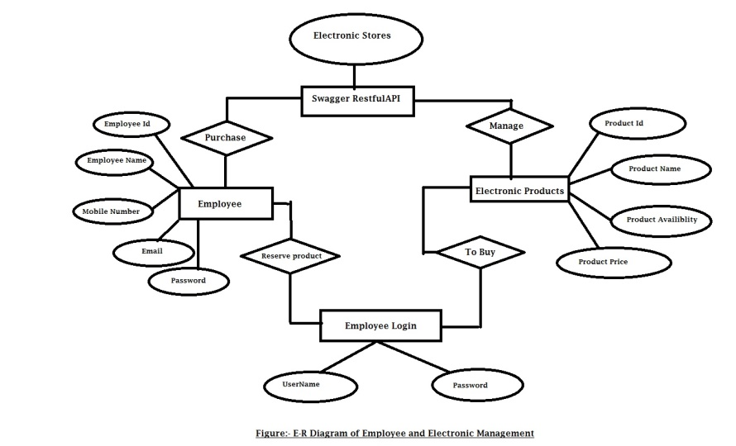

**Result:**

**(i)- Employee Table**

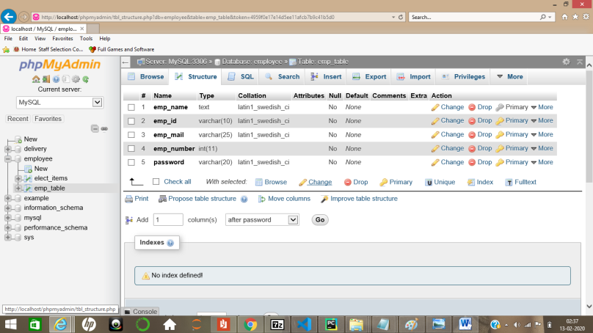

**(ii)- Electronic Table**

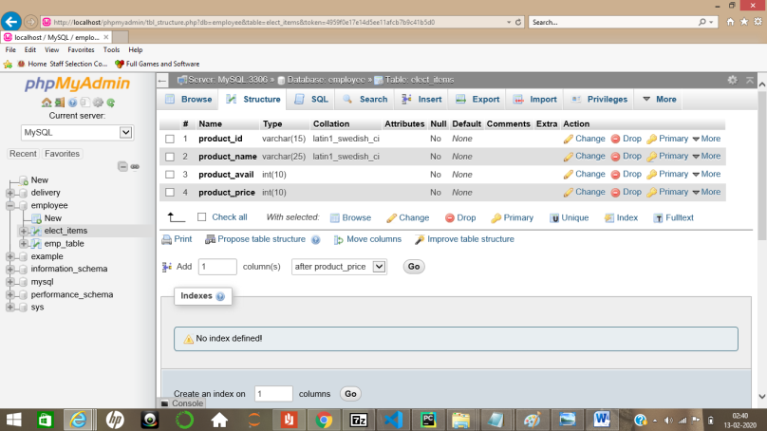

**(iii)- Swagger UI 1.0**

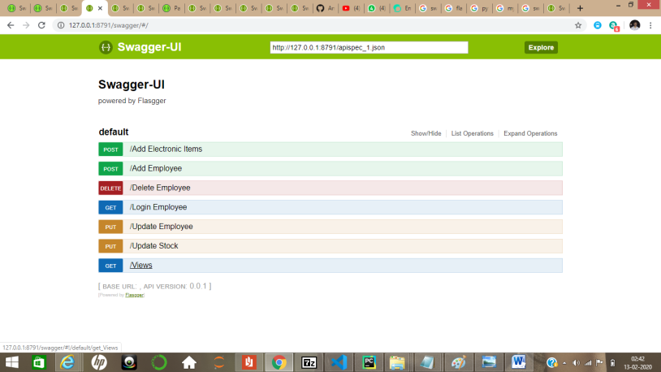

**(iv)- Swagger UI 1.1**

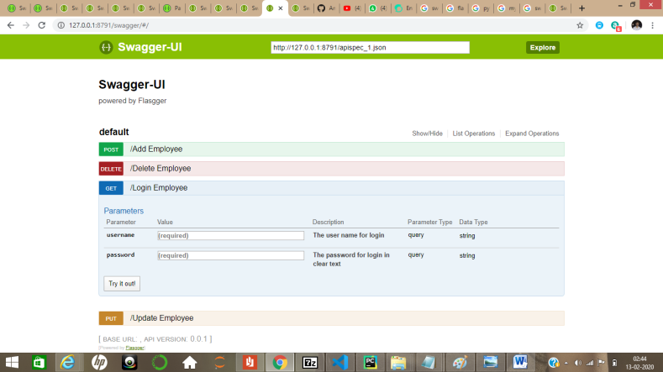

**(v)- Swagger UI 1.2**

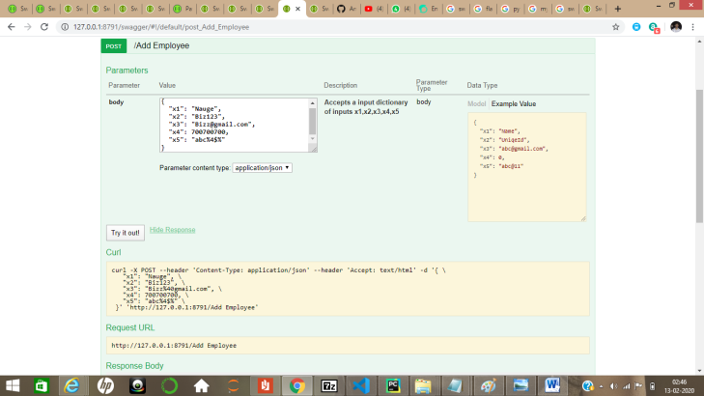

**(vi)- Employee Table Connected With Swagger And Mysql.**

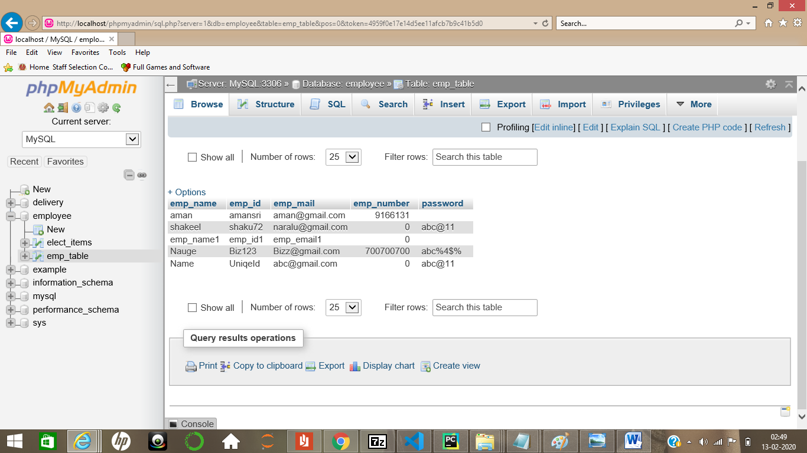

**ThankYou.**

**Name: Amrtya Srivastava**

**Number:9166131859**

**Email:amrtyasrivastava7@gmail.com**

**Project GitHub:** <https://github.com/Amrtyasrivastava/nuage_project>

**Refrence:** <https://editor.swagger.io/>

**\*\*\*Best For Regards\*\*\***