Downscaling Rainfall over India using Explainable AI (XAI)
Progress Report & Proposed Extension — Explainable Downscaling of CMIP6 Future Rainfall Projections
Field | Details
Submitted by | ________________________________
Roll No. | ________________________________
Guided by | ________________________________
Academic Year | 2025–26
Status | Core project complete and validated; extension proposed below

Part A — Work Completed (Core Project)
The core objective of the synopsis — statistical downscaling of rainfall over India using machine learning, explained with SHAP — has been implemented, executed, and validated. The approach follows Lyu & Yong (2025) and Hisam et al. (2025): large-scale atmospheric predictors are mapped to high-resolution observed rainfall through ML regression, and the trained model is interpreted with explainable-AI techniques.

A.1 Data used
Dataset | Role | Details
ERA5 reanalysis (ECMWF) | Predictors (X) | u850, v850, q850, rh850, z500, MSLP, T2m — monthly, 1980–2023
IMD gridded rainfall | Target (y) | 0.25° × 0.25° over India, monthly aggregate, 1980–2023
India state shapefile | Analysis/plots | Regional masks and publication-quality maps

Temporal split: training 1980–2010, validation 2011–2015, testing 2016–2023. All reported results are computed on the test years, which the models never saw during training.

A.2 Models compared (test set, mm/month)
Model | R² | RMSE | MAE | Correlation
LightGBM (best) | 0.73 | 52.7 | 16.8 | 0.85
XGBoost | 0.71 | 54.1 | 17.5 | 0.84
Random Forest | 0.70 | 55.3 | 16.0 | 0.84
Linear regression (traditional baseline) | 0.21 | 89.6 | 44.0 | 0.46

Gradient-boosting models roughly triple the explained variance of the traditional linear approach, confirming that non-linear ML is required to capture monsoon dynamics.

A.3 Explainability findings
- Humidity controls Indian rainfall. Specific humidity at 850 hPa (moisture supply) is the dominant SHAP driver over 53.5% of Indian grid cells; relative humidity (saturation) over 46.4%.
- Season matters. During the monsoon (JJAS), moisture supply governs nearly the whole country; in winter (DJF), saturation takes over the peninsula — consistent with the northeast monsoon.
- Secondary drivers are physically sensible. 2 m temperature dominates in the Himalayan belt, meridional wind over the far south (northeast-monsoon flow), and sea-level pressure near the Odisha coast — the model independently identified cyclone-driven rainfall.

These results demonstrate that the model's reasoning is consistent with known monsoon physics — the central trust argument of explainable downscaling.
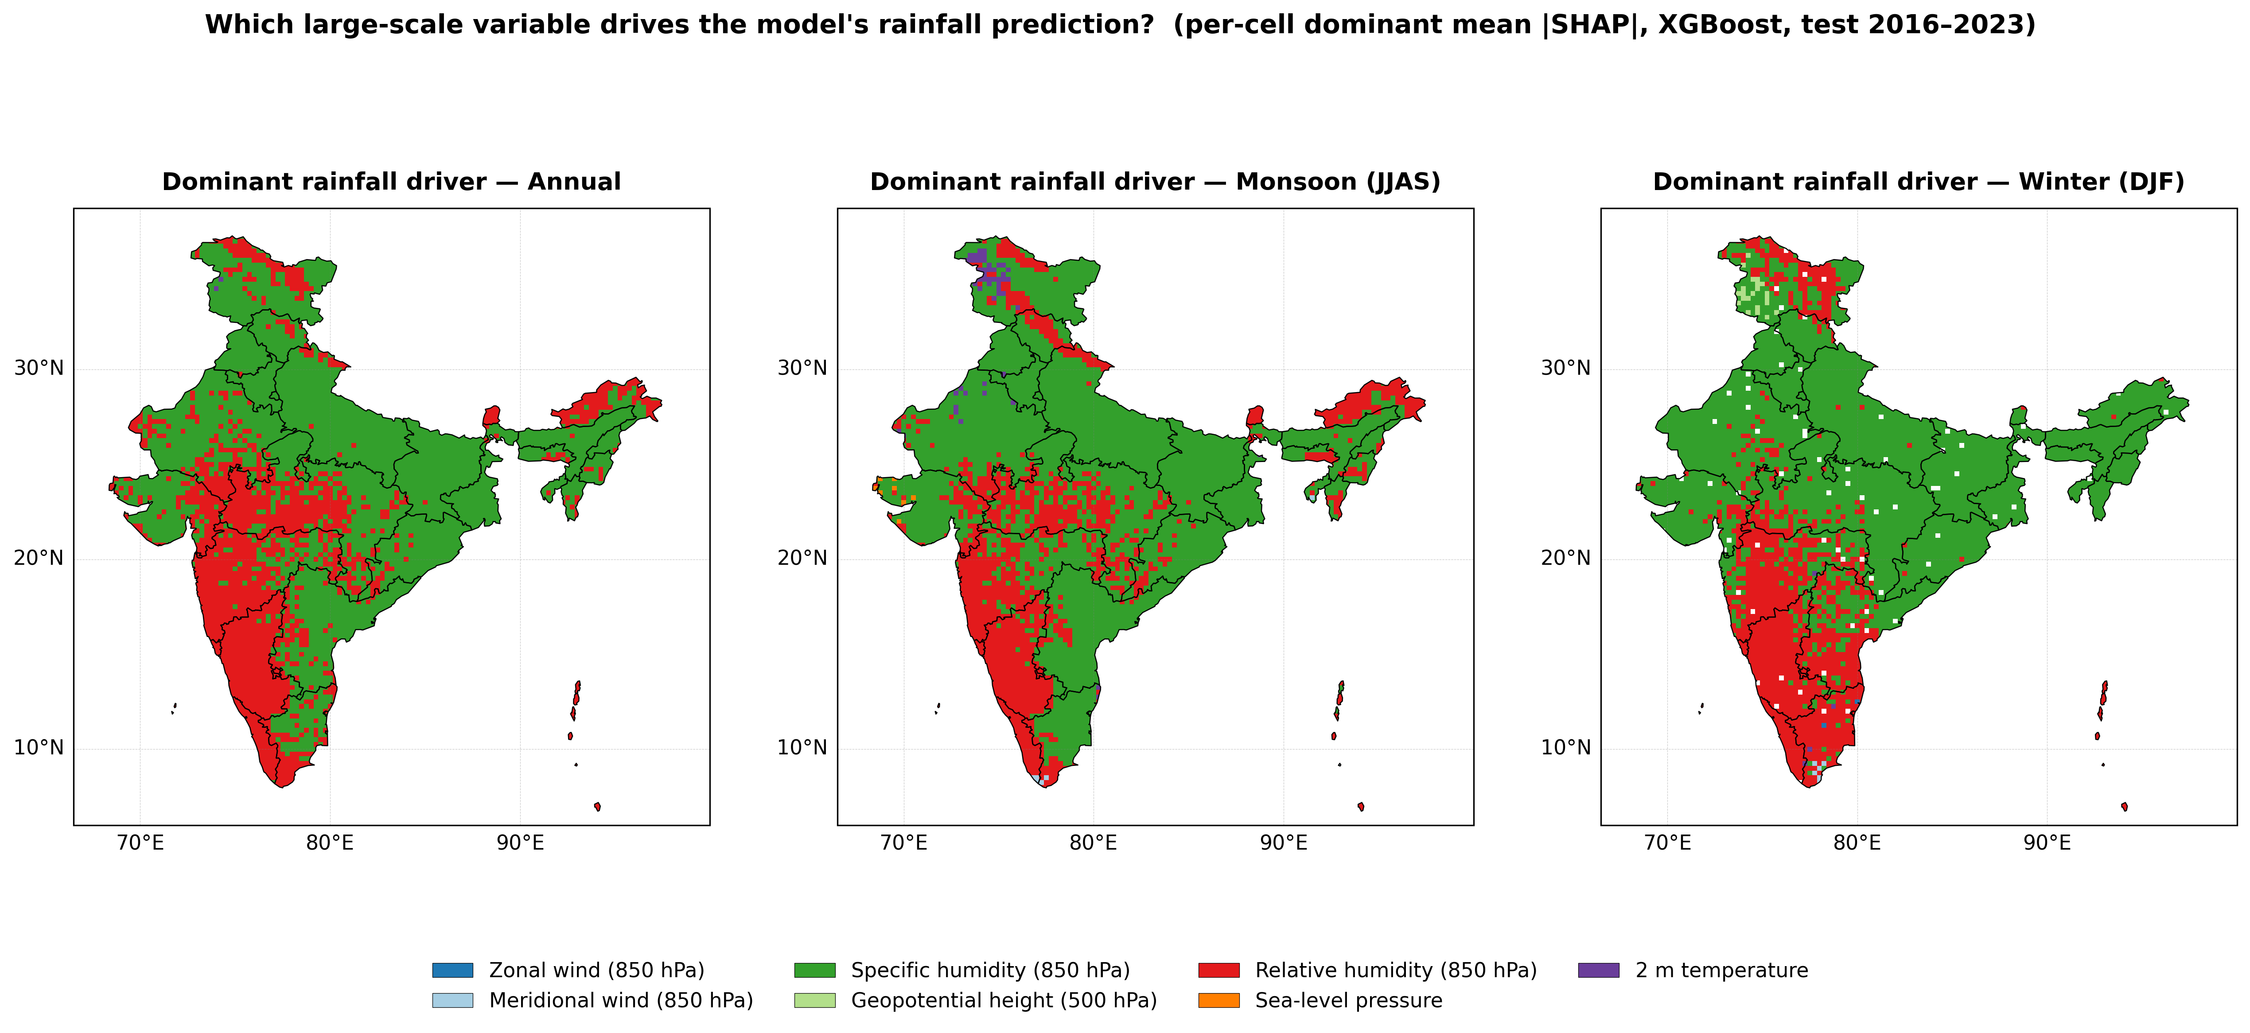
Fig. 1 — Dominant rainfall driver per grid cell (SHAP), annual / monsoon / winter. To our knowledge the first seasonal-and-regional XAI driver analysis of rainfall downscaling over India.
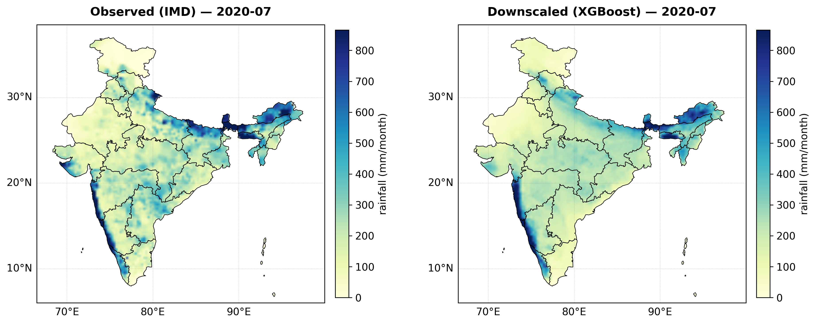
Fig. 2 — Observed (IMD) vs downscaled (XGBoost) rainfall, July 2020 (an unseen test month).

Part B — Proposed Extension: Explainable Downscaling of CMIP6 Future Projections

B.1 Motivation and research gap
Statistical downscaling of future rainfall over India exists in the literature, and explainable ML downscaling has been demonstrated for present-day climates in other regions (Turkey, China). However, the two have not been combined for India: existing future-rainfall studies project how rainfall may change, but not why, in terms of physically interpretable drivers. Applying the validated explainable model from Part A to CMIP6 future scenarios closes this gap.

B.2 Novelty statement (honest framing)
“To our knowledge, this is the first explainable (SHAP-based) ML downscaling of future rainfall change over India — projecting not only how monsoon rainfall may change by 2050–2100 under CMIP6 scenarios, but which physical drivers cause that change, region by region and season by season.”

B.3 Objectives
- Acquire monthly CMIP6 output (1–2 GCMs; historical + SSP2-4.5 and SSP5-8.5) for the same seven predictor variables used in Part A.
- Bias-correct GCM predictors against ERA5 over the overlap period (1980–2014) using per-month quantile mapping.
- Apply the trained downscaling model to corrected future predictors for the near (2040–2070) and far (2070–2100) future.
- Produce rainfall-change maps (future minus 1985–2014 baseline) for India, per season.
- Apply SHAP to the future predictions to attribute projected rainfall change to physical drivers — the novel contribution.

B.4 Data requirements
Item | Source | Approx. size | Access
CMIP6 monthly fields: hus/hur/ua/va (850 hPa), zg (500 hPa), psl, tas | Public CMIP6 archive (Google Cloud / ESGF) | 100–300 MB | Public, no institutional licence required
Candidate GCMs: EC-Earth3, MPI-ESM1-2-HR (well-rated over South Asia) | Same | — | —
Scenarios: historical (1980–2014), SSP2-4.5, SSP5-8.5 (2040–2100) | Same | — | —

Everything else (trained models, SHAP pipeline, mapping tools, validation code) already exists from Part A and is reused unchanged.

B.5 Methodology
- Download and regrid CMIP6 monthly predictors to the 0.25° analysis grid.
- Bias correction: per-month, per-cell quantile mapping of each GCM predictor to ERA5 statistics over 1980–2014; verify corrected historical run reproduces observed rainfall when passed through the model.
- Prediction: run the trained XGBoost/LightGBM downscaler on corrected SSP2-4.5 and SSP5-8.5 predictors for 2040–2070 and 2070–2100.
- Change analysis: seasonal rainfall-change maps and sub-regional summaries (Western Ghats, Indo-Gangetic Plain, Northeast, arid Rajasthan, peninsula).
- Explainable attribution: SHAP on future predictions; difference in driver importance (future vs baseline) shows which physical mechanism drives each region's change.

B.6 Work plan
Week | Task | Deliverable
1 | CMIP6 data download, regridding, quality checks | Analysis-ready GCM predictor cube
2 | Bias correction + verification against ERA5/IMD | Corrected predictors; verification report
3 | Future predictions, change maps | Seasonal rainfall-change maps (2 scenarios × 2 horizons)
4 | SHAP attribution of change; driver-change maps | Novel figures: “why rainfall changes” per region
5 | Write-up, integration into final report/paper | Final report chapter + presentation slides

B.7 Expected outcomes
- Downscaled seasonal rainfall projections for India (2040–2070, 2070–2100; SSP2-4.5 and SSP5-8.5).
- Rainfall-change maps relative to the 1985–2014 baseline.
- SHAP driver-change maps: the first region-by-region physical attribution of projected rainfall change over India.
- Material suitable for a conference or journal submission, as envisaged in the synopsis.

B.8 Assumptions and limitations (stated up-front)
- Stationarity: the predictor–rainfall relationship learned from 1980–2010 is assumed to hold in a warmer climate — the standard assumption of all statistical downscaling, stated explicitly.
- Ensemble size: 1–2 GCMs are used for tractability within the project timeline; a full multi-model ensemble is identified as future work.
- Scenarios, not forecasts: results are conditional projections (“under SSP5-8.5, the model projects…”), not deterministic predictions.

References
- Lyu, Y. & Yong, B. (2025). Using an Explainable Machine Learning Approach for Rainfall Downscaling. JGR: Machine Learning and Computation.
- Hisam, E., Sertel, E. & Seker, D. Z. (2025). Precipitation downscaling with the integration of multiple precipitation products… Science of the Total Environment, 1002, 180540.
- Lundberg, S. M. & Lee, S.-I. (2017). A unified approach to interpreting model predictions (SHAP). NeurIPS.
- Eyring, V. et al. (2016). Overview of CMIP6 experimental design and organization. Geoscientific Model Development.
- Wilby, R. L. & Wigley, T. M. L. (1997). Downscaling GCM output: A review. Progress in Physical Geography.

