PuneStay: Nearby Services WebGIS — Project Report
PUNESTAY: A NEARBY SERVICES WEBGIS FOR FINDING PGs, HOSTELS AND FLATS NEAR COLLEGES AND OFFICES IN PUNE, INDIA
SUBJECT REPORT SUBMITTED TO
SYMBIOSIS INSTITUTE OF GEOINFORMATICS
FOR PARTIAL FULFILMENT OF THE M.SC. DATA SCIENCE AND SPATIAL ANALYTICS DEGREE
Subject: WebGIS
BY
Aarshad Rathod
PRN: 25070243029
BATCH 2025-27
SYMBIOSIS INSTITUTE OF GEOINFORMATICS
SYMBIOSIS INTERNATIONAL (DEEMED UNIVERSITY)
5TH FLOOR, ATUR CENTRE, GOKHALE CROSS ROAD, MODEL COLONY, PUNE 411016
October 2026

Acknowledgement
I wish to express my sincere thanks to the Symbiosis Institute of Geoinformatics (SIG), Symbiosis International (Deemed University), Pune, for providing an excellent academic environment and the opportunity to carry out this project as part of the M.Sc. Data Science and Spatial Analytics programme.
I am grateful to Dr. T. P. Singh, Director, Symbiosis Institute of Geoinformatics, for his leadership and for fostering a culture of applied research.
I am deeply thankful to Dr. Veena Parihar for guidance, constructive feedback and encouragement throughout the WebGIS course and this project.
I thank the faculty members of the programme for the foundation in spatial databases, web technologies and geospatial analysis on which this work is built.
This project relies on open data and open software. I acknowledge the OpenStreetMap contributors and the Overpass API service; the Overture Maps Foundation for its open Places dataset; the Kaggle community for the open Pune rental dataset; ANAROCK for its published Pune rental market figures; the OSRM project and its public demo server for routing; Nominatim for geocoding; Open-Meteo for weather; OpenFreeMap, Esri, OpenTopoMap and CARTO for basemap tiles; and the communities behind PostgreSQL, PostGIS, GeoServer, FastAPI, React, MapLibre GL JS and Leaflet.
I thank the friends and classmates who tried the map and gave feedback, and my family for their patience and support.

Summary
Students and young professionals arriving in Pune search for a paying guest (PG) room, hostel or flat with three questions in mind: how far it is from college or office, what is around it, and whether the listing can be trusted. Commercial portals answer the first two unevenly and the third not at all. This report presents PuneStay, a Nearby Services WebGIS built for the Pune region (about 1,770 km²) that answers all three on one map and that fulfils the WebGIS course brief, Project 1: Nearby Services WebGIS.
The core system lets a user choose a location by clicking the map, typing latitude and longitude or using the phone's position; pick one of 22 service categories and a subcategory; and ask for everything within a radius, the nearest N places, or both. The server answers from PostGIS with a distance-sorted GeoJSON list that stays in step with the markers on a Leaflet map; a popup and a side panel show each place. Every spatial layer is also published through GeoServer as WMS and WFS and can be switched on as an overlay. Denied geolocation, invalid coordinates, points outside Pune and empty results all produce explicit messages.
On top of this core, PuneStay adds the rental extension: 520 real PG and hostel listings imported from OpenStreetMap (110) and Overture Maps Places (410), of which 393 carry a phone number; 1,010 colleges and offices as commute destinations; road travel time from any listing to the chosen destination through OSRM; 8,391 real 2021 flat rents aggregated into a heatmap and an area-comparison page; a night-safety score from nearby police posts and lit roads; and a community layer in which owners add and claim listings and students confirm, flag and correct them. Trust rules limit abuse: a confirmation counts only from within 300 m of the place, safety reports only within 500 m, a new account's first listing waits for an administrator, and daily limits apply.
All data are real. No rent, vacancy or rating was invented; where a value is unknown the interface says so. The platform runs on a FastAPI and PostGIS back end, a React front end with MapLibre GL JS for the main map and Leaflet for the course-brief page, and a portable GeoServer, all on a laptop without Docker. Sixty-one automated API checks pass and the production build is verified on desktop and phone layouts in a Dark Charcoal and Teal theme with six basemaps.
PuneStay is a working prototype that points students to places worth visiting; it is not a verified rental registry, and its published rents will fill in only as owners and students report them.
Keywords: WebGIS; nearby services; spatial query; PostGIS; GeoServer; Leaflet; MapLibre; OpenStreetMap; Overture Maps; routing; student housing; Pune

Table of contents
Acknowledgement · Summary · List of figures · List of tables · List of abbreviations
- Introduction: context and motivation; problem statement; research gap; aim, objectives and research questions; scope and delimitations; contributions; organisation of the report
- Literature review: WebGIS and spatial decision support; spatial databases and nearby queries; OGC web services and GeoServer; browser mapping libraries; volunteered geographic information and open place data; routing with open data; trust, reviews and crowd verification; interface, accessibility and privacy; synthesis
- Study area and data: study area; users and stakeholders; data used; listings from two open datasets; service points; colleges, offices and localities; past flat rents; data quality assessment
- System design and methodology: conceptual framework; WebGIS architecture; geospatial data model; API design and error handling; spatial operations; Nearby Services core; commute time and directions; rent evidence; night-safety score; trust rules; publishing through GeoServer; interface design; privacy and security; testing; deployment; software and tools
- Results: implementation status register; Nearby Services page; home map; directions and basemaps; data coverage; compare areas and rent evidence; adding and managing listings; saved places and phone layout; interface themes; automated tests
- Discussion: answers to the research questions; meeting the course brief; real data and honest gaps; completeness of open place data; trust rules and their trade-offs; the WebGIS as a delivery layer; threats to validity
- Conclusion and future work: summary of contributions; achievement of objectives; limitations; future work; prototype and operational use
References · Appendix A: Objective-to-evidence traceability · Appendix B: API endpoint reference · Appendix C: Database schema (excerpt) · Appendix D: Installation and run guide · Appendix E: Configuration parameters · Appendix F: Test checklist

List of figures
Figure | Title
4.1 | WebGIS architecture of PuneStay: three tiers and the external services
4.2 | Workflow of a Nearby Services search from the user's origin to the synchronised list and markers
5.1 | Nearby Services page before a search
5.2 | Hospitals and clinics within 2 km of the city centre: 160 results with the top-results strip
5.3 | Home map: clustered listing pins, Places cards, floating page nav, header tools and map-type picker
5.4 | Details drawer with commute time to COEP and community actions
5.5 | Compare areas page
5.6 | Add listing form with geocoded, draggable pin
5.7 | Saved places
5.8 | Home map at phone width
5.9 | Nearby Services page at phone width

List of tables
Table | Title
1.1 | Objectives and research questions
2.1 | Synthesis of the reviewed literature and the design response
3.1 | Data used by the platform
3.2 | Quality assessment of the data used
4.1 | Responsibilities of each tier
4.2 | Database tables and their role
4.3 | Spatial operations used in the platform
4.4 | Trust rules for community contributions
4.5 | Interface design features
4.6 | Software and libraries
5.1 | Course-brief core: implementation status
5.2 | Rental extension: implementation status
6.1 | Research questions and answers supported by the evidence
7.1 | Objective status
7.2 | Proposed roadmap
A.1 | Objectives, where they are implemented, and where they are evidenced
B.1 | Parameters and responses of the API endpoints
E.1 | Main settings and code defaults
F.1 | Manual and automated test cases

List of abbreviations
Abbreviation | Full form
API | Application Programming Interface
BBOX | Bounding box
CRS | Coordinate Reference System
CSV | Comma-Separated Values
EPSG | European Petroleum Survey Group (CRS code registry)
GeoJSON | Geographic JavaScript Object Notation
GiST | Generalised Search Tree (spatial index)
GIS | Geographic Information System
GPS | Global Positioning System
HTTP(S) | Hypertext Transfer Protocol (Secure)
JSON | JavaScript Object Notation
JWT | JSON Web Token
KNN | K-nearest neighbours
OGC | Open Geospatial Consortium
OSM | OpenStreetMap
OSRM | Open Source Routing Machine
PBKDF2 | Password-Based Key Derivation Function 2
PG | Paying guest accommodation
POI | Point of Interest
REST | Representational State Transfer
SLD | Styled Layer Descriptor
SQL | Structured Query Language
UI | User Interface
VGI | Volunteered Geographic Information
WebGIS | Web-based Geographic Information System
WFS | Web Feature Service
WMS | Web Map Service

Chapter 1: Introduction

1.1 Context and motivation
Pune is one of India's largest education and information-technology hubs. Every academic year tens of thousands of students and new employees arrive from other cities and look for a paying guest (PG) room, a hostel bed or a shared flat. The decision depends on where the place is: how long the commute to college or office will take, whether a bus stop, metro station, mess, hospital or pharmacy is within walking distance, and whether the lane feels safe at night. These are spatial questions, yet the tools people use answer them weakly. Commercial portals list rooms by locality name, show one place at a time, rarely give travel time, and hold listings that are stale or never existed. Word of mouth and WhatsApp groups are current but cannot be searched on a map.
A WebGIS is the natural answer: a spatial database that stores places and services with their geometry, a server that answers distance questions, map services that any client can draw, and a browser map on which a user can click a point and ask "what is near here?". The WebGIS course brief, Project 1: Nearby Services WebGIS, asks for exactly this system: location input by map click, coordinates or geolocation; category and subcategory filtering; radius and nearest-N search; a distance-sorted list synchronised with map markers; popups or a side panel; PostGIS queries with a proper coordinate reference system; layers published through GeoServer; a Leaflet front end; and handling of denied geolocation, invalid input and empty results.
PuneStay was built to meet that brief and to use it for a real problem. The nearby-services core is the required system. The rental extension on top of it turns a generic service finder into a tool a student would actually open: real PG and hostel listings, commute time, rent evidence, a night-safety score and a community that keeps the listings honest.
This report documents the WebGIS as it was built: the data and their sources, the spatial database and API, the publishing of layers through GeoServer, the two map clients, the trust rules, the interface, and the testing. It also records, honestly, what is missing, above all published rents, and what remains to be done before the platform could be used by many students.

1.2 Problem statement
- Housing search is spatial but the tools are not. Portals filter by locality name and show distance to nothing in particular; a student needs distance and travel time to one specific college or office.
- Nearby services decide liveability. A room is only as good as the mess, bus stop, pharmacy and hospital around it, and these must be found around any point, within a chosen distance, sorted by how far they are.
- Listings cannot be trusted. Anyone can post a listing anywhere; portals have no way to confirm that a place exists, is still open or has rooms.
- Rent information is thin and often invented. Asking prices are quoted without evidence; a platform must either hold real rent data or say that it does not know.
- Open data are uneven. OpenStreetMap and Overture Maps carry many of Pune's PGs and services, but with varying completeness, missing phone numbers and no rents, so coverage has to be measured and reported.

1.3 Research gap
Nearby-search applications and spatial decision support are well described in the WebGIS literature, and open stacks of PostGIS, GeoServer and Leaflet are standard. Housing portals exist commercially but are closed, and the academic literature on student housing search rarely combines spatial queries with routing and crowd verification. In the material reviewed in Chapter 2 I did not find an openly documented, open-source WebGIS that (i) implements the full nearby-services pattern with radius and nearest-N queries on PostGIS and OGC services, (ii) joins it to real, attributed housing listings from open datasets with provenance, (iii) adds road travel time to user-chosen destinations, and (iv) applies location-checked community verification with explicit trust rules, for an Indian city. This is a statement about the reviewed material, not a claim that no such work exists.

1.4 Aim, objectives and research questions
The aim is to design and build a Nearby Services WebGIS for Pune that meets the course brief and extends it into a trustworthy, map-first search for PGs, hostels and flats near a student's college or office, using only real data.
ID | Objective | Research question
O1 | Implement the nearby-services core: location input, categories, radius and nearest-N, synchronised list and markers, error handling | RQ1: How should a PostGIS query be designed so that radius and nearest-N searches stay correct and fast across 10,000 points?
O2 | Design the spatial database and REST API with provenance for every record | RQ2: How can listings, services, destinations and community actions be stored so that the source and status of every fact stay visible?
O3 | Publish every layer through GeoServer as WMS and WFS and consume them in the client | RQ3: What does OGC publishing add to a map that already has a JSON API?
O4 | Assemble real housing and service data from open sources and measure their coverage | RQ4: How complete are OpenStreetMap and Overture Maps for PGs, hostels and services in Pune, and what is missing?
O5 | Add commute time, rent evidence and a night-safety score as decision aids | RQ5: Can routing, open rent observations and nearby-POI densities give a student useful, honest decision support?
O6 | Build community verification with trust rules, and deliver everything through an accessible, responsive interface | RQ6: Which rules keep crowd contributions useful without letting anyone post anything anywhere?

1.5 Scope and delimitations
The study area is a rectangle of about 1,770 km² around Pune (Section 3.1), covering Pune city, Pimpri-Chinchwad and the Hinjewadi, Wagholi, Hadapsar and Kharadi growth areas. The platform covers the full chain from data import to map display. It stores PGs and hostels; flats appear as rent evidence (past flat rents by housing society) rather than as individual listings, because no open dataset of current flat listings exists. Rents are shown only when published by an owner or agreed by two students; imported listings show "Rent not published". Routing uses the public OSRM demonstration server, which is rate-limited and not for production. The platform runs on a laptop with a portable PostgreSQL and GeoServer and has not been deployed publicly. Screenshots in this report show the real imported data; no demonstration or synthetic rows exist in the database.

1.6 Contributions
- A complete Nearby Services WebGIS as specified by the course brief: Leaflet client, PostGIS radius and nearest-N queries in EPSG:4326 geography, 22 service categories with subcategories, GeoServer WMS and WFS layers, and explicit error states.
- A real-data import pipeline for 520 PG and hostel listings (OpenStreetMap and Overture Maps, de-duplicated within 80 m and 150 m), 10,492 service points in 22 categories, 1,010 colleges and offices, 91 named localities and 8,391 real flat-rent observations, with a coverage report of what is still missing.
- A spatial data model and REST API (FastAPI and psycopg) in which every listing carries its source, source reference, status and verification counts, and every community action is logged with the device's distance from the place.
- A commute layer (OSRM routes cached per listing and destination), a rent-evidence layer (2021 flat rents scaled with the ANAROCK Q1 2025 uplift, labelled as estimates) and a night-safety score from police posts, lit roads and late-opening shops.
- A trust model for crowd contributions: location-checked confirmation within 300 m, safety reports within 500 m, administrator approval of a new account's first listing, ownership claims on imported places and daily limits.
- A two-client interface: a MapLibre GL JS main map with clustering, directions and six basemaps, and the Leaflet course-brief page, in a Dark Charcoal and Teal theme with a light option, verified on desktop and phone, with 61 automated API checks.

1.7 Organisation of the report and evidence vocabulary
Chapter 2 reviews the literature, Chapter 3 describes the study area and data, Chapter 4 presents the design and methods, Chapter 5 reports what was built and the results, Chapter 6 discusses them, and Chapter 7 concludes. Appendices give the objective-to-evidence traceability, the API reference, the database schema, the installation guide, the configuration parameters and the test checklist. Implementation status uses four terms: built and checked (implemented and exercised by an automated or manual test), built (implemented, formal test still to be recorded), partial and planned.

Chapter 2: Literature Review

2.1 WebGIS and spatial decision support
A WebGIS moves the classic GIS functions of storage, query, analysis and display onto a server and a browser so that anyone with a link can use them (Fu & Sun, 2011). Spatial decision-support systems combine data, models and interactive maps for one decision problem (Keenan & Jankowski, 2019); choosing a room near a college is such a problem, with location, distance, services and trust as its criteria. The open stack of a spatial database, a server application and a browser map library is now the standard way to build these systems, and the course brief prescribes it: PostGIS for queries, GeoServer for publishing, Leaflet for display.

2.2 Spatial databases and nearby queries
PostGIS extends PostgreSQL with geometry and geography types, spatial functions and GiST indexes built on R-trees (Guttman, 1984; Obe & Hsu, 2021). Two query patterns answer "what is near here?": a radius query, in which ST_DWithin on the geography type finds every feature within a distance in metres on the ellipsoid, and a nearest-neighbour query, in which the index-assisted distance operator orders candidates and LIMIT returns the closest N (Obe & Hsu, 2021). Doing distance arithmetic on geography rather than on raw degrees is essential at Pune's latitude, where one degree of longitude is about 105 km but one degree of latitude about 111 km. These two patterns are the heart of the nearby-services core (Section 4.6).

2.3 OGC web services and GeoServer
The Open Geospatial Consortium standardised the Web Map Service for rendered map images (OGC, 2006) and the Web Feature Service for vector features (OGC, 2010). GeoServer implements both over PostGIS tables and SQL views and lets styles be defined in SLD (GeoServer, n.d.). Publishing through OGC services separates data from any one client: the same layer can be drawn in Leaflet, QGIS or another application, and a SQL view can expose a filtered, renamed subset without copying data. The brief requires that the spatial layers be published this way, in addition to the application's own JSON API.

2.4 Browser mapping libraries
Leaflet is a small, widely used library for raster-tile maps with markers, popups and layer controls (Agafonkin, n.d.). MapLibre GL JS renders vector tiles on the GPU, supports data-driven styling, clustering and feature state, and can switch its whole style at run time (MapLibre contributors, n.d.). PuneStay uses both: Leaflet for the course-brief page, where simplicity and OGC overlay support matter, and MapLibre for the main map, where 520 pins with clustering, hover and selection states, several overlays and six basemaps are drawn together.

2.5 Volunteered geographic information and open place data
Goodchild (2007) described citizens as sensors producing volunteered geographic information with local knowledge but variable accuracy. OpenStreetMap is accurate where mappers are active and uneven elsewhere (Haklay, 2010); its road network is close to complete worldwide (Barrington-Leigh & Millard-Ball, 2017), but points of interest depend on local effort. Quality of VGI can be assessed against reference data, from contributor history, or from internal consistency and geographic context (Senaratne et al., 2017). The Overture Maps Foundation publishes an open Places dataset that merges several commercial and open sources with a category taxonomy and confidence scores (Overture Maps Foundation, n.d.). Combining the two sources and measuring their overlap is a practical completeness check, and it is how PuneStay assembled its listings (Sections 3.4 and 5.5).

2.6 Routing with open data
The Open Source Routing Machine computes shortest paths on OpenStreetMap roads in milliseconds using contraction hierarchies (Luxen & Vetter, 2011). Travel time rather than straight-line distance is what a commuter experiences, and a route geometry drawn on the map explains the number. The OSRM project runs a public demonstration server intended for testing, not production, which is the fallback PuneStay uses when no local instance is running.

2.7 Trust, reviews and crowd verification
Online reviews influence consumer choice strongly (Luca, 2016), and they are manipulated: promotional reviews are common where the incentive to post them is high (Mayzlin et al., 2014). Crowd-sourced geographic data face the same incentives, especially in a rental market where a fake or stale listing costs a student a wasted visit. Location-based platforms counter this with check-ins tied to the device's position (Roick & Heuser, 2013). PuneStay adopts that idea for verification, which counts only from within a short distance of the place, and adds administrator approval of first listings, ownership claims and rate limits (Section 4.9).

2.8 Interface, accessibility and privacy
Accessibility guidance applies to map interfaces as to any web page (W3C, 2018): controls must be reachable by keyboard, text must have contrast in both light and dark themes, and motion must respect a user's reduced-motion setting. Location is personal data; in India the Digital Personal Data Protection Act, 2023 governs its processing (Government of India, 2023). PuneStay stores a device position only as a distance check on a community action and never publishes it, and it never sends the viewer's position to third-party services.

2.9 Synthesis
Theme | Established | Limitation | Design response in PuneStay
WebGIS and decision support | Open stack of PostGIS, GeoServer and a browser map is standard (Keenan & Jankowski, 2019) | A map delivers results, it does not validate them | Provenance on every record; "Rent not published" instead of estimates
Spatial queries | ST_DWithin and KNN ordering answer radius and nearest-N (Obe & Hsu, 2021) | Degree-based distance is wrong at Pune's latitude | Geography type and metre radii throughout
OGC services | WMS and WFS decouple data from clients (OGC, 2006, 2010) | Extra server to run and configure | Portable GeoServer; SQL view for services; overlays switchable in Leaflet
VGI and open places | OSM and Overture carry many Pune places (Haklay, 2010; Overture, n.d.) | Uneven completeness, no rents, missing phones | Two sources merged and de-duplicated; coverage report; claims by owners
Routing | OSRM gives road time from OSM (Luxen & Vetter, 2011) | Public server is rate-limited | Results cached per listing and destination; local OSRM as an option
Trust | Reviews are gamed (Mayzlin et al., 2014); check-ins tie actions to place (Roick & Heuser, 2013) | Verification must not block honest users | Distance-checked confirmation, approval of first listings, daily limits
Accessibility and privacy | WCAG 2.1 (W3C, 2018); DPDP Act (Government of India, 2023) | Location is sensitive | Device position used only as a distance, never stored for display or shared

Chapter 3: Study Area and Data

3.1 Study area
The study area is the Pune urban region in Maharashtra, defined in the platform configuration (PUNE_BBOX) as a bounding box from 73.62° E to 74.05° E and 18.40° N to 18.75° N, about 45 km by 39 km or roughly 1,770 km². It contains Pune city, Pimpri-Chinchwad, the Hinjewadi and Baner-Balewadi IT corridor in the west, Kharadi, Viman Nagar and Wagholi in the east, Hadapsar and Kondhwa in the south-east, and Nigdi and Chikhali in the north. The bounding box is used four ways: points typed or clicked outside it are refused with a message, it limits every data import, it bounds the map and geocoder, and it defines the area for coverage statistics. The map opens on the city centre (18.5204° N, 73.8567° E). All geometry is stored in EPSG:4326; distances are computed on the WGS84 ellipsoid with the PostGIS geography type, so radii are true metres without a projected grid.

3.2 Users and stakeholders
Intended users are students and young professionals looking for a room near a specific college or office, owners and managers of PGs and hostels who list and claim their places, and an administrator who approves first listings and ownership claims and watches data coverage. Secondary users are college placement and hostel offices, who could point incoming students to the map. These are intended roles; the platform has been used so far by the author and a few classmates.

3.3 Data used by the platform
Data | Source | Form | Role | Status
PG and hostel listings | OpenStreetMap (tourism=hostel, guest_house and PG tags) via the Overpass API; Overture Maps Places release 2026-09-23.1 | 520 points (EPSG:4326) with name, address, phone, website, gender where tagged | Primary content | Imported and de-duplicated
Service points (POIs) | OpenStreetMap via Overpass, 22 categories | 10,492 points with OSM tags | Nearby-services core; nearest-service columns; safety score | Imported
Colleges and offices | OpenStreetMap amenity=college/university and office/IT-park tags | 1,010 points (213 colleges, 797 offices) | Commute destinations; demand side of coverage | Imported
Localities | OpenStreetMap place nodes plus 228 Kaggle locality names geocoded once with Nominatim | 228 locality points, 91 marked major | Area comparison, grouping of rents | Imported
Past flat rents | Kaggle "Rental price of Pune" (Sakhare, 2021), CC0 | 8,391 rent observations, 1,561 placed on a named building, 6,830 at locality precision | Rent heatmap, past-rents layer, area comparison | Imported
Rent uplift factor | ANAROCK Residential Market Viewpoints, Pune Q1 2025 | One factor, 1.63, from five localities | Scales 2021 rents to a labelled 2025 estimate | Reference figures only
Roads for routing | OpenStreetMap through the public OSRM server | Route geometry, duration, distance | Commute time and directions | Built; cached
Geocoding | Nominatim (OpenStreetMap) | Address to point and point to address, cached | Add-listing form; pin address | Built; cached
Basemaps | OpenFreeMap (Liberty, Positron, Dark), Esri World Imagery, OpenTopoMap, OpenStreetMap, CARTO | Vector and raster tiles | Display | Built
Weather | Open-Meteo, city centre only | Current temperature and condition | Context chip on the Nearby page | Built
Community data | PuneStay accounts and actions | Listings, photos, confirmations, flags, rent suggestions, claims, safety reports | Verification and updates | Built; empty at submission

3.4 Listings from two open datasets
No open dataset of current PG listings exists, so the listings were assembled from the two open place datasets that cover Pune. The OSM import (scripts/import_osm_lodging.py) selected tourism=hostel, tourism=guest_house and nodes whose name or tags identify a PG, excluded institutional hostels (college, railway, police and similar) by a name pattern, classified each place as PG or hostel and as boys, girls or any from its tags and name, and merged duplicates within 80 m. The Overture import (scripts/import_overture_lodging.py) downloaded the Places theme for the bounding box with the official overturemaps command-line tool and selected the hostel and bed-and-breakfast categories and co-living brands. A place within 150 m of an existing OSM listing with a name similarity of at least 0.45 was merged rather than added, and the OSM row recorded Overture in its also_in column.
After the final import the database holds 520 listings: 110 from OSM (72 hostels, 38 PGs) and 410 from Overture (119 hostels, 291 PGs). Eleven places are confirmed by both datasets. Of the 520, 393 (76%) carry a phone number and 296 (57%) a website, which is what makes the map useful for a student; 179 (34%) state whether they are for boys or girls, 16 list amenities, and none publishes a rent or has photos, because neither source records them. Every row keeps its source and source reference (an OSM node or way id, or an Overture GERS id), so a listing can be traced back and, once an owner claims it, updated without losing provenance.

3.5 Service points
Services were imported from OSM through the Overpass API (scripts/fetch_overpass.py and load_pois.py) in 22 categories chosen for a student's daily life: food and mess (2,094), hospitals and clinics (1,352), parks (969), ATMs (826), offices and IT parks (797), bus stops (699), places of worship (593), banks (496), schools (425), grocery shops (415), hostels and PGs (323), fuel and charging (294), pharmacies (229), localities (228), colleges (213), street lamps (127), public toilets (95), libraries (92), metro stations (89), police stations (75), post offices (37) and fire stations (24): 10,492 points in all. OSM node, way and relation identifiers are encoded in one integer column so that re-imports update rather than duplicate. The original OSM tags are kept in a JSONB column, from which the API derives the subcategory (for example clinic, doctors or dentist under hospitals) and the phone, website, opening hours and address shown in results.

3.6 Colleges, offices and localities
The 1,010 destinations are the places a commute is measured to: 213 colleges and universities and 797 offices and IT parks, each with a name and kind, searchable by name from the header. Localities come from OSM place nodes and from the 228 locality names in the rent dataset, geocoded once through Nominatim and cached; 91 of them are marked as major localities and serve as the units of the area-comparison page.

3.7 Past flat rents
The only open rent data found for Pune is a CC0 dataset of 2021 flat listings (Sakhare, 2021). Each row names a housing society or locality, the number of bedrooms and the monthly rent. The import (scripts/build_rent_observations.py) placed 1,561 rows on a named building found in OSM and 6,830 at the centroid of their locality, recording the precision on every row. A single uplift factor of 1.63, the ratio of ANAROCK's published Q1 2025 rents to the 2021 medians across five localities both sources cover, scales the 2021 values to a 2025 estimate. The interface labels these values as past rents and estimates everywhere they appear; they are evidence about an area, never the rent of a listing.

3.8 Data quality assessment
Data | Principal finding | Consequence for use
Listings | Two sources overlap on only 11 places; neither has rents, photos or room availability; gender known for a third | "Rent not published" and "Not stated" shown instead of guesses; owners invited to claim and complete
Service points | Rich for hospitals, food and transport; street lamps almost unmapped (127 for the whole city) | Lamp term of the safety score switched off until more than 2,000 lamps exist
Destinations | Offices concentrated in IT parks; small colleges sometimes mapped as a single point | Search by name; coverage report lists colleges without listings nearby
Localities | Names from the rent dataset do not always match OSM names | Geocoded once, cached, major ones curated by a script
Past flat rents | 2021 values; four of five rows known only to locality precision | Shown as past rents with the year; heatmap at 500 m cells; one city-wide uplift factor labelled an estimate
Routing | Public OSRM server is rate-limited and may be unavailable | Results cached per listing and destination; message when routing is unavailable
Community data | None yet beyond test accounts | Trust rules in place; real verification counts will accumulate with use

Chapter 4: System Design and Methodology

4.1 Conceptual framework
PuneStay follows a five-stage workflow. Open data are imported into PostGIS with their provenance; derived columns (nearest services, safety score) are computed in SQL; a FastAPI server answers spatial questions as GeoJSON and GeoServer publishes the same tables as WMS and WFS; two browser clients draw the answers; and the community corrects the data through trust-checked actions that flow back into the database. Figure 4.1 (Section 4.2) draws the architecture; the Nearby Services workflow is drawn in Section 4.6.

4.2 WebGIS architecture
The platform has three tiers (Table 4.1). The data tier is PostgreSQL 16.14 with PostGIS 3.6.2 and pg_trgm, run as a portable server on port 5433 because the laptop had no Docker and an existing PostgreSQL without PostGIS on 5432. The application tier is a FastAPI service (Python 3.14) that uses psycopg 3 with plain SQL, a connection pool, JWT authentication and eleven routers; it also hosts uploaded photos. Beside it, a portable GeoServer 2.28 on port 8080 publishes the workspace punestay from a PostGIS store. The presentation tier is a React 18 single-page application built with Vite: the main map uses MapLibre GL JS 4.7 and the course-brief page uses Leaflet 1.9.4. External services are OSRM for routes, Nominatim for geocoding, Open-Meteo for weather and five tile providers for basemaps. The architecture diagram follows in Figure 4.1.
Tier | Component | Responsibility
Data | PostgreSQL 16 + PostGIS 3.6 (port 5433) | Geometry storage, GiST indexes, radius and KNN queries, derived columns, views
Data | GeoServer 2.28 (port 8080) | WMS and WFS for pois, services (SQL view), listings_public, destinations, safety_reports and wards, with an SLD style
Application | FastAPI + psycopg 3 (port 8000) | REST and GeoJSON API, validation, authentication, trust rules, routing and geocoding proxies, photo storage
Application | Import scripts (Python) | Overpass and Overture downloads, de-duplication, rent observations, derived columns, coverage report, GeoServer configuration
Presentation | React + MapLibre GL JS | Home map: clusters, filters, cards, details drawer, directions, basemaps, heatmap and overlays
Presentation | React + Leaflet | Nearby Services page with WMS overlays and layer control
External | OSRM, Nominatim, Open-Meteo, tile servers | Routes, geocoding, weather, basemaps

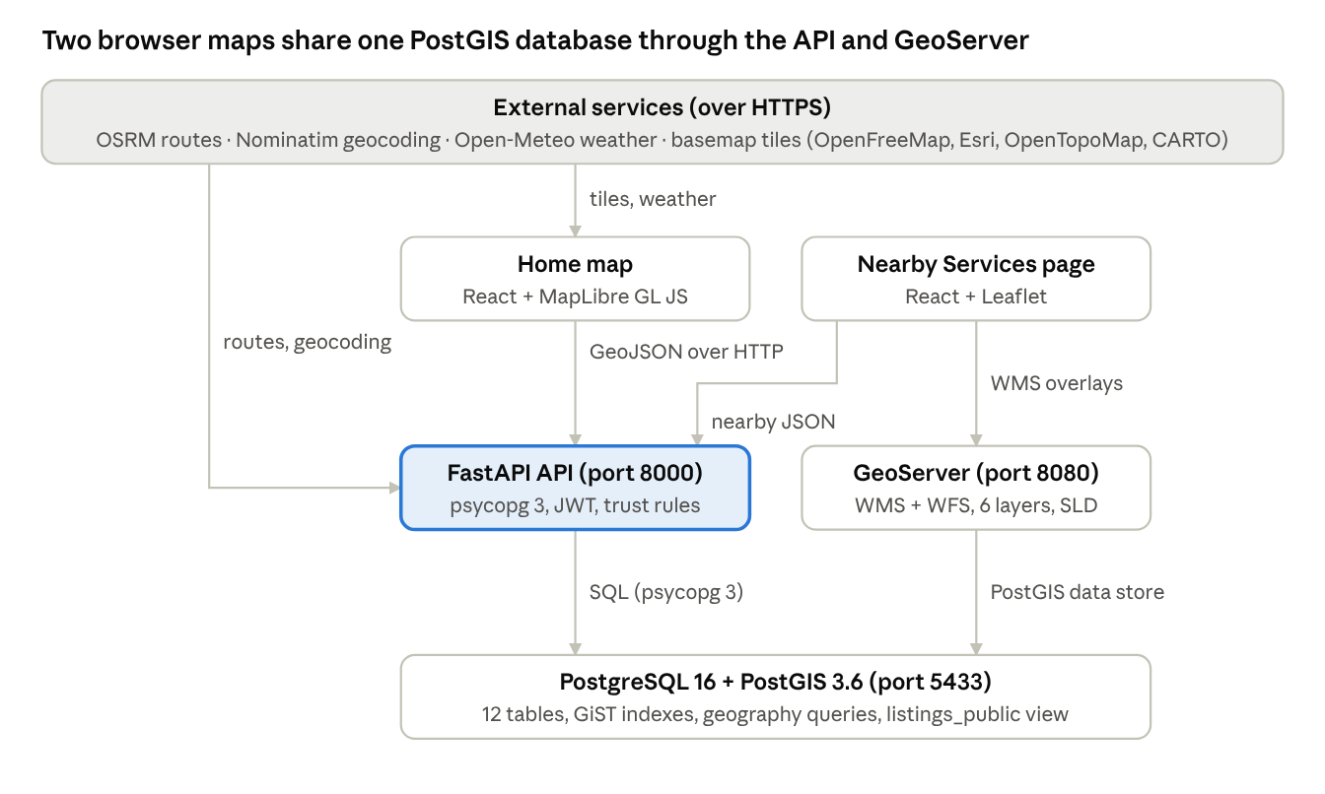
Figure 4.1: WebGIS architecture of PuneStay. Both clients read GeoJSON from the API; the Leaflet page also draws GeoServer WMS overlays; the API and GeoServer read the same PostGIS database.

4.3 Geospatial data model
The schema (db/init/01_schema.sql, excerpt in Appendix C) has ten tables and one view (Table 4.2). Every spatial table stores GEOMETRY(Point, 4326) with a GiST index; wards is a polygon table kept for a future boundary layer. Listings carry provenance columns (source, source_ref, also_in) and status columns (status, verify_count, flag_count), and rent_min and vacancy are nullable so that an unknown value is stored as unknown rather than guessed. The public view listings_public excludes hidden and pending rows and is what both the API and GeoServer serve to the map.
Table | Rows (Oct 2026) | Role
users | accounts | Name, email, PBKDF2 password hash, role (student, owner, admin), trusted flag
listings | 520 | PGs and hostels with provenance, rent, vacancy, status, nearest-service and safety columns
listing_photos | 0 | Up to five photos per listing, stored as files, served by the API
pois | 10,492 | Service points in 22 categories with OSM tags (JSONB)
destinations | 1,010 | Colleges and offices for commute time
wards | 0 | Polygon layer reserved for ward boundaries
commute_cache | computed | Duration and distance per listing, destination and mode
listing_actions | 0 | Confirmations, flags and rent suggestions with the device's distance from the place
listing_claims | 0 | Ownership claims on imported listings with status and phone
safety_reports | 0 | Night-safety reports with category and note
rent_observations | 8,391 | Past flat rents with precision (building or locality) and bedrooms
geocode_cache | cached | Nominatim answers, forward and reverse
listings_public (view) | 520 | Rows served to the map: not hidden, not pending

4.4 API design and error handling
The API (Appendix B) has 45 endpoints in eleven routers. Reads return GeoJSON FeatureCollections or plain JSON; writes require a JWT bearer token issued by /auth/login. Every error is a JSON object with a plain-English detail: 400 for invalid or out-of-area coordinates and unknown categories, 401 for a missing or expired token, 403 for an action the role does not allow or a trust rule refuses (for example confirming from more than 300 m away), 404 for a missing listing, 409 for a duplicate, 422 for a malformed body, 429 for a daily limit, 503 when the database, the routing server or the geocoder cannot be reached. The Nearby Services endpoint returns an empty collection with a message rather than an error when nothing matches, so the client can show "No pharmacies found within 500 m. Try a larger radius" instead of a failure.

4.5 Spatial operations used in the platform
Operation | PostGIS expression | Used for
Radius search | ST_DWithin(geom::geography, origin::geography, radius_m) | Services within a radius; confirmation within 300 m; safety report within 500 m; duplicates within 80 m and 150 m
Nearest-N | ORDER BY geom <-> origin LIMIT n (index-assisted KNN) | Nearest services; nearest bus stop, metro, mess and hospital per listing
Distance | ST_Distance(a::geography, b::geography) | Distances in metres in every result; verification distance stored with each action
Bearing | degrees(ST_Azimuth(origin, geom)) | Direction of each service from the origin
Viewport filter | geom && ST_MakeEnvelope(w, s, e, n, 4326) | Listings, reports and rents for the visible map
Grid aggregation | ST_SnapToGrid and ST_MakeEnvelope at 500 m | Rent heatmap cells with the median of the observations inside
Containment | ST_Within and bounding-box checks | Points outside the study area are refused
Trigram similarity | similarity(name_a, name_b) (pg_trgm) | De-duplication between OSM and Overture; destination name search

4.6 Nearby Services: the course-brief core
The Nearby Services function (routers/nearby.py) takes an origin, an optional category list and subcategory, a radius in metres (50 to 25,000), a nearest-N limit (1 to 200) and an optional name filter. The origin is validated in three steps: both coordinates must be present, they must lie within valid latitude and longitude ranges, and they must fall inside the Pune bounding box; each failure returns a 400 with a message that tells the user what to do. When neither radius nor limit is given, the service defaults to the 20 nearest places within 2 km. The query builds an origin point with ST_SetSRID(ST_MakePoint(lng, lat), 4326), applies ST_DWithin on geography for the radius, orders by the index-assisted distance operator and applies the limit, so "within radius", "nearest N" and "both" are the same query with different clauses. Each result carries the category and its human label, the subcategory derived from the OSM tags, name, phone, website, opening hours, address, distance in metres and bearing in degrees. The response is a GeoJSON FeatureCollection with the origin, the query and a count; an empty result includes a message. The categories endpoint returns the 22 categories with counts and their subcategories for the pickers. The workflow is drawn in Figure 4.2 (Section 4.6.1).
On the client (pages/NearbyPage.jsx and the shared hook nearby.js) the origin comes from a map click, a dragged marker, typed coordinates with range and area checks, the browser's geolocation with a message for each denial code, or a shareable link such as #/nearby?lat=18.52&lng=73.85&category=hospital. Every change to the origin or filters re-runs the search. Results are drawn as colour-coded Leaflet markers with a dashed radius circle, numbered in distance order in the list; clicking a marker highlights its row and clicking a row opens the marker's popup, so the list and the map stay synchronised. The same search is available on the home map as a sidebar tab, with the markers drawn by MapLibre.

4.6.1 Workflow
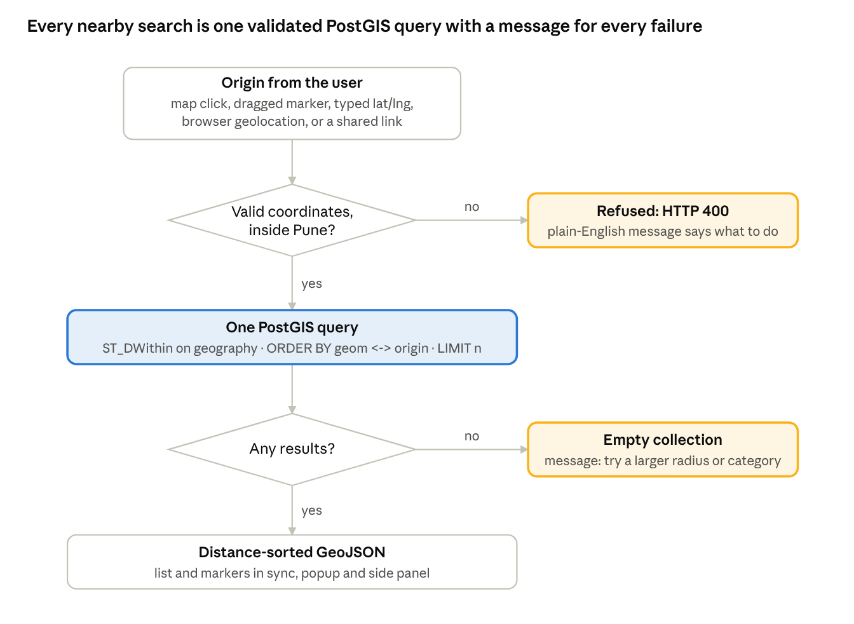
Figure 4.2: Workflow of a Nearby Services search from the user's origin to the synchronised list and markers. Both failure paths end in a message, never a blank map.

4.7 Commute time and directions
A destination is a college or office chosen from the header search. With a destination set, the listings query joins the commute cache so that every pin and card shows minutes by road, and the filter can drop listings beyond a chosen travel time. The route endpoint asks OSRM (a local instance if configured, otherwise the public demonstration server) for the car, bike or foot route between two points and returns the duration, distance and GeoJSON line; the listing-to-destination variant caches the result in commute_cache keyed by listing, destination and mode. The Directions card on the home map generalises this: from a college or office or from the phone's position to the selected listing, with the route drawn on the map and a link that opens the same trip in Google Maps.

4.8 Rent evidence
Because imported listings have no rent, PuneStay separates rent facts from rent evidence. A rent is shown on a listing only when its owner published it or when two students suggested values within 15% of each other. Rent evidence comes from the 8,391 past flat rents: the heatmap endpoint aggregates them into 500 m cells with the median rent, the past-rents layer draws one dot per housing society sized by sample count and coloured by the 2025 estimate, and the area-comparison page reports median 1 BHK and 2 BHK rents per locality. Every such figure is labelled with its year and as an estimate where the uplift factor was applied.

4.9 Night-safety score
The score (scripts/compute_derived.py and services/nearby.py) is a 0 to 100 index computed per listing from nearby service points: up to 40 points for street lamps within 200 m (4 per lamp) only when the city has more than 2,000 mapped lamps, otherwise this term is dropped and the maximum rescaled; 20, 12 or 5 points for the nearest police station within 500 m, 1,500 m or farther; up to 20 points for late-opening shops, ATMs, pharmacies and food places within 300 m (2 each); and minus 5 per community safety report within 300 m in the last six months, up to minus 20. Because Pune has only 127 mapped lamps, the score currently uses the police and shop terms, and the interface shows it with a text level (Good, Moderate, Low) rather than as a precise number. It is a screening aid, not a measurement of safety.

4.10 Trust rules for community contributions
Action | Rule | Reason
Add a listing | Signed-in account; a new account's first listing is pending until an administrator approves it; approval marks the account trusted; 3 listings per day | Stops anonymous or bulk fake listings
Confirm a listing ("I am here, it is real") | Device position sent with the request; counts only within 300 m plus the reported GPS accuracy up to 200 m; one per account per listing; 10 actions per day | Ties a confirmation to presence at the place
Flag as wrong or closed | One per account per listing; three flags hide the listing until an administrator restores it | Lets students remove dead listings without deleting evidence
Suggest a rent | Applied when two suggestions agree within 15% | Prevents one person setting a price
Claim an imported listing | Phone number given; administrator calls the number already listed for the place before approving; 3 claims per day | Gives ownership to the real operator
Report an unsafe spot | Device position within 500 m; 3 per day | Keeps reports local and limited
Everything | Every action stores the device's distance from the place, never its coordinates for display | Auditability with privacy

4.11 Publishing through GeoServer
A script (scripts/configure_geoserver.py) creates the workspace punestay, a PostGIS data store on the project database, and six layers: pois, listings_public, destinations, safety_reports, wards and a SQL view named services that selects the service categories with a derived subcategory column. A point style, punestay_point, is uploaded as SLD and applied. Each layer is then available as WMS (image/png tiles) and WFS (GeoJSON features) at http://localhost:8080/geoserver/punestay. The Leaflet page offers two WMS overlays, all services and listings, as switches; a tile error produces the message "GeoServer overlay could not be loaded" and the page keeps working, because the overlays are optional. Any desktop GIS can load the same layers.

4.12 Interface design
Feature | Design
Theme | Dark Charcoal and Teal by default with a light theme behind a sun/moon toggle; all colours are tokens so both themes share one stylesheet
Home map | Clustered pins coloured by rent band (grey when rent not published), hover and selection states, labels at high zoom, a Places tab of cards, a Filters tab, a Nearby tab, a floating page nav, a Directions card and a map-type picker with Streets, Satellite, Terrain, Light, Dark and OSM
Details drawer | Photos or a patterned initials field, status badges, rent or "Rent not published", commute card with route, facts tiles, amenities, nearest services, community actions, call and website buttons
Nearby page | Three-step card panel (Where, What, How far), collapsible GeoServer layers, results list, rounded map with map-type, zoom and locate controls, a status bar with live Pune weather, and a top-results strip
Content pages | Compare areas, Saved places (browser-local shortlist), My listings, Add or edit listing with address geocoding and a draggable pin, Admin
Phone layout | Sidebar and drawer become bottom sheets; a bottom bar switches Places, Filters and Nearby; the Nearby page stacks map over panel
Accessibility | Keyboard focus rings, ARIA roles on tabs, dialogs and menus, reduced-motion support, contrast checked in both themes

4.13 Privacy and security
Passwords are hashed with PBKDF2; sessions use HS256 JSON Web Tokens signed with a secret from the environment; administrator registration needs a separate setup token so that no one can create an admin from the public form. The device position used for confirmations and safety reports is converted to a distance on the server and only the distance is stored. The weather chip always queries the city centre, never the viewer's position. Website links on listings are validated to http or https and rendered as text, which prevents script injection. Uploaded photos are checked for type and size before writing. Secrets live in a .env file that is not committed; the example file contains none.

4.14 Testing and verification strategy
Testing combines an automated API suite and manual browser checks. The suite (backend/tests/smoke_api.py) runs 61 checks against the live API: health, listings and detail, nearby services with radius, nearest-N, subcategory and error cases, destinations, routes, account registration and login, listing creation and the pending-approval path, the 300 m confirmation rule, device-checked safety reports, flags, rent suggestions, the claim flow, administrator approval and the daily limits, then deletes its test accounts and rows. The front end is checked with a production build and in the browser on desktop and phone layouts after every change; Appendix F lists the manual cases.

4.15 Deployment
The platform runs on a Windows laptop: PostgreSQL and PostGIS as a portable server under the user's local application data, GeoServer as a portable binary with a JDK 21, the API through uvicorn and the front end through Vite in development or as a static build. Four scripts start and stop the database and GeoServer. A public deployment would need a host for the API and database with PostGIS (for example a small virtual machine or a managed PostgreSQL), a static host for the front end, a local OSRM instance built from the Maharashtra extract, and HTTPS so that phone browsers share their position.

4.16 Software and tools
Component | Use | Version or source
PostgreSQL + PostGIS | Spatial database | 16.14 + 3.6.2, portable build
GeoServer | WMS and WFS publishing | 2.28.x, portable; JDK 21
Python, FastAPI, psycopg | API and import scripts | Python 3.14, FastAPI, psycopg 3
React, Vite | Front end | React 18, Vite 5
MapLibre GL JS | Home map | 4.7.1
Leaflet | Nearby Services page | 1.9.4
lucide-react | Icons | 0.468
overturemaps CLI, DuckDB | Overture Places download | overturemaps.org
Overpass API | OSM extracts | overpass-api.de
OSRM | Routing | router.project-osrm.org (fallback)
Nominatim | Geocoding | nominatim.openstreetmap.org
Open-Meteo | Weather | open-meteo.com
OpenFreeMap, Esri, OpenTopoMap, OSM, CARTO | Basemaps | tile services
Google Fonts | Inter, Plus Jakarta Sans | fonts.google.com

Chapter 5: Results: Implementation and Evidence
This chapter reports what was built and what it shows. Section 5.1 gives the implementation status of the nearby-services core and the rental extension. Sections 5.2 to 5.9 present each part with screenshots taken from the running platform on 20 October 2026 with the real imported data; no demonstration rows exist. Section 5.10 reports the automated tests.

5.1 Implementation status register
Area (course brief) | Capability | Status
Location input | Map click, draggable marker, typed latitude and longitude with range and area checks, browser geolocation with per-error messages, shareable link | Built and checked
Filtering | 22 categories with counts; subcategories derived from OSM tags; name filter | Built and checked
Search modes | Within radius (500 m to 10 km), nearest N (5 to 100), both | Built and checked
Results | Distance-sorted GeoJSON list with distance and bearing, synchronised with markers; popup and side panel; top-results strip | Built and checked
Spatial query | PostGIS geography, ST_DWithin plus KNN ordering, EPSG:4326 | Built and checked
GeoServer | Six layers as WMS and WFS, SQL view, SLD style; two WMS overlays in Leaflet | Built and checked
Error handling | Denied or unavailable geolocation, invalid coordinates, outside-area point, unknown category, empty result, GeoServer down, API down | Built and checked

Area (extension) | Capability | Status
Listings | 520 real PGs and hostels with provenance, clustering, rent bands, filters, cards, details drawer | Built and checked
Commute | Destination search over 1,010 colleges and offices, cached OSRM travel time per listing, route line, directions card with car, bike and foot modes | Built and checked
Rent evidence | 8,391 past flat rents: 500 m heatmap, society dots, area comparison with 2025 estimates | Built and checked
Safety | Night-safety score per listing; community safety reports within 500 m | Built and checked
Community | Accounts, add and edit listings with photos and geocoded pins, confirm within 300 m, flag, suggest rent, claim imported listings, pending approval, daily limits | Built and checked
Admin | Statistics, approval queue, claims, flagged listings, accounts, data-coverage panel | Built and checked
Interface | Dark and light themes, six basemaps on both maps, phone layout, Saved shortlist, Compare areas | Built and checked
Data completeness | Published rents on listings; photos; ward boundaries | Partial: depends on owners and students; wards planned
Deployment | Public HTTPS hosting; local OSRM | Planned

5.2 Nearby Services page
The Nearby Services page is the course-brief deliverable. Figure 5.1 shows it before a search: the three-step panel, the GeoServer layer switches, the empty results card, the map with its controls and the status bar with live Pune weather. Figure 5.2 shows a search from the city centre (18.5204, 73.8567) for hospitals and clinics within 2 km: 160 results drawn as red markers inside the dashed radius circle, the four nearest in the strip under the map (Manish Clinic at 118 m, Surya Sahyadri at 144 m, Dr. Dilip Shah at 334 m, Milenkari Clinic at 347 m) and the full list in the panel. The same query through the API returns the FeatureCollection in well under a second on the laptop, because ST_DWithin and the KNN ordering both use the GiST index on 10,492 points.
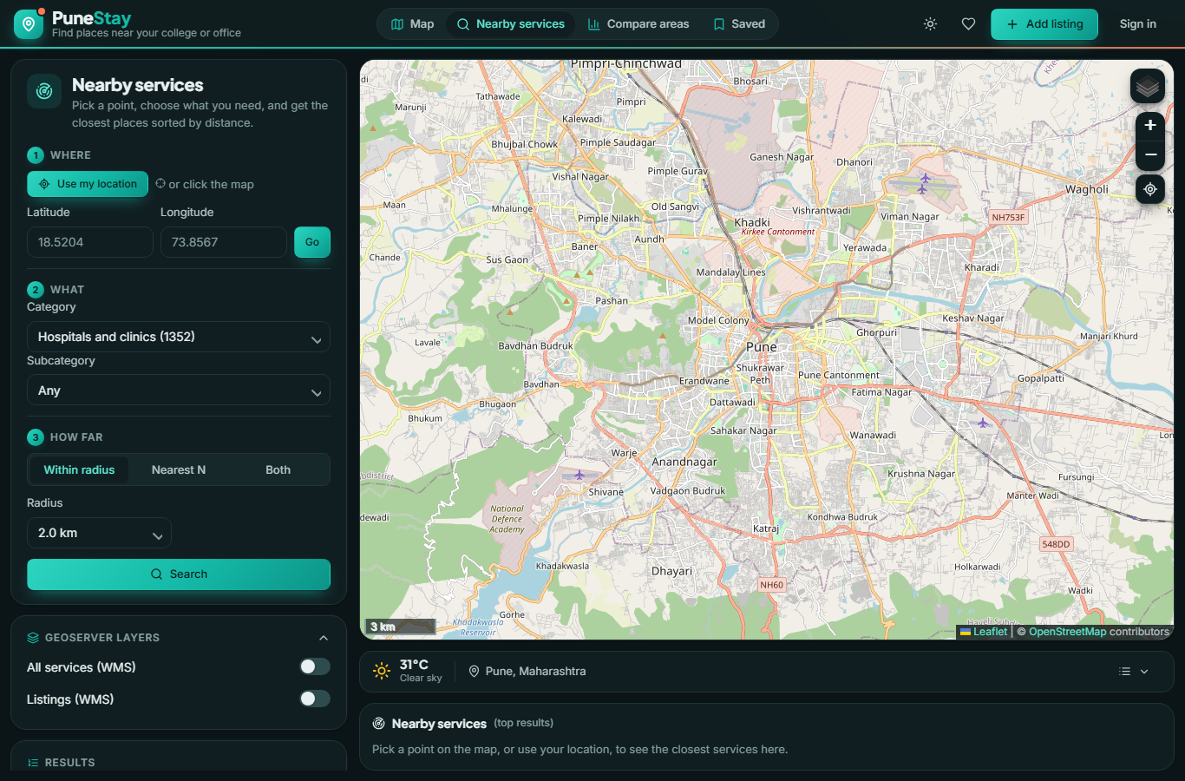
Figure 5.1: Nearby Services page before a search: the three-step panel, GeoServer layer switches, empty results card, map with map-type, zoom and locate controls, and the status bar with live Pune weather.
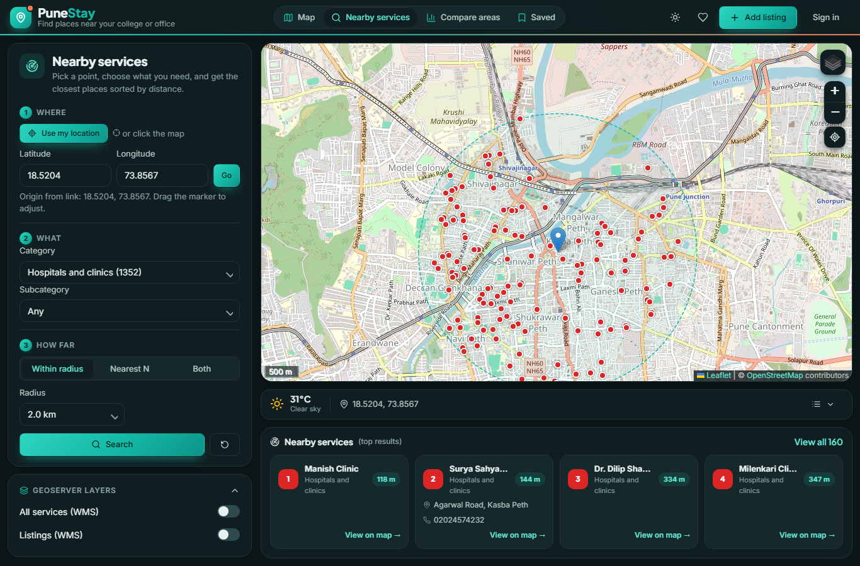
Figure 5.2: Hospitals and clinics within 2 km of the city centre: 160 results as markers inside the dashed radius circle, the four nearest in the strip under the map, and the full list in the panel.

5.3 Home map
Figure 5.3 shows the home map: clustered listing pins over central Pune, the Places tab with cards, the floating page nav, the header with destination search, Filters, Nearby and Directions, and the map-type picker. Pins are grey because no imported listing has a published rent; once a rent is published the pin takes its rent band colour. Figure 5.4 shows the details drawer for a girls' hostel near Deccan Gymkhana with COEP chosen as destination: status badges, "Rent not published" with the suggest-rent prompt, the four fact tiles including the night-safety level, 6 minutes by road to COEP, and the community actions.
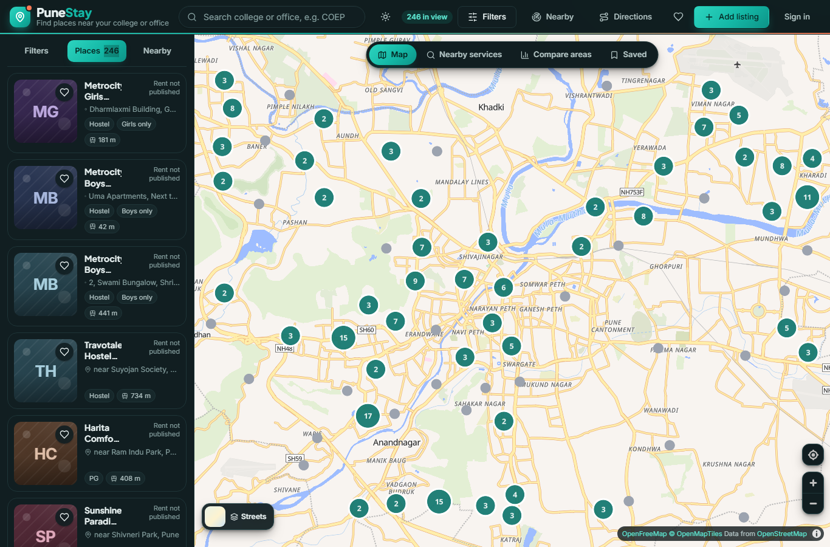
Figure 5.3: Home map: clustered listing pins over central Pune, the Places cards, the floating page nav, the header with destination search, Filters, Nearby and Directions, and the map-type picker. Pins are grey because no imported listing has a published rent.
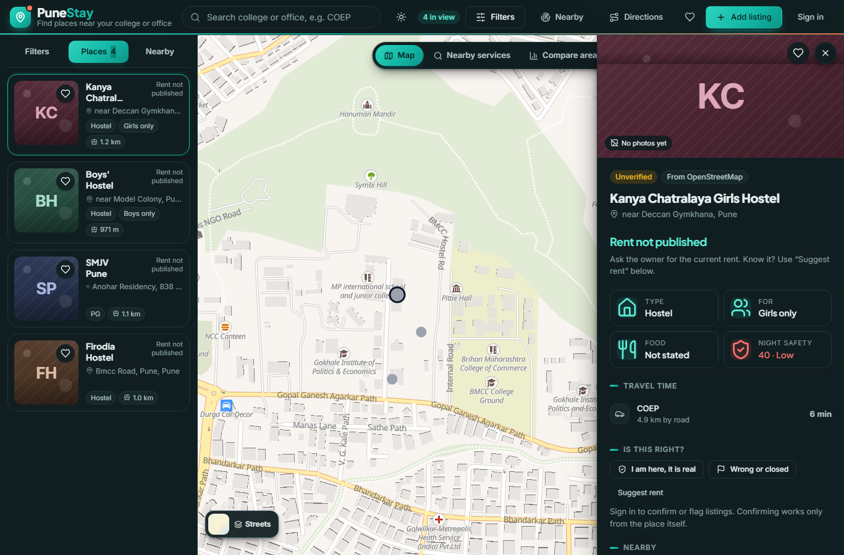
Figure 5.4: Details drawer for Kanya Chatralaya Girls Hostel with COEP as destination: status and source badges, "Rent not published", fact tiles with the night-safety level, 4.9 km and 6 minutes by road, and the community actions.

5.4 Directions and basemaps
The Directions card routes from a college, office or the phone's position to the selected listing. In the test shown in the drawer, COEP to Kanya Chatralaya Girls Hostel is 4.9 km and 6 minutes by car; the route is drawn on the map and the same trip opens in Google Maps from a link. The map-type picker offers Streets, Satellite, Terrain, Light, Dark and OSM; a switch rebuilds every PuneStay layer on the new style, which was verified by checking that the listings source, route and markers exist after switching to Satellite. The Leaflet page offers the same five raster choices in its layer control.

5.5 Data coverage
The Admin page and scripts/coverage_report.py report the same numbers. Of the 520 listings, 393 (76%) have a phone number and 296 (57%) a website; 179 (34%) say whether they are for boys or girls; 16 list amenities; 11 are confirmed by both open datasets; none has a published rent, photos or three confirmations yet. Nine localities with at least five colleges or offices within 2 km have three or fewer listings (Chinchwad, Tingrenagar, Nigdi, Vishrantwadi, Lullanagar, Wanawadi, Wanowrie, Bhugaon and Dhanori), and 14 of 205 colleges have no listing within 1.5 km, among them the National Defence Academy, the College of Military Engineering and MIMER Medical College. These are the places where owner listings would add most value.

5.6 Compare areas and rent evidence
Figure 5.5 shows the Compare areas page for two localities: listings on the map, median PG rent (shown as a dash until rents are reported), typical 1 BHK and 2 BHK flat rents as 2025 estimates with the number of past rents behind them, night-safety score, share with rooms available and average distance to the nearest bus stop, metro, mess and hospital, with the better value shaded. On the home map the flat-rent heatmap and the past-rents dots draw the same observations.
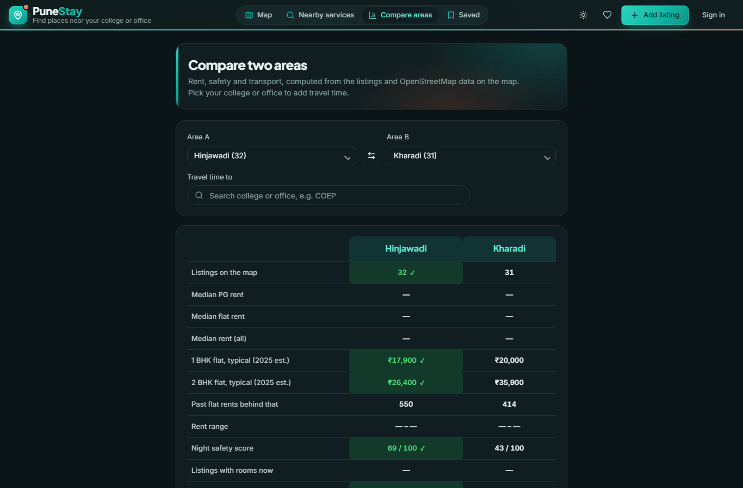
Figure 5.5: Compare areas page: two localities side by side with listings, past flat rents as 2025 estimates, safety score and nearest-service distances; the better value is shaded.

5.7 Adding and managing listings
Figure 5.6 shows the Add listing form: basics, rent, amenities, contact, photos and the location card in which an address is geocoded through Nominatim and the pin dragged to the gate. A duplicate check lists existing listings within 100 m before submission. An end-to-end test as the administrator (trusted account) created a listing, which appeared immediately as a pin, a card and a drawer; the test row was then deleted. For a new account the same submission is held as pending and listed in the administrator's approval queue; approval publishes it and marks the account trusted.
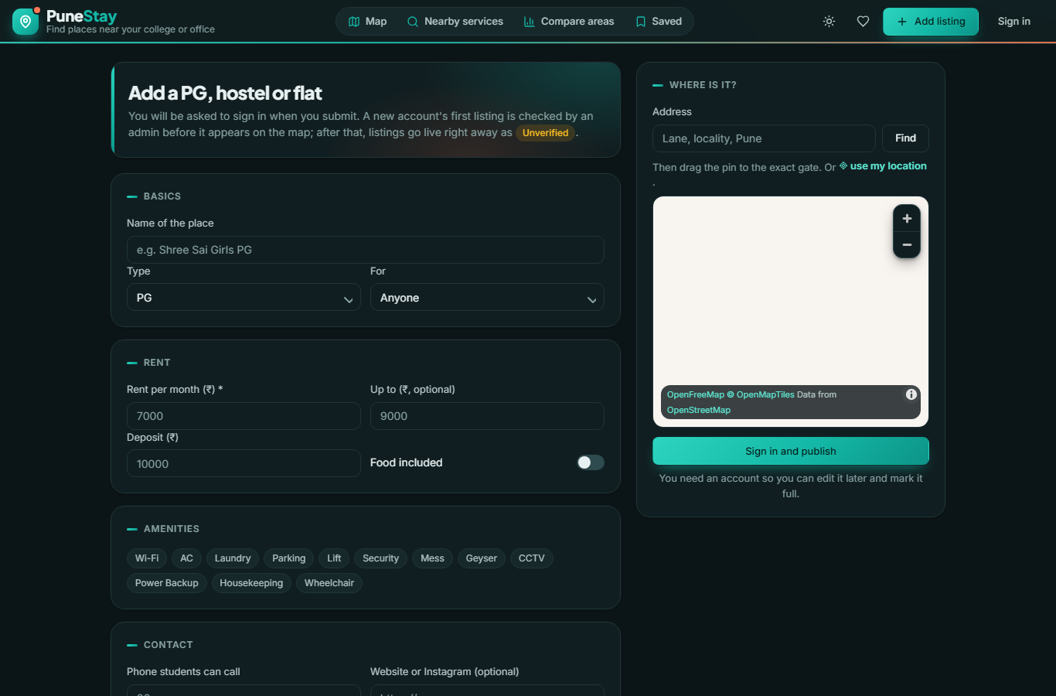
Figure 5.6: Add listing form with basics, rent, amenities, contact and the location card in which an address is geocoded and the pin dragged to the gate.

5.8 Saved places and phone layout
Figure 5.7 shows the Saved page, a browser-local shortlist filled from the heart buttons. Figures 5.8 and 5.9 show the home map and the Nearby page at phone width (390 px): the sidebar becomes a bottom sheet, a bottom bar switches Places, Filters and Nearby, and the Nearby page stacks the map above the panel.
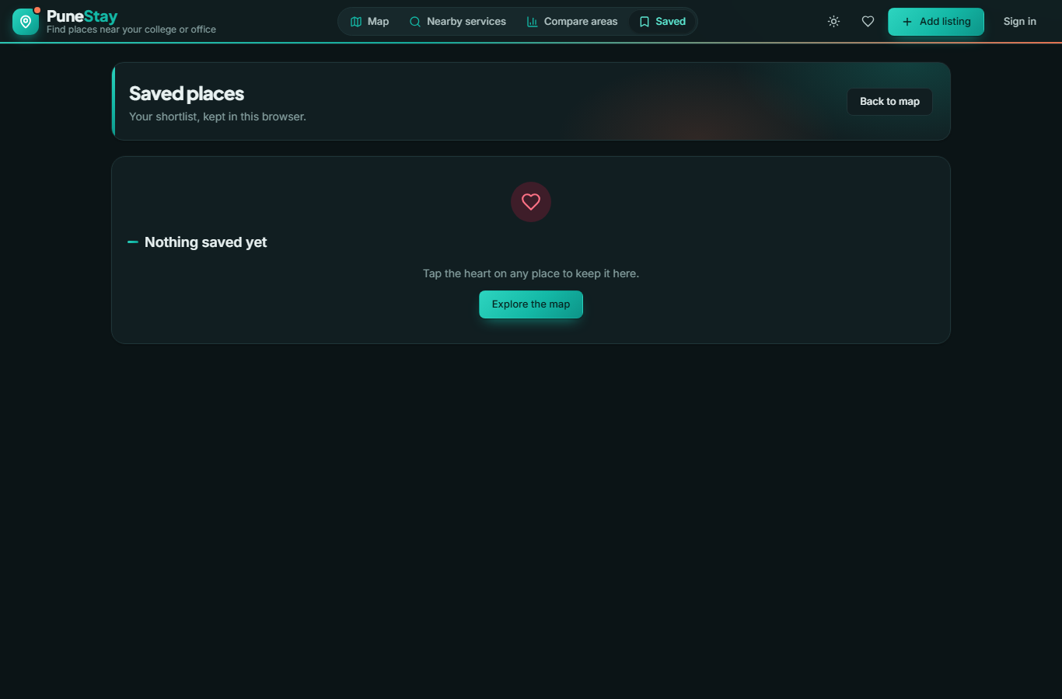
Figure 5.7: Saved places: the browser-local shortlist built from the heart buttons.
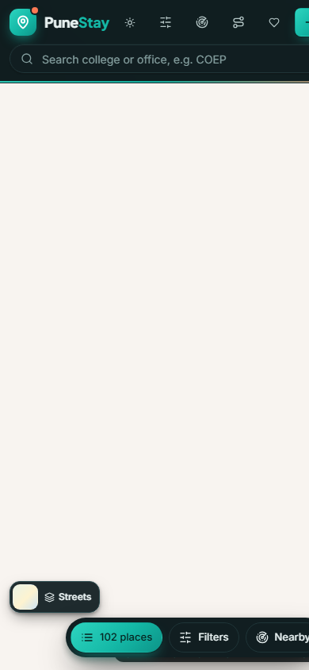
Figure 5.8: Home map at phone width: the sidebar becomes a bottom sheet and a bottom bar switches Places, Filters and Nearby.
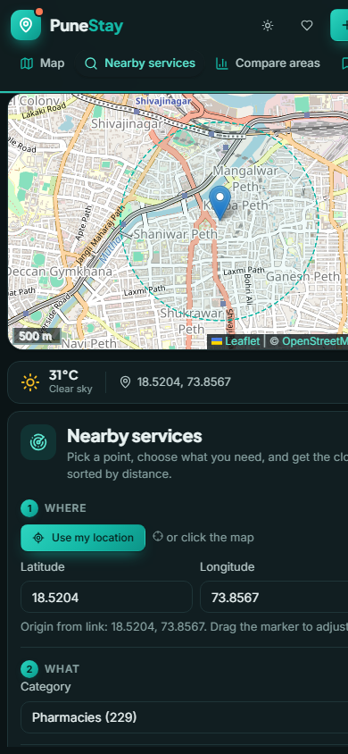
Figure 5.9: Nearby Services page at phone width with pharmacies within 1 km: the map stacks above the panel.

5.9 Interface themes
The platform opens in the Dark Charcoal and Teal theme; the sun button in the header switches to the light theme and the choice is remembered. All figures in this chapter are in the dark theme.

5.10 Automated tests
The API test suite was run after the final change and reported 61 checks passed. The checks cover the nearby-services endpoint (radius, nearest N, both, subcategory, name filter, invalid and outside-area coordinates, unknown category, empty result message), listings and detail, destinations and routes, registration and login, the pending-approval path for a new account, the 300 m confirmation rule (refused from afar, accepted nearby), device-checked safety reports, flags and hiding after three flags, rent suggestions and agreement, the claim flow with administrator decision, the daily limits, and clean-up. The production build of the front end compiles without errors.

Chapter 6: Discussion

6.1 Answers to the research questions
RQ | Answer | Confidence
RQ1 | One query serves radius, nearest-N and both: ST_DWithin on geography for the radius and the index-assisted distance operator for the order, on a GiST index; 10,492 points answer in well under a second on a laptop | High: implemented, timed informally and covered by tests
RQ2 | Every listing carries source, source reference, other sources that list it, status and counts; nullable rent and vacancy keep unknowns unknown; actions store distance, not position; a public view hides pending and hidden rows | High
RQ3 | OGC publishing adds reuse: the same six layers draw in Leaflet as WMS overlays and open in any GIS as WFS without touching the API; it costs a second server and configuration script | High for the mechanism; usage beyond this project untested
RQ4 | OSM and Overture together give 520 PGs and hostels, 76% with phones, but neither has rents or photos, their overlap is only 11 places, and nine localities with demand have three or fewer listings | High: counts from the database and coverage report
RQ5 | Routing gives true commute minutes; past flat rents give honest area-level evidence; the safety score is a coarse screen limited by missing lamp data | Moderate: methods work; usefulness to students not yet measured
RQ6 | Distance-checked confirmation, approval of first listings, ownership claims and daily limits let anyone contribute while blocking anonymous bulk posting | Moderate: rules enforced and tested; abuse under real use not yet observed

6.2 Meeting the course brief
Every requirement of Project 1: Nearby Services WebGIS is implemented and evidenced: the three ways to give a location, category and subcategory filtering, radius and nearest-N with a combined mode, a distance-sorted list synchronised with markers, popup and side panel, PostGIS queries in a proper CRS, GeoServer layers consumed in Leaflet, and explicit handling of denied geolocation, invalid input and empty results. Appendix A traces each requirement to the code and the section that evidences it. The rental extension does not change the core; it reuses the same query service, the same data model and the same map stack.

6.3 Real data and honest gaps
The decision to use only real data shaped the platform. It removed six sample listings, a demo mode and every estimated rent, and it replaced them with "Rent not published", "Not stated" and a coverage report. The cost is visible: all 520 pins are grey and the median PG rent on the comparison page is a dash. The benefit is that nothing on the map is invented, and the community features exist precisely to fill the gaps: an owner who claims a listing publishes its rent, two students who agree set it, and photos follow. The 8,391 flat rents show what honest area-level evidence looks like when it exists.

6.4 Completeness of open place data
The import is itself a finding. Overture Maps contributed almost four times as many PGs as OpenStreetMap, yet the two agree on only 11 places, which suggests both are far from complete and that a student-facing map will always depend on owners adding their own places. Phone numbers are the most useful field and the best covered (76%); gender and amenities are poorly covered; street lamps are almost absent from OSM in Pune, which disabled the lamp term of the safety score. Where contributors confirm or correct a place, PuneStay could in turn feed OSM, closing the loop between the two kinds of volunteered data.

6.5 Trust rules and their trade-offs
Requiring presence within 300 m makes a confirmation meaningful but excludes students who know a place but are not standing at it; the GPS-accuracy allowance of up to 200 m softens this for poor signals. Holding a new account's first listing for approval protects the map but delays honest owners until an administrator acts; the queue is therefore the first item on the Admin page. Daily limits are generous for real users and tight for scripts. These rules are a starting point whose thresholds should be tuned once real contribution patterns are seen.

6.6 The WebGIS as a delivery layer
A polished interface can make thin data look authoritative. PuneStay counters this with labels at every point where a value is uncertain: the year on past rents, "estimate" on uplifted values, "Not stated" on unknown attributes, the source badge on imported listings, and a text level rather than a number for safety. The dark theme and animations were added because a map students enjoy using is a map they contribute to, not as a substitute for data.

6.7 Threats to validity
- No published rents exist yet, so the rent filters and bands are untested with real values.
- The safety score currently rests on police and shop distances only; it has not been validated against any safety data.
- Routing uses a public server with rate limits; a demonstration under load could fail until a local OSRM is installed.
- The community rules have been exercised only by automated tests and the author, not by real contributors.
- Testing of the front end was manual; there is no automated browser test suite.

Chapter 7: Conclusion and Future Work

7.1 Summary of contributions
PuneStay is a working Nearby Services WebGIS for Pune. It finds services around any point by radius or nearest-N from a PostGIS database, publishes its layers through GeoServer, and draws them in Leaflet with synchronised lists and markers and explicit error states, as the course brief requires. On that core it places 520 real PG and hostel listings with provenance, commute time and directions to 1,010 colleges and offices, 8,391 real past flat rents as area evidence, a night-safety screen, and a community layer with location-checked verification, ownership claims and administrator approval. Everything is delivered through a responsive, themed interface with six basemaps and is backed by 61 automated API checks.

7.2 Achievement of objectives
ID | Evidence | Status
O1 | Nearby Services page and API, 22 categories, radius and nearest-N, synchronised list and markers, error messages; tests | Achieved
O2 | Twelve-table PostGIS schema with provenance, public view, 45-endpoint API with JSON errors | Achieved
O3 | Six GeoServer layers as WMS and WFS with an SLD style, two WMS overlays in Leaflet | Achieved
O4 | OSM and Overture imports, de-duplication, coverage report with thin localities and uncovered colleges | Achieved; completeness limited by the sources
O5 | Cached OSRM commute, directions card, rent heatmap and comparison, safety score | Achieved as methods; usefulness to students not yet measured
O6 | Trust rules enforced and tested; dark and light themes; phone layout; accessibility basics | Achieved; real contribution patterns pending

7.3 Limitations
The limitations in Section 6.7 bound the conclusions: listings have no published rents or photos until owners and students add them, the safety score is coarse, routing depends on a public server, and the platform runs on a laptop without a public link. The ward boundary layer is reserved in the schema but not loaded.

7.4 Future work
Stage | Content | Gate
1 | Owner outreach: invite the 393 listings with phone numbers to claim their place and publish rent, photos and availability | First 50 claimed listings
2 | Student pilot: one college, students confirm and flag listings from the spot; tune the 300 m rule and daily limits from real patterns | Agreement between confirmations
3 | Local routing: OSRM built from the Maharashtra extract for unlimited, offline-safe commute queries | Public deployment plan
4 | Deployment: HTTPS hosting of API, database and front end; backups; data-retention policy | Security checklist
5 | Extensions: ward boundaries, Marathi interface, email verification, automated browser tests, feeding confirmed places back to OpenStreetMap | Stages 1 and 2

7.5 Prototype and operational use
PuneStay is a course prototype that is ready for a supervised pilot with one college. Operational use by many students would need permanent hosting, a local routing server, moderation capacity for the approval queue, and enough owner participation that published rents and photos cover most listings.

References
Agafonkin, V. (n.d.). Leaflet: An open-source JavaScript library for interactive maps [Software]. https://leafletjs.com/
ANAROCK Research. (2025). Residential market viewpoints: Pune, Q1 2025 [Report]. ANAROCK Property Consultants.
Barrington-Leigh, C., & Millard-Ball, A. (2017). The world's user-generated road map is more than 80% complete. PLoS ONE, 12(8), e0180698. https://doi.org/10.1371/journal.pone.0180698
Fu, P., & Sun, J. (2011). Web GIS: Principles and applications. Esri Press.
GeoServer. (n.d.). GeoServer user manual [Software documentation]. https://docs.geoserver.org/
Goodchild, M. F. (2007). Citizens as sensors: The world of volunteered geography. GeoJournal, 69(4), 211–221. https://doi.org/10.1007/s10708-007-9111-y
Government of India. (2023). The Digital Personal Data Protection Act, 2023 (Act No. 22 of 2023). Ministry of Law and Justice.
Guttman, A. (1984). R-trees: A dynamic index structure for spatial searching. Proceedings of the 1984 ACM SIGMOD International Conference on Management of Data, 47–57. https://doi.org/10.1145/602259.602266
Haklay, M. (2010). How good is volunteered geographical information? A comparative study of OpenStreetMap and Ordnance Survey datasets. Environment and Planning B: Planning and Design, 37(4), 682–703. https://doi.org/10.1068/b35097
Keenan, P. B., & Jankowski, P. (2019). Spatial decision support systems: Three decades on. Decision Support Systems, 116, 64–76. https://doi.org/10.1016/j.dss.2018.10.010
Luca, M. (2016). Reviews, reputation, and revenue: The case of Yelp.com (Harvard Business School Working Paper No. 12-016). Harvard Business School.
Luxen, D., & Vetter, C. (2011). Real-time routing with OpenStreetMap data. Proceedings of the 19th ACM SIGSPATIAL International Conference on Advances in Geographic Information Systems, 513–516. https://doi.org/10.1145/2093973.2094062
MapLibre contributors. (n.d.). MapLibre GL JS [Software]. https://maplibre.org/
Mayzlin, D., Dover, Y., & Chevalier, J. (2014). Promotional reviews: An empirical investigation of online review manipulation. American Economic Review, 104(8), 2421–2455. https://doi.org/10.1257/aer.104.8.2421
Obe, R. O., & Hsu, L. S. (2021). PostGIS in action (3rd ed.). Manning.
Open Geospatial Consortium. (2006). OpenGIS Web Map Server implementation specification, version 1.3.0 (OGC 06-042). https://www.ogc.org/standards/wms
Open Geospatial Consortium. (2010). OpenGIS Web Feature Service 2.0 interface standard (OGC 09-025r1). https://www.ogc.org/standards/wfs
Open-Meteo. (n.d.). Free weather API [Data set]. https://open-meteo.com/
OpenStreetMap contributors. (n.d.). OpenStreetMap [Data set]. Retrieved via the Overpass API. https://www.openstreetmap.org
Overture Maps Foundation. (n.d.). Overture Maps Places [Data set]. https://overturemaps.org/
PostGIS Project Steering Committee. (n.d.). PostGIS documentation [Software documentation]. https://postgis.net/documentation/
Project OSRM. (n.d.). Open Source Routing Machine [Software]. https://project-osrm.org/
Ramírez, S. (n.d.). FastAPI [Software]. https://fastapi.tiangolo.com/
Roick, O., & Heuser, S. (2013). Location based social networks: Definition, current state of the art and research agenda. Transactions in GIS, 17(5), 763–784. https://doi.org/10.1111/tgis.12032
Sakhare, A. (2021). Rental price of India's IT capital, Pune [Data set, CC0 1.0]. Kaggle. https://www.kaggle.com/
Senaratne, H., Mobasheri, A., Ali, A. L., Capineri, C., & Haklay, M. (2017). A review of volunteered geographic information quality assessment methods. International Journal of Geographical Information Science, 31(1), 139–167. https://doi.org/10.1080/13658816.2016.1189556
World Wide Web Consortium. (2018). Web Content Accessibility Guidelines (WCAG) 2.1. https://www.w3.org/TR/WCAG21/

Appendix A: Objective-to-Evidence Traceability
ID | Implementation (files) | Evidence in this report
O1 | backend/app/routers/nearby.py, frontend/src/nearby.js, pages/NearbyPage.jsx, components/NearbyPanel.jsx | Sections 4.6, 5.2; Figures 5.1, 5.2; Appendix F
O2 | db/init/01_schema.sql, backend/app/routers/*.py, backend/app/auth.py, db.py | Sections 4.3, 4.4; Appendix B, C
O3 | scripts/configure_geoserver.py, scripts/setup_geoserver.ps1, NearbyPage.jsx (WMS overlays) | Sections 4.11, 5.2
O4 | scripts/fetch_overpass.py, load_pois.py, import_osm_lodging.py, fetch_overture_places.py, import_overture_lodging.py, build_rent_observations.py, coverage_report.py | Sections 3.3 to 3.8, 5.5; data/COVERAGE.md
O5 | backend/app/services/osrm.py, routers/route.py, routers/rents.py, routers/areas.py, scripts/compute_derived.py, components/DirectionsPanel.jsx | Sections 4.7 to 4.9, 5.3, 5.4, 5.6
O6 | routers/listings_write.py, routers/safety.py, routers/admin.py, frontend/src/styles.css, theme.js, basemaps.js, App.jsx | Sections 4.10, 4.12, 5.7 to 5.9

Appendix B: API Endpoint Reference
All paths are relative to http://localhost:8000. Reads need no token; writes need Authorization: Bearer \<JWT> from /auth/login.
Endpoint | Parameters | Response
GET /health | none | {ok, database}
GET /nearby | lat, lng, category (comma list), subcategory, radius_m (50 to 25,000), limit (1 to 200), q | GeoJSON FeatureCollection sorted by distance with distance_m, bearing_deg, origin, query, count, message when empty; 400 for bad or outside-area input
GET /nearby/categories | none | Categories with label, count and subcategories
GET /listings | bbox, rent_max, rent_known, type, gender, food, vacancy, destination_id, max_commute_s, limit | GeoJSON of public listings with commute_s when a destination is given
GET /listings/{id} | id | Listing, photos, contact phone, commutes, nearby services by category
GET /listings/near | lat, lng, radius_m | Listings near a point (duplicate check)
POST /listings | body: name, address, lat, lng, type, gender, rent, deposit, amenities, phone, website, vacancy | Created listing; status pending for an untrusted account; 429 over the daily limit
PUT /listings/{id}, GET /listings/{id}/edit, PATCH /listings/{id}/vacancy, DELETE /listings/{id} | owner or admin | Updated listing or confirmation
POST /listings/{id}/photos, DELETE /listings/{id}/photos/{photo_id} | multipart images, up to 5 | Photo records
POST /listings/{id}/verify | body: device lat, lng, accuracy_m | verify_count and status; 403 beyond 300 m
POST /listings/{id}/flag | body: reason | flag_count and status
POST /listings/{id}/rent-update | body: rent_min, rent_max | applied when two suggestions agree
POST /listings/{id}/claim, GET /listings/{id}/my-claim | body: phone, note | Claim status
GET /listings/{id}/my-actions, GET /listings/mine/all | token | My actions; my listings, claims and trusted flag
GET /pois, GET /pois/categories, GET /pois/nearby | bbox, category; lat, lng | Service points
GET /destinations, GET /destinations/{id} | q, kind, limit | Colleges and offices
GET /route | from, to (lng,lat), mode | duration_s, distance_m, geometry; 503 when routing is unavailable
GET /route/listing/{id}/destination/{id} | mode | Same, cached in commute_cache
GET /geocode, GET /geocode/reverse | q; lat, lng | Point or address, cached
GET /flat-rents, GET /flat-rents/summary | bbox | Society dots; summary
GET /areas, GET /areas/compare, GET /areas/grid, GET /areas/wards | min listings; a, b, destination_id; bbox, cell_m, source | Localities; comparison; heatmap cells; wards
GET /safety-reports, POST /safety-reports, DELETE /safety-reports/{id} | bbox; body with device position | Reports; 403 beyond 500 m
POST /auth/register, POST /auth/login, GET /auth/me | name, email, phone, password, role, admin_token | User and token
GET /admin/stats, /pending, /claims, /flagged, /users, /coverage; PATCH /admin/pending/{id}, /claims/{id}, /listings/{id}/status | admin token | Statistics, queues, decisions, coverage

Appendix C: Database Schema (excerpt)
The full schema is in db/init/01_schema.sql. The core table is reproduced below.
CREATE EXTENSION IF NOT EXISTS postgis;
CREATE EXTENSION IF NOT EXISTS pg_trgm;

CREATE TABLE listings (
id SERIAL PRIMARY KEY,
owner_id INT REFERENCES users(id) ON DELETE SET NULL,
name TEXT NOT NULL,
address TEXT NOT NULL,
geom GEOMETRY(Point, 4326) NOT NULL,
listing_type TEXT NOT NULL CHECK (listing_type IN ('pg', 'flat', 'hostel')),
gender TEXT NOT NULL CHECK (gender IN ('male', 'female', 'any')),
rent_min INT CHECK (rent_min >= 0), -- NULL = rent not published
rent_max INT CHECK (rent_max IS NULL OR rent_max >= rent_min),
deposit INT,
food_included BOOLEAN NOT NULL DEFAULT false,
amenities JSONB NOT NULL DEFAULT '[]'::jsonb,
contact_phone TEXT,
vacancy BOOLEAN, -- NULL = not known
status TEXT NOT NULL DEFAULT 'unverified'
CHECK (status IN ('pending', 'unverified', 'verified', 'hidden')),
verify_count INT NOT NULL DEFAULT 0,
flag_count INT NOT NULL DEFAULT 0,
source TEXT NOT NULL DEFAULT 'user'
CHECK (source IN ('user', 'seed', 'osm', 'overture', 'demo', 'import')),
source_ref TEXT, -- OSM node/way id or Overture GERS id
also_in TEXT[] NOT NULL DEFAULT '{}', -- other sources listing the same place
website TEXT,
safety_score INT CHECK (safety_score BETWEEN 0 AND 100),
nearest_bus_stop_id INT REFERENCES pois(id), nearest_bus_stop_m INT,
nearest_metro_id INT REFERENCES pois(id), nearest_metro_m INT,
nearest_mess_id INT REFERENCES pois(id), nearest_mess_m INT,
nearest_hospital_id INT REFERENCES pois(id), nearest_hospital_m INT,
created_at TIMESTAMPTZ NOT NULL DEFAULT now(),
updated_at TIMESTAMPTZ NOT NULL DEFAULT now()
);
CREATE INDEX listings_geom_idx ON listings USING GIST (geom);
CREATE INDEX listings_status_idx ON listings (status);
CREATE UNIQUE INDEX listings_source_ref_idx ON listings (source, source_ref) WHERE source_ref IS NOT NULL;

CREATE VIEW listings_public AS
SELECT * FROM listings WHERE status NOT IN ('hidden', 'pending');

The Nearby Services query, as executed by the API:
SELECT p.id, p.category, p.name, p.tags->>'phone' AS phone,
ST_Distance(p.geom::geography, o.g::geography)::int AS distance_m,
degrees(ST_Azimuth(o.g, p.geom))::int AS bearing_deg
FROM (SELECT ST_SetSRID(ST_MakePoint(%(lng)s, %(lat)s), 4326) AS g) o, pois p
WHERE p.category = ANY(%(cats)s)
AND ST_DWithin(p.geom::geography, o.g::geography, %(radius)s)
ORDER BY p.geom <-> o.g
LIMIT %(limit)s;

Appendix D: Installation and Run Guide
- Install Python 3.12 or later, Node.js 20 or later and a JDK 21.
- Run scripts\setup_portable_pg.ps1 once to unpack PostgreSQL 16 with PostGIS 3.6 under %LOCALAPPDATA%\PuneStay on port 5433 and create the punestay database with db\init\01_schema.sql.
- Copy .env.example to .env and set POSTGRES_PORT=5433, JWT_SECRET, ADMIN_EMAIL and ADMIN_SETUP_TOKEN; leave NOMINATIM_EMAIL empty or set a real address.
- Create the Python environment and install the API: python -m venv .venv, then .venv\Scripts\pip install -r backend\requirements.txt.
- Load the data in order: fetch_overpass.py, load_pois.py, load_extra_localities.py, import_osm_lodging.py, fetch_overture_places.py, import_overture_lodging.py, build_rent_observations.py, compute_derived.py (all under scripts, run with the virtual environment's Python).
- Run scripts\setup_geoserver.ps1 once, then scripts\geoserver_start.ps1 and python scripts\configure_geoserver.py to publish the layers.
- Start the services: scripts\pg_start.ps1; .venv\Scripts\uvicorn backend.app.main:app --port 8000; npm install and npm run dev inside frontend.
- Open http://localhost:5173 (home map) and http://localhost:5173/#/nearby (course-brief page). GeoServer is at http://localhost:8080/geoserver.
- Run the tests with .venv\Scripts\python backend\tests\smoke_api.py.

Appendix E: Configuration Parameters
Setting | Value | Meaning
PUNE_BBOX | 18.40, 73.62, 18.75, 74.05 | Study area: points outside are refused; import extent; coverage area
POSTGRES_HOST / PORT / DB / USER | localhost / 5433 / punestay / punestay | Portable PostGIS server
JWT_SECRET | random string | Signs session tokens; random per run if missing
ADMIN_EMAIL, ADMIN_SETUP_TOKEN | set in .env only | Allow one administrator account to register
OSRM_URL | http://localhost:5000 | Local router; public demo server used when unreachable
NOMINATIM_URL, NOMINATIM_EMAIL | nominatim.openstreetmap.org, empty | Geocoder and optional contact; placeholder addresses are rejected by Nominatim
GEOSERVER_URL / USER / PASSWORD | http://localhost:8080/geoserver, admin | Layer publishing
RENT_UPLIFT | 1.63 | 2021 to 2025 factor for flat-rent estimates
MAX_LISTINGS_PER_REQUEST | 2,000 | Cap on one listings query
Verification radius | 300 m plus GPS accuracy up to 200 m | Confirmation rule
Safety report radius | 500 m | Report rule
Daily limits | 3 listings, 10 actions, 3 reports, 3 claims | Per account per day
Default nearby search | 20 nearest within 2 km | When no radius or limit is given

Appendix F: Test Checklist
# | Test | Expected | Result
1 | Click the Nearby map | Origin marker, inputs filled, search runs | Pass
2 | Type 18.5204, 73.8567 and Go | Same as a click; outside-area values refused with the bounding box in the message | Pass
3 | Deny geolocation | Message naming the denial and the alternatives | Pass
4 | Hospitals within 2 km from the centre | 160 results, nearest first, markers inside the circle | Pass
5 | Nearest 5 pharmacies | Five markers, circle hidden | Pass
6 | Both: within 1 km, nearest 10 | At most 10 inside the circle | Pass
7 | Subcategory clinic | Only clinics returned | Pass
8 | Empty result (fire stations within 500 m of a quiet spot) | Message suggesting a larger radius, no error | Pass
9 | Click a list row | Marker highlighted and popup opened; click a marker highlights the row | Pass
10 | Switch on All services (WMS) | GeoServer tiles drawn; with GeoServer stopped, a message and the page keeps working | Pass
11 | Home map pan and zoom | Listings re-queried for the viewport; clusters expand | Pass
12 | Choose COEP as destination | Minutes on pins and cards; commute filter works | Pass
13 | Directions from COEP to a listing | Route drawn, time and distance shown, Google Maps link | Pass
14 | Switch basemap to Satellite | Imagery with labels; pins, route and markers kept | Pass
15 | Add a listing as a trusted account | Pin, card and drawer appear immediately | Pass
16 | Add a listing as a new account | Listing pending; visible in the admin queue; approval publishes it | Pass (automated)
17 | Confirm a listing from 2 km away | Refused with a 403 and a message | Pass (automated)
18 | Three flags | Listing hidden; admin can restore | Pass (automated)
19 | Daily limit | Fourth listing in a day refused with 429 | Pass (automated)
20 | Phone width 390 px | Bottom bar, sheets, stacked Nearby page | Pass
21 | Theme toggle | Dark to light and back; choice remembered | Pass

