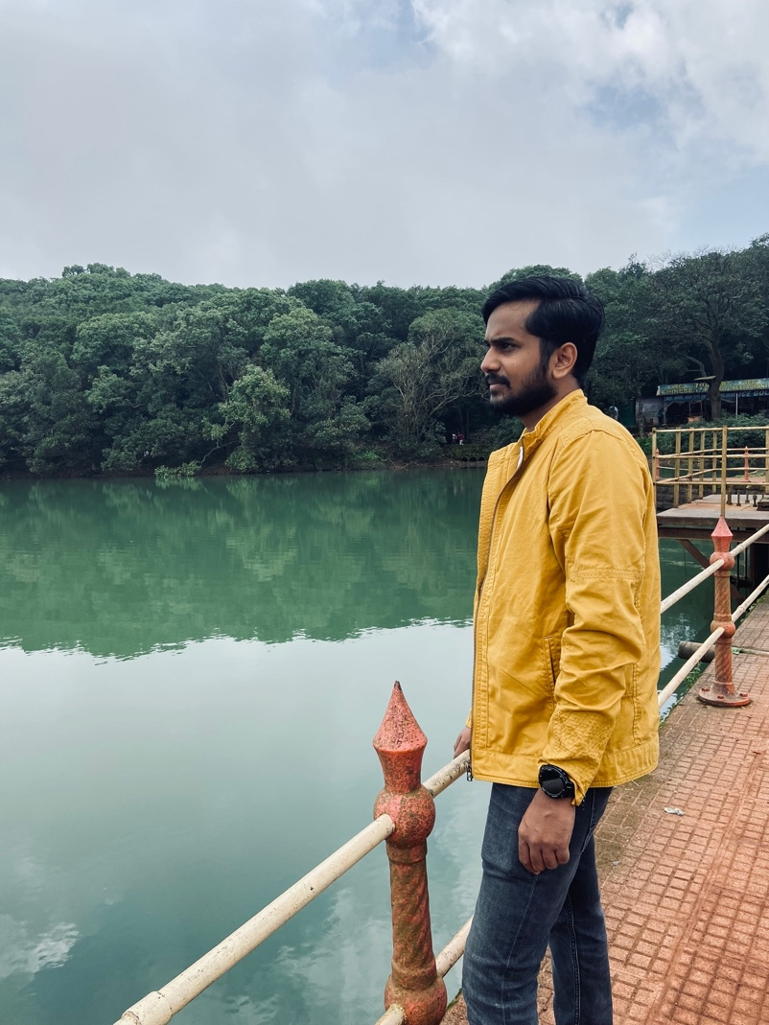

Amrut Patil

Associate (ESG Engineering Department)

Hi everyone,

I am very much excited to join MSCI. Looking forward to meeting and talking to you all. Till then let me take this opportunity to introduce myself.

I have studied BE IT from North Maharashtra University, Jalgaon. Back in Nov 2014 I started my career with Kanaka Software Pvt. Ltd. Where I got to learn and work on Ruby on Rails first time. After spending 1.5 enjoyable years there I got transferred to Antuit.ai there I worked on mixed technologies like React, ML, Angular, ROR etc. After spending 4.5 years I decided to make a change and joined Capgemini, where I spent my most of the time on bench. As I like to be working, quitted it after 5 months and joined Dassault Systems. Here so far, I worked on SSO protocols, ML, ROR, AWS, Azure DevOps etc.

I will be joining MSCI on 19th Sept 2022 in our Pune office as an Associate. I will be working in ESG Engineering Department. As I love exploring technology and learn more as I grow, I would putting my hard work and would like to see result. I am feeling that MSCI is the perfect opportunity in my career phase right now to showcase my skills, learn more and to grow together.

Apart from work I love playing cricket, computer games, long rides, long drives, movies and stuff. Also, I like to keep myself physically fit. I would love to own a sports car on day. I believe in simplicity.

Well, that’s all about me for now, we will surely be in touch in case our work or interests overlap.