**SCHOOL OF COMPUTER SCIENCE AND ENGINEERING**

**DEPARTMENT OF INTELLIGENT SYSTEM**

**LOVELY PROFESSIONAL UNIVERSITY, JALANDHAR**

**FORMAT FOR PREPARING END TERM PROJECT REPORT**

The purpose of the report is to explain overall working of the project. The report should contain an account of the activity for whole of project and as well as implementation of its working.

1. First Page (Appendix 1)

1. Declaration Page (Appendix 2)

1. Table of Contents (Appendix 3)

1. Bonafide Certificate for Supervisor Signature and Details (Appendix 4)

1. Background and objectives of the project assigned.

An introductory description (2-3 pages) of the project with respect to: Background, motivation and outcome of project and concrete goals and objectives.

1. Description of Project

The students are required to provide description in terms of modules and prepare pictorial flow of project. 7. Description of Work Division in terms of Roles among Students.

Here students are required to explain the work done by each student for roles allotted in MTE report.

8. Implementation of scheduled work of Project

The students are required to provide implementation of project in terms of its working and provide screenshots of designed web pages with proper explanation.

1. Technologies and Framework to be used.

The students are required to mention the technology and platform to be used in project.

1. SWOT Analysis achieved in project.

Include an analysis of project in terms of Strengths, Weaknesses, Opportunities and Threats. Strengths and weaknesses refer to the internal capabilities of the project, i e are under its control, and should be regarded relative to competitors, whereas opportunities and threats are found in the external environment, usually outside the control of the project.

Typing Instructions:

The impression on the typed copies should be black in color. One and a half spacing should be used for typing the text, and shall be typed in the Font style ‘Times New Roman’ and Font size 12, unless otherwise stated explicitly.

**APPENDIX 1**

# TITLE OF PROJECT

Indian Electricity Website

END TERM REPORT

***by***

*Nikita Kaushik*

## NAME OF THE CANDIDATE(S)

(Section: ____K19BY__)

(Roll Number(s): _37 , 38 , 39__)



### **Department of Intelligent Systems**

**School of Computer Science Engineering**

**Lovely Professional University, Jalandhar**

Month - April Year - 2020

**APPENDIX 2**

## Student Declaration

This is to declare that this report has been written by me/us. No part of the report is copied from other sources. All information included from other sources have been duly acknowledged. I/We aver that if any part of the report is found to be copied, I/we are shall take full responsibility for it.

Name: Yeshwant

Roll number: _37__

Name: Sagar

Roll number: __38_

Name : Amrut

Roll number: _39__

### PlaceDate

#### APPENDIX 3

#### TABLE OF CONTENTS

**TITLE**

* 1. ........**Introductory description of the project**....................
     1. **...........................Description.............................................**
     2. **....................Contents of project........................................**
  2. **...........................Actual Webpage…...................................**
     1. **................................. . cons ……......................................**
     2. **...................................some screen shots........................**

APPENDIX 4

BONAFIDE CERTIFICATE

Certified that this project report “……….Indian Electricity Website……………..” is the bonafide work of Sagar , Yeshwant and Amrut.…………” who carried out the project work under my supervision.

Nikita Kaushik

U id : 25821

**Introductory Description Of the project :**

|  |
| --- |
| Conserving electricity serves the double purpose of helping stop global warming and saving a lot of money over time. Take a look around your home and office: any appliance that operates on electricity can be made more energy efficient. Insulating your home and changing your daily habits are also effective ways to reduce the amount of electricity you use. Read on for more details on how to save electricity. |
| Embrace natural light. Open up your curtains and let the sun shine in! Using natural light whenever possible instead of relying on artificial light can greatly reduce the amount of electricity you use during the day. The same is true whether you work in an office or spend your days in your house. Exposure to natural light also increases happiness, giving you an even greater incentive to raise the blinds. Try to arrange your workspace so that natural light floods your desk. Keep the overhead lights off when possible. When you need extra lighting, use a low-powered desk lamp instead. Buy curtains or blinds in a light shade. They will still allow light to come through, but also provide privacy when you need it. |
| Change your bulbs. Replacing regular incandescent light bulbs with compact fluorescent (CFL) or LED bulbs is a big energy saver. Incandescent bulbs release 98% of their consumed energy through heat, while CFL and LED bulbs are much more energy efficient and last several times longer.[3] CFL bulbs were the first alternative to incandescent bulbs, and they use only about 1/4 the energy of incandescent bulbs. They contain trace amounts of mercury, so they must be disposed of properly when they burn out. LED bulbs are newer to the market. They're more expensive than CFLs, but they last longer and don't contain mercury. |

**Description of the Project:**

We made this project as a assignment by our teacher but it was very crucial about the management of account by the government , staff members anywhere , at this Point of time where the population is very high where maintaining record of each and every individual is next to impossible , so by the projects like this we find more about making life of peoples easier and can be said as home service where every individual has an account wherever on whichever gadget he can access all the facilities and this data can be stored on server by this medium important time of peoples is saved and we can store the maximum data of every individual all over the community .

**About the project :**

There is a user login panel named as Indian electricity pay counter in the webpage where any individual can register an account and can utilize the modern way of Payments , the main aim of the project is to save time of peoples and make payments digitalised as now india is one of the developing countries and as per Digital India .

**Contents on the project :**

The webpage is made with mainly html , css and some basic javascript .

The main content the web page it is built with proper use of major attributes for a basic layout which mainly contains the structure like rowspan , colspan ,buttons like submit ,etc . But we even used css to decorate webpage with some color to make that look beautiful, and proper use means we used inline css in the webpage ,and moreover classes .and javascript helped in adding some extra details on login panel of the user .

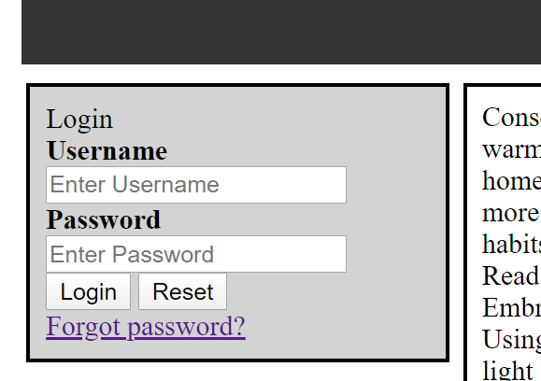

The content of the webpages , first is login panel where the user can login.the login panel consist of the user name , password and two simple button to login or reset it also contains the forget password in case of any difficulties faced by the user .

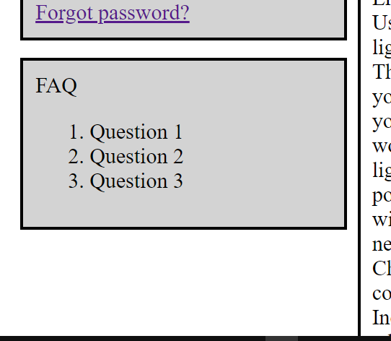

The second content of the webpage is the quick links for the frequently asked questions which make an ease for the user while any difficulties faced by them.It contains small questions like create account , change your password ,etc.

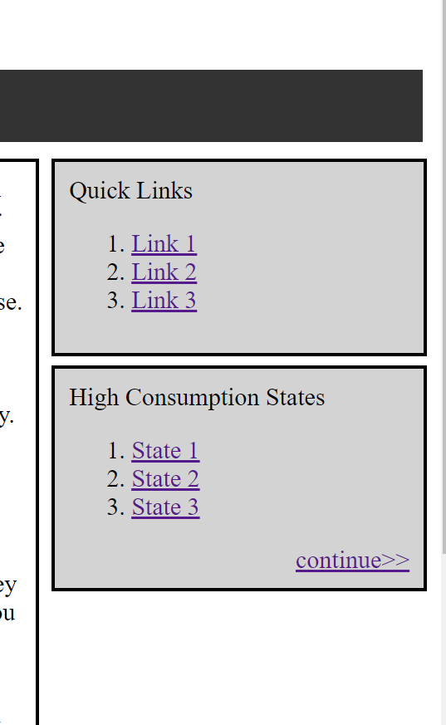

The Complete Right side of the webpage there are some redirecting link made available to user so that user should not waste their time in finding the links .Various links such as bill payments , etc are been provided for the efficiency of user

To create awareness we have made a box where the electricity consumptions of various states is been showed

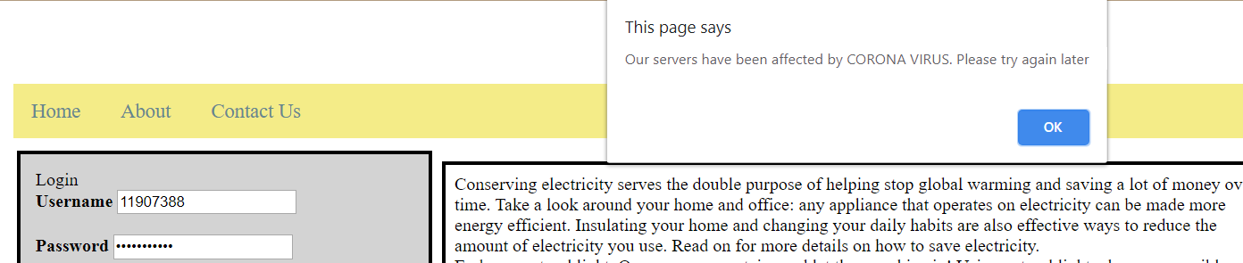

Here we have used some javascript to display a message as we can see on the top of the page if any issue related to server’s datamanagement occurs it displays the message for the user .

**Cons :**

1. This may be the best way to handle all the details of the person almost every individual this may contain their own personal information ,but the fact is if the server gets hacked not only data of the person but all the personal information would be leaked caused by an vulnerability .Along with that it is true that the data kept in servers in highly encrypted form it would not be that easy to hack.
2. So ,here then comes the second con for the management system that is though it is hard to hack the server but loosing of crucial information like username and password would lead a individual in extremely bad situation .As all your detail is on the account .