**Text based Captcha using Python**

*A project report submitted in partial fulfilment for the Award of*

**BACHELOR OF TECHNOLOGY**

**IN**

**Computer Science & Engineering**

By

Neelratan Singh (11907361)

Amrut Puyed (11907388)

Subham Nandi (11907305)

**To**



LOVELY PROFESSIONAL UNIVERSITY, PUNJAB, INDIA

NOV, 2020

**Acknowledgement**

The satisfaction that accompanies the successful completion of this project would be in complete without the mention of the people who made it possible, without whose constant guidance and encouragement would have made efforts go in vain. I consider myself privileged to express gratitude and respect towards all those who guided us through the completion of this project.

I convey thanks to my project guide **Dr. Ishan Kumar** of Computer Science and Engineering Department for providing encouragement, constant support and guidance which was of a great help to complete this project successfully.

Last but not the least, we wish to thank our **parents** for financing our studies in this college as well as for constantly encouraging us to learn engineering. Their personal sacrifice in providing this opportunity to learn engineering is gratefully acknowledged.

**Abstract**

**CAPTCHA :** A **CAPTCHA**  is a type of challenge-response test used in computing to determine whether or not the user is human.

CAPTCHAs are, by definition, fully automated, requiring little human maintenance or intervention to administer, producing benefits in cost and reliability. The most common, typical CAPTCHA Code is a text based image with distorted letters of different fonts, blurry or confusing backgrounds with random lines. The user is asked to re-enter the letters or numbers to obtain services. If the user fails, then the access is denied.

CAPTCHA technique is basically a challenge response test which involves a computer (server) initiating a task for the user to complete. If the user completes it successfully then the user is considered as “human” else it is treated as a “web-bot”.

Abbreviations

* **GUI** : Graphical User Interface
* **CAPTCHA :** Completely Automated Public Turning test to tell Computers and Humans Apart
* **AD :** Advertisement
* **Email :** Electronic mail

**List of Figures**

5. GUI Design

Figure 1. Entering Registration Number…..………………10

Figure 2. Entering Password………………………………11

Figure 3. Entering Captcha…………………………………11

Figure 4. Verification Message………………………...….12

6. Coding

Figure 5. Code 1 Part 1…………………………..……...….13

Figure 6. Code 1 Part 2……………………..…………...….14

Figure 7. Code 1 Part 3……………………………….....….15

Figure 8. Code 2………………………...…………………..15

**Contents**

1. INTRODUCTION………………………………………………....7

1.1. Purpose………………………………………………………..7

1.2. System Overview…………………………………………......7

1.3. Problem Statement…………………..………… …………....7

1.4. Goal & Vision…………………………………….…………...8

2. REQUIREMENTS SPECIFICATIONS…………………………...8

2.1. Hardware Requirements …………………………….………..8

2.2. Software Requirements………………………………………..8

3. PROCEDURE…………………………………………...………....9

4. Constraints & Assumptions…………………………………….….9

5. GUI Design for Frontend…………………………………………10

6. Coding………………………………………………………..…...12

7. Result / Conclusion………………………………………………16

8. References………………………………………………………17

1. **Introduction**

This section gives a scope description and overview of

Everything included in this Project Report. Also, the purpose

for this document is described and system overview along

with goal and vision are listed.

* 1. **Purpose**

The purpose of this document is to give a detailed

description of Text based Captcha using Python Project.

It will illustrate the purpose and complete declaration for

the development of system. It will also explain system

constraints, interface and interactions with users. This

document is primarily intended to anyone who wants to

get an overview of how Captcha works, its outcomes and

possible usages in future.

* 1. **System Overview**

A CAPTCHA system presents a visitor with an obscured word, words, or phrase. The obscuring is usually achieved by warping the words, distorting the background, or segmenting the word by adding lines.Users are asked to decode the image and enter the alphanumeric characters in the correct order (they may or may not be case sensitive) before submitting the form. Upon form submission, the response is verified, and users are either taken to the next step or presented with an error.

* 1. **Problem Statement**

Nowdays on every platform Bot is main reason for very high traffic on internet. “Bot” generally refers to any program that is set to automatically complete some process, whether it’s posting news on Twitter or leaving spam in website comment sections. Used correctly, these programs are fairly useful, but they can also be used to generate useless/ad-ridden/malicious content, overwhelm a site with signups, rig online poll results, scrape email addresses, or do any number of other unpleasant things. It’s just best not to let them in. To overcome this problem we need Captcha system. CAPTCHA motto goes, to create a task that is “Easy for people, hard for bots.”

* 1. **Goal & Vision**

The main goal of CAPTCHA is to put forth a test which is simple and straight forward for any human to answer but for a computer, it is almost impossible to solve. CAPTCHAs can be used by websites that offer services like online polls and registration forms. Web-based email services like Gmail, Yahoo and Hotmail offer free email accounts for their users. However, upon each sign-up process, CAPTCHAs are used to prevent spammers from using a bot to generate hundreds of spam mail accounts.

**2. Requirements Specification**

**2.1. Hardware Requirements**

To access this application, you only need a

PC/Laptop with Python install on it. Also check if

python GUI working on it or not.

**2.2. Software Requirements**

For this system to work you need python compiler to

write the code and execute it. You also need to install

the necessary package for python GUI to work. After

executing you can use this software in new window

which will appear after executing the code

**3. Procedure**

1. First open the python compiler.
2. After opening python compiler, type the code and attach all images required by the program.
3. After typing all the code, execute it.
4. After executing new window will open where registration number, password and verify captcha option will be present. Type the required detail and after that type the captcha shown and verify it.
5. If you are verified then you are logged in otherwise you need to fill all the details again.

**4. Constraints & Assumptions**

Image Captcha only available for image not for any other means like

audio or any mathematical calculations. It only supports English

language and will not work with any other language. It is note case

sensitive so writing in any case will work. Since this project is of

small level so only limited number of captchas are available

**5. GUI Design for Frontend**

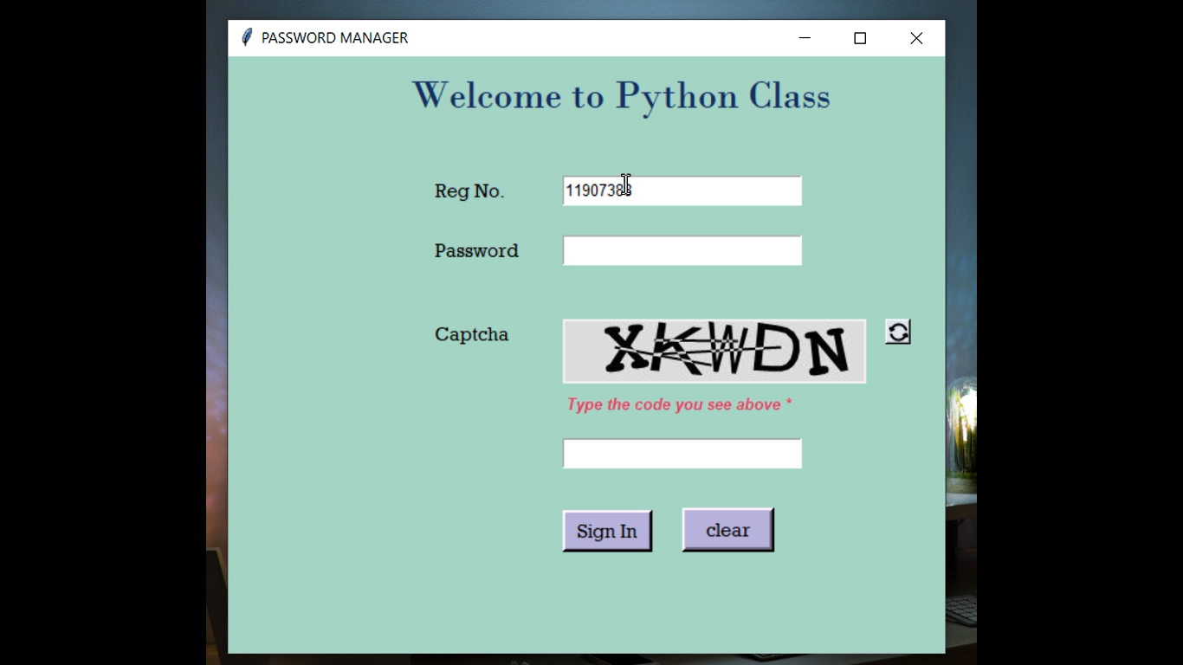

Figure 1

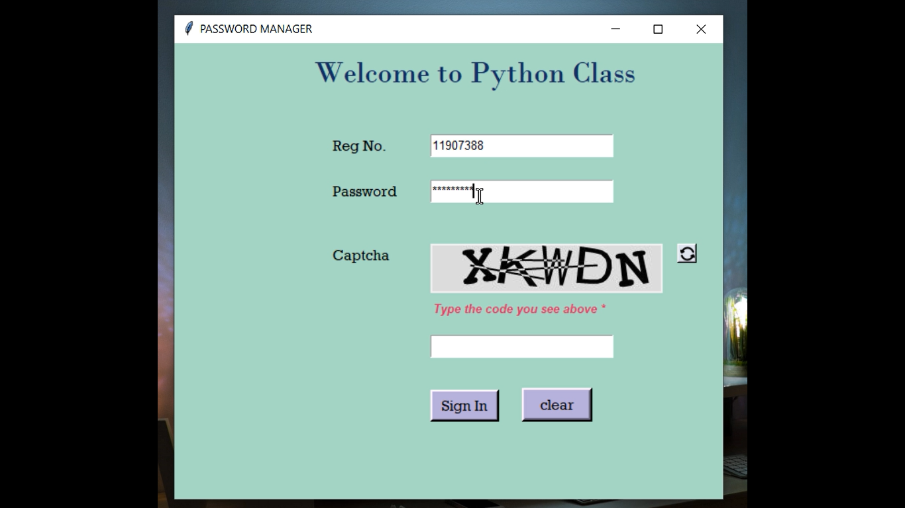

Figure 2

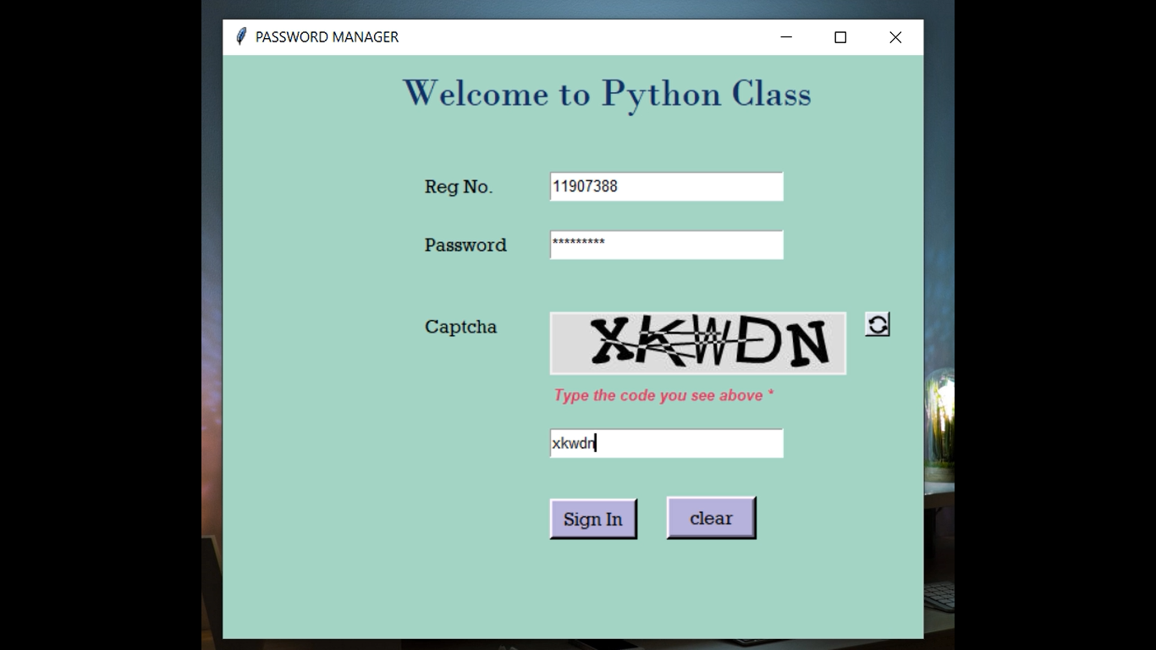

Figure 3

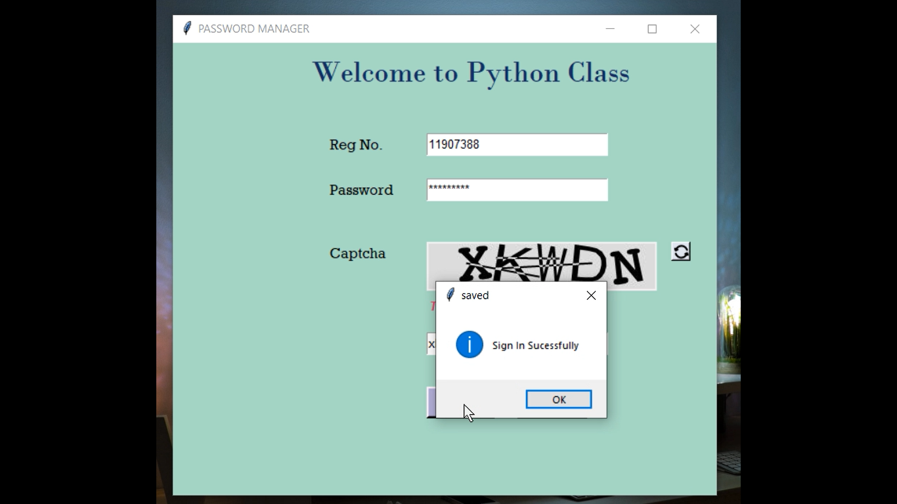

Figure 4

**6. Coding**

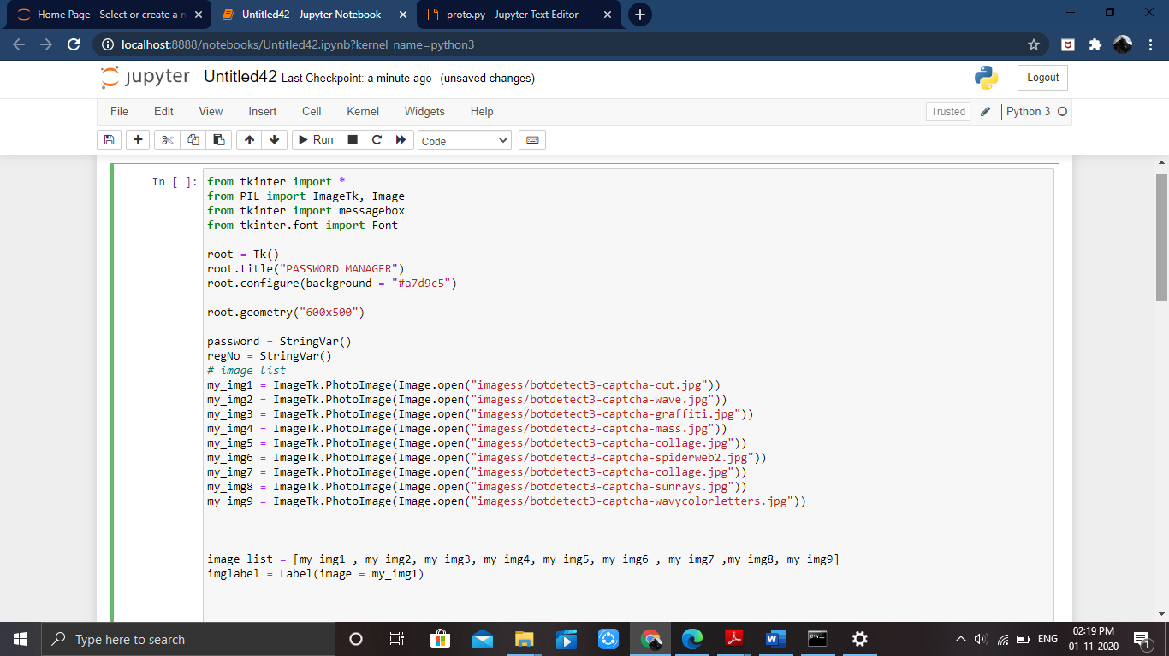

Figure 5

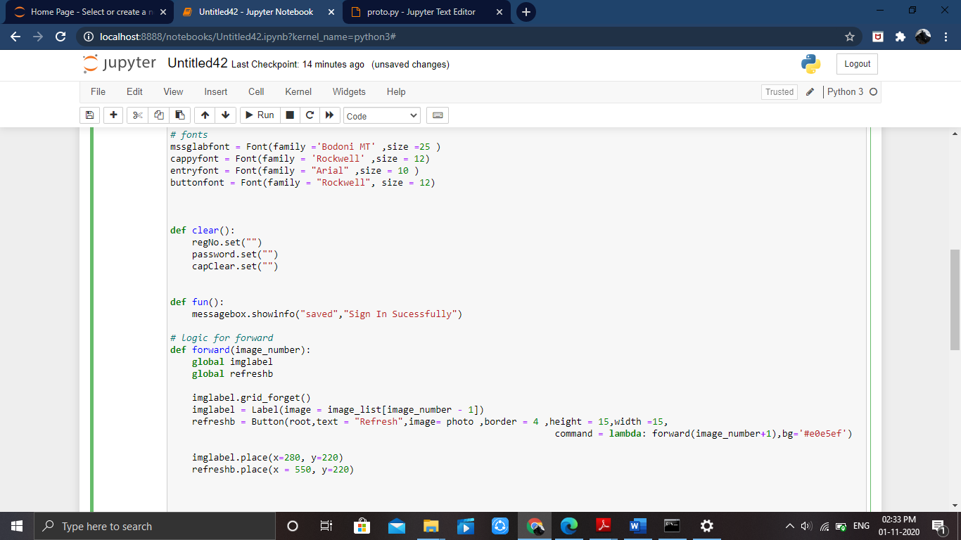

Figure 6

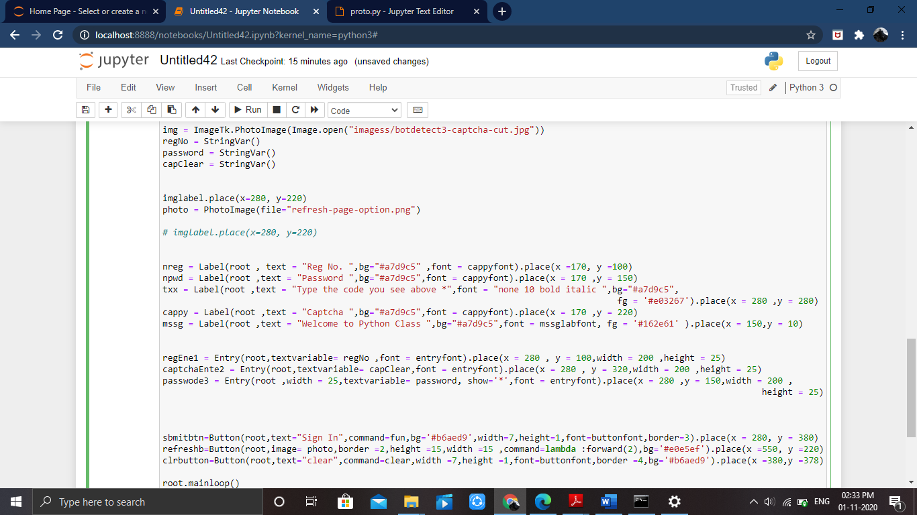

Figure 7

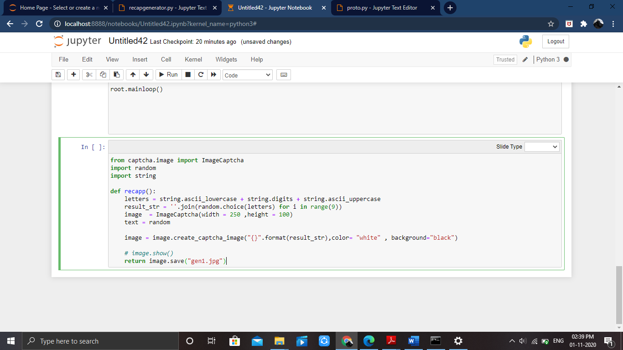

Figure 8

**7. Result / Conclusion**

The captcha helps us to avoid both spam and bot present on different platform. It helps different platform to avoid fake accounts or post . The experience of developing this project also helped us learning lot about python and python GUI. It also simplify the problem of redundant accounts on any platform.

It helps us to learn how to code in python and we are able to learn more about different module present in python. It also proved beneficial for us because we were able to design GUI in python .

**8. References**

* <https://en.wikipedia.org/wiki/CAPTCHA>
* <https://electricalfundablog.com/captcha-code-works-design-types>
* <https://www.sciencedirect.com/topics/computer-science/captcha>
* <https://www.gohacking.com/what-is-captcha-how-it-works>