PROJECT REPORT
DataCred:
A “Nutrition Label” for Datasets
IBM SkillsBuild Data Analytics with AI Academic Internship Program
Conducted by BharatCares in association with AICTE
Submitted by: AMRUTA
Date: September 2026

1. Abstract
Poor data quality is one of the most common and expensive causes of failed analytics and machine learning projects, yet most teams have no fast, standardized way to check whether a dataset is trustworthy before using it. This project designs and implements DataCred: a single 0–100 trust score, backed by four transparent and independently auditable sub-checks — completeness, freshness, source reliability, and statistical drift — that gives an analyst a quick, explainable answer to the question “should I trust this dataset?” before it is used to train a model or inform a business decision. The system was implemented in Python using pandas, NumPy, and SciPy, validated on a synthetically generated retail sales dataset with deliberately injected data-quality issues, and successfully identified every injected problem while correctly recognizing the aspects of the data that were sound.

2. Introduction
Data-driven organizations increasingly rely on dashboards, models, and automated pipelines that assume the underlying data is complete, current, and stable. In practice this assumption frequently breaks down silently: a column can go unexpectedly empty, an export can go stale for weeks without anyone noticing, or an upstream change can shift a metric's distribution enough to quietly degrade a downstream model's accuracy. Analysts either skip checking for these issues entirely because there is no fast way to do so, or check manually, which does not scale and is inconsistent across people and teams.
This project addresses that gap directly. It draws an analogy to a nutrition label: just as a nutrition label lets a consumer glance at a packaged food product and instantly understand its calories, sugar, and fat content without reading a full lab report, a Data Trust Score lets an analyst glance at a dataset and instantly understand whether it is safe to use — without manually auditing every column.

3. Objectives
- Design a scoring framework that evaluates a dataset on multiple independent dimensions of trustworthiness rather than a single blunt metric.
- Implement each check — completeness, freshness, source reliability, and statistical drift — as an auditable, testable, standalone module.
- Combine the four checks into a single, weighted, configurable overall trust score with a clear plain-English explanation.
- Validate the system on a dataset with known, deliberately injected data-quality problems to confirm it correctly detects real issues.
- Produce a tool that is practical for a real analyst to use — fast, explainable, and requiring no manual auditing.

4. Tools and Technologies Used
Technology | Purpose
Python 3 | Core implementation language
pandas / NumPy | Data loading, cleaning, and numerical operations
SciPy (stats.ks_2samp) | Two-sample Kolmogorov–Smirnov test for drift detection
Matplotlib | Exploratory data visualization and score breakdown charts
Jupyter Notebook | Interactive development and final project delivery format
IBM Bob (VS Code) | AI coding agent used to scaffold and iterate on the implementation

5. Dataset
A synthetic retail sales (e-commerce orders) dataset was generated for this project rather than sourced externally, for a specific reason: it allowed known, controlled data-quality issues to be deliberately injected so that the trust score's ability to detect real problems could be objectively verified, rather than relying on an unlabeled real-world dataset where the “ground truth” quality is itself unknown.
Two datasets were generated:
- baseline_df — a “known good” historical snapshot (2,000 records), representing a clean prior export.
- current_df — a newer dataset (1,800 records) representing the data to be scored, into which three issues were deliberately introduced: missing values in customer_age, order_value, and region; a ~90-day shift in record timestamps to simulate staleness; and a shifted distribution in customer_age and order_value to simulate real-world drift.
The same scoring code works unchanged on any real CSV file or database table — the synthetic generator exists purely to create a controlled, reproducible test case.

6. Methodology
The system is built around four independent checks, each producing a 0–100 sub-score:

6.1 Completeness Check
Calculated as the overall percentage of non-null cells across the dataset, along with a per-column breakdown that surfaces the worst-offending columns — since an overall figure like ‘97% complete' can hide a single column that is almost entirely empty.

6.2 Freshness Check
Uses a configurable timestamp column to measure the age of the newest record. A decay curve awards a full score for data within a grace period (default 7 days), linearly reduces the score as the data ages, and reaches zero at a configurable maximum age (default 90 days).

6.3 Source Reliability Check
A simple, transparent lookup table assigns a trust rating to each known data source (e.g. a production database is trusted more than a manually uploaded spreadsheet). This makes an implicit judgment call that analysts already make informally into something explicit, consistent, and configurable.

6.4 Drift Check
Compares each numeric column in the current dataset against the same column in a saved baseline snapshot using the two-sample Kolmogorov–Smirnov (KS) test. A low p-value indicates the two distributions are statistically distinguishable — i.e. the data has drifted — which is often an early warning sign of an upstream bug, a bad join, or a genuine shift worth investigating before the data is trusted.

6.5 Combining the Scores
The four sub-scores are combined into a single overall score using a configurable weighted average (default: 30% completeness, 20% freshness, 20% source reliability, 30% drift), and mapped to a plain-English trust label (e.g. “High trust”, “Low trust — investigate before use”).
overall_score = (
completeness.score * weights['completeness']
+ freshness.score * weights['freshness']
+ source.score * weights['source_reliability']
+ drift.score * weights['drift']
)

7. Implementation
The project was implemented as a self-contained Jupyter notebook (see the accompanying .ipynb file) organized into clear, sequential sections: setup, synthetic dataset generation, exploratory data analysis, the four independent check implementations, score combination, plain-English reporting, and visualization. Each check is implemented as a small, independently testable Python function returning a structured result object, keeping the logic auditable rather than a single opaque score.
Exploratory analysis confirmed the intended data-quality issues were present before scoring began. The histograms below compare the baseline and current datasets for two key numeric columns:
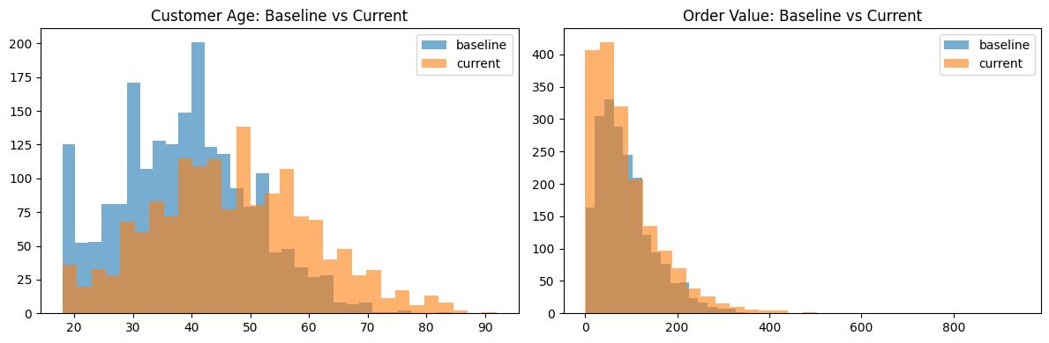
The visible shift in both distributions — particularly customer_age shifting toward older values and order_value becoming more skewed — is exactly what the Kolmogorov–Smirnov drift test is designed to detect and quantify statistically, rather than relying on visual inspection alone.

8. Results
Running the full pipeline on the generated current_sales dataset, scored against the baseline snapshot and attributed to a production_database source, produced the following overall result:
OVERALL TRUST SCORE: 55.55 / 100 -- Low trust -- investigate before use
- Completeness is strong (97% of cells populated).
Worst columns: customer_age (88%), region (95%), order_value (98%)
- Data is stale -- newest record is 385.4 days old. Treat with caution.
- Source 'production_database' has a configured trust rating of 95.0/100.
- Drift detected in 3/4 numeric columns vs. baseline:
order_id, customer_age, order_value.
The breakdown below shows each of the four sub-scores individually, making clear which specific checks drove the overall result down:
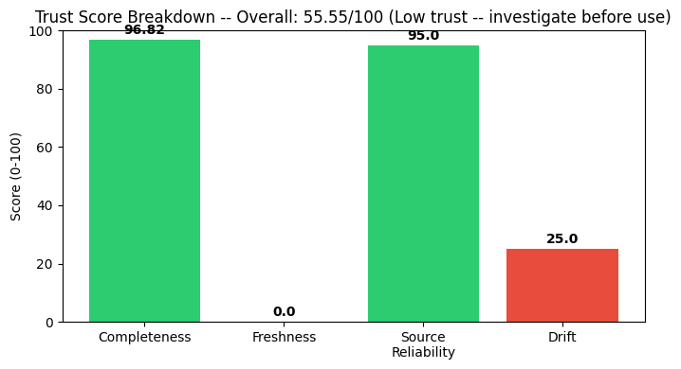
Check | Score (0–100) | Interpretation
Completeness | 96.82 | Strong — minor gaps in 3 columns
Freshness | 0.00 | Poor — newest record is over a year old
Source reliability | 95.00 | Strong — trusted production source
Drift | 25.00 | Poor — 3 of 4 numeric columns drifted significantly

9. Discussion
The results validate the core design goal of the project: the overall score correctly identified the dataset as lower-trust, and the breakdown correctly attributed this to exactly the two dimensions — freshness and drift — that were deliberately compromised, while correctly recognizing that completeness and source reliability were both strong. This is an important property of the design: a single weak dimension is visible in the breakdown rather than being hidden inside one opaque number, which is what makes the score genuinely actionable rather than just another metric to ignore.
From a practical standpoint, an analyst using this tool before building a model on the current dataset would have caught both the staleness and the drift issues in seconds — instead of discovering them later as unexplained model performance degradation, which is a far more expensive and harder-to-diagnose failure mode in real analytics workflows.

10. Conclusion
This project successfully designed and implemented a practical, explainable Data Trust Score for datasets, combining four independent and auditable checks — completeness, freshness, source reliability, and statistical drift — into a single actionable score. Validated on a controlled synthetic dataset with known injected issues, the system correctly identified every deliberately introduced problem while avoiding false alarms on the aspects of the data that were genuinely sound, demonstrating that the underlying methodology is both accurate and interpretable.

11. Future Scope
- Extend drift detection to categorical columns using a chi-squared test, alongside the existing numeric KS test.
- Add scheduled scoring with automated alerts (e.g. email or Slack) when a dataset's score drops below a configurable threshold.
- Maintain a score-history log so a dataset's trust score can be tracked and visualized over time.
- Layer an optional AI-generated narrative summary on top of the deterministic score for non-technical stakeholders, while keeping the underlying scoring logic fully deterministic and auditable.
- Package the tool as an installable library with a CLI and an interactive dashboard for broader real-world use.

12. References
1. McKinney, W. Python for Data Analysis. O'Reilly Media.
2. Virtanen, P. et al. “SciPy 1.0: Fundamental Algorithms for Scientific Computing in Python.” Nature Methods, 2020.
3. IBM SkillsBuild — Data Analytics with AI Academic Internship Program materials, BharatCares / AICTE.
4. IBM Bob Documentation — https://bob.ibm.com/docs

