Healthcare Analytics Dashboard
A Power BI-Based Analytical Framework for Child Care,
Custody, Transition, Discharge, and Reunification Data
PROJECT RESEARCH PAPER

Abstract
This paper presents the design and development of an interactive Healthcare Analytics Dashboard using Microsoft Power BI to organize and explore child-care, custody, healthcare, transition, discharge, and reunification-related data. The dashboard converts structured records into a consolidated analytical interface containing key performance indicators, annual discharge outcomes, HHS care by year, stage overview, monthly stage distribution, an HHS transition-rate gauge, CBP custody trends, stage distribution, detailed custody records, and a month-based slicer. In the final project view, the KPI cards show approximately 4K, 5K, 6K, 363K, 12K, and 4K; the displayed HHS Transition Rate is 74.55; and the CBP Custody Details table reports a displayed total of 6,061. The project demonstrates how business-intelligence and visualization techniques can support descriptive and exploratory analysis while keeping the interpretation limited to the available dataset and configured measures.

Keywords: Power BI; healthcare analytics; child welfare; data visualization; business intelligence; dashboard; custody; reunification

1. Introduction
Organizations working with child welfare and healthcare information may need to examine several dimensions of a case at the same time, including custody status, care, transitions, placement stages, discharge outcomes, and reunification-related activity. When such information is stored only as rows and columns, identifying patterns across time or comparing measures can require substantial manual effort.
Research has shown that child-welfare administrative systems and electronic health records can contain complementary information. Dexheimer et al. demonstrated the feasibility of linking electronic health record and child-welfare databases, highlighting the value of integrated information for children in protective custody [1]. Research on healthcare quality measures for children in foster care similarly found that electronic health records and child-welfare systems provide different but complementary information [2]. These findings provide motivation for analytical interfaces that make multiple measures easier to inspect and compare.
This project applies a business-intelligence approach rather than attempting to make clinical or causal claims. Microsoft Power BI is used to transform the available structured dataset into an interactive dashboard that supports filtering, aggregation, trend analysis, and visual comparison.

2. Problem Statement
The underlying dataset contains records associated with different dates, stages, custody measures, healthcare measures, transitions, and discharge outcomes. Manual inspection of these records can make it difficult to obtain a rapid overall view, compare periods, and identify changes across stages. The problem addressed by this project is therefore the lack of a single, interactive analytical interface that organizes these measures into a clear and user-friendly view.

3. Objectives
- Organize child-care and reunification-related records into an analytical model suitable for visualization.
- Create KPI cards that provide a rapid high-level summary of important measures.
- Visualize annual discharge outcomes and HHS care by year.
- Examine monthly stage distributions and stage-level proportions.
- Present the configured HHS Transition Rate in a dedicated gauge.
- Analyze CBP custody values over time using a trend visual.
- Provide detailed custody records through a tabular view.
- Enable month-based filtering through an interactive slicer.
- Present the final dashboard in a consistent, professional, and easy-to-navigate layout.

4. Related Work
Data integration and analytics are increasingly relevant to child-welfare and healthcare information systems. Dexheimer et al. developed automated approaches for linking electronic health record data with child-welfare databases and reported that integrated data can help address gaps in access to critical health-history information [1].
A feasibility study by Kelleher et al. examined healthcare quality measures for children and adolescents in foster care. The study found that electronic health records contained detailed healthcare information while child-welfare systems contained stronger information about custodial arrangements, demonstrating the complementary nature of the two data sources [2].
More recent work has also investigated machine-learning approaches for child-welfare placement outcomes. Trudeau et al. developed and validated predictive models for placement success and discussed ethical considerations associated with decision-support applications [3]. Although the present project does not implement predictive modeling, this literature illustrates a potential direction for future analytical extensions.

5. Methodology
The project follows a structured data-to-dashboard workflow. The methodology is intentionally descriptive and visualization-oriented.
Stage | Activity | Purpose
1 | Data preparation | Organize date, stage, custody, care, transition, and discharge-related fields.
2 | Time preparation | Prepare date fields for monthly and yearly grouping.
3 | Measure preparation | Use configured sums, totals, and the project transition-rate measure.
4 | Visual design | Select cards, charts, gauge, slicer, and table according to analytical purpose.
5 | Interaction | Apply month-based filtering and Power BI visual interactions.
6 | Validation | Review displayed totals, labels, ordering, readability, and overall dashboard consistency.

6. Dashboard Architecture and Design
The final dashboard is organized as a single-page analytical interface. A title area identifies the dashboard, the upper section contains KPI cards, and the main canvas is divided into summary, trend, distribution, rate, and detail areas. A month slicer is positioned on the left so that users can filter the analytical view without navigating away from the main page.
Component | Analytical Role
KPI Cards | Six cards summarize major measures and provide an immediate overview.
Annual Discharge Outcomes | Waterfall-style visual showing configured increase, decrease, and total outcomes by year.
HHS Care by Year | Column chart comparing the sum of children in HHS care across the available periods.
Stage Overview | Compact visual summarizing stage-level measures.
Monthly Stage Distribution | Monthly comparison of stage-related measures.
HHS Transition Rate | Gauge displaying the configured transition-rate measure; final displayed value: 74.55.
CBP Custody Trend | Line chart showing custody measure changes across displayed years.
Stage Distribution | Donut chart showing the distribution across the available stage categories.
CBP Custody Details | Table containing dates and custody values, with a displayed total of 6,061.
Month Slicer | Interactive filter for January through December.

7. Final Dashboard View
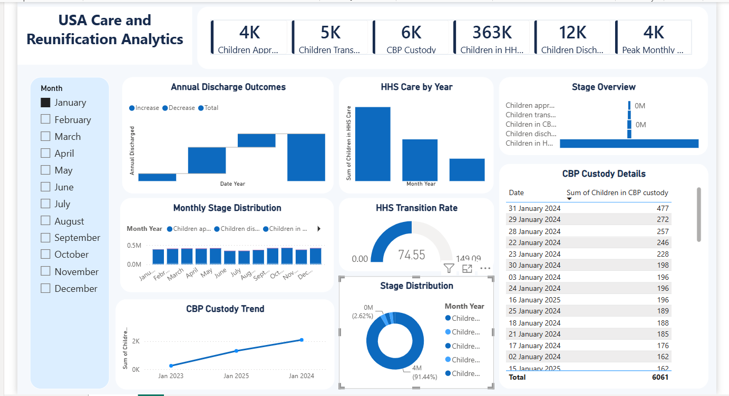
Figure 1. Final Power BI dashboard used for the project submission.
The dashboard uses a restrained blue-and-white visual theme to maintain consistency across cards and charts. The left-side slicer provides filtering, while the central canvas prioritizes high-level metrics and trends. The detailed custody table complements the aggregate visuals by retaining access to date-level values.

8. Results and Discussion
The completed dashboard provides a consolidated view of the available measures. The six KPI cards present approximately 4K, 5K, 6K, 363K, 12K, and 4K, depending on the configured metric represented by each card. The HHS Transition Rate gauge displays 74.55, while the CBP Custody Details table shows a displayed total of 6,061.
The annual discharge visual provides a year-oriented view of configured discharge outcomes, while the HHS Care by Year chart enables direct comparison between the displayed periods. The Monthly Stage Distribution visual provides a month-level comparison, and the CBP Custody Trend highlights changes in the custody measure across the displayed years.
An important strength of the dashboard is the combination of aggregation and detail. KPI cards and charts provide a rapid overview, while the custody table allows users to inspect individual dates and values. The month slicer adds interactivity and allows the user to examine a selected month rather than relying only on the overall view.
These outputs should be interpreted as descriptive dashboard results. They do not establish causal relationships, clinical effectiveness, or predictive performance. Any operational or policy decision based on the dashboard should be supported by validated definitions, data-quality checks, appropriate governance, and domain expertise.

9. Advantages
- Interactive and user-friendly single-page interface.
- Rapid access to high-level summary measures.
- Combination of trend, comparison, distribution, rate, and detail visuals.
- Month-based filtering for interactive exploration.
- Reduced dependence on manual inspection of large tables.
- Consistent visual structure that supports quick interpretation.
- Expandable foundation for future analytical and reporting requirements.

10. Limitations
- The dashboard is primarily a descriptive analytics and visualization system.
- Results depend on the quality, completeness, coverage, and definitions of the underlying dataset.
- Displayed measures reflect the Power BI model and configured aggregations.
- The project does not independently validate the source data.
- No causal inference or clinical recommendation is made from the dashboard.
- Some stage labels and measure names are abbreviated in visuals because of available dashboard space.

11. Future Scope
Future development can extend the dashboard beyond the current descriptive layer. Possible enhancements include automated data refresh, drill-through pages, additional time-intelligence measures, richer quality indicators, role-based access, geographic analysis where appropriate, and improved metadata documentation.
Predictive analytics could also be explored after establishing reliable data definitions and sufficient historical data. Such extensions should include model validation, fairness assessment, privacy controls, human oversight, and clear documentation of appropriate and inappropriate uses. Research on predictive placement modeling demonstrates both the technical potential and the importance of ethical considerations in child-welfare decision-support systems [3].

12. Conclusion
This project demonstrates the development of a Power BI-based Healthcare Analytics Dashboard for exploring child-care, custody, healthcare, transition, discharge, and reunification-related information. By combining KPI cards, interactive filtering, trend charts, distribution visuals, a transition-rate gauge, and detailed records, the dashboard converts structured data into an accessible analytical interface.
The final system provides a practical example of how business-intelligence tools can support exploratory analysis while maintaining a clear boundary between visualization and clinical or causal interpretation. The dashboard therefore serves as a foundation that can be enhanced with stronger data governance, additional analytical measures, and validated advanced analytics in future work.

References
[1] J. W. Dexheimer, S. J. Beal, P. Divekar, E. S. Hall, V. Patel, and M. V. Greiner, “Automated Patient Linking for Electronic Health Record and Child Welfare Databases,” Journal of Technology in Human Services, vol. 37, no. 4, pp. 286–292, 2019, doi: 10.1080/15228835.2019.1578327.
[2] K. Kelleher et al., “Health care quality measures for children and adolescents in Foster Care: feasibility testing in electronic records,” BMC Pediatrics, vol. 18, 2018, article 78, doi: 10.1186/s12887-018-1064-4.
[3] K. J. Trudeau, J. Yang, J. Di, Y. Lu, and D. R. Kraus, “Predicting successful placements for youth in child welfare with machine learning,” Children and Youth Services Review, vol. 153, 2023, article 107117, doi: 10.1016/j.childyouth.2023.107117.
[4] Microsoft, “Power BI documentation,” Microsoft Learn, 2026. Accessed for general Power BI dashboard and visualization terminology.

End of Research Paper

