Online Payments Fraud Detection using ML
NAME- Amruta Madhukar Khade

1. INTRODUCTION
1.1 Project Overview
This project focuses on identifying fraudulent online financial transactions using Machine Learning techniques. With the rapid growth of digital payments, ensuring transaction security has become critically important.
The system uses a trained classification model integrated into a web application developed using Flask. Users can input transaction details through the interface and instantly receive predictions indicating whether a transaction is fraudulent or legitimate.

1.2 Purpose
The primary objective of this project is to classify online transactions as fraudulent or legitimate based on transaction attributes. Since fraud detection is a classification problem, the system predicts categorical outcomes (Fraud / Not Fraud).
This project aims to enhance digital payment security by identifying suspicious activities and reducing financial risks.

2. LITERATURE SURVEY
2.1 Existing Problem
With millions of transactions occurring daily, manual fraud detection is impractical. Traditional rule-based systems rely on static thresholds and often:
- Generate high false positives
- Fail to adapt to evolving fraud patterns
- Lead to financial losses and reduced customer trust
Machine Learning models overcome these limitations by learning patterns from historical data.

2.2 References
- PaySim Synthetic Dataset for mobile financial transactions
- Research on fraud detection using:
  - Decision Trees
  - Random Forest
  - Support Vector Machines (SVM)
  - Extra Trees Classifier

2.3 Problem Statement Definition
To design and develop a Machine Learning-based system that can accurately classify online financial transactions as fraudulent or legitimate using transaction attributes such as:
- Transaction step
- Transaction type
- Amount
- Old and new balances

3. IDEATION & PROPOSED SOLUTION
3.1 Empathy Map Canvas
The Empathy Map is used to understand the needs, concerns, and expectations of users such as banks and customers. It helps in identifying key problems related to online fraud and designing a suitable solution.
- Think & Feel: Users are worried about unauthorized transactions and financial losses.
- See: Increasing cases of online payment fraud in digital platforms.
- Say & Do: Users demand secure and reliable transaction systems.
- Pain Points: Unexpected money loss and lack of immediate fraud detection.
- Gains: Fast, accurate, and secure fraud detection ensuring trust in digital payments.

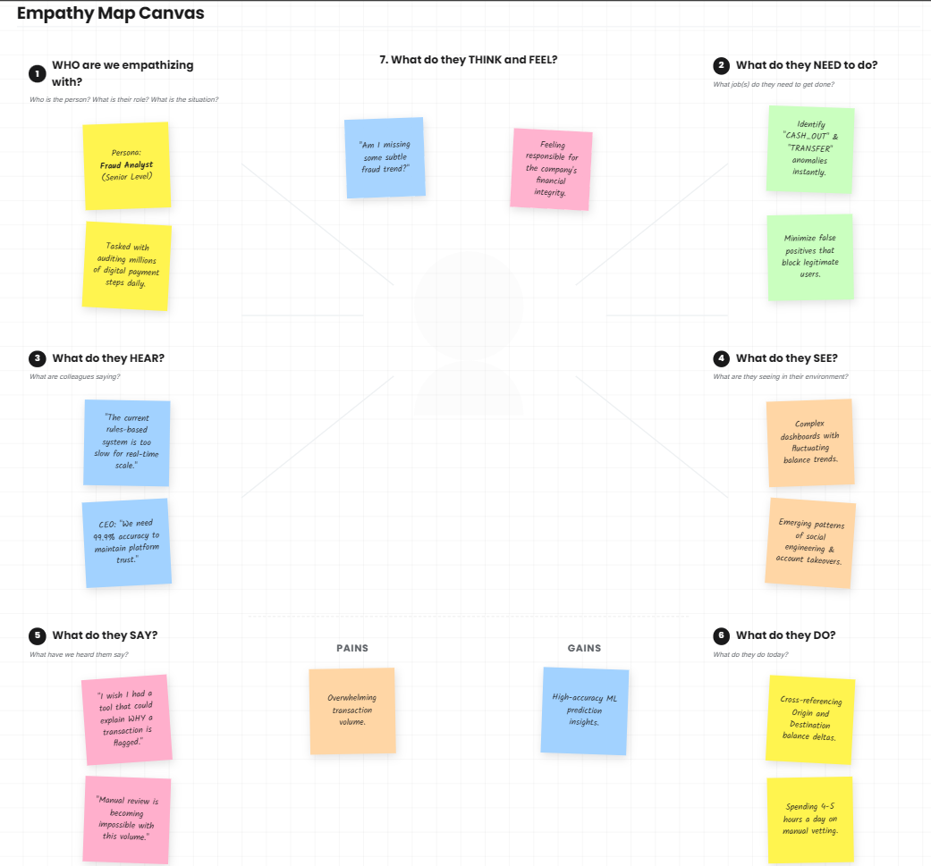
3.2 Ideation & Brainstorming
During the ideation phase, various Machine Learning algorithms were explored to identify the most effective approach for fraud detection. The algorithms considered include:
- Decision Tree
- Random Forest
- Support Vector Machine (SVM)
- Extra Trees Classifier
Each model was evaluated based on performance metrics such as Accuracy, Precision, Recall, and F1-score. Special focus was given to Recall due to the imbalanced nature of fraud datasets.
After thorough analysis, the best-performing model was selected and integrated into a Flask-based web application.
The final system provides a user-friendly interface where users can enter transaction details and receive real-time predictions indicating whether the transaction is fraudulent or legitimate.
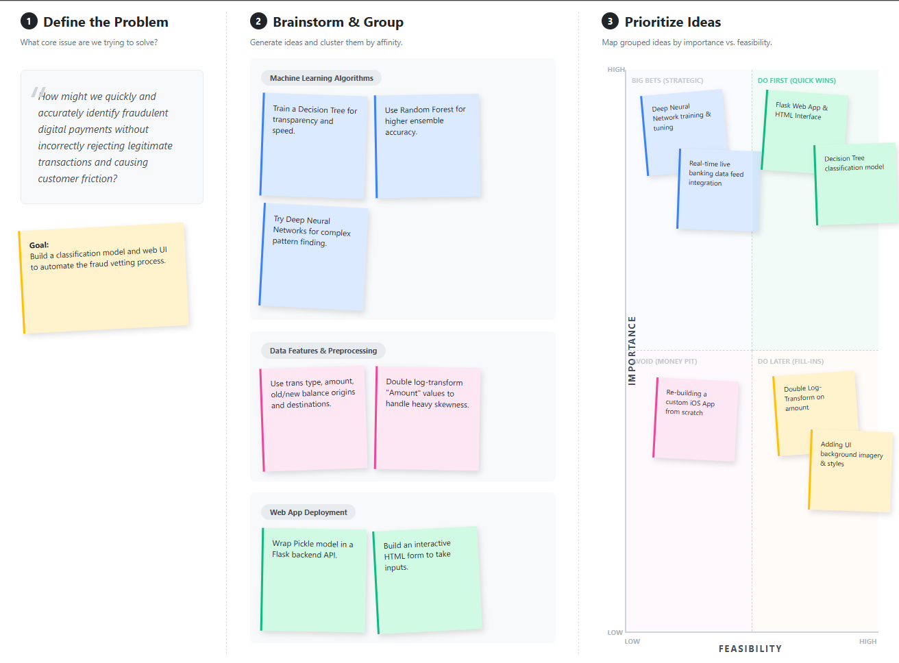
PROPOSED SOLUTION:
Sr.No | Parameter | Description
1 | Problem Statement (Problem to be solved) | With the rapid increase in online transactions, detecting fraudulent activities has become difficult. Traditional rule-based systems fail to identify new fraud patterns and generate many false alerts. There is a need for an intelligent system that can automatically detect fraudulent transactions accurately and quickly.
2 | Idea / Solution Description | The proposed system uses Machine Learning algorithms to classify online transactions as fraudulent or legitimate. A Flask-based web application is developed where users can enter transaction details through the Predict page. The system processes the data and provides real-time predictions on the Submit page.
3 | Novelty / Uniqueness | The system combines Machine Learning with a simple and user-friendly web interface. It provides instant fraud detection without requiring technical knowledge. The use of data preprocessing and trained models improves prediction accuracy compared to traditional methods.
4 | Social Impact / Customer Satisfaction | The system helps in reducing financial fraud and protecting users from monetary loss. It increases trust in digital payment systems and ensures safer online transactions, improving overall customer satisfaction.
5 | Business Model (Revenue Model) | The system can be offered as a service to banks and financial institutions. Revenue can be generated through subscription-based models or API integration services for fraud detection in payment systems.
6 | Scalability of the Solution | The system can be scaled by deploying it on cloud platforms like AWS or Heroku. It can handle multiple users simultaneously and can be updated with new data to improve model performance over time.

4. REQUIREMENT ANALYSIS
4.1 Functional Requirements
- Accept transaction details (step, type, amount, balances)
- Apply preprocessing and transformations
- Predict whether a transaction is fraudulent
- Display result clearly on the web interface

4.2 Non-Functional Requirements
- Performance: Fast prediction (within seconds)
- Usability: Simple and intuitive UI
- Availability: Reliable Flask server
- Security: Safe handling of transaction data

5. PROJECT DESIGN
5.1 Data Flow
Flow:
User → Web Interface → Flask Backend → Data Processing → ML Model → Result Display
- User visits Home Page
- Navigates to Predict Page
- Enters transaction details
- Clicks Submit
- Data goes to Flask Backend
- Backend processes data using ML Model
- Result is returned and shown on Submit Page

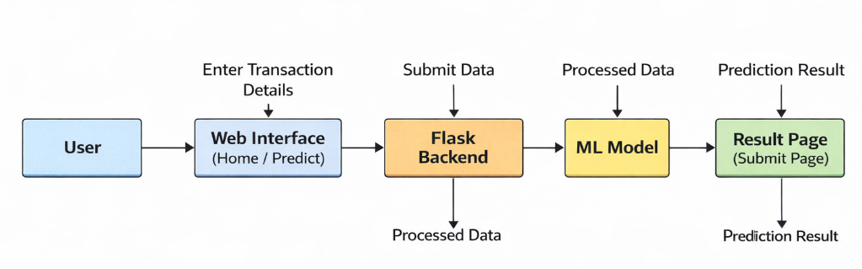

User stories:
User Type | Functional Requirement | User Story ID | User Story / Task | Acceptance Criteria | Priority | Release
User | View Home Page | US-1 | As a user, I want to view the home page to understand the project | Home page loads successfully | High | Sprint-1
User | Navigate to Prediction Page | US-2 | As a user, I want to go to the prediction page to enter transaction details | User can open predict page | High | Sprint-1
User | Enter Transaction Data | US-3 | As a user, I want to input transaction details (amount, type, balance) | Form accepts input correctly | High | Sprint-1
User | Submit Data | US-4 | As a user, I want to submit transaction data for fraud detection | Data is sent to backend | High | Sprint-1
User | View Prediction Result | US-5 | As a user, I want to see whether the transaction is fraud or not | Result displayed (Fraud / Not Fraud) | High | Sprint-1
User | Input Validation | US-6 | As a user, I want error messages if I enter invalid data | System shows proper error message | Medium | Sprint-2

5.2 Solution Architecture
The system follows a Three-Tier Architecture:
- Presentation Layer: HTML, CSS web pages
- Application Layer: Flask backend handling requests
- Data Layer: Trained ML model (.pkl file using Scikit-learn)

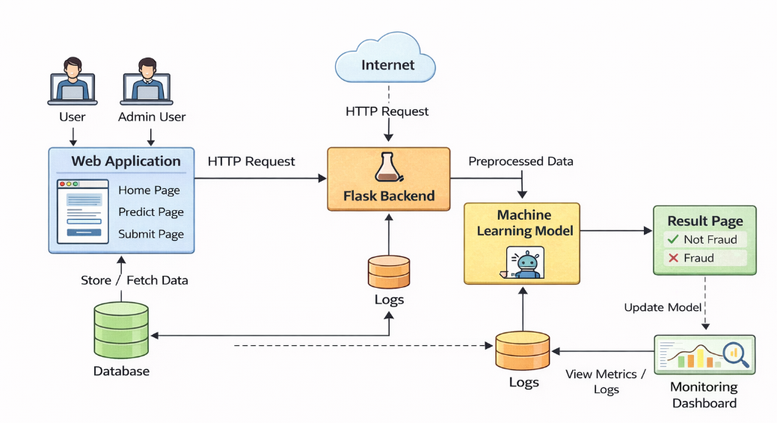
Fraud detection system architecture flowchart

6. PROJECT PLANNING & SCHEDULING
6.1 Technical Architecture
The system is designed using a combination of Machine Learning and web technologies to ensure efficient fraud detection and user interaction.
- Programming Language: Python 3
- Backend Framework: Flask
- Libraries Used: Pandas, NumPy, Scikit-learn
- Frontend Technologies: HTML, CSS
- Model Storage: Pickle (.pkl file)

6.2. Sprint Planning & Estimation
The project was developed using an Agile approach, divided into multiple phases with estimated timelines.

📊 Project Timeline Chart:
Phase | Task | Duration | Time Period
Phase 1 | Data Collection & EDA | 5 Days | Week 1
Phase 2 | Model Training & Evaluation | 7 Days | Week 2
Phase 3 | Backend Development (Flask) | 5 Days | Week 3
Phase 4 | Frontend Design & Integration | 4 Days | Week 3
Phase 5 | Testing & Deployment | 3 Days | Week 4

6.3 Sprint Delivery Schedule
The project followed an iterative development cycle, where each module was developed, tested, and improved continuously.
- Initial sprints focused on data preprocessing and model building
- Mid sprints focused on backend and frontend integration
- Final sprints involved testing, debugging, and deployment
This structured approach ensured timely completion of the project with efficient performance and reliability.

7. CODING & SOLUTIONING
7.1 Feature 1: Prediction API
- Flask endpoint /pred processes user input
- Applies logarithmic transformation (log1p) to handle skewness
- Reshapes input data for model prediction

7.2 Feature 2: Web Interface
- Responsive UI with HTML/CSS
- Pages:
  - Home Page
  - Prediction Form Page
  - Result Page

7.3 Dataset Description
- Dataset: PaySim synthetic financial dataset
- Features:
  - Step
  - Type
  - Amount
  - Old Balance
  - New Balance
- Highly imbalanced dataset (fraud cases are rare)

8. PERFORMANCE TESTING
8.1 Performance Metrics
- Accuracy
- Precision
- Recall
- F1-Score
Due to class imbalance, Recall and F1-score were prioritized to ensure maximum fraud detection.

9. RESULTS
The system successfully predicts fraudulent transactions based on user inputs.
Outputs include:
- Home Page
- Prediction Form
- Result Page showing Fraud / Not Fraud

Output Screenshots:

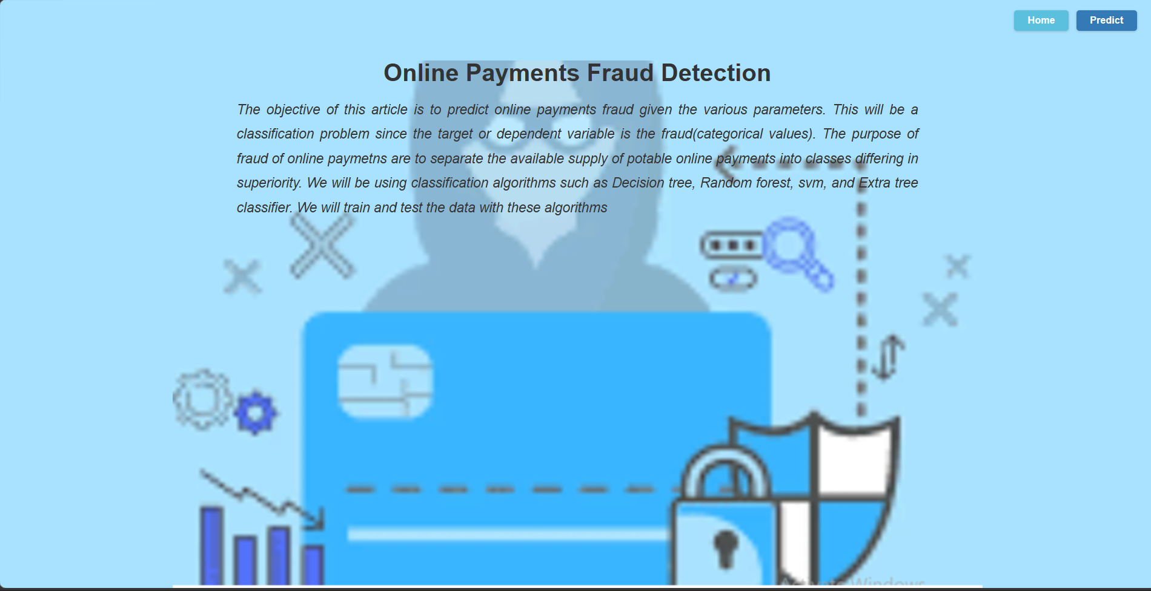
9.1. Home page
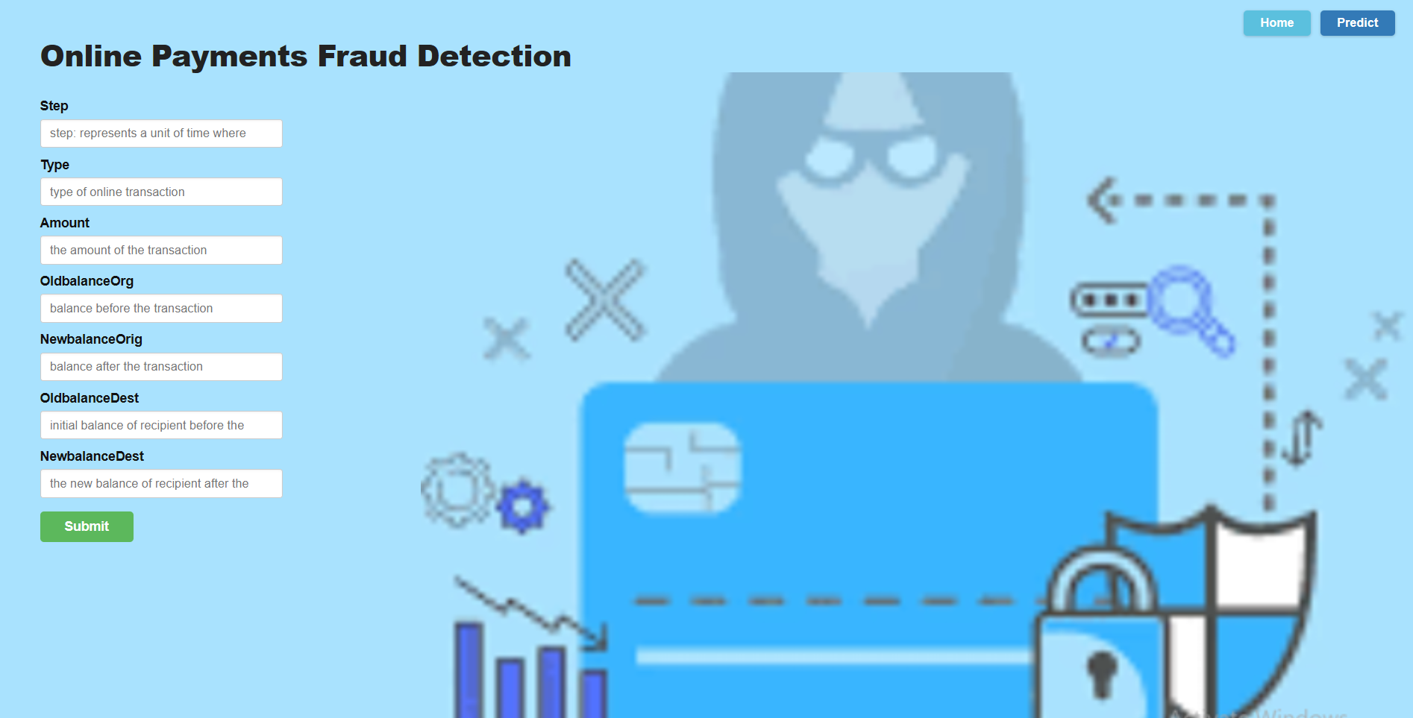
9.2.1. predict page
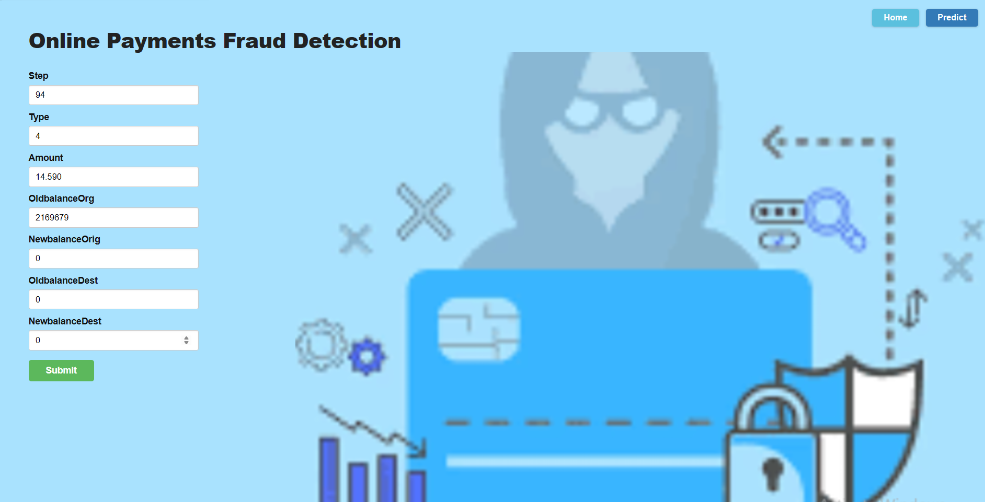
9.2.2 predict page
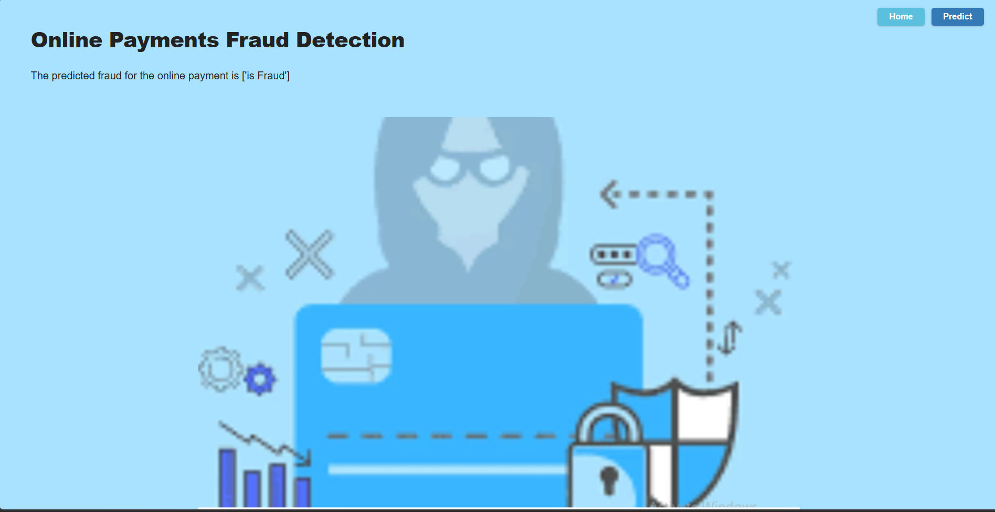
9.3. submit page

10. ADVANTAGES & DISADVANTAGES
Advantages
- Fast and real-time predictions
- User-friendly interface
- Automates complex fraud detection process

Disadvantages
- Model performance may degrade over time
- Requires retraining with new data
- May produce false positives in some cases

11. CONCLUSION
The Online Payments Fraud Detection System demonstrates how Machine Learning can enhance financial security. By integrating predictive models with a Flask-based web application, the system provides a fast, efficient, and reliable solution for detecting fraudulent transactions.

12. FUTURE SCOPE
- Real-time fraud detection using streaming data
- Integration with banking systems for automatic blocking
- Admin dashboard for monitoring fraud activity
- Cloud deployment (AWS, Heroku)
- Database integration for transaction logging

