Document name | Java Major Project
Version no. | 1.0
Release date | 23rd August 2020
Classification | Departmental



This document of Cybage Software Pvt. Ltd. is for restricted circulation. No part of this publication may be reproduced, stored in a retrieval system or transmitted in any form or by any means – recording, photocopying, electronic and mechanical, without prior written permission of Cybage Software Pvt. Ltd.
Java Major Project

Document History

Ver. No | Release Date | Created By / Modified By and Date | Reviewed By and Date | Approved By and Date | Remarks and Changes Made
0.1 | 23rd August 2021 | Asfiya Khan |  |  | Initial draft.

Deccan Sport club

Project Statement:
Develop web based application for Deccan Sport club

Abstract of the System:
Main goal is to develop web based system for Deccan Sport club. Sport club offers various sports like cricket, badminton, swimming, basketball, Volleyball, etc. Club runs various batches with offers. User can register into system and view various offers for sports. User can enroll into membership online.

System Roles:
- Admin
- Manager
- User
Admin Role:
- Add/delete/update/view sports
- Create login credentials for manager
- Send account details to manager through email
- Unlock accounts if locked due to 3 invalid login attempts
- Reports:- enrollment reports, sport reports, batches report
- Can see logs of users activity

Manager role:
- Login into system (credentials given by admin)
- Add/delete/update/view offers / batches
- View enrollment (approve / reject)
- Reports:- enrollment reports, sport reports, batches report
- Setting(change password, forget password)
- Remember me

User Role:
- Register and login into system
- View batches and offers
- Comments, likes for existing offers
- Take membership
- Renew membership
- Activate account using otp
- Login with otp
- Setting(change password, forget password)
- Remember me

Technologies to be used:

- Spring Architecture
- Spring Rest for Web Services
- Spring Data JPA
- MYSQL
- HTML5
- CSS3/SASS/ Bootstrap/RWD
- Angular/REACT
- Static code validator – Linter/Hinter
- Editors – VSCode, Eclipse, STS, etc.
- Code coverage reports – SonarQube
- Git repository
- Other DevOps tools to be implemented.

System architecture:
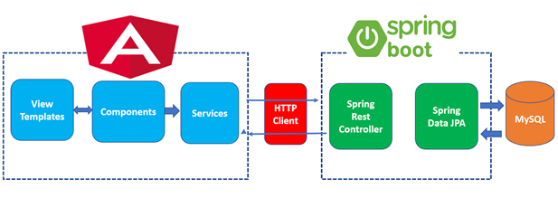

Note – Make assumptions whenever required in project

You are also expected to integrate the feedback system with this project and it will be two services where Sports Club service will internally give call to the feedback service which is consumed in angular/react.

Sports Club service
REST API
Feedback system service
REST API

FET Angular/React

- Bonus points:
- Earn bonus points by implementing following features.
  - Report builder(providing different options to build reports)
  - Angular Material UI for UI design
  - Captcha to avoid brute force attack
  - Implementing SSL/TLS security

