**DISTRIBUTED OPERATING SYSTEM**

**PROJECT-2**

**Group Members:**

Name: Shreya Singh UFID: 7915 4462

Name: Amruta Basrur UFID: 4463 4819

**Implementation Details:**

This project implements Gossip and Push-Sum algorithm for full, 3D, Random 2D, torus, line and imperfect line topology.

**Determination of convergence time**

GOSSIP ALGORITHM

* In Gossip, a node stops transmitting once it has heard the gossip for 10 times.
* For convergence, the percentage of nodes which have received gossip varies from topology to topology. We have assumed the percentage for line topology to be 50-70% of number of nodes and for other topologies it is 90% of number of nodes.
* In the Gossip algorithm, convergence is reached when the above percentage of nodes in a network has received the gossip at least 10 times.

PUSH SUM ALGORITHM

* A network node is terminated when its s/w ratio did not change more than 10-10 in 3 consecutive rounds.
* Convergence varies from topology to topology and is reached when the below percentage of nodes are terminated/converged.

Random 2D- 75%

Line- 90%

Imperfect Line – 70%

All other topologies – 90%

* To find this value, we analysed the topologies and number of nodes for maximum nodes to have correct weighted average.

**Interesting Observations:**

* For gossip algorithm, the efficiency of algorithm increases when a node transmits a message to any random alive neighbour, i.e. a node which has received gossip less than 10 times.
* Similarly, for push-sum we observed that the efficiency of algorithm increases when a node transmits a message to any random alive neighbour, i.e. a node which has not achieved convergence.
* For line topology, when network size is less 50 s/w ratio is not accurate for all the nodes. Also, for higher number of nodes line fails to converge faster than other topologies like full network.
* Torus topology is behaving efficiently than full topology as the number of actors goes on increasing.
* Also, the graph of gossip and push-sum have similar characteristics for a topology since push- sum seems to use the basic idea of gossip algorithm for s/w value propagation.

**Graph of Convergence time vs size of the network:**

GOSSIP ALGORITHM

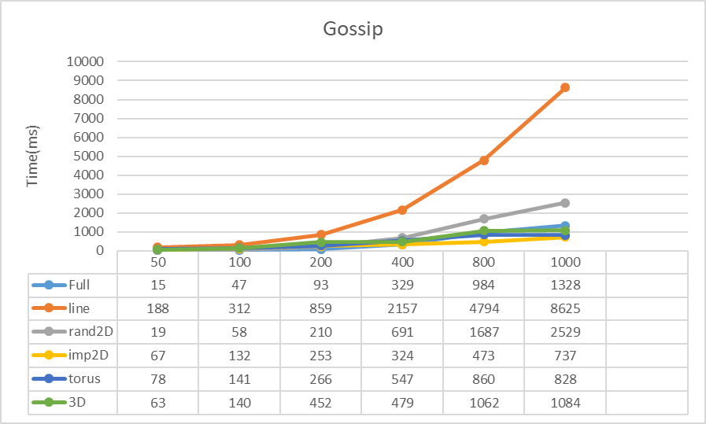

Here, line topology takes the maximum time to converge followed by rand2D. This is because line has the least number of neighbours and rand2D randomly selects co-ordinates in [1,1].

The convergence time of topologies is as follows:

Full< torus<imp2D<3D<rand2D<line

PUSH-SUM ALGORITHM

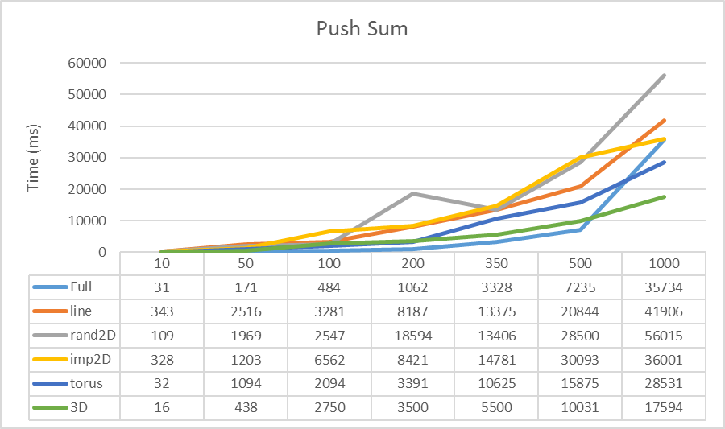

Here, rand2D topology takes the maximum time to converge followed by line. This is because line has the least number of neighbours and rand2D randomly selects co-ordinates in [1,1].

The convergence time of topologies is as follows:

Full<3D<torus<imp2D<line<rand2D