# Sequence Diagram of

# Software Patch Management

# Web Application

**Sponsored by: Coupa Software**

*Team members:*

Amruta Gadgil

Fei Hao

Pramothini Dhandapany

*Faculty advisor:*

Patrick Tague ([tague@cmu.edu](mailto:tague@cmu.edu))

December 11, 2015

As shown in Fig. 1, which is the Sequence Diagram of uploading new file (csv) and updating report, inventory, and chart, user could register an account in the web application, and admin will set and grant the privilege of the account. After admin’s operation, the account is activated and user could use it to login to the web application.

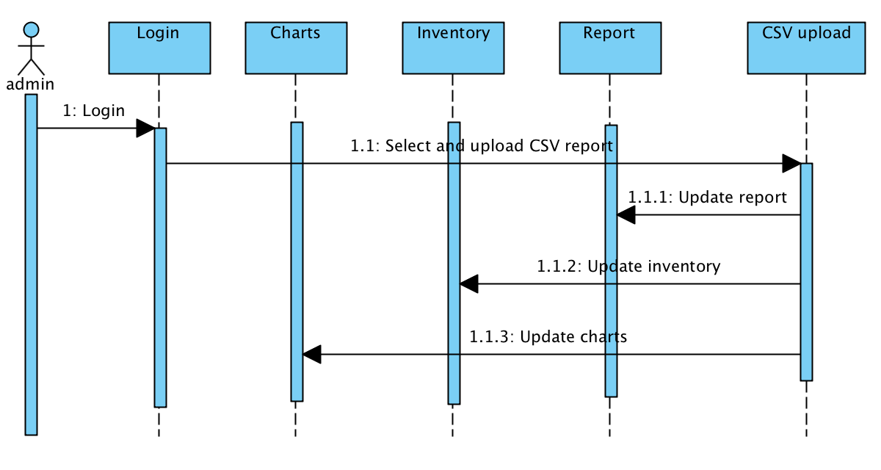

*Fig. 1 System Diagram of upload new file (csv) and update report, inventory, and chart*

As shown in Fig. 2, which is the Sequence Diagram of viewing inventory, reports and charts, and updating assets importance rating after login, (admin and non-admin) user could view distribution charts, Asset table (Inventory), and Report table. For admin user, he/she could assign importance rating and the Report table as well as distribution pie chart will be updated accordingly.

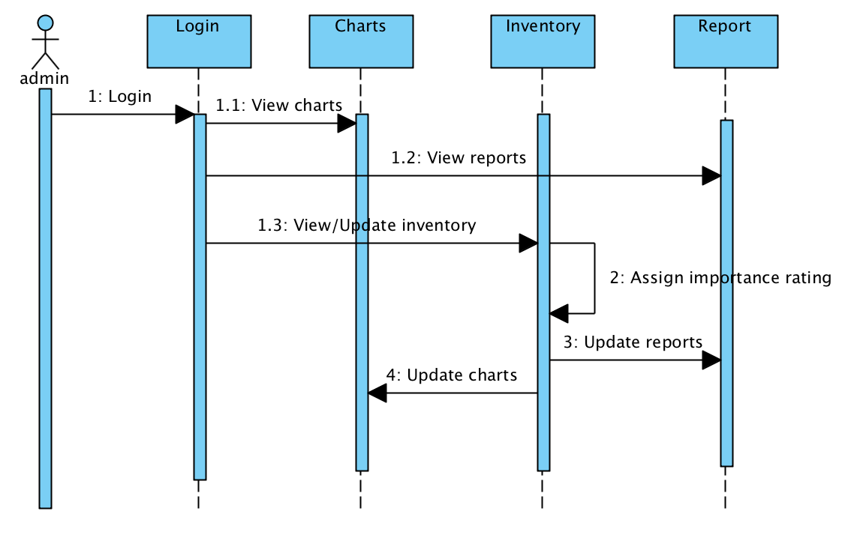

*Fig. 2 Sequence Diagram of view inventory, reports and charts; and update assets importance rating*

As shown in Fig. 3, which is the Sequence Diagram of registering and creating account, user could register an account in the web application, and admin will set and grant the privilege of the account. After admin’s operation, the account is activated and user could use it to login to the web application.

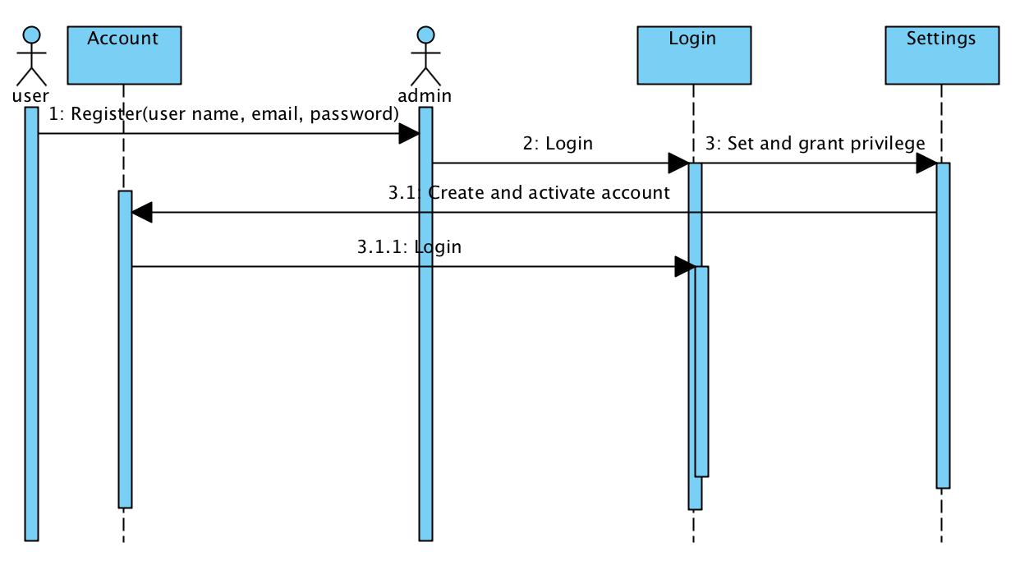

*Fig. 3 Sequence Diagram of* *register and create account*