# System Diagram of

# Software Patch Management

# Web Application

**Sponsored by: Coupa Software**

*Team members:*

Amruta Gadgil

Fei Hao

Pramothini Dhandapany

*Faculty advisor:*

Patrick Tague ([tague@cmu.edu](mailto:tague@cmu.edu))

December 11, 2015

As shown in Fig. 1, which is the System Diagram, the web application will take in two inputs:

1. CSV report file provided by Qualys by scanning networks of assets on AWS. It lists all the vulnerabilities detected, and contains detailed information of each vulnerability, like IP, severity, CVE-ID, title, threat, impact, etc.
2. Asset importance rating, which indicates environmental impact, and is provided by system administrator. The importance rating is defined to range from 1 to 5, with 5 as the most important, and 1 as the least important.

With these inputs, the web application will first pull a complete system inventory of vulnerabilities as well as assets from Qualys scan report (CSV file) and save it to backend database. Then it will use a formula to calculate the business risk of each vulnerability, combining severity with asset importance rating. If an asset was not assigned an importance rating by system administrator, it will have a default value of 5.

After calculation, the web application will populate the vulnerabilities with business risk and assets with importance rating into its web interface for user to view and update. The web application also allows the user to download the report in standard, processable format, such as csv and json.

*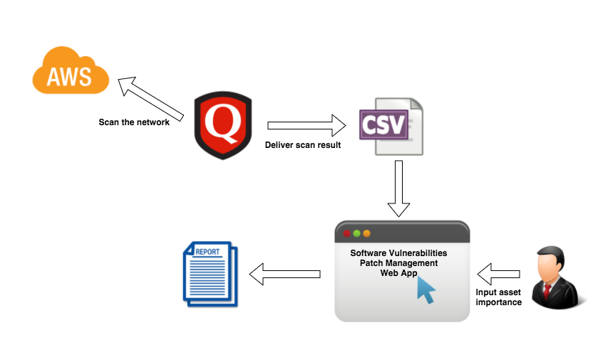Fig. 1 System Diagram*