# Use Case Diagram of

# Software Patch Management

# Web Application

**Sponsored by: Coupa Software**

*Team members:*

Amruta Gadgil

Fei Hao

Pramothini Dhandapany

*Faculty advisor:*

Patrick Tague ([tague@cmu.edu](mailto:tague@cmu.edu))

December 11, 2015

As shown in Fig. 1, which is the Use Case Diagram, the functionalities of the web application are shown. Two actors, admin and non-admin user are identified. Basic functionalities, like viewing report table, viewing asset importance table, viewing distribution pie chart are open to both actors. However, for functionalities which will update the data, like uploading CSV file, updating asset importance rating, requires admin privileges to accomplish.

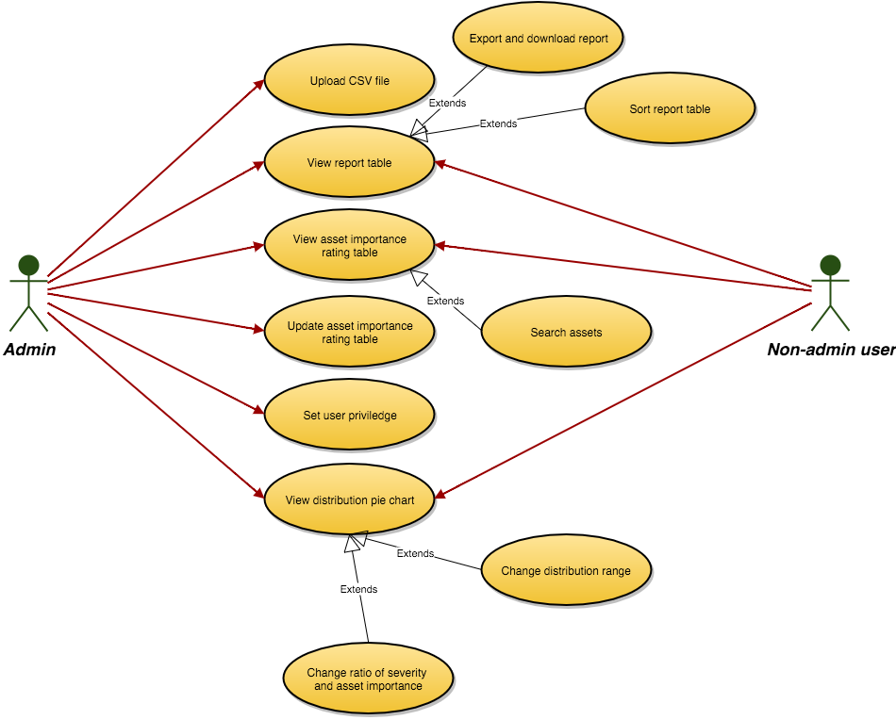

*Fig. 1 Use Case Diagram*