# Tutorial of

# Software Patch Management

# Web Application

**Sponsored by: Coupa Software**

*Team members:*

Amruta Gadgil

Fei Hao

Pramothini Dhandapany

*Faculty advisor:*

Patrick Tague ([tague@cmu.edu](mailto:tague@cmu.edu))

December 11, 2015

# Table of Contents

1. Login 3

2. Dashboard 3

3. Reports 5

4. Assets 6

5. User Setting (admin only) 7

6. Upload CSV file (admin only) 8

8. Registration 9

1. Login

Type the URL of the web application in your browser or click the provided link to the web application, you will see the Login page, as shown in Fig. 1.

If you already have an account, enter user name and password, and click “Sign In” to sign in the web application.

If you do not have an account, click the “Don’t have an account?” link on upper right corner of the page to go to Registration page (please refer to Section 8).

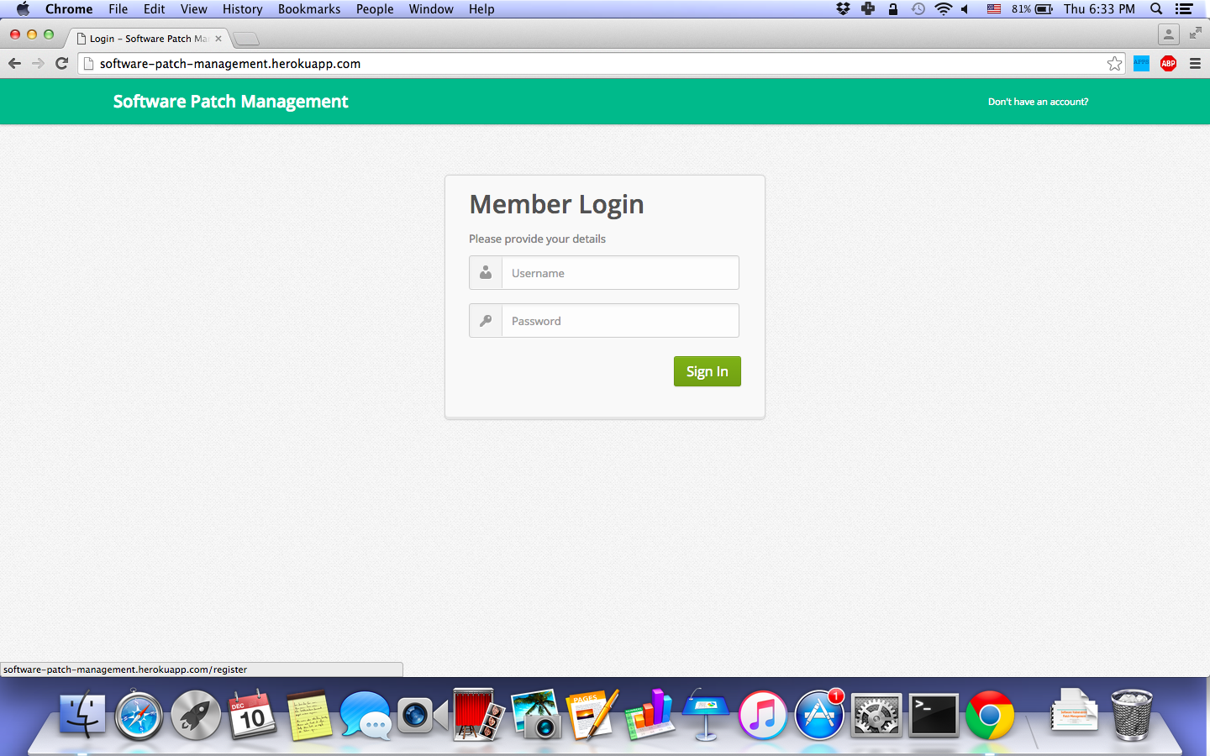

*Fig. 1 Login page*

2. Dashboard

After login, you can see that the system a navigation bar at the top, as shown in Fig. 2, which contains four tabs (if you are not admin user, you can only see three tabs).

The first page you can see right after login is the Dashboard page. It has a pie chart, which shows the distribution of vulnerabilities by business risk. Different colors indicating different level of business risk, including “Low”, “Medium” and “High”.

Next to the pie chart, there are two sliders. The first one is to change the ratio of asset importance rating and severity when calculating business risk. The default ratio is 5-5, which means that the business risk value is calculated by adding asset importance rating and severity in equal proportion. You can click and drag the point of the slider to change the ratio, and thus change the business risk distribution, which could be reflected in the pie chart, as shown in Fig. 3.

The second slider is to modify the distribution range of business risk. The left pointer indicates the upper range of “Low” (and also lower range of “Medium”), and the right pointer indicates the upper range of “Medium” (and also lower range of “High”). You can click and drag the pointers to modify the range, and the distribution in pie chart will be changed accordingly. Moreover, the range value in the legend of the pie chart will also be updated, as shown in Fig. 3.

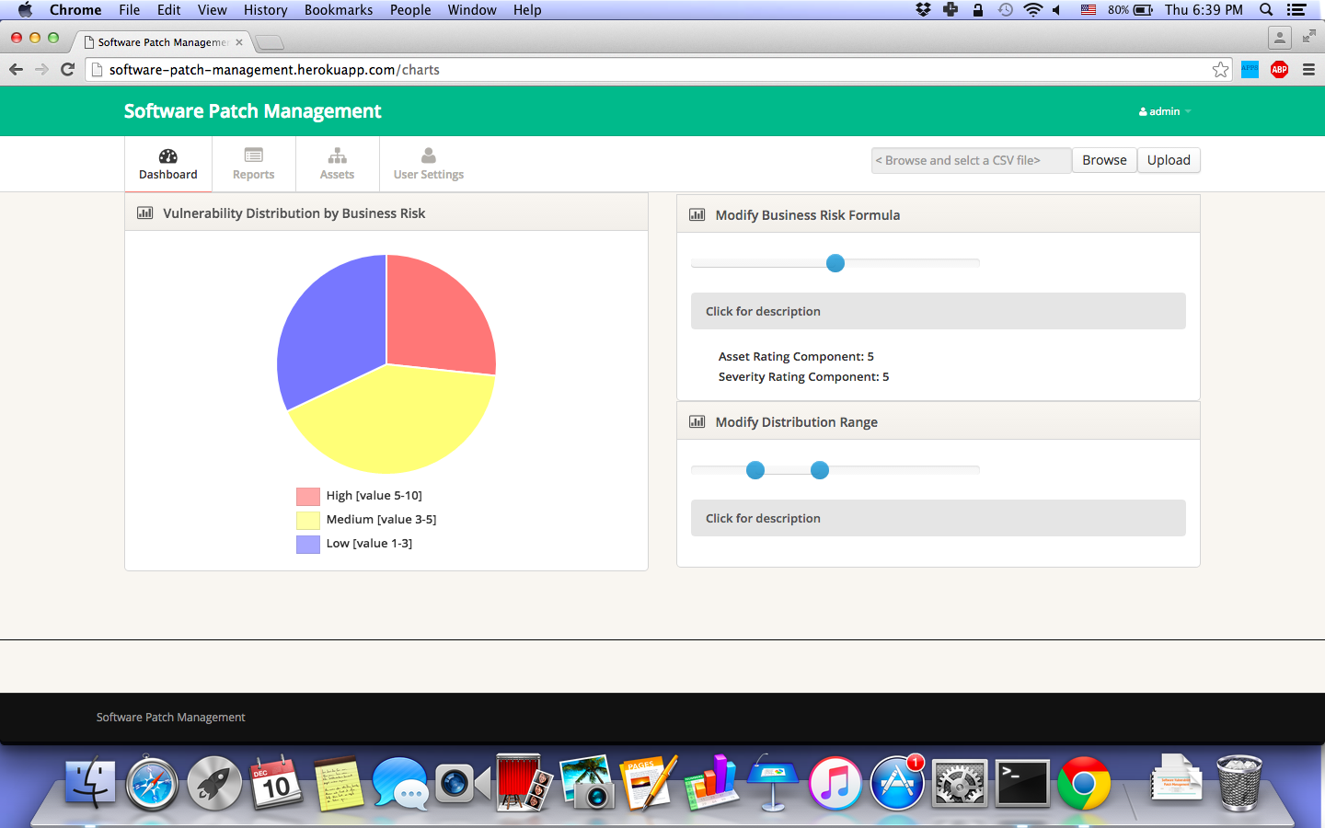

*Fig. 2 Dashboard page*

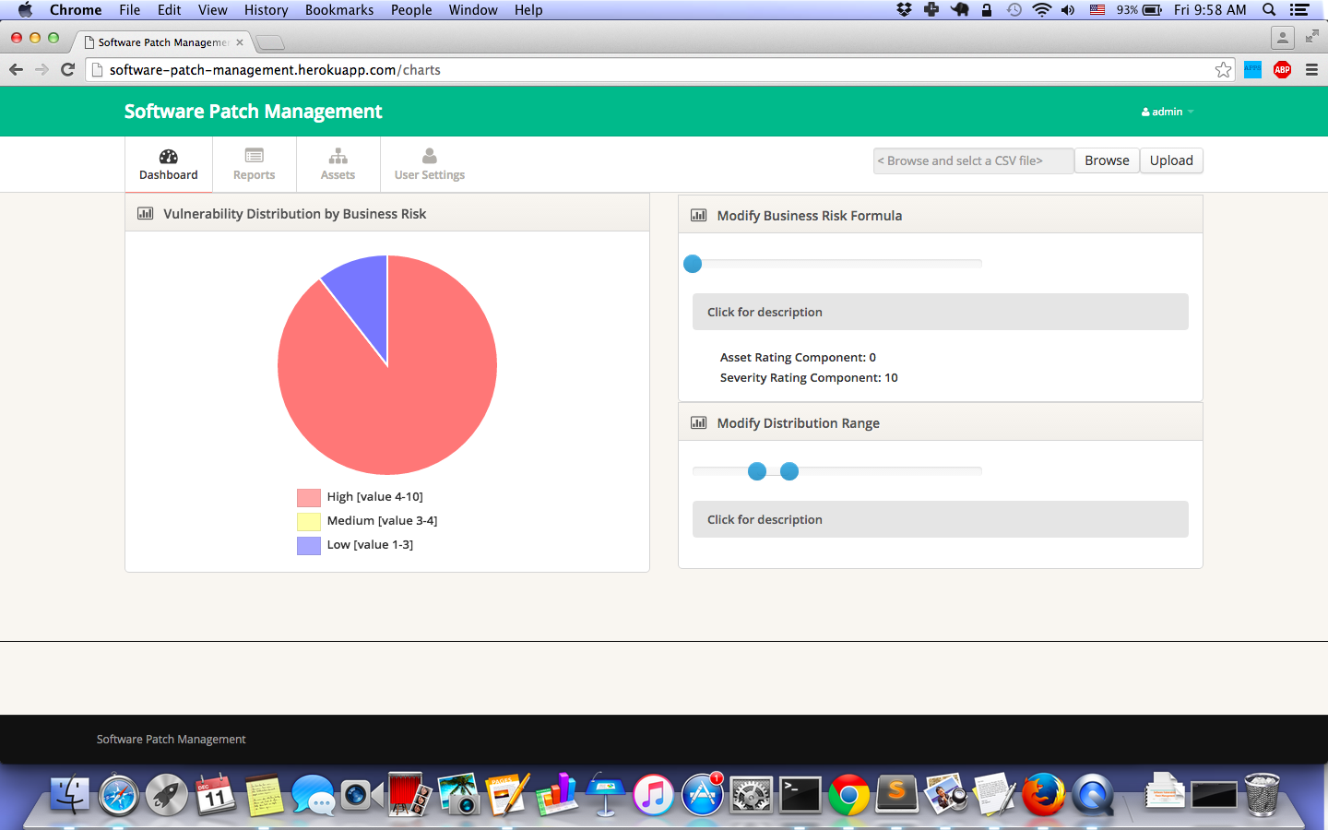

*Fig. 3 Dashboard page – after slider change*

3. Reports

Click “Reports” tab in navigation bar, you will go into the Reports page, as shown in Fig. 4. The page has a table that shows vulnerabilities in rows, with columns of “IP”, “BUSINESS RISK”, “TITLE”, “CVE ID”, “THREAT”, “IMPACT”, “SOLUTION”, and “SEVERITY”. You can browse the table to view the vulnerabilities and detailed information.

You can sort the vulnerabilities by any of the columns, just click the column title and the table will be shown in sorted order.

You can export the table by clicking the “CSV” or “JSON” link at the upper right corner of the table. “CSV” will export and download the table as “export.csv”, and “JSON” as “export_as_json.json”.

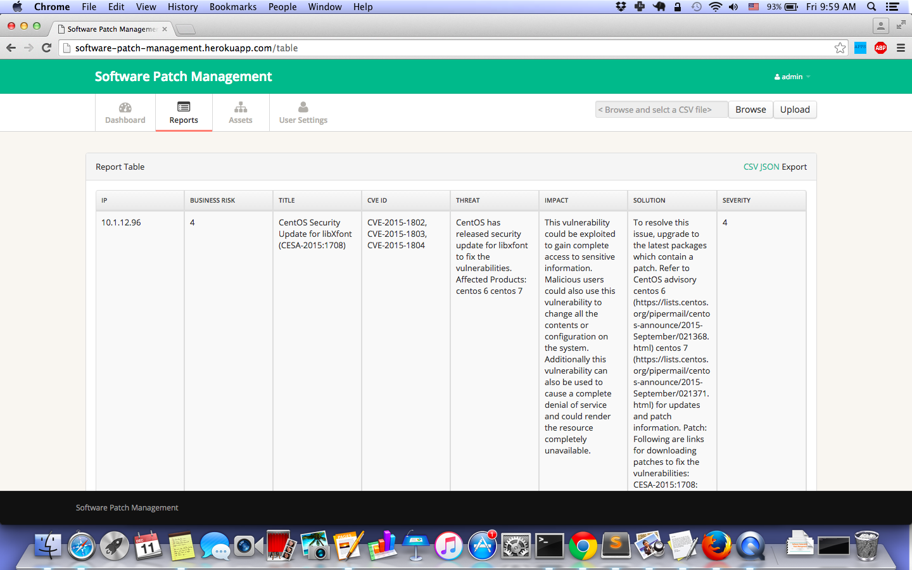

*Fig. 4 Reports page*

4. Assets

Click “Assets” tab in navigation bar, you will go into the Assets page, as shown in Fig. 5. The page has a table that shows the assets in rows, with columns of “IP” and “IMPORTANCE RATING”.

The importance rating of each IP is presented in star-based format. If you are an admin, you can change the importance rating by clicking the stars. After the change, remember to click “SUBMIT” at upper right corner of the table to save your change.

There is a check box in the row of every asset, you can check that check box to select multiple assets, or you can check the check box in the column title (next to “SELECT FOR BULK EDIT”) to select all assets. Then, if you are an admin user, you can change the importance rating value of all the selected assets by the “Bulk edit” at the upper left corner of the table. After the change, remember to click “SUBMIT” to save your change.

Before hitting “SUBMIT”, you can click “CANCEL” to discard the changes you made.

A search box is provided for the table, with which you can search assets with certain pattern. Type the pattern in the search box and press “enter” key, the table will only show assets that match the pattern.

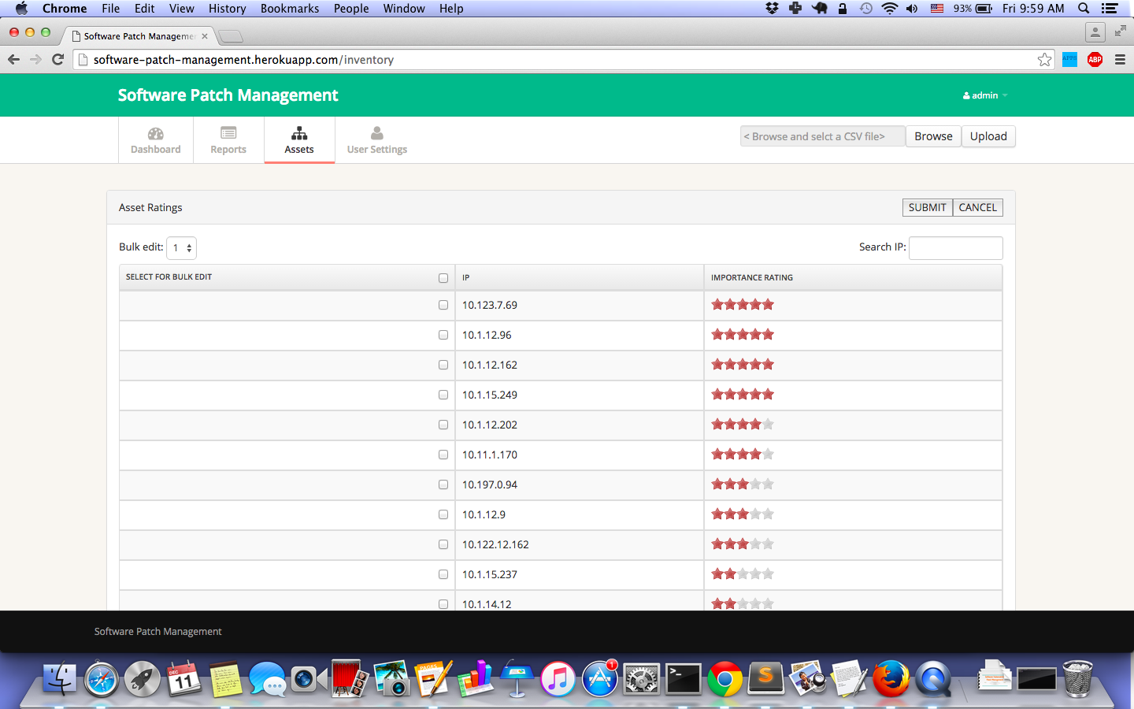

*Fig. 5 Assets page*

5. User Setting (admin only)

Click “User Settings” tab in navigation bar, you will go into the User Settings page, as shown in Fig. 6. The page has a table that shows the user accounts of the web application in rows, with columns of “USER NAME”, “EMAIL”, “APPROVE AS ADMIN”, “APPROVE AS NONADMIN” and “DELETE USER”.

If you are an admin, you can click the green check button in column “APPROVE AS ADMIN” or “APPROVE AS NONADMIN” to approve the corresponding user account as admin or non-admin.

Note that both admin and non-admin could view the charts and sliders in Dashboard page, the report table in Reports page, and the asset importance rating in Assets page. However, only admin user could view the User Setting page and upgrade users, upload new CSV files, and change asset importance rating.

You can also click the red cross button in column “DELETE USER” to delete the corresponding account.

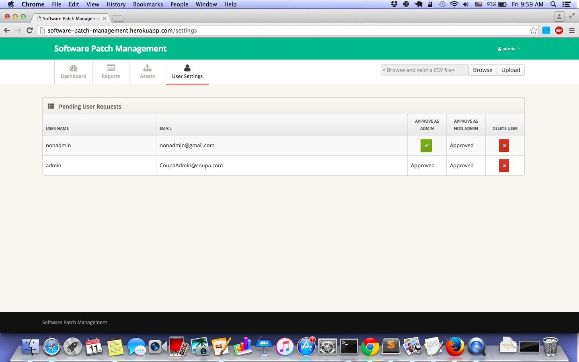

*Fig. 6 User Settings page*

6. Upload CSV file (admin only)

If you are an admin, in the navigation bar, there are buttons for you to select and upload a new CSV file.

You can click the “Browse” button and an explorer will be popped up for you to select the file you want to upload.

After selection, you can click the “Upload” button, and the web application will first validate the file. If the validation passed, the data of the CSV file will be read and the report table in Report page and assets table in Asset page will be updated. However, if the validation failed, an alert message will be popped up with error message showing reason that why the file is not considered valid.

The validation process is to validate that the uploaded file conforms to the standard report format of Qualys reports.

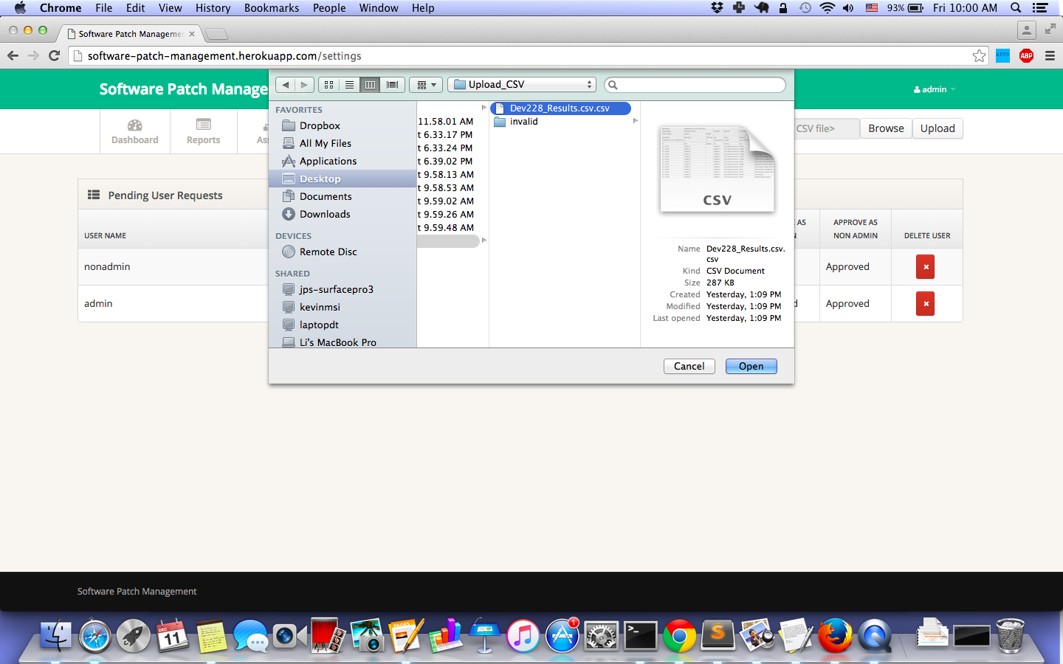

*Fig. 7 Upload CSV file*

8. Registration

If you do not have an account for the system, you can go to the Login page, and then click the “Don’t have an account?” link on upper right corner of the page to go to Registration page, as shown in Fig. 1.

In the Registration page, as shown in Fig. 8, you can see that there are fields for you to fill out to register for an account. Note that the password must be at least 8 characters long, and must contain at least one lower-case letter, one upper-case letter, one number, and one special character.

After filling out the form, click “Register” and your account is created. However, you still cannot login to the web application, because you have to wait for the admin to activate the account and grant you privilege.

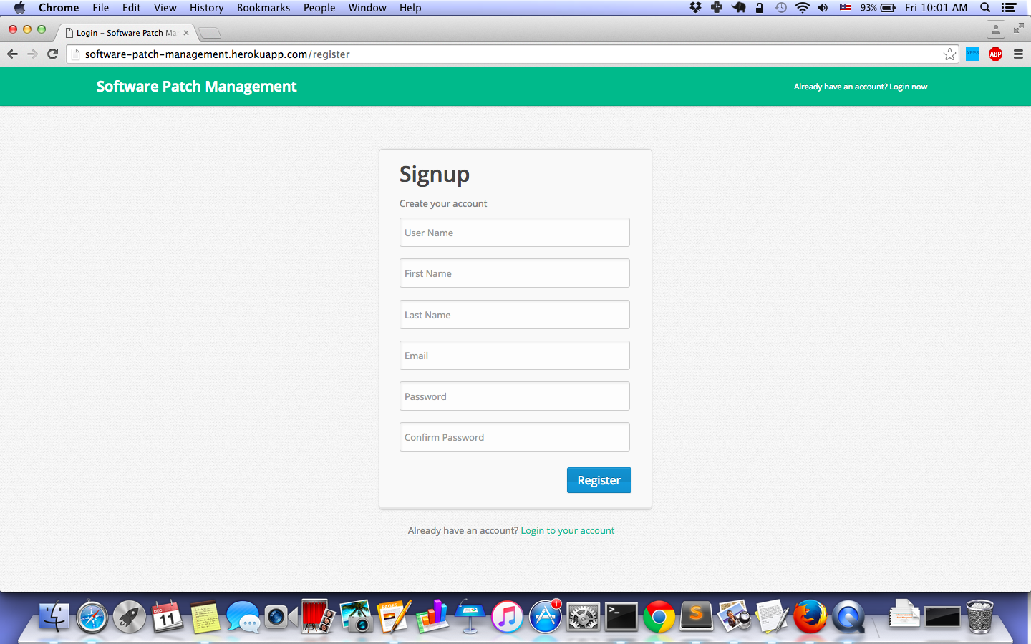

*Fig. 8 Registration page*