Does It Rain More in Seattle, WA than in San Francisco, CA?
Amruta Hegde

Introduction

Problem Statement
Seattle is often described as a rainy city, but San Francisco is also a Pacific Coast city that experiences wet weather. This project asks: Does it rain more in Seattle than in San Francisco? I compare the cities in three ways: how much precipitation they receive, how often precipitation occurs, and whether the difference changes throughout the year.

Data
Seattle is represented by the SEATTLE 2.1 ESE station, while San Francisco is represented by the San Francisco International Airport Station.
Data search portal: https://www.ncei.noaa.gov/cdo-web/search
GHCN-Daily overview: https://www.ncei.noaa.gov/products/land-based-station/global-historical-climatology-network-daily
File | Station | Station ID
seattle_rain.csv | SEATTLE 2.1 ESE, WA US | US1WAKG0225
sf_rain.csv | SAN FRANCISCO INTERNATIONAL AIRPORT, CA US | USW00023234
The study period is January 1, 2018 to December 31, 2022, which is five full years.

Methods
When I inspected the files, the Seattle file had 1,658 rows against 1,826 for San Francisco, which has one row for every day of the five years. Seattle was missing precipitation for 190 days (about 10%), and plotting the raw daily values showed the longest gap: 62 days, from January 9 to March 11, 2018. Dropping these dates would have left the two cities with different days, so I estimated each missing value using the average for the same calendar day in the other years and flagged every estimate. The estimates averaged 0.126 inches against 0.112 for real observations, which makes sense because many gaps fall in the wet season. Estimated days almost never equal exactly zero, so they tend to count as days with precipitation. Because of that, I also repeated the comparison using only observed days.
I examined both the average daily precipitation and the percentage of days with any precipitation. I compared the cities across all days and then month by month. Welch's t-test was used to compare average precipitation, and a two-sample proportion test was used to compare the percentage of days with precipitation, using a significance level of 0.05.

Results
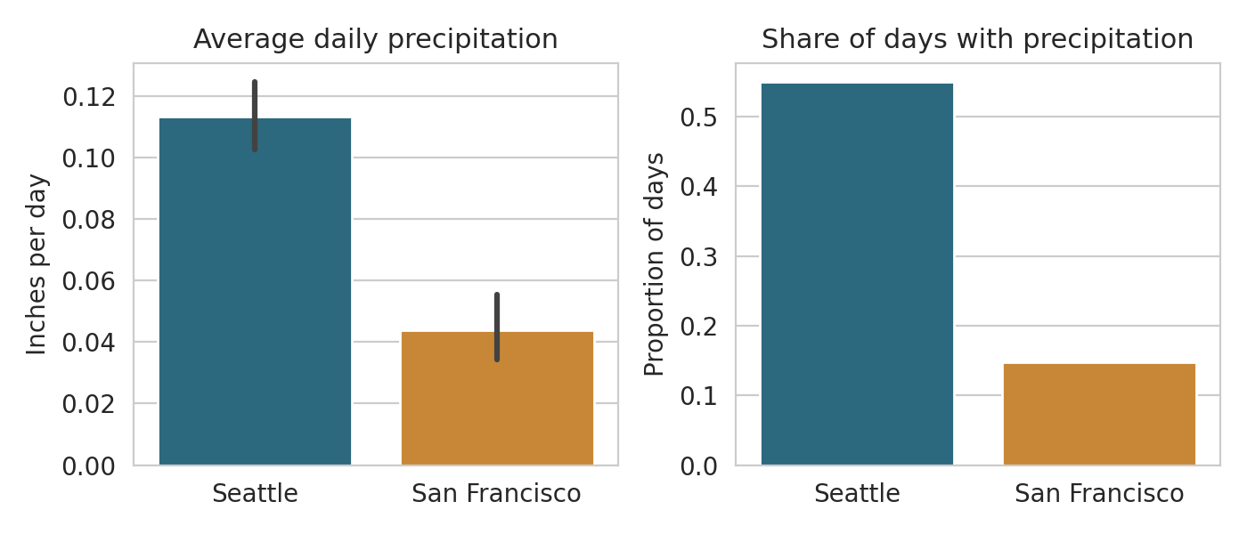
Figure 1. Overall comparison
Figure 1 gives the overall answer. Seattle averaged about 0.113 inches of precipitation per day compared with 0.044 in San Francisco, roughly 2.6 times as much, and the confidence intervals do not overlap. The right panel shows an even larger gap: precipitation was recorded on about 55% of Seattle days but only about 15% of San Francisco days. The median San Francisco day had none at all. Both differences were statistically significant (p < 0.001).
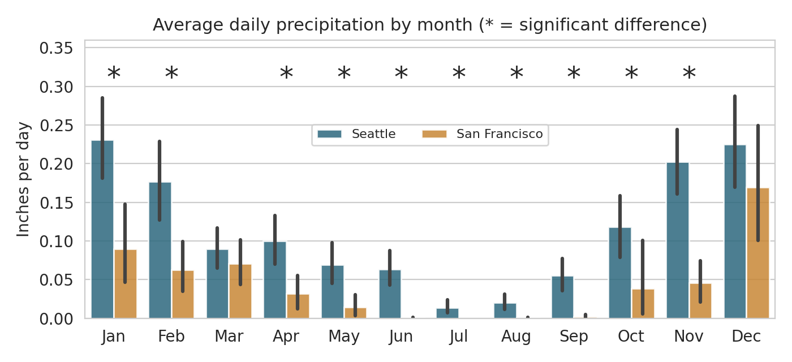
Figure 2. Average daily precipitation by month
Figure 2 asks whether this was only a winter effect. It was not: Seattle's average was higher in all twelve months, although the gap was uneven. It was wide in January (0.231 versus 0.090 inches per day) and November (0.203 versus 0.046), and it nearly closed in March (0.090 versus 0.071) and December (0.225 versus 0.169). Those are the only two months without an asterisk, so for amount, the difference in those months could be due to chance. San Francisco's average is close to zero from June through September.
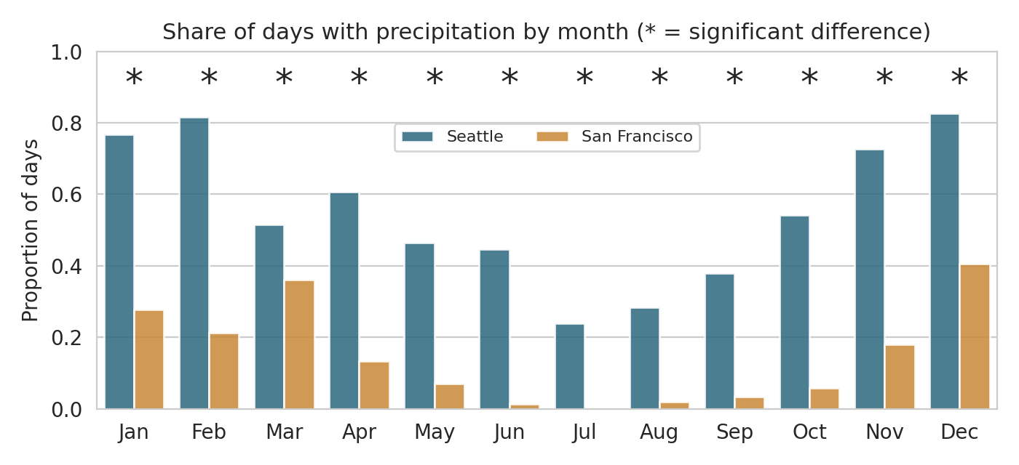
Figure 3. Share of days with precipitation by month
Figure 3 changes the picture a little. When I switched from amount to frequency, the difference became significant in all twelve months, including March and December. In December it rained on about 83% of Seattle days versus about 41% of San Francisco days. In summer the contrast is sharper: San Francisco almost never recorded precipitation from June through September (0% to 3% of days), while Seattle still did on roughly 24% to 45% of days. This is why I think being "rainier" has to include how often it rains, not only how much. A stricter correction for twelve tests (Bonferroni) still leaves 9 months significant for amount and 11 for frequency.
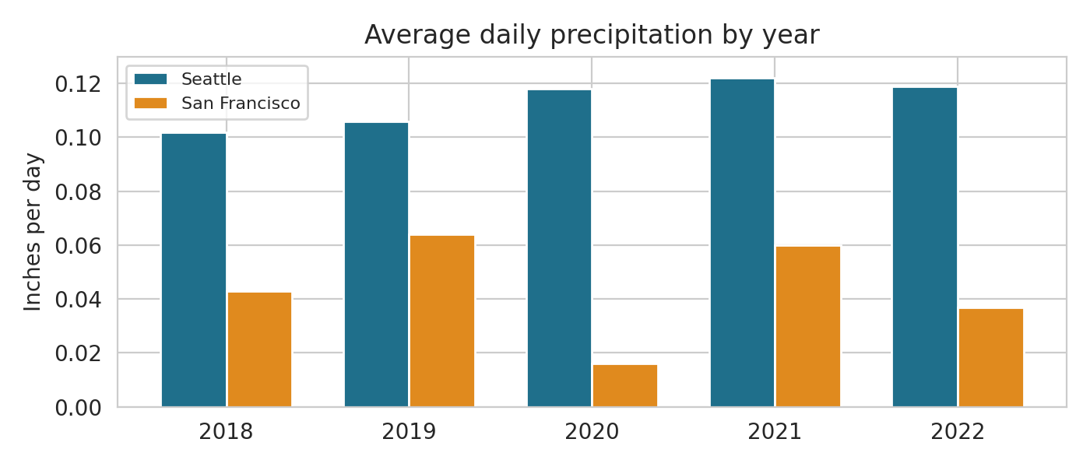
Figure 4. Average daily precipitation by year
Figure 4 checks whether five years of averaging hides one unusual year. Seattle was steady, between 0.102 and 0.122 inches per day, while San Francisco swung from 0.064 in 2019 to just 0.016 in 2020, an unusually dry year. Even so, Seattle came out ahead in every year.
Using only the 1,636 days with a real Seattle observation, the averages were almost unchanged (0.112 versus 0.044 inches), and Seattle's share of days with precipitation dropped from 55% to about 51%, as expected once estimated days are removed. The conclusion does not depend on the imputation.

Conclusion
Yes, it rains more in Seattle than in San Francisco. From 2018 through 2022, Seattle received about 2.6 times as much average daily precipitation as San Francisco and had precipitation on more than three times as many days. The difference was not limited to one season: Seattle experienced precipitation more frequently in every month of the year.
There are some limitations. Each city is represented by only one weather station, so the results describe these locations rather than every part of the two cities. Seattle also has missing observations, although the robustness check shows that filling those gaps does not change the conclusion. Finally, five years is a relatively short period for drawing conclusions about long-term climate patterns.
Overall, however, the data provide strong evidence that Seattle was both wetter and more frequently wet than San Francisco during the 2018–2022 study period.

