Do Socioeconomic Factors Predict School Performance?
DATA 5100 Education Project

Abstract
This study asks how well the socioeconomic characteristics of a school’s community predict its average ACT score. Using data for 7,227 U.S. schools (EdGap socioeconomic data joined to the National Center for Education Statistics Common Core of Data), ordinary least squares (OLS) regression was used to compare single-predictor, quadratic, five-predictor, and reduced models and to test whether charter status adds predictive value. Median income alone explained 21.1% of the variance in average ACT score (mean absolute error, MAE = 1.713 points), whereas the share of students receiving free or reduced-price lunch alone explained 61.4%. A five-predictor model reached R² = 0.628 (MAE = 1.145); removing median income and married-family share changed neither fit (nested F-test, p = 0.807). In the reduced model, the standardized coefficient of lunch share (−1.78) was about 6 and 14 times larger in magnitude than those of college education (0.28) and unemployment (−0.12). Charter status did not improve the model (adjusted difference −0.18 points, p = 0.138). Socioeconomic context therefore predicts school-level ACT performance substantially but incompletely; the associations are not causal estimates.

Introduction
Differences in average test scores between schools are among the most persistent findings in education research. Since the Coleman report (Coleman et al., 1966), studies have linked family and community socioeconomic status to academic achievement; a meta-analysis by Sirin (2005) reported a medium to strong positive association, and Reardon (2011) documented a widening achievement gap between high- and low-income families. Knowing how much of the variation in school performance can be anticipated from community conditions matters for educational equity, for targeting support to schools, and for interpreting comparisons between schools.
This report asks: how accurately can a school’s average ACT score be predicted from socioeconomic measures of its community, and which measures carry the predictive information? The ACT is a college admissions exam scored from 1 to 36. A secondary question is whether school charter status improves prediction once socioeconomic factors are accounted for. The goal is to quantify association and predictive performance, not to estimate causal effects.
Data. Two datasets were combined. EdGap_data, for each school, the average ACT score (SAT scores are converted to ACT equivalents) and five measures describing the school’s community: median household income (dollars), unemployment rate, percentage of adults with a college education, percentage of married families, and percentage of students receiving free or reduced-price lunch (the last four stored as proportions between 0 and 1). The ccd_sch_029_1617_w_1a_11212017.csv supplies each school’s state, zip code, type, level, and charter status (Yes, No, or Not applicable). The two sources were cleaned, joined on the school identifier, and imputed for missing values in a separate data-preparation workflow, yielding one row per school (7,227 schools). The unit of analysis is therefore the school, not the individual student.

Theoretical Background
OLS linear regression models a response y as a linear combination of p predictors and estimates the coefficients by minimizing the sum of squared residuals (Kutner et al., 2005; James et al., 2021):
y_{i} = β₀ + β₁x_{i1} + … + β_{p}x_{ip} + ε_{i}, β̂ = (X^{T}X)⁻¹X^{T}y (1)
Each coefficient β_{j} is the expected change in y per one-unit increase in x_{j} holding the other included predictors constant. A quadratic term x² allows curvature while keeping the model linear in its coefficients, and a categorical predictor such as charter status enters as a 0/1 indicator whose coefficient is the adjusted difference between groups. Fit is summarized by R² and by two error measures in the units of the response (ACT points):
R² = 1 − SSR/SST, MAE = (1/n) Σ|y_{i} − ŷ_{i}|, RMSE = √[(1/n) Σ(y_{i} − ŷ_{i})²] (2)
where SSR and SST are the residual and total sums of squares; for one predictor, R² equals the squared correlation. RMSE weights large errors more than MAE. Whether q extra terms improve a model is tested with the nested-model F-test (ANOVA) comparing a reduced (R) and a full (F) model:
F = [(SSR_{R} − SSR_{F})/q] / [SSR_{F}/(n − p_{F} − 1)] (3)
Correlated predictors inflate coefficient standard errors and can make informative predictors appear insignificant. The variance inflation factor, VIF_{j} = 1/(1 − R_{j}²), with R_{j}² from regressing predictor j on the others, measures this overlap; values above about 5 are usually considered problematic. Standardizing predictors, z = (x − x̄)/s, expresses coefficients per standard deviation so their magnitudes are comparable; this linear rescaling leaves fitted values, R², MAE, and t-statistics unchanged. Residual plots check for curvature and non-constant variance, the Jarque–Bera test and skewness/kurtosis check normality, and the Durbin–Watson statistic (near 2 for uncorrelated residuals) checks dependence. Because very small effects become significant in large samples, effect size (change in R² or MAE) is reported alongside p-values.

Methodology
All models were fitted by OLS on the full dataset with statsmodels (Seabold & Perktold, 2010); MAE, RMSE, and standardization (StandardScaler) used scikit-learn (Pedregosa et al., 2011), and data handling and plots used pandas, matplotlib, and seaborn (McKinney, 2010; Waskom, 2021). Significance was assessed at α = 0.05, and all error metrics are in-sample. The procedure, in order, was:
1. Single-predictor models. For each of the five predictors, a linear model (ACT = β₀ + β₁x) and a quadratic model (adding x²) were fitted and compared by R², MAE, and F-test. Median income was examined further with scatter and residual plots.
2. Multiple regression. A model with all five predictors was fitted. Pairwise correlations and VIFs were computed to assess overlap.
3. Reduced model. Predictors that were not significant in the five-predictor model and that overlapped with others (median income and married-family share) were removed, leaving ACT = β₀ + β₁(unemployment) + β₂(college) + β₃(lunch). Full and reduced models were compared by R², MAE, and a nested F-test.
4. Standardization. The three reduced-model predictors were standardized to mean 0 and standard deviation 1 and the model refitted to compare coefficient magnitudes. Residuals versus fitted values were inspected for the single-predictor income, full, and reduced models.
5. Charter status. Schools labeled “Not applicable” (199) were excluded. The reduced model with and without a charter indicator (non-charter as reference) was fitted on the same 7,028 schools labeled Yes or No and compared by the indicator’s coefficient, a nested F-test, R², and MAE. The analysis is in the notebook education_modeling.ipynb, which reads education_clean.csv.

Computational Results

Single-predictor and quadratic models
The linear median-income model had a slope of 4.732 × 10⁻⁵ ACT points per dollar (about 0.47 points per $10,000; p < 0.001), R² = 0.211, RMSE = 2.228, and MAE = 1.713 (Figure 1a; Table 1). Its residual spread decreases as predicted score increases, from about −7 to +10 points at the lowest predicted scores to a narrow band at the highest (Figure 1b). The quadratic income model had R² = 0.219 and MAE = 1.697; the squared-term coefficient was −1.99 × 10⁻¹⁰ (p = 1.4 × 10⁻¹⁷), the nested F-test gave F = 73.23 (p = 1.40 × 10⁻¹⁷), and the fitted curve peaks near $190,000 (Figure 1a). For the other predictors, free/reduced-lunch share was the strongest single predictor (linear R² = 0.614, MAE = 1.169) and unemployment rate the weakest (R² = 0.188, MAE = 1.742).
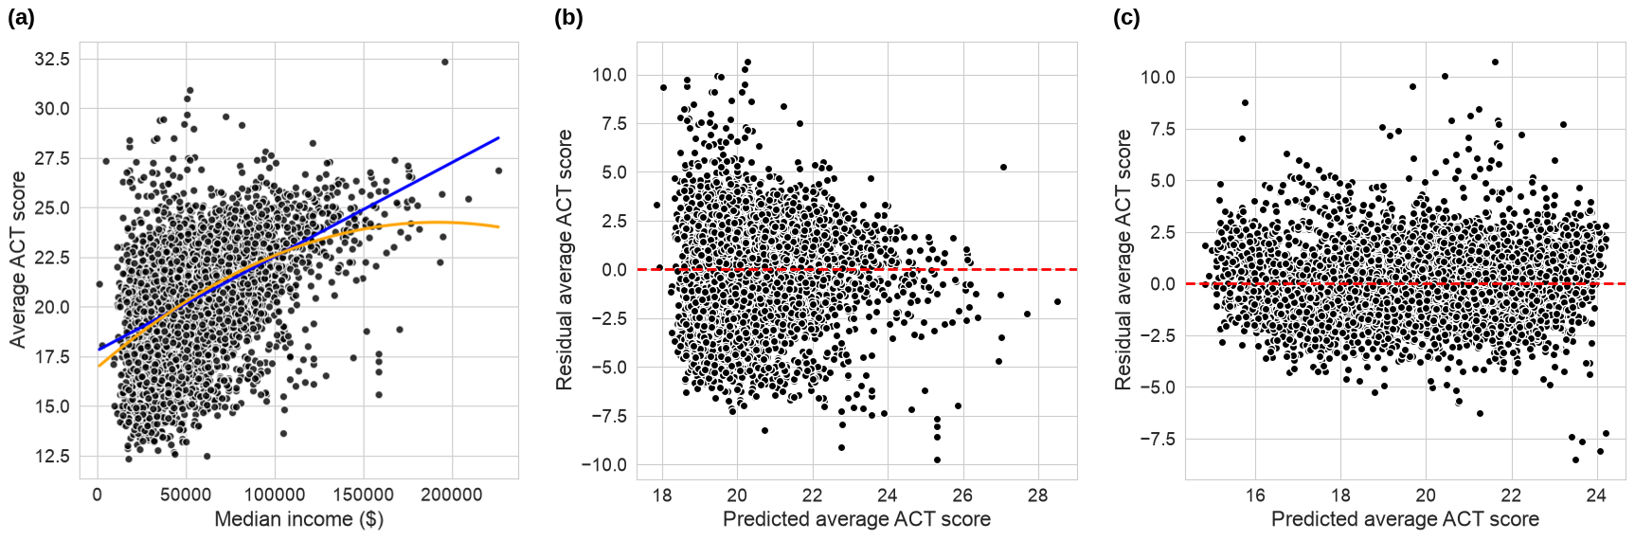
Figure 1. (a) Average ACT score versus median income with linear (blue) and quadratic (orange) fits. (b) Residuals versus predicted ACT score for the median-income model. (c) Residuals versus predicted ACT score for the reduced three-predictor model.

Multiple and reduced models
The five-predictor model had R² = 0.628 and MAE = 1.145. Unemployment rate (β = −2.269, p < 0.001), college education (β = 1.739, p < 0.001), and lunch share (β = −7.605, p < 0.001) were significant; married-family share (β = −0.075, p = 0.577) and median income (β = −1.2 × 10⁻⁷, p = 0.920) were not. Median income correlated 0.71 with college education and 0.62 with married-family share (Figure 2a). The VIFs were 1.61 (unemployment), 2.08 (college), 2.02 (married), 2.68 (income), and 1.59 (lunch). The condition number was 1.34 × 10⁶.
The reduced model retained unemployment, college education, and lunch share, with coefficients of −2.168, 1.714, and −7.586 (all p < 0.001), a condition number of 25.9, R² = 0.6279, and MAE = 1.1455. The nested F-test of the full against the reduced model gave F = 0.215 (p = 0.807) (Table 1). Holding the other two predictors fixed, a 10-percentage-point increase in lunch share corresponded to a change of −0.76 ACT points, in college education +0.17, and in unemployment −0.22. Residuals of the full and reduced models were evenly distributed around zero without visible curvature or funnel shape, with a few large residuals (about +10 and −8.5 points; Figure 1c). Residual skewness was 0.59, kurtosis 6.0, the Jarque–Bera p-value near zero, and the Durbin–Watson statistic 1.48.
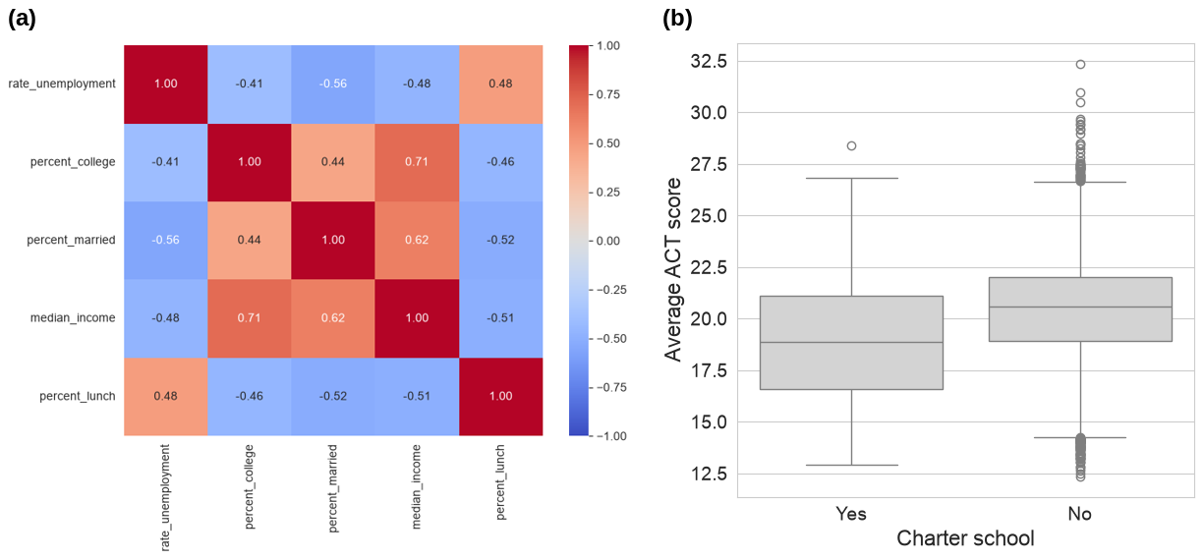
Figure 2. (a) Pearson correlation matrix of the five socioeconomic predictors. (b) Distribution of average ACT score for non-charter (No) and charter (Yes) schools.
Table 1. In-sample comparison of fitted models (n = 7,227).
Model | Predictors | R² | MAE | RMSE
Income, linear | median income | 0.211 | 1.713 | 2.228
Income, quadratic | median income, income² | 0.219 | 1.697 | 2.217
Lunch share only | free/reduced-lunch share | 0.614 | 1.169 | —
Full | all five predictors | 0.628 | 1.145 | 1.530
Reduced | unemployment, college, lunch | 0.628 | 1.145 | 1.530
RMSE for the quadratic, full, and reduced models is √(SSR/n) from the ANOVA tables; “—” indicates a metric not computed in the notebook.

Standardized coefficients
Table 2. Reduced model coefficients, unstandardized and standardized (all p < 0.001).
Predictor | Coef. (SE) | t | Std. coef. | Std. 95% CI
Intercept | 22.640 (0.102) | 220.9 | 20.299 | [20.263, 20.334]
Unemployment rate | −2.168 (0.374) | −5.80 | −0.123 | [−0.164, −0.081]
College education | 1.714 (0.127) | 13.50 | 0.283 | [0.242, 0.324]
Free/reduced lunch | −7.586 (0.093) | −81.99 | −1.777 | [−1.819, −1.734]
Standardization left R² (0.6279), MAE (1.1455), the t-statistics, and the fitted values identical to the unscaled reduced model, and reduced the condition number to 1.93. The standardized lunch coefficient (−1.777) was 6.3 times the magnitude of the college coefficient (0.283) and 14.5 times that of the unemployment coefficient (−0.123).

Charter status
Of the 7,227 schools, 6,858 were non-charter, 170 charter, and 199 “Not applicable.” Among the 7,028 compared schools, the mean (median, SD) average ACT score was 20.36 (20.60, 2.50) for non-charter and 19.02 (18.89, 3.14) for charter schools (Figure 2b). With the three socioeconomic predictors in the model, the charter coefficient was −0.179 ACT points (SE 0.121, 95% CI [−0.415, 0.058], p = 0.138), and the nested F-test gave F = 2.20 (p = 0.138). R² changed from 0.6276 to 0.6277 and MAE was 1.1525 for both models. The socioeconomic coefficients were −2.31 (unemployment), 1.67 (college), and −7.56 (lunch).

Discussion
The results answer the main question affirmatively but with qualifications. Median income alone is a weak predictor (R² = 0.21), and the funnel in its residuals shows that prediction errors are largest, and scores most variable, in lower-income communities, so income does not pin down performance there. The quadratic term is statistically significant, and the flattening above roughly $100,000 suggests diminishing returns to income, but it lowers MAE by only 0.016 points; the significance reflects the large sample rather than a practically useful improvement.
Most of the predictive power comes from one variable. Lunch share alone achieves R² = 0.614, and adding unemployment and college education raises R² by only 0.014 and lowers MAE by about 0.02 points. The improvement over income therefore reflects the strength of the lunch measure rather than the benefit of combining many measures. A plausible but untested explanation is that lunch share measures student-level poverty directly, whereas income, education, and marriage describe the surrounding community. The loss of significance of median income in the five-predictor model does not mean income is unrelated to scores: its information is largely contained in correlated variables (r = 0.71 with college education, 0.62 with married-family share). Because all VIFs are below 3, the overlap is moderate rather than extreme, yet the nested F-test (p = 0.807) and identical R² and MAE show that income and marriage rate add nothing measurable, so the simpler reduced model is preferred. The funnel pattern of the income-only model disappears in the reduced model, indicating that the income model’s unequal error spread came from omitted predictors rather than from the functional form.
Charter status is not a useful additional predictor. The raw gap of 1.34 points between charter and non-charter schools shrinks to 0.18 points after adjustment and is not significant, and R² and MAE are unchanged. This suggests that charter schools in these data serve students and communities with different socioeconomic profiles, and that this, rather than school type, accounts for the raw gap. The evidence is limited by the small number of charter schools (170): the confidence interval ([−0.415, 0.058]) is wide enough that a small negative or positive difference cannot be excluded, and selection into charter schools is not measured.
Sources of error and evidence that tempers the conclusions. About 37% of the variance is unexplained, and the typical error (MAE = 1.145) is substantial against a between-school standard deviation of about 2.5 points; some schools are mispredicted by 8 to 10 points. Residuals are non-normal (heavy-tailed, skewness 0.59, kurtosis 6.0), and a Durbin–Watson value of 1.48 suggests mild positive dependence, plausibly because schools in the same state or district share unmeasured influences. Standard errors may therefore be understated, although the key coefficients have t-statistics from 5.8 to 82, so their significance is unlikely to be an artifact; the borderline charter result deserves more caution. All metrics are in-sample, so accuracy on new schools is probably lower. Further limitations are omitted variables (funding, teacher experience), state differences in the share of students who take the ACT, the effect of imputation during data preparation, and the use of community-level measures to describe school-level outcomes, which prevents inferences about individual students. Because the data are observational, none of the coefficients show that changing a predictor would change scores. Validation with train/test splits or cross-validation, robust or state-clustered standard errors, and state-specific models are the natural next steps.

Conclusion
This report examined how far a school’s typical ACT performance can be anticipated from the economic and social profile of the community around it. Socioeconomic measures account for roughly 63% of the variation between schools, with a typical prediction error of about 1.1 ACT points, but nearly all of that predictive power comes from the share of students receiving free or reduced-price lunch; median income and married-family share add nothing once three measures (lunch share, college education, unemployment) are included, and charter status adds nothing beyond them.
These findings matter for how school results are read. Because average ACT scores mirror community poverty so closely, ranking schools by unadjusted scores is likely to reflect the circumstances of their students more than the quality of their teaching, and a poverty indicator such as lunch share could help identify schools where additional support may be needed. The analysis cannot show which interventions would raise scores, and about 37% of the variation remains unexplained. Future work should validate the models on held-out schools, account for state differences, and add school-level characteristics such as funding.

References
Coleman, J. S., Campbell, E. Q., Hobson, C. J., McPartland, J., Mood, A. M., Weinfeld, F. D., & York, R. L. (1966). Equality of educational opportunity. U.S. Department of Health, Education, and Welfare, Office of Education. https://eric.ed.gov/?id=ED012275
James, G., Witten, D., Hastie, T., & Tibshirani, R. (2021). An introduction to statistical learning: With applications in R (2nd ed.). Springer. https://doi.org/10.1007/978-1-0716-1418-1
Kutner, M. H., Nachtsheim, C. J., Neter, J., & Li, W. (2005). Applied linear statistical models (5th ed.). McGraw-Hill/Irwin.
McKinney, W. (2010). Data structures for statistical computing in Python. In Proceedings of the 9th Python in Science Conference (pp. 56–61). https://doi.org/10.25080/Majora-92bf1922-00a
National Center for Education Statistics. (2017). Common Core of Data (CCD): Public school universe survey, 2016–17. U.S. Department of Education. https://nces.ed.gov/ccd/
Pedregosa, F., Varoquaux, G., Gramfort, A., Michel, V., Thirion, B., Grisel, O., Blondel, M., Prettenhofer, P., Weiss, R., Dubourg, V., Vanderplas, J., Passos, A., Cournapeau, D., Brucher, M., Perrot, M., & Duchesnay, É. (2011). Scikit-learn: Machine learning in Python. Journal of Machine Learning Research, 12, 2825–2830. https://www.jmlr.org/papers/v12/pedregosa11a.html
Reardon, S. F. (2011). The widening academic achievement gap between the rich and the poor: New evidence and possible explanations. In G. J. Duncan & R. J. Murnane (Eds.), Whither opportunity? Rising inequality, schools, and children’s life chances (pp. 91–116). Russell Sage Foundation.
Seabold, S., & Perktold, J. (2010). Statsmodels: Econometric and statistical modeling with Python. In Proceedings of the 9th Python in Science Conference (pp. 92–96). https://doi.org/10.25080/Majora-92bf1922-011
Sirin, S. R. (2005). Socioeconomic status and academic achievement: A meta-analytic review of research. Review of Educational Research, 75(3), 417–453. https://doi.org/10.3102/00346543075003417
Waskom, M. L. (2021). Seaborn: Statistical data visualization. Journal of Open Source Software, 6(60), Article 3021. https://doi.org/10.21105/joss.03021

