Does It Rain More in Seattle, WA than in San Francisco, CA?
Amruta Hegde

Introduction

Problem Statement
Seattle is often described as a rainy city, but San Francisco is also a Pacific Coast city that experiences wet weather. This project asks: Does it rain more in Seattle than in San Francisco? I compare the cities in three ways: how much precipitation they receive, how often precipitation occurs, and whether the difference changes throughout the year.

Data
Seattle is represented by the SEATTLE 2.1 ESE station, while San Francisco is represented by the San Francisco International Airport Station.
Data search portal: https://www.ncei.noaa.gov/cdo-web/search
GHCN-Daily overview: https://www.ncei.noaa.gov/products/land-based-station/global-historical-climatology-network-daily
File | Station | Station ID
seattle_rain.csv | SEATTLE 2.1 ESE, WA US | US1WAKG0225
sf_rain.csv | SAN FRANCISCO INTERNATIONAL AIRPORT, CA US | USW00023234
The study period is January 1, 2018 to December 31, 2022, which is five full years. The column PRCP is daily precipitation, which I take to be in inches (the standard units for U.S. Climate Data Online downloads). The largest daily values, 2.60 inches in Seattle and 4.02 inches in San Francisco, are consistent with inches.
In the tidy data, the two cities are labeled SEA (Seattle) and SF (San Francisco).

Methods
The Seattle dataset was missing precipitation measurements for 190 days, including a long gap in early 2018. Rather than removing those dates, I estimated the missing values using the average precipitation for the same calendar day in the other available years. I kept track of these estimated values and also performed a separate analysis using only days with actual observations to check whether the results depended on the imputation.
I examined both the average daily precipitation and the percentage of days with any precipitation. I also compared the cities month by month. Welch's t-test was used to compare average precipitation, and a two-sample proportion test was used to compare the percentage of days with precipitation.

Results
Figure 1 provides the overall comparison between Seattle and San Francisco and shows that Seattle received substantially more precipitation during the study period.
Figure 2 shows that this difference was present throughout the year. Seattle had higher average daily precipitation than San Francisco in every month, although the size of the difference varied by season. Asterisks indicate months in which the difference in average daily precipitation between Seattle and San Francisco was statistically significant.
Figure 3 shows that Seattle also experienced precipitation on a much larger share of days. This is important because being "rainier" is not only about the total amount of precipitation but also how frequently precipitation occurs.
Figure 4 shows the average daily precipitation by year. Seattle remained wetter than San Francisco across the five-year study period, rather than the overall difference being driven by only one unusually wet year.
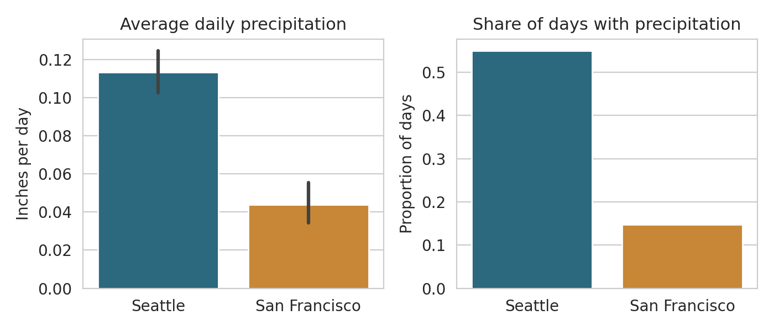  Figure 1. Overall comparison | 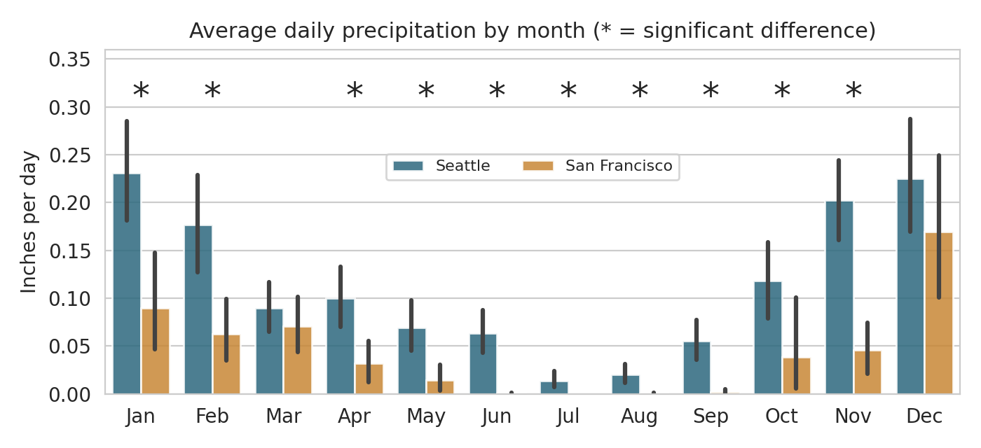  Figure 2. Average daily precipitation by month
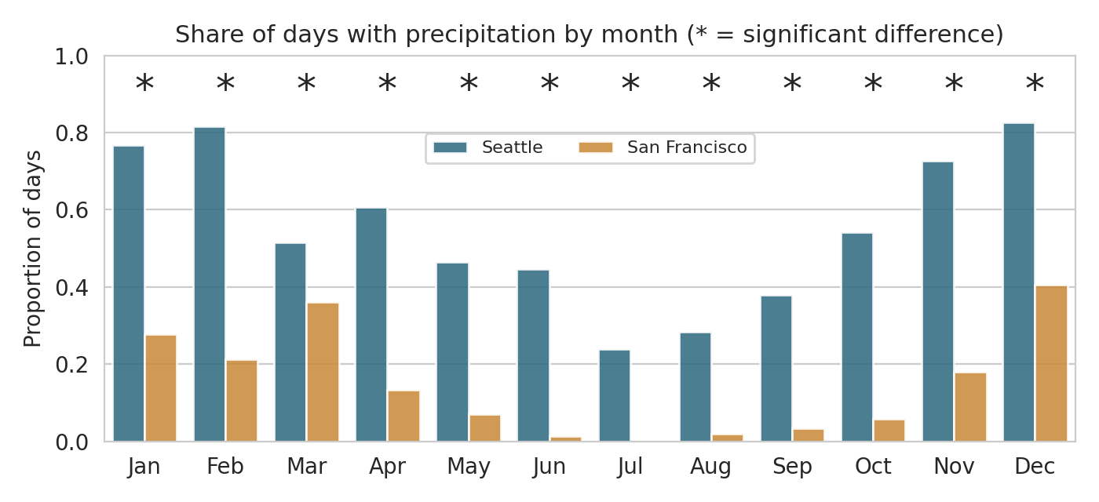  Figure 3. Share of days with precipitation by month | 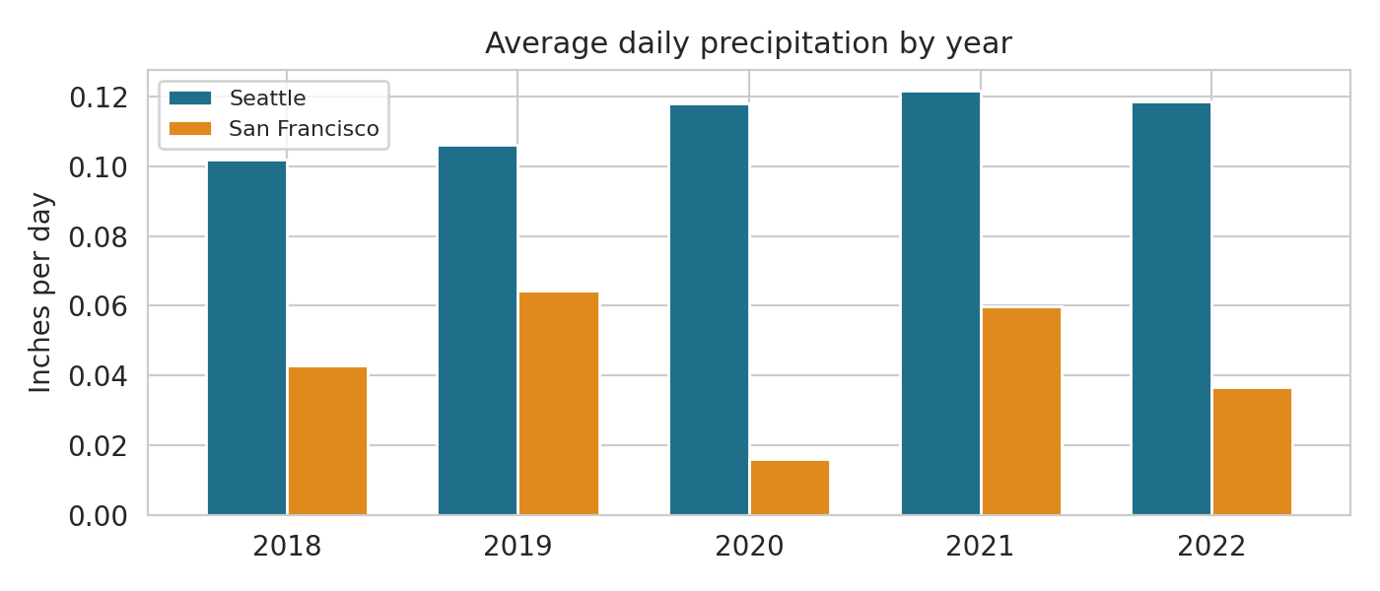  Figure 4. Average daily precipitation by year

Conclusion
Yes, it rains more in Seattle than in San Francisco. From 2018 through 2022, Seattle received about 2.6 times as much average daily precipitation as San Francisco and had precipitation on more than three times as many days. The difference was not limited to one season: Seattle experienced precipitation more frequently in every month of the year.
There are some limitations. Each city is represented by only one weather station, so the results describe these locations rather than every part of the two cities. Seattle also has missing observations, although the robustness check shows that filling those gaps does not change the conclusion. Finally, five years is a relatively short period for drawing conclusions about long-term climate patterns.
Overall, however, the data provide strong evidence that Seattle was both wetter and more frequently wet than San Francisco during the 2018–2022 study period.

