Assignment 3

Test Plan: Simple Web Browser using Android

1) There are 2 projects. One project for the application and one separate Android test project for testing the application. The Android test project can be downloaded & can be executed in eclipse.

2) Testing is done using Unit tests and Junit framework.

3) Unit tests are as follows:

Features tested are:

|  |  |  |  |  |  |
| --- | --- | --- | --- | --- | --- |
| Sr. No | Test case | Description | Expected output | Actual output | Result |
|  |  |  |  |  |  |
| 1. | Android application | Open the application. | Browser should run as an android application | Browser runs as an android application | Pass |
| 2 | Browser test | Open the application and open any valid url in browser | Browser shall stay in its own activity, without invoking the existing browser in the system. | Browser stays in its own activity, without invoking the existing browser in the system. | Pass |
| 3 | Render HTML | Open a url with rich text & images in it | The browser should render html page with rich text & imges in it. | The browser should render html page with rich text & imges in it. | Pass |
| 4 | Hyperlink test | Open a url which has hyperlinks and click on any 1 hyperlink in it | On clicking on the hyperlink, browser should open the page contents to the location specified in the hyperlink or display an error. | On clicking on the hyperlink, browser opens the page contents to the location specified in the hyperlink or display an error. | Pass |
| 5 | Back Button test | Click Back button | If there is previously entered url, previous page should get loaded | If there is previously entered url, previous page gets loaded | Pass |
| 6 | Forward Button test | Click Forward button | If back button is used, next page should get loaded | If back button is used, next page gets loaded | Pass |
| 7 | Home Button test | Click Home button | http://www.google.com page should get loaded | http://www.google.com page gets loaded | Pass |
| 8 | URL address bar test | Open browser and check the url address bar | After entering valid url, If enter key pressed or ‘Go’ button is pressed, browser should load the page | After entering valid url, If enter key pressed or ‘Go’ button is pressed, browser loads the page | Pass |
| 9 | Error test | Open browser and enter invalid url & try to load page. check the status bar | After entering invalid url, If enter key pressed or ‘Go’ button is pressed, browser should display error. | After entering invalid url, If enter key pressed or ‘Go’ button is pressed, browser displays error. | Pass |
| 10 | URL address bar test | Type in valid url manually | After opening the application, url address bar should be manually edited in browser. | After opening the application, url address bar can be manually edited in browser. | Pass |
| 11 | Scrollbar test | Open valid url and check the scrollbar of the browser | After entering valid url, browser should display the page with the scrollbar if required. | After entering valid url, browser displays the page with the scrollbar if required. | Pass |
| 12 | Favorites test | Open valid url in browser and click menu. | After opening menu. ‘Save to bookmarks’ option should be visible and page should be saved to the bookmarks. | After opening menu. ‘Save to bookmarks’ option is visible and page can be saved to bookmarks. | Pass |
| 13 | Open Favourites test | Open menu and select ‘Go to bookmarks’ | After opening menu. ‘Go to bookmarks’ option should be visible and list of saved bookmarks should appear. On clicking of any one, valid page should appear. | After opening menu. ‘Go to bookmarks’ option is visible and list of saved bookmarks appear. On clicking of any one, valid page appears. | Pass |
| 14 | zoom in and zoom out test | Open valid url and click on zoom in and zoom out | The current page display should zoom in or zoom out as per clicked. | The current page display zooms in or zooms out the page as per clicked. | Pass |

4) JUnit tests are covered in class ‘MainActivityTest’ in Android test project ‘SimpleBrowserTest’ ‘com.example.simplebrowser.test’ package.

This class extends ActivityInstrumentationTestCase2<MainActivityTest> class.

Screen shot of the successfully executed Junit test cases is attached below:

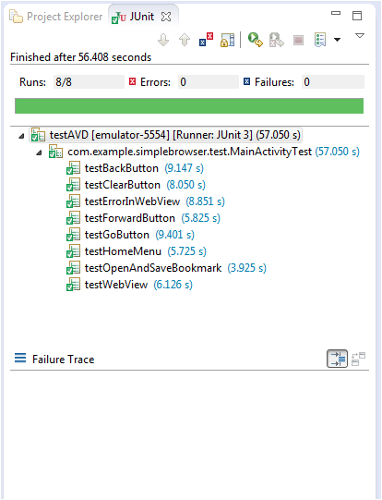

5) Differences between Android Application Framework and JFrame:

1. For testing purpose, we had to create a new android test application,

but in JFrame, we only created new class for writing test cases. Android project has its own folder structure defined. JFrame is a simple java project.

1. We get enhanced APIs in Android, for example bookmark is an option provided in its API. But in JFrame, for creating history, we had to use stack for storing all the url addresses.
2. Layout is separately defined for Android applications. Layout is in different file named activity_main.xml. But for JFrame, layout and business logic is defined in same class.