# Amruta satpute

# Roll no : 19026

# Reverse Geocoding in QGIS

**Aim** : To extract location details and save as csv.

# Introduction:

Reverse geocoding is the process of converting geographic coordinates (latitude and longitude) into a human-readable address or location description. For example, if you have the coordinates of a location, reverse geocoding can help you determine the exact street address or location name.

# Tools:

* QGIS: A free tool for mapping and working with geographic data.
* MMQGIS Plugin: An additional tool in QGIS that helps with tasks like reverse geocoding.
* OpenStreetMap (OSM): A free map that provides location data, which is used for reverse geocoding.

# Data Source:

* **OpenStreetMap (OSM):**is used to find the addresses from your coordinates.
* **Location Data CSV file**: Contains the latitude and longitude coordinates

# Steps :

Step 1 : Go to plugins and install Map Tiler and QuikMapServices

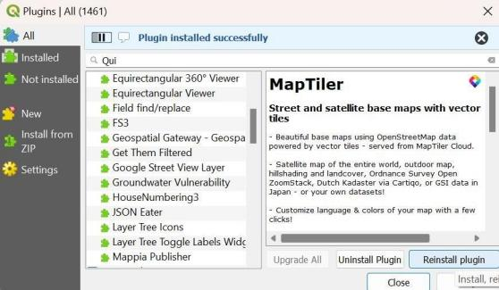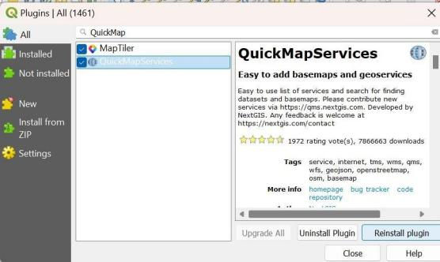

Step 2 : Go to web then click on QuickMapServices and then OSM and then click on OSM standards

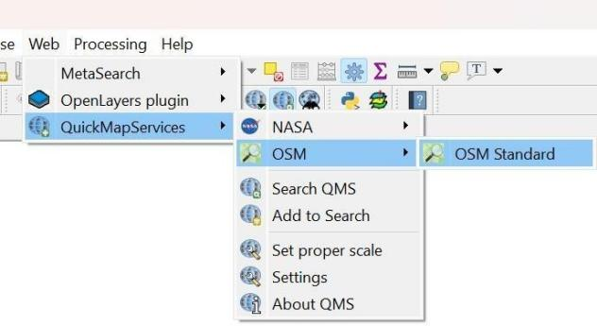

Step 3 : Now we need add Location_Data file for this go to layers and click on add layer and then add delimenited text layer

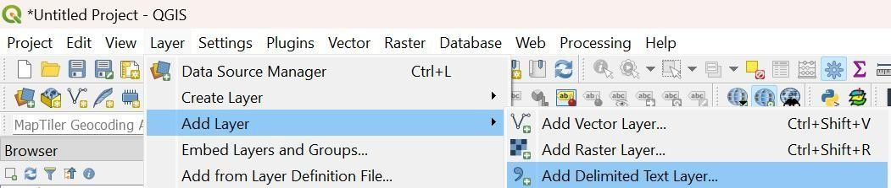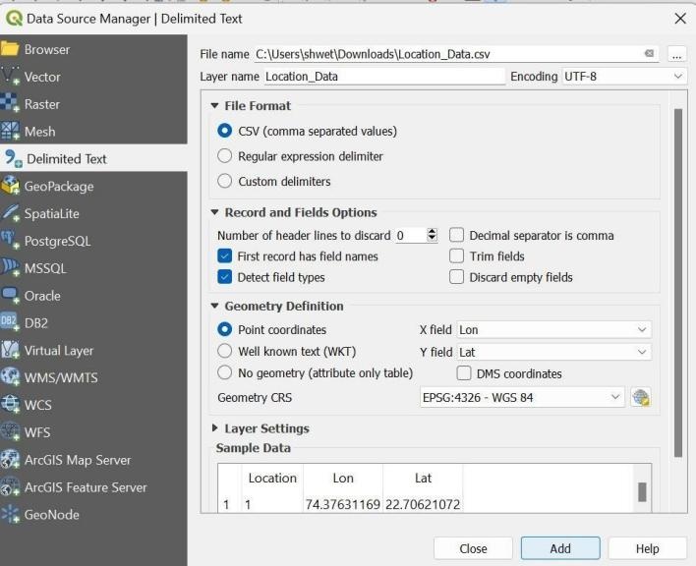

Click on add

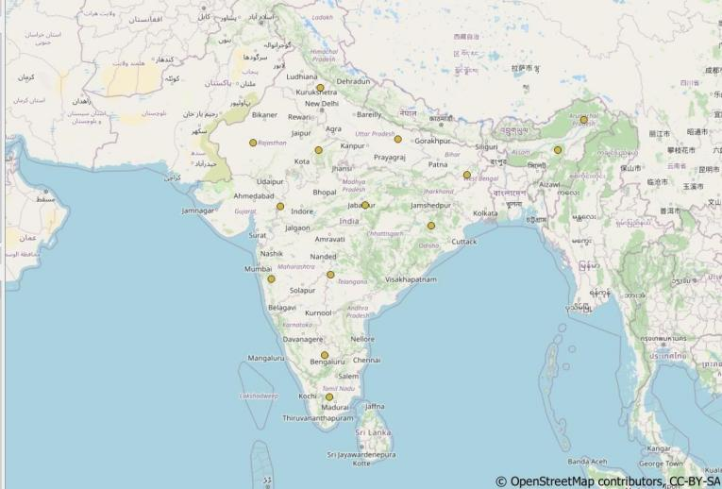

Step 4 : now for extract the location data we need to install mmqgis

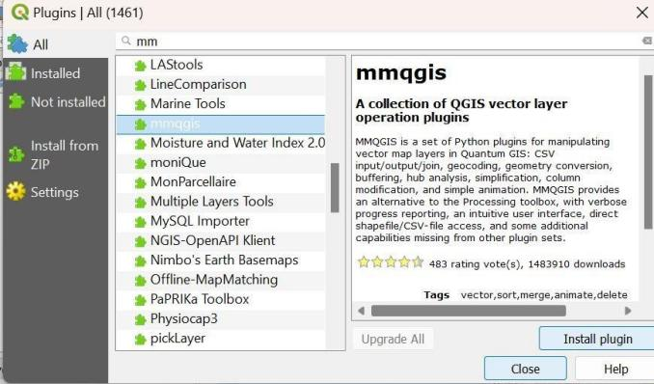

Step 5 : then click on MMQGIS then Geocode and then click on Reverse Geocode

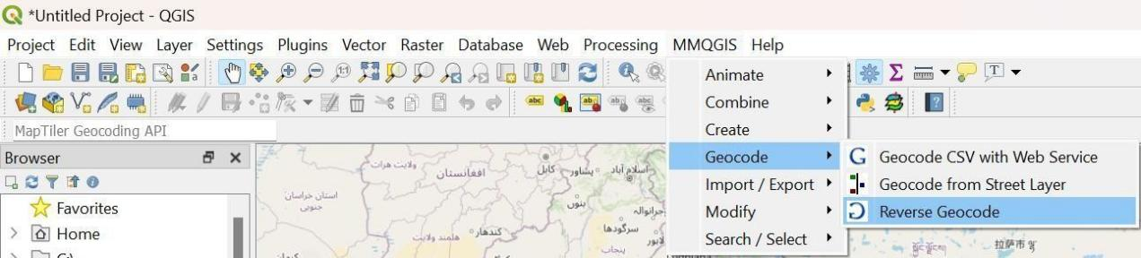

Step 6 : now save output file on your location

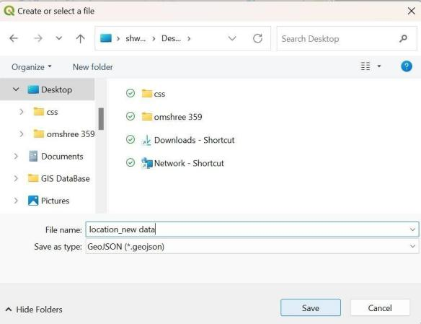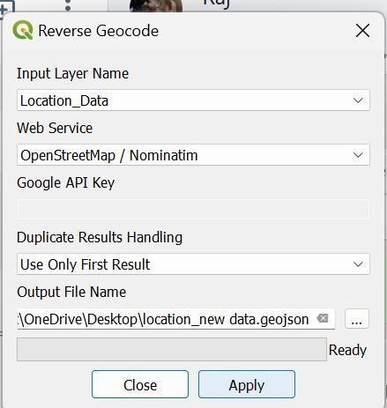

Step 7 : Right click on location _ new data and open attribute table

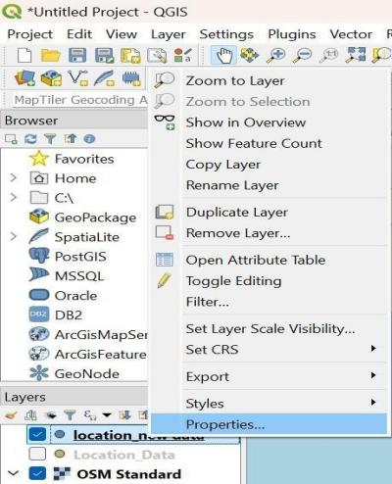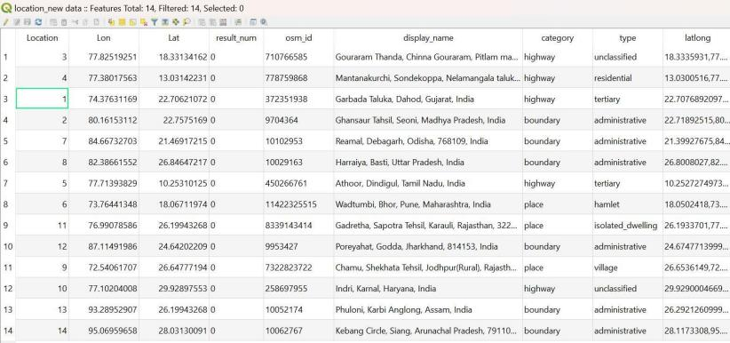

Step 8 : now go to MMGQIS and then import / export and then click on attributes to csv file

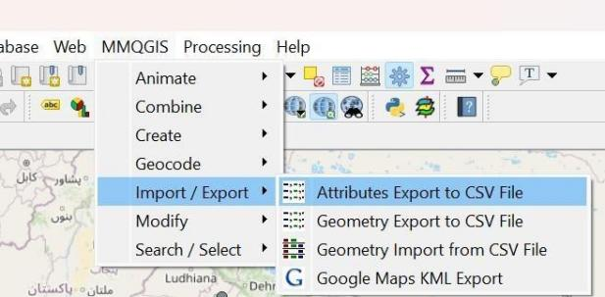

Step 9 : save file

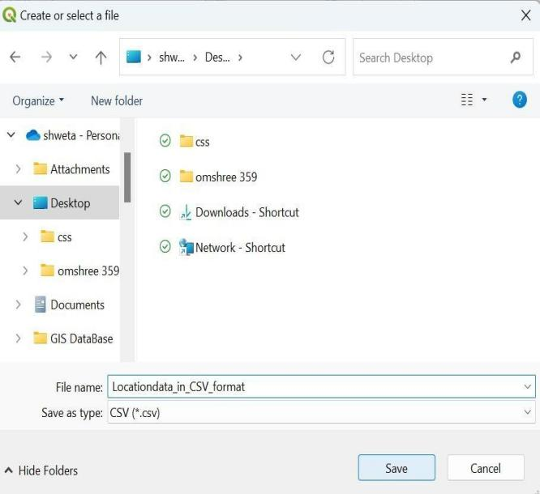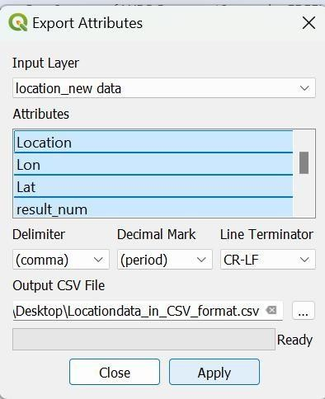

Step 10 : Now go on Location data _in_CSV file Step 11 : It will show the data

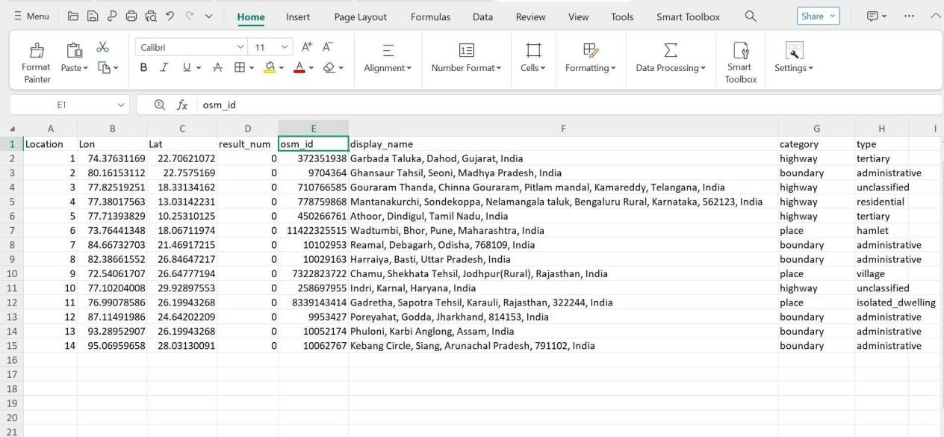

**Project Link : <https://editor.giscloud.com/map/2889273/gis-project>**

**Reference:**

Data set : <https://drive.google.com/file/d/17jXv4vf2CxdJ-QEW3gsY_iFVKPcw5bhf/view>

Github: <https://github.com/AmrutaSatpute18005/GIS-project/blob/main/gis%20project.qgz>

**Conclusion** : The above project has been implemented and executed successfully.