Selenium

Version No.: SELENIUM WEB DRIVER WITH COREJAVA
Date of Release: 05/02/2024

1.0 Introduction
Selenium automate web browser, that’s it! Selenium is a set of different software tools each with a different approach to supporting test automation. Most Selenium QA Engineers focus on the one or two tools that most meet the needs of their project, however learning all the tools will give you many different options for approaching different test automation problems. The entire suite of tools results in a rich set of testing functions specifically geared to the needs of testing of web applications of all types. These operations are highly flexible, allowing many options for locating UI elements and comparing expected test results against actual application behavior. One of Selenium’s key features is the support for executing one’s tests on multiple browser platforms.

1.1 History of Selenium
Selenium first came to life in 2004 when Jason Huggins was testing an internal application at Thought Works.
Being a smart guy, he realized there were better uses of his time than manually stepping through the same tests with every change he made. He developed a JavaScript library that could drive interactions with the page, allowing him to automatically rerun tests against multiple browsers. That library eventually became Selenium Core, which underlies all the functionality of Selenium Remote Control (RC) and Selenium IDE. Selenium RC was ground-breaking because no other product allowed you to control a browser from a language of your choice.
While Selenium was a tremendous tool, it wasn’t without its drawbacks. Because of its JavaScript based automation engine and the security limitations browsers apply to JavaScript, different things became impossible to do. To make things worse, webapps became more and more powerful over time, using all sorts of special features new browsers provide and making these restrictions more and more painful.
In 2006 a plucky engineer at Google named Simon Stewart started work on a project he called Web Driver. Google had long been a heavy user of Selenium, but testers had to work around the limitations of the product. Simon wanted a testing tool that spoke directly to the browser using the ‘native’ method for the browser and operating system, thus avoiding the restrictions of a sandboxed JavaScript environment. The Web Driver project began with the aim to solve the Selenium’ pain-points.
Jump to 2008. The Beijing Olympics mark China’s arrival as a global power, massive mortgage default in the United States triggers the worst international recession since the Great Depression, The Dark Knight is viewed by every human (twice), still reeling from the untimely loss of Heath Ledger. But the most important story of that year was the merging of Selenium and Web Driver.
Selenium had massive community and commercial support, but Web Driver was clearly the tool of the future. The joining of the two tools provided a common set of features for all users and brought some of the brightest minds in test automation under one roof. Perhaps the best explanation for why Web Driver and Selenium are merging was detailed by Simon Stewart, the creator of Web Driver, in a joint email to the Web Driver and Selenium community on August 6, 2009.
“Why are the projects merging?
Partly because Web Driver addresses some shortcomings in selenium (by being able to bypass the JS sandbox, for example. And we’ve got a gorgeous API), partly because selenium addresses some shortcomings in Web Driver (such as supporting a broader range of browsers) and partly because the main selenium contributors and I felt that it was the best way to offer users the best possible framework.”

Browser Compatibility
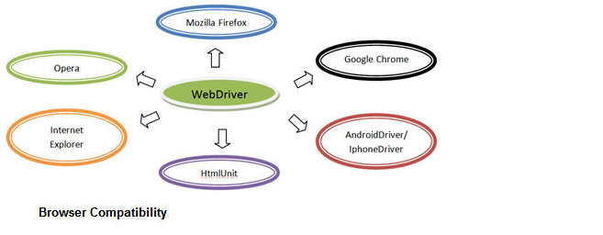
Web Driver supports diverse range of web browsers and their versions. It supports all the conventional browsers in addition to some unique and rare browsers like HtmlUnit browser unlike Selenium RC and Selenium IDE.
HtmlUnit Browser executes the test scripts analogous to other browsers except the fact that it runs in the headless mode i.e. GUI-less mode and the user won’t be able to view the test script execution. Said that the test script execution transpires in headless mode, thus the execution speed takes a roll and quickens the execution.
Web Driver also supports web based mobile testing. Thus it provides Android Driver and IPhone Driver to back web based mobile testing.
Note: Web Driver doesn’t readily support new browsers.
Language Support
Earlier in the sessions we learned to create scripts using record and playback functionality. We also saw how to create them manually using Selenese commands. While creating such test scripts, we come across various constraints.
Some of the limitations imposed by Selenium IDE are:
- Doesn’t support iterations and conditional statements
- Doesn’t support loops
- Doesn’t support error handling
- Doesn’t support test script dependency
The above impediments can be troubleshot programmatically. Web Driver facilitates the user to choose within the different programming languages and build their test script in the designated language.
Selenium Web Driver supported programming languages are:
- Java
- C#
- PHP
- Pearl
- Ruby
- Python
Thus the user can pick any one of the programming language (provided the language is supported by Web Driver) based on his/her competency and can start building test scripts.
Speed
When compared to other tools of Selenium suite, Web Driver turns out to be the fastest tool amongst all. The communication is not channelized via any external intervention; rather the tool directly communicates with the browser same as that of any user. Thus, Web Driver takes advantage of the browser’s native compatibility towards automation.

1.5 Selenium Environment Set Up
In order to develop Selenium RC or WebDriver scripts, users have to ensure that they have the initial configuration done. Setting up the environment involves the following steps.
- Download and Install Java
- Download and Configure Eclipse
- Configure FireBug and FirePath
- Configure Selenium RC
- Configure Selenium WebDriver

Download and Install Java
We need to have JDK (Java Development Kit) installed in order to work with Selenium WebDriver/Selenium. Let us see how to download and install Java.
Step 1 : Navigate to the URL:
http://www.oracle.com/technetwork/java/javase/downloads/index.html
Step 2 : Go to "Downloads" section and select "JDK Download".
Step 3 : Select "Accept License Agreement" radio button.
Step 4 : Select the appropriate installation. Click the appropriate link and save the .exe file to your disk.

Step 5 : Run the downloaded exe file to launch the Installer wizard. Click 'Next' to continue.
Step 6 : Select the features and click 'Next'.
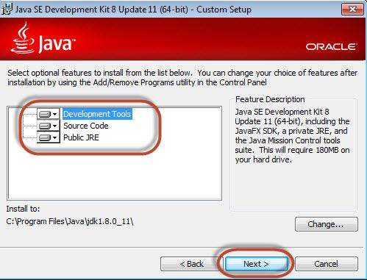
Step 7 : The installer is extracted and its progress is shown in the wizard.
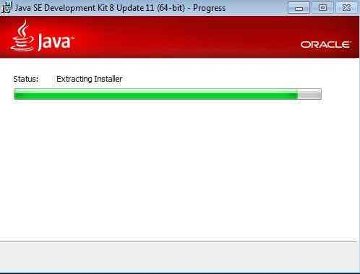

Step 8 : The user can choose the install location and click 'Next'.
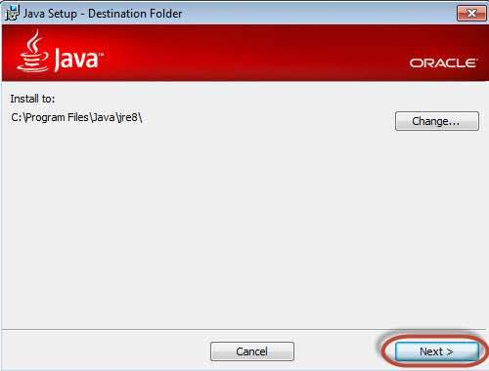
Step 9 : The installer installs the JDK and new files are copied across.
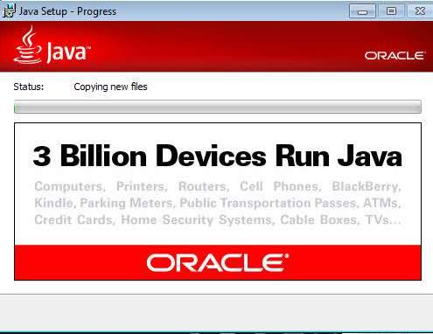
Step 10 : The Installer installs successfully and displays the same to the user.
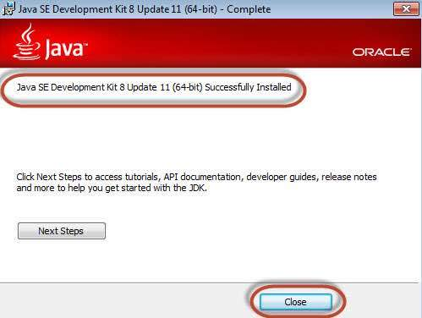
Step 11 : To verify if the installation was successful, go to the command prompt and just type 'java' as a command. The output of the command is shown below. If the Java installation is unsuccessful or if it had NOT been installed, it would throw an "unknown command" error.
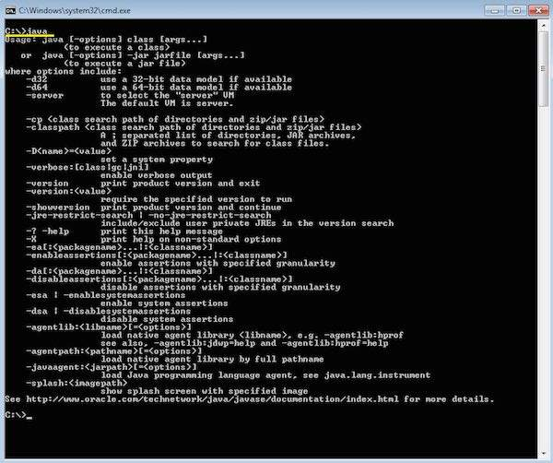

1.6 Download and Configure Eclipse
Step 1 : Navigate to the URL: http://www.eclipse.org/downloads/ and download the appropriate file based on your OS architecture.
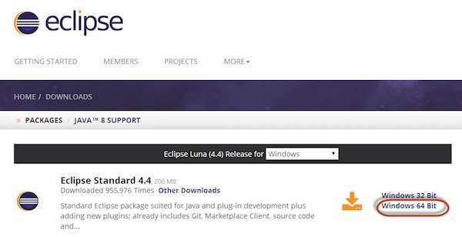
Step 2 : Click the 'Download' button.
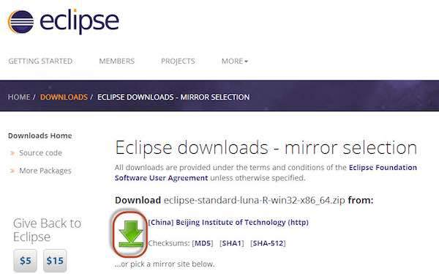
Step 3 : The download would be in a Zipped format. Unzip the contents.
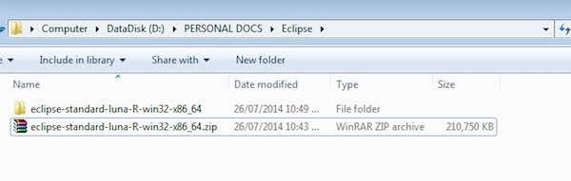
Step 4 : Locate Eclipse.exe and double click on the file.
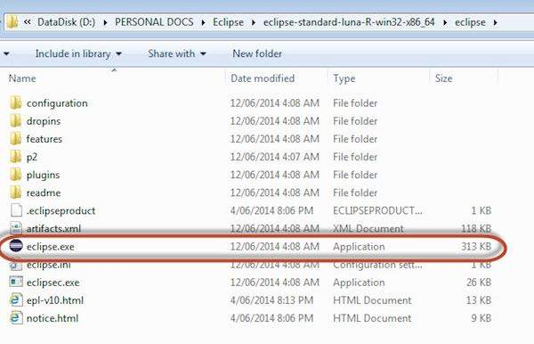
Step 5 : To configure the workspace, select the location where the development has to take place.
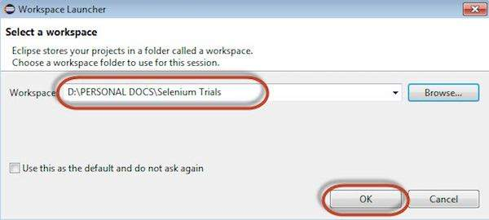
Step 6 : The Eclipse window opens as shown below.
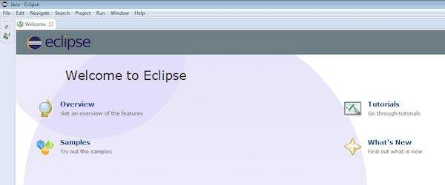

1.7 Configure FireBug and FirePath
To work with Selenium RC or WebDriver, we need to locate elements based on their XPath or ID or name, etc. In order to locate an element, we need tools/plugins.
Step 1 : Navigate to the URL : https://addons.mozilla.org/en-US/firefox/addon/firebug/ and download plugin.
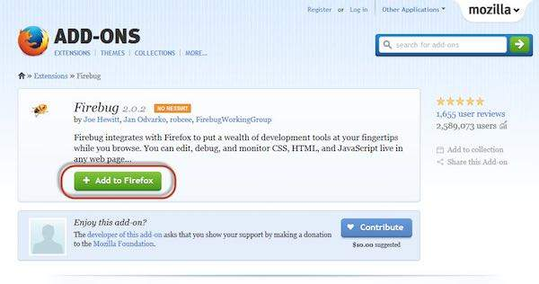
Step 2 : The add-on installer is shown to the user and it is installed upon clicking the 'Install' button.
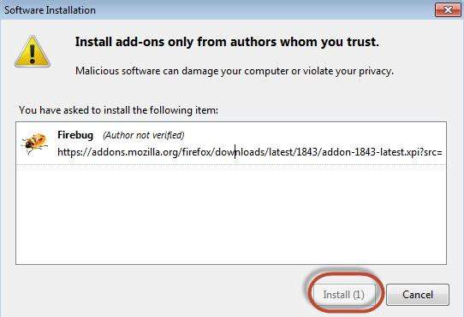
Step 3 : After installing, we can launch the plugin by navigating to "Web Developer" >> "Firebug".
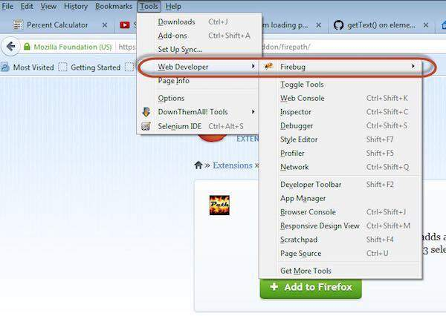
Step 4 : FirePath, a plugin that works within Firebug, helps users to grab the 'XPath' of an element. Install FirePath by navigating to "https://addons.mozilla.org/en-US/firefox/addon/firepath/"
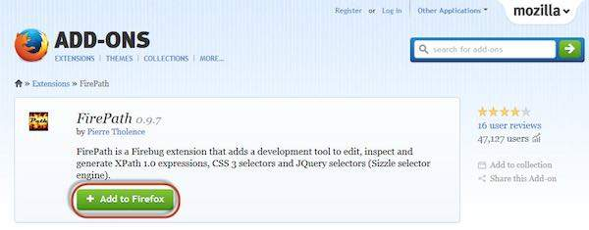
Step 5 : The add-on installer is shown to the user and it is installed upon clicking the 'Install' button.
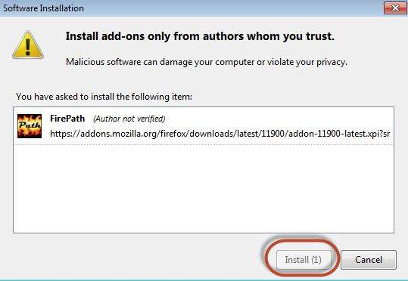
Step 6 : Now launch "Firebug" by navigating to "Tools" >> "Webdeveloper" >> "Firebug".
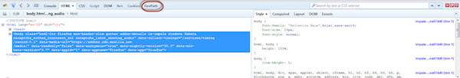

Example
Now let us understand how to use FireBug and FirePath with an example. For demonstration, we will use www.google.com and capture the properties of the text box of "google.com".
Step 1 : First click on the arrow icon as highlighted in the following screenshot and drag it to the object for which we would like to capture the properties. The HTML/DOM of the object would be displayed as shown below. We are able to capture the 'ID' of the input text box with which we can interact.
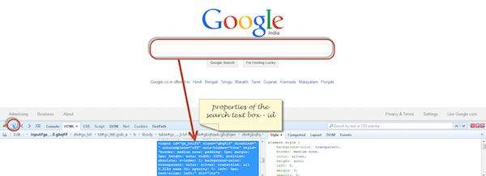
Step 2 : To fetch the XPath of the object, go to 'firepath' tab and perform the following steps.
- Click the Spy icon.
- Select the Control for which we would like to capture the XPath
- XPath of the selected control would be generated.
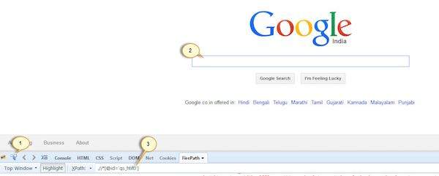

1.8 Configure Selenium RC
Now let us look at how to configure Selenium Remote control. We will understand how to develop scripts with Selenium RC in later chapters, however for now, we will understand just the configuration part of it.
Step 1 : Navigate to the Selenium downloads section http://www.seleniumhq.org/download/ and download Selenium Server by clicking on its version number as shown below.
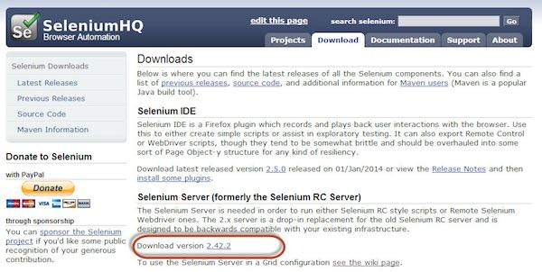
Step 2 : After downloading, we need to start the Selenium Server. To do so, open command prompt and navigate to the folder where the downloaded JAR file is kept as shown below.
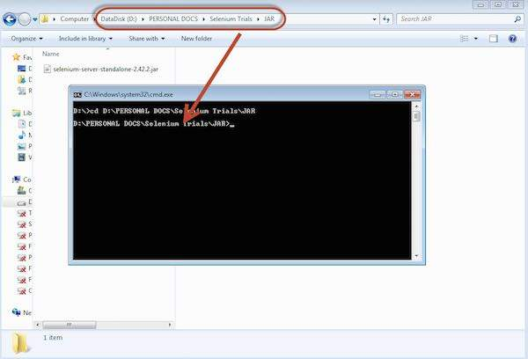
Step 3 : To start the server, use the command 'java -jar <<downloaded jar name >> and if java JDK is installed properly, you would get a success message as shown below. Now we can start writing Selenium RC scripts.
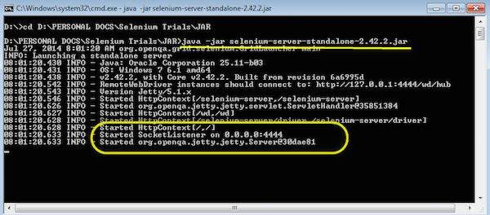

1.9 Configure Selenium WebDriver
Now let us look at how to configure Selenium WebDriver. We will understand how to develop scripts with Selenium WebDriver in later chapters, however for now, we will understand just the configuration part of it.
Step 1 : Navigate to the selenium downloads section http://www.seleniumhq.org/download/ and download Selenium WebDriver by clicking on its version number as shown below.
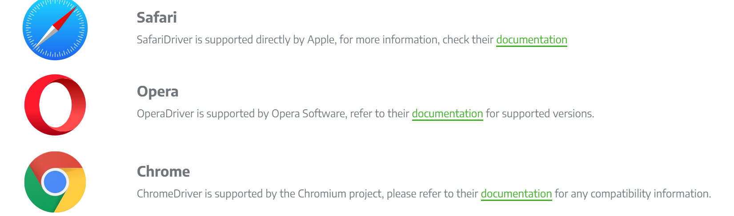
Step 2 : Click on the standalone jar file link from Download section of official website www.selenium.dev
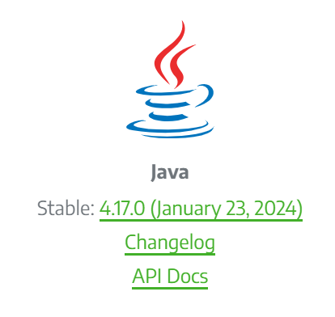

2.0 Points to be Remember:
- Selenium suite is comprised of 4 basic components; Selenium IDE, Selenium RC, WebDriver, Selenium Grid.
- WebDriver allows user to perform web based automation testing. WebDriver is a different tool altogether that has various advantages over Selenium RC.
- WebDriver supports a wide range of web browsers, programming languages and test environments.
- WebDriver directly communicates with the web browser and uses its native compatibility to automate.
- WebDriver’s support doesn’t only limits in the periphery of traditional user actions. Instead it supports efficient handling mechanisms for complex user actions like dealing with dropdowns, Ajax calls, switching between windows, navigation, handling alerts etc.
- WebDriver enables user to perform web based mobile testing. To support the same, WebDriver introduces AndroidDriver and IphoneDriver.
- WebDriver is faster than other tools of Selenium Suite because it makes direct calls to browser without any external intervention.

2.1 What is selenium

What is selenium webdriver
What is selenium webdriver and how it help us in software testing process?
Webdriver in selenium (http://docs.seleniumhq.org/projects/webdriver/) is an Interface and it is designed to overcome some limitations of selenium RC software testing tool. However selenium WebDriver's development is in process so still there are few limitations and known issues available in selenium WebDriver. Selenium WebDriver is also known as Selenium 2 and used for web as well mobile
applications testing. It is freeware software testing tool and mostly used as a regression testing tool for web and mobile applications.
Selenium 2 supports most of all browsers to run your test cases and many programming languages like C#, Java, Python, Ruby, .Net, Perl, PHP, etc.. to create and modify your test scripts. Selenium 2(WebDriver) controls browser directly from operating system level so it is interacting very fast and with more realistic way with browsers. Major people in world using Selenium webdriver with java.
Difference between WebDriver and selenium RC Software Testing Tools
WebDriver
- Selenium WebDriver software testing tool do not require selenium server for running test.
- WebDriver is using native automation from each and every supported language for running automation scripts on browsers.
- WebDriver supports web as well mobile application testing so you can test mobile applications (iPhone or Android).
- Supporting latest versions of almost all browsers.
- WebDriver controls the browser itself.
Selenium RC
- Required selenium server for running test.
- Selenium RC software testing tool is using JavaScripts to drive automation with browser.
- Selenium RC supports only web application testing.
- Supporting all browsers but not supporting latest versions.
- Selenium RC is using javascript to interact and operate on web page

1.3 Create And Run First Webdriver Script With Eclipse
Run First Webdriver Script
You need to install web driver with eclipse to run your script in webdriver. After installation of web driver software testing tool, you need to write a java code in eclipse for your test case of software web application. Let me give you one simple example of creating simple webdriver script for software web application. First of all you need to create the package called
"Testing Pack" under your project and then create new class file 'mytestclass.java' under that package. Now copy-paste bellow given code in your 'mytestclass.java' file.

To get the Current URL of the Application
Package co.in.quickitdotnet;

import org.openqa.selenium.WebDriver;
import org.openqa.selenium.firefox.FirefoxDriver;

public class mytestclass {

public static void main(String[] args) {
WebDriver driver = new FirefoxDriver();
driver.get("http://www.quickitdotnet.co.in ");
String i = driver.getCurrentUrl();
System.out.println(i);
driver.close();
}
}

Now you are ready to run your script from Run menu as shown bellow.
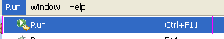

Script Explanation
Above script will
- open Firefox browser.
- Then driver.get syntax will open 'http://only-testing-blog.blogspot.in/' software application in firefox browser.
- Then driver.getCurrentUrl() will get the current page URL and it will be stored in variable 'i'. And at last, it will print value of variable in console as shown bellow.

1.4 - How to Maximize a firefox browser window using Selenium WebDriver

difference between single and double slash in X-path?
Single slash ‘/ ’
- Single slash ( / ) start selection from the document node
- It allows you to create ‘absolute’ path expressions
Double Slash ‘// ’
- Double slash ( // ) start selection matching anywhere in the document
- It enables to create ‘relative’ path expressions

By using driver.manage().window().maximize(); you will maximize the browser window

1.5 What is HTML?
As you know HTML Hyper Text Markup Language used for describing web pages. Each tag represents a document content. HTML contains tags with angle brackets like and plain text. There are two tags one is start tag and second tag is end tag. Every tag should end with a forward slash before the tag name.
Syntax:
<tagname>content here</tagname>
<html>
<head></head>
<body>
<h1>My First H1 Heading</h1>
<p>My first paragraph content goes here</p>
</body>
</html>
HTML tags determine to display the content to display on the web browser. The current version (At the time of writing) of HTML is version 5.
Now coming to our selenium, we generally see the below elements / attributes in any of the simple web page.
- Text-box
- Text-area
- link
- radio-buttons
- check-box
- drop-down / list-box
- table, Etc....
We can divide the elements in three ways:
1. Single Elements
2. Group Elements
3. Customized Elements
For Single elements, we can easily find out an locator to work with selenium. We can locate by ID or by Link or by Link Text.
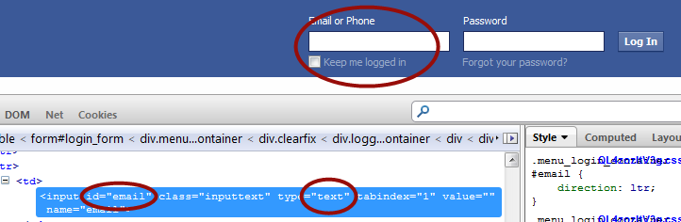
For Group elements, we should try to prefer name as identifier along with a combination of value or index property.
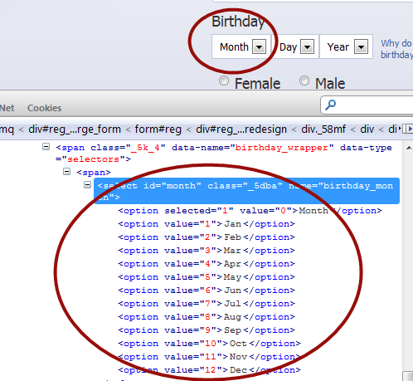
In the below screen shot, we can use name as "birthday_month" and value to select the particular month.

Locators for selenium
Selenium webdriver uses 8 locators to find the elements on web page. The following are the list of object identifier or locators supported by selenium.
We have prioritized the list of locators to be used when scripting.

id - >
Select element with the specified @id attribute.

Name
Select first element with the specified @name attribute.

Linktext
Select link (anchor tag) element which contains text matching the specified link text

Partial Linktext
Select link (anchor tag) element which contains text matching the specified partial link text

Tag Name
Locate Element using a Tag Name .

Class name
Locate Element using a Tag Name ..

Css
Select the element using css selectors. You can check here for Css examples and You can also refer W3C CSS Locatros

Xpath
Locate an element using an XPath expression.
Locating an Element By ID:
The most efficient way and preferred way to locate an element on a web page is By ID. ID will be the unique on web page which can be easily identified.
IDs are the safest and fastest locator option and should always be the first choice even when there are multiple choices, It is like an Employee Number or Account which will be unique.
Example 1:
<div id="toolbar">.....</div>
Example 2:
<input id="email" class="required" type="text"/>
We can write the scripts as
WebElement Ele = driver.findElement(By.id("toolbar"));
Unfortunately there are many cases where an element does not have a unique id (or the ids are dynamically generated and unpredictable like GWT). In these cases we need to choose an alternative locator strategy, however if possible we should ask development team of the web application to add few ids to a page specifically for (any) automation testing.
Locating an Element By Name:
When there is no Id to use, the next worth seeing if the desired element has a name attribute. But make sure there the name cannot be unique all the times. If there are multiple names, Selenium will always perform action on the first matching element
Example:
<input name="register" class="required" type="text"/>
WebElement register= driver.findElement(By.name("register"));
Locating an Element By LinkText:
Finding an element with link text is very simple. But make sure, there is only one unique link on the web page. If there are multiple links with the same link text (such as repeated header and footer menu links), in such cases Selenium will perform action on the first matching element with link.
Example:
<a href="http://www.seleniumhq.org">Downloads</a>
WebElement download = driver.findElement(By.linkText("Downloads"));
Locating an Element By Partial LinkText:
In the same way as LinkText, PartialLinkText also works in the same pattern.
User can provide partial link text to locate the element.
Example:
<a href="seleniumhq.org">Download selenium server</a>
WebElement download = driver.findElement(By.PartialLinkText("Download"));
Locating an Element By TagName:
TagName can be used with Group elements like , Select and check-boxes / dropdowns.
below is the example code:
Select select = new Select(driver.findElement(By.tagName("select")));
select.selectByVisibleText("Nov");
or
select.selectByValue("11");
Locating an Element By Class Name:
There may be multiple elements with the same name, if we just use findElementByClassName,m make sure it is only one. If not the you need to extend using the classname and its sub elements.
Example:
WebElement classtest =driver.findElement(By.className(“sample”));
CSS Selector:
CSS mainly used to provide style rules for the web pages and we can use for identifying one or more elements in the web page using css.
If you start using css selectors to identify elements, you will love the speed when compared with XPath. Check this for more details on Css selectors examples
We can you use Css Selectors to make sure scripts run with the same speed in IE browser. CSS selector is always the best possible way to locate complex elements in the page.
Example:
WebElement CheckElements = driver.findElements(By.cssSelector("input[id=email']"));
XPath Selector:
XPath is designed to allow the navigation of XML documents, with the purpose of selecting individual elements, attributes, or some other part of an XML document for specific processing
There are two types of xpath
  - Native Xpath:
It is like directing the xpath to go in direct way. like
Example:
html/head/body/table/tr/td
Here the advantage of specifying native path is, finding an element is very easy as we are mention the direct path. But if there is any change in the path (if some thing has been added/removed) then that xpath will break.
  - Relative Xpath.
In relative xpath we will provide the relative path, it is like we will tell the xpath to find an element by telling the path in between.
Advantage here is, if at all there is any change in the html that works fine, until unless that particular path has changed. Finding address will be quite difficult as it need to check each and every node to find that path.
Example:
//table/tr/td
Example Syntax to work with Image
xpath=//img[@alt='image alt text goes here']
Example syntax to work with table
xpath=//table[@id='table1']//tr[4]/td[2]
xpath=(//table[@class='nice'])//th[text()='headertext']/
Example syntax to work with anchor tag
xpath=//a[contains(@href,'href goes here')]
xpath=//a[contains(@href,'#id1')]/@class
Example syntax to work with input tags
xpath=//input[@name='name2' and @value='yes']
We will take and sample XML document and we will explain different methods available to locate an element using Xpath

How to find title of the web page?
- Always create method for business logic you need to implement
- Take xpath of title
- Compare Title with equal ignore case
package co.in.quickitdotnet;

import org.openqa.selenium.By;
import org.openqa.selenium.WebDriver;
import org.openqa.selenium.WebElement;
import org.openqa.selenium.firefox.FirefoxDriver;

public class Selenium_Example003 {

public static void main(String[] args) {
// TODO Auto-generated method stub
WebDriver driver = new FirefoxDriver();
driver.get("http://localhost/orangehrm/symfony/web/index.php/auth/login");
driver.manage().window().maximize();
checkTitle(driver);
//driver.quit();

}

public static void checkTitle(WebDriver driver)
{
WebElement e = driver.findElement(By.xpath("//*[@id='logInPanelHeading']"));
String title = e.getText();
if(title.equalsIgnoreCase("Login Panel"))
{
System.out.println("Title is present");
}else{
System.out.println("Error: Invalid Title");
}

}

}

How to check validation message for username and password
- Go to URL
- Take xpath of validation message of username or password
- Apply by if loop

package co.in.quickitdotnet;

import org.openqa.selenium.By;
import org.openqa.selenium.WebDriver;
import org.openqa.selenium.WebElement;
import org.openqa.selenium.firefox.FirefoxDriver;

public class Selenium_Example004 {

public static void main(String[] args) {
// check validation message
WebDriver driver = new FirefoxDriver();
driver.get("http://localhost/orangehrm/symfony/web/index.php/auth/login");
driver.manage().window().maximize();
checkMessage(driver);
//driver.quit();

}

public static void checkMessage(WebDriver driver)
{

WebElement e = driver.findElement(By.xpath("//*[@id='btnLogin']"));
e.click();
e = driver.findElement(By.xpath("//*[@id='spanMessage']"));
String title = e.getText();
if(title.equals("Username cannot be empty"))
{
System.out.println("Validation appeared ");
}else{
System.out.println("Error: Sorry validation does not match");
}

}

}

How to send strings of character in the input field of username
Sendkeys: Sending Special character(Enter , F5, Ctrl, Alt etc..) to webdriver from our script. This can be done by using sendKeys method itself. For this purpose we will use the Keys method as parameter to the sendKeys method.
SendKeys ()Example
driver.findElement(By.id("name")).sendKeys(Keys.F5);
//Sending arrow down key
driver.findElement(By.id("name")).sendKeys(Keys.ARROW_DOWN);
//sending pagedown key from keyboard

driver.findElement(By.id("name")).sendKeys(Keys.PAGE_DOWN);
//sending space key
driver.findElement(By.id("name")).sendKeys(Keys.SPACE);
//sending tab key
driver.findElement(By.id("name")).sendKeys(Keys.TAB);
•
• //sending alt key
• driver.findElement(By.id("name")).sendKeys(Keys.ALT);

package co.in.quickitdotnet;

import org.openqa.selenium.By;
import org.openqa.selenium.WebDriver;
import org.openqa.selenium.WebElement;
import org.openqa.selenium.firefox.FirefoxDriver;

public class Selenium_Example006 {

public static void main(String[] args) {
// check validation message for password
WebDriver driver = new FirefoxDriver();
driver.get("http://localhost/orangehrm/symfony/web/index.php/auth/login");
driver.manage().window().maximize();
login(driver);
driver.quit();

}

public static void login(WebDriver driver)
{
WebElement e = driver.findElement(By.id("txtUsername"));
e.sendKeys("admin");
e= driver.findElement(By.id("txtPassword"));
e.sendKeys("admin");
e= driver.findElement(By.name("Submit"));
e.click();

}

}
Selenium Webdriver Wait Command

ImplicitlyWait Command
Purpose: Selenium WebDriver has borrowed the idea of implicit waits from Watir. This means that we can tell Selenium that we would like it to wait for a certain amount of time before throwing an exception that it cannot find the element on the page. We should note that implicit waits will be in place for the entire time the browser is open. This means that any search for elements on the page could take the time the implicit wait is set for.
Implicitly wait Example
WebDriver driver => new FirefoxDriver();

driver.manage().timeouts().implicitlyWait(10, TimeUnit.SECONDS);

driver.get("http://url_that_delays_loading");

WebElement myDynamicElement = driver.findElement(By.id("myDynamicElement"));

Fluent Wait Command
Purpose: Each FluentWait instance defines the maximum amount of time to wait for a condition, as well as the frequency with which to check the condition. Furthermore, the user may configure the wait to ignore specific types of exceptions whilst waiting, such as NoSuchElementExceptions when searching for an element on the page.
Fluent Wait Example
// for its presence once every 5 seconds.

Wait wait = new FluentWait(driver)

.withTimeout(30, SECONDS)

.pollingEvery(5, SECONDS)

.ignoring(NoSuchElementException.class);

WebElement foo = wait.until(new Function() {

public WebElement apply(WebDriver driver) {

return driver.findElement(By.id("foo"));

}

});

Expected Conditions Command
Purpose: Models a condition that might reasonably be expected to eventually evaluate to something that is neither null nor false.

Explicitly wait Example
1  2  3 | WebDriverWait wait = new WebDriverWait(driver, 10);  WebElement element = wait.until(ExpectedConditions.elementToBeClickable(By.id(>someid>)));

PageLoadTimeout Command
Purpose: Sets the amount of time to wait for a page load to complete before throwing an error. If the timeout is negative, page loads can be indefinite.

1 | driver.manage().timeouts().pageLoadTimeout(100, SECONDS);

SetScriptTimeout Command
Purpose: Sets the amount of time to wait for an asynchronous script to finish execution before throwing an error. If the timeout is negative, then the script will be allowed to run indefinitely.
1 | driver.manage().timeouts().setScriptTimeout(100,SECONDS);

Sleep Command
Purpose: This is rarely used, as it always force the browser to wait for a specific time. Thread.Sleep is never a good idea and that’s why Selenium provides wait primitives. If you use them you can specify much higher timeout value which makes tests more reliable without slowing them down as the condition can be evaluated as often as it’s required.
1 | Thread.sleep(1000);
Handling KeyBoard Event and Mouse Event
In Webdriver, handling keyboard events and mouse events (including actions such as Drag and Drop or clicking multiple elements With Control key) are done using the advanced user interactions API . It contains Actions and Action classes which are needed when performing these events.
In order to perform action events, we need to use org.openqa.selenium.interactions.Actions class.
Here is the sample code to work with Action Class
// Configure the Action
Actions action = new Actions(driver);

// To click on the element
action.moveToElement(element).click().perform();
Note: We need to use perform() to execute the action.
Using Action API, keyboard interactions are simple to do with webdriver. In Advanced User Interactions API, interaction with element is possible either by clicking on element or sending a Keys using sendKeys()
To use mouse actions, we need to use current location of the element and then perform the action.
The following are the regularly used mouse and keyboard events :
Method : clickAndHold()
Purpose: Clicks without releasing the current mouse location
Method : contentClick()
Purpose: Performs a context-click at the current mouse location.
Method: doubleClick()
Purpose: Performs a double click at the current mouse location
Method: dragAndDrop(source,target)
Parameters: Source and Target
Purpose: Performs click and hold at the location of the source element and moves to the location of the target element then releases the mouse.
Method : dragAndDropBy(source,x-offset,y-offset)
Parameters: Source, xOffset - horizontal move, y-Offset - vertical move Offset
Purpose: Performs click and hold at the location of the source element moves by a given off set, then releases the mouse.
Method: keyDown(modifier_key)
Parameters: Modifier_key (keys.ALT or Keys.SHIFT or Keys.CONROL)
Purpose: Performs a modifier key press, doesn't release the modifier key. Subsequent interactions may assume it's kept pressed
Method: keyUp(modifier_key)
Parameters: Modifier_key (keys.ALT or Keys.SHIFT or Keys.CONROL)
Purpose: Performs a key release.
Method: moveByOffset(x-offset, y-offset): Parameters: X-Offset , Horizontal offset, a negative value means moving the mouse to left side.
Y-Offset, vertical offset, a negative value means moving the mouse to up.
Purpose: Moves the mouse position from its current position by the given offset.
Check for the example here Resizing a web element using movebyoffset
Method: moveToElement(toElement)
Parameters: toElement - Element to Move to
Purpose: It moves the Mouse to the middle of the element.
Method: release()
Purpose: It releases the left mouse button at the current mouse location.
Method: sendKeys(onElement, charSequence)
Parameters: onElement, which will receive the keyStrokes, usually text field.
charsequence- any string value representing the sequence of keyStrokes to be sent.
Purpose: It sends a series of keyStrokes onto the element

MouseHover Example
4.0 Checkbox is selected Functionality
Webdriver Select method to work with dropdowns
WebDriver’s support classes called “Select”, which provides useful methods for interacting with select options. User can perform operations on a select dropdown and also de-select operation using the below methods.

Method Name: selectByIndex
Syntax: select.selectByIndex(Index);
Purpose: To Select the option based on the index given by the user.
There is an attribute called "values" which will have the index values.

Method Name: selectByValue
Syntax: select.selectByValue(Value);
Purpose: To Select the options that have a value matching with the given argument by the user.

Method Name: selectByVisibleText
Syntax: select.selectByVisibleText(Text);
Purpose: To Select all options that display text matching the given argument. It will not look for any index or value, it will try to match the VisibleText (which will display in dropdown)

Method Name: deselectByIndex
Syntax: select.deselectByIndex(Index);
Purpose: To Deselect the option at the given index. The user has to provide the value of index.

Method Name: deselectByValue
Syntax: select.deselectByValue(Value);
Purpose: To Deselect all options that have a value matching the given argument.

Method Name: deselectByVisibleText
Syntax: select.deselectByVisibleText(Text);
Purpose: To Deselect all options that display text matching the given argument.

Method Name: deselectAll
Syntax: select.deselectAll();
Purpose: To Clear all selected entries. This works only when the SELECT supports multiple selections. It throws NotImplemented eError if the "SELECT" does not support multiple selections. In select it mandatory to have an attribute multiple="multiple"
Dropdown Example with Select
package co.in.quickitdotnet;

import java.util.List;
import java.util.concurrent.TimeUnit;

import org.openqa.selenium.By;
import org.openqa.selenium.WebDriver;
import org.openqa.selenium.WebElement;
import org.openqa.selenium.firefox.FirefoxDriver;
import org.openqa.selenium.support.ui.Select;

public class Selenium_Example014 {

public static void main(String[] args) {
// TODO Auto-generated method stub

WebDriver driver = new FirefoxDriver();
driver.get("http://localhost/orangehrm/symfony/web/index.php/admin/listMailConfiguration");
driver.manage().window().maximize();
login(driver);
edit(driver);
dropdown(driver);

}

public static void login(WebDriver driver)
{
WebElement e = driver.findElement(By.id("txtUsername"));
e.sendKeys("admin");
e= driver.findElement(By.id("txtPassword"));
e.sendKeys("admin");
e= driver.findElement(By.name("Submit"));
e.click();

}
public static void edit(WebDriver driver) {

WebElement e = driver.findElement(By.xpath("//*[@id='editBtn']"));

driver.manage().timeouts().implicitlyWait(10, TimeUnit.SECONDS);
e.click();
}

public static void dropdown(WebDriver driver) {

WebElement e = driver.findElement(By.xpath("//*[@id='emailConfigurationForm_cmbMailSendingMethod']"));
Select sec = new Select(e);

sec.selectByIndex(1);
System.out.println(sec.getFirstSelectedOption().getText());
//sec.deselectByVisibleText("SMTP");
//System.out.println(sec.getFirstSelectedOption().getText());
sec.selectByValue("sendmail");
System.out.println(sec.getFirstSelectedOption().getText());
List<WebElement> li = sec.getOptions();

for(int i=0; i<li.size(); i++)
{
System.out.println("Text is:"+li.get(i).getText());
System.out.println("Value is" +li.get(i).getAttribute("value"));
}

}

}

Handling Web tables, iframe and dynamic elements
3 different topics and their handling mechanisms in selenium script.
- Web Tables/HTML tables
- Frames
- Dynamic elements

#1) Web Tables/HTML Tables
In this module we will learn about the web tables or html tables in a web page, tags available in html and how to handle web tables dynamically.
Web tables are basically group of elements that are logically stored in a row and column format. It is used to organize similar information in a web page.
Below is an example of Html table:
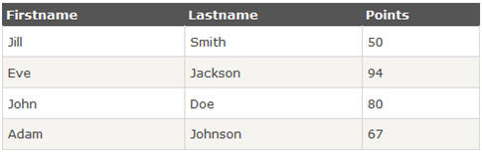
Below is the snippet of html structure of an html table:
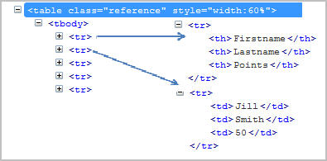
Below tags are generally defined in an html tables:
1.’table’ tag defines html table.
2.’tbody’ tag defines container for rows and columns.
3.’tr’ defines rows in an html table.
4.’td’/’th’ define column of an html table.
Find the details of a web table:
There are many ways we can handle a web table.
Approach #1:
Below is the xpath of one of the cell in html table. Let’s say “firstname”
//div[@id=’main’]/table[1]/tbody/tr[1]/th[1]
tr[1] defines first row and th[1] defines first column.
If number of rows and columns are always constant, let’s say our html table will always have 5 rows and 3 columns.
1 | for(int numberOfRows=1; numberOfRows<=5; numberOfRows++)
2 | {

3 | for(int numberOfCol=1; numberOfCol <=3; numberOfCol++)
4 | {

5 | System.out.println(driver.findElement(By.xpath(“//div[@id='main']/table[1]/tbody/tr[“+numberOfRows+”]/th[“+numberOfCol+”]”)));
6 |  | }

7 | }

Except row and column number, each component of xpath remains the same. So you can iterate using “for loop” for each row and column as mentioned above.
Approach #2:
First approach is best suitable for the table which doesn’t change its dimensions and always remains the same. Above approach will not be a perfect solution for dynamically changing web tables.
Let’s take above html table as an example:
1 | WebElement htmltable=driver.findElement(By.xpath("//*[@id='main']/table[1]/tbody"));
2 | List<WebElement> rows=htmltable.findElements(By.tagName("tr"));

3
4 | for(int rnum=0;rnum<rows.size();rnum++)

5 | {
6 | List<WebElement> columns=rows.get(rnum).findElements(By.tagName("th"));

7 | System.out.println("Number of columns:"+columns.size());
8

9 | for(int cnum=0;cnum<columns.size();cnum++)
10 |  | {

11 | System.out.println(columns.get(cnum).getText());
12 | }

13 | }
Step 1: First get the entire html table and store this in a variable ‘htmltable’ of type web element.
Step 2: Get all the rows with tag name ‘tr’ and store all the elements in a list of web elements. Now all the elements with tag ‘tr’ are stored in ‘rows’ list.
Step 3: Loop through each row and get the list of elements with tag ‘th’. ‘rows.get(0)’ will give first row and ‘findElements(By.tagName(“th”))’ will give list of columns for the row.
Step 4: Iterate using ‘columns.getsize()’ and get the details of each cell.
Note: Above approach will be best suitable if the table dimensions changes dynamically.
This concludes the topic how to handle web tables in selenium. Next we will learn about handling an element inside frame.

#2) Frames:
In this section we will learn about the frames in a web page and how to identify the frames. Also we will find out how we can handle a frame in selenium WebDriver.
Many developers like to place elements inside frame. Frame is just like a container where few elements can be grouped.
Identification of a frame:
Different ways to know if the element is present inside a frame or not
#1. Right click on the element. Check if “This Frame” option is available. If This frame option is available, it means that the element is inside a frame.
#2. View page source of the web page and check if any tag is available for ‘iframe’.
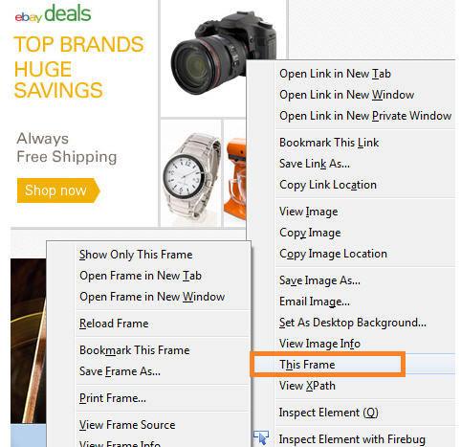
Verify Number of frames in a webpage:
All the frames are having tag name as “iframe”.
List<WebElement> frameList=driver.findElements(By.tagName(“iframe”));
System.out.println(frameList.size());
In above example: frameList will have all the list of frames and frameList.size() will give the number of frames.
Handling an element inside frame:
If an element is inside a frame then control has to switch to frame first and then start operating on the elements.
Step 1: To switch inside a frame:
driver.switchTo().frame(1); //pass frame number as parameter.
or
driver.switchTo().frame(“frame Name”); //pass frame name as parameter.
or
driver.switchTo().frame(“xpath of the frame”);
Step 2: After switching inside a frame selenium will be able to operate on elements.
driver.findElement(//*[@id=’username’]).sendKeys(“username”);
driver.findElement(//*[@id=’pass’]).sendKeys(“password”);
Here, we have learned how to handle an element inside frame and next we will cover about the different ways to handle dynamic element.

#3) Dynamic elements:
In this section we will learn different ways to handle dynamic element and construct generic Xpath.
In few scenarios, element attributes change dynamically. It can be ‘id’, ’name’ etc.
Example: let’s say ‘id’ of a username field is ‘username_123’ and the xpath will be
//*[@id=’username_123′] but when you open the page again the ‘id’ of ‘username’ field might have changed and the new value may be ‘username_234’.
In this case the test will fail because the selenium could not find the xpath you have passed earlier as the id of the field has changed to some other value.
There are many approaches depending upon the type of problem:
Problem Type 1: If part of the attribute value changes.
Example: As in the above example, id value changes but few fields remains constant.
‘username_123’ changed to ‘username_234’ but ‘username’ always remained constant.
You can construct xpath as below:
driver.findElement(By.xpath(“//*[contains(@id,’username’)]”)).sendKeys(“username”);
driver.findElement(By.xpath(“//*[starts-with(@id,’user’)]”)).sendKeys(“username”);
‘contains’ is a java method which checks if id contains the substring username.
starts-with() checks if any attribute starts with “user”.
Problem Type 2: If entire value of the attribute changes dynamically.
Again in this case, there could be different approaches:
gain in this case, there could be different approaches:
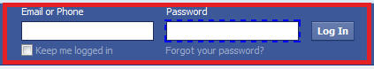
For example: if id of ‘login’ field changes dynamically and there is no constant value to use contains method.
Solution: Use of sendKeys.
Selenium provides different api to use function keys. For example tab key, enter keys, F5 etc.
Step 1: Enter password
driver.findElement(By.id(“password”)).sendKeys(“password”));
Step 2: Use key functions to navigate to element.
driver.findElement(By.id(“password”)).sendKeys(Keys.ENTER));
or
driver.findElement(By.id(“password”)).sendKeys(Keys.TAB));
Handling Date / Time Picker Through Selenium
For DateTime selection, HTML5 has a new of control shown below.
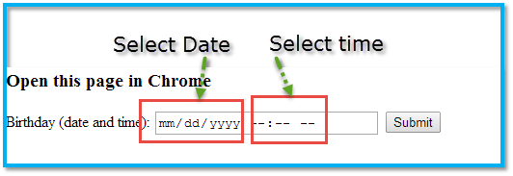
If we see the DOM of the DateTime Picker control, there will be only one input box for both date , time.
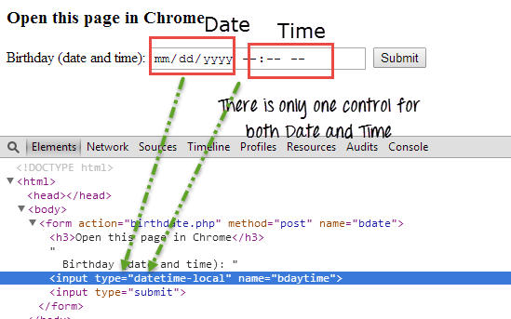
So to handle this type of control first we will fill date with separating with delimiter, i.e. if date is 09/25/2013, then we will pass 09252013 to the input box. Once done, we will shift focus from date to time by pressing 'tab' & fill time.
If we need to fill 02:45 PM , we will pass it a '0245PM' to the same input box.
Date Time Example
import java.util.List;

import java.util.concurrent.TimeUnit;

import org.openqa.selenium.By;

import org.openqa.selenium.Keys;

import org.openqa.selenium.WebDriver;

import org.openqa.selenium.WebElement;

import org.openqa.selenium.chrome.ChromeDriver;

import org.testng.annotations.Test;

public class DateTimePicker {

@Test

public void dateTimePicker(){

System.setProperty("webdriver.chrome.driver", "chromedriver.exe");

WebDriver driver = new ChromeDriver();

driver.manage().timeouts().implicitlyWait(10, TimeUnit.SECONDS);

driver.get("http://demo.guru99.com/selenium");

//Find the date time picker control

WebElement dateBox = driver.findElement(By.xpath("//form//input[@name='bdaytime']"));

//Fill date as mm/dd/yyyy as 09/25/2013

dateBox.sendKeys("09252013");

//Press tab to shift focus to time field

dateBox.sendKeys(Keys.TAB);

//Fill time as 02:45 PM

dateBox.sendKeys("0245PM");

}

}

Uploading File with Selenium

There are different ways to handle file uploads with Selenium Webdriver.
The First and the Easy way is simple case of just finding the element and typing the absolute path of the document into it.
HTML code should look similar to this :
<input type="file" name="datafile">
Syntax:
//Find the element of upload button and send the path
WebElement element= driver.findElement(By.name("datafile"));
element.sendKeys("C:\Users \testfile.txt");
NOTE: This works only when the textbox is enabled. So please make sure that the input element is visible.
The OTHER WAY to Handle File Upload
What If there is no text box / input tag to send the file path using Sendkeys method????
You will have only a button (Customized button) and when click on browse button, browser opens a window popup and to select the file from windows, And as we know selenium will not support OS controls.
We can use AutoIt tool (open source tool) which takes the responsibility to upload the file.
About AutoIT : AutoIt v3 is a freeware BASIC-like scripting language designed for automating the Windows GUI and general scripting.
We need to call the AutoIt script after clicking on the upload button. Immediatly ater clicking on Upload button, the control should be transfered to AutoIt which takes care of uploading the file.
Syntax:
Runtime.getRuntime().exec("AutoIt .exe filepath");
Download and Install Autoit tool from Download AutoIt
Example:
Runtime.getRuntime().exec("D:/fileupload.exe");
AutoIt script should have the following:
Step 1 : First After clicking on 'Upload' button, the cursor will move to the Window popup.
The below step should be the first line in the script. 'File Upload' is the name of the window popup when opened with Mozilla. The name changes depending on the browser.
Mozilla - File Upload
Chrome - Open
and for IE - Choose File to Upload
WinWaitActive("File Upload")
Step 2 : Once the window popup is active, we should send the path of the document which need to be uploaded.
Send("Full path of the document")
Step 3 : After that we need to click on Open button which will upload the document.
Send("{ENTER}")

Navigation Methods in Webdriver with Examples

Navigate.To(URL)
Method Name: navigate.to(URL)
Syntax: driver.navigate().to(URL);
Purpose: This methods Load a new web page in the current browser window. This is done using an HTTP GET operation, and the method will block until the load is complete.
Parameters: URL – It should be a fully qualified URL.
Example:
@Test
public void navigationToURLExample()
{

driver= new FirefoxDriver();
driver.navigate().to("http://www.google.com");
}

Navigate.To(String)
Method Name: navigate.to(String)
Syntax: driver.navigate().to(String);
Purpose: This methods Load a new web page in the current browser window. It is an Overloaded version of to(String) that makes it easy to pass in a URL.
Parameters: URL String
Example:

@Test
public void navigationToStringExample()
{
driver= new FirefoxDriver();
String URL="http://www.facebook.com";
driver.navigate().to(URL);
}

Navigate.Back()
Method Name: navigate().back()
Syntax: driver.navigate().back();
Purpose: To move back a single "item" in the web browser's history. And it will not perform any action if you are on the first page viewed.
Parameters: N/A
Example:
@Test
public void navigationBackExample()
{
driver= new FirefoxDriver();
String URL="http://www.facebook.com";
driver.navigate().to(URL);
driver.findElement(By.linkText("Forgot your password?")).click();
driver.navigate().back();
}
In the above example, to work with navigate back method, we atleast need to travel to one single page in the browser history.
The first page we have opened is facebook.com page and then traveled to forgot password page. Now the browser has two pages in the history. If we now use navigate.back(), it will redirect the user to facebook.com page.

Navigate.Forward()
Method Name: navigate().forward()
Syntax: driver.navigate().forward();
Purpose: To move a single "item" forward in the web browser's history. And it will not perform any action if we are on the latest page viewed.
Parameters: N/A
Example:
@Test
public void navigationForwardExample()
{
driver= new FirefoxDriver();
String URL="http://www.facebook.com";
driver.navigate().to(URL);
driver.findElement(By.linkText("Forgot your password?")).click();
driver.navigate().back();
Thread.sleep(1000);
driver.navigate().forward();
}
In the above example, to work with navigate forward method, we atleast need to travel to one or multiple pages in the browser history.
The first page we have opened is facebook.com page and then traveled to forgot password page. Now the browser has two pages in the history. If we now use navigate.back(), it will redirect the user to facebook.com page.
And now again if we navigate.forward(), it will redirect the user to forgot password page.

Navigate.Refresh()
Method Name: navigate().refresh()
Syntax: driver.navigate().refresh();
Purpose: It refreshes the current web page
Parameters: N/A
Example:

public void navigationRefreshExample()
{
driver= new FirefoxDriver();
String URL="http://www.facebook.com";
driver.navigate().to(URL);
driver.findElement(By.linkText("Forgot your password?")).click();
driver.findElement(By.id("identify_email")).sendKeys("sample@email.com");
driver.navigate().refresh();
}
Below is the sample code to perform page refresh using Action Driver class
@Test
public void testRefreshPage() {

driver= new FirefoxDriver();
driver.navigate().to("http://google.com");
Actions actions = new Actions(driver);
actions.keyDown(Keys.CONTROL).sendKeys(Keys.F5).perform();
}
There are few scenarios where we need to check if the data is getting cleared once when the page refreshes. And for few websites , it will display an alert when the user tries to refresh the page without saving the form which user has entered data.
In the above example, we are just refreshing the web page after entering the values using sendkeys().

Handling cookies in webdriver
Selenium webdriver can perform required task with respect to browser cookies. We add , delete, delete particular cookie by passing the name, and so on. Let us look all of the in details.
First let us see how add cookie works:
Add Cookie
Method Name: addCookie(Cookie cookie)
Syntax:driver.manage().addCookie(arg0);
Purpose: To add a specific cookie into cookies. If the cookie's domain name is left blank, it is assumed that the cookie is meant for the domain of the current document.
Parameters: cookie - The name of the cookie to add.
Click here for example program
Delete Cookie
Method Name: deleteCookie(Cookie cookie)
Syntax: driver.manage().deleteCookie(arg0);
Purpose: Delete a cookie from the browser's "cookie jar". The domain of the cookie will be ignored.
Parameter: Cookie
Click here for example program
Delete Cookie with Name
Method Name: deleteCookieNamed(java.lang.String name)
Syntax: driver.manage().deleteCookieNamed(arg0);
Purpose: Delete the named cookie from the current domain. This is equivalent to setting the named cookie's expiry date to sometime in the past.
Parameters: name - The name of the cookie to delete
Click here for example program
Delete All Cookies
Method Name: deleteAllCookies()
Syntax: driver.manage().deleteAllCookies();
Purpose: It will delete all the cookies for the current domain.
Parameters: N/A
Click here for example program
Get Cookies
Method Name: getCookies()
Syntax: driver.manage().getCookies();
Purpose: Get all the cookies for the current domain. This is the equivalent of calling "document.cookie" and parsing the result.
Returns: A Set of cookies for the current domain.
Get the Cookie with Specific Name
Method Name: getCookieNamed(java.lang.String name)
Syntax: driver.manage().getCookieNamed(arg0);
Purpose: To Get a cookie with a given name.
Parameters: name - the name of the cookie
Returns: It will return the cookie value for the name specified, or null if no cookie found with the given name
Using webdriver we can easily pass the cookie to the domain. In order to pass cookie, we should use a method named "addCookie(cookie)"
Method Name: addCookie(Cookie cookie)
Syntax:driver.manage().addCookie(arg0);
Purpose: To add a specific cookie into cookies. If the cookie's domain name is left blank, it is assumed that the cookie is meant for the domain of the current document.
Parameters: cookie - The name and value of the cookie to be add.
Example:
@Test
public void addCookie()
{
driver= new FirefoxDriver();
String URL="http://flipkart.com/";
driver.navigate().to(URL);
//we should pass name and value for cookie as parameters
// In this example we are passing, name=mycookie and value=123456789123
Cookie name = new Cookie("mycookie", "123456789123");
driver.manage().addCookie(name);

// After adding the cookie we will check that by displaying all the cookies.
Set<Cookie> cookiesList = driver.manage().getCookies();
for(Cookie getcookies :cookiesList) {
System.out.println(getcookies );
}
}
The output looks like below. We can see the added cookie along with the other cookies of the domain.
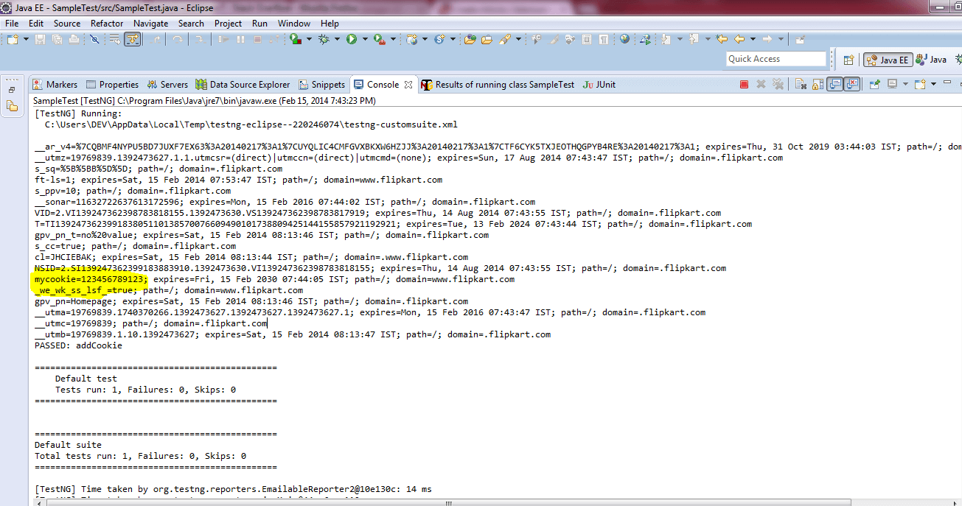
Delete Cookie
Delete Cookie with Name
Delete All Cookies
User can delete a cookie from the browser's "cookie jar". The domain of the cookie will be ignored.
User can delete the named cookie from the current domain. This is equivalent to setting the named cookie's expiry date to sometime in the past.
User can also delete all the cookies for the current domain using driver.manage().deleteAllCookies();
Example:
Deleting the specific cookie with cookie name "--utmb"
@Test
public void deleteCookieNamedExample()
{
driver= new FirefoxDriver();
String URL="http://www.flipkart.com";
driver.navigate().to(URL);
driver.manage().deleteCookieNamed("__utmb");
}
Deleting all the cookies of the domain
@Test
public void deleteAllCookiesExample()
{
driver= new FirefoxDriver();
String URL="http://www.flipcart.com";
driver.navigate().to(URL);
driver.manage().deleteAllCookies();
}
WebDriver Methods:

We will look in detail for each of the webdriver methods that we have. The first that we use is 'driver.get(url)' after starting the browser.
When we get the driver object, the below are the methods that we can perform operation on a driver. In IDE like eclipse, when we enter driver. and click on space bar, it will show all the below methods.
get()
getCurrentUrl();
getTitle()
findElements()
findElement()
getPageSource()
close()
quit()

Method Name :- get()
Syntax: get(url)
Example: driver.get();
Purpose: It will load a new web page in the current browser window. This is done using an http get operation, and the method will block until the load is complete.
Parameters: URL - The URL to load and it should be a fully qualified URL

Method Name: getCurrentUrl()
Syntax: getCurrentUrl()
Example: driver.getCurrentUrl();
Purpose: Gets a string representing the current URL that the browser is opened.
Returns: The URL of the page currently loaded in the browser

Method Name: getTitle()
Syntax: getTitle()
Example: driver.getTitle();
Purpose: Gets the title of the current web page.
Returns: The title of the current page, with leading and trailing white space stripped, or null if one is not already set

Method Name: findElements()
Syntax: findElements(By by)
Example: driver.findElements(By.xpath("//");
Purpose: Find all elements within the current page using the given mechanism.
Parameters: By - The locating mechanism to use
Returns: A list of all WebElements, or an empty list if nothing matches

Method Name: findElement()
Syntax: WebElement findElement(By by)
Example: driver.findElements(By.xpath("//");
Purpose: Find the first WebElement using the given method.
Parameters: By - The locating mechanism
Returns: The first matching element on the current page
Throws: NoSuchElementException - it will return exception if no matching elements are found

Method Name: getPageSource()
Syntax: getPageSource()
Example: driver.getPageSource();
Purpose: Get the source of the currently loaded page. If the page has been modified after loading (for example, by Javascript) there is no guarantee that the returned text is that of the modified page.
Returns: The source of the current page

Method Name: close()
Syntax: void close()
Example: driver.close();
Purpose: Close the current window, if there are multiple windows, it will close the current window which is active and quits the browser if it's the last window opened currently.

Method Name: quit()
Syntax: void quit()
Example: driver.quit();
Purpose: Quits this driver instance, closing every associated window which is opened.

Method Name: getWindowHandles()
Syntax: Set getWindowHandles()
Example: driver.getWindowHandles();
Purpose: Return a set of window handles which can be used to iterate over all the open windows of this Webdriver instance by passing them to switchTo().WebDriver.Options.window()
Returns: A set of window handles which can be used to iterate over all the open windows.

Method Name: getWindowHandle()
Syntax: String getWindowHandle()
Example: driver.getWindowHandle();
Parameter: Return an opaque handle to this window that uniquely identifies it within this driver instance. This can be used to switch to this window at a later date
switchTo
WebDriver.TargetLocator switchTo()
The next future commands will be performed to a different frame or window.
Returns: A Target Locator which can be used to switch or select a frame or window

Method Name: navigate()
Syntax: WebDriver.Navigation navigate()
Example: driver.navigate.to("");
Purpose: An abstraction allowing the driver to access the browser's history and to navigate to a given URL.
Returns: A WebDriver.Navigation that allows the selection of what to do next

Method Name: manage()
Syntax: WebDriver.Options manage()
Purpose: Gets the Option interface
Returns: An option interface
Checking Screenshot with Selenium
Its very important to take screenshot when we execute a test script. When we execute huge number of test scripts, and if some test fails, we need to check why the test has failed.
It helps us to debug and identify the problem by seeing the screen shot.
In selenium webdriver, we can take the screen shot using the below command.
File scrFile = ((TakesScreenshot)driver).getScreenshotAs(OutputType.FILE);
Check the framework example of Taking ScreenShot for ONLY Failed Tests using TestNG
The below example explains how to take the screen shot when the test fails.
import java.io.File;
import org.apache.commons.io.FileUtils;
import org.openqa.selenium.By;
import org.openqa.selenium.OutputType;
import org.openqa.selenium.TakesScreenshot;
import org.openqa.selenium.WebDriver;
import org.openqa.selenium.firefox.FirefoxDriver;
import org.testng.annotations.Test;

public class takeScreenShotExample{
public WebDriver driver;

@Test
public void openBrowser() throws Exception {
driver = new FirefoxDriver();
driver.manage().window().maximize();
driver.get("http://www.google.com");
try{
//the below statement will throw an exception as the element is not found, Catch block will get executed and takes the screenshot.
driver.findElement(By.id("testing")).sendKeys("test");

//if we remove the below comment, it will not return exception and screen shot method will not get executed.
//driver.findElement(By.id("gbqfq")).sendKeys("test");
}
catch (Exception e){
System.out.println("I'm in exception");
//calls the method to take the screenshot.
getscreenshot();
}
}

public void getscreenshot() throws Exception
{
File scrFile = ((TakesScreenshot)driver).getScreenshotAs(OutputType.FILE);
//The below method will save the screen shot in d drive with name "screenshot.png"
FileUtils.copyFile(scrFile, new File("D:\\screenshot.png"));
}
}
How to run webdriver on google chorme
Selenium webdriver uses 8 locators to find the elements on web page. The following are the list of object identifier or locators supported by selenium.
We have prioritized the list of locators to be used when scripting.

id - >
Select element with the specified @id attribute.

Name
Select first element with the specified @name attribute.

Linktext
Select link (anchor tag) element which contains text matching the specified link text

Partial Linktext
Select link (anchor tag) element which contains text matching the specified partial link text

Tag Name
Locate Element using a Tag Name .

Class name
Locate Element using a Tag Name ..

Css
Select the element using css selectors. You can check here for Css examples and You can also refer W3C CSS Locatros

Xpath
Locate an element using an XPath expression.
Locating an Element By ID:
The most efficient way and preferred way to locate an element on a web page is By ID. ID will be the unique on web page which can be easily identified.
IDs are the safest and fastest locator option and should always be the first choice even when there are multiple choices, It is like an Employee Number or Account which will be unique.
Example 1:
<div id="toolbar">.....</div>
Example 2:
<input id="email" class="required" type="text"/>
We can write the scripts as
WebElement Ele = driver.findElement(By.id("toolbar"));
Unfortunately there are many cases where an element does not have a unique id (or the ids are dynamically generated and unpredictable like GWT). In these cases we need to choose an alternative locator strategy, however if possible we should ask development team of the web application to add few ids to a page specifically for (any) automation testing.
Locating an Element By Name:
When there is no Id to use, the next worth seeing if the desired element has a name attribute. But make sure there the name cannot be unique all the times. If there are multiple names, Selenium will always perform action on the first matching element
Example:
<input name="register" class="required" type="text"/>
WebElement register= driver.findElement(By.name("register"));
Locating an Element By LinkText:
Finding an element with link text is very simple. But make sure, there is only one unique link on the web page. If there are multiple links with the same link text (such as repeated header and footer menu links), in such cases Selenium will perform action on the first matching element with link.
Example:
<a href="http://www.seleniumhq.org">Downloads</a>
WebElement download = driver.findElement(By.linkText("Downloads"));
Locating an Element By Partial LinkText:
In the same way as LinkText, PartialLinkText also works in the same pattern.
User can provide partial link text to locate the element.
Example:
<a href="seleniumhq.org">Download selenium server</a>
WebElement download = driver.findElement(By.PartialLinkText("Download"));
Locating an Element By TagName:
TagName can be used with Group elements like , Select and check-boxes / dropdowns.
below is the example code:
Select select = new Select(driver.findElement(By.tagName("select")));
select.selectByVisibleText("Nov");
or
select.selectByValue("11");
Locating an Element By Class Name:
There may be multiple elements with the same name, if we just use findElementByClassName,m make sure it is only one. If not the you need to extend using the classname and its sub elements.
Example:
WebElement classtest =driver.findElement(By.className(“sample”));
CSS Selector:
CSS mainly used to provide style rules for the web pages and we can use for identifying one or more elements in the web page using css.
If you start using css selectors to identify elements, you will love the speed when compared with XPathWe can you use Css Selectors to make sure scripts run with the same speed in IE browser. CSS selector is always the best possible way to locate complex elements in the page.
Example:
WebElement CheckElements = driver.findElements(By.cssSelector("input[id=email']"));
XPath Selector:
XPath is designed to allow the navigation of XML documents, with the purpose of selecting individual elements, attributes, or some other part of an XML document for specific processing
There are two types of xpath
1. Native Xpath, it is like directing the xpath to go in direct way. like
Example:
html/head/body/table/tr/td
Here the advantage of specifying native path is, finding an element is very easy as we are mention the direct path. But if there is any change in the path (if some thing has been added/removed) then that xpath will break.
2. Relative Xpath.
In relative xpath we will provide the relative path, it is like we will tell the xpath to find an element by telling the path in between.
Advantage here is, if at all there is any change in the html that works fine, until unless that particular path has changed. Finding address will be quite difficult as it need to check each and every node to find that path.
Example:
//table/tr/td
Example Syntax to work with Image
xpath=//img[@alt='image alt text goes here']
Example syntax to work with table
xpath=//table[@id='table1']//tr[4]/td[2]
xpath=(//table[@class='nice'])//th[text()='headertext']/
Example syntax to work with anchor tag
xpath=//a[contains(@href,'href goes here')]
xpath=//a[contains(@href,'#id1')]/@class
Example syntax to work with input tags
xpath=//input[@name='name2' and @value='yes']
We will take and sample XML document and we will explain different methods available to locate an element using Xpath
How to Run webdriver using IE Browser

To run selenium webdriver in IE browser, we need InternetExplorerDriver which is a standalone server which implements WebDriver's wire protocol.
First of all, download latest version of IEDriver server for webdriver. You can download latest version server from Download InternetExplorerEDriver
Note: Choose the IEdriver server based on your working environment as there are two different zip files for both 32 and 64 bit IE . Recommended 32bit IEDriver which is less prone to errors when compared with 64bit driver.
Save the downloaded file to your local machine.
In you code you need to set the system property for IE driver as
System.setProperty("webdriver.ie.driver", "pathofchromedriver\\IEDriverServer.exe");
Please find the below example program for running webdriver in IE browser. It has a test method which will validate google home page title once when the browser is opened.
package com.test;

import org.openqa.selenium.WebDriver;
import org.openqa.selenium.ie.InternetExplorerDriver;
import org.testng.Assert;
import org.testng.annotations.AfterClass;
import org.testng.annotations.BeforeClass;
import org.testng.annotations.Test;

public class TestIEBrowser {

static String driverPath = "IE driver path";
public WebDriver driver;

@BeforeClass
public void setUp() {
System.out.println("*******************");
System.out.println("launching IE browser");
System.setProperty("webdriver.ie.driver", driverPath+"IEDriverServer.exe");
driver = new InternetExplorerDriver();
driver.manage().window().maximize();
}

@Test
public void testGooglePageTitleInIEBrowser() {
driver.navigate().to("http://www.google.com");
String strPageTitle = driver.getTitle();
System.out.println("Page title: - "+strPageTitle);
Assert.assertTrue(strPageTitle.equalsIgnoreCase("Google"), "Page title doesn't match");
}

@AfterClass
public void tearDown() {
if(driver!=null) {
System.out.println("Closing IE browser");
driver.quit();
}
}
}
As we all know, InternetExplorerDriver works only with Windows system and the execution speed is slow Comparatively to other browsers.
Most of the time when working with Internet explorer, we may end up seeing issues such as 'NoSuchElementFound' exception because of Synchronization
However when working with InternetExplorerDriver there are some issues with mouse events when the browser window does not have focus, and attempting to hover over elements.
Your test scripts may work fine with Firefox and Chrome browsers which are intelligent enough find the elements in the DOM, but Internet Explorer is slow because of which you will end up with an exception.
To avoid issues when executing scripts with Internet explorer, try to use 'Css selectors' which will minimize your issues.

When ever working with Internet explorer browser for Selenium webdriver, the below are the common issues that you may come across.
1. If see issue some thing like 'Unexpected error launching Internet Explorer' below, You have to set 'Enable protected mode' option in all levels with same value.
org.openqa.selenium.remote.SessionNotFoundException: Unexpected error launching Internet Explorer. Protected Mode settings are not the same for all zones. Enable Protected Mode must be set to the same value (enabled or disabled) for all zones. (WARNING: The server did not provide any stacktrace information)
Command duration or timeout: 516 milliseconds
Please follow below steps to set:
1. Open Internet Explorer browser--> Select Internet Options from Tools menu
2. Select Security Tab --> Select Enable Protected Mode option -- > Check the default Zone level for 'Internet'. If you look at the screen shot below, security level for this zone is selected as 'Allowed level for this zone : Medium to High.' and 'Enable Protected Mode' option is Checked.
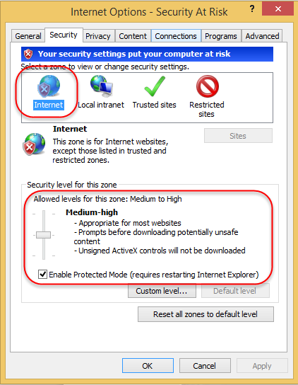
Now you need to make sure that, for the other Zones, such as 'Local Internet' and 'Trusted sites' is also selected as ABOVE. You may don't need to do anything with 'Restricted Site' option. We can leave the option as is and by default 'Enable Protected Mode' option will be Checked.
Now after changing the settings, please click on 'Apply' and 'Ok' button.
There is also an other alternative for setting the protected mode using desired capabilities as below: -
DesiredCapabilities capabilities = DesiredCapabilities.internetExplorer();
capabilities.setCapability(InternetExplorerDriver.INTRODUCE_FLAKINESS_BY_IGNORING_SECURITY_DOMAINS,true);
But how ever, the first option is advised and it is not that hard to set internet explorer browser settings.
You can checkout for the required configuration options which are defined IE required configuration for Selenium Webdriver
2. Make sure that the IE browser zoom level is set to 100% so that the native mouse events can be set to the correct coordinates.
3. It may be silly one, But make sure you provide correct path when setting the property of Internet explorer driver.
Hope you will Run your scripts in IE browser without any issues.
Handle window Popup using selenium
There are many cases, where a application displays multiple windows when you open a website. Those are may be advertisements or may be a kind of information showing on popup windows. We can handle multiple windows using Windows Handlers in selenium webdriver.
Step 1: After opening the website, we need to get the main window handle by using driver.getWindowHandle();
The window handle will be in a form of lengthy alpha numeric
Step 2: We now need to get all the window handles by using driver.getWindowHandles();
Step 3: We will compare all the window handles with the main Window handles and perform the operation the window which we need.
The below example shows how to handle multiple windows and close all the child windows which are not need. We need to compare the main window handle to all the other window handles and close them.
package com.pack;

import java.util.Set;
import org.openqa.selenium.WebDriver;
In Selenium to work with iFrames, we have different ways to handle frame depending on the need. Please look at the below ways of handling frames
driver.switchTo().frame(int arg0);
Select a frame by its (zero-based) index. That is, if a page has multiple frames (more than 1), the first frame would be at index "0", the second at index "1" and so on.
Once the frame is selected or navigated , all subsequent calls on the WebDriver interface are made to that frame. i.e the driver focus will be now on the frame. What ever operations we try to perform on pages will not work and throws element not found as we navigated / switched to Frame.
Parameters: Index - (zero-based) index
Returns: driver focused on the given frame (current frame)
Throws: NoSuchFrameException - If the frame is not found.
Example: if iframe id=webklipper-publisher-widget-container-frame, it can be written as driver.switchTo().frame("webklipper-publisher-widget-container-frame"); Below is the code snippet to work with switchToFrame using frame id.
public void switchToFrame(int frame) {
try {
driver.switchTo().frame(frame);
System.out.println("Navigated to frame with id " + frame);
} catch (NoSuchFrameException e) {
System.out.println("Unable to locate frame with id " + frame
+ e.getStackTrace());
} catch (Exception e) {
System.out.println("Unable to navigate to frame with id " + frame
+ e.getStackTrace());
}
}
driver.switchTo().frame(String arg0);
Select a frame by its name or ID. Frames located by matching name attributes are always given precedence over those matched by ID.
Parameters: name Or Id - the name of the frame or the id of the frame element.
Returns: driver focused on the given frame (current frame)
Throws: NoSuchFrameException - If the frame is not found
Below is the example code snippet using frame name.

public void switchToFrame(String frame) {
try {
driver.switchTo().frame(frame);
System.out.println("Navigated to frame with name " + frame);
} catch (NoSuchFrameException e) {
System.out.println("Unable to locate frame with id " + frame
+ e.getStackTrace());
} catch (Exception e) {
System.out.println("Unable to navigate to frame with id " + frame
+ e.getStackTrace());
}
}
driver.switchTo().frame(WebElement frameElement);
Select a frame using its previously located WebElement.
Parameters: frameElement - The frame element to switch to.
Returns: driver focused on the given frame (current frame).
Throws: NoSuchFrameException - If the given element is neither an iframe nor a frame element. And StaleElementReferenceException - If the WebElement has gone stale.
Below is the example code to send an Element to the and switch.
public void switchToFrame(WebElement frameElement) {
try {
if (isElementPresent(frameElement)) {
driver.switchTo().frame(frameElement);
System.out.println("Navigated to frame with element "+ frameElement);
} else {
System.out.println("Unable to navigate to frame with element "+ frameElement);
}
} catch (NoSuchFrameException e) {
System.out.println("Unable to locate frame with element " + frameElement + e.getStackTrace());
} catch (StaleElementReferenceException e) {
System.out.println("Element with " + frameElement + "is not attached to the page document" + e.getStackTrace());
} catch (Exception e) {
System.out.println("Unable to navigate to frame with element " + frameElement + e.getStackTrace());
}
}
Some times when there are multiple Frames (Frame in side a frame), we need to first switch to the parent frame and then we need to switch to the child frame. below is the code snippet to work with multiple frames.
public void switchToFrame(String ParentFrame, String ChildFrame) {
try {
driver.switchTo().frame(ParentFrame).switchTo().frame(ChildFrame);
System.out.println("Navigated to innerframe with id " + ChildFrame
+ "which is present on frame with id" + ParentFrame);
} catch (NoSuchFrameException e) {
System.out.println("Unable to locate frame with id " + ParentFrame
+ " or " + ChildFrame + e.getStackTrace());
} catch (Exception e) {
System.out.println("Unable to navigate to innerframe with id "
+ ChildFrame + "which is present on frame with id"
+ ParentFrame + e.getStackTrace());
}
}
After working with the frames, main important is to come back to the web page. if we don't switch back to the default page, driver will throw an exception. Below is the code snippet to switch back to the default content.
public void switchtoDefaultFrame() {
try {
driver.switchTo().defaultContent();
System.out.println("Navigated back to webpage from frame");
} catch (Exception e) {
System.out
.println("unable to navigate back to main webpage from frame"
+ e.getStackTrace());
}
}

How to handle JAVAScript Alert

Generally JavaScript popups are generated by web application and hence they can be easily controlled by the browser.
Webdriver offers the ability to cope with javascript alerts using Alerts API
// Get a handle to the open alert, prompt or confirmation
Alert alert = driver.switchTo().alert();
Alert is an interface. There below are the methods that are used
//Will Click on OK button.
alert.accept();
// Will click on Cancel button.
alert.dismiss()
//will get the text which is present on th Alert.
alert.getText();
//Will pass the text to the prompt popup
alert.sendkeys();
//Is used to Authenticate by passing the credentials
alert.authenticateUsing(Credentials credentials)

Working with Alerts using Selenium Webdriver:
The below is the sample code for alerts, please copy and make an html file and pass it to the webdriver.
<html>
<head>
<title>Selenium Easy Alerts Sample </title>
</head>
<body>
<h2>Alert Box Example</h2>
<fieldset>
<legend>Alert Box</legend><p>Click the button to display an alert box.</p>
<button onclick="alertFunction()">Click on me</button>
<script>
function alertFunction()
{
alert("I am an example for alert box!");
}
</script>
</fieldset>
</body>
</html>
The below program will demonstrate you working on Alerts popup using above html file.
import org.openqa.selenium.Alert;
import org.openqa.selenium.By;
import org.openqa.selenium.WebDriver;
import org.openqa.selenium.firefox.FirefoxDriver;
import org.testng.annotations.Test;

public class PopupsHandling {
WebDriver driver=new FirefoxDriver();
@Test
public void ExampleForAlert() throws InterruptedException
{
driver.manage().window().maximize();
driver.get("file:///C:/path/alerts.html");
Thread.sleep(2000);
driver.findElement(By.xpath("//button[@onclick='alertFunction()']")).click();
Alert alert=driver.switchTo().alert();
System.out.println(alert.getText());
alert.accept();
}
}

Working with Confirmation Popups
The below is the sample code for confirmation Popup, please copy and make an html file and pass it to the webdriver as below.
<html>
<head>
<title>Selenium Easy Confirm popup Sample </title>
</head>
<body>
<h2>Confirm Box Example</h2>
<fieldset>
<legend>Confirm Box</legend>
<p>Click the button to display a confirm box.</p>
<button onclick="confirmFunction()">Click on me</button>
<p id="confirmdemo"></p>
<script>
function confirmFunction()
{
var cb;
var c=confirm("I am an Example for Confirm Box.\n Press any button!");
if (c==true)
{
cb="You Clicked on OK!";
}
else
{
cb="You Clicked on Cancel!";
}
document.getElementById("confirmdemo").innerHTML=cb;
}
</script>
</fieldset>
</body>
</html>
The below program will demonstrate you working on Confirmation popup using above html file.
import org.openqa.selenium.Alert;
import org.openqa.selenium.By;
import org.openqa.selenium.WebDriver;
import org.openqa.selenium.firefox.FirefoxDriver;
import org.testng.annotations.Test;

public class PopupsHandling {
WebDriver driver=new FirefoxDriver();
@Test
public void ExampleForConfirmBox() throws InterruptedException
{
driver.manage().window().maximize();
driver.get("file:///C:/path/confirmation.html");
Thread.sleep(2000);
driver.findElement(By.xpath("//button[@onclick='confirmFunction()']")).click();
Alert alert=driver.switchTo().alert();
System.out.println(alert.getText());
alert.dismiss();
}
}

Working with Prompt Popups.
In prompt, you can enter the text using webdriver sendkeys("text..")
The below is the sample code for prompt popup, please copy and make an html file and pass it to the webdriver as below.
<html>
<head>
<title>Selenium Easy Prompt popup Sample </title>
</head>
<body>
<h2>Prompt Box Example</h2>
<fieldset>
<legend>Prompt Box</legend>
<p>Click the button to demonstrate the prompt box.</p>
<button onclick="promptFunction()">Click on me</button>
<p id="promptdemo"></p>
<script>
function promptFunction()
{
var x;
var person=prompt("Please enter your name","Your name");
if (person!=null)
{
x="Hello " + person + "! Welcome to Selenium Easy..";
document.getElementById("promptdemo").innerHTML=x;
}
}
</script>
</fieldset>
</body>
</html>
The below program will demonstrate you working on prompt popup using above html file.
import org.openqa.selenium.Alert;
import org.openqa.selenium.By;
import org.openqa.selenium.WebDriver;
import org.openqa.selenium.firefox.FirefoxDriver;
import org.testng.annotations.Test;

public class PopupsHandling {
WebDriver driver=new FirefoxDriver();

@Test
public void ExampleForPromptBox() throws InterruptedException
{
driver.manage().window().maximize();
driver.get("file:///C:/path/prompt.html");
Thread.sleep(2000);
driver.findElement(By.xpath("//button[@onclick='promptFunction()']")).click();
Alert alert=driver.switchTo().alert();
driver.switchTo().alert().sendKeys("Helllo");
alert.accept();
System.out.println(alert.getText());
}
}

Defining Firefox Profile preferences using Selenium Webdriver

Some times, you may need to update the preferences within Firefox. We can do this by instantiating a Firefox Profile object and then update the settings.
We will then need to pass this object into FirefoxDriver which will load the profile with your defined settings.
You can check them using command "about:config" in the borwser. It will display a warning message and then asks you to proceed if required. Becarefull when doing any changes.
Let us assume that you wanted to have google as the startup page for Firefox. To do this we will need to update the browser.startup.homepage preference.
Follow below steps to add a website as your homepage:
1. Let's first start by creating the FirefoxProfile object:
FirefoxProfile ffprofile= new FirefoxProfile();
2. Now we will set the preference by using the below method:
profile.setPreference("browser.startup.homepage","http://www.google.com");
3. To get the profile to be used, we need to pass it in to the driver. To do this, we need
to do the following:
driver = new FirefoxDriver(ffprofile);
4. Now run your test. The final code should look like the following:
import org.openqa.selenium.By;
import org.openqa.selenium.WebDriver;
import org.openqa.selenium.WebElement;
import org.openqa.selenium.firefox.FirefoxDriver;
import org.openqa.selenium.firefox.FirefoxProfile;
import org.testng.annotations.Test;

public class FireFoxProfileExample {

WebDriver driver;

@Test
public void testExamples(){
FirefoxProfile profile = new FirefoxProfile();
profile.setPreference("browser.startup.homepage",
"http://www.google.com");
driver = new FirefoxDriver(profile);

WebElement element = driver.findElement(By.name("q"));
element.sendKeys("100");

}
You can check if that has applied to the firefox or not. Please enter "about:config" in address bar, and type "browser.startup.homepage".
It will display the website that you have added.

Set browser width and height in Selenium Webdriver

Selenium WebDriver allows resizing and maximizing window natively from its API. We use 'Dimension' class to resize the window.
Lets take the help of Selenium WebDrivers Dimension Class and declare object say 'd' by initializing it with width and height as 420X600 as shown below:
Remember, We need to import the statement 'import org.openqa.selenium.Dimension'
import org.openqa.selenium.Dimension;
import org.openqa.selenium.WebDriver;
import org.openqa.selenium.firefox.FirefoxDriver;
import org.testng.annotations.Test;
public class browser {

@Test
public void openBrowserwithGivenDimension()
{

WebDriver driver = new FirefoxDriver();
driver.navigate().to("http://google.co.in");
System.out.println(driver.manage().window().getSize());
Dimension d = new Dimension(420,600);
//Resize the current window to the given dimension
driver.manage().window().setSize(d);
}
}
We can set the size and perform testing with lower resolution. We can also perform testing on Responsive sites which automatically get adjust based on the browser size.

Read data from Properties file using Java Selenium
In Selenium .properties files are mainly used to store GUI locators / elements, and also Global fields like database configuration details
'.properties' files are mainly used in Java programs to maintain project configuration data, database config or project settings etc. Each parameter in properties file are stored as a pair of strings, in key and value format, where each key is on one line. You can easily read properties from some file using object of type Properties.
Below is a example program which demonstrate to read the data from .properties file using Java.
import java.io.File;
import java.io.FileInputStream;
import java.io.FileNotFoundException;
import java.io.IOException;
import java.util.Properties;
import org.openqa.selenium.By;
import org.openqa.selenium.WebDriver;
import org.openqa.selenium.firefox.FirefoxDriver;

public class ReadFileData {

public static void main(String[] args) {
File file = new File("D:/Dev/ReadData/src/datafile.properties");

FileInputStream fileInput = null;
try {
fileInput = new FileInputStream(file);
} catch (FileNotFoundException e) {
e.printStackTrace();
}
Properties prop = new Properties();

//load properties file
try {
prop.load(fileInput);
} catch (IOException e) {
e.printStackTrace();
}

WebDriver driver = new FirefoxDriver();

driver.get(prop.getProperty("URL"));
driver.findElement(By.id("Email")).sendKeys(prop.getProperty("username"));
driver.findElement(By.id("Passwd")).sendKeys(prop.getProperty("password"));
driver.findElement(By.id("SignIn")).click();

System.out.println("URL ::" + prop.getProperty("URL"));
System.out.println("User name::" +prop.getProperty("username"));
System.out.println("Password::" +prop.getProperty("password"));
}
}
The below is the Output after executing the program: We are passing the properties values to the webdriver and printing the values at end
URL ::http://gmail.com
User name::testuser
Password::password123
We can also get all the key value pairs in the properties file using the below java program:
import java.io.File;
import java.io.FileInputStream;
import java.io.FileNotFoundException;
import java.io.IOException;
import java.util.Enumeration;
import java.util.Properties;
public class ReadFileData {

public static void main(String[] args) {

File file = new File

("D:/Dev/ReadData/src/datafile.properties");
FileInputStream fileInput = null;
try {
fileInput = new FileInputStream(file);
} catch (FileNotFoundException e) {
e.printStackTrace();
}
Properties prop = new Properties();
try {
prop.load(fileInput);
} catch (IOException e) {
e.printStackTrace();
}

Enumeration KeyValues = prop.keys();
while (KeyValues.hasMoreElements()) {
String key = (String) KeyValues.nextElement();
String value = prop.getProperty(key);
System.out.println(key + ":- " + value);
}
}
}
We have not used individual property name to get the KeyValue in the above program. It will get all the key values which are available in the .properties file
The Output of the above program:
URL:- http://gmail.com
password:- password123
username:- testuser
The below is the sample properties file that was used for the above tests. Remember white space between the property name and property value is always ignored. The following is the example.
username=testuser
username = testuser
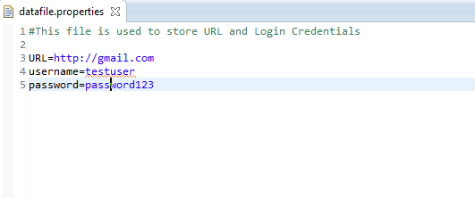
How to create properties file?
Navigate to File menu -> New -> Click on File
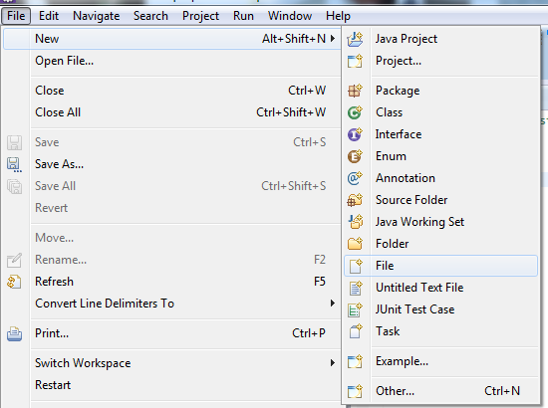
The only thing we need to do is, give the file name and give the extension as '.properties'. (Example: dataFile.properties)
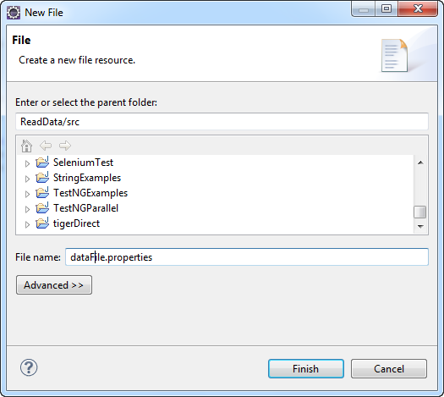

Scrolling web page with Selenium Webdriver using java
We can scroll the web page using javaScript Executor in the java code.We have taken the below example with three different scenarios of scrolling a webpage.
1. We may require to scroll to bottom of the page and then perform operations. For this scenario we have created a test 'scrollingToBottomofAPage'/
2. Some times, we may require to scroll to particular element and peform operations on that particular element. For this we need to pass the element on which we need to perform operation. For this scenario we have created a test 'scrollingToElementofAPage'/
3. We can also use the coordinates to scroll to particular position by passing the coordinates. For this scenario we have created a test 'scrollingByCoordinatesofAPage'/
package com.scroll.page;

import org.openqa.selenium.By;
import org.openqa.selenium.JavascriptExecutor;
import org.openqa.selenium.WebDriver;
import org.openqa.selenium.WebElement;
import org.openqa.selenium.firefox.FirefoxDriver;
import org.testng.annotations.AfterClass;
import org.testng.annotations.BeforeClass;
import org.testng.annotations.Test;

public class PageScroll {
WebDriver driver;
String URL = "https://www.linkedin.com/";

@BeforeClass
public void setUp() {
driver = new FirefoxDriver();
driver.get(URL);
driver.manage().window().maximize();
}

@Test(priority=1)
public void scrollingToBottomofAPage() {
driver.navigate().to(URL);
((JavascriptExecutor) driver)
.executeScript("window.scrollTo(0, document.body.scrollHeight)");
}

@Test(priority=2)
public void scrollingToElementofAPage() {
driver.navigate().to(URL+"directory/companies?trk=hb_ft_companies_dir");
WebElement element = driver.findElement(By.linkText("Import/Export"));
((JavascriptExecutor) driver).executeScript(
"arguments[0].scrollIntoView();", element);
}

@Test(priority=3)
public void scrollingByCoordinatesofAPage() {
driver.navigate().to(URL+"job/?trk=hb_ft_jobs");
((JavascriptExecutor) driver).executeScript("window.scrollBy(0,500)");
}

@AfterClass
public void tearDown() {
driver.quit();
}
}
The more better way to do this is having a utils class and define reusable methods. We can call these methods from different classes/tests.
We need to pass the driver to the method.
public static void scrollToBottom(WebDriver driver) {
((JavascriptExecutor) driver)
.executeScript("window.scrollTo(0, document.body.scrollHeight)");
}
In the same way, we may need to scroll to particular element and perform operations. To do this we need the below example reusable method. We need to pass the driver and element.
public static void scrollTo(WebDriver driver, WebElement element) {
((JavascriptExecutor) driver).executeScript(
"arguments[0].scrollIntoView();", element);
}

Download file using selenium webdriver

As we know we cannot simulate OS actions with Selenium. We use AutoIt tool to upload documents To handle Download functionality with selenium, we need to do some settings to the browser using Firefox profile using preferences, so that it automatically download the files to the defined folder. Then we can write code to check if the folder is downloaded or not.
Below is the example program to download a file
package com.pack;

import org.openqa.selenium.By;
import org.openqa.selenium.WebDriver;
import org.openqa.selenium.firefox.FirefoxDriver;
import org.openqa.selenium.firefox.FirefoxProfile;
import org.testng.annotations.Test;

public class FileDownloadExample {

public static String downloadPath = "D:\\seleniumdownloads";
@Test
public void testDownload() throws Exception {
WebDriver driver = new FirefoxDriver(FirefoxDriverProfile());
driver.manage().window().maximize();
driver.get("http://spreadsheetpage.com/index.php/file/C35/P10/");
driver.findElement(By.linkText("smilechart.xls")).click();
}

public static FirefoxProfile FirefoxDriverProfile() throws Exception {
FirefoxProfile profile = new FirefoxProfile();
profile.setPreference("browser.download.folderList", 2);
profile.setPreference("browser.download.manager.showWhenStarting", false);
profile.setPreference("browser.download.dir", downloadPath);
profile.setPreference("browser.helperApps.neverAsk.openFile",
"text/csv,application/x-msexcel,application/excel,application/x-excel,application/vnd.ms-excel,image/png,image/jpeg,text/html,text/plain,application/msword,application/xml");
profile.setPreference("browser.helperApps.neverAsk.saveToDisk",
"text/csv,application/x-msexcel,application/excel,application/x-excel,application/vnd.ms-excel,image/png,image/jpeg,text/html,text/plain,application/msword,application/xml");
profile.setPreference("browser.helperApps.alwaysAsk.force", false);
profile.setPreference("browser.download.manager.alertOnEXEOpen", false);
profile.setPreference("browser.download.manager.focusWhenStarting", false);
profile.setPreference("browser.download.manager.useWindow", false);
profile.setPreference("browser.download.manager.showAlertOnComplete", false);
profile.setPreference("browser.download.manager.closeWhenDone", false);
return profile;
}
}
We will explain you the preferences that we have set to Firefox browser.
setPreference("browser.download.folderList", 2);
Default Value: 1
The value of browser.download.folderList can be set to either 0, 1, or 2. When set to 0, Firefox will save all files downloaded via the browser on the user's desktop. When set to 1, these downloads are stored in the Downloads folder. When set to 2, the location specified for the most recent download is utilized again.
setPreference("browser.download.manager.showWhenStarting", false);
Default Value: true
The browser.download.manager.showWhenStarting Preference in Firefox's about:config interface allows the user to specify whether or not the Download Manager window is displayed when a file download is initiated.
browser. helperApps. alwaysAsk. force
True: Always ask what to do with an unknown MIME type, and disable option to remember what to open it with False (default): Opposite of above
browser. helperApps. neverAsk. saveToDisk
A comma-separated list of MIME types to save to disk without asking what to use to open the file. Default value is an empty string.
browser. helperApps. neverAsk. openFile
A comma-separated list of MIME types to open directly without asking for confirmation. Default value is an empty string.
browser. download. dir
The last directory used for saving a file from the "What should (browser) do with this file?" dialog.
browser.download.manager.alertOnEXEOpen
True (default): warn the user attempting to open an executable from the Download Manager
False: display no warning and allow executable to be run
Note: In Firefox, this can be changed by checking the "Don't ask me this again" box when you encounter the alert.
browser. download. manager. closeWhenDone
True: Close the Download Manager when all downloads are complete
False (default): Opposite of the above
browser. download. manager. focusWhenStarting
True: Set the Download Manager window as active when starting a download
False (default): Leave the window in the background when starting a download
Handling untrusted Certificate
Before jumping on to the example, first let us see What is SSL Certificate and When do we get UNTRUSTED CONNECTION Alert / Error.

Firstly, WHAT IS SSL CERTIFICATE ?
SSL is used to keep sensitive information which is sent across the Internet encrypted so that only the intended recipient understand it. This is important because, the information that we send on the internet is passed from one system to other system to the destination server.
If it is not encrypted with an SSL certificate, any computer in between you and the destination server can see your private information such as credit card numbers, usernames, passwords and other sensitive information.
When an SSL certificate is used, the information will be encrypted and it will ensure that you are sending information to the right server and not to a criminal’s server.

WHEN DO WE GET UNTRUSTED CONNECTION ERROR
When ever you try to visit a website whose web address starts with https, your communication with this site is encrypted to ensure your privacy. Before starting the encrypted communication the website, you will be presented with a "certificate" to identify itself.
The certificate helps to determine whether the site you are visiting is actually the site that it claims to be. If there is any problem with the certificate, you will see an alert saying 'This Connection Is Untrusted'. What it means is that browser (Firefox/Chrome etc) isn't able to verify the identity of the website, there cab be several problems which can cause browser to reject a certificate.
This is how the error looks like :
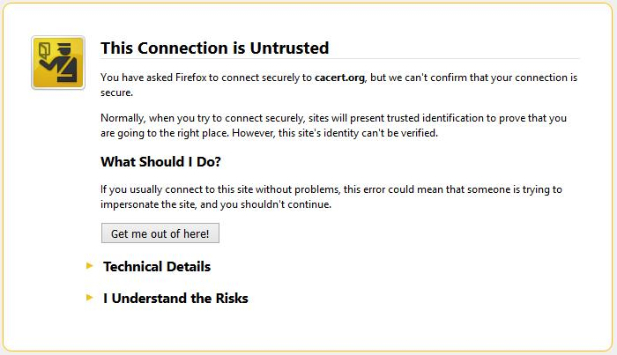
The below are the common errors that we see :

1. Certificate will not be valid until (date)
Error code: sec_error_expired_issuer_certificate
This error can occur if our system clock has the wrong date, check error message which will be in the past. We can fix this problem, by setting system clock to current date.

2. Certificate expired on (date)
Error code: sec_error_expired_certificate
This error occurs when a website identity certification has expired. This can also occur if system clock has the wrong date. We can fix this problem, by setting system clock to current date.

3. Certificate is only valid for (site name)
Error code: ssl_error_bad_cert_domain
This error says that the identification sent to you by the site is actually for another site. While anything you send would be safe from eavesdroppers , the recipient may not be the same who you think it is.
The above listed errors are the common errors, you may come across other errors which actually depends on the websites that you access.
Now Let us see how to handle SSL Untrusted Connection and Accept with Selenium webdriver. Let me try to do with Firefox browser first and then we will go with other browsers.
We will create new firefox profile and set 'setAcceptUntrustedCertificates' as true and setAssumeUntrustedCertificateIssuer as false.
package com.example;

import org.openqa.selenium.By;
import org.openqa.selenium.WebDriver;
import org.openqa.selenium.WebElement;
import org.openqa.selenium.firefox.FirefoxDriver;
import org.openqa.selenium.firefox.FirefoxProfile;
import org.testng.Assert;
import org.testng.annotations.AfterClass;
import org.testng.annotations.BeforeClass;
import org.testng.annotations.Test;

public class SSLExample {

private WebDriver driver;

@BeforeClass
public void setUp() {
//Creating new Firefox profile
FirefoxProfile profile = new FirefoxProfile();
profile.setAcceptUntrustedCertificates(true);
profile.setAssumeUntrustedCertificateIssuer(false);
driver = new FirefoxDriver(profile);
driver.manage().window().maximize();
}

@Test
public void openApplication() {
System.out.println("Navigating application");
driver.get("https://cacert.org/");
WebElement headingEle = driver.findElement(By.cssSelector(".story h3"));
//Validate heading after accepting untrusted connection
String expectedHeading = "Are you new to CAcert?";
Assert.assertEquals(headingEle.getText(), expectedHeading);
}

@AfterClass
public void tearDown() {
if(driver!=null)
driver.quit();
}

}
Done. You have now accepted the SSL Certificate with Selenium webdriver.
To work with Chrome and IE, You can check the example here to Handle SSL certificates in Chrome and Internet explorer

How to verify tooltip text with selenium webdriver using java
When user mouse hovers an any item (Button/link/field etc), without clicking it, and a tool tip may appear with information about the item being hovered. And Some times it may require us to check for the tooltip text.
There are different ways in showing tool tip to the user. We will look into two such different examples, one is with simple HTML and other example with Jquery ToolTip.
Example#1:
Let us take selenium official website to verify the tooltip in the first case.
Here when we mouse hover on the header, it has anchor tag with title attribute which is displayed as tooltip. Below is the screen shot:
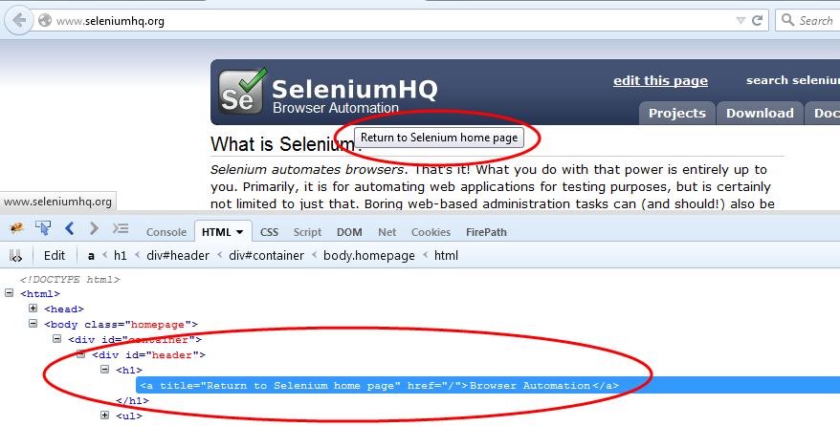
In this case it is very simple to get tooltip text by using selenium getAttribute() method.
Syntax:
WebElement element = driver.findElement(By.cssSelector(".header"));
String toolTipText = element.getAttribute("title");
We will follow the below steps for Case#1:
1. Open browser
2. Identify the element
3. Get tool tip text by attribute
4. compare Actual with Expected tool tip text
Example#2:
Now let us take JQuery example for tool tip.
Here when user mouse hover on the text field, it will display the tool tip. But when you observer the HTML, it doesn't have any title attribute. When ever user mouse hover, it will generate a div tag in which tool tip text resides. Check the below screen shot.
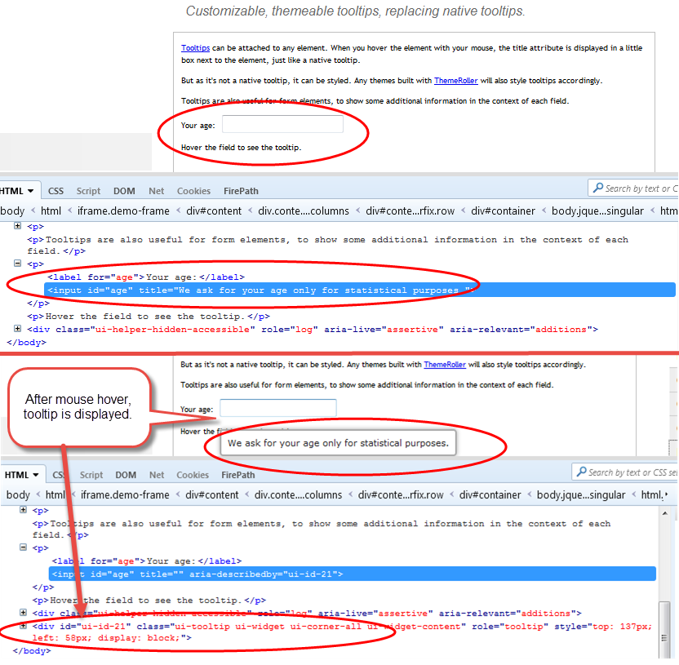
So here getAttribute() will not work. To get the tool tip text here, we need to take the help of Selenium actions class.
Syntax:
Actions action = new Actions(driver);
WebElement element = driver.findElement(By.id("boxElement"));
actions.moveToElement(element).build().perform();
We will follow the below steps for Case#2:
1. Open browser
2. Switch to Frame
3. Identify the element
4. Mouse Hover on the text field using Actions class
5. Get tool tip text by attribute
6. compare Actual with Expected tool tip text
Let us now create an example for above cases and see how they work.
1. Create a class with name 'ToolTipExample.java'
2. Create two test methods 'toolTipCase1' and 'toolTipCase2'
3. Will have Before and After class for driver setup and teardown.
package com.tooltip;

import org.openqa.selenium.By;
import org.openqa.selenium.WebDriver;
import org.openqa.selenium.WebElement;
import org.openqa.selenium.firefox.FirefoxDriver;
import org.openqa.selenium.interactions.Actions;
import org.openqa.selenium.support.ui.ExpectedConditions;
import org.openqa.selenium.support.ui.WebDriverWait;
import org.testng.Assert;
import org.testng.annotations.AfterClass;
import org.testng.annotations.BeforeClass;
import org.testng.annotations.Test;

public class ToolTipExample {

String seleniumURL = "http://docs.seleniumhq.org";
String jQueryURL = "https://jqueryui.com/tooltip/";
public WebDriver driver;

@BeforeClass
public void setUp() {
driver = new FirefoxDriver();
driver.manage().window().maximize();
}

@Test
public void toolTipCase1() {
driver.navigate().to(seleniumURL);

WebElement element = driver.findElement(By.cssSelector("#header>h1 a"));
// Get tooltip text
String toolTipText = element.getAttribute("title");
System.out.println("Tool tip text present :- " + toolTipText);

// Compare toll tip text
Assert.assertEquals("Return to Selenium home page", toolTipText);
}

@Test
public void toolTipCase2() {
driver.navigate().to(jQueryURL);

// As there is frame, we have to navigate to frame
WebDriverWait wait = new WebDriverWait(driver, 5);
wait.until(ExpectedConditions.frameToBeAvailableAndSwitchToIt(By.cssSelector(".demo-frame")));

// Text box field, where we mouse hover
WebElement element = driver.findElement(By.id("age"));

// Use action class to mouse hover on Text box field
Actions action = new Actions(driver);
action.moveToElement(element).build().perform();
WebElement toolTipElement = driver.findElement(By.cssSelector(".ui-tooltip"));

// To get the tool tip text and assert
String toolTipText = toolTipElement.getText();
Assert.assertEquals("We ask for your age only for statistical purposes.", toolTipText);

}

@AfterClass
public void tearDown() {
if (driver != null) {
driver.quit();
}
}
}

Handling Security Certificates in Chrome and IE browser using WebDriver

As we know SSL is mainly used to keep sensitive information encrypted when sending across the Internet, which is important because, the information that we send on the internet is passed by connecting with multiple systems to the destination server. You can know more info on this here .Different SSL certificate Errors
This is how the error looks like :
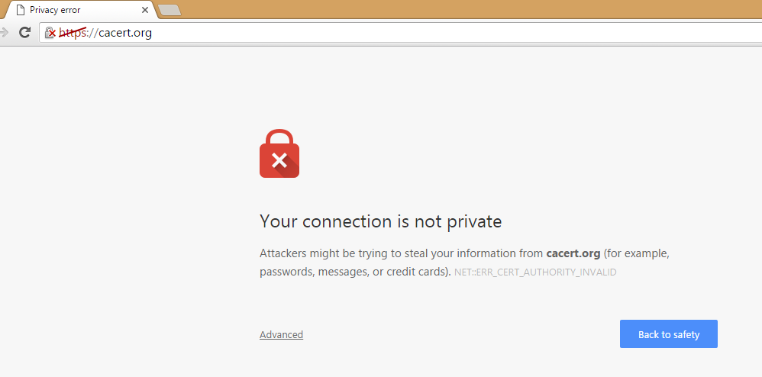
Let us now see the example :
package com.example;

import org.openqa.selenium.By;
import org.openqa.selenium.WebDriver;
import org.openqa.selenium.WebElement;
import org.openqa.selenium.chrome.ChromeDriver;
import org.openqa.selenium.remote.CapabilityType;
import org.openqa.selenium.remote.DesiredCapabilities;
import org.testng.Assert;
import org.testng.annotations.AfterClass;
import org.testng.annotations.BeforeClass;
import org.testng.annotations.Test;

public class SSLExample_Chrome {

private WebDriver driver;

@BeforeClass
public void setUp() {
DesiredCapabilities capability = DesiredCapabilities.chrome();
// To Accept SSL certificate
capability.setCapability(CapabilityType.ACCEPT_SSL_CERTS, true);
// setting system property for Chrome browser
System.setProperty("webdriver.chrome.driver", "E:/chromedriver.exe");
// create Google Chrome instance and maximize it
driver = new ChromeDriver(capability);
driver.manage().window().maximize();
}

@Test
public void openApplication() {
System.out.println("Navigating application");
driver.get("https://cacert.org/");
WebElement headingEle = driver.findElement(By.cssSelector(".story h3"));
// Validate heading after accepting untrusted connection
String expectedHeading = "Are you new to CAcert?";
Assert.assertEquals(headingEle.getText(), expectedHeading);
}

@AfterClass
public void tearDown() {
if (driver != null)
driver.quit();
}
}
Unlike handling SSL certificates in firefox and chrome browser are different when it comes to IE. In IE browser, we may have to handle it using javascript like like below :
System.setProperty("webdriver.ie.driver", "D:/IEDriverServer.exe");
driver = new InternetExplorerDriver();
driver.manage().window().maximize();
driver.get("https://cacert.org/");
driver.get("javascript:document.getElementById('overridelink').click();");

Database testing using Java, Selenium, TestNG example

As we know every application has to maintain a database like My SQL, Oracle or any other databases to store all its data. And where as Selenium Webdriver is used for testing web applications and we perform many operations like submitting information and some times retrieving information and validate them.
In selenium scripts, when there is a need of getting the Data from the database we may have to use APIs which helps to interact with database like JDBC.
Java Database Connectivity(JDBC) is a Java API which is used to connect and interact with Database.
Why do we use JDBC instead ODBC?
ODBC is developed and written in C, which is platform Independent. where as JDBC API is a specification provides set of interfaces which are written and developed in Java programming language.
How to Connect to database using JDBC?
The below are the Steps to Connect to database, before proceeding, you need to have MySQL Connector. You can download from here Download MySQL Connector Jar and add it the build path as we add selenium webdriver jar.
1. Load and Registering the Driver
2. Establishing Connection.
3. Creating Statement Object
4. Execute the Statement
5. Closing the connection.

1. Load and Register the Driver:
For registering the Driver we Load the Driver class using forName() method.
forName() is the static factory method which is present in predefined class called "Class". This method loads the class which is mentioned as parameter.
Class.forName("com.mysql.jdbc.Driver");// class.forName load the Driver class
Internally this Driver class will register the driver by using static method called registerDriver().

2. Establishing Connection:
For establishing connection with database we call static method called getConnection(...) present in DriverManager Class. This method contains three arguments of string type. i.e., url, username and password
DriverManager.getConnection("jdbc:mysql://localhost:3306/Employee","root","root");
URL contains "jdbc(main protocol):mysql(sub protocol for mySql)://localhost:3306(sub name for mysql (host:prot))/Employee(database)" and this method return type is Connection Object ie.,
Connection con=DriverManager.getConnection("jdbc:mysql://localhost:3306/Employee","root","root");

3. Creating Statement Object:
For creating statement object we need to call a method called createStatement() which is present in Connection Interface.
con.createStatement();
And this method returns Statement object and it is no argument method.
Statement st= con.createStatement();

4.Executing Queries:
For executing queries there are different methods present in Statement Interface for retrieving records and for updating records.
Retrieving records:
for executing select queries(for fetching records) we call a method called executeQuery(String qry) by taking string as parameter.
st.executeQuery("Select * from Employee");
This method returns ResultSet object.
Resultset rs= st.executeQuery("Select * from Employee");// once executeQuery() executes the query and stores the records in to ResultSet object.
Now we need to get the records from ResultSet object. To access the resultset object it uses a method called next() which presents in ResultSet Interface.
By default Resultset reference 'rs' points to before first row. it moves rs to next row and returns true. When it returns true we retrieve the data in first row. next() returns false when rs points to after the last row. this next() will repeats the execution using while loop till it returns false.
To get the data from rows we use getXxx(..) taking string or integer as parameters. Here integer means column position and string means column name of the record. xxx indicates primitive datatypes or string object.
while(rs.next()) {
int EmpId= rs.getInt("EmpId");
String EmpName= rs.getString("EmpName");
String EmpAddress=rs.getString(3);
Double EmpSal= rs.getDouble(4);
String EmpDept=rs.getString("EmpDept");
System.out.println(EmpId+"\t"+EmpName+"\t"+EmpAddress+"\t"+EmpSal+"\t"+EmpDept);
}
Updating records:
To update records in a table we use a method called executeUpdate(String str)
st.executeUpdate("update Employee set EmpName='Robert' where EmpId=2");
which returns integer value as how many records have been updated.
int result = st.executeUpdate("update Employee set EmpName='Robert' where EmpId=2");
System.out.println("number of records updated is" +result);

5. Closing the Connection:
Once execution of all statements were completed we need to close all the connections by using method called close() present in Connection interface
con.close();
Selenium Grid is a component of the Selenium testing framework that allows you to run tests in parallel across multiple machines and browsers. It enables you to distribute test execution across a network of machines, which can significantly reduce the time it takes to run a large suite of tests. The basic idea behind Selenium Grid is to have a hub that controls multiple nodes.
Here's a brief overview of how Selenium Grid works:
- Hub:
  - The hub is the central component that manages the test execution across multiple machines (nodes).
  - It acts as a server to which test scripts connect to request a browser for testing.
  - The hub distributes the test to an available node that has the desired browser and platform configuration.
- Node:
  - Nodes are machines that execute the actual test cases.
  - Each node registers with the hub and provides information about the browsers and platforms it can run.
  - Nodes take commands from the hub and execute the tests in the specified browser.
- Test Script:
  - Test scripts are written using Selenium WebDriver, just like in a non-distributed Selenium setup.
  - The test script communicates with the hub to request a browser for testing.
Here are the basic steps to set up and use Selenium Grid:
- Start the Hub:
  - Launch the Selenium Grid hub using the command:
java -jar selenium-server-standalone.jar -role hubjava -jar selenium-server-standalone.jar -role hub
- Start the Nodes:
  - Launch Selenium Grid nodes on machines where you want to run tests.
java -jar selenium-server-standalone.jar -role node -hub http://hub_address:4444/grid/registerjava -jar selenium-server-standalone.jar -role node -hub http://hub_address:4444/grid/register
- Run Test Scripts:
  - Modify your Selenium test scripts to specify the hub's address, so they can connect to it.
  - When you run your test scripts, Selenium Grid will distribute them to available nodes based on browser and platform requirements.
Selenium Grid supports parallel execution of tests across different browsers, operating systems, and devices, making it a powerful tool for large-scale test automation. It helps ensure that your web application behaves correctly across various environments.

