Core Java

Date of Release: 05/02/2024

Contents
1.0 Introduction 3
1.1 History of Java 3
1.2 Version of Java 4
1.3 Java Key Feature(SODA ME PANI) 4
1.4 Java Environment 5
1.5 Java Development Kit (JDK) 5
1.6 Application Programming Interface 7
1.7 Components of JAVA Architecture 8
1.8 JAVA API (Application Programming Interface) 9
1.9 Tools you will need: 10
1.10 Local Environment Set Up 11
1.11 Setting up the path for windows 2000/XP: 11
1.12 Setting up the path for windows 95/98/ME: 12
1.13 Setting up the path for Linux, UNIX, Solaris 12
1.14 Popular Java Editors: 12
1.15 Let’s Start with First Java Program 13
1.16 Run your program on Command Prompt 14
1.17 Basic Syntax: 14
1.18 Comments in Java 15
2.0 Java Identifiers: 16
2.1 Java Specifiers: 16
2.2 Java Variables: 17
3.0 Array in Java 17
3.1 What are Advantages and Disadvantages of arrays? 19
4.0 Creating Strings: 21
4.1 String Manipulation 21
4.2 Way of Finding String Length: 21
4.3 Java - String charAt() Method 23
Parameters: 23
Return Value: 23
4.4 Java - String concat() Method 23
4.5 Java - String toUpperCase() Method 24
Return Value: 24
4.6 Java - String toLowerCase() Method 25
Return Value: 25
Example: 26
4.7 Java - String Split() Method 26
4.8 Java - String substring () Method 28
4.9 Java - String indexOf() Method 29
4.10 Java - String trim () Method 30
4.11 Java - String IsEmpty() Method 31
4.12 Java - String lastIndexOf() Method 32
4.13 Java - String equalsIgnoreCase()Method 33
4.14 Java - String replace()Method 35
4.15 Java - String StartsWith()and EndsWith()Method 36
Return Value: 36
5. 0 Looping 37
5.1 Let’s understand do- while loop 38
Syntax: 38
5.2 While Loop 41
Syntax: 41
5.3 For Loop 43
Syntax: 44
Flow Diagram 45
Example: 45
5.4 Loop Control Statements: 47
Syntax: 47
5.5 Continue: 49
Syntax: 49
Flow Diagram 49
5.6 Java Decision Making 51
The? : Operator: 52
Example: 52
Exp1? Exp2:Exp3 52
5.7 If Statement: 53
Syntax: 53
5.8 If…..Else Statement: 54
Syntax: 54
Flow Diagram 54
5.9 The if...else if...else Statement: 56
5.10 Switch --- Case Statement 57
5.11 for-each loop (Advanced or Enhanced For loop): 60
Advantage of for-each loop: 61
Syntax of for-each loop: 61
6.0 Scanner class in Java 62
Commonly used methods of Scanner class 62
Java Scanner Example to get input from console 63
7. 0 Data Type 65
7.1 Primitive Data Types: 65
byte: 65
short: 65
int: 66
long: 66
float: 66
double: 67
boolean: 67
char: 67
Reference Data Types: 68
8.0 Access Specifier in JAVA 68
8.1 Private access Specifier 68
Simple example of private access Specifier 69
8.2 Default access Specifier 69
Example of default access Specifier 70
8.3 Protected access Specifier 71
8.4 Public access Specifier 73
Example of public access Specifier 73
8.5 Understanding all java access Specifiers 74
9.0 Java OOPs Advantages 75
OOPs (Object Oriented Programming System) 75
9.1 Object 76
9.2 Class 76
9.4 Advantage of OOPs over Procedure-oriented programming language 76
What is difference between object-oriented programming language and object-based programming language? 77
6.2 Advantage of naming conventions in java 77
CamelCase in java naming conventions 78
10.0 Object and Class in Java 79
10.1 Object in Java 79
7.2 Class in Java 80
7.3 Syntax to declare a class: 80
10.2 Simple Example of Object and Class 81
10.3 Instance variable in Java 82
11.0 Methods in Java 82
11.1 Advantage of Method 82
11.2 Use of new keyword 82
11.3 Example of Object and class that maintains the records of students 82
12.0 Exception Handling 85
12.1 What is exception? 85
12.2 What is exception handling 85
12.3 Advantage of Exception Handling 85
Hierarchy of Java Exception classes 87
12.4 Types of Exception 87
12.5 Difference between checked and unchecked exceptions 88
1) Checked Exception 88
2) Unchecked Exception 88
3) Error 88
12.6 Common scenarios where exceptions may occur 88
1) Scenario where ArithmeticException occurs 88
2) Scenario where NullPointerException occurs 88
3) Scenario where NumberFormatException occurs 89
4) Scenario where ArrayIndexOutOfBoundsException occurs 89
12.7 Java Exception Handling Keywords 89
12.8 Java Try Block 89
12.9 Internal working of java try-catch block 91
12.10 Multiple Catch Block 93
12.11 Rules for Exception Handling 94
12.12 JAVA Finally Block 94
12.13 Why use java finally 95
12.14 Usage of Java finally 96
Case 1 96
12.15 JAVA Throw Exception 99
12.16 Java Throws Exception 101
Syntax of java throws 101
12.17 Which exception should be declared 101
12.18 Advantage of Java throws keyword 101
12.19 Which exception should be declared 102
12.20 Advantage of Java throws keyword 102
12.21 Let’s learn difference between Throw and Throws 104
12.22 Difference between final, finally and finalize 104
13.00 Collections: 105
13.1 Java Array List 105
13.2 Java Linked List class 107
13.3 Difference between ArrayList and LinkedList 109
13.4 Java List Iterator Interface 110
Commonly used methods of List Iterator Interface: 110
13.5 HashSet Class Interface 112
13.6 Hierarchy of HashMap class: 112
13.7 Example of HashMap class: 112
13.8 Java HashTable Class 113
13.9 Difference between Hashmap and HashTable 115
14.0 Vectors 116
14.1 The Purpose of this keyword in JAVA 118
15.0 JAVA I/O 121
Stream 121
15.1 OutputStream 122
15.2 InputStream 122
15.3 Commonly used methods of OutputStream class 122
InputStream class 122
Commonly used methods of InputStream class 122
15.4 File Handling in JAVA 123
15.5 File Reading Program 125
15.6 Java BufferedOutputStream and BufferedInputStream 126
16.0 Interface in java 127
16.1 Why use Java interface? 127
16.2 Understanding relationship between classes and interfaces 128
16.3Multiple inheritance example of Java interface 129
16.4 Hierarchy of interface 131
17.0 Abstract Class in JAVA 131
17.1 Abstraction in Java 132
17.2 Ways to achieve Abstaction 132
Example abstract class 132
Example abstract method 132
17.3 Example of abstract class that has abstract method 133
17.4 Another Example of Java Abstract 134
17.5 Difference between abstract class and interface 137
18.0 Why Super keyword in JAVA 138
Usage of java super Keyword 138
1) super is used to refer immediate parent class instance variable. 139
1) Solution by super keyword 140
2) Super is used to invoke parent class constructor. 141
1) Note: super () is added in each class constructor automatically by compiler. 142
2) Another example of super keyword where super() is provided by the compiler implicitly. 142
3) super can be used to invoke parent class method 143
Program in case super is not required 145
19.0 String Vs StringBuffer VS StringBuilder 145
19.1 When should we choose String and StringBuffer? 146
Advantage and disadvantage in String: 146
Advantage and disadvantage of StringBuffer or StringBuilder: 146
19.2 .Creating String , StringBuffer objects: 146
19.3 StringBuffer: 147
19.5 Special operations those we can only perform on StringBuffer and StringBuilder: 147
19.6 Concatenation: 147
Using append() method 147
19.7 Comparison: 148
20.0 Constructor in java 149
20.1 Rules for creating java constructor 149
20.2 Types of java constructors 149
20.3 Java Default Constructor 149
20.4 Syntax of default constructor: 149
20.5 Example of default constructor 150
20.6 What is the purpose of default constructor? 151
20.7 Java parameterized constructor 152
20.8 Why use parameterized constructor? 152
20.9 Example of parameterized constructor 152
20.10 Constructor Overloading in Java 153
Example of Constructor Overloading 153
20.11 Difference between constructor and method in java 154
20.12 Java Copy Constructor 155
20.13 Copying values without constructor 157
Copying values without constructor 157
20.14 Does constructor return any value? 158
20.15 Can constructor perform other tasks instead of initialization? 158
21.0 Inheritance in JAVA 158
21.1 Why use inheritance in java 159
21.2 Syntax of Java Inheritance 159
21.3 Understanding the simple example of inheritance 159
21.4 Types of inheritance in java 160
21.5 Why multiple inheritances are not supported in java? 162
22.0 Polymorphism 163
23.0 Method Overloading in JAVA 165
23.1 Advantage of method overloading? 165
23.2 Different ways to overload the method 165
23.3 Example of Method Overloading by changing the no. of arguments 165
23.4 Example of Method Overloading by changing data type of argument 166
Example of Method Overloading by changing data type of argument 166
23.5 Why Method Overloaing is not possible by changing the return type of method? 167
23.6 Can we overload main() method? 168
23.7 Method Overloading and Type Promotion 169
Example of Method Overloading with TypePromotion if matching found 170
23.8 Example of Method Overloading with Type Promotion in case ambiguity 171
24.0 Method Overriding in Java 172
24.1 Usage of Java Method Overriding 172
24.2 Understanding the problem without method overriding 173
24.3 Example of method overriding 173
24.4 Real example of Java Method Overriding 174
24.5 Can we override static method? 176
24.6 Why we cannot override static method? 177
24.7 Can we override java main method? 177
24.8 Difference between method Overloading and Method Overriding in java 177
24.9 Java Method Overloading example 178
24.10 Java Method Overriding example 178
25.0 Encapsulation 179
25.2 Simple example of encapsulation in java 179
26.0 JAVA Regular Expression (REGEX) 181
26.1 java.util.regex package 181
26.2 Matcher class 181
26.3 Pattern class 182
26.4 Example of Java Regular Expressions 182
26.5 Regular Expression 2 183
27.0 JDBC 184
27.1 Why use JDBC 184
28.0 Database Testing using Selenium: Step by Step Guide 185
1) Make a connection to the Database 186
2) Send Queries to the Database 187
3) Process the results 188
28.2 Example of Database Testing with Selenium 189
28.3 Summary 201

1.0 Introduction
Java programming language was originally developed by Sun Microsystems which was initiated by James Gosling and released in 1995 as core component of Sun Microsystems' Java platform (Java 1.0 [J2SE]).
The language originally called as “Oak”. Later on Oak was renamed “JAVA” due to some legal snags. The team developed a web browser called “Hot Java” to locate and run applet program on internet.
As of December 2008, the latest release of the Java Standard Edition is 6 (J2SE). With the advancement of Java and its widespread popularity, multiple configurations were built to suite various types of platforms. Ex: J2EE for Enterprise Applications, J2ME for Mobile Applications.
Sun Microsystems has renamed the new J2 versions as Java SE, Java EE and Java ME respectively. Java is guaranteed to be Write Once, Run Anywhere.

1.1 History of Java
James Gosling initiated the Java language project in June 1991 for use in one of his many set-top box projects. The language, initially called Oak after an oak tree that stood outside Gosling's office, also went by the name Green and ended up later being renamed as Java, from a list of random words.
Sun released the first public implementation as Java 1.0 in 1995. It promised Write Once, Run Anywhere (WORA), providing no-cost run-times on popular platforms.
On 13 November 2006, Sun released much of Java as free and open source software under the terms of the GNU General Public License (GPL).
On 8 May 2007, Sun finished the process, making all of Java's core code free and open-source, aside from a small portion of code to which Sun did not hold the copyright.

1.2 Version of Java

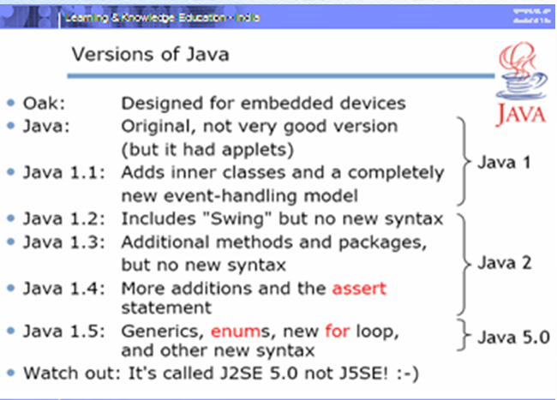

1.3 Java Key Feature(SODA ME PANI)

Java has following key features.

- Simple: Java is designed to be easy to learn. If you understand the basic concept of OOP Java would be easy to master.
- Object Oriented: In Java, everything is an Object. Java can be easily extended since it is based on the Object model.
- Distributed/Dynamic: Java is designed for the distributed environment of the internet. Java is considered to be more dynamic than C or C++ since it is designed to adapt to an evolving environment. Java programs can carry extensive amount of run-time information that can be used to verify and resolve accesses to objects on run-time.
- Architectural: Java compiler generates an architecture-neutral object file format which makes the compiled code to be executable on many processors, with the presence of Java runtime system. Most striking feature of Java.
- Multithreaded: With Java's multithreaded feature it is possible to write programs that can do many tasks simultaneously. This design feature allows developers to construct smoothly running interactive applications.
- Extensible: Java Program support various functions same as C, C++, This functions is called “Native Methods”. Native methods are linked dynamically at the runtime.
- Platform independent/ Portable: Unlike many other programming languages including C and C++, when Java is compiled, it is not compiled into platform specific machine, rather into platform independent byte code. This byte code is distributed over the web and interpreted by virtual Machine (JVM) on whichever platform it is being run.
- Artificial Intelligence: Being Artificial Intelligence compiler in Java is written in ANSI C with a clean portability boundary which is a POSIX subset.
- Neutral: Being architectural-neutral and having no implementation dependent aspects of the specification makes Java portable
- Interpreted: Java byte code is translated on the fly to native machine instructions and is not stored anywhere. The development process is more rapid and analytical since the linking is an incremental and light weight process.

1.4 Java Environment

Java Environment includes a large number of development tools and hundreds of classes and methods. The development tools are part of the system known as Java Development Kit (JDK) and the classes and methods are part of Java Standard Library (JSL) also known as Application Programming Interface.

1.5 Java Development Kit (JDK)
The Java Development Kit comes with a collection of tools that are used for developing and running Java Programs. They Include:
Applet Viewer (For Viewing Java applets)
Javac (Java Compiler)
Java (Java Interpreter)
Javap (Java disassembler)
Javah (for C Header Files)
Javadoc (For Creating HTML Document)
Jdb (Java Debugger)

Tool | Description
Applerviewers | Enable us to run Java Applets(without actually java-compatible browser)
Java | Java Interpreter, which runs applets and application by reading and interpreting Byte code.
Javac | Java Compiler, which translate java source code to byte code files that interpreter can understand.
Javadoc | Creates HTML format documentation from java Source Code files
Javah | Produces header files for use with native methods.
Javap | Java dissembler which enables us to convert byte code files into program description.
Jdb | Java debugger, which help us to find errors in our programs

1.6 Application Programming Interface

Java standard Library includes hundreds of classes and methods grouped into several packages.

JAVA. Lang: (Language Support Package): A collection of classes and methods required for implementing basic feature of java.

JAVA.Util: A Collection of classes to provide utility functions such as date and time functions

JAVA.IO: A Collection of classes required for input/output manipulation.

JAVA.AWT: The Abstract Window Tool Kit package contains class that implements platform- independent graphical user interface.

JAVA. Applet: This includes a set of classes that allows us to create Java applets.

1.7 Components of JAVA Architecture
- Let’s understand architecture of JAVA

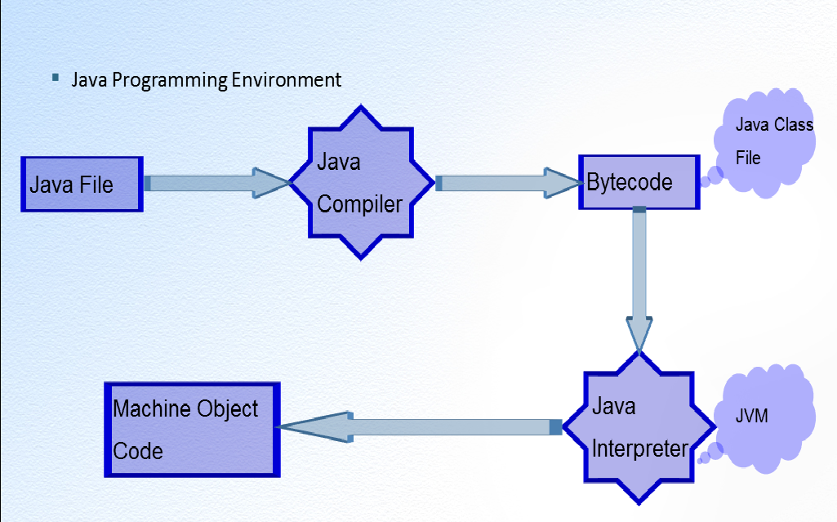

JVM (JAVA Virtual Machine): Java Virtual Machine is heart of JAVA.
JVM is a self-contained operating environment that behaves as if it is a separate computer.
For Example: Java applets run in a Java Virtual Machine that has no access to the host operating system. This design has 2 advantages:
- System Independence: A JAVA application will run the same in any JAVAVM regardless of the hardware and software underlying the system.
- Security: Because VM has no Contact with the operating System, there is little possibility of Java Program damaging other files or applications.

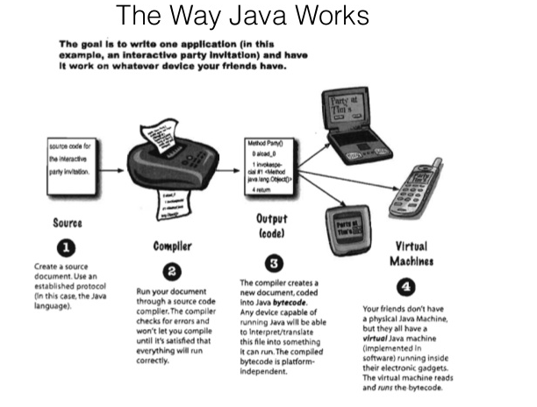

1.8 JAVA API (Application Programming Interface)

An application programming Interface (API) is Library of Functions that java provides for programmer for common tasks like File Transfer, Networking and Data Structures.

- Lets’ See following diagram of API

API

Java. AWT
Windows, Button, Mouse
Image

Java. Applet
Applet Class
Java.awt.peer

GUI Toolkit

Java.Util

System.getProperty
Java. I/O
System. Out
.Print
Java. Lang

Length Method for arrays; Exceptions
Java.Net

Sockets

1.9 Tools you will need:
For performing the examples discussed in this tutorial, you will need a Pentium 200-MHz computer with a minimum of 64 MB of RAM (128 MB of RAM recommended).
You also will need the following software’s:
- Linux 7.1 or Windows 95/98/2000/XP operating system.
- Java JDK 8
- Microsoft Notepad or any other text editor

1.10 Local Environment Set Up
If you are still willing to set up your environment for Java programming language, then this section guides you on how to download and set up Java on your machine. Please follow the following steps to set up the environment.
Java SE is freely available from the link Download Java. So you download a version based on your operating system.
Follow the instructions to download java and run the .exe to install Java on your machine. Once you installed Java on your machine, you would need to set environment variables to point to correct installation directories:

1.11 Setting up the path for windows 2000/XP:
Assuming you has installed Java in c:\Program Files\java\jdk directory:
- Right-click on 'My Computer' and select 'Properties'.
- Click on the 'Environment variables' button under the 'Advanced' tab.
- Now, alter the 'Path' variable so that it also contains the path to the Java executable. Example, if the path is currently set to 'C: \WINDOWS\SYSTEM32', then change your path to read 'C:\WINDOWS\SYSTEM32;c:\Program Files\java\jdk\bin'.
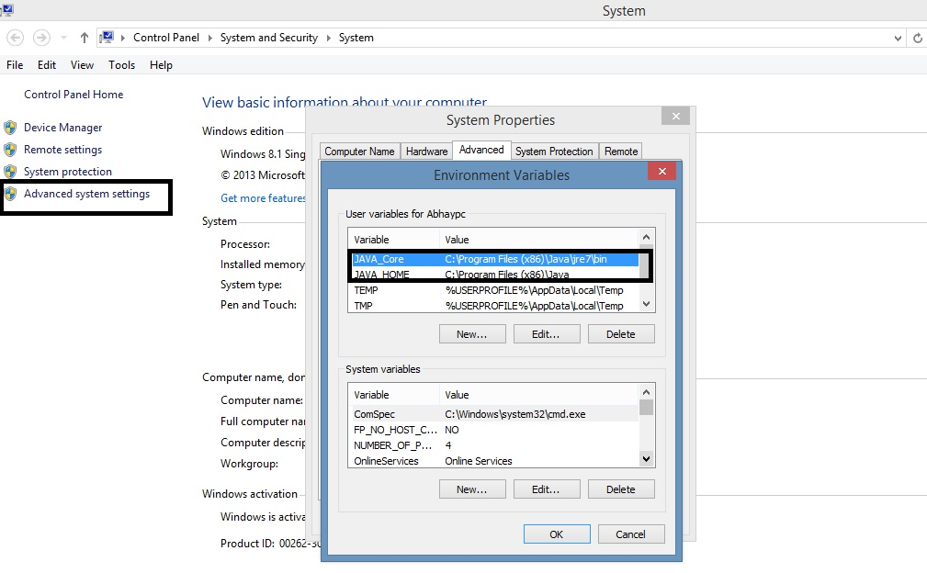

1.12 Setting up the path for windows 95/98/ME :
Assuming you has installed Java in c:\Program Files\java\jdk directory:
- Edit the 'C:\autoexec.bat' file and add the following line at the end:
'SET PATH=%PATH%;C:\Program Files\java\jdk\bin'

1.13 Setting up the path for Linux, UNIX, Solaris
Environment variable PATH should be set to point to where the Java binaries have been installed. Refer to your shell documentation if you have trouble doing this.
Example, if you use bash as your shell, then you would add the following line to the end of your '.bashrc: export PATH=/path/to/java:$PATH'

1.14 Popular Java Editors:
To write your Java programs, you will need a text editor. There are even more sophisticated IDEs available in the market. But for now, you can consider one of the following:
- Notepad: On Windows machine you can use any simple text editor like Notepad (Recommended for this tutorial), Text Pad.
- Net beans: is a Java IDE that is open-source and free which can be downloaded from http://www.netbeans.org/index.html.
- Eclipse: is also a Java IDE developed by the eclipse open-source community and can be downloaded from http://www.eclipse.org/.

1.15 Let’s Start with First Java Program

Execute First Java Program

/* This is my first java program.
* This will print 'Hello World' as the output
*/

public class Example {

public static void main(String [] args) {
System.out.println("Hello World");
}
}

Output:

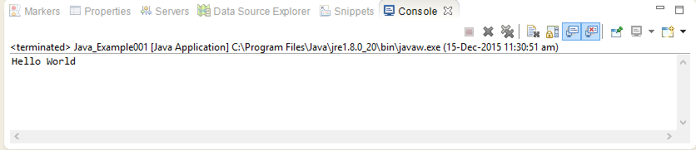

1.16 Run your program on Command Prompt
Let's look at how to save the file, compile and run the program. Please follow the steps given below:
- Open notepad and add the code as above.
- Save the file as: MyFirstJavaProgram.java.
- Open a command prompt window and go to the directory where you saved the class. Assume its C:\.
- Type ' javac Example.java ' and press enter to compile your code. If there are no errors in your code, the command prompt will take you to the next line (Assumption: The path variable is set).
- Now, type ' java Example ' to run your program.
- You will be able to see ' Hello World ' printed on the window.

1.17 Basic Syntax:
*About Java programs, it is very important to keep in mind the following points.
- Case Sensitivity - Java is case sensitive, which means identifier Hello and hello would have different meaning in Java.
- Class Names - For all class names the first letter should be in Upper Case.
If several words are used to form a name of the class, each inner word's first letter should be in Upper Case.
Example: public class Example

- Method Names - All method names should start with a Lower Case letter.
If several words are used to form the name of the method, then each inner word's first letter should be in Upper Case.
Example public void myMethodName
- Program File Name - Name of the program file should exactly match the class name.
When saving the file, you should save it using the class name (Remember Java is case sensitive) and append '.java' to the end of the name (if the file name and the class name do not match your program will not compile).
Example: Assume 'Example' is the class name. Then the file should be saved as 'Example.java' not “example1.java’

public static void main (String args[]) - Java program processing starts from the main () method which is a mandatory part of every Java.

1.18 Comments in Java
Java supports single-line and multi-line comments very similar to c and c++. All characters available inside any comment are ignored by Java compiler.

First Java Program
public class Example{

/* This is my first java program.
* This will print 'Hello World' as the output
* This is an example of multi-line comments.
*/

public static void main(String [] args){
// This is an example of single line comment
/* This is also an example of single line comment. */
System.out.println("Hello World");
}
}

2.0 Java Identifiers:
All Java components require names. Names used for classes, variables and methods are called identifiers.
In Java, there are several points to remember about identifiers. They are as follows:
- All identifiers should begin with a letter (A to Z or a to z), currency character ($) or an underscore (_).
- After the first character identifiers can have any combination of characters.
- A key word cannot be used as an identifier.
- Most importantly identifiers are case sensitive.
- Examples of legal identifiers: age, $salary, _value, __1_value
- Examples of illegal identifiers: 123abc, -salary

2.1 Java Specifiers:
Like other languages, it is possible to modify classes, methods, etc., by using Specifiers. There are two categories of Specifiers:
- Access Specifiers: default, public , protected, private
- Non-access Specifiers: final, abstract
We will be looking into more details about Specifiers in the next section.

2.2 Java Variables:
We would see following type of variables in Java:
- Local Variables
- Class Variables (Static Variables)
- Instance Variables (Non-static variables)

3.0 Array in Java
Java provides a data structure, the array, which stores a fixed-size sequential collection of elements of the same type. An array is used to store a collection of data, but it is often more useful to think of an array as a collection of variables of the same type.
Instead of declaring individual variables, such as number0, number1, ..., and number99, you declare one array variable such as numbers and use numbers[0], numbers[1], and ..., numbers[99] to represent individual variables.
Array Declaration
public class Java_Example023 {

public static void main(String[] args) {
// TODO Auto-generated method stub

//datatype[] name = new datatype[size]
char[] array = new char[5];

array[0]='a';
array[1]='e';
array[2]='i';
array[3]='o';
array[4]='u';

System.out.println(array[0]);
System.out.println(array[1]);
System.out.println(array[2]);
System.out.println(array[3]);
System.out.println(array[4]);

}

}

O/p=>
a
e
i
o
u

How to declare character Array
public class Java_Example022 {

// Example Explain about Basic Character Array
public static void main(String[] args) {
// TODO Auto-generated method stub
char[] array = {'a','e','i','o','u'};
System.out.println(array[0]);
System.out.println(array[1]);
System.out.println(array[2]);
System.out.println(array[3]);
}

}

3.1 What are Advantages and Disadvantages of arrays?
Advantages:
1. It is used to represent multiple data items of same type by using only single name.
2. It can be used to implement other data structures like linked lists, stacks, queues, trees, graphs etc.
3. 2D arrays are used to represent matrices.
Disadvantages:
1. We must know in advance that how many elements are to be stored in array.
2. Array is static structure. It means that array is of fixed size. The memory which is allocated to array cannot be increased or reduced.
3. Since array is of fixed size, if we allocate more memory than requirement then the memory space will be wasted. And if we allocate less memory than requirement, then it will create problem.
4. The elements of array are stored in consecutive memory locations. So insertions and deletions are very difficult and time consuming.

3.0 String Class in JAVA
Strings, which are widely used in Java programming, are a sequence of characters.
In the Java programming language, strings are objects .The Java platform provides the String class to create and manipulate strings.

4.0 Creating Strings:
The most direct way to create a string is to write:
String str = "Hello world!";
Whenever it encounters a string literal in your code, the compiler creates a String object with its value in this case, "Hello world!'.
As with any other object, you can create String objects by using the new keyword and a constructor. The String class has eleven constructors that allow you to provide the initial value of the string using different sources, such as an array of characters.
Note: The String class is immutable; so that once it is created a String object cannot be changed. If there is a necessity to make a lot of modifications to Strings of characters, then you should use String Buffer & String Builder Classes.

4.1 String Manipulation
The String class has a number of methods for examining the contents of strings, finding characters or substrings within a string, changing case, and other tasks.
Let’s start to introduce with different methods of strings

4.2 Way of Finding String Length:
Methods used to obtain information about an object are known as accessor methods. One accessor method that you can use with strings is the length () method, which returns the number of characters contained in the string object.
Below given program is an example of length() , method String class.
String Length Example
public class Java_Example026 {
/**
* @param args: To Overcome array fixed size problem , strings come in the picture,you can
* add more data into it;
*/
public static void main(String[] args) {
// TODO Auto-generated method stub
String str1= "Tester";
System.out.println("The length of String is:"+ str1.length());
System.out.println(str1.charAt(0));
System.out.println(str1.charAt(1));
System.out.println(str1.charAt(2));
System.out.println(str1.charAt(3));
System.out.println(str1.charAt(4));
System.out.println(str1.charAt(5));
}

}

Output=>The length of String is: 6
T
e
s
t
e
r

4.3 Java - String charAt() Method
This method returns the character located at the String's specified index. The string indexes start from zero.

Parameters:
Here is the detail of parameters:
- index -- Index of the character to be returned.

Return Value:
- This method Returns a char at the specified index.

4.4 Java - String concat() Method
The String class includes a method for concatenating two strings:
Syntax : string1.concat(string2);
This returns a new string that is string1 with string2 added to it at the end. You can also use the concat() method with string literals, as in:
Strings are more commonly concatenated with the + operator, as in:
String Concatenation Example
package co.in.quickitdotnet;

public class Java_Example017 {

/**
* @param args
*/
public static void main(String[] args) {
// TODO Auto-generated method stub
int i = 000007;
String st = Integer.toString(i);
String str = "James Bond";

System.out.println(st+str);
System.out.println("Concatenate string is :"+ str+st);
}

}
Output is: 7James Bond
Concatenate string is: James Bond7

4.5 Java - String toUpperCase() Method
Variant converts all of the characters in this String to upper case.
Syntax:
toUpperCase();

Return Value:
- It returns the String, converted to uppercase.
To Upper Case String Example
package co.in.quickitdotnet;

public class Java_Example027 {

public static void main(String[] args) {
// TODO Auto-generated method stub

String str = "Hello";
System.out.println("Default Case: "+ str);
System.out.println("Upper case is: "+ str.toUpperCase());
}
}

O/p=> Default Case: Hello
Upper case is: HELLO

4.6 Java - String toLowerCase() Method
Variant converts all of the characters in this String to lower case.
Syntax:
toLowerCase ();

Return Value:
- It returns the String, converted to lowercase.

Example:
To Lower Case String Example
package co.in.quickitdotnet;

public class Java_Example027 {

public static void main(String[] args) {
// TODO Auto-generated method stub

String str = "Hello";
System.out.println("Default Case: "+ str);
System.out.println("Lower case is: "+ str.toLowerCase());
}
}

O/p=> Default Case: Hello
Lower case is: hello

4.7 Java - String Split() Method

Suppose, I have a string, "004-034556", that I want to split into two strings:
string1=004
string2=034556
That means the first string will contain the characters before '-', and the second string will contain the characters after '-'. I also want to check if the string has '-' in it. If not, I will throw an exception. How can I do this?
String Split Program
package co.in.quickitdotnet;

public class Java_Example027 {

public static void main(String[] args) {
// TODO Auto-generated method stub

String string = "004-034556";
String[] parts = string.split("-");
String part1 = parts[0]; // 004
String part2 = parts[1];

}
}

Output=> 004
034556

4.8 Java - String substring () Method
This method has two variants and returns a new string that is a substring of this string. The substring begins with the character at the specified index and extends to the end of this string or up to endIndex - 1 if second argument is given.
Syntax:
public String substring(int startIndex): This method returns new String object containing the substring of the given string from specified startIndex (inclusive).

Always passed position as number under Substring and will return "String" relevant to that
position.

public String substring(int start Index, int end Index): This method returns new String object containing the substring of the given string from specified startIndex to endIndex.
String Array Program
package co.in.quickitdotnet;
public class Java_Example029 {
public static void main(String[] args) {
// TODO Auto-generated method stub
String str = "Java_Example029";
System.out.println(str.substring(12));
System.out.println(str.substring(0, 4));
System.out.println(str.substring(13));

}

}

Output:
029
Java
29

4.9 Java - String indexOf() Method
Returns the index within this string of the first occurrence of the specified substring. If it does not occur as a substring, -1 is returned.

String indexOf() Example
public class Java_Example030 {

/*This Example will explain you how to get correct position of string in big string
*
*/
public static void main(String[] args) {
// TODO Auto-generated method stub
String str = "https://www.google.com";
System.out.println(str.indexOf("www."));
System.out.println(str.indexOf(".com"));

//System.out.println(str.substring(str.indexOf("www.") , str.indexOf(".com")));

}

}

Output:
8
18

4.10 Java - String trim () Method
This method returns a copy of the string, with leading and trailing whitespace omitted.

String trim Example
package co.in.quickitdotnet;

public class Java_Example032 {
/*This Example will explain you how to get correct position of string in big string
* If we are entering username there might be chance user will enter space
* So before entering any entity in the database we have to trim.
*/
public static void main(String[] args) {
// TODO Auto-generated method stub
String str = " QuickITDotNet ";
System.out.println("Hi"+" "+ str +"!");
System.out.println("Hi"+" "+str.trim() +"!");

}

}

Output:
Hi QuickITDotNet !
Hi QuickITDotNet!

4.11 Java - String IsEmpty() Method

It always return Boolean value, if empty string is passed then will gives you status "True" otherwise "False"

String IsEmpty() Example
package co.in.quickitdotnet;

public class Java_Example033 {
/*This Example will explain about isEmpty() manipulation .
* It always return boolean value , if empty string is passed then will gives you
* status "True" otherwise "False"
*/
public static void main(String[] args) {
// TODO Auto-generated method stub
String str = "";
String str1 = "Hi";
System.out.println("First String empty status:"+" "+str.isEmpty());
System.out.println("Second String str1 status:"+" "+str1.isEmpty());
}

}
Output:
First String empty status: true
Second String str1 status: false

4.12 Java - String lastIndexOf() Method
LastIndexOf() method Searches for the last occurrence of a character or substring.
String IsEmpty() Example
package co.in.quickitdotnet;

public class Java_Example035 {
/*This Example will explain about character placed at which position
* by giving charAt(3) will give you third postion.
*
*/
public static void main(String[] args) {
// TODO Auto-generated method stub
String str = "sampleceodex";
System.out.println(str.charAt(3));// will gives you index at 3 position.
System.out.println(str.indexOf("e"));//Always passed string under indexof()operation
System.out.println(str.lastIndexOf("e"));
}

}

Output:
p
5
10

4.13 Java - String equalsIgnoreCase()Method
System will ignore case sensitive factor and if the text value is same it will gives you boolean expression True/ False

String equalsIgnoreCase() Example
package co.in.quickitdotnet;

/* If value is 'true', both are equal..
If value is 'false', both are not equal..=> Equal
// Ignore Case
* System will ignore case sensitive factor and if the text value is same it will
* gives you boolean expression True/ False;

*/
public class Java_Example036 {

public static void main(String[] args) {
// TODO Auto-generated method stub
String str = "apple ";
String str1= "APPLE";
System.out.println("Equal result:"+ str.equals(str1));
System.out.println("Equal with Ignore Case: "+ str.equalsIgnoreCase(str1));

}

}

4.14 Java - String replace()Method
This method returns a new string resulting from replacing all occurrences of oldChar in this string with newChar.

String replace()Example
package co.in.quickitdotnet;
/* Replace the String with manipulation str.replace()*/
public class Java_Example037 {

public static void main(String[] args) {
// TODO Auto-generated method stub
String str= "Hi Abhay! Please take coffee. Abhay Like coffee";

System.out.println("Replacing text:"+str.replace("coffee", "cold drink"));// replacing letter'e' with 'M'

}

}
Output:
Replacing text: Hi Abhay! Please take cold drink. Abhay Like cold drink
Output:
Equal result: false
Equal with Ignore Case: false

4.15 Java - String StartsWith()and EndsWith()Method
StartsWith: This method has two variants and tests if a string starts with the specified prefix beginning a specified index or by default at the beginning.
Endswith: This method tests if this string ends with the specified suffix.
Parameters:
Here is the detail of parameters:
- prefix -- the prefix to be matched.
- toffset -- where to begin looking in the string.

Return Value:
- It returns true if the character sequence represented by the argument is a prefix of the character sequence represented by this string; false otherwise.
String StartsWith() and EndsWith()Example
package co.in.quickitdotnet;
/* Test the string with Start at and end with*/
/*This will gives you boolean Expression. If the value is true then will give result true*/
public class Java_Example038
public static void main(String[] args) {
// TODO Auto-generated method stub
String str = "Product001";
String str1= "OPD001";
System.out.println("Starts with:"+str.startsWith("Pro"));
System.out.println("Starts with:"+str1.startsWith("Pro"));
// check with EndWidth Example
String str2= "Employee001";
System.out.println("Ends with:"+ str2.endsWith("001"));
}
}
Output:
Starts with: true
Starts with: false
Ends with: true

5. 0 Looping
There may be a situation when you need to execute a block of code several number of times. In general, statements are executed sequentially: The first statement in a function is executed first, followed by the second, and so on.
Programming languages provide various control structures that allow for more complicated execution paths.
A loop statement allows us to execute a statement or group of statements multiple times and following is the general form of a loop statement in most of the programming languages:
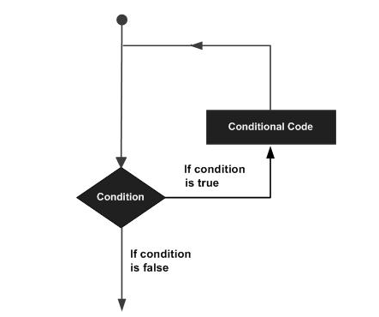

5.1 Let’s understand do- while loop
A do...while loop is similar to a while loop, except that a do...while loop is guaranteed to execute at least one time.

Syntax:
The syntax of a do...while loop is:
Syntax of do-while
do
{
//Statements
}while(Boolean_expression);

Notice that the Boolean expression appears at the end of the loop, so the statements in the loop execute once before the Boolean is tested.
If the Boolean expression is true, the control jumps back up to do statement, and the statements in the loop execute again. This process repeats until the Boolean expression is false.
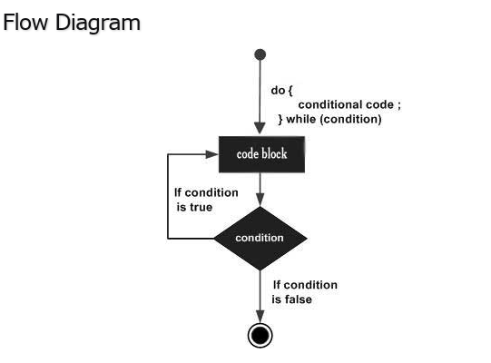
Do- while Loop Example
package co.in.quickitdotnet;

public class Test {

public static void main(String args[]){
int x = 10;

do{
System.out.print("value of x : " + x );
x++;
System.out.print("\n");
}while( x < 20 );
}

Output :
value of x : 10
value of x : 11
value of x : 12
value of x : 13
value of x : 14
value of x : 15
value of x : 16
value of x : 17
value of x : 18
value of x : 19

5.2 While Loop
A while loop statement in java programming language repeatedly executes a target statement as long as a given condition is true.

Syntax:
The syntax of a while loop is:
while Loop Example
package co.in.quickitdotnet;
while(Boolean_expression)
{
//Statements
}

Here, statement(s) may be a single statement or a block of statements. The condition may be any expression, and true is any non-zero value.
When executing, if the boolean_expression result is true, then the actions inside the loop will be executed. This will continue as long as the expression result is true.
When the condition becomes false, program control passes to the line immediately following the loop
Flow Diagram:
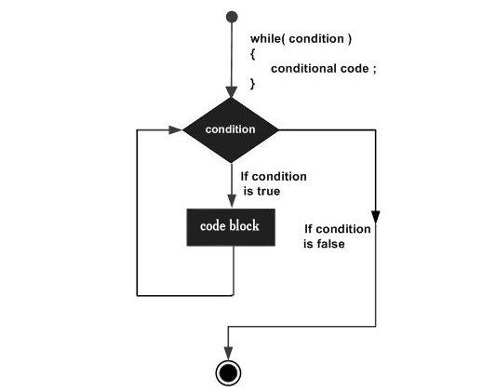
Here, key point of the while loop is that the loop might not ever run. When the expression is tested and the result is false, the loop body will be skipped and the first statement after the while loop will be executed.
While Loop Example
package co.in.quickitdotnet;

public class Test {

public static void main(String args[]) {
int x = 10;
while( x < 20 ) {
System.out.print("value of x : " + x );
x++;
System.out.print("\n");
}
}
}

Output:
value of x : 10
value of x : 11
value of x : 12
value of x : 13
value of x : 14
value of x : 15
value of x : 16
value of x : 17
value of x : 18
value of x : 19

5.3 For Loop
A for loop is a repetition control structure that allows you to efficiently write a loop that needs to execute a specific number of times.
A for loop is useful when you know how many times a task is to be repeated.

Syntax:
The syntax of for loop is:
Here is the flow of control in a for loop:
- The initialization step is executed first, and only once. This step allows you to declare and initialize any loop control variables. and this step ends with a semi colon (;)
- Next, the Boolean expression is evaluated. If it is true, the body of the loop is executed. If it is false, the body of the loop will not be executed and control jumps to the next statement past the for loop.
- After the body of the for loop gets executed, the control jumps back up to the update statement. This statement allows you to update any loop control variables. This statement can be left blank with a semicolon at the end.
- The Boolean expression is now evaluated again. If it is true, the loop executes and the process repeats (body of loop, then update step, then Boolean expression). After the Boolean expression is false, the for loop terminates.

Flow Diagram
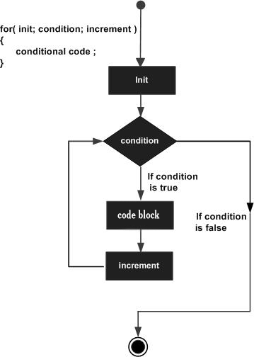

Example:
For Loop Example
package co.in.quickitdotnet;

public class Test {

public static void main(String args[]) {

for(int x = 10; x < 20; x = x+1) {
System.out.print("value of x : " + x );
System.out.print("\n");
}
}
}

Output :
value of x : 10
value of x : 11
value of x : 12
value of x : 13
value of x : 14
value of x : 15
value of x : 16
value of x : 17
value of x : 18
value of x : 19

5.4 Loop Control Statements:
Loop control statements change execution from its normal sequence. When execution leaves a scope, all automatic objects that were created in that scope are destroyed.
Java supports the following control statements
The break statement in Java programming language has the following two usages:
- When the break statement is encountered inside a loop, the loop is immediately terminated and program control resumes at the next statement following the loop.
- It can be used to terminate a case in the switch statement (covered in the next chapter).

Syntax:
The syntax of a break is a single statement inside any loop:
Break;
Flow Diagram
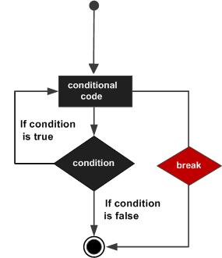

For Loop Example
package co.in.quickitdotnet;
public class Test {

public static void main(String args[]) {
int [] numbers = {10, 20, 30, 40, 50};
for(int x : numbers ) {
if( x == 30 ) {
break;
}
System.out.print( x );
System.out.print("\n");
}
}
}
Output:
10
20

5.5 Continue:
The continue keyword can be used in any of the loop control structures. It causes the loop to immediately jump to the next iteration of the loop.
- In for loop, the continue keyword causes control to immediately jump to the update statement.
- In a while loop or do/while loop, control immediately jumps to the Boolean expression.

Syntax:
The syntax of continue is a single statement inside any loop:
Continue;

Flow Diagram
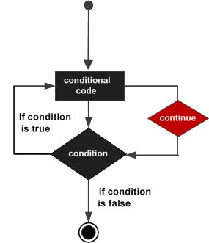

Continue Example
package co.in.quickitdotnet;

public class Test {

public static void main(String args[]) {
int [] numbers = {10, 20, 30, 40, 50};

for(int x : numbers ) {
if( x == 30 ) {
continue;
}
System.out.print( x );
System.out.print("\n");
}
}
}
Output:
10
20
30
40

5.6 Java Decision Making
Decision making structures have one or more conditions to be evaluated or tested by the program, along with a statement or statements that are to be executed if the condition is determined to be true, and optionally, other statements to be executed if the condition is determined to be false.
Following is the general form of a typical decision making structure found in most of the programming languages:
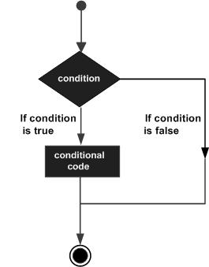
Java programming language provides following types of decision making statements. Click the following links to check their detail.
Statement | Description
if statement | An if statement consists of a Boolean expression followed by one or more statements.
if...else statement | An if statement can be followed by an optional else statement, which executes when the boolean expression is false.
nested if statements | You can use one if or else if statement inside another if or else if statement(s).
switch statement | A switch statement allows a variable to be tested for equality against a list of values.

The? : Operator:

Example:

Exp1? Exp2:Exp3

5.7 If Statement:
if statement consists of a Boolean expression followed by one or more statements.

Syntax:
The syntax of if statement is:
if(Boolean expression)
{
//Statements will execute if the Boolean expression is true
}
IF Example
package co.in.quickitdotnet;

public class Test {

public static void main(String args[]){
int x = 10;

do{
System.out.print("value of x : " + x );
x++;
System.out.print("\n");
}while( x < 20 );
}

5.8 If…..Else Statement:
An if statement can be followed by an optional else statement, which executes when the Boolean expression is false.

Syntax:
The syntax of an if...else is:
if(Boolean_expression){
//Executes when the Boolean expression is true
} else {
//Executes when the Boolean expression is false
}
If the boolean expression evaluates to true, then the if block of code will be executed, otherwise else block of code will be executed.

Flow Diagram
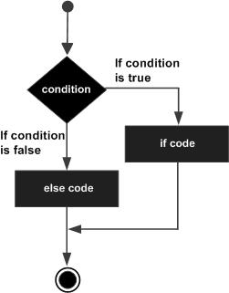

If Else Loop Example
package co.in.quickitdotnet;

public class Java_Example046 {

public static void main(String[] args) {
// TODO Auto-generated method stub

int x = 10;
int y= 12;
if(x>y){
System.out.println("X is greatest number"+x);
}
else{

System.out.println("y is the greatest number: "+y);
}
}

}
Output: y is the greatest number

5.9 The if...else if...else Statement:
An if statement can be followed by an optional else if...else statement, which is very useful to test various conditions using single if...else if statement.
When using if, else if , else statements there are few points to keep in mind.
- An if can have zero or one else's and it must come after any else if's.
- An if can have zero to many else if's and they must come before the else.
- Once an else if succeeds, none of the remaining else if's or else's will be tested.
if...else if ---if Loop Example
package co.in.quickitdotnet;

public class Java_Example048 {

public static void main(String[] args) {
// This Example demonstrate for If elseif else
int age = 60;
if(age>=18 && age<=50){
System.out.println("The person is young: "+age);
}
else if(age<18){
System.out.println("The person is Teenager:"+ age);

}else
{

System.out.println("The person is old:"+age);
}
}

}

5.10 Switch --- Case Statement
A switch statement is useful when you need to select one of several alternatives based on the value of an integer, a character, or a String variable. The basic form of the switch statement is this:
switch (expression)
{
case constant:
statements;
break;
[ case constant-2:
statements;
break; ] ...
[ default:
statements;
break; ] ...
}
The expression must evaluate to an int, short, byte, or char. It can’t be a long or a floating-point type.
Each grouping of code lines that starts with the case keyword and ends with a break statement is a case group. You can code as many case groups as you want or need. Each group begins with the word case, followed by a constant (usually, a numeric, character, or string literal) and a colon.
Then you code one or more statements that you want executed if the value of the switch expression equals the constant. The last line of each case group is a break statement, which causes the entire switch statement to end.
The default group, which is optional, is like a catch-all case group. Its statements are executed only if none of the previous case constants matches the switch expression.
The case groups are not true blocks marked with braces. Instead, each case group begins with the case keyword and ends with the case keyword that starts the next case group. All the case groups together, however, are defined as a block marked with a set of braces.
The last statement in each case group usually is a break statement. A break statement causes control to skip to the end of the switch statement. If you omit the break statement, control falls through to the next case group. Accidentally leaving out break statements is the most common cause of trouble with using a switch statement.
Switch Case Example
package co.in.quickitdotnet;

import java.util.Scanner;

public class Java_Example050 {

public static void main(String[] args) {
// Using Switch statement
Scanner s = new Scanner(System.in);
System.out.println("Please enter your choice");
System.out.println("1: Cofee");
System.out.println("2: black Cofee");
System.out.println("3: Tea");
System.out.println("4: Green Tea");
int choice = s.nextInt();
s.close();
switch(choice)
{
case 1:
System.out.println("Please take your cofee");
break;
case 2:
System.out.println("Please take your Black Cofee");
break;
case 3:
System.out.println("Please take your Tea");
break;
case 4:
System.out.println("Please take your Green Tea");
break;
default:
System.out.println("Invalid Choice");

}

}

}

5.11 for-each loop (Advanced or Enhanced For loop):
The for-each loop introduced in Java5. It is mainly used to traverse array or collection elements. The advantage of for-each loop is that it eliminates the possibility of bugs and makes the code more readable.

Advantage of for-each loop:
- It makes the code more readable.
- It eliminates the possibility of programming errors.

Syntax of for-each loop:
for(data type variable : array | collection){}
For Each Loop Example
package co.in.quickitdotnet;

public class Java_Example056 {

public static void main(String[] args) {
// TODO Auto-generated method stub
char[] array = {'a','e','i','o','u'};
for(int i=0; i<array.length; i++)
{
System.out.println(array[i]);
}
}

}

Output:
a
e
i
o
u

6.0 Scanner class in Java
There are various ways to read input from the keyboard; the java.util.Scanner class is one of them.
The Java Scanner class breaks the input into tokens using a delimiter that is whitespace by default. It provides many methods to read and parse various primitive values.
Java Scanner class is widely used to parse text for string and primitive types using regular expression.
Java Scanner class extends Object class and implements Iterator and Closeable interfaces.

Commonly used methods of Scanner class
There is a list of commonly used Scanner class methods:
Method | Description
public String next() | It returns the next token from the scanner.
public String nextLine() | It moves the scanner position to the next line and returns the value as a string.
public byte nextByte() | It scans the next token as a byte.
public short nextShort() | It scans the next token as a short value.
public int nextInt() | It scans the next token as an int value.
public long nextLong() | It scans the next token as a long value.
public float nextFloat() | It scans the next token as a float value.
public double nextDouble() | It scans the next token as a double value.

Java Scanner Example to get input from console
Scanner Example
package co.in.quickitdotnet;

import java.util.Scanner;

public class Java_Example058 {

public static void main(String[] args) {
// TODO Auto-generated method stub
System.out.println("Please enter your number:");
Scanner s = new Scanner(System.in);
int num= s.nextInt();
s.close();
for(int i =1; i<=num; i++){
String str = Integer.toString(i);// Convert number int to String
if(i<10){
System.out.println("0"+str);
}else{

System.out.println(str);
}

}

}

}

Output:
Please enter your number:
5
01
02
03
04
05

7. 0 Data Type

Variables are nothing but reserved memory locations to store values. This means that when you create a variable you reserve some space in memory.
Based on the data type of a variable, the operating system allocates memory and decides what can be stored in the reserved memory. Therefore, by assigning different data types to variables, you can store integers, decimals, or characters in these variables.
There are two data types available in Java:
- Primitive Data Types
- Reference/Object Data Types

7.1 Primitive Data Types:
There are eight primitive data types supported by Java. Primitive data types are predefined by the language and named by a keyword. Let us now look into detail about the eight primitive data types.

byte:
- Byte data type is an 8-bit signed two's complement integer.
- Minimum value is -128 (-2^7)
- Maximum value is 127 (inclusive)(2^7 -1)
- Default value is 0
- Byte data type is used to save space in large arrays, mainly in place of integers, since a byte is four times smaller than an int.
- Example: byte a = 100 , byte b = -50

short:
- Short data type is a 16-bit signed two's complement integer.
- Minimum value is -32,768 (-2^15)
- Maximum value is 32,767 (inclusive) (2^15 -1)
- Short data type can also be used to save memory as byte data type. A short is 2 times smaller than an int
- Default value is 0.
- Example: short s = 10000, short r = -20000

int:
- Int data type is a 32-bit signed two's complement integer.
- Minimum value is - 2,147,483,648.(-2^31)
- Maximum value is 2,147,483,647(inclusive).(2^31 -1)
- Int is generally used as the default data type for integral values unless there is a concern about memory.
- The default value is 0.
- Example: int a = 100000, int b = -200000

long:
- Long data type is a 64-bit signed two's complement integer.
- Minimum value is -9,223,372,036,854,775,808.(-2^63)
- Maximum value is 9,223,372,036,854,775,807 (inclusive). (2^63 -1)
- This type is used when a wider range than int is needed.
- Default value is 0L.
- Example: long a = 100000L, long b = -200000L

float:
- Float data type is a single-precision 32-bit IEEE 754 floating point.
- Float is mainly used to save memory in large arrays of floating point numbers.
- Default value is 0.0f.
- Float data type is never used for precise values such as currency.
- Example: float f1 = 234.5f

double:
- double data type is a double-precision 64-bit IEEE 754 floating point.
- This data type is generally used as the default data type for decimal values, generally the default choice.
- Double data type should never be used for precise values such as currency.
- Default value is 0.0d.
- Example: double d1 = 123.4

boolean:
- boolean data type represents one bit of information.
- There are only two possible values: true and false.
- This data type is used for simple flags that track true/false conditions.
- Default value is false.
- Example: boolean one = true

char:
- char data type is a single 16-bit Unicode character.
- Minimum value is '\u0000' (or 0).
- Maximum value is '\uffff' (or 65,535 inclusive).
- Char data type is used to store any character.
- Example: char letterA ='A'

Reference Data Types:
- Reference variables are created using defined constructors of the classes. They are used to access objects. These variables are declared to be of a specific type that cannot be changed. For example, Employee, Puppy etc.
- Class objects, and various type of array variables come under reference data type.
- Default value of any reference variable is null.
- A reference variable can be used to refer to any object of the declared type or any compatible type.
- Example: Animal animal = new Animal("giraffe");

8.0 Access Specifier in JAVA
There are two types of Specifiers in java: access Specifiers and non-access Specifiers.
The access Specifier in java specifies accessibility (scope) of a data member, method, constructor or class.
There are 4 types of java access Specifiers:
- private
- default
- protected
- public
There are many non-access Specifiers such as static, abstract, synchronized, native, volatile, transient etc. Here, we will learn access Specifiers.

8.1 Private access Specifier
The private access Specifier is accessible only within class.

Simple example of private access Specifier
In this example, we have created two classes A and Simple. A class contains private data member and private method. We are accessing these private members from outside the class, so there is compile time error.

Private access Specifier
- class A{
- private int data=40;
- private void msg(){System.out.println("Hello java");}
- }

- public class Simple{
- public static void main(String args[]){
- A obj=new A();
- System.out.println(obj.data);//Compile Time Error
- obj.msg();//Compile Time Error
- }
- }

8.2 Default access Specifier

If you don't use any Specifier, it is treated as default by default. The default Specifier is accessible only within package.

Example of default access Specifier

In this example, we have created two packages pack and mypack. We are accessing the A class from outside its package, since A class is not public, so it cannot be accessed from outside the package.

Default Specifier Example
package co.in.quickitdotnet;
// Save by A.Java

- package pack;
- class A{
- void msg(){System.out.println("Hello");}
- }

Default Example
package co.in.quickitdotnet;
// Save by B.Java
- package mypack;
- import pack.*;
- class B{
- public static void main(String args[]){
- A obj = new A();//Compile Time Error
- obj.msg();//Compile Time Error
- }
- }

8.3 Protected access Specifier
The protected access Specifier is accessible within package and outside the package but through inheritance only.
The protected access Specifier can be applied on the data member, method and constructor. It can't be applied on the class.
Example of protected access Specifier
In this example, we have created the two packages pack and mypack. The A class of pack package is public, so can be accessed from outside the package. But msg method of this package is declared as protected, so it can be accessed from outside the class only through inheritance.
In this example, we have created the two packages pack and mypack. The A class of pack package is public, so can be accessed from outside the package. But msg method of this package is declared as protected, so it can be accessed from outside the class only through inheritance.

Protected access Specifier
package co.in.quickitdotnet;

- //save by A.java
- package pack;
- public class A{
- protected void msg(){System.out.println("Hello");}
- }

Protected access Specifier
package co.in.quickitdotnet;
- //save by B.java
- package mypack;
- import pack.*;

- class B extends A{
- public static void main(String args[]){
- B obj = new B();
- obj.msg();
- }
- }

Output: Hello

8.4 Public access Specifier
The public access Specifier is accessible everywhere. It has the widest scope among all other Specifiers.

Example of public access Specifier
Public Access Example
package co.in.quickitdotnet;
//save by A.Java
- package pack;
- public class A{
- public void msg(){System.out.println("Hello");}
- }

Example
package co.in.quickitdotnet;
- //save by B.java

- package mypack;
- import pack.*;

- class B{
- public static void main(String args[]){
- A obj = new A();
- obj.msg();
- }
- }

Output: Hello

8.5 Understanding all java access Specifiers
Let's understand the access Specifiers by a simple table.
Access Specifier | within class | within package | outside package by subclass only | outside package
Private | Y | N | N | N
Default | Y | Y | N | N
Protected | Y | Y | Y | N
Public | Y | Y | Y | Y

9.0 Java OOPs Advantages
Object Oriented Programming is a paradigm that provides many concepts such as inheritance, data binding, polymorphism etc.
Simula is considered as the first object-oriented programming language. The programming paradigm where everything is represented as an object, is known as truly object-oriented programming language.
Smalltalk is considered as the first truly object-oriented programming language.

OOPs (Object Oriented Programming System)
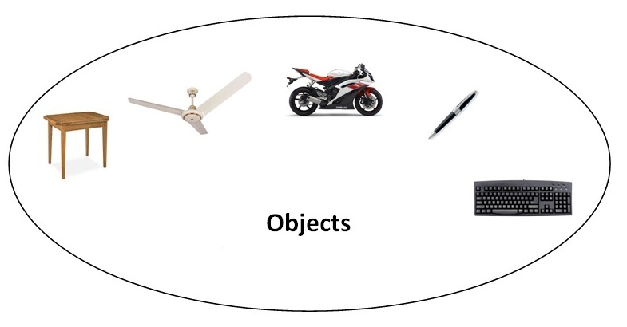Object means a real word entity such as pen, chair, table etc. Object-Oriented Programming is a methodology or paradigm to design a program using classes and objects. It simplifies the software development and maintenance by providing some concepts:
- Object
- Class
- Inheritance
- Polymorphism
- Abstraction
- Encapsulation

9.1 Object
Any entity that has state and behavior is known as an object. For example: chair, pen, table, keyboard, bike etc. It can be physical and logical.

9.2 Class
Collection of objects is called class. It is a logical entity.

Inheritance
When one object acquires all the properties and behaviours of parent object i.e. known as inheritance. It provides code reusability. It is used to achieve runtime polymorphism.
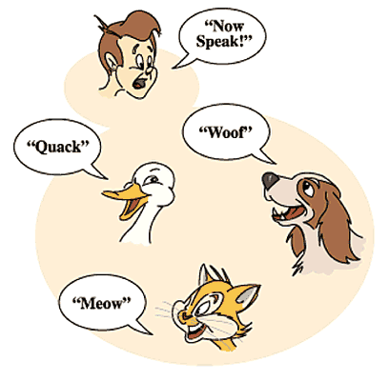

9.4 Advantage of OOPs over Procedure-oriented programming language
1) OOP’s make development and maintenance easier where as in Procedure-oriented programming language it is not easy to manage if code grows as project size grows.
2) OOP’s provides data hiding whereas in Procedure-oriented programming language a global data can be accessed from anywhere.
3) OOP’s provides ability to simulate real-world event much more effectively. We can provide the solution of real word problem if we are using the Object-Oriented Programming language.

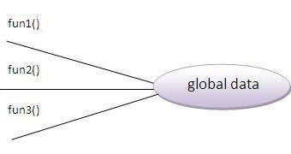 | 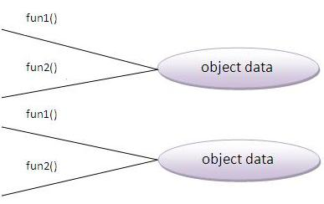

What is difference between object-oriented programming language and object-based programming language?
Object based programming language follows all the features of OOPs except Inheritance. JavaScript and VBScript are examples of object based programming languages.

6.1 Java Naming Conventional
Java naming convention is a rule to follow as you decide what to name your identifiers such as class, package, variable, constant, method etc.
But, it is not forced to follow. So, it is known as convention not rule.
All the classes, interfaces, packages, methods and fields of java programming language are given according to java naming convention.

6.2 Advantage of naming conventions in java
By using standard Java naming conventions, you make your code easier to read for yourself and for other programmers. Readability of Java program is very important. It indicates that less time is spent to figure out what the code does.
Name | Convention
class name | should start with uppercase letter and be a noun e.g. String, Color, Button, System, Thread etc.
interface name | should start with uppercase letter and be an adjective e.g. Runnable, Remote, ActionListener etc.
method name | should start with lowercase letter and be a verb e.g. actionPerformed(), main(), print(), println() etc.
variable name | should start with lowercase letter e.g. firstName, orderNumber etc.
package name | should be in lowercase letter e.g. java, lang, sql, util etc.
constants name | should be in uppercase letter. e.g. RED, YELLOW, MAX_PRIORITY etc.

CamelCase in java naming conventions
Java follows camel case syntax for naming the class, interface, method and variable.
If name is combined with two words, second word will start with uppercase letter always e.g. actionPerformed(), firstName, ActionEvent, ActionListener etc.

10.0 Object and Class in Java
In this page, we will learn about java objects and classes. In object-oriented programming technique, we design a program using objects and classes.
Object is the physical as well as logical entity whereas class is the logical entity only.

10.1 Object in Java
An entity that has state and behavior is known as an object e.g. chair, bike, marker, pen, table, car etc. It can be physical or logical (tengible and intengible). The example of intangible object is banking system.
An object has three characteristics:
- State: represents data (value) of an object.
- Behavior: represents the behavior (functionality) of an object such as deposit, withdraw etc.
- identity: Object identity is typically implemented via a unique ID. The value of the ID is not visible to the external user. But,it is used internally by the JVM to identify each object uniquely.
For Example: Pen is an object. Its name is Reynolds, color is white etc. known as its state. It is used to write, so writing is its behavior.

Object is an instance of a class. Class is a template or blueprint from which objects are created. So object is the instance(result) of a class.

7.2 Class in Java
A class is a group of objects that has common properties. It is a template or blueprint from which objects are created.
A class in java can contain:
- data member
- method
- constructor
- block
- class and interface

7.3 Syntax to declare a class:

class <class_name>{
data member;
method;
}

10.2 Simple Example of Object and Class
In this example, we have created a Java_Example083 class that has two data members’ id and name. We are creating the object of the Student class by new keyword and printing the objects value.
Class Example
package co.in.quickitdotnet;

public class Java_Example083 {
int id= 1;//data member (also instance variable)
String Name= "Testing";//data member (also instance variable)
public static void main(String[] args) {
// TODO Auto-generated method stub
Java_Example083 s1=new Java_Example083();//creating an object of Student
System.out.println(s1.id);
System.out.println(s1.Name);

}

}

Output=>
1
Testing

10.3 Instance variable in Java
A variable that is created inside the class but outside the method, is known as instance variable. Instance variable doesn't get memory at compile time.It gets memory at runtime when object(instance) is created. That is why, it is known as instance variable.

11.0 Methods in Java
In java, a method is like function i.e. used to expose behaviour of an object.

11.1 Advantage of Method
- Code Reusability
- Code Optimization

11.2 Use of new keyword
The new keyword is used to allocate memory at runtime.

11.3 Example of Object and class that maintains the records of students
In this example, we are creating the two objects of Student class and initializing the value to these objects by invoking the insertRecord method on it. Here, we are displaying the state (data) of the objects by invoking the displayInformation method.

Declaration of method in class
package co.in.quickitdotnet;

public class Java_Example084 {
int rollno;
String name;
public static void main(String[] args) {
Java_Example084 s1=new Java_Example084();
Java_Example084 s2=new Java_Example084();
s1.insertRecord(111,"Karan");
s2.insertRecord(222,"Aryan");
s1.displayInformation();
s2.displayInformation();
}

void insertRecord(int r, String n)
{ //method
rollno=r;
name=n;
}

void displayInformation(){
System.out.println(rollno+" "+name);}//method

}

Output:
111 Karan
222 Aryan
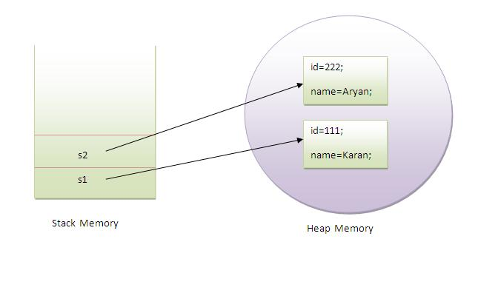
As you see in the above figure, object gets the memory in Heap area and reference variable refers to the object allocated in the Heap memory area. Here, s1 and s2 both are reference variables that refer to the objects allocated in memory.

12.0 Exception Handling

The exception handling in java is one of the powerful mechanisms to handle the runtime errors so that normal flow of the application can be maintained.
In this page, we will learn about java exception, its type and the difference between checked and unchecked exceptions.

12.1 What is exception?
Dictionary Meaning: Exception is an abnormal condition.
In java, exception is an event that disrupts the normal flow of the program. It is an object which is thrown at runtime.

12.2 What is exception handling
Exception Handling is a mechanism to handle runtime errors such as ClassNotFound, IO, SQL, Remote etc.

12.3 Advantage of Exception Handling
The core advantage of exception handling is to maintain the normal flow of the application. Exception normally disrupts the normal flow of the application that is why we use exception handling. Let's take a scenario:
Exception Scenario
- statement 1;
- statement 2;
- statement 3;
- statement 4;
- statement 5;//exception occurs
- statement 6;
- statement 7;
- statement 8;
- statement 9;
- statement 10;

Suppose there is 10 statements in your program and there occurs an exception at statement 5, rest of the code will not be executed i.e. statement 6 to 10 will not run. If we perform exception handling, rest of the statement will be executed. That is why we use exception handling in java.

Hierarchy of Java Exception classes
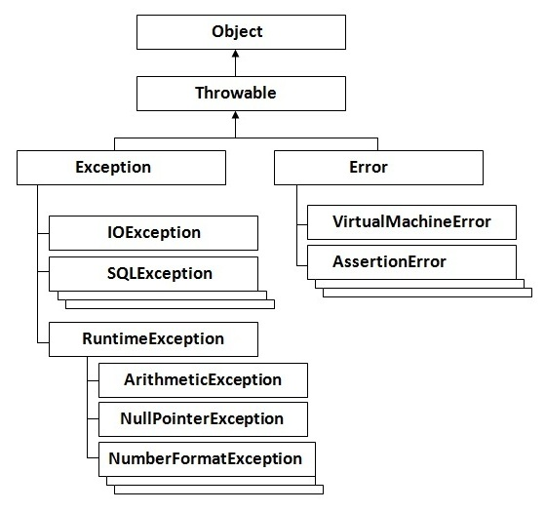

12.4 Types of Exception
There are mainly two types of exceptions: checked and unchecked where error is considered as unchecked exception. The sun microsystem says there are three types of exceptions:
- Checked Exception
- Unchecked Exception
- Error

12.5 Difference between checked and unchecked exceptions

1) Checked Exception
The classes that extend Throwable class except RuntimeException and Error are known as checked exceptions e.g.IOException, SQLException etc. Checked exceptions are checked at compile-time.

2) Unchecked Exception
The classes that extend RuntimeException are known as unchecked exceptions e.g. ArithmeticException, NullPointerException, ArrayIndexOutOfBoundsException etc. Unchecked exceptions are not checked at compile-time rather they are checked at runtime.

3) Error
Error is irrecoverable e.g. OutOfMemoryError, VirtualMachineError, AssertionError etc.

12.6 Common scenarios where exceptions may occur
There are given some scenarios where unchecked exceptions can occur. They are as follows:

1) Scenario where ArithmeticException occurs
If we divide any number by zero, there occurs an ArithmeticException.
int a=50/0;//ArithmeticException

2) Scenario where NullPointerException occurs
If we have null value in any variable, performing any operation by the variable occurs an NullPointerException.
- String s=null;
- System.out.println(s.length());//NullPointerException

3) Scenario where NumberFormatException occurs
The wrong formatting of any value, may occur NumberFormatException. Suppose I have a string variable that have characters, converting this variable into digit will occur NumberFormatException.
- String s="abc";
- int i=Integer.parseInt(s);//NumberFormatException

4) Scenario where ArrayIndexOutOfBoundsException occurs
If you are inserting any value in the wrong index, it would result ArrayIndexOutOfBoundsException as shown below:
- int a[]=new int[5];
- a[10]=50; //ArrayIndexOutOfBoundsException

12.7 Java Exception Handling Keywords
There are 5 keywords used in java exception handling.
- try
- catch
- finally
- throw
- throws

12.8 Java Try Block
Java try block is used to enclose the code that might throw an exception. It must be used within the method.
Java try block must be followed by either catch or finally block.
Try Catch Syntax
- try{
- //code that may throw exception
- }catch(Exception_class_Name ref){}

12.9 Internal working of java try-catch block
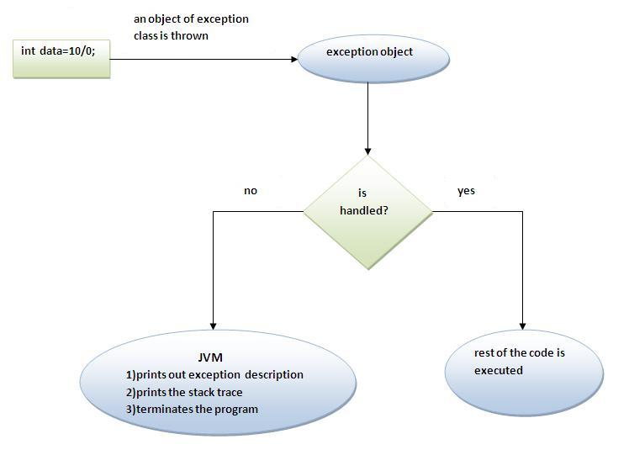
The JVM firstly checks whether the exception is handled or not. If exception is not handled, JVM provides a default exception handler that performs the following tasks:
- Prints out exception description.
- Prints the stack trace (Hierarchy of methods where the exception occurred).
- Causes the program to terminate.
But if exception is handled by the application programmer, normal flow of the application is maintained i.e. rest of the code is executed.

Example of Try-Catch Block
package co.in.quickitdotnet;

public class Java_Example075 {

public static void main(String[] args) {
// TODO Auto-generated method stub
try{
int data=50/0;//may throw exception
System.out.println("rest of the code..."+ data);
}catch(Exception e){
e.printStackTrace();
}
}

}

Output: java.lang.ArithmeticException: / by zero
at co.in.quickitdotnet.Java_Example075.main(Java_Example075.java:8)

12.10 Multiple Catch Block
If you have to perform different tasks at the occurrence of different Exceptions, use java multi catch block.
Let's see a simple example of java multi-catch block.
Multiple Catch Block Example
package co.in.quickitdotnet;

public class Java_Example076 {

public static void main(String[] args) {
// TODO Auto-generated method stub
try{
int a[]=new int[5];
a[6]=30/0;
}
catch(ArithmeticException e)
{
e.printStackTrace();
}
catch(ArrayIndexOutOfBoundsException e)
{
System.out.println("task 2 completed");
}
catch(Exception e)
{
System.out.println("common task completed");
}
finally{
System.out.println("I am Finally");
}
System.out.println("rest of the code...");
}
}
Output=> java.lang.ArithmeticException: / by zero
at co.in.quickitdotnet.Java_Example076.main(Java_Example076.java:9)
I am Finally
rest of the code...

12.11 Rules for Exception Handling
Rule: At a time only one Exception is occured and at a time only one catch block is executed.
Rule: All catch blocks must be ordered from most specific to most general i.e. catch for ArithmeticException must come before catch for Exception .
Rule: Finally always be executed.

12.12 JAVA Finally Block
Java finally block is a block that is used to execute important code such as closing connection, stream etc.
Java finally block is always executed whether exception is handled or not.
Java finally block must be followed by try or catch block.
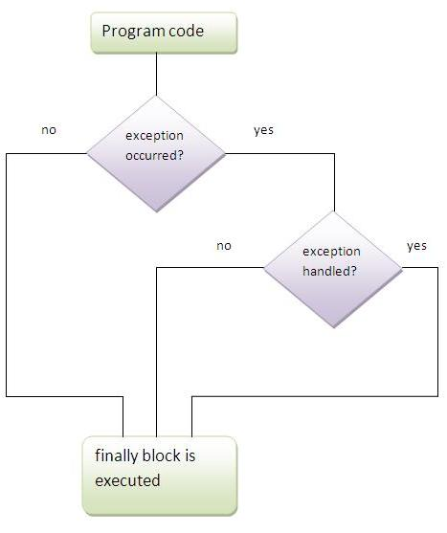

Note: If you don't handle exception, before terminating the program, JVM executes finally block(if any).

12.13 Why use java finally
- Finally block in java can be used to put "cleanup" code such as closing a file, closing connection etc.

12.14 Usage of Java finally
Let's see the different cases where java finally blocks can be used.

Case 1
Let's see the java finally example where exception doesn't occur.
Finally Example
package co.in.quickitdotnet;

public class Java_Example078 {
public static void main(String[] args) {
// TODO Auto-generated method stub
try{
int a[]=new int[5];
a[4]=30/6;
}
catch(ArithmeticException e)
{
e.printStackTrace();
}
catch(ArrayIndexOutOfBoundsException e)
{
e.printStackTrace();
}
catch(Exception e)
{
e.printStackTrace();
}
finally{
System.out.println("I am Finally");
}
System.out.println("rest of the code...");
}
}

Rule: For each try block there can be zero or more catch blocks, but only one finally block.
Output: I am Finally
rest of the code...

Note: The finally block will not be executed if program exits(either by calling System.exit() or by causing a fatal error that causes the process to abort).

System.exit()Example
package co.in.quickitdotnet;

public class Java_Example080 {
public static void main(String[] args) throws Exception {
// Finally block will not get execute when system.exit call or any Fatal error which is 3rd type of Exception.
try{
int a[]=new int[5];
a[4]=30/5;
System.out.println("Just before System Exit");
System.exit(-1);

}
catch(ArithmeticException e)
{
e.printStackTrace();
}
catch(ArrayIndexOutOfBoundsException e)
{
e.printStackTrace();
}
catch(Exception e)
{
e.printStackTrace();
}
finally{
System.out.println("I am Finally");
}
System.out.println("rest of the code...");
}
}
Output :=> Just before System Exit

12.15 JAVA Throw Exception

The Java throw keyword is used to explicitly throw an exception.
We can throw either checked or unchecked exceptions in java by throw keyword. The throw keyword is mainly used to throw custom exception. We will see custom exceptions later.
The syntax of java throw keyword is given below.
Throw Exception Syntax
throw exception;
Let's see the example of throw IOException.
Throw Exception Syntax
throw new IOException("sorry device error);
In this example, we have created the validate method that takes integer value as a parameter. If the age is less than 18, we are throwing the ArithmeticException otherwise print a message welcome to vote.
Throw keyword Example
package co.in.quickitdotnet;

public class Java_Example081 {
//The Java throw keyword is used to explicitly throw an exception.
//We can throw either checked or unchecked exception in java by throw keyword.

public static void main(String[] args) {
validate(12);
System.out.println("rest of the code...");
}
static void validate(int i) {

int age = i;
if(age<18) {
throw new ArithmeticException("not valid");
}
else {
System.out.println("welcome to vote");
}
}
}
Output: Exception in thread "main" java.lang.ArithmeticException: not valid
at co.in.quickitdotnet.Java_Example081.validate(Java_Example081.java:18 at co.in.quickitdotnet.Java_Example081.main(Java_Example081.java:11)

12.16 Java Throws Exception
The Java throws keyword is used to declare an exception. It gives information to the programmer that there may occur an exception so it is better for the programmer to provide the exception handling code so that normal flow can be maintained.
Exception Handling is mainly used to handle the checked exceptions. If there occurs any unchecked exception such as NullPointerException, it is programmers fault that he is not performing checkup before the code being used.

Syntax of java throws
Syntax for throws
return_type method_name() throws exception_class_name{ }

12.17 Which exception should be declared
Ans) checked exception only, because:
- Unchecked Exception: under your control so correct your code.
- Error: beyond your control e.g. you are unable to do anything if there occurs VirtualMachineError or StackOverflowError.

12.18 Advantage of Java throws keyword
Now Checked Exception can be propagated (forwarded in call stack).
It provides information to the caller of the method about the exception.
Syntax for throws
return_type method_name() throws exception_class_name{
//method code
}

12.19 Which exception should be declared
Ans) checked exception only, because:
Unchecked Exception: under your control so correct your code.
Error: beyond your control e.g. you are unable to do anything if there occurs VirtualMachineError or StackOverflowError.

12.20 Advantage of Java throws keyword
Now Checked Exception can be propagated (forwarded in call stack). It provides information to the caller of the method about the exception.
Throws Example
package co.in.quickitdotnet;

import java.io.IOException;

public class Java_Example082 {

void m()throws IOException{
throw new IOException("device error");//checked exception
}
void n()throws IOException{ m();
}
void p(){
try{
n();
}catch(Exception e)
{
System.out.println("exception handled");
}
}
public static void main(String args[]){
Java_Example082 obj=new Java_Example082();
obj.p();
System.out.println("normal flow...");
}
}

Output:
exception handled
normal flow...

12.21 Let’s learn difference between Throw and Throws

No. | Throw | throws
1) | Java throw keyword is used to explicitly throw an exception. | Java throws keyword is used to declare an exception.
2) | Checked exception cannot be propagated using throw only. | Checked exception can be propagated with throws.
3) | Throw is followed by an instance. | Throws is followed by class.
4) | Throw is used within the method. | Throws is used with the method signature.
5) | You cannot throw multiple exceptions. | You can declare multiple exceptions e.g.  public void method()throws IOException,SQLException.

12.22 Difference between final, finally and finalize
There are many differences between final, finally and finalize. A list of differences between final, finally and finalize are given below:
No. | Final | finally | finalize
1) | Final is used to apply restrictions on class, method and variable. Final class can't be inherited, final method can't be overridden and final variable value can't be changed. | Finally is used to place important code, it will be executed whether exception is handled or not. | Finalize is used to perform clean up processing just before object is garbage collected.
2) | Final is a keyword. | Finally is a block. | Finalize is a method.

13.00 Collections:

Let’s see hierarchy of collection Interface.

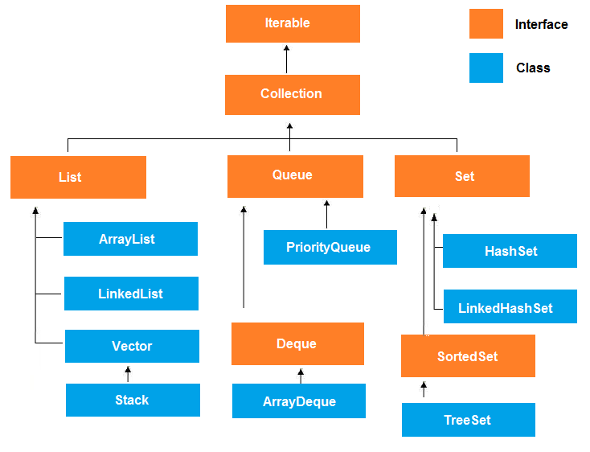

13.1 Java Array List

Java Array List class uses a dynamic array for storing the elements. It extends Abstract List class and implements List interface.
Java Array List class can contain duplicate elements.
Java Array List class maintains insertion order.
Java Array List class is non-synchronized.
Java Array List allows random access because array works at the index basis.
In Java Array List class, manipulation is slow because a lot of shifting needs to be occurred if any element is removed from the array list.
ArrayList Syntax
ArrayList<String> al=new ArrayList<String>();

ArrayList Example
package co.in.quickitdotnet;

import java.util.ArrayList;

public class Java_Example068 {

public static void main(String[] args) {
// Collections API ArrayList
ArrayList<String> list = new ArrayList<String>();
list.add("Delhi");// add is the properties where you can add the element so arrays can be grown dynamically
list.add("2");
list.add("Goa");
list.add("2");
list.add("Maths");
System.out.println("Size of arraylist is "+ list.size());
System.out.println("Get 1st element: "+list.get(2));
for(int i =0; i<list.size(); i++)// Extract all the elements in the webpage
{
System.out.println("Result: "+ list.get(i));
}

}

}

Output=>
Delhi
2
Goa
2
Maths

13.2 Java Linked List class
- Java Linked List class uses doubly linked list to store the elements. It extends the Abstract List class and implements List and Deque interfaces.
- Java Linked List class can contain duplicate elements.
- Java Linked List class maintains insertion order.
- Java Linked List class is non-synchronized.
- In Java Linked List class, manipulation is fast because no shifting needs to be occurred.
- Java Linked List class can be used as list, stack or queue.
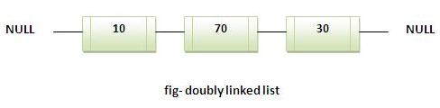

Linked List Example
package co.in.quickitdotnet;

import java.util.Iterator;
import java.util.LinkedList;

public class Java_Example073 {

public static void main(String[] args) {
// This example will give idea about linked list
LinkedList<String> al=new LinkedList<String>();
al.add("Ravi");
al.add("Vijay");
al.add("Ravi");
al.add("Ajay");
Iterator<String> itr=al.iterator();
while(itr.hasNext()){
System.out.println(itr.next());
}
}
}

Output:
Ravi
Vijay
Ravi
Ajay

13.3 Difference between ArrayList and LinkedList
Array List and Linked List both implements List interface and maintains insertion order. Both are non-synchronized classes.
But there are many differences between Array List and Linked List classes that are given below.
ArrayList | LinkedList
1) Array List internally uses dynamic array to store the elements. | Linked List internally uses doubly linked list to store the elements.
2) Manipulation with Array List is slow because it internally uses array. If any element is removed from the array, all the bits are shifted in memory. | Manipulation with LinkedList is faster than ArrayList because it uses doubly linked list so no bit shifting is required in memory.
3) ArrayList class can act as a list only because it implements List only. | LinkedList class can act as a list and queue both because it implements List and Deque interfaces.
4) ArrayList is better for storing and accessing data. | LinkedList is better for manipulating data.

13.4 Java List Iterator Interface

List Iterator Interface is used to traverse the element in backward and forward direction.

Commonly used methods of List Iterator Interface:
- public boolean hasNext();
- public Object next();
- public boolean hasPrevious();
- public Object previous();
List Iterator in Java
- import java.util.*;
- public class TestCollection8{
- public static void main(String args[]){

- ArrayList<String> al=new ArrayList<String>();
- al.add("Amruta");
- al.add("Vijay");
- al.add("Kumar");
- al.add(1,"Sachin");

- System.out.println("element at 2nd position: "+al.get(2));

- ListIterator<String> itr=al.listIterator();

- System.out.println("traversing elements in forward direction...");
- while(itr.hasNext()){
- System.out.println(itr.next());
- }

- System.out.println("traversing elements in backward direction...");
- while(itr.hasPrevious()){
- System.out.println(itr.previous());
- }
- }
- }

Output: element at 2nd position: Vijay
traversing elements in forward direction...
Amruta
Sachin
Vijay
Kumar
traversing elements in backward direction...
Kumar
Vijay
Sachin
Amruta

13.5 HashSet Class Interface

- A HashMap contains values based on the key. It implements the Map interface and extends AbstractMap class.
- It contains only unique elements.
- It may have one null key and multiple null values.
- It maintains no order.

13.6 Hierarchy of HashMap class:
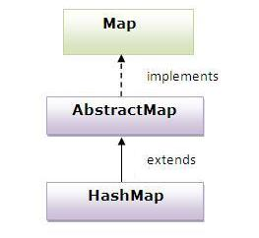

13.7 Example of HashMap class:

Hash Map Example
- class TestCollection13{
- public static void main(String args[]){

- HashMap<Integer,String> hm=new HashMap<Integer,String>();

- hm.put(100,"Amruta");
- hm.put(101,"Vijay");
- hm.put(102,"Rahul");

- for(Map.Entry m:hm.entrySet()){
- System.out.println(m.getKey()+" "+m.getValue());
- }
- }
- }

13.8 Java HashTable Class
- A Hashtable is an array of list.Each list is known as a bucket.The position of bucket is identified by calling the hashcode() method.A Hashtable contains values based on the key. It implements the Map interface and extends Dictionary class.
- It contains only unique elements.
- It may have not have any null key or value.
- It is synchronized.
HashTable Example
package co.in.quickitdotnet;
import java.util.Hashtable;
import java.util.Set;

public class Java_Example069 {
/// Hashtable also grows dynamically having key pair value
public static void main(String[] args) {
// TODO Auto-generated method stub
Hashtable< String, String> table = new Hashtable<String , String>();
table.put("name", "Amruta");
table.put("Place", "India");
System.out.println(table.get("name"));
System.out.println(table);
Set<String>keys = table.keySet();// Iteration of hashtable we need to create object of Set
for(String data:keys)
{
System.out.println("Elemets: "+ table.get(data));
}

}

}
Output:
Amruta
{name=Amruta, Place=India}
Elemets: Amruta
Elemets: India

13.9 Difference between Hashmap and HashTable
HashMap and Hashtable both are used to store data in key and value form. Both are using hashing technique to store unique keys.
But there are many differences between HashMap and Hashtable classes that are given below.
HashMap | Hashtable
1) HashMap is non synchronized. It is not-thread safe and can't be shared between many threads without proper synchronization code. | Hashtable is synchronized. It is thread-safe and can be shared with many threads.
2) HashMap allows one null key and multiple null values. | Hashtable doesn't allow any null key or value.
3) HashMap is a new class introduced in JDK 1.2. | Hashtable is a legacy class.
4) HashMap is fast. | Hashtable is slow.
5) We can make the HashMap as synchronized by calling this code  Map m = Collections.synchronizedMap(hashMap); | Hashtable is internally synchronized and can't be unsynchronized.
6) HashMap is traversed by Iterator. | Hashtable is traversed by Enumerator and Iterator.
7) Iterator in HashMap is fail-fast. | Enumerator in Hashtable is not fail-fast.
8) HashMap inherits AbstractMap class. | Hashtable inherits Dictionary class.

14.0 Vectors

Vector implements a dynamic array. It is similar to ArrayList, but with two differences:
- Vector is synchronized.
- Vector contains many legacy methods that are not part of the collections framework.
Vector proves to be very useful if you don't know the size of the array in advance or you just need one that can change sizes over the lifetime of a program.

Vector Example
package co.in.quickitdotnet;

import java.util.Enumeration;
import java.util.Vector;

public class Java_Example074 {

public static void main(String[] args) {
// TODO Auto-generated method stub
/* Vector of initial capacity(size) of 2 */
Vector<String> vec = new Vector<String>(2);

/* Adding elements to a vector*/
vec.addElement("Apple");
vec.addElement("Orange");

System.out.println("Size is: "+vec.size());
System.out.println("Capacity is: "+vec.capacity());

vec.addElement("Mango");

System.out.println("Size is: "+vec.size());
System.out.println("Capacity is: "+vec.capacity());
vec.addElement("Fig");

/* check size and capacityIncrement*/
System.out.println("Size is: "+vec.size());
System.out.println("Default capacity increment is: "+vec.capacity());

vec.addElement("fruit1");
vec.addElement("fruit2");
vec.addElement("fruit3");

/*size and capacityIncrement after two insertions*/
System.out.println("Size after addition: "+vec.size());
System.out.println("Capacity after increment is: "+vec.capacity());

/*Display Vector elements*/
Enumeration<String> en = vec.elements();
System.out.println("\nElements are:");
while(en.hasMoreElements())
System.out.print(en.nextElement() + " ");
}
}

14.1 The Purpose of this keyword in JAVA
this keyword is used to refer to current object.
this is always a reference to the object on which method was invoked.
this can be used to invoke current class constructor.
this can be passed as an argument to another method.
Example :
This Example
class Box
{
Double width, weight, dept;
Box (double w, double h, double d)
{
this.width = w;
this.height = h;
this.depth = d;
}
}

Here this is used to initialize member of current object.

The this is used to call overloaded constructor in java

class Car
{
private String name;
public Car()
{
this("BMW"); //oveloaded constructor is called.
}
public Car(Stting n)
{
this.name=n; //member is initialized using this.
}
}

this is also used to call Method of that class.

public void getName()
{
System.out.println("Studytonight");
}

public void display()
{
this.getName();
System.out.println();
}

this is used to return current Object
public Car getCar()
{
return this;
}

15.0 JAVA I/O
Java I/O (Input and Output) is used to process the input and produce the output based on the input.
Java uses the concept of stream to make I/O operation fast. The java.io package contains all the classes required for input and output operations.
We can perform file handling in java by java IO API.

Stream
A stream is a sequence of data.In Java a stream is composed of bytes. It's called a stream because it's like a stream of water that continues to flow.
In java, 3 streams are created for us automatically. All these streams are attached with console.
1) System.out: standard output stream(System.out.println(“Amruta”));
2) System.in: standard input stream
3) System.err: standard error stream (System.err.println(“error”));

15.1 OutputStream
Java application uses an output stream to write data to a destination, it may be a file,an array, peripheral device or socket.

15.2 InputStream
Java application uses an input stream to read data from a source, it may be a file, an array, peripheral device or socket.

15.3 Commonly used methods of OutputStream class

Method | Description
1) public void write(int)throws IOException: | is used to write a byte to the current output stream.
2) public void write(byte[])throws IOException: | is used to write an array of byte to the current output stream.
3) public void flush()throws IOException: | flushes the current output stream.
4) public void close()throws IOException: | is used to close the current output stream.

InputStream class
InputStream class is an abstract class.It is the superclass of all classes representing an input stream of bytes.

Commonly used methods of InputStream class
Method | Description
1) public abstract int read()throws IOException: | reads the next byte of data from the input stream.It returns -1 at the end of file.
2) public int available()throws IOException: | returns an estimate of the number of bytes that can be read from the current input stream.
3) public void close()throws IOException: | is used to close the current input stream.

15.4 File Handling in JAVA
Java FileOutputStream is an output stream for writing data to a file.
If you have to write primitive values then use FileOutputStream.Instead, for character-oriented data, prefer FileWriter.But you can write byte-oriented as well as character-oriented data
File Writing program , how to write program
package co.in.quickitdotnet;

import java.io.FileNotFoundException;
import java.io.FileOutputStream;
import java.io.IOException;

public class Java_Example0086 {

public static void main(String[] args) throws IOException {
// This Example will demonstrate file handling in java
try {
FileOutputStream fs = new FileOutputStream("C://SeleniumClass//abc.txt");
String s = "We are learning Selenium";
byte[] b= s.getBytes();//converting string to byte array
fs.write(b);
fs.close();
System.out.println("Success");
} catch (FileNotFoundException e) {
// TODO Auto-generated catch block
e.printStackTrace();
}

}

}

Output=> Success

15.5 File Reading Program

How to read data from document and display result in console panel Example
package co.in.quickitdotnet;

import java.io.FileInputStream;
import java.io.FileNotFoundException;
import java.io.IOException;

public class Java_Example086 {

public static void main(String[] args) throws IOException {
// Reading program by using FileInputStream
FileInputStream fs = null;
try {
fs = new FileInputStream("C://SeleniumClass//abc.txt");
} catch (FileNotFoundException e) {
// TODO Auto-generated catch block
e.printStackTrace();
}
int i = 0;
while((i=fs.read())!=-1){
System.out.print((char)i);
}

}

}

Output: We are learning Selenium

15.6 Java BufferedOutputStream and BufferedInputStream

Waiting for contents

16.0 Interface in java

An interface in java is a blueprint of a class. It has static constants and abstract methods only.
The interface in java is a mechanism to achieve fully abstraction. There can be only abstract methods in the java interface not method body. It is used to achieve fully abstraction and multiple inheritances in Java.
Java Interface also represents IS-A relationship.
It cannot be instantiated just like abstract class.

16.1 Why use Java interface?
There are mainly three reasons to use interface. They are given below.
- It is used to achieve fully abstraction.
- By interface, we can support the functionality of multiple inheritances.
- It can be used to achieve loose coupling.
The java compiler adds public and abstract keywords before the interface method and public, static and final keywords before data members.

In other words, Interface fields are public, static and final bydefault, and methods are public and abstract.
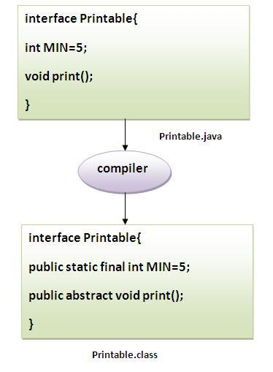

16.2 Understanding relationship between classes and interfaces
As shown in the figure given below, a class extends another class, an interface extends another interface but a class implements an interface.
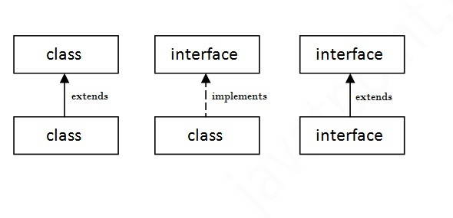

16.3Multiple inheritance example of Java interface

Example of Interface
package co.in.quickitdotnet;

public class Java_Example089 implements Show_089, Dance{

public static void main(String[] args) {
// TODO Auto-generated method stub
Java_Example089 t = new Java_Example089();
t.show();
t.dance();
}

@Override
public void show() {
// TODO Auto-generated method stub
System.out.println("Show must go on");

}

@Override
public void dance() {
// TODO Auto-generated method stub
System.out.println("Dancing is good for health");
}

}

Interface
package co.in.quickitdotnet;

interface Show_089 {
void show();
}

Output:
Show must go on
Dancing is good for health

16.4 Hierarchy of interface
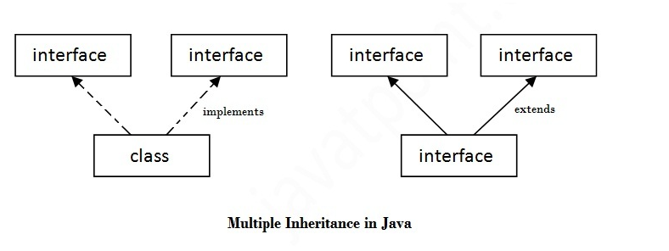

Rules:

A Class implements interface
An interface always extends interface

17.0 Abstract Class in JAVA

A class that is declared with abstract keyword, is known as abstract class in java. It can have abstract and non-abstract methods (method with body).
Before learning java abstract class, let's understand the abstraction in java first.

17.1 Abstraction in Java
Abstraction is a process of hiding the implementation details and showing only functionality to the user.
Another way, it shows only important things to the user and hides the internal details for example sending sms, you just type the text and send the message. You don't know the internal processing about the message delivery.
Abstraction lets you focus on what the object does instead of how it does it.

17.2 Ways to achieve Abstaction
There are two ways to achieve abstraction in java
- Abstract class (0 to 100%)
- Interface (100%)
- A class that is declared as abstract is known as abstract class. It needs to be extended and its method implemented. It cannot be instantiated.

Example abstract class
abstract class A
{

}

Example abstract method

A method that is declared as abstract and does not have implementation is known as abstract method.

abstract void printStatus();//no body and abstract

17.3 Example of abstract class that has abstract method
In this example, Bike the abstract class that contains only one abstract method run. It implementation is provided by the Honda class.

Abstraction Example Parent Class
package co.in.quickitdotnet;

abstract class Bike {
abstract void speed();

}

Abstraction Example in Child Class
package co.in.quickitdotnet;

public class Honda_Activa extends Bike {

public static void main(String[] args) {
// TODO Auto-generated method stub
Bike b = new Honda_Activa();
b.speed();
}

@Override
void speed() {
System.out.println("testing");

}

}

Output: testing

17.4 Another Example of Java Abstract

Suppose I want to print rate of interest of different bank, let’s say SBI, BOB, PNB

All these banks are related to abstract class means “Bank” , so we need to create one abstract class Bank , showing only important functions without implementation of features . In abstraction as we know we are hiding implementation details and showing only important details.

Abstraction Bank Class
package co.in.quickitdotnet;

abstract class Bank {
abstract int getRateOfInterest();
}

Now, we will create class SBI_Bank and BOB_Bank which extends parent Bank.

Creation of different bank class by implementing their Rate of Interest
package co.in.quickitdotnet;
class SBI_Bank extends Bank {

@Override
int getRateOfInterest() {
// TODO Auto-generated method stub
return 8;
}

}

Creation of different bank class by implementing their Rate of Interest
package co.in.quickitdotnet;
class BOB_Bank extends Bank{
@Override
int getRateOfInterest() {
// TODO Auto-generated method stub
return 12;
}
}

Now we will have Test Bank class where we can implement our logic

Actually implementation under TestBank
package co.in.quickitdotnet;

public class Testbank {

public static void main(String[] args) {
Bank b = new SBI_Bank();
Bank T = new BOB_Bank();
int Rate = b.getRateOfInterest();
int BOB_Rate = T.getRateOfInterest();
System.out.println("Rate of interest SBI bank is "+Rate);
System.out.println("Rate of interest SBI bank is "+BOB_Rate);

}
}

Output:
Rate of interest SBI bank is 8
Rate of interest SBI bank is 12

17.5 Difference between abstract class and interface
Abstract class and interface both are used to achieve abstraction where we can declare the abstract methods. Abstract class and interface both can't be instantiated.
But there are many differences between abstract class and interface that are given below.
Abstract class | Interface
1) Abstract class can have abstract and non-abstract methods. | Interface can have only abstract methods.
2) Abstract class doesn't support multiple inheritance. | Interface supports multiple inheritance.
3) Abstract class can have final, non-final, static and non-static variables. | Interface has only static and final variables.
4) Abstract class can have static methods, main method and constructor. | Interface can't have static methods, main method or constructor.
5) Abstract class can provide the implementation of interface. | Interface can't provide the implementation of abstract class.
6) The abstract keyword is used to declare abstract class. | The interface keyword is used to declare interface.
7) Example:  public abstract class Shape{  public abstract void draw();  } | Example:  public interface Drawable{  void draw();  }
Simply, abstract class achieves partial abstraction (0 to 100%) whereas interface achieves fully abstraction (100%)

18.0 Why Super keyword in JAVA

The super keyword in java is a reference variable that is used to refer immediate parent class object.
Whenever you create the instance of subclass, an instance of parent class is created implicitly i.e. referred by super reference variable.

Usage of java super Keyword
- super is used to refer immediate parent class instance variable.
- super() is used to invoke immediate parent class constructor.
- super is used to invoke immediate parent class method.

1) super is used to refer immediate parent class instance variable.

Problem without super keyword
class Vehicle{
int speed=50;
}
class Bike3 extends Vehicle{
int speed=100;
void display(){
System.out.println(speed);//will print speed of Bike
}
public static void main(String args[]){
Bike3 b=new Bike3();
b.display();
}
}

Output: 100
In the above example Vehicle and Bike both class have a common property speed. Instance variable of current class is referred by instance by default, but I have to refer parent class instance variable that is why we use super keyword to distinguish between parent class instance variable and current class instance variable.

Solution by super keyword

By using super keyword
class Vehicle{
int speed=50;
}
class Bike4 extends Vehicle{
int speed=100;
void display(){
System.out.println(super.speed);//will print speed of Vehicle now
}
public static void main(String args[]){
Bike4 b=new Bike4();
b.display();

}
}

Output:50

2) Super is used to invoke parent class constructor.
The super keyword can also be used to invoke the parent class constructor as given below:
By using super keyword
class Vehicle{
Vehicle(){System.out.println("Vehicle is created");}
}

class Bike5 extends Vehicle{
Bike5(){
super();//will invoke parent class constructor
System.out.println("Bike is created");
}
public static void main(String args[]){
Bike5 b=new Bike5();

}
}

Output: Vehicle is created
Bike is created

Note: super () is added in each class constructor automatically by compiler.
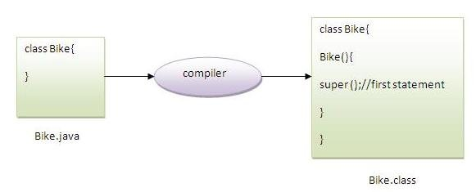
As we know well that default constructor is provided by compiler automatically but it also adds super() for the first statement. If you are creating your own constructor and you don't have either this() or super() as the first statement, compiler will provide super() as the first statement of the constructor.

Another example of super keyword where super() is provided by the compiler implicitly.
By using super keyword
class Vehicle{
Vehicle(){System.out.println("Vehicle is created");}
}

class Bike6 extends Vehicle{
int speed;
Bike6(int speed){
this.speed=speed;
System.out.println(speed);
}
public static void main(String args[]){
Bike6 b=new Bike6(10);
}
}
Output: Vehicle is created

3) super can be used to invoke parent class method
The super keyword can also be used to invoke parent class method. It should be used in case subclass contains the same method as parent class as in the example given below:

By using super keyword
class Person{
void message(){System.out.println("welcome");}
}

class Student16 extends Person{
void message(){System.out.println("welcome to java");}

void display(){
message();//will invoke current class message() method
super.message();//will invoke parent class message() method
}

public static void main(String args[]){
Student16 s=new Student16();
s.display();
}
}

Output: welcome to java
welcome
In the above example Student and Person both classes have message() method if we call message() method from Student class, it will call the message() method of Student class not of Person class because priority is given to local.

In case there is no method in subclass as parent, there is no need to use super. In the example given below message() method is invoked from Student class but Student class does not have message() method, so you can directly call message() method.

Program in case super is not required

class Person{
void message(){System.out.println("welcome");}
}
class Student17 extends Person{
void display(){
message();//will invoke parent class message() method
}

public static void main(String args[]){
Student17 s=new Student17();
s.display();
}
}

Output: welcome

19.0 String Vs StringBuffer VS StringBuilder
- String is an immutable sequence of characters.
- StringBuffer is mutable sequence of characters.
- StringBuilder is also mutable sequence of characters.

The only difference between StringBuffer and StringBuilder:
- StringBuffer object is thread safe , it means StringBuffer object is modified by multiple concurrently, because all its methods are declared as "synchronized".
- StringBuilder class is given in jdk 1.5 version as non thread -safe class, means all its methods are non synchronized methods.
- So , in single model application we must use StringBuilder, so that object locking and unlocking will not be there, hence performance is increased.
- In single thread model application operations are executed in sequence hence there is no chance of object corruption.

19.1 When should we choose String and StringBuffer?
- If we do not want to store string modifications in the same memory we must choose String.
- To do modifications in the same memory, we must choose StringBuffer or StringBuilder.

Advantage and disadvantage in String:
- Advantage : Since modifications are preserving in another memory location, we will have both original and modified values.
- Disadvantage: It consumes lot memory for every operation, as it stores it modifications in new memory. So it leads to performance issue.
- Solution: To solve this performance issue , in projects developers store string data using StringBuilder or StringBuffer after all modifications they convert into String and pass it back to user.

Advantage and disadvantage of StringBuffer or StringBuilder:
- Advantage: It given high performance because consumes less memory as all modifications stored in same memory.
- Disadvantage: Original value will not be preserved.

19.2 .Creating String , StringBuffer objects:

String:
- String object can be created in two ways.
- By using string literal : String str="instance of java ";
- By using its constructors: String str= new String("instaneofjavaforus") ;

19.3 StringBuffer:
- By using its available constructors
- StringBuffer str= new StringBuffer();

19.4 StringBuilder:
- By using its available constructors
- StringBuilder str= new StringBuilder ();

19.5 Special operations those we can only perform on StringBuffer and StringBuilder:
- append
- insert
- delete
- reverse
- Since string is immutable we cannot perform these operations on String.

19.6 Concatenation:
- Using String object we can concat new string to the current string in two ways.
- Using + operator
- Using concat() method.
- Using StringBuffer we can perform concat operation only in one way
- Using append() method
- Using StringBuilder we can perform concat operation only in one way

Using append() method
package com.instanceofjavaforus;
public Class SBDemo{
public static void main (String args[]) {
String str="Java";
StringBuffer sb= new StringBuffer("Java");
StringBuilder sbr= new StringBuilder("Java");
System.out.println(str.concat(" language"));
System.out.println(sb.append(" language"));
System.out.println(sbr.append(" language"));
}
}

OutPut:
Java language
Java language
Java language

19.7 Comparison:
- Using equals() method String objects are compared with state, because it is overridden in this class. Also hashcode(0 method is overridden in order to satisfy equals() method contract.
- But in StringBuffer and in StringBuilder equals() method is not overridden , so using equals() method their object are compared with reference.

20.0 Constructor in java

Constructor in java is a special type of method that is used to initialize the object.
Java constructor is invoked at the time of object creation. It constructs the values i.e. provides data for the object that is why it is known as constructor.

20.1 Rules for creating java constructor
There are basically two rules defined for the constructor.
- Constructor name must be same as its class name
- Constructor must have no explicit return type

20.2 Types of java constructors
There are two types of constructors:
- Default constructor (no-arg constructor)
- Parameterized constructor
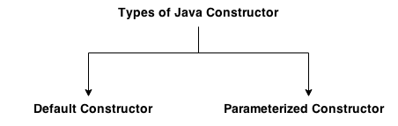

20.3 Java Default Constructor
A constructor that have no parameter is known as default constructor.

20.4 Syntax of default constructor:
<class_name>(){}

20.5 Example of default constructor
In this example, we are creating the no-arg constructor in the Bike class. It will be invoked at the time of object creation.
Empty Constructor
class Bike1{
Bike1(){System.out.println("Bike is created");}
public static void main(String args[]){
Bike1 b=new Bike1();
}
}

Output:
Bike is created

Rule: If there is no constructor in a class, compiler automatically creates a default constructor.
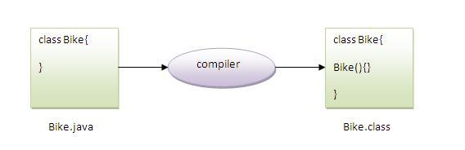

20.6 What is the purpose of default constructor?
Default constructor provides the default values to the object like 0, null etc. depending on the type.

Default Constructor
class Student3{
int id;
String name;

void display(){System.out.println(id+" "+name);}

public static void main(String args[]){
Student3 s1=new Student3();
Student3 s2=new Student3();
s1.display();
s2.display();
}
}

Output:
0 null
0 null
Explanation: In the above class,you are not creating any constructor so compiler provides you a default constructor.Here 0 and null values are provided by default constructor.

20.7 Java parameterized constructor
A constructor that has parameters is known as parameterized constructor.

20.8 Why use parameterized constructor?
Parameterized constructor is used to provide different values to the distinct objects.

20.9 Example of parameterized constructor
In this example, we have created the constructor of Student class that has two parameters. We can have any number of parameters in the constructor.

Parameterized Constructor
class Student4{
int id;
String name;

Student4(int i,String n){
id = i;
name = n;
}
void display(){System.out.println(id+" "+name);}

public static void main(String args[]){
Student4 s1 = new Student4(111,"Karan");
Student4 s2 = new Student4(222,"Aryan");
s1.display();
s2.display();
}

111 Karan
222 Aryan

20.10 Constructor Overloading in Java
Constructor overloading is a technique in Java in which a class can have any number of constructors that differ in parameter lists.The compiler differentiates these constructors by taking into account the number of parameters in the list and their type.

Example of Constructor Overloading

- class Student5{
- int id;
- String name;
- int age;
- Student5(int i,String n){
- id = i;
- name = n;
- }
- Student5(int i,String n,int a){
- id = i;
- name = n;
- age=a;
- }
- void display(){System.out.println(id+" "+name+" "+age);}

- public static void main(String args[]){
- Student5 s1 = new Student5(111,"Karan");
- Student5 s2 = new Student5(222,"Aryan",25);
- s1.display();
- s2.display();
- }
- }

Output:
111 Karan 0
222 Aryan 25

20.11 Difference between constructor and method in java
There are many differences between constructors and methods. They are given below.
Java Constructor | Java Method
Constructor is used to initialize the state of an object. | Method is used to expose behaviour of an object.
Constructor must not have return type. | Method must have return type.
Constructor is invoked implicitly. | Method is invoked explicitly.
The java compiler provides a default constructor if you don't have any constructor. | Method is not provided by compiler in any case.
Constructor name must be same as the class name. | Method name may or may not be same as class name.

20.12 Java Copy Constructor
There is no copy constructor in java. But, we can copy the values of one object to another like copy constructor in C++.
There are many ways to copy the values of one object into another in java. They are:
- By constructor
- By assigning the values of one object into another
- By clone() method of Object class
In this example, we are going to copy the values of one object into another using java constructor.
Copying Value
class Student6{
int id;
String name;
Student6(int i,String n){
id = i;
name = n;
}

Student6(Student6 s){
id = s.id;
name =s.name;
}
void display(){System.out.println(id+" "+name);}
public static void main(String args[]){
Student6 s1 = new Student6(111,"Karan");
Student6 s2 = new Student6(s1);
s1.display();
s2.display();
}
}

Output:
111 Karan
111 Karan

20.13 Copying values without constructor
We can copy the values of one object into another by assigning the objects values to another object. In this case, there is no need to create the constructor.

Copying values without constructor

class Student7{
int id;
String name;
Student7(int i,String n){
id = i;
name = n;
}
Student7(){}
void display(){System.out.println(id+" "+name);}

public static void main(String args[]){
Student7 s1 = new Student7(111,"Karan");
Student7 s2 = new Student7();
s2.id=s1.id;
s2.name=s1.name;
s1.display();
s2.display();
}
}

Output:
111 Karan
111 Karan

20.14 Does constructor return any value?
Ans: Yes, that is current class instance (You cannot use return type yet it returns a value).

20.15 Can constructor perform other tasks instead of initialization?
Yes, like object creation, starting a thread, calling method etc. You can perform any operation in the constructor as you perform in the method.

Inheritance in JAVA

Inheritance in java is a mechanism in which one object acquires all the properties and behaviors of parent object.
The idea behind inheritance in java is that you can create new classes that are built upon existing classes. When you inherit from an existing class, you can reuse methods and fields of parent class, and you can add new methods and fields also.
Inheritance represents the IS-A relationship, also known as parent-child relationship.

21.1 Why use inheritance in java
- For Method Overriding (so runtime polymorphism can be achieved).
- For Code Reusability.

21.2 Syntax of Java Inheritance
- class Subclass-name extends Superclass-name
- {
- //methods and fields
- }
The extends keyword indicates that you are making a new class that derives from an existing class.
In the terminology of Java, a class that is inherited is called a super class. The new class is called a subclass.

21.3 Understanding the simple example of inheritance
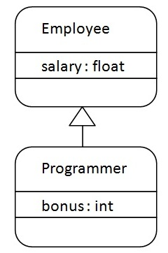
As displayed in the above figure, Programmer is the subclass and Employee is the superclass. Relationship between two classes is Programmer IS-A Employee. It means that Programmer is a type of Employee.
How to Inheritance
class Employee{
float salary=40000;
}
class Programmer extends Employee{
int bonus=10000;
public static void main(String args[]){
Programmer p=new Programmer();
System.out.println("Programmer salary is:"+p.salary);
System.out.println("Bonus of Programmer is:"+p.bonus);
}
}

Programmer salary is: 40000.0
Bonus of programmer is: 10000
In the above example, Programmer object can access the field of own class as well as of Employee class i.e. code reusability.

21.4 Types of inheritance in java
On the basis of class, there can be three types of inheritance in java: single, multilevel and hierarchical.
In java programming, multiple and hybrid inheritance is supported through interface only. We will learn about interfaces later.
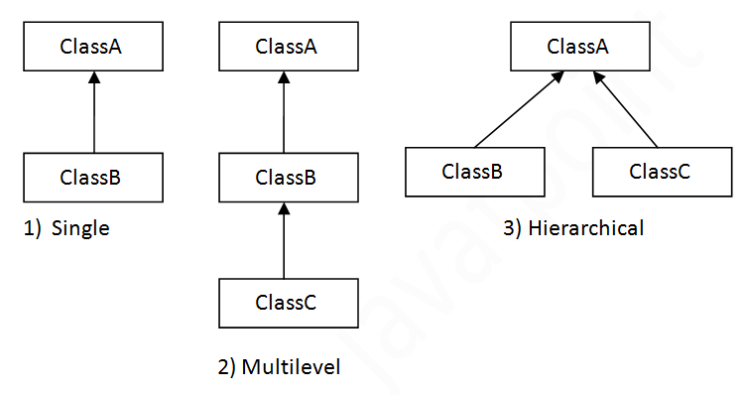

Note: Multiple inheritance not supported in java through class.
When a class extends multiple classes i.e. known as multiple inheritance.
For Example:
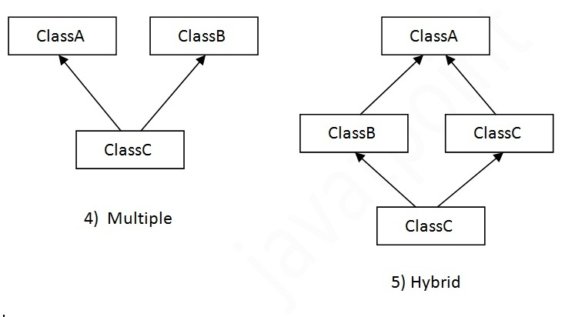

21.5 Why multiple inheritances are not supported in java?
To reduce the complexity and simplify the language, multiple inheritance is not supported in java.
Consider a scenario where A, B and C are three classes. The C class inherits A and B classes. If A and B classes have same method and you call it from child class object, there will be ambiguity to call method of A or B class.
Since compile time errors are better than runtime errors, java renders compile time error if you inherit 2 classes. So whether you have same method or different, there will be compile time error now.
Example of Multiple Inheritance
class A{
void msg(){System.out.println("Hello");}
}
class B{
void msg(){System.out.println("Welcome");}
}
class C extends A,B{//suppose if it were

Public Static void main(String args[]){
C obj=new C();
obj.msg();//Now which msg() method would be invoked?
}
}

Output: Compile Time Error

22.0 Polymorphism
Polymorphism is THE concept to master if you want to master object-oriented programming. Because Java is an object-oriented language, it makes sense that you should learn the concepts and power of polymorphism in Java.
When one task is performed by different ways i.e. known as polymorphism. For example: to convense the customer differently, to draw something e.g. shape or rectangle etc.
In java, we use method overloading and method overriding to achieve polymorphism.
Another example can be to speak something e.g. cat speaks meaw, dog barks woof etc.
Simply put, polymorphism is what allows actions to act differently based on the object performing the action or the object the action is being performed on.
Let's just use a super simple, real life example.
What is a typical sound that a cat makes? Let's just say its meow.
Let's call this action makeSound() because remember, a method can represent an action.
What sound does a dog make? Let's just say a dog goes woof.
We can also call this action makeSound().
Let's also just pretend that all animals can makeSound().
Thus, makeSound(), depending on the type of animal, does something different. The action acts differently based on the object.
This concept of polymorphism in Java especially, is actually not hard to understand at all.
Oh look, different animals make different sounds, and the same method can be used to make each distinct sound.
One powerful tool for using polymorphic behavior is to use the same method name but in the same class, over and over again to get the desired affects you want. How can we use polymorphism in Java to accomplish this?
By Method Overloading
By Dynamic Method Binding

23.0 Method Overloading in JAVA
If classes have multiple methods by same name but different parameters, it is known as Method Overloading.
If we have to perform only one operation, having same name of the methods increases the readability of the program.
Suppose you have to perform addition of the given numbers but there can be any number of arguments, if you write the method such as a (int,int) for two parameters, and b (int,int,int) for three parameters then it may be difficult for you as well as other programmers to understand the behaviour of the method because its name differs. So, we perform method overloading to figure out the program quickly.

23.1 Advantage of method overloading?
Method overloading increases the readability of the program.

23.2 Different ways to overload the method
There are two ways to overload the method in java

- By changing number of arguments
- By changing the data type

In java, Method Overloading is not possible by changing the return type of the method.

23.3 Example of Method Overloading by changing the no. of arguments
In this example, we have created two overloaded methods, first sum method performs addition of two numbers and second sum method performs addition of three numbers.
Method Overloading
class Calculation{
void sum(int a,int b){System.out.println(a+b);}
void sum(int a,int b,int c){System.out.println(a+b+c);}

public static void main(String args[]){
Calculation obj=new Calculation();
obj.sum(10,10,10);
obj.sum(20,20);

}
}

Output: 30
40

23.4 Example of Method Overloading by changing data type of argument
In this example, we have created two overloaded methods that differs in data type. The first sum method receives two integer arguments and second sum method receives two double arguments.

Example of Method Overloading by changing data type of argument

class Calculation2{
void sum(int a,int b){System.out.println(a+b);}
void sum(double a,double b){System.out.println(a+b);}

public static void main(String args[]){
Calculation2 obj=new Calculation2();
obj.sum(10.5,10.5);
obj.sum(20,20);

}
}

Output:21.0
40

23.5 Why Method Overloaing is not possible by changing the return type of method?
In java, method overloading is not possible by changing the return type of the method because there may occur ambiguity. Let's see how ambiguity may occur:
because there was problem:
class Calculation3{
int sum(int a,int b){System.out.println(a+b);}
double sum(int a,int b){System.out.println(a+b);}

public static void main(String args[]){
Calculation3 obj=new Calculation3();
int result=obj.sum(20,20); //Compile Time Error

}
}

int result=obj.sum(20,20); //Here how can java determine which sum() method should be called

23.6 Can we overload main() method?
Yes, by method overloading. You can have any number of main methods in a class by method overloading. Let's see the simple example:
class Overloading1{
public static void main(int a){
System.out.println(a);
}

public static void main(String args[]){
System.out.println("main() method invoked");
main(10);
}
}

Output: main() method invoked
10

23.7 Method Overloading and Type Promotion
One type is promoted to another implicitly if no matching datatype is found. Let's understand the concept by the figure given below:
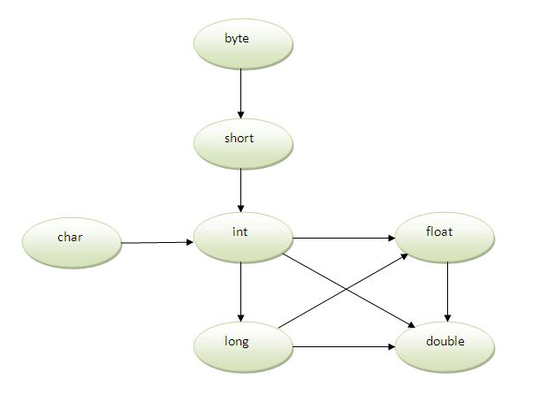
As displayed in the above diagram, byte can be promoted to short, int, long, float or double. The short datatype can be promoted to int,long,float or double. The char datatype can be promoted to int,long,float or double and so on
Example of Method Overloading with TypePromotion
class OverloadingCalculation1{
void sum(int a,long b){System.out.println(a+b);}
void sum(int a,int b,int c){System.out.println(a+b+c);}

public static void main(String args[]){
OverloadingCalculation1 obj=new OverloadingCalculation1();
obj.sum(20,20);//now second int literal will be promoted to long
obj.sum(20,20,20);

}
}

Output: 40
60
If there are matching type arguments in the method, type promotion is not performed.

Example of Method Overloading with TypePromotion if matching found

class OverloadingCalculation2{
void sum(int a,int b){System.out.println("int arg method invoked");}
void sum(long a,long b){System.out.println("long arg method invoked");}

public static void main(String args[]){
OverloadingCalculation2 obj=new OverloadingCalculation2();
obj.sum(20,20);//now int arg sum() method gets invoked
}
}

Output: int arg method invoked

23.8 Example of Method Overloading with Type Promotion in case ambiguity
If there are no matching type arguments in the method, and each method promotes similar number of arguments, there will be ambiguity.
class OverloadingCalculation3{
void sum(int a,long b){System.out.println("a method invoked");}
void sum(long a,int b){System.out.println("b method invoked");}

public static void main(String args[]){
OverloadingCalculation3 obj=new OverloadingCalculation3();
obj.sum(20,20);//now ambiguity
}
}

Output: Compile Time Error

24.0 Method Overriding in Java
If subclass (child class) has the same method as declared in the parent class, it is known as method overriding in java.
In other words, If subclass provides the specific implementation of the method that has been provided by one of its parent class, it is known as method overriding.

24.1 Usage of Java Method Overriding
- Method overriding is used to provide specific implementation of a method that is already provided by its super class.
- Method overriding is used for runtime polymorphism

Rules for Java Method Overriding
- method must have same name as in the parent class
- method must have same parameter as in the parent class.
- must be IS-A relationship (inheritance).

24.2 Understanding the problem without method overriding
Let's understand the problem that we may face in the program if we don't use method overriding.
class Vehicle{
void run(){System.out.println("Vehicle is running");}
}
class Bike extends Vehicle{
public static void main(String args[]){
Bike obj = new Bike();
obj.run();
}
}

Output: Vehicle is running
Problem is that I have to provide a specific implementation of run() method in subclass that is why we use method overriding.

24.3 Example of method overriding
In this example, we have defined the run method in the subclass as defined in the parent class but it has some specific implementation. The name and parameter of the method is same and there is IS-A relationship between the classes, so there is method overriding.

class Vehicle{
void run(){System.out.println("Vehicle is running");}
}
class Bike2 extends Vehicle{
void run(){System.out.println("Bike is running safely");}

public static void main(String args[]){
Bike2 obj = new Bike2();
obj.run();
}

Output: Bike is running safely

24.4 Real example of Java Method Overriding
Consider a scenario, Bank is a class that provides functionality to get rate of interest. But, rate of interest varies according to banks. For example, SBI, ICICI and AXIS banks could provide 8%, 7% and 9% rate of interest.

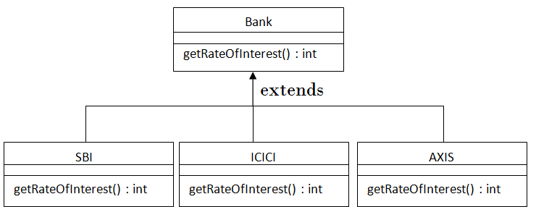
class Bank{
int getRateOfInterest(){return 0;}
}

class SBI extends Bank{
int getRateOfInterest(){return 8;}
}

class ICICI extends Bank{
int getRateOfInterest(){return 7;}
}
class AXIS extends Bank{
int getRateOfInterest(){return 9;}
}

class Test2{
public static void main(String args[]){
SBI s=new SBI();
ICICI i=new ICICI();
AXIS a=new AXIS();
System.out.println("SBI Rate of Interest: "+s.getRateOfInterest());
System.out.println("ICICI Rate of Interest: "+i.getRateOfInterest());
System.out.println("AXIS Rate of Interest: "+a.getRateOfInterest());
}
}

Output:
SBI Rate of Interest: 8
ICICI Rate of Interest: 7
AXIS Rate of Interest: 9

24.5 Can we override static method?
No, static method cannot be overridden. It can be proved by runtime polymorphism, so we will learn it later.

24.6 Why we cannot override static method?
Because static method is bound with class whereas instance method is bound with object. Static belongs to class area and instance belongs to heap area.

24.7 Can we override java main method?
No, because main is a static method.

24.8 Difference between method Overloading and Method Overriding in java

There are many differences between method overloading and method overriding in java. A list of differences between method overloading and method overriding are given below:
No. | Method Overloading | Method Overriding
1) | Method overloading is used to increase the readability of the program. | Method overriding is used to provide the specific implementation of the method that is already provided by its super class.
2) | Method overloading is performed within class. | Method overriding occurs in two classes that have IS-A (inheritance) relationship.
3) | In case of method overloading, parameter must be different. | In case of method overriding, parameter must be same.
4) | Method overloading is the example of compile time polymorphism. | Method overriding is the example of run time polymorphism.
5) | In java, method overloading can't be performed by changing return type of the method only. Return type can be same or different in method overloading. But you must have to change the parameter. | Return type must be same or covariant in method overriding.

24.9 Java Method Overloading example
class OverloadingExample{
static int add(int a,int b){return a+b;}
static int add(int a,int b,int c){return a+b+c;}
}

24.10 Java Method Overriding example
class Animal{
void eat(){System.out.println("eating...");}
}
class Dog extends Animal{
void eat(){System.out.println("eating bread...");}
}

25.0 Encapsulation
Binding (or wrapping) code and data together into a single unit is known as encapsulation. For example: capsule, it is wrapped with different medicines.
A java class is the example of encapsulation. Java bean is the fully encapsulated class because all the data members are private here.
Encapsulation in java is a process of wrapping code and data together into a single unit, for example capsule i.e. mixed of several medicines.

We can create a fully encapsulated class in java by making all the data members of the class private. Now we can use setter and getter methods to set and get the data in it.
The Java Bean class is the example of fully encapsulated class.

25.1 Advantage of Encapsulation in java
By providing only setter or getter method, you can make the class read-only or write-only.
It provides you the control over the data. Suppose you want to set the value of id i.e. greater than 100 only, you can write the logic inside the setter method.

25.2 Simple example of encapsulation in java
Let's see the simple example of encapsulation that has only one field with its setter and getter methods.
- //save as Student.java
- package com.javatpoint;
- public class Student{
- private String name;

- public String getName(){
- return name;
- }
- public void setName(String name){
- this.name=name
- }
- }

- //save as Test.java
- package com.javatpoint;
- class Test{
- public static void main(String[] args){
- Student s=new Student();
- s.setname("vijay");
- System.out.println(s.getName());
- }
- }

Compile By: javac -d . Test.java
Run By: java com.javatpoint.Test

26.0 JAVA Regular Expression (REGEX)

The Java Regex or Regular Expression is an API to define pattern for searching or manipulating strings.
It is widely used to define constraint on strings such as password and email validation. After learning java regex tutorial, you will be able to test your own regular expressions by the Java Regex Tester Tool.
Java Regex API provides 1 interface and 3 classes in java.util.regex package.

26.1 java.util.regex package
It provides following classes and interface for regular expressions. The Matcher and Pattern classes are widely used in java regular expression.
- MatchResult interface
- Matcher class
- Pattern class
- PatternSyntaxException class

26.2 Matcher class
It implements MatchResult interface. It is a regex engine i.e. used to perform match operations on a character sequence.
No. | Method | Description
1 | boolean matches() | test whether the regular expression matches the pattern.
2 | boolean find() | finds the next expression that matches the pattern.
3 | boolean find(int start) | finds the next expression that matches the pattern from the given start number.

26.3 Pattern class
It is the compiled version of a regular expression. It is used to define a pattern for the regex engine.
No. | Method | Description
1 | static Pattern compile(String regex) | compiles the given regex and return the instance of pattern.
2 | Matcher matcher(CharSequence input) | creates a matcher that matches the given input with pattern.
3 | static boolean matches(String regex, CharSequence input) | It works as the combination of compile and matcher methods. It compiles the regular expression and matches the given input with the pattern.
4 | String[] split(CharSequence input) | splits the given input string around matches of given pattern.
5 | String pattern() | returns the regex pattern.

26.4 Example of Java Regular Expressions

- /*Create a regular expression that accepts alpha numeric characters only. Its
- length must be 6 characters long only.*/

- import java.util.regex.*;
- class RegexExample6{
- public static void main(String args[]){
- System.out.println(Pattern.matches("[a-zA-Z0-9]{6}", "arun32"));//true
- System.out.println(Pattern.matches("[a-zA-Z0-9]{6}", "kkvarun32"));//false (more than 6 char)
- System.out.println(Pattern.matches("[a-zA-Z0-9]{6}", "JA2Uk2"));//true
- System.out.println(Pattern.matches("[a-zA-Z0-9]{6}", "arun$2"));//false ($ is not matched)
- }}

26.5 Regular Expression 2
- /*Create a regular expression that accepts 10 digit numeric characters
- starting with 7, 8 or 9 only.*/

- import java.util.regex.*;
- class RegexExample7{
- public static void main(String args[]){
- System.out.println("by character classes and quantifiers ...");
- System.out.println(Pattern.matches("[789]{1}[0-9]{9}", "9953038949"));//true
- System.out.println(Pattern.matches("[789][0-9]{9}", "9953038949"));//true

- System.out.println(Pattern.matches("[789][0-9]{9}", "99530389490"));//false (11 characters)
- System.out.println(Pattern.matches("[789][0-9]{9}", "6953038949"));//false (starts from 6)
- System.out.println(Pattern.matches("[789][0-9]{9}", "8853038949"));//true

- System.out.println("by metacharacters ...");
- System.out.println(Pattern.matches("[789]{1}\\d{9}", "8853038949"));//true
- System.out.println(Pattern.matches("[789]{1}\\d{9}", "3853038949"));//false (starts from 3)

- }}

27.0 JDBC
Java JDBC is a java API to connect and execute query with the database. JDBC API uses jdbc drivers to connect with the database.
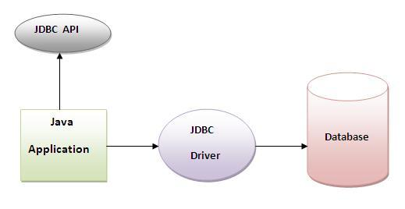

27.1 Why use JDBC
Before JDBC, ODBC API was the database API to connect and execute query with the database. But, ODBC API uses ODBC driver which is written in C language (i.e. platform dependent and unsecured). That is why Java has defined its own API (JDBC API) that uses JDBC drivers (written in Java language).

28.0 Database Testing using Selenium: Step by Step Guide

Selenium Webdriver is limited to testing your applications using Browser. To use Selenium Webdriver for Database Testing you need to use the JDBC ("Java Database Connectivity").

JDBC (Java Database Connectivity) is a SQL level API that allows you to execute SQL statements. It is responsible for the connectivity between the Java Programming language and a wide range of databases. The JDBC API provides the following classes and interfaces

Driver Manager
Driver
Connection
Statement
ResultSet
SQLException

In order to test your Database using Selenium, you need to observe the following 3 steps
1. Make a connection to the Database
2. Send Queries to the Database
3. Process the results
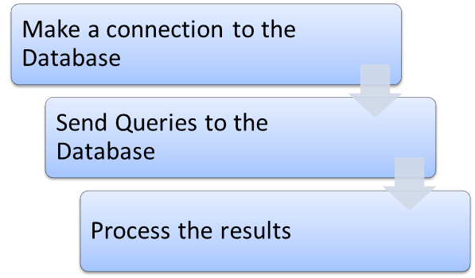

1) Make a connection to the Database

In order to make a connection to the database the syntax is

DriverManager.getConnection(URL, "userid", "password" )

Here,

Userid is the username configured in the database
Password of the configured user
URL is of format jdbc:< dbtype>://ipaddress:portnumber/db_name"
<dbtype>- The driver for the database you are trying to connect. To connect to oracle database this value will be "oracle"

For connecting to database with name "emp" in MYSQL URL will bejdbc:mysql://localhost:3036/emp

And the code to create connection looks like

Connection con = DriverManager.getConnection(dbUrl,username,password);

You also need to load the JDBC Driver using the code

Class.forName("com.mysql.jdbc.Driver");

2) Send Queries to the Database

Once connection is made, you need to execute queries.

You can use the Statement Object to send queries.

Statement stmt = con.createStatement();

Once the statement object is created use the executeQuery method to execute the SQL queries

stmt.executeQuery(select * from employee;);

3) Process the results

Results from the executed query are stored in the ResultSet Object.

Java provides loads of advance methods to process the results. Few of the methods are listed below

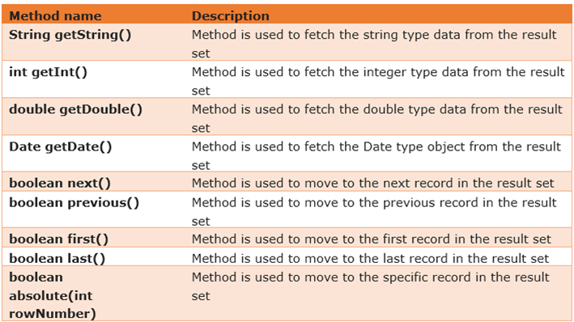

28.2 Example of Database Testing with Selenium

Step 1) Install MySQL Server and MySQL Workbench

While installing MySQL Server, please note the database

Username
Password
Port Number

It will be required in further steps.

MySQL Workbench makes it easy to administer the database without the need to code SQL. Though, you can also use the MySQL Terminal to interact with the database.

Step 2) In MySQL WorkBench, connect to your MySQL Server

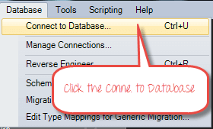

In the next screen,

Select Local Instance of MySQL
Enter Port Number
Enter Username
Enter Password
Click OK

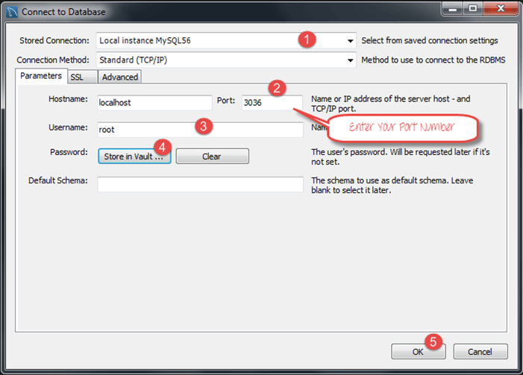

Step 3) To Create Database,

Click create Schema Button
Enter Name of Schema/Database
Click Apply

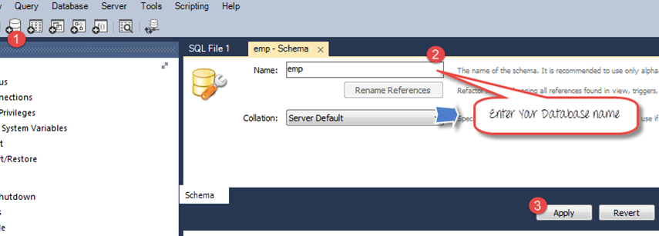

Step 4) In the navigator menu,

Click on Tables, beneath the emp database
Enter Table name as employee
Enter Fields as Name and Age
Click Apply

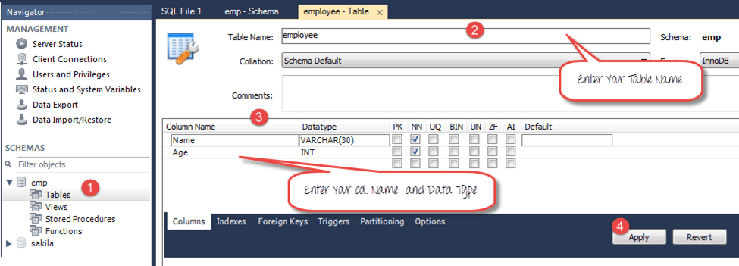
You will see the following pop-up. Click Apply
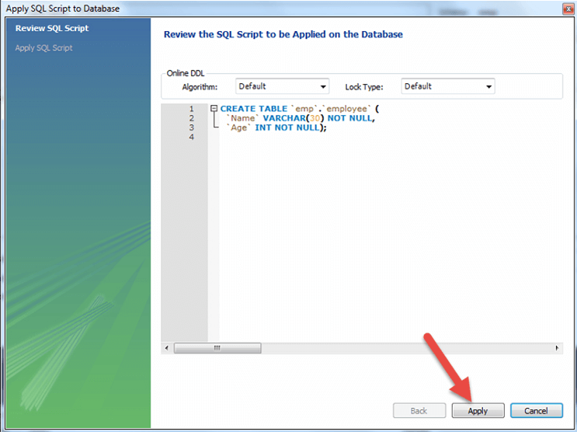

Step 5) We will create following data

Name | Age
Top | 25
Nick | 36
Bill | 47

To create data into the Table

In navigator, select the employee table
In right pane, click Form Editor
Enter Name and Age
Click Apply

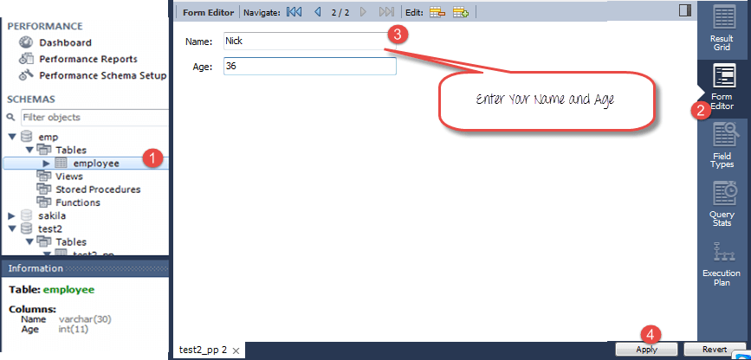

Repeat the process until all data is created.

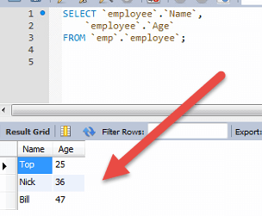

Step 6) Download the MySQL JDBC connector here
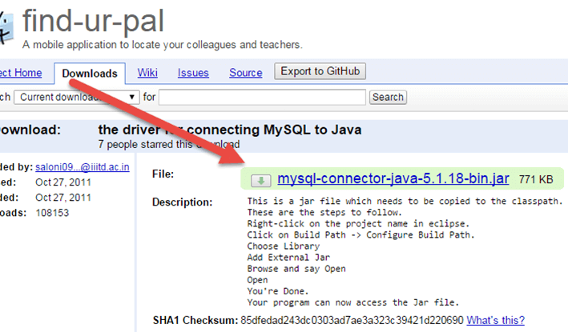

Step 7) Add the downloaded Jar to your Project

Right click on your Java File. Then click on Build Pathà Configure build path
Select the libraries
Click on add external JARs
You can see MySQL connector java in your library
Click on open to add it to the project

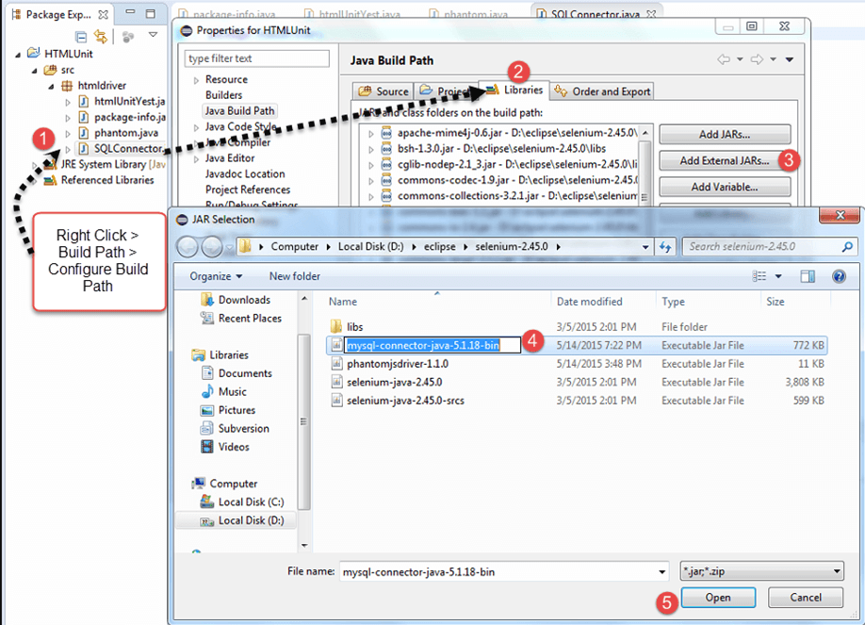
Step 8) Copy the following code into the editor
Package htmldriver;
import java.sql.Connection;
import java.sql.Statement;
import java.sql.ResultSet;
import java.sql.DriverManager;
import java.sql.SQLException;
public class SQLConnector {
public static void main(String[] args) throws ClassNotFoundException, SQLException {
//Connection URL Syntax: "jdbc:mysql://ipaddress:portnumber/db_name"
String dbUrl = "jdbc:mysql://localhost:3036/emp";

//Database Username
String username = "root";

//Database Password
String password = "guru99";

//Query to Execute
String query = "select * from employee;";

//Load mysql jdbc driver
Class.forName("com.mysql.jdbc.Driver");

//Create Connection to DB
Connection con = DriverManager.getConnection(dbUrl,username,password);

//Create Statement Object
Statement stmt = con.createStatement();

// Execute the SQL Query. Store results in ResultSet
ResultSet rs= stmt.executeQuery(query);

// While Loop to iterate through all data and print results
while (rs.next()){
String myName = rs.getString(1);
String myAge = rs.getString(2);
System. out.println(myName+" "+myAge);
}
// closing DB Connection
con.close();
}
}

Step 8) Execute the code, and check the output

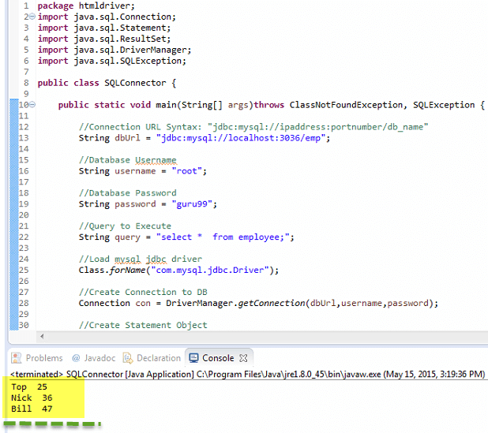

28.3 Summary

In order to test Database using Selenium you need to
Make a connection to the Database
Send Queries to the Database
Process the results

The Syntax to connect to Database is
DriverManager.getConnection(URL, "userid", "password" )

You will also need the Statement Object to send queries
Statement stmt = con.createStatement();
To send the query to database use execute query and store the results in the ResultSet object.
ResultSet rs = stmt.executeQuery(select * from employee;);

Java provides lots of built-in methods to process the SQL Output using the ResultSet Object

