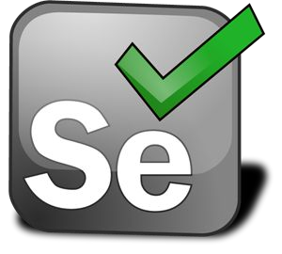

**Selenium : Complete UI Automation**

Selenium : Course Introduction

* This Certiﬁcation Course is aimed at individual who are looking for

**“UI Automation Testing and Selenium End-To-End Testing Automation”**.

* I am Amruta from QuickITDotNet.



**Perfect Course for UI Automation …**



Selenium Automation



Core Java

TestNG - Execution



Selenium Frameworks



Java Collection Framework

Selenium WebDriver

End-To-End Flow using GIT & Jenkins

**Selenium : UI Automation**

* **What else you will get as a part of this Course?**
* Course related Documents.
* Complete Code Base for Practice.
* Automation Framework Functional Code.
* Lifetime access of this Complete Course.
* UI Automation Interview Preparation Guide.
* Course Completion Certiﬁcation
  + Digital Soft Copy Certiﬁcation will be issued on completion of this course.
* Course Material - Code Files
  + All Code, Resource will be available on Public GitHub Repo, Repo location will be shared section wise or Segment wise.

Good Luck & Happy Learning…

**Thank You...**

Don’t be the Same! Be Better!!!