

**BitWorld Solution, Baramati.**  **Date-31/05/2021**

**Sub: Internship Completion Letter.**

**Dear Amruta Manohar Suryawanshi,**

This letter is to certify the **Ms. Amruta Manohar Suryawanshi** Student

Of **VidyaPratishtan’s Institute of Information Technology(VIIT),**

Baramati. has successfully completed her internship program in **Bitworld**

**Software Solution, Baramati.**.

She had to work on a project titled

“**Healthcare System”.** Her Internship tenure was from 1st July 2020 to

31st May 2021.She was actively involved in the projects task assigned

To her.

During her tenure, we found her to be hardworking, diligent and

honest in Performing her duties, also her services were found to be

satisfactory. The management would like to thank her for her services

to the company, And we wish her all the best in her future endeavors.

Regards,

Thanking You

For BitWorld Solution

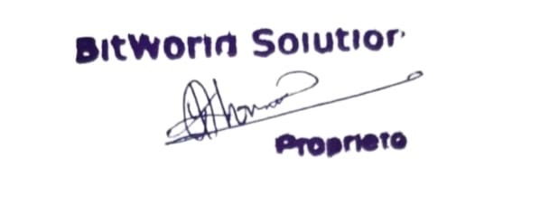

**SandipKhomane**

**Founder of Bit World Solution**

