1.Write a Python program to print “Hello Python”

print(“Hello python”)

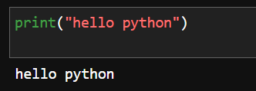

2. Write a Python program to do arithmetical operations addition and division.?

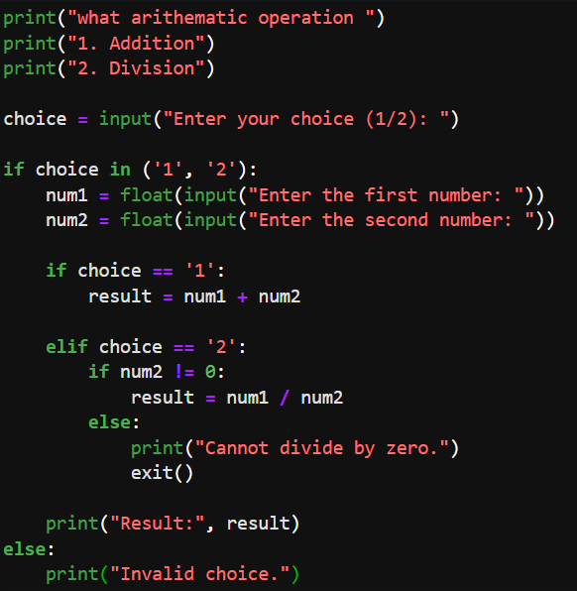

3. Write a Python program to find the area of a triangle?

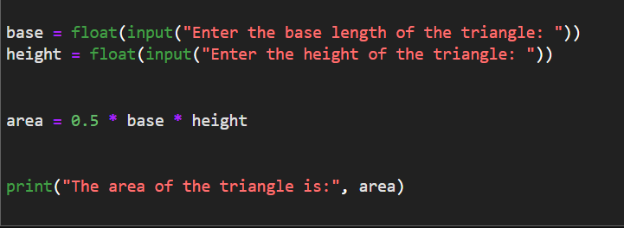

4. Write a Python program to swap two variables?

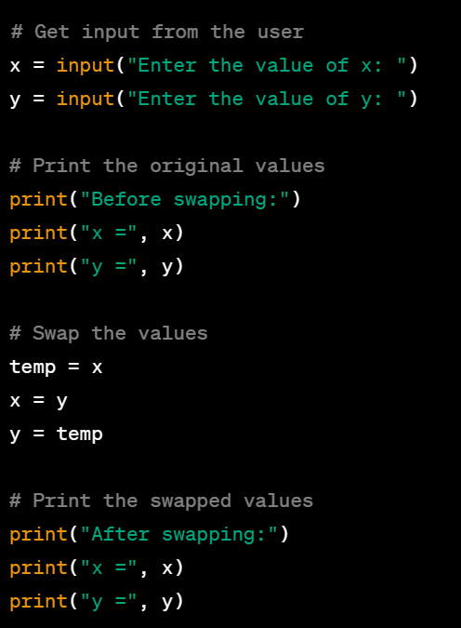

5. Write a Python program to generate a random number?

