**Creating Microservices for account and loan**

**1.** Account Microservice

**ApplicationController.java**

package com.cognizant.account.controller;

import org.springframework.web.bind.annotation.GetMapping;

import org.springframework.web.bind.annotation.PathVariable;

import org.springframework.web.bind.annotation.RestController;

import org.slf4j.Logger;

import org.slf4j.LoggerFactory;

*@RestController*

public class AccountController {

private static final Logger ***LOGGER*** = LoggerFactory.*getLogger*(AccountController.class);

*@GetMapping*("/accounts/{number}")

public Account getAccountDetails(*@PathVariable* String number) {

***LOGGER***.info("START - getAccountDetails");

Account account = new Account(number, "savings", 234343);

***LOGGER***.info("END - getAccountDetails");

return account;

}

// Dummy Account class (you can also put this in a separate file)

static class Account {

private String number;

private String type;

private double balance;

public Account(String number, String type, double balance) {

this.number = number;

this.type = type;

this.balance = balance;

}

public String getNumber() {

return number;

}

public String getType() {

return type;

}

public double getBalance() {

return balance;

}

}

}

**AccountApplication.java**

package com.cognizant.account;

import org.springframework.boot.SpringApplication;

import org.springframework.boot.autoconfigure.SpringBootApplication;

*@SpringBootApplication*

public class AccountApplication {

public static void main(String[] args) {

SpringApplication.*run*(AccountApplication.class, args);

}

}

**Output:**

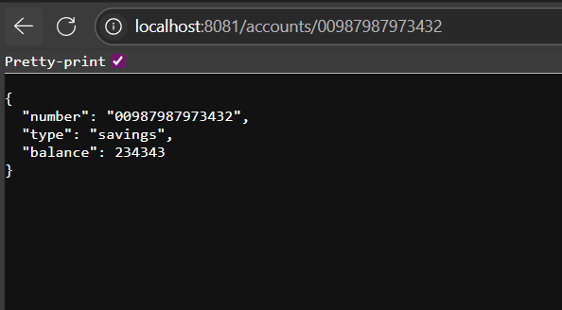

**2. Loan Microservice**

**LoanController.java**

package com.cognizant.loan.controller;

import org.springframework.web.bind.annotation.*;

*@RestController*

*@RequestMapping*("/loans")

public class LoanController {

*@GetMapping*("/{number}")

public Loan getLoan(*@PathVariable* String number) {

return new Loan(number, "car", 400000, 3258, 18);

}

static class Loan {

public String number;

public String type;

public double loan;

public double emi;

public int tenure;

public Loan(String number, String type, double loan, double emi, int tenure) {

this.number = number;

this.type = type;

this.loan = loan;

this.emi = emi;

this.tenure = tenure;

}

}

}

**LoanApplication.java**

package com.cognizant.loan;

import org.springframework.boot.SpringApplication;

import org.springframework.boot.autoconfigure.SpringBootApplication;

*@SpringBootApplication*

public class LoanApplication {

public static void main(String[] args) {

SpringApplication.*run*(LoanApplication.class, args);

}

}

**Output:**

