Findfile
Introduction:

Desktop search tools search within a user's own computer files as opposed to searching the Internet. These tools are designed to find information on the user's PC, including web browser history, e-mail archives, text documents, sound files, images, and video.

One of the main advantages of desktop search programs is that search results arrive within a few seconds or less; Microsoft Windows search companion "can be some help, but it searches through Windows files and folders only, not e-mail or contact databases, and unless you enable the Indexing Service (in Windows 2000 or XP), the Windows search tool is extremely slow." MS Windows Vista enables the indexing service by default.

Most desktop search engines build and maintain an index database to achieve reasonable performance when searching several gigabytes of data. Indexing usually takes place when the computer is idle and most search applications can be set to suspend indexing if a portable computer is running on batteries, in order to save power. There are notable exceptions, however: Voidtools' “Everything” Search Engine, which performs searches over only file names — not the files' contents — for NTFS volumes only, is able to build its index from scratch in just a few seconds.

Another exception is “Vegnos” Desktop Search Engine, which performs searches over file names and files' contents without building any indices. The benefits to not having indices is that, in addition to not requiring persistent storage, more powerful queries (e.g., regular expressions) can be issued, whereas indexed search engines are limited to keyword-based queries. An index may also not be up-to-date, when a query is performed. In this case, results returned will not be accurate (that is, a hit may be shown when it is no longer there, and a file may not be shown, when in fact it is a hit). There are disadvantages to not indexing. Namely, the time to complete a query can be significant, and the issued query can also be resource-intensive.

Desktop search tools typically collect three types of information about files:

- File and folder names

- Metadata, such as titles, authors, comments in file types such as MP3, PDF and JPEG
file content (for supported types of documents only)

Program to find a file or directory in a drive or directory using database which is previously created. Here we use linear search approach --sorting the elements of size 2-3 lacs is not feasible, it takes more time to create database. The advantage of sorted list is that its faster than linear search. But its not significant because linear search takes only around 0.009 seconds to search an element in a database of 3-4 lacs elements. So the linear search have upper hand over all other searching technique. It saves the sorting time.

This program to search files and folder in any drive or directory whose database is previously created using the same program. Program uses windows API so it works only in Windows systems. It searches files 30-50% faster than windows default explorer search. Advantages over default search engine is that it support “&” (and) and “|”(or) wild cards. We can redirect output of search to a file for future reference. The database it creates for searching process can be used to analyse files and folders in that folder.

Problem statement:

Windows is a remarkable OS to use and implement for daily life. No doubt it is the most commonly used OS on the PC, but certain menial task such as assigning file ID3 properties, changing user permission, sharing, encryption and searching can be a cumbersome process. We've mostly focused on the searching process. We all know the famous Windows Search Index.. Implemented under windows service, uses basically 3 operations, SearchIndex, SearchProtocolHost and SearchFilterHost.

The SearchIndex is where Windows makes an indexing of directory(usually the most searched locations) and the Protocol and Filter Host help to filter or narrow the search results.. All this seem very useful and advanced, most people do not implement it and it consumes a lot of memory. Our search index is a simple searching tool which helps user to find files within mere seconds and barely consumes memory.. It is quite efficient and simple, yet elegant!

Input:

- Before searching any file in any folder, database must be created for that folder. To do this just click the create database button in GUI front-end. Note: the program must be present in the same folder for which you are creating database
for command line usage :

$ findfile -db

- Name of the file to be searched, a word 'file'. If the file name contains spaces then it must be enclosed in quotes. Syntax: “file name”.
example: to search a file “abcd”

$ findfile “abcd”

Using GUI front-end just type the name of the file in the given text box

Switches:

Switch | Description | Example
-f <filename> | It will redirect the search result to a file with file name specified | Filename -f “asdf.txt” “abcd”  searchs for abcd and output will be present in asdf.txt
-d <directory> | Searches the pattern only in specified directory | Filename -d “drive/stuff” “abcd”  searches for abcd pattern in “drive/stuff” directory

Pattern support:

Operator | Description | Example
search_term & search_term | Searches for both patterns and output will be generated only if the element has both pattern | Findfile “abd&xyz”  output will have files which contains both terms
search_term | search_term | Searches for both patterns and output will be generated if the element has at least one pattern | Findfile “abd|xyz”  output will have files which contains at least one term

Methodology:

Real time searching a file in drive takes lot of time when dealing with large amount data or files. Creating a database for directory hierarchy is convenient and it saves lot of time for searching a file. The database contains the all files name and its directory path. Database uses $ character/symbol to differentiate between folder and file. It takes significantly less memory to store only the directory name followed by the file names. Each directory will have the full path specified but not the files. This reduces the total amount of space occupied.

Database example:
Let us take a folder which contains only 3 files and 1 folder. Assuming the folder in stored in
E://Folder\stuff\abc

If each of the files present in the abc folder had full path extension then,
E://Folder\stuff\abc
E://Folder\stuff\abc\hello.txt
E://Folder\stuff\abc\world.mp3
E://Folder\stuff\abc\important.zip

Since each time the directory path is stored, this occupies a large amount of memory. This is completely redundant. To avoid this, the following method is used,

. . . . . . . .
. . . . . . . .
$ ---- Next line is a folder
E://Folder\stuff\abc ---- Folder name
hello.txt ---- files
world.mp3
important.zip
$
E://Folder\stuff\abc\work ---- Sub Folder
work.txt
vtu.doc
. . . . . . .
. . . . . . .

When this method was implemented in output database, the file size reduced considerably, it dropped from 11.3Mb to 3.7Mb

For creating a database, we have to traverse folders recursively. Once the database is created searching becomes efficient. If the search element is a file, the two variables are required. Former for keeping track of files location or parent directory path of the file. And the latter variable keeping track of the file name.

Pattern is compared with every element, line by line in linear fashion. If search is successful then the output is displayed and searching process is continued. The output path will be in the form of parent folder path\filename

We used same procedure to perform both task of redirecting the output to a file and displaying the output in the standard console. Thus, decreasing the code size. The function print()- writes to a file or to the console depending on the parameter passed. Same function performs the file search and folder search.

The function findfileDir() finds the files in specified folder. It first searches for the folder by finding '$' symbol and if the folder is found then it searches for files in that directory. In search function, first we need to check whether database file is present or not. If it is not present, then searching is not possible. If it is present then it accesses the database file and searches for the pattern. After scanning every line, the program checks if it has reached the end of file. If it hasn't reached the end of file, then it continues the search. If the line is '$' then it indicates that next line is path of a directory it stores next line in directory variable. If it is not '$' then the search continues for the remaining part of the file.

Wild card support:
Our function handles wild card support too. If '&' operator is given as input then the function searches for first pattern and then searches for second pattern without printing the result. If '|' is given as input, it will print the output if any one of the pattern is present.
getstring() function is used to get the two separate strings and to check whether any wild card operator is present or not.

Implementation:

Programming languages used:
- C++ with windows API for main program
- Python with GTK library for GUI front-end.

Operating system:

- Microsoft Windows XP

- Microsoft Windows 7

- Microsoft Windows 8 (and 8.1)

Code:

// FindFile
// This program finds file and folder using prerequisite database
// Input: <filename> OR -dir <dir_name> OR -f <output_filename> <filename>
// OR -d <directory> <filename>
// Output: searched file path(s) and No. of pattern match found

#include <iostream>
#include <fstream>
#include <cstring>
#include <windows.h>
#include "win.h"
#include <sys/time.h>

using namespace std;

//////////////////////////////////////

void print(ostream &outFile, ofstream &file, const string dir, const string fileName)
// To redirect the output to a file or console
{

if(file.is_open()) // Check if output file is open or not
{
file << "Found : " << dir << "\\" << fileName << endl;
}
else
{
outFile << "Found : " << dir << "\\" << fileName << endl;
}
}

///////////////////////////////////////

void getString(char search[], char term[2][20], int &andOprator)
// To implement Wild card by segregating search pattern
{
int flag=1;
int i,j,k;

for(i=0,j=0,k=0; search[i] != '\0'; i++)
{
if(search[i] == '|')
{
flag = 0;
andOprator=0;
}

else if(search[i] == '&')
{
flag = 0;
andOprator=1;
}
else if(flag)
{
term[1][j] = search[i];
j++;
}
else
{
term[2][k] = search[i];
k++;
}
}

term[1][j] = '\0' ;
term[2][k] = '\0' ;

}

////////////////////////////////////////

void findFile(char term[2][20], ofstream &outFile,int dirFlag, int andOprator)
// Function to find file/folder
{
ifstream fileInput;

int c=0,notVisited,term2Flag=1,flag;
string line,dirPath;
char filetx[500];

if(term[2][0] == '\0')
term2Flag=0;

strcpy(filetx,"findTemp.txt");
fileInput.open(filetx);

if( ! fileInput )
{
cout << "File database is not created, create database by running \'Findfile -o\' \n" ;
return;
}

while(!fileInput.eof())
{
getline(fileInput, line);
flag=1;

if(line.find("$", 0) == 0) // Check If next line is a directory
{
getline(fileInput, line);
dirPath = line; // Store the parent directory path in a variable

if(dirFlag) // Check if it is a directory search
{
if ( dirPath.find(term[1], 0) != string::npos)
{
line="";
print(cout, outFile , dirPath, line);
c++;
notVisited = 0;
}
}
flag=0;

}

else if ( line.find(term[1], 0) != string::npos && flag && !dirFlag)
{
if ( line.find(term[2], 0) != string::npos && andOprator)
{
print(cout, outFile , dirPath, line);
c++;
}
else if(!andOprator)
{
print(cout, outFile , dirPath, line);
c++;
}

}

else if ( line.find(term[2], 0) != string::npos && !andOprator && term2Flag
&& flag && !dirFlag)
{
print(cout, outFile , dirPath, line);
c++;
}
}

fileInput.clear();
fileInput.close();

if(c==0)
cout << "File doesn't exist \n";
else
cout << "There are " << c << " matches" << endl ;

}

///////////////////////////////

void findfileDir(char term[2][20], ofstream &outFile, char dirc[], int ando)
// To find a file within a specified directory
{
ifstream fileInput;
int c=0,term2Flag=1, offset1;
string line,direc;

if(term[2][0] == '\0') // If only one pattern is present, term2flag set to zero
term2Flag=0;

fileInput.open("findTemp.txt"); // Opens the database file

if( ! FileInput )
{
cout << "File database is empty, create database by running \'Findfile -db\' " << endl;
return;
}

while(!fileInput.eof())
{
getline(fileInput, line);

if(line.find("$", 0) == 0)
{
getline(fileInput, line);
if ( line.find(dirc, 0) != string::npos)
{
direc = line;
break;
}
}
}

if(fileInput.eof())
{
cout << "Invalid path !" << endl ;
return;
}

while(!fileInput.eof())
{
getline(fileInput, line);

if(line.find("$", 0) == 0)
{
getline(fileInput, line);
if ( line.find(dirc, 0) == string::npos)
break;
else
direc=line;
}
else
{
if ( line.find(term[1], 0) != string::npos)
{
if ( line.find(term[2], 0) != string::npos && ando)
{
print(cout, outFile , direc, line);
c++;
}
else if(!ando)
{
print(cout, outFile , direc, line);
c++;
}
}
else if ((line.find(term[2], 0) != string::npos) && !ando && term2Flag )
{
print(cout, outFile , direc, line);
c++;
}
}

}

fileInput.clear();
fileInput.close();

if(c==0)
cout << "File doesn't exist \n";
else
cout << "There are " << c << " matches" << endl ;
}

/////////////////////////////////////////
// start of main()

int main(int argc, char *argv[])
{
char search[100],outfile[100],var[2][20];
ofstream file,FileOut;
TCHAR pwd[MAX_PATH];
int dirs,ando=0;
if(strcmpi(argv[1],"-db")==0) // -db : create our database
{
if (!GetCurrentDirectory(MAX_PATH,pwd))
{
cout << "error ! cant find the path !\n";
return errno;
}
file.open("findTemp.txt");
cout << "Files and folders database of "<< pwd << " is creating..." << endl;
file << "$" << endl<< pwd << endl;
struct timeval t;
gettimeofday(&t,NULL);
double start = t.tv_sec+(t.tv_usec/1000000.0);
ListDirectoryContents(pwd,file);
gettimeofday(&t,NULL);
double stop = t.tv_sec+(t.tv_usec/1000000.0);
cout << "finished..." << stop-start << endl;
file.close();
}
else if(strcmpi(argv[1],"-f")==0) // -f : write output in specific file
{
strcpy(outfile,argv[2]);
strcpy(search,argv[3]);
cout << "File to be searched is : " << search <<" outfile : " << outfile << endl;
dirs = 0;
FileOut.open(outfile);
getString(search,var,ando);
findFile(var,FileOut,dirs,ando);
}
else if(strcmpi(argv[1],"-d")==0) // -d : Find in specific folder
{
char dirc[100];
strcpy(dirc,argv[2]);
strcpy(search,argv[3]);
cout << "File to be searched is :" << search << " in directory : " << dirc << endl;
FileOut.open("dirOut.txt");
getString(search,var,ando);
findfileDir(var,FileOut,dirc,ando);
}
else if(strcmpi(argv[1],"-dir")==0) // -d : Find in specific folder
{
strcpy(search,argv[2]);
dirs = 1;
cout << "Folder to be searched is :" << search << endl;
getString(search,var,ando);
findFile(var,FileOut,dirs,ando);
}
else
{
strcpy(search,argv[1]);
dirs = 0;
cout << "File to be searched is :" << search << endl;
getString(search,var,ando);
findFile(var,FileOut,dirs,ando);
}

return 0;
}

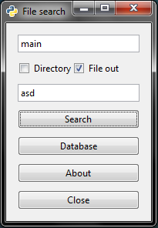
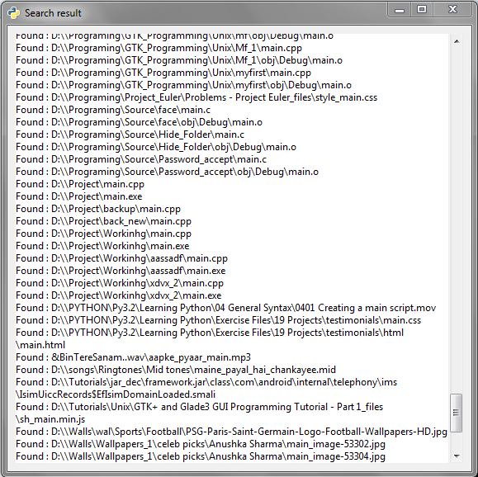

Analysis:
Comparison between windows and Findfile
(Data analysed and performed on a test PC)
Database created by Windows Indexing occupies – Apporx. 400MB
Database created by Finefile – Approx. 3.7MB

Trial Case
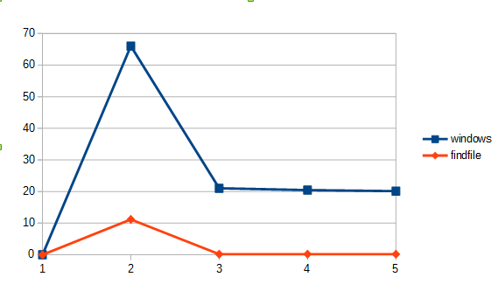

Repeated search of same file
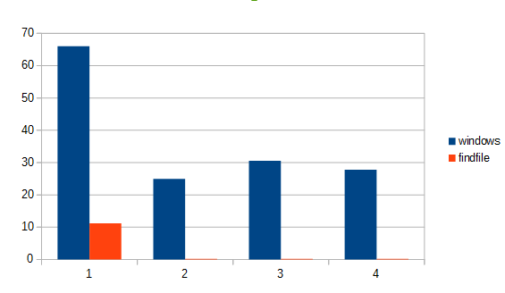

Searching of different files

Conclusion:

This is a pure, simple and a quite a satisfactory search engine. It allows user to fetch a particular files easily and at remarkable speed. Very useful if certain folder contains a large amount of small files. Though this search engine has its fair share of advantage, it isn't complex and flexibly as Unix, but certainly makes a difference to Windows, as it require way less memory and certainly more faster. The implementation of a user friendly and an efficient search engine definitely makes it easier over an extended period of time.

Advantages:

As earlier mentioned, windows existing search engine is relatively slow and cumbersome. Although indexing mechanism helps improve fast and accurate information retrieval, it lacks basic user friendliness and versatility. Even though user is aware of existence of a file in specific path but not sure of it, windows fails to recognize it! This search engine is useful for an everyday casual user who manages large amount of files in a single folder or drive as he can access the data faster.
Externally, user has to specify the type of file (.xxx- extension) he is looking for before he can work on it. Most importantly, default search engine do not support wild cards, which allows user to search a file by just 'type' or/and 'file name', making searching not very supple, as user is restricted to any one pattern to be specified in key string.
Further, time consumption is excessive, ample of time is taken to search for files which reside deep within directories. Windows perform quick search only on recent files and ones which are closer to root directory making it a greater disadvantage in real time. If a tree hierarchy is required, it is possible to obtain it. This allows user to easily find the files in the sub directories.

Disadvantages:

Both windows indexing and Findfile need to have rebuild it's database overtime as new files are added. This can be cumbersome process if the user deletes or adds new files constantly, the Findfile will still find the deleted file or refuse to find the new file.
The pattern search string is limited to only 2 search pattern. If many files have to to found simultaneously, it is not possible.

Reference:

The Complete reference C++ --Herbert Schildts
Wikipedia
Microsoft help Page

