Food Delivery & Restaurant Aggregator
Project Requirement Document (PRD)
Angular SPA + ASP.NET Core Microservices (4) + Ocelot API Gateway + SQL Server + EF Core Code-First + JWT + Testing

Use Case Title | Food Delivery & Restaurant Aggregator
Roles | Customer, Restaurant Partner, Admin, Delivery Agent (optional)
Simulated Order Rules | Delivery slots, prep time, cancellation windows, promo codes, GST, refund stub
UI Theme | Modern, premium, mobile-first, quick reorder focused
Project Positioning: This document follows the same structured PRD style as the attached prompt and adapts it to a food ordering and restaurant aggregation domain suitable for corporate training, assessments, and guided implementation.
A) Application Overview
Food delivery operations become fragmented when customers discover restaurants in one place, restaurants manage menus elsewhere, drivers coordinate through calls, and administrators reconcile orders manually. This often leads to late deliveries, incorrect item availability, refund disputes, and weak operational visibility.
The Food Delivery & Restaurant Aggregator system centralizes restaurant discovery, menu browsing, carting, checkout, order tracking, partner administration, menu management, delivery assignment, and reporting within a single platform. It supports a multi-actor flow where customers place orders, restaurant partners manage preparation, administrators supervise the platform, and delivery agents receive assigned trips.
The frontend is implemented in Angular as a single-page application, while the backend is built using exactly four ASP.NET Core microservices behind an Ocelot API Gateway. SQL Server is used as the primary database, and EF Core Code-First manages entities, DbContext classes, relationships, and migrations.
This project is intentionally framed as a corporate-training-friendly solution. It helps students practice secure API design, modular UI structure, DTO-driven service contracts, JWT-based access control, quality gates, and sprint-based planning using a realistic aggregator business domain.
B) Objective
- Provide a fast and mobile-friendly food ordering experience for customers.
- Support secure authentication and role-based access for customer, partner, and admin journeys.
- Design a scalable backend using exactly four microservices and Ocelot API Gateway routing.
- Enable reliable order capture, checkout validation, and delivery status tracking.
- Allow restaurant partners to maintain menus, availability, preparation timelines, and order actions.
- Expose dashboards and reports for sales, cancellations, partner performance, and SLA monitoring.
- Give students a complete reference implementation blueprint covering Angular, ASP.NET Core, EF Core, JWT, testing, and Agile planning.
C) Roles & Access Control
Customer: Browse restaurants, search dishes, maintain addresses, add items to cart, apply offers, complete checkout, track order status, review order history, and manage profile information.
Restaurant Partner: Manage restaurant profile, operating status, service areas, menus, item availability, preparation timelines, incoming order acceptance, and fulfillment readiness updates.
Admin: Manage users and partners, onboard restaurants, moderate menus, configure commissions and tax rules, supervise refund/cancellation cases, monitor dashboards, and export reports.
Delivery Agent (optional): View assigned deliveries, accept tasks, update pickup/drop milestones, and complete delivery status updates.
Security Implementation: Angular route guards protect /customer/*, /partner/*, /admin/*, and /delivery/* routes. ASP.NET Core APIs use JWT Bearer authentication and [Authorize(Roles="...")] attributes on secured endpoints. Admin-only APIs are additionally restricted through gateway policies and service-level authorization checks.
D) UI Design Architecture (Angular)
Angular Modules: CoreModule, SharedModule, AuthModule, CustomerModule, PartnerModule, AdminModule, DeliveryModule (optional), ReportsModule.
Routing Structure: /auth/* for authentication, /customer/* for consumer ordering flows, /partner/* for restaurant operations, /admin/* for governance and reports, /delivery/* for rider updates.
Reusable UI Components: search bar, cuisine chips, restaurant card, menu item card, cart badge, stepper, status badge, toast notification, confirmation dialog, pagination control, order timeline, KPI cards, filter drawer, and export buttons.
Cross-cutting Features: JWT interceptor, global HTTP error handler, role-aware navigation, common validation messaging, loading indicators, and centralized API service wrappers.
UI Design Pattern (1 pattern): Wizard / Stepper Pattern is applied to the Checkout flow so users move through address, time slot, payment, and order review in a structured sequence. This reduces checkout drop-off, prevents missing required information, and makes validations more understandable on smaller screens.
Layer | Examples | Purpose
Core / Shared | JWT interceptor, toasts, error handling, confirmation modals | Consistency and centralized behavior
Customer | Landing, restaurant list, menu, cart, checkout, history | Food discovery and ordering journey
Partner / Admin | Menu CRUD, order queue, dashboards, reports | Operations, control, analytics

E) Page-by-Page Functional Requirements
1. Landing / Home
Purpose: Provide the first discovery experience with promotions, cuisine shortcuts, location-aware restaurant suggestions, and search-driven navigation.
UI components: Hero banner, search bar, cuisine tiles, promoted restaurant cards, location selector, quick reorder panel.
Fields + validations: Location optional but preferred. Search trims whitespace. Serviceability validation required when delivery address is selected.
API calls (service + gateway path): GET /gateway/catalog/home, GET /gateway/catalog/restaurants/nearby
Success/error messages: Home data loaded successfully / Unable to load nearby restaurants.
Navigation rules: Users can open restaurant detail, login, signup, or switch delivery address.
2. Signup
Purpose: Allow new customer or partner onboarding based on registration mode.
UI components: Registration form, mobile/email fields, OTP or password setup, role choice when enabled.
Fields + validations: Name required. Email/mobile must be valid. Password strength required. Duplicate account blocked.
API calls (service + gateway path): POST /gateway/auth/register
Success/error messages: Account created successfully / Duplicate account / Invalid input.
Navigation rules: Successful registration redirects to login or profile completion.
3. Login
Purpose: Authenticate users and issue JWT tokens for protected operations.
UI components: Email/mobile, password, remember-me, forgot password, sign-in CTA.
Fields + validations: Credentials mandatory. Inactive or blocked users cannot sign in.
API calls (service + gateway path): POST /gateway/auth/login
Success/error messages: Login successful / Invalid credentials / User inactive.
Navigation rules: Redirects by role to customer home, partner console, admin dashboard, or delivery workspace.
4. Restaurant Listing
Purpose: Enable search, filter, sort, and browse of restaurants and cuisines.
UI components: Search, filters, rating chips, ETA filters, offer tags, restaurant list, pagination.
Fields + validations: Search optional. Sort value must be recognized. ETA filter numeric. Closed restaurants shown with disabled actions.
API calls (service + gateway path): GET /gateway/catalog/restaurants, GET /gateway/catalog/restaurants/search?q=
Success/error messages: Results loaded / No restaurants found / Server error.
Navigation rules: Selecting a restaurant opens its menu detail page.
5. Restaurant / Menu Details
Purpose: Display restaurant information and available menu items with add-to-cart capability.
UI components: Restaurant hero panel, categories sidebar, menu cards, veg/non-veg badges, add button, sticky cart summary.
Fields + validations: Quantity must be >= 1. Customization rules validated before add. Mixed cart rule may block cart if another restaurant already exists.
API calls (service + gateway path): GET /gateway/catalog/restaurants/{id}, POST /gateway/orders/cart/items
Success/error messages: Item added to cart / Item unavailable / Cart belongs to another restaurant.
Navigation rules: User can continue browsing or open the cart.
6. Cart
Purpose: Review selected items, apply coupon, adjust quantity, and see pricing summary.
UI components: Cart item rows, quantity stepper, coupon input, bill summary, remove action.
Fields + validations: Quantity cannot be zero. Coupon validated against order minimum, expiry, and restaurant eligibility.
API calls (service + gateway path): GET /gateway/orders/cart, POST /gateway/orders/cart/apply-coupon, PUT /gateway/orders/cart/items/{id}
Success/error messages: Cart updated / Coupon applied / Coupon invalid / Item removed.
Navigation rules: User can continue shopping or move to checkout.
7. Checkout
Purpose: Collect address, time slot, instructions, and order review details in a guided flow.
UI components: Stepper, address selector, slot chooser, instructions field, order summary.
Fields + validations: Address required. Slot required when scheduled delivery is enabled. Length validation on delivery instructions.
API calls (service + gateway path): GET /gateway/orders/checkout/context, POST /gateway/orders/checkout/validate
Success/error messages: Checkout validated / Address outside service area / Slot unavailable.
Navigation rules: Next and Back navigation depend on step completion.
8. Payment
Purpose: Simulate payment success and failure before order placement confirmation.
UI components: Payment options, wallet/card/COD radio buttons, payment status modal.
Fields + validations: Supported payment method required. COD may be restricted by order value or restaurant policy.
API calls (service + gateway path): POST /gateway/orders/payments/simulate
Success/error messages: Payment successful / Payment failed / COD not allowed.
Navigation rules: On success, continue to place order; on failure, retry or switch method.
9. Order Confirmation
Purpose: Show final order summary and initial ETA after successful placement.
UI components: Success banner, order id, ETA panel, bill summary, help links.
Fields + validations: Readonly screen; no additional entry validation.
API calls (service + gateway path): POST /gateway/orders/orders, GET /gateway/orders/orders/{id}
Success/error messages: Order placed successfully / Unable to fetch order details.
Navigation rules: Navigate to live tracking or order history.
10. Order History + Order Details
Purpose: List previous orders and allow customers to review status and details.
UI components: History cards/grid, search, reorder CTA, order timeline.
Fields + validations: Date range optional but validated. Reorder disabled if items unavailable.
API calls (service + gateway path): GET /gateway/orders/orders, GET /gateway/orders/orders/{id}
Success/error messages: History loaded / No past orders found.
Navigation rules: User may reorder, open detail, or raise support request.
11. Admin Dashboard
Purpose: Provide platform-level visibility into orders, GMV, partners, and service performance.
UI components: KPI cards, approval queue, trend charts, SLA widgets, top restaurants.
Fields + validations: Dashboard filters optional. Date range validated when entered.
API calls (service + gateway path): GET /gateway/admin/dashboard
Success/error messages: Dashboard loaded / Unable to fetch metrics.
Navigation rules: Admin can drill into reports, partners, and order queue.
12. Admin Restaurant Management (CRUD)
Purpose: Create, edit, approve, and deactivate restaurant and menu records.
UI components: Partner form, menu CRUD table, availability toggles, tax/commission settings.
Fields + validations: Restaurant name mandatory. Service zone required. Menu price > 0. Duplicate item names blocked per restaurant.
API calls (service + gateway path): GET/POST/PUT /gateway/admin/restaurants, GET/POST/PUT /gateway/catalog/menu-items
Success/error messages: Restaurant saved / Menu updated / Validation failed.
Navigation rules: After save, remain on edit screen or return to list.
13. Admin Orders Management
Purpose: Supervise order queue, overrides, cancellations, and refund actions.
UI components: Master-detail layout, queue table, status action buttons, refund notes panel.
Fields + validations: Only supported transitions allowed. Mandatory reason for cancellation/refund. Refund amount cannot exceed paid amount.
API calls (service + gateway path): GET /gateway/admin/orders, PUT /gateway/admin/orders/{id}/status
Success/error messages: Status updated / Invalid transition / Unauthorized action.
Navigation rules: User can return to queue, open next order, or export list.
14. Admin Reports
Purpose: Provide exports and insight views for sales, order mix, partner performance, and cancellations.
UI components: Charts, filters, export buttons, tabular report grids.
Fields + validations: Date filters mandatory for bounded reports. Export file format required.
API calls (service + gateway path): GET /gateway/admin/reports/sales, GET /gateway/admin/reports/partners
Success/error messages: Report generated / No data found / Export failed.
Navigation rules: Admin can download CSV/PDF and move back to dashboard.
F) Status Lifecycle
Customer Order Lifecycle: Draft Cart -> Checkout Started -> Payment Pending -> Paid -> Restaurant Accepted -> Preparing -> Ready for Pickup -> Picked Up -> Out for Delivery -> Delivered.
Exception branches: Payment Failed returns the user to retry. Customer Cancel Requested is allowed within a defined window before preparation starts. Restaurant Rejected may occur due to item unavailability or outside service limits. Refund Initiated and Refunded represent post-payment recovery states.
Who can change status: Customer can cancel during allowed window and track status only. Restaurant Partner can move order from Accepted to Preparing and Ready for Pickup. Delivery Agent can mark Picked Up and Delivered. Admin can override, cancel, or refund based on policy and audit reason capture.
Stage | Typical Owner | Key Rule
Draft Cart / Checkout | Customer | User can edit cart, address, and slot before payment
Paid / Accepted / Preparing | Restaurant Partner | Preparation starts only after successful payment or permitted COD selection
Picked Up / Delivered | Delivery Agent | Tracking milestones must be chronological
Cancelled / Refunded | Admin or system policy | Reason capture and audit logging are mandatory

G) Microservices System Architecture (4 Services + Ocelot)
The solution uses exactly four backend microservices behind a single Ocelot API Gateway. Inter-service communication starts with synchronous REST APIs for clarity and ease of learning. Future enhancement can introduce async events for notifications, delivery updates, and analytics streams.
- 1) Identity/Auth Service - signup/login, JWT generation, roles/claims, user status, password and session management.
- 2) Restaurant Catalog Service - restaurant onboarding read APIs, cuisines, menus, item availability, pricing, and discovery/search.
- 3) Order & Delivery Service - cart, checkout, payments simulation, order placement, delivery assignment, and order tracking.
- 4) Admin/Reporting Service - partner approvals, commissions, moderation, support operations, dashboards, reports, and exports.
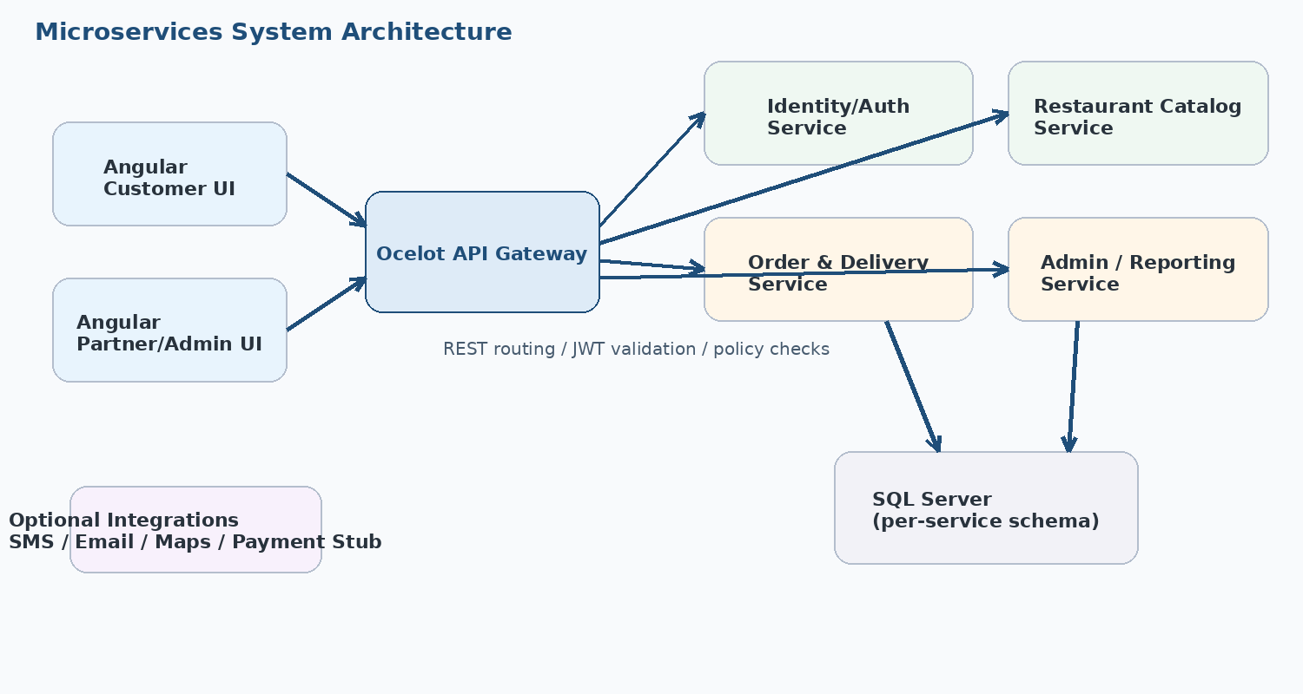
Architecture diagram: Angular UIs route through Ocelot to four ASP.NET Core microservices backed by SQL Server.
H) Database Design (SQL Server + EF Core Code-First)
Each microservice maintains entity models, DbContext, migrations, repository/service layers, and DTO contracts. EF Core Code-First steps are: create models -> configure DbContext -> add migrations -> update database -> verify schema and data in SSMS.
Representative entities include Users, Restaurants, Categories, MenuItems, Carts, CartItems, Addresses, Orders, OrderItems, Payments, and DeliveryAssignments. DTO models must be used for API transactions so EF entities are not exposed directly outside the service boundary.
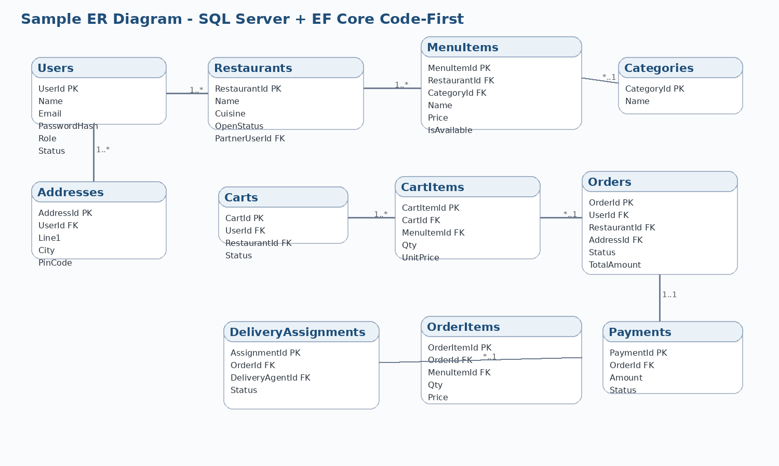
Sample ER diagram. Students may design their own final ERD, indexes, and normalization choices.
Entity | Key purpose | Example relationships
Users | Authentication and role ownership | One user can own many addresses or one partner restaurant
Restaurants / MenuItems | Restaurant discovery and item catalog | One restaurant has many menu items and categories
Carts / CartItems | Pre-order user selections | One cart has many cart items
Orders / OrderItems / Payments | Final transaction capture | One order has many items and one payment record
DeliveryAssignments | Delivery workflow tracking | One order may have one current delivery assignment

I) REST API Summary (By Service + Gateway)
Postman and Swagger/OpenAPI should be used for endpoint testing, request/response documentation, and basic contract validation.
Gateway Route Outline: /gateway/auth/*, /gateway/catalog/*, /gateway/orders/*, /gateway/admin/*
Service | Method + route | Purpose
Auth | POST /gateway/auth/register | Register customer or partner account
Auth | POST /gateway/auth/login | Authenticate and generate JWT token
Catalog | GET /gateway/catalog/restaurants | Search and list restaurants
Catalog | GET /gateway/catalog/restaurants/{id} | Fetch restaurant details and menu
Orders | GET /gateway/orders/cart | Get current cart
Orders | POST /gateway/orders/cart/items | Add item to cart
Orders | POST /gateway/orders/payments/simulate | Simulate payment success or failure
Orders | POST /gateway/orders/orders | Create final order
Orders | GET /gateway/orders/orders/{id} | Get order detail and timeline
Admin | GET /gateway/admin/dashboard | Get dashboard KPIs
Admin | PUT /gateway/admin/orders/{id}/status | Apply supervised status change
Admin | GET /gateway/admin/reports/sales | Generate sales report

J) Software Required
- Angular CLI, Node.js, npm, and Visual Studio Code for SPA development.
- .NET SDK and Visual Studio 2022 or VS Code for ASP.NET Core microservices.
- Microsoft SQL Server Developer Edition and SQL Server Management Studio (SSMS).
- Ocelot NuGet package for API Gateway routing.
- Postman or Swagger UI for API testing and documentation.
- Git and GitHub/Azure DevOps for source control and sprint collaboration.
K) Testing & Quality Plan
Backend Testing (NUnit): Unit tests should cover service methods, validators, repository logic, mapping, and policy checks. Target coverage is >= 90% using coverlet and reportgenerator.
Frontend Testing (Jasmine + Karma): Component tests should cover restaurant list rendering, cart behavior, checkout stepper validation, route guards, and mocked service calls.
Quality / Vulnerability Checks: SonarQube or SonarLint, dotnet analyzers, npm audit, and optional OWASP dependency check can be used to detect code smells, dependency risks, and maintainability issues.
Area | Examples | Expected outcome
Backend NUnit | Auth service, cart calculations, status rules, refund checks | Reliable business logic and regression safety
Frontend Jasmine/Karma | Restaurant list, menu add-to-cart, checkout guards | Stable UI behavior and route protection
Quality Gates | SonarLint, dotnet analyzers, npm audit | Reduced maintainability and dependency risks

L) Student Deliverables (Diagrams + Planning)
- Use Case Diagram covering Customer, Partner, Admin, and optional Delivery Agent flows.
- Class Diagram showing core entities, DTOs, services, repositories, and relationships.
- Sequence Diagram for the key flow: Search Restaurant -> Add to Cart -> Checkout -> Payment -> Place Order.
- ER Diagram for SQL Server schema design.
- Work Breakdown Structure (WBS) with module-level tasks.
- Agile sprint plan using Azure Boards, Jira, or Trello including sprint goals, backlog, story points/hours, and Definition of Done.
- Recommended sprint duration: 2 weeks per sprint for incremental UI, API, testing, and report delivery.
M) Test Cases (Table Format)
Test Case | Role | Steps | Expected Result | Type | Related Service
TC01 | Customer | Login with valid credentials | JWT issued and user redirected | Functional | Auth
TC02 | Customer | Search by cuisine and location | Matching restaurants displayed | Functional | Catalog
TC03 | Customer | Add available menu item to cart | Cart count and totals updated | Functional | Orders
TC04 | Customer | Apply invalid coupon code | Coupon rejected with message | Validation | Orders
TC05 | Customer | Checkout with out-of-zone address | Checkout blocked | Validation | Orders
TC06 | Customer | Simulate payment failure | Order not created; retry allowed | Negative | Orders
TC07 | Customer | Place order after successful payment | Order id generated and confirmation shown | Functional | Orders
TC08 | Partner | Accept order and mark preparing | Status changes to Preparing | Functional | Orders
TC09 | Delivery Agent | Update order to Picked Up then Delivered | Timeline updates in order detail | Functional | Orders
TC10 | Admin | Update status with unsupported transition | System rejects invalid transition | Negative | Admin
TC11 | Admin | Access secured report endpoint | Authorized admin receives report data | Security | Admin
TC12 | Customer | Access /admin route without role | HTTP 403 or redirect to unauthorized page | Security | Gateway/Admin

N) Deliverables & Evaluation Criteria
Area | Weightage | Evaluation focus
Angular UI + wireframes alignment | 20% | Screens match planned flows, reuse shared components, and validate input properly
Microservices + Ocelot Gateway | 20% | Exactly four services, clean routing, modular responsibilities
JWT security + role authorization | 15% | Protected endpoints and route guards implemented correctly
SQL Server + EF Core Code-First | 15% | Entities, DbContext, migrations, and DTO usage are correct
Testing coverage | 15% | Backend and frontend tests meet quality expectations and coverage goals
Quality gates | 5% | Static analysis and vulnerability checks executed
Diagrams + sprint plan | 10% | Required documentation and Agile planning artifacts submitted

O) Conclusion
The Food Delivery & Restaurant Aggregator project is a strong reference use case for learning modern web application architecture with Angular and ASP.NET Core microservices. It combines customer ordering, partner operations, delivery tracking, security, reporting, and testing within one cohesive business scenario.
Because the system uses exactly four services, DTO-based APIs, JWT authorization, EF Core Code-First, and structured student deliverables, it fits well for guided training, assessments, and portfolio-ready implementation work.
📲 Screen Design (Wireframes)
The following low-fidelity wireframes illustrate the major screens expected in the Angular application. Students may refine visual styling while keeping the functional zones, information hierarchy, and navigation intent intact.
Landing / Home
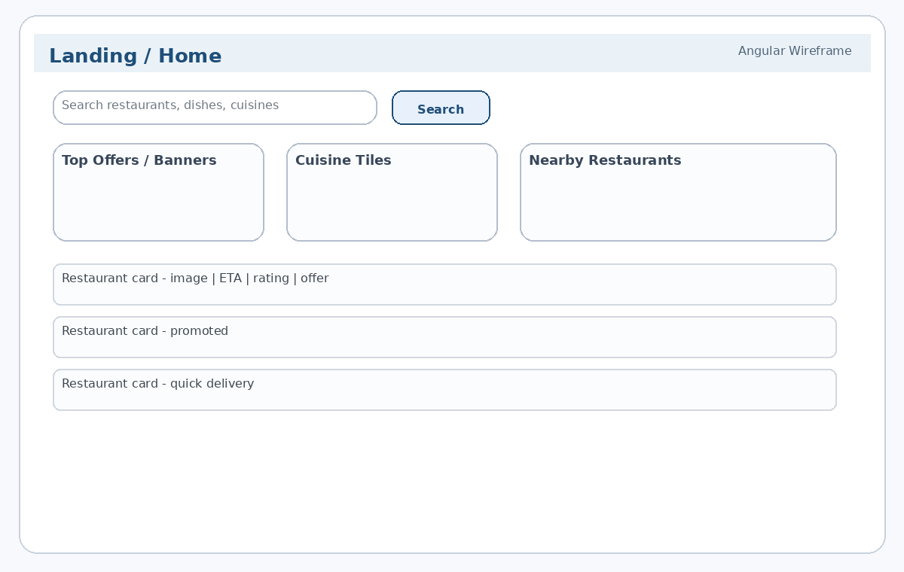
Wireframe: Landing / Home
Login / Signup
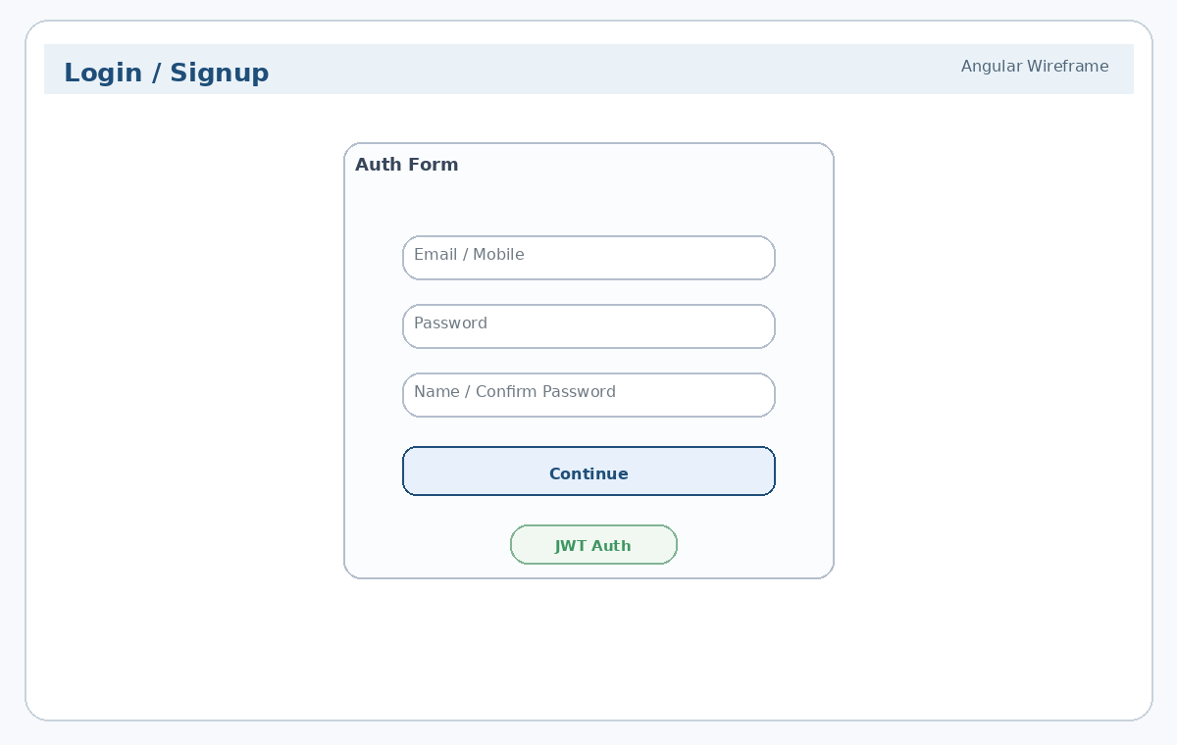
Wireframe: Login / Signup
Restaurant Listing
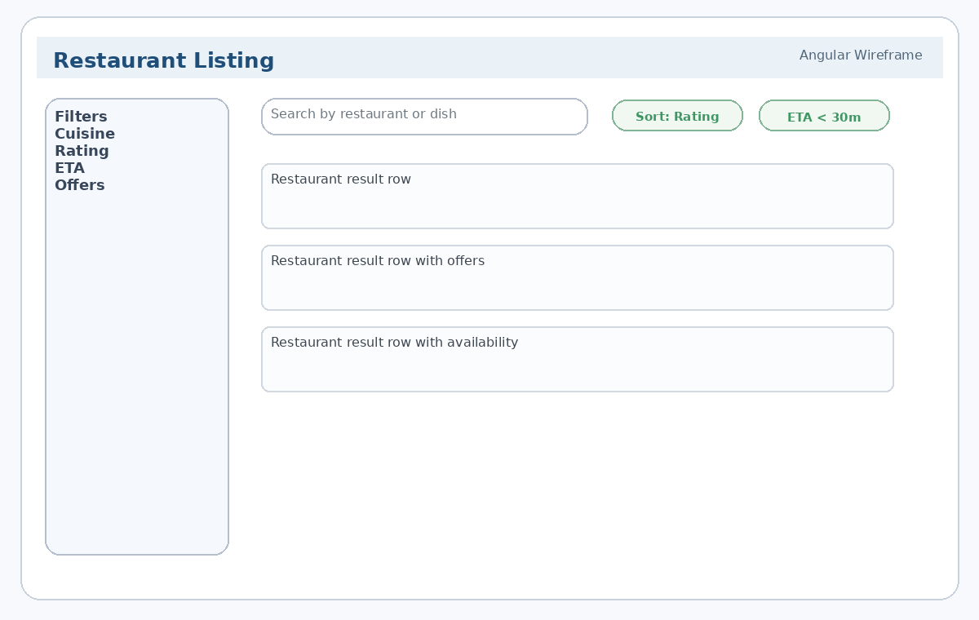
Wireframe: Restaurant Listing
Restaurant / Menu Details
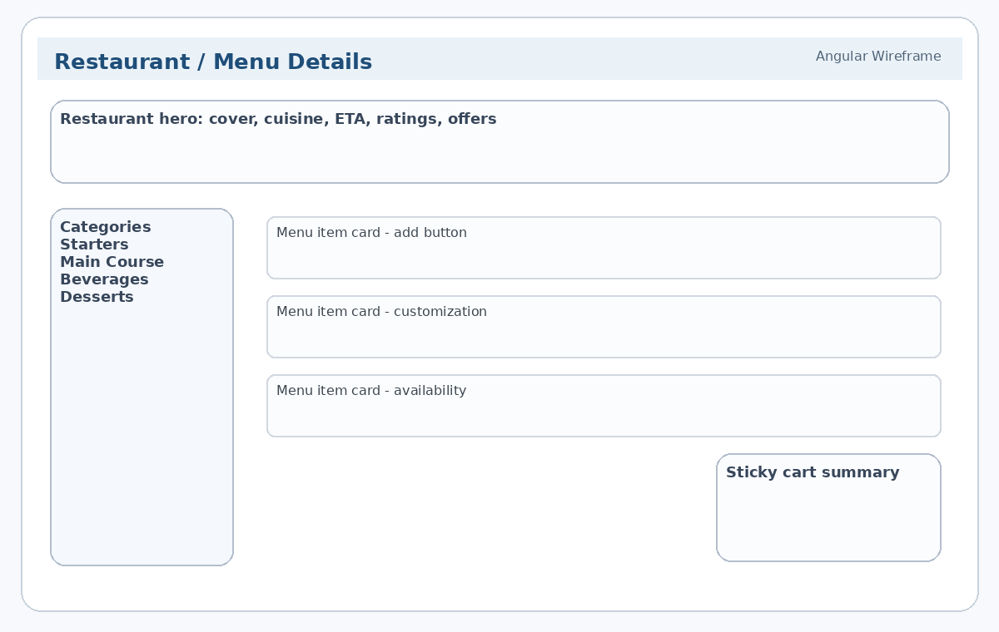
Wireframe: Restaurant / Menu Details
Cart
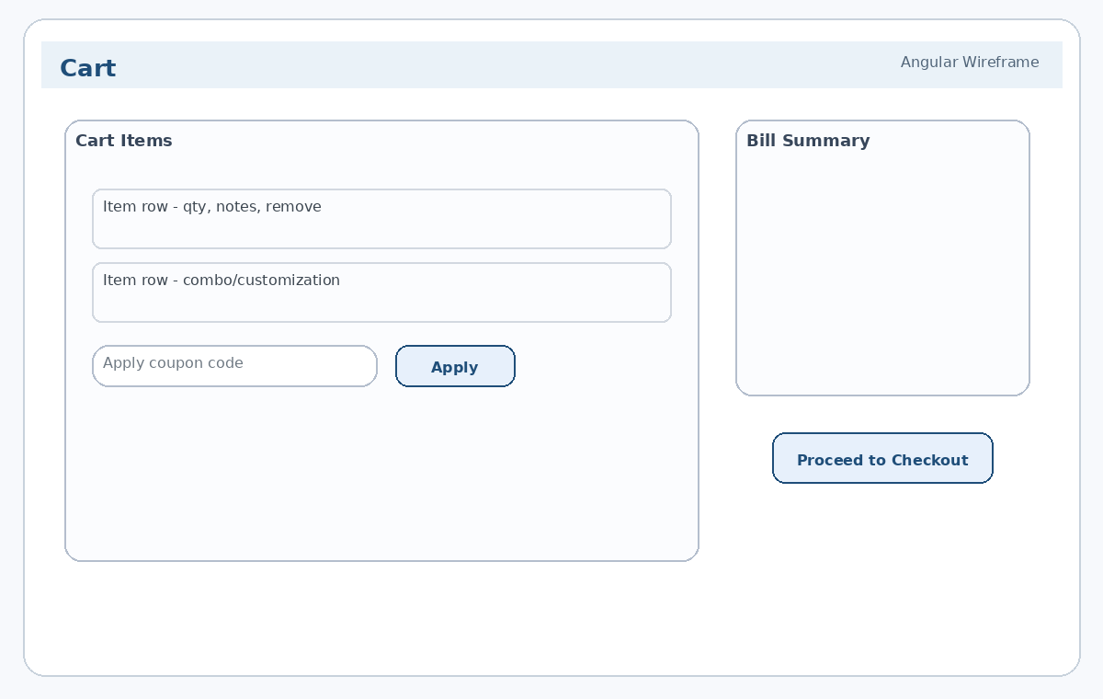
Wireframe: Cart
Checkout Wizard
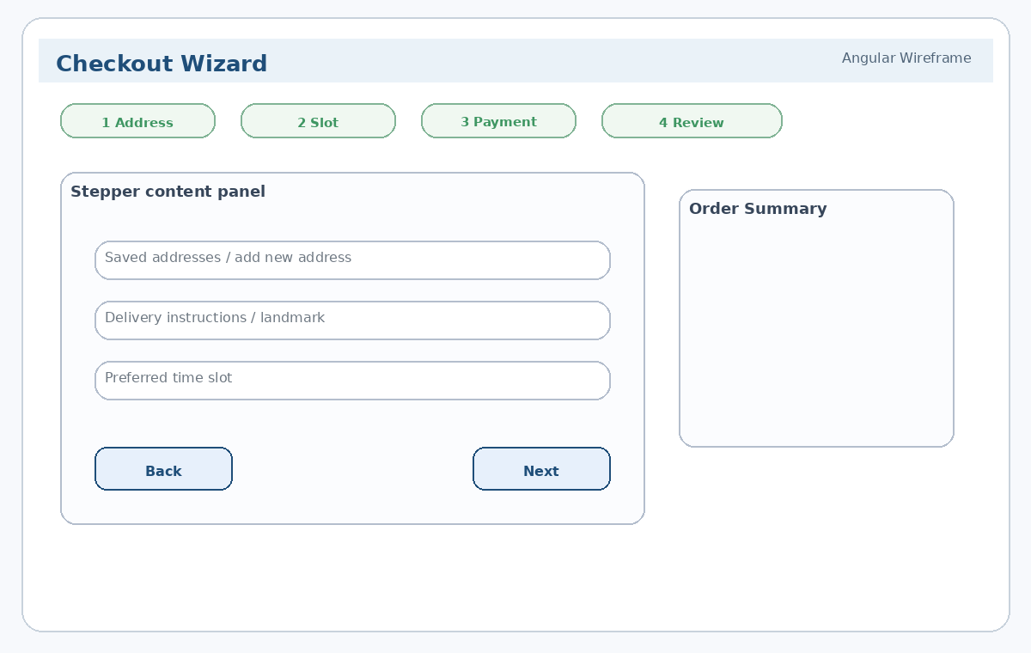
Wireframe: Checkout Wizard
Order Confirmation / History
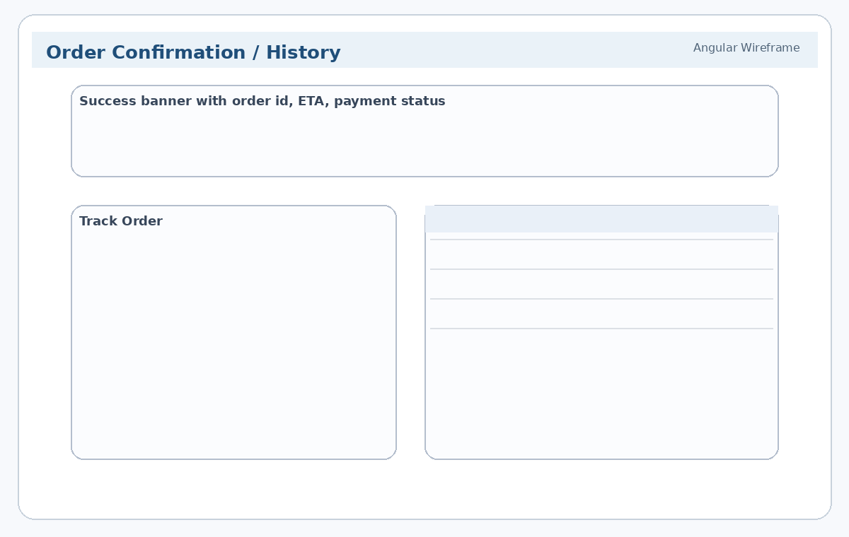
Wireframe: Order Confirmation / History
Admin Dashboard
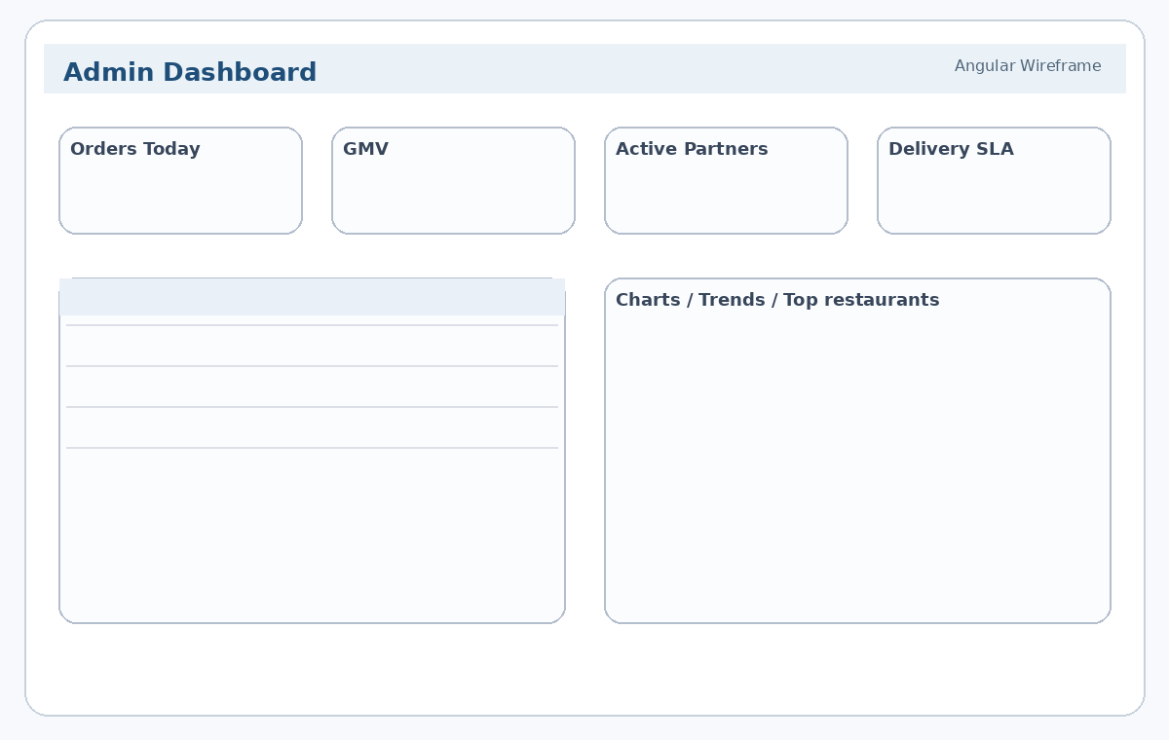
Wireframe: Admin Dashboard
Admin Restaurant / Menu Management
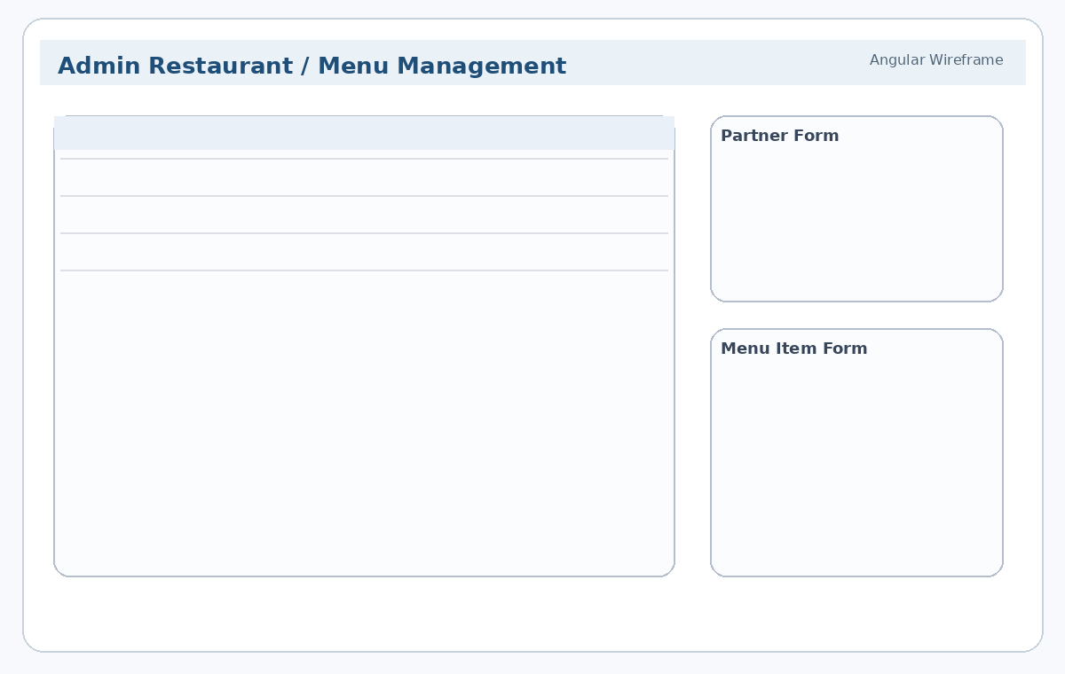
Wireframe: Admin Restaurant / Menu Management
Admin Orders Management
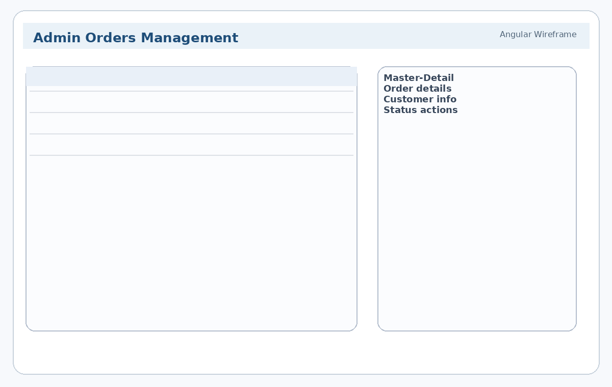
Wireframe: Admin Orders Management
Admin Reports
