**BANK APPLICATION USING ENTITY FRAMEWORK:**

**Bank.cs**

using System;

using System.Collections.Generic;

using System.Data;

using System.Data.SqlClient;

using System.Linq;

using System.Text;

namespace ArrayOfAccount

{

public class Bank

{

BankContext context;

//SqlConnection conn;

//Account[] accounts;

List<Account> accounts;

//Transaction[] transactions;

List<Transaction> transactions;

int MAX_SIZE = 5;

int count,transCount;

public Bank()

{

context = new BankContext();

//accounts = new Account[5];

accounts = new List<Account>();

//transactions = new Transaction[5];

transactions = new List<Transaction>();

count = 0;

transCount = 0;

}

public void AddAccounts()

{

string typeChoice;

do

{

Console.WriteLine("Do you want to open a savings or current account");

Console.WriteLine("key in 's' for savings and 'c' for current");

Console.WriteLine("Key in e to exit");

typeChoice = Console.ReadLine().ToLower();

switch (typeChoice)

{

case "s":

accounts.Add(new SavingsAccount());

break;

case "c":

accounts.Add(new CurrentAccount());

break;

case "e":

Console.WriteLine("we are done creating accounts");

break;

default:

Console.WriteLine("Ïnvalid option, please try again");

break;

}

if (typeChoice=="s" || typeChoice=="c")

{

//accounts[count].GetAccountDetailsFromUser();

//accounts[accounts.Count - 1].GetAccountDetailsFromUser();

InsertAccountDetails();

}

else

continue;

count++;

} while (typeChoice!="e");

}

private void InsertAccountDetails()

{

Account account = new Account();

Console.WriteLine("please enter the Account number");

account.AccountNumber = Console.ReadLine();

Console.WriteLine("please enter the Account Holders name");

account.Name = Console.ReadLine();

Console.WriteLine("please enter the Account type");

account.AccountType = Console.ReadLine();

Console.WriteLine("please enter the Phone Number");

account.Phone = Console.ReadLine();

Console.WriteLine("please enter the Initial Balance");

account.Balance = Convert.ToDouble(Console.ReadLine());

context.accounts.Add(account);

context.SaveChanges();

}

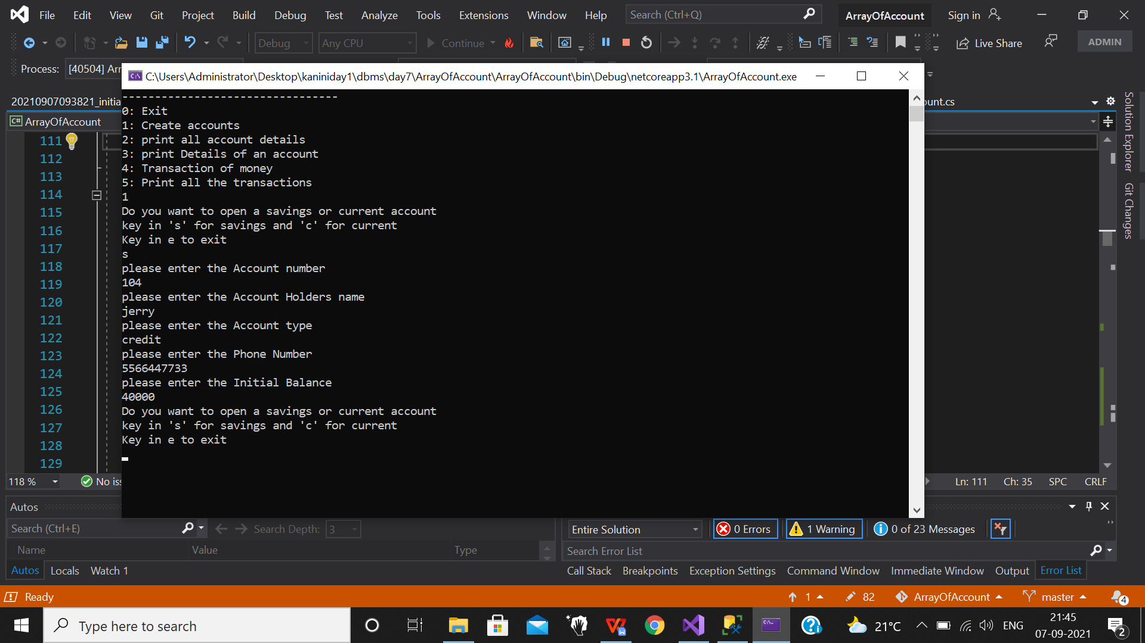

public void PrintAccountDetails()

{

List<Account> accounts = context.accounts.ToList();

foreach (var item in accounts)

{

Console.WriteLine("Account number " + item.AccountNumber);

Console.WriteLine("Account holder's Name " + item.Name);

Console.WriteLine("Account Type " + item.AccountType);

Console.WriteLine("Phone Number " + item.Phone);

Console.WriteLine("Initial Balance " + item.Balance);

Console.WriteLine("---------------------------------");

}

}

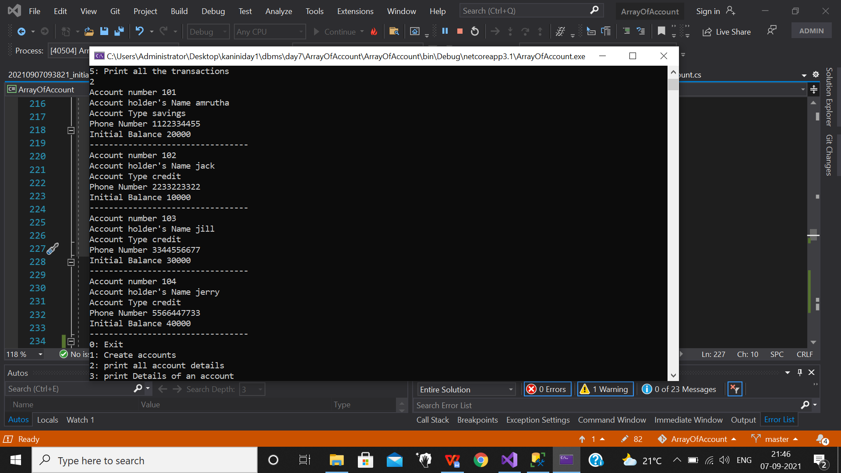

public void PrintAccountByNumber()

{

Console.WriteLine("please enter the Account number");

string id = Console.ReadLine();

List<Account> accounts = context.accounts.Where(e => e.AccountNumber == id).ToList();

foreach (var item in accounts)

{

Console.WriteLine("Account number " + item.AccountNumber);

Console.WriteLine("Account holder's Name " + item.Name);

Console.WriteLine("Account Type " + item.AccountType);

Console.WriteLine("Phone Number " + item.Phone);

Console.WriteLine("Initial Balance " + item.Balance);

Console.WriteLine("---------------------------------");

}

}

